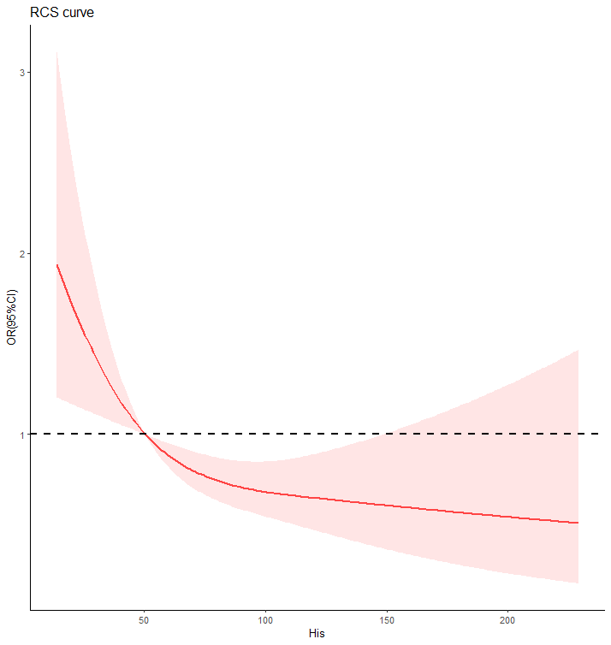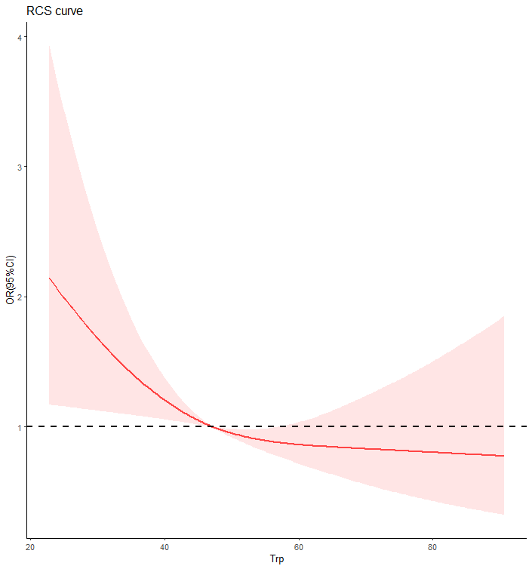
Fig S1 | The RCS curve of His and Trp. The red curve was derived from multivariate analysis that adjusted for age, gender, body mass index, systolic blood pressure, diastolic blood pressure, low-density lipoprotein cholesterol, high-density lipoprotein cholesterol, triglyceride, glycosylated hemoglobin, urinary creatinine, serum creatinine and duration of diabetic nephropathy. His, histidine; Trp, tryptophan.

TABLE S1 | Odds ratio of metformin for the risk of diabetic nephropathy in woman.
 | metformin
 | OR (95%CI) | P
Univariable model | 1.6 (1.01,2.53) | 0.049
Multivariable model1 | 1.77 (1.07,2.92) | 0.026
Multivariable model2 | 1.93 (1.15,3.22) | 0.013
OR, odd ratio.
Multivariable Model 1 was adjusted for variables in Model 1 age, body mass index, concentrations of systolic blood pressure, diastolic blood pressure, low-density lipoprotein cholesterol, high-density lipoprotein cholesterol, triglyceride, total cholesterol, glycosylated hemoglobin.
Multivariable Model 2 was adjusted for variables in Model 2 and concentrations of uric acid, serum creatinine and the duration of diabetic nephropathy.

TABLE S2 | Odds ratio of Histidine (His) for the risk of diabetic nephropathy.
OR (95%CI) |  | P
Univariable model
His, per μmol/L | 0.78 (0.65,0.95) | 0.009
<51μmol/L | reference
≥51μmol/L | 0.67 (0.49,0.92) | 0.013
Multivariable model1
His, per μmol/L | 0.77 (0.63,0.94) | 0.005
<51μmol/L | reference
≥51μmol/L | 0.64 (0.47,0.89) | 0.007
Multivariable model2
His, per μmol/L | 0.71 (0.57,0.88) | < 0.001
<51μmol/L | reference
≥51μmol/L | 0.56 (0.4,0.79) | < 0.001
Multivariable model3
His, per μmol/L | 0.71 (0.57,0.88) | < 0.001
<51μmol/L | reference
≥51μmol/L | 0.56 (0.4,0.79) | < 0.001
Multivariable model4
His, per μmol/L | 0.72 (0.58,0.89) | 0.001
<51μmol/L | reference
≥51μmol/L | 0.56 (0.4,0.8) | 0.001
In different models, the categorical His divided into two groups by 51μmol/L was used as a reference, and then observed changes of numerical and categorical His respectively, OR, odd ratio.
Multivariable Model 1 was adjusted for age, gender, body mass index.
Multivariable Model 2 was adjusted for variables in Model 1 and concentrations of systolic blood pressure, diastolic blood pressure, low-density lipoprotein cholesterol, high-density lipoprotein cholesterol, triglyceride, total cholesterol, glycosylated hemoglobin.
Multivariable Model 3 was adjusted for variables in Model 2 and concentrations of uric acid, serum creatinine.
Multivariable Model 4 was adjusted for variables in Model 3 and concentrations of use of metformin.

TABLE S3 | Odds ratio of Histidine (His) for the risk of diabetic nephropathy in different group by gender.
 | man |  | woman
 | OR(95%CI) | P | OR(95%CI) | P
Univariable model
His, per μmol/L | 0.87 (0.68,1.11) | 0.236 | 0.68 (0.5,0.93) | 0.008
<51μmol/L | reference |  | reference
≥51μmol/L | 0.78 (0.5,1.22) | 0.273 | 0.57 (0.35,0.9) | 0.015
Multivariable model1
His, per μmol/L | 0.87 (0.68,1.11) | 0.231 | 0.66 (0.48,0.91) | 0.004
<51μmol/L | reference |  | reference
≥51μmol/L | 0.78 (0.5,1.22) | 0.278 | 0.52 (0.32,0.83) | 0.006
Multivariable model2
His, per μmol/L | 0.85 (0.64,1.11) | 0.218 | 0.54 (0.38,0.78) | < 0.001
<51μmol/L | reference |  | reference
≥51μmol/L | 0.7 (0.43,1.13) | 0.142 | 0.41 (0.24,0.68) | < 0.001
Multivariable model3
His, per μmol/L | 0.85 (0.64,1.11) | 0.218 | 0.54 (0.38,0.78) | < 0.001
<51μmol/L | reference |  | reference
≥51μmol/L | 0.7 (0.43,1.13) | 0.142 | 0.41 (0.24,0.68) | < 0.001
Multivariable model4
His, per μmol/L | 0.85 (0.65,1.12) | 0.248 | 0.57 (0.39,0.81) | < 0.001
<51μmol/L | reference |  | reference
≥51μmol/L | 0.7 (0.43,1.14) | 0.152 | 0.44 (0.26,0.74) | 0.02
In different models, the categorical His divided into two groups by 51μmol/L was used as reference, and then observed changes of numerical and categorical His respectively, OR, odd ratio.
Multivariable Model 1 was adjusted for age, gender, body mass index.
Multivariable Model 2 was adjusted for variables in Model 1 and concentrations of systolic blood pressure, diastolic blood pressure, low-density lipoprotein cholesterol, high-density lipoprotein cholesterol, triglyceride, total cholesterol, glycosylated hemoglobin.
Multivariable Model 3 was adjusted for variables in Model 2 and concentrations of uric acid, serum creatinine.
Multivariable Model 4 was adjusted for variables in Model 3 and concentrations of use of metformin.

TABLE S4 | Odds ratio of Histidine (His) for the risk of diabetic nephropathy.
OR (95%CI) |  | P
Univariable model
His, per μmol/L | 0.78 (0.65,0.95) | 0.009
<51μmol/L | reference
≥51μmol/L | 0.67 (0.49,0.92) | 0.013
Multivariable model1
His, per μmol/L | 0.77 (0.63,0.94) | 0.005
<51μmol/L | reference
≥51μmol/L | 0.64 (0.47,0.89) | 0.007
Multivariable model2
His, per μmol/L | 0.71 (0.57,0.88) | < 0.001
<51μmol/L | reference
≥51μmol/L | 0.56 (0.4,0.79) | < 0.001
Multivariable model3
His, per μmol/L | 0.71 (0.57,0.89) | < 0.001
<51μmol/L | reference
≥51μmol/L | 0.55 (0.39,0.78) | < 0.001
Multivariable model4
His, per μmol/L | 0.72 (0.57,0.89) | 0.001
<51μmol/L | reference
≥51μmol/L | 0.56 (0.4,0.8) | 0.001
The missing values were interpolated using the random forest method. In different models, the categorical His divided into two groups by 51μmol/L was used as a reference, and then observed changes of numerical and categorical His respectively, OR, odd ratio.
Multivariable Model 1 was adjusted for age, gender, body mass index.
Multivariable Model 2 was adjusted for variables in Model 1 and concentrations of systolic blood pressure, diastolic blood pressure, low-density lipoprotein cholesterol, high-density lipoprotein cholesterol, triglyceride, total cholesterol, glycosylated hemoglobin.
Multivariable Model 3 was adjusted for variables in Model 2 and concentrations of uric acid, serum creatinine.
Multivariable Model 4 was adjusted for variables in Model 3 and concentrations of use of Metformin.

TABLE S5 | Odds ratio of Histidine (His) for the risk of diabetic nephropathy in different group by gender.
 | man |  | woman
 | OR(95%CI) | P | OR(95%CI) | P
Univariable model
His, per μmol/L | 0.87 (0.68,1.11) | 0.236 | 0.68 (0.5,0.93) | 0.008
<51μmol/L | reference |  | reference
≥51μmol/L | 0.78 (0.5,1.22) | 0.273 | 0.57 (0.35,0.9) | 0.015
Multivariable model1
His, per μmol/L | 0.87 (0.68,1.11) | 0.231 | 0.66 (0.48,0.91) | 0.004
<51μmol/L | reference |  | reference
≥51μmol/L | 0.78 (0.5,1.22) | 0.278 | 0.52 (0.32,0.83) | 0.006
Multivariable model2
His, per μmol/L | 0.85 (0.64,1.11) | 0.218 | 0.54 (0.38,0.78) | < 0.001
<51μmol/L | reference |  | reference
≥51μmol/L | 0.7 (0.43,1.13) | 0.142 | 0.41 (0.24,0.68) | < 0.001
Multivariable model3
His, per μmol/L | 0.83 (0.63,1.1) | 0.176 | 0.58 (0.41,0.84) | 0.001
<51μmol/L | reference |  | reference
≥51μmol/L | 0.67 (0.41,1.09) | 0.106 | 0.43 (0.26,0.73) | 0.001
Multivariable model4
His, per μmol/L | 0.84 (0.64,1.1) | 0.185 | 0.59 (0.41,0.84) | 0.001
<51μmol/L | reference |  | reference
≥51μmol/L | 0.68 (0.42,1.1) | 0.111 | 0.45 (0.27,0.76) | 0.003
The missing values were interpolated using the random forest method. In different models, the categorical His divided into two groups by 51μmol/L was used as reference, and then observed changes of numerical and categorical His respectively, OR, odd ratio.
Multivariable Model 1 was adjusted for age, gender, body mass index.
Multivariable Model 2 was adjusted for variables in Model 1 and concentrations of systolic blood pressure, diastolic blood pressure, low-density lipoprotein cholesterol, high-density lipoprotein cholesterol, triglyceride, total cholesterol, glycosylated hemoglobin.
Multivariable Model 3 was adjusted for variables in Model 2 and concentrations of uric acid, serum creatinine.
Multivariable Model 4 was adjusted for variables in Model 3 and concentrations of use of Metformin.

