SUPPLEMENTARY MATERIALS
Article Title: Synthesis, characterization, in vitro antibacterial and in vivo antimalarial studies of arylsulphonamoyl ala-val carboxamide dipeptides
Journal name: Organic Chemistry Research
Author names: Ogakwu Sunday Adoga^{1*}, U. C. Okoro¹, D. Dattatraya², M. Shukula², Maya Makatini³
Authors’ affiliations
¹Department of Pure and Industrial Chemistry, University of Nigeria, Nsukka
²Department of Chemistry, Indian Institute of Technology, Kanpur
³Department of Chemistry, University of Witwatersrand, Johannesburg, South Africa
Corresponding author email: adogasundayo@gmail.com

APPENDIX I
¹H, ¹³C NMR and MS Spectra of Compounds
2-(phenylsulfonamido)propanoic acid
Spectrum 1a

2-(4-methylphenylsulfonamido)propanoic acid
Spectrum 1b

2-(4-nitrophenylsulfonamido)propanoic acid
Spectrum 1c

tert-butyl (1-(ethylamino)-3-methyl-1-oxobutan-2-yl)carbamate
Spectrum 2a
tert-butyl (3-methyl-1-oxo-1-(propylamino)butan-2-yl)carbamate
Spectrum 2b

tert-butyl (1-(butylamino)-3-methyl-1-oxobutan-2-yl)carbamate
Spectrum 2c

tert-butyl (3-methyl-1-oxo-1-(piperidin-1-yl)butan-2-yl)carbamate
Spectrum 2d

tert-butyl (1-(dimethylamino)-3-methyl-1-oxobutan-2-yl)carbamate
Spectrum 2e
tert-butyl (3-methyl-1-oxo-1-(1H-pyrazol-1-yl)butan-2-yl)carbamate
Spectrum 2f
tert-butyl (3-methyl-1-oxo-1-(pyrrolidin-1-yl)butan-2-yl)carbamate
Spectrum 2g
tert-butyl (1-(diethylamino)-3-methyl-1-oxobutan-2-yl)carbamate
Spectrum 2h
N-ethyl-3-methyl-2-(2-(phenylsulfonamido)propanamido)butanamide (3a)
Spectrum 1

Spectrum 2
N-ethyl-3-methyl-2-(2-(4-methylphenylsulfonamido)propanamido)butanamide (3b) Spectrum 3
Spectrum 4

N-ethyl-3-methyl-2-(2-(4-nitrophenylsulfonamido)propanamido)butanamide (3c)
Spectrum 5
Spectrum 6
Spectrum 7

3-methyl-2-(2-(phenylsulfonamido)propanamido)-N-propylbutanamide (3d)
Spectrum 8
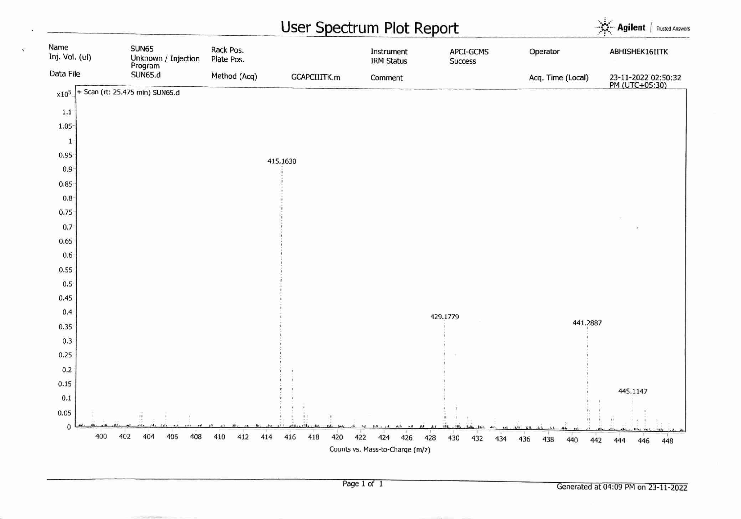
Spectrum 9Spectrum 10
3-methyl-2-(2-(4-methylphenylsulfonamido)propanamido)-N-propylbutanamide (3e)
Spectrum 11
Spectrum 12
3-methyl-2-(2-(4-nitrophenylsulfonamido)propanamido)-N-propylbutanamide (3f)
Spectrum 13
Spectrum 14
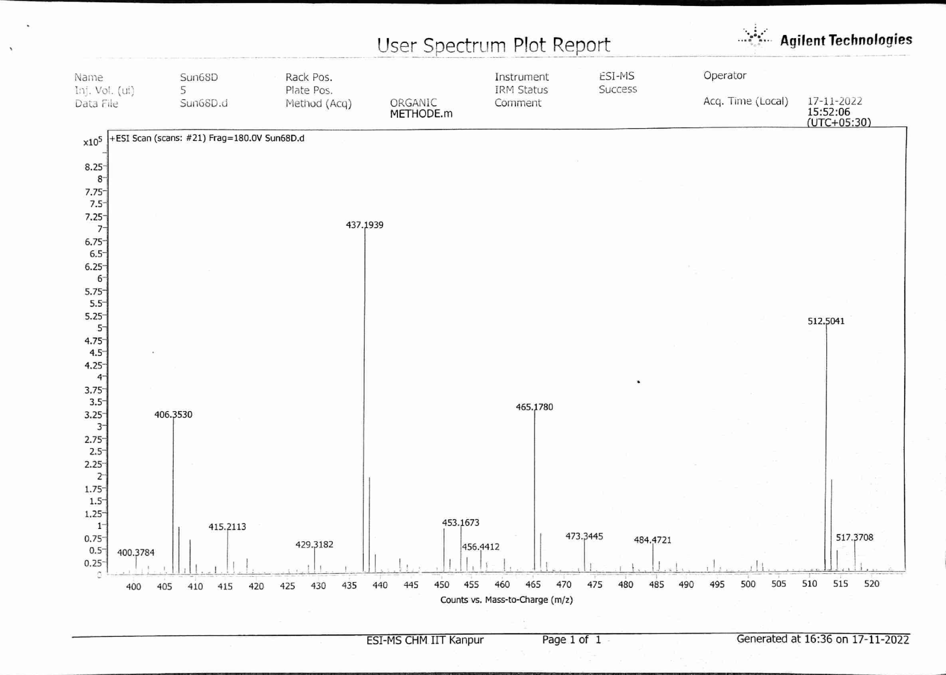
Spectrum 15
N,N,3-trimethyl-2-(2-(phenylsulfonamido)propanamido)butanamide (3g)
Spectrum 16
Spectrum 17
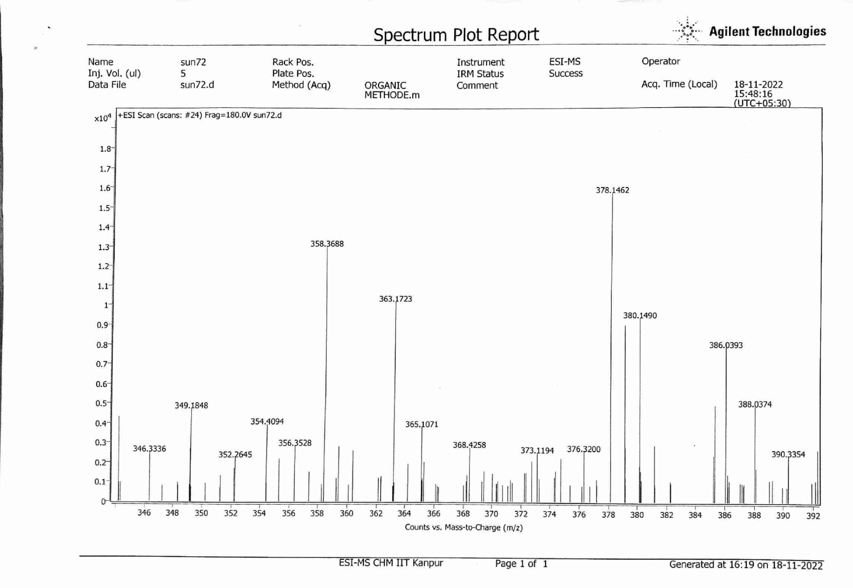
Spectrum 18

N,N,3-trimethyl-2-(2-(4-methylphenylsulfonamido)propanamido)butanamide (3h)
Spectrum 19
Spectrum 20
Spectrum 21
N,N,3-trimethyl-2-(2-(4-nitrophenylsulfonamido)propanamido)butanamide (3i)
Spectrum 22
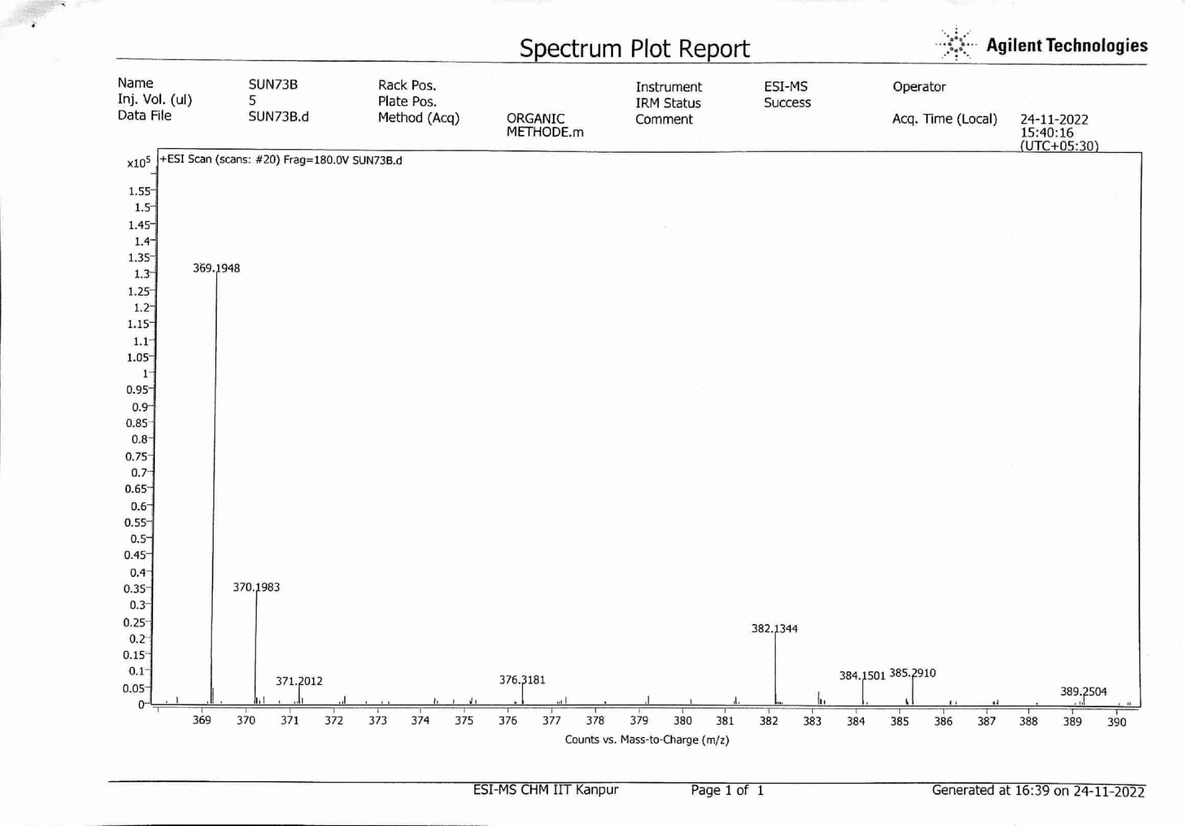
Spectrum 23
N-butyl-3-methyl-2-(2-(phenylsulfonamido)propanamido)butanamide (3j)
Spectrum 24
Spectrum 25
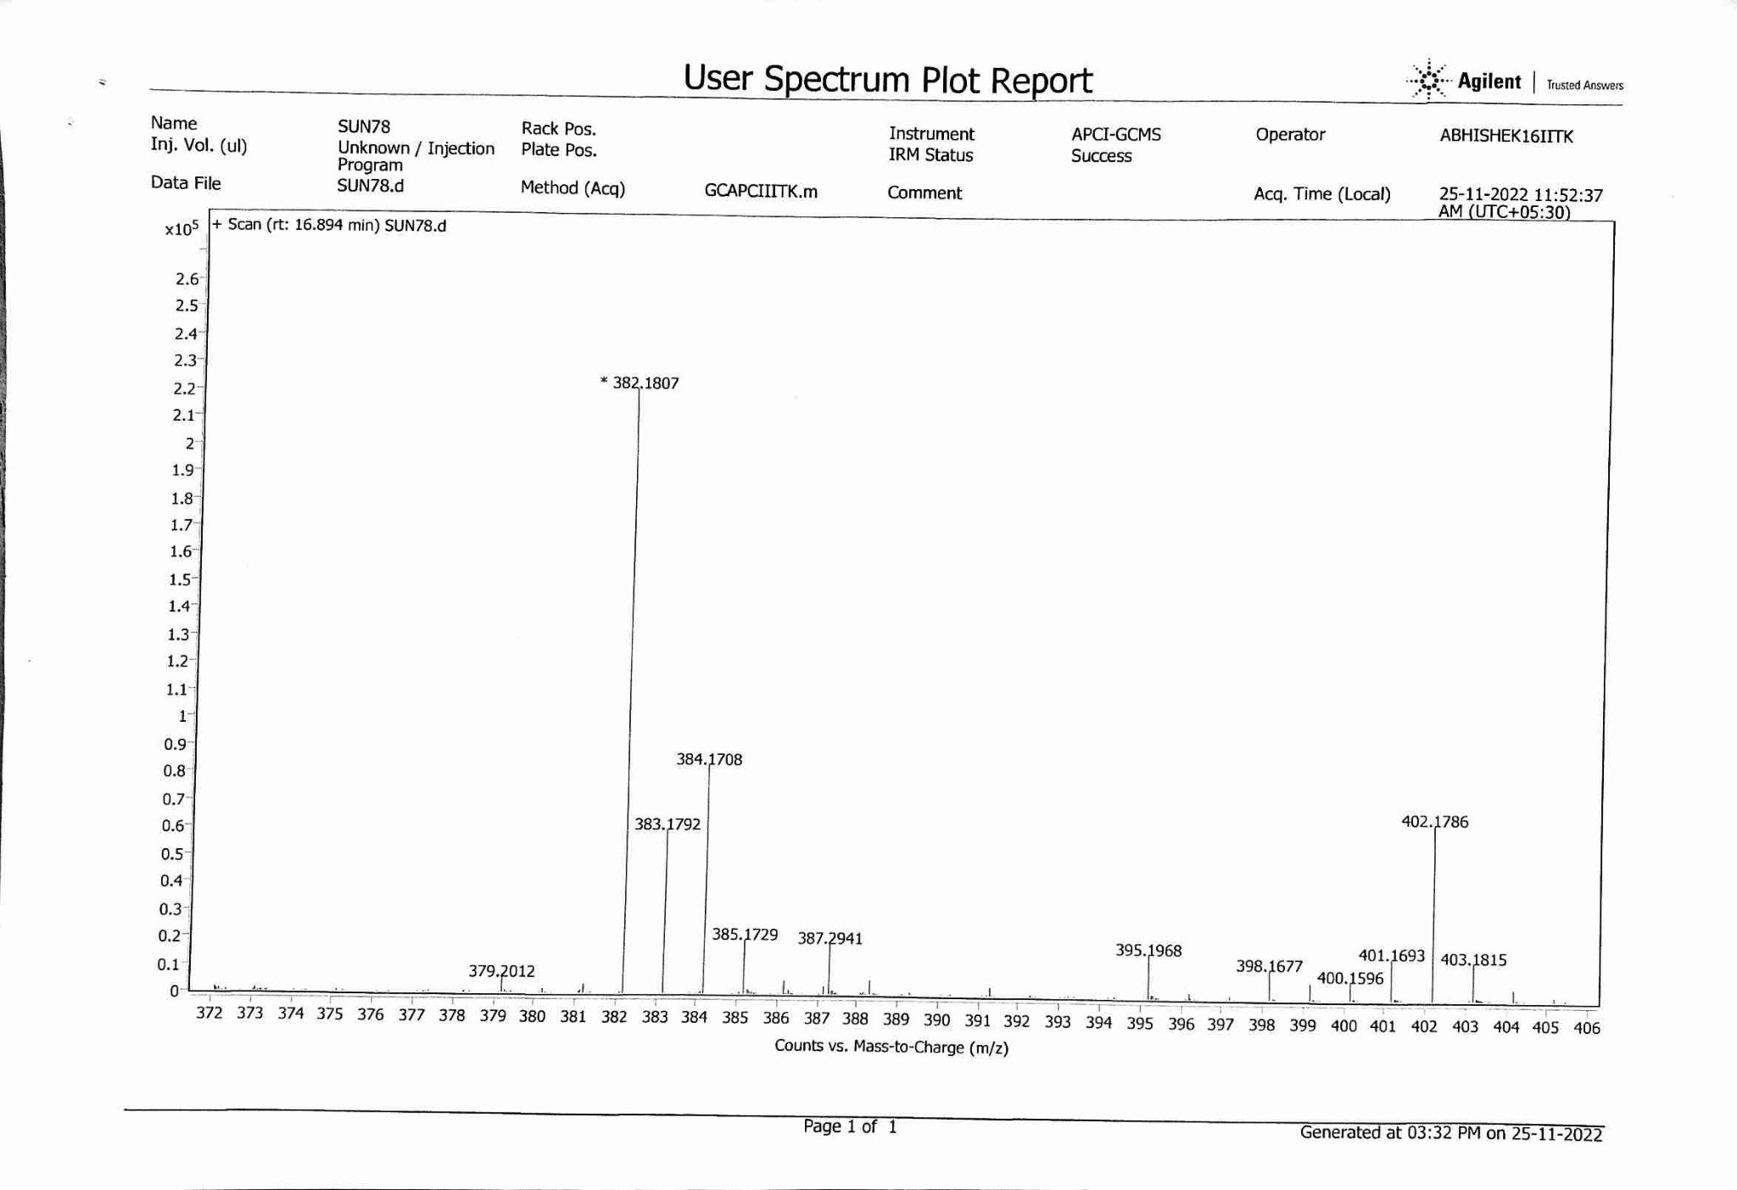
Spectrum 26

N-butyl-3-methyl-2-(2-(4-methylphenylsulfonamido)propanamido)butanamide (3k)
Spectrum 27
Spectrum 28

N-butyl-3-methyl-2-(2-(4-nitrophenylsulfonamido)propanamido)butanamide (3l)
Spectrum 29
Spectrum 30

N-(3-methyl-1-oxo-1-(piperidin-1-yl)butan-2-yl)-2-(phenylsulfonamido)propanamide (3m)
Spectrum 31
Spectrum 32
Spectrum 33
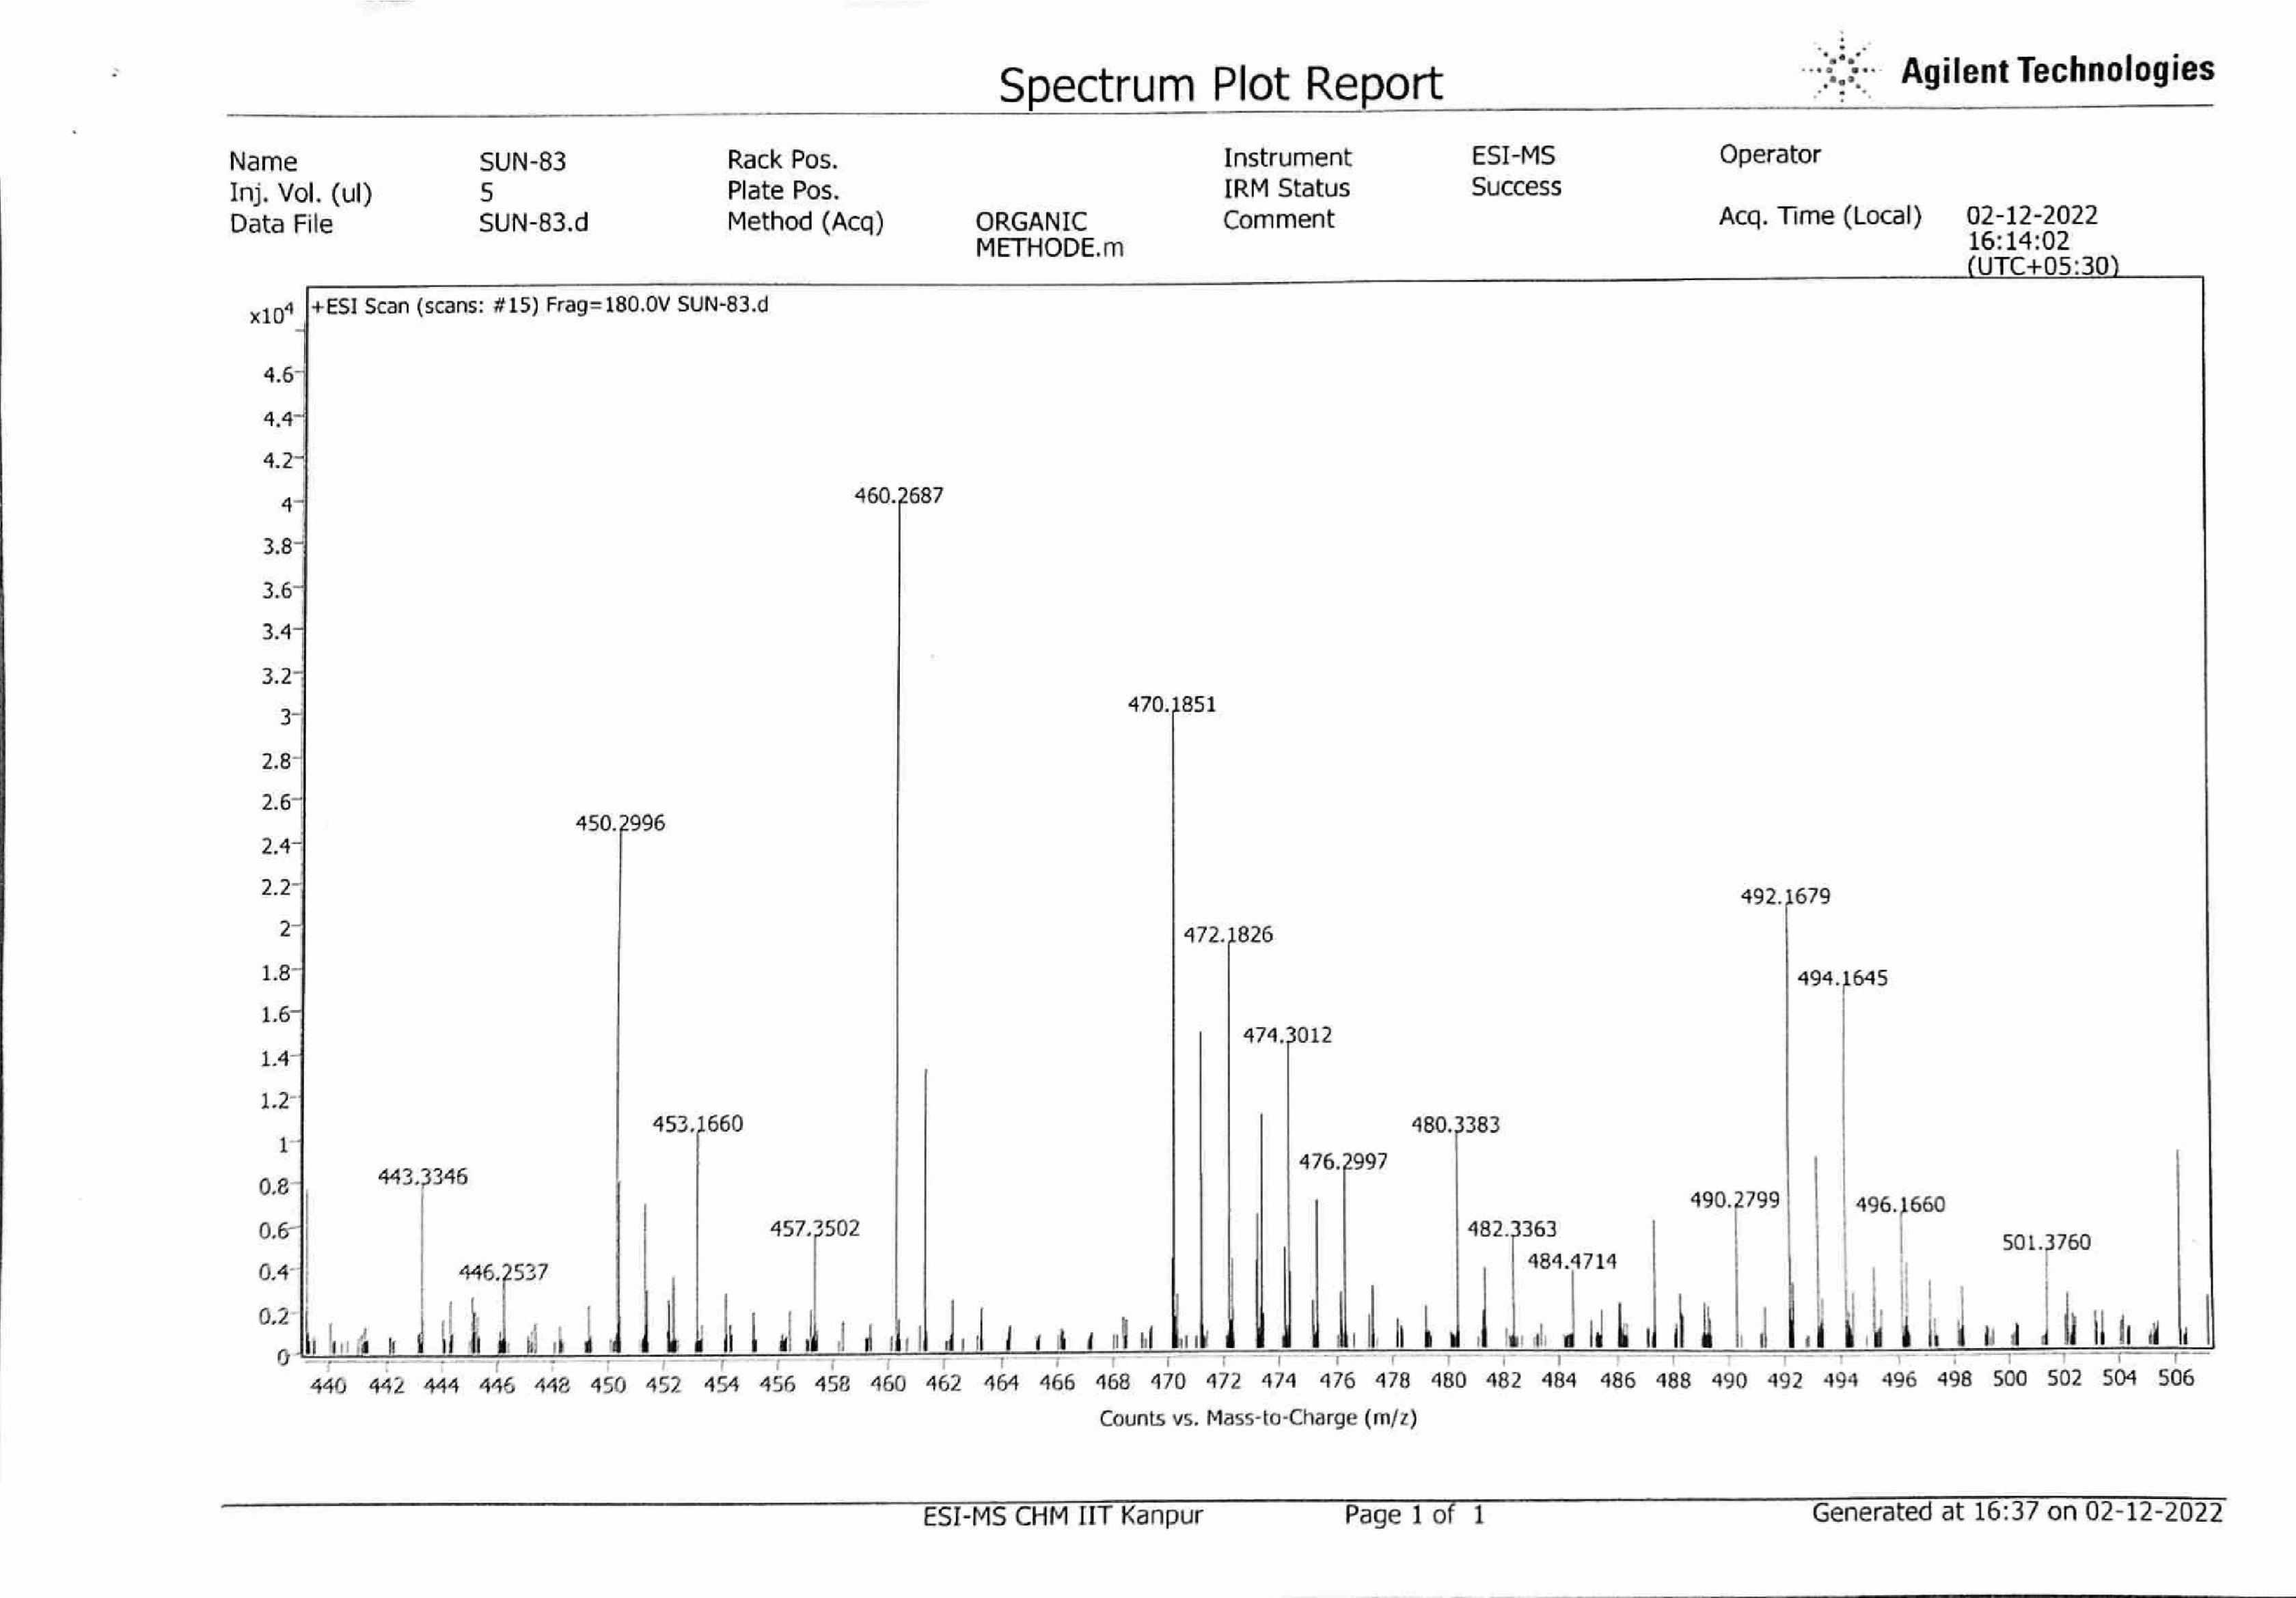

N-(3-methyl-1-oxo-1-(piperidin-1-yl)butan-2-yl)-2-(4-nitrophenylsulfonamido)
propanamide (3n)
Spectrum 33
Spectrum 34

N-(3-methyl-1-oxo-1-(1H-pyrazol-1-yl)butan-2-yl)-2-(phenylsulfonamido)propanamide (3o)
Spectrum 35
Spectrum 36

N-(3-methyl-1-oxo-1-(1H-pyrazol-1-yl)butan-2-yl)-2-(4-methylphenylsulfonamido)
Propanamide (3p)
Spectrum 37
Spectrum 38

N-(3-methyl-1-oxo-1-(1H-pyrazol-1-yl)butan-2-yl)-2-(4-nitrophenylsulfonamido) propanamide (3q)
Spectrum 39
Spectrum 40

N-(3-methyl-1-oxo-1-(pyrrolidin-1-yl)butan-2-yl)-2-(phenylsulfonamido)propanamide (3r)
Spectrum 41
Spectrum 42
Spectrum 43
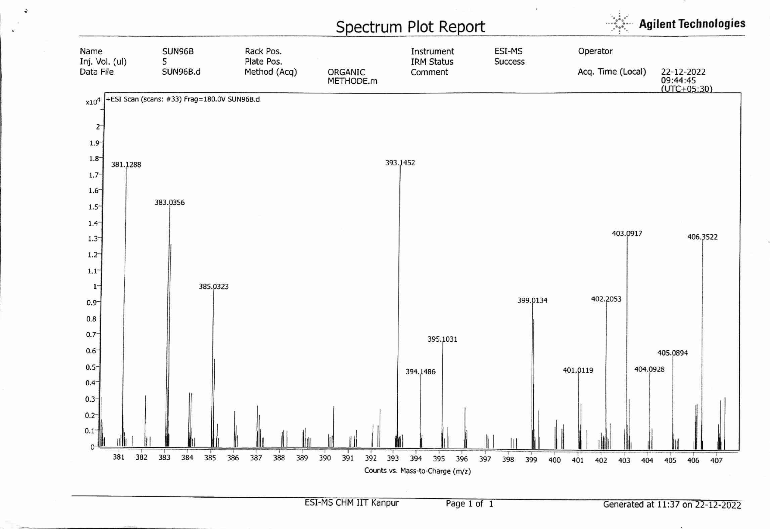
N-(3-methyl-1-oxo-1-(pyrrolidin-1-yl)butan-2-yl)-2-(4-methylphenylsulfonamido)
Propanamide (3s)
Spectrum 44
Spectrum 45
Spectrum 46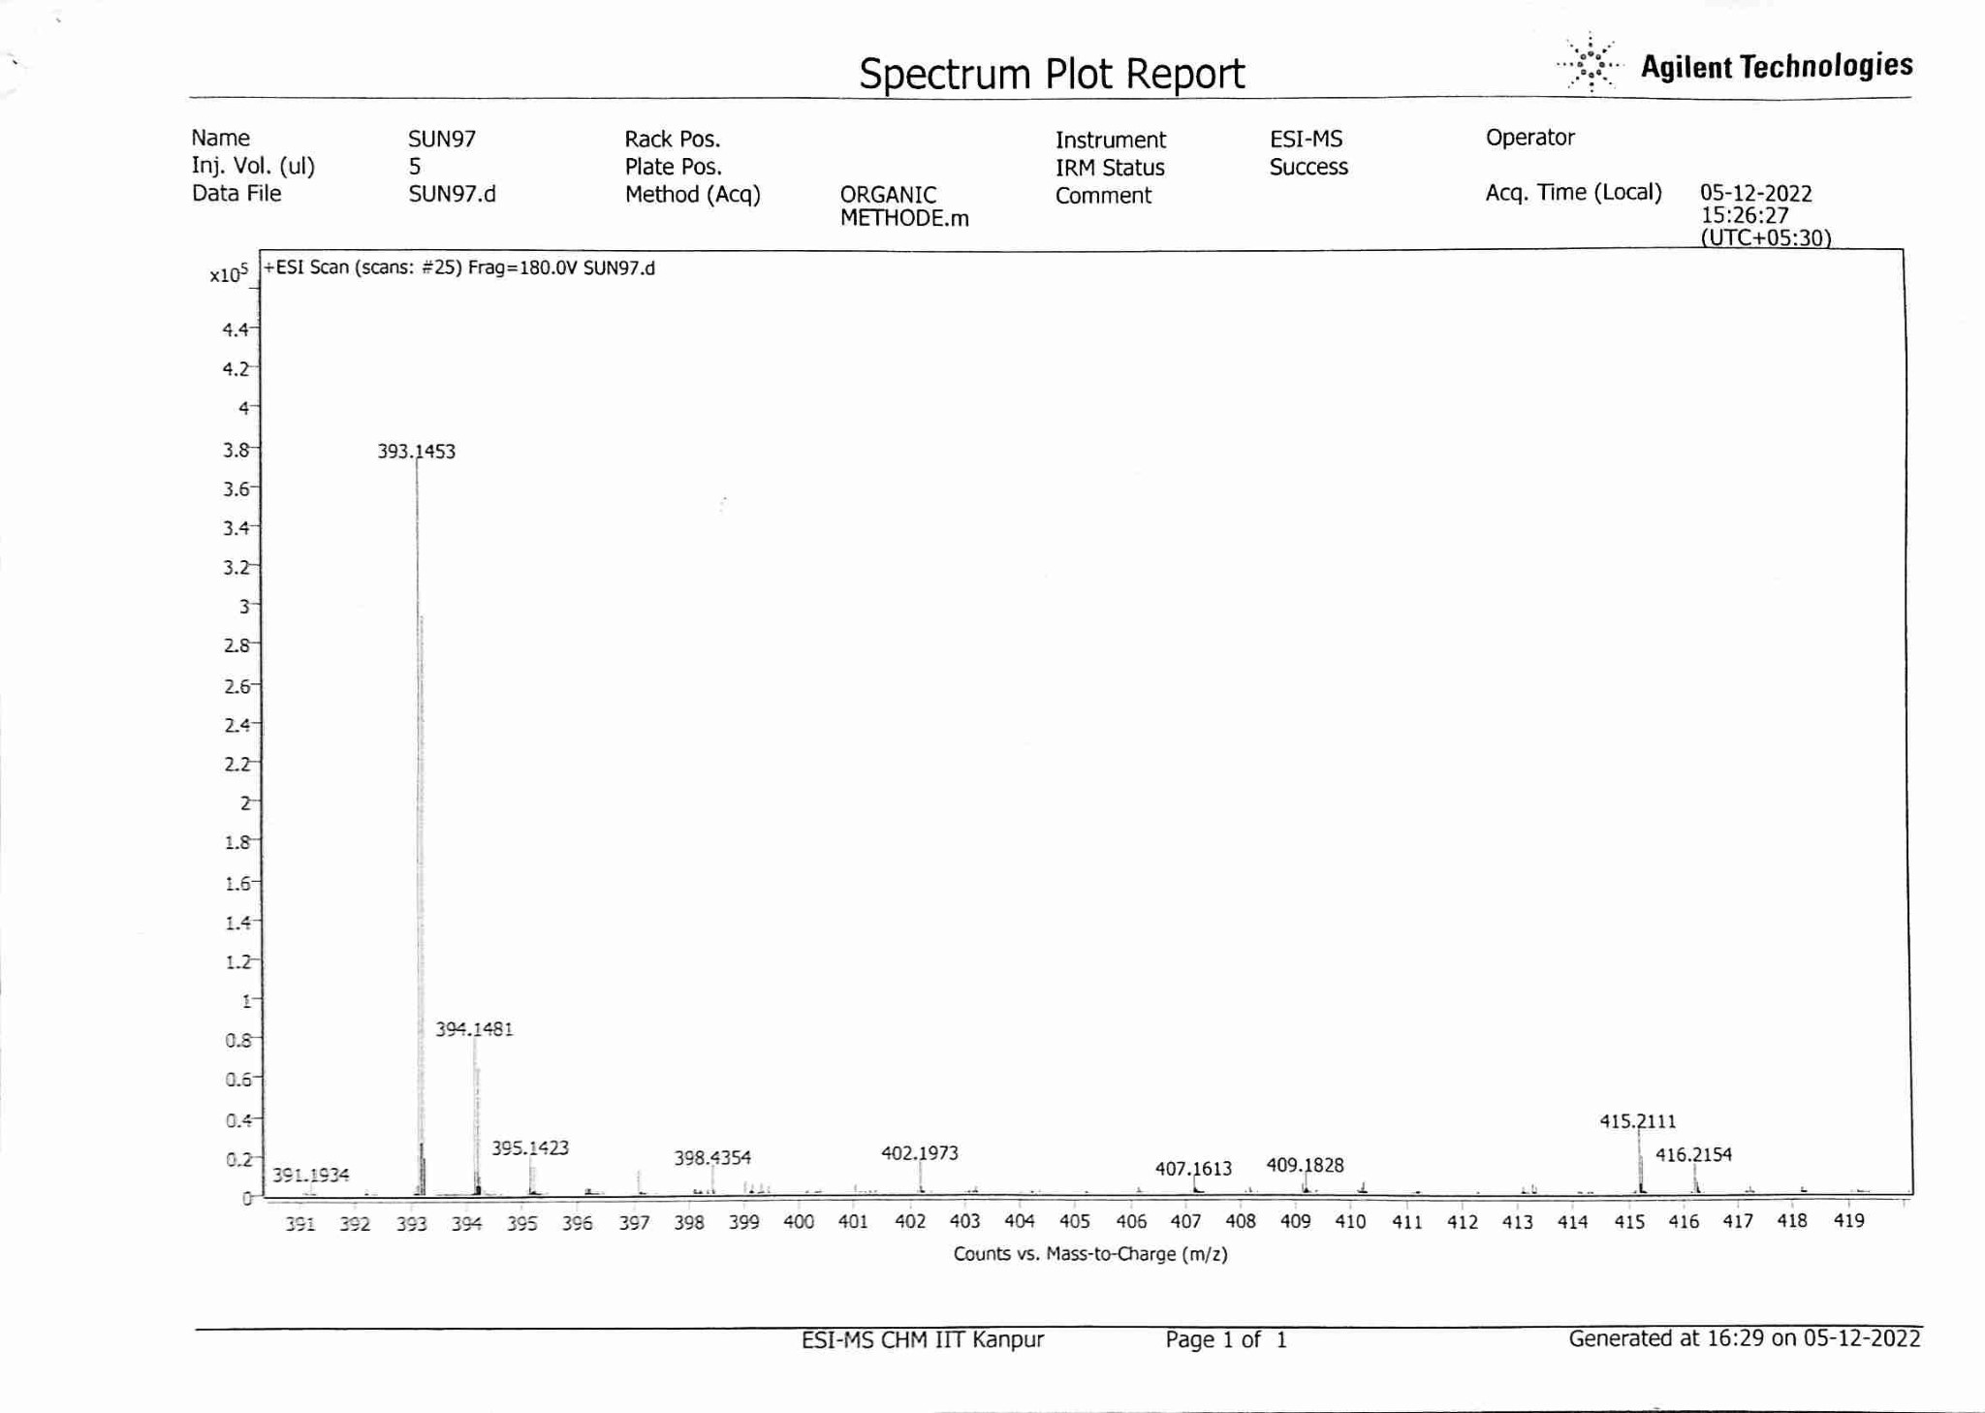
N-(3-methyl-1-oxo-1-(pyrrolidin-1-yl)butan-2-yl)-2-(4-nitrophenylsulfonamido)
Propanamide (3t)
Spectrum 47
Spectrum 48

N,N-diethyl-3-methyl-2-(2-(phenylsulfonamido)propanamido)butanamide (3u)
Spectrum 49
Spectrum 50
Spectrum 51
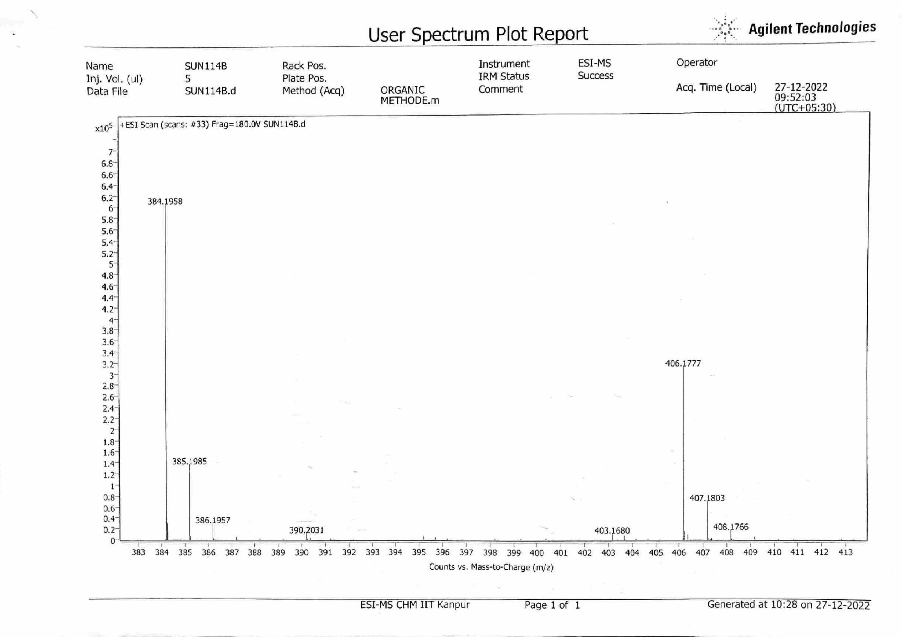
N,N-diethyl-3-methyl-2-(2-(4-methylphenylsulfonamido)propanamido)butanamide (3v)
Spectrum 52
Spectrum 53
Spectrum 54
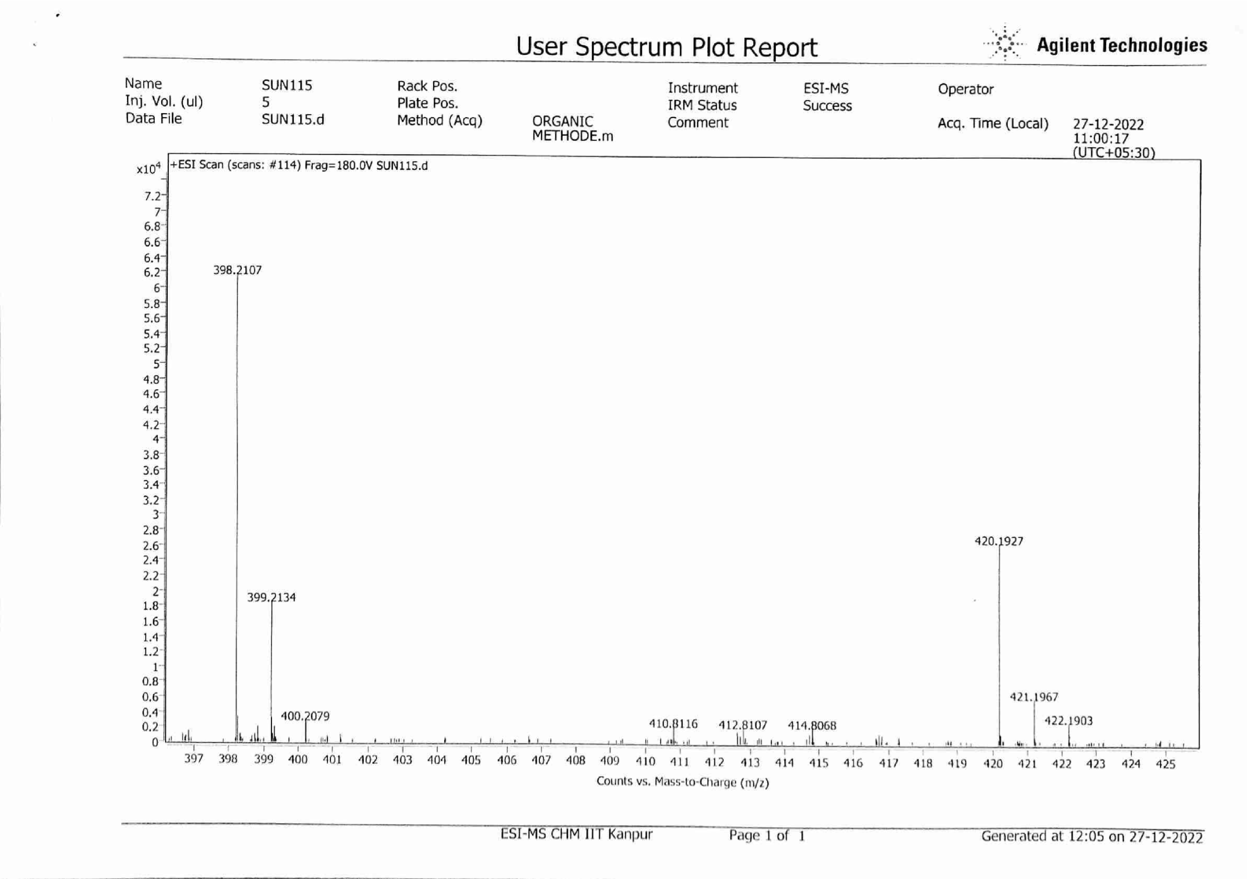
N,N-diethyl-3-methyl-2-(2-(4-nitrophenylsulfonamido)propanamido)butanamide (3w)
Spectrum 55

Spectrum 56
Spectrum 57
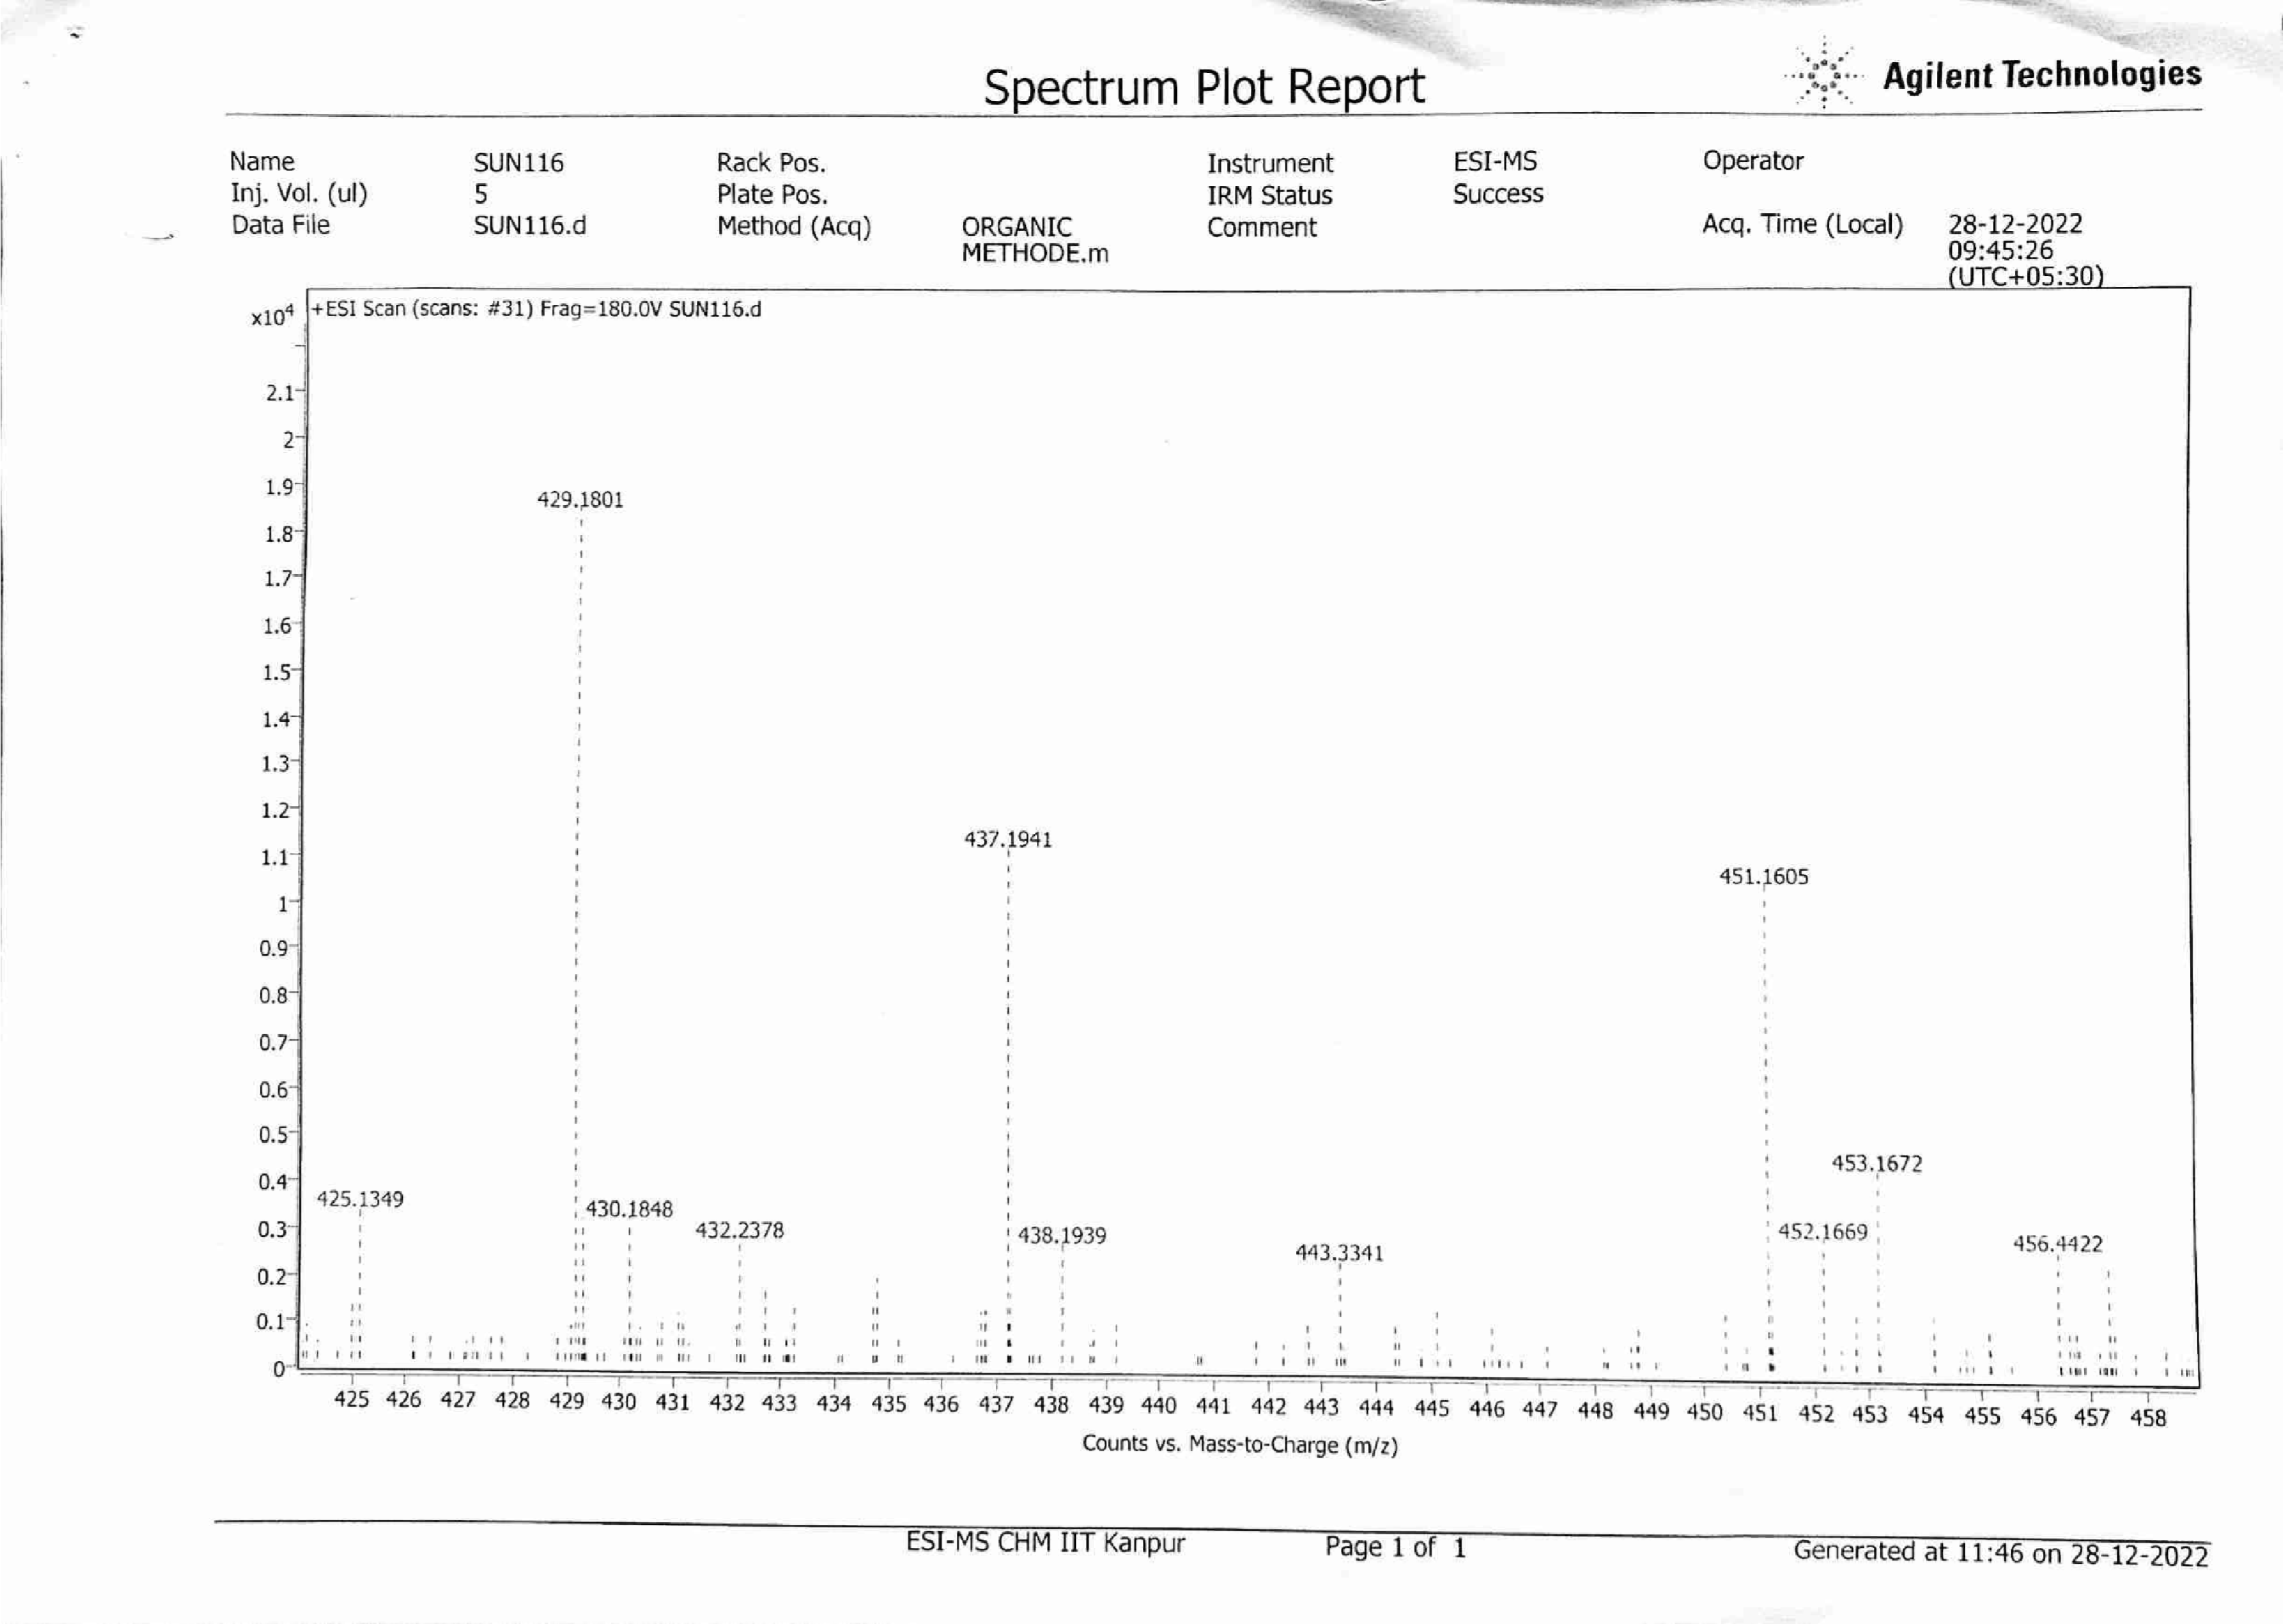
APPENDIX II
Corresponding FTIR Spectra of Compounds
N-ethyl-3-methyl-2-(2-(phenylsulfonamido)propanamido)butanamide (3a)

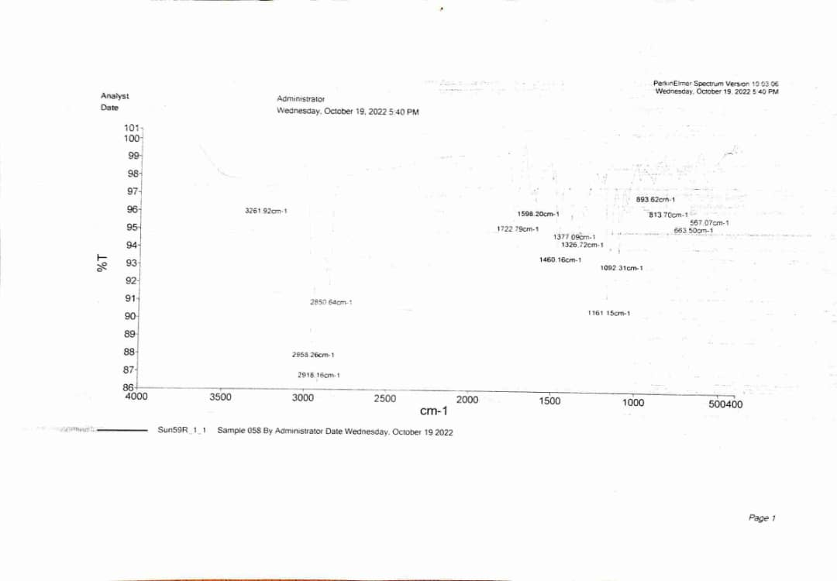
N-ethyl-3-methyl-2-(2-(4-methylphenylsulfonamido)propanamido)butanamide (3b)
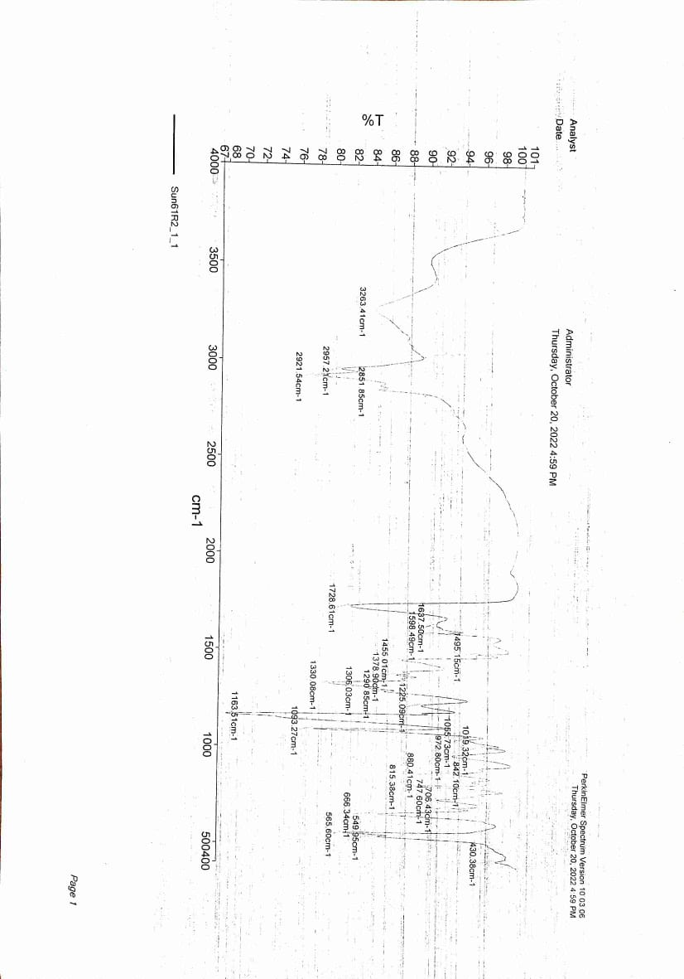

N-ethyl-3-methyl-2-(2-(4-nitrophenylsulfonamido)propanamido) butanamide (3c)
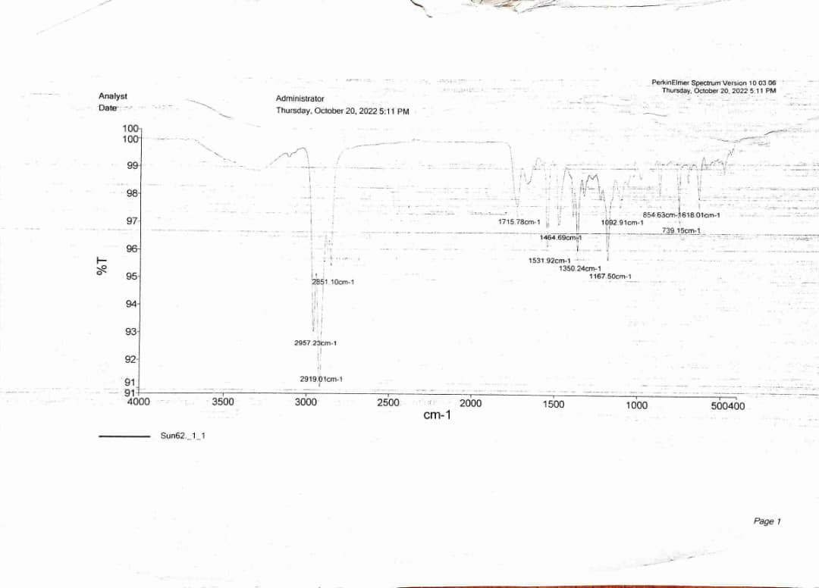

3-methyl-2-(2-(phenylsulfonamido)propanamido)-N-propylbutanamide (3d)
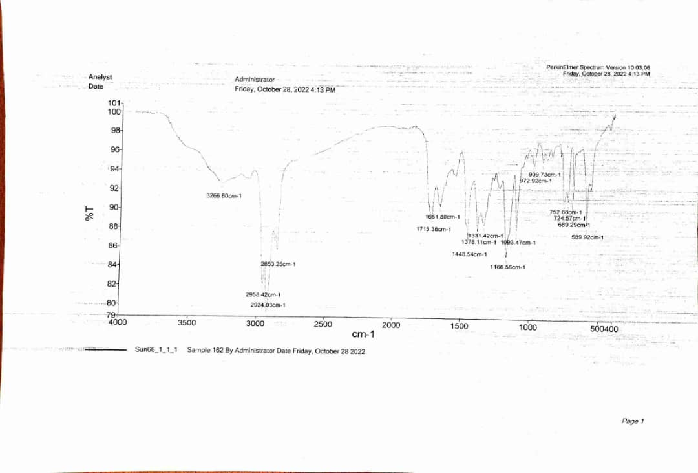

3-methyl-2-(2-(4-methylphenylsulfonamido)propanamido)-N-propylbutanamide (3e)
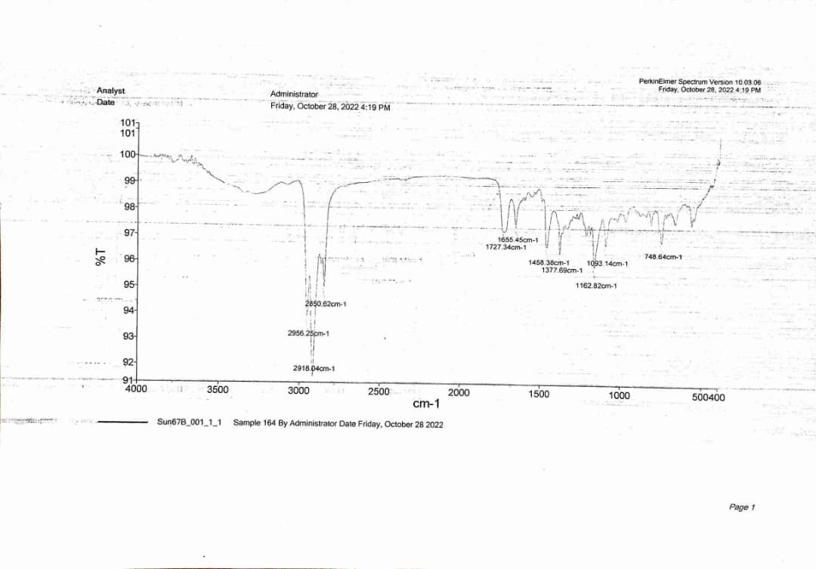
3-methyl-2-(2-(4-nitrophenylsulfonamido) propanamido)-N-propylbutanamide (3f)
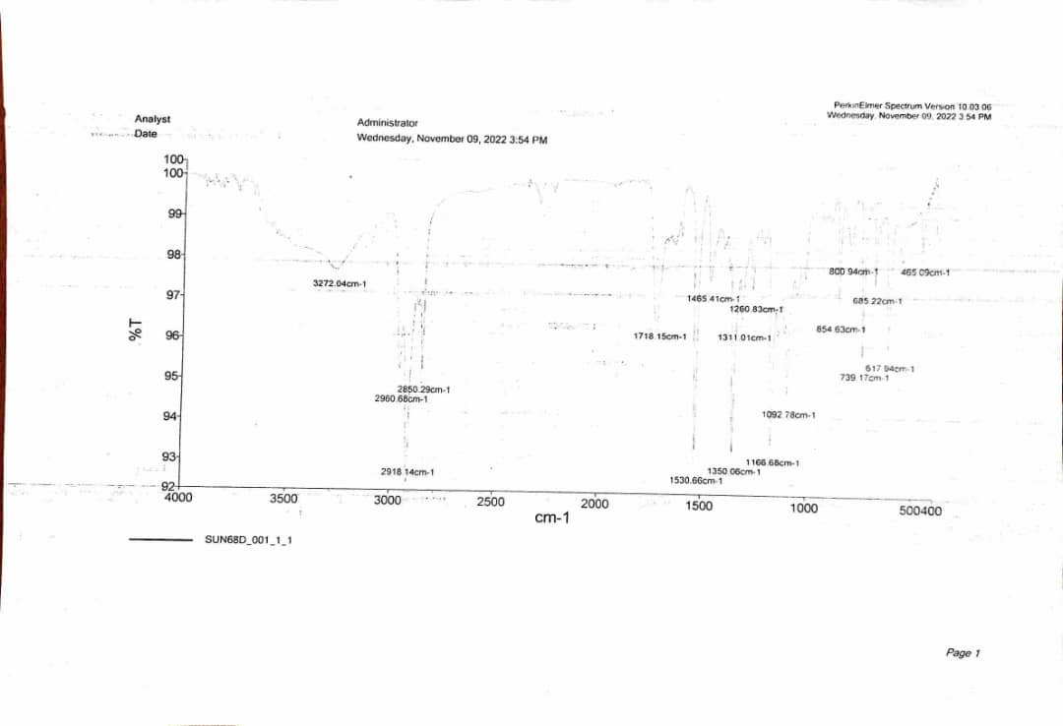
N,N,3-trimethyl-2-(2-(phenylsulfonamido)propanamido)butanamide (3g)
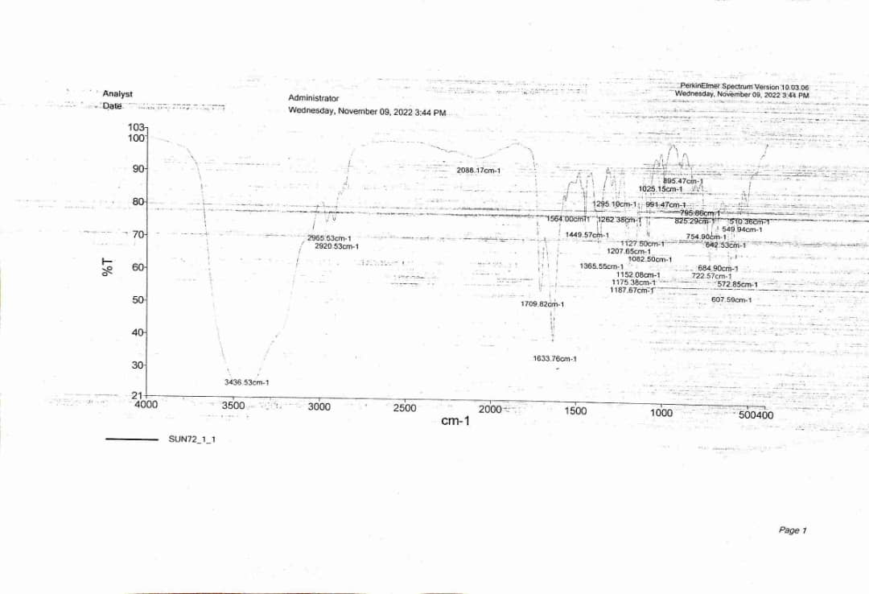
N,N,3-trimethyl-2-(2-(4-methylphenylsulfonamido) propanamido) butanamide (3h)
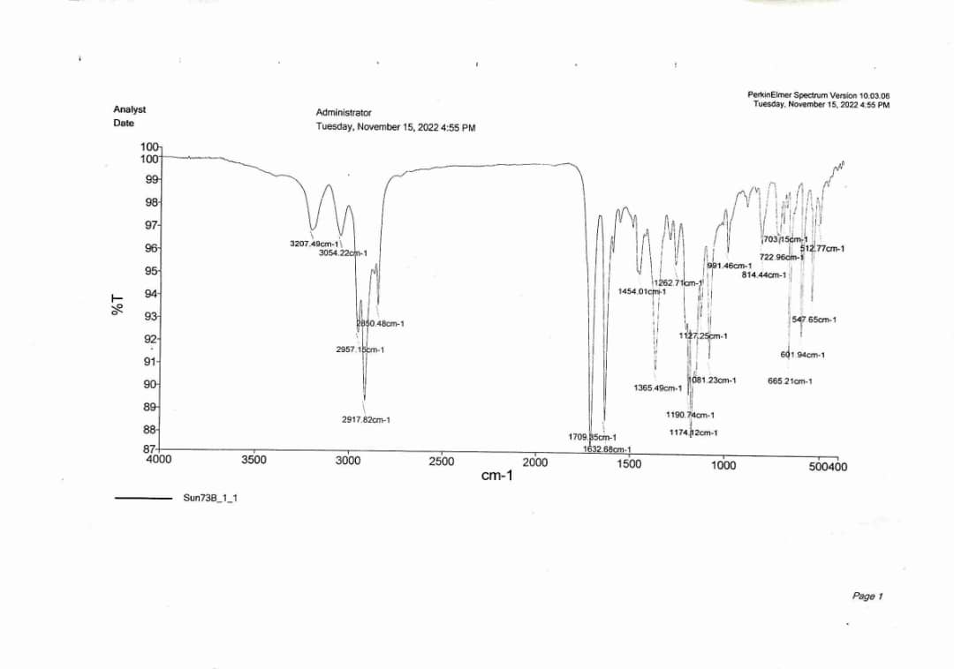

N,N,3-trimethyl-2-(2-(4-nitrophenylsulfonamido)propanamido)butanamide (3i)
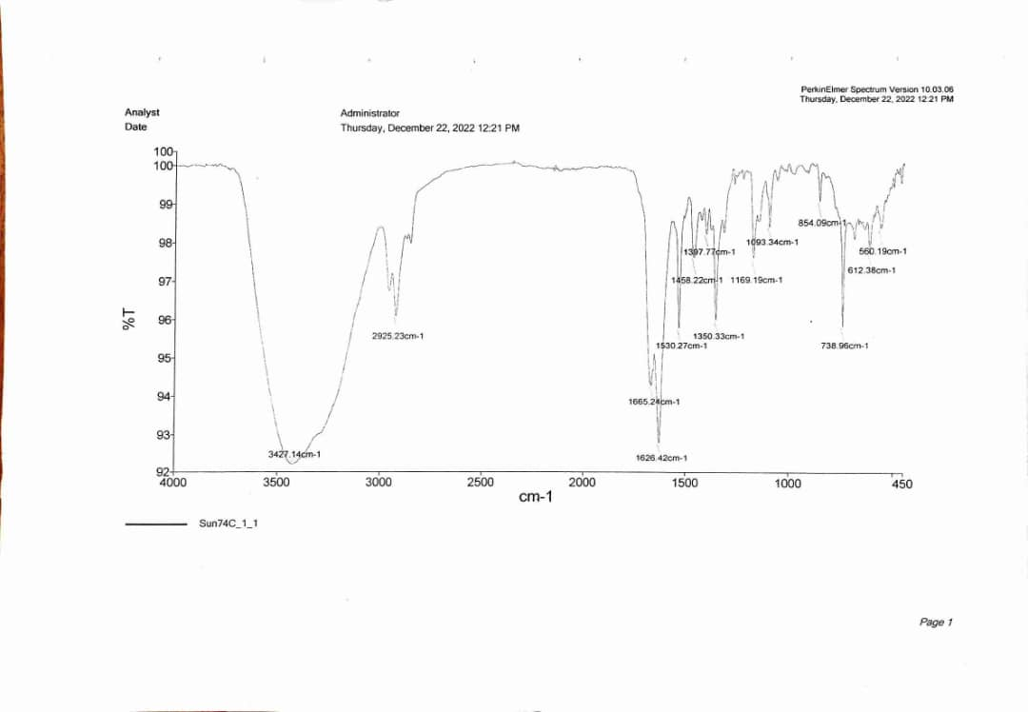

N-butyl-3-methyl-2-(2-(phenylsulfonamido)propanamido)butanamide (3j)
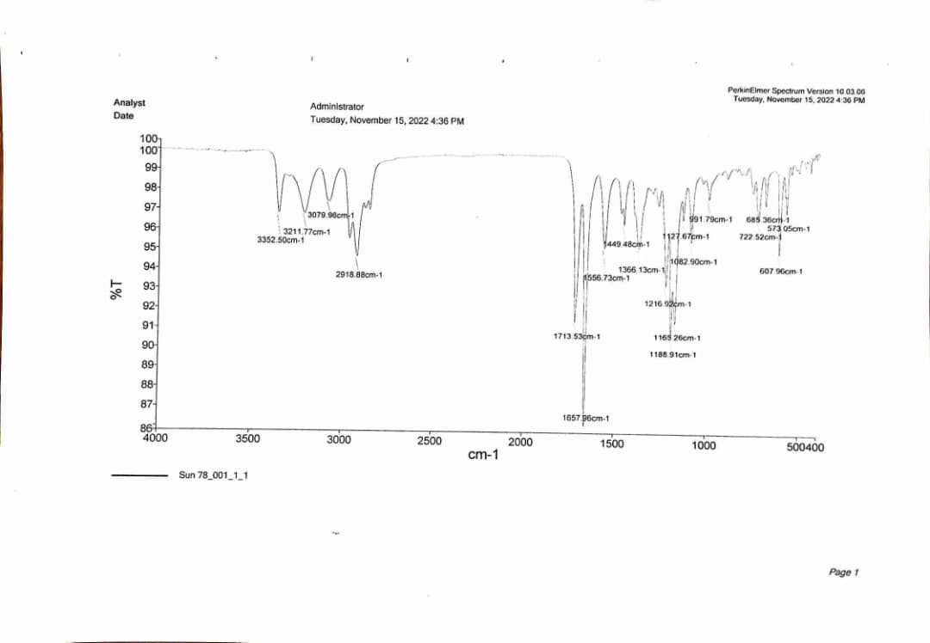

N-butyl-3-methyl-2-(2-(4-methylphenylsulfonamido) propanamido) butanamide (3k)
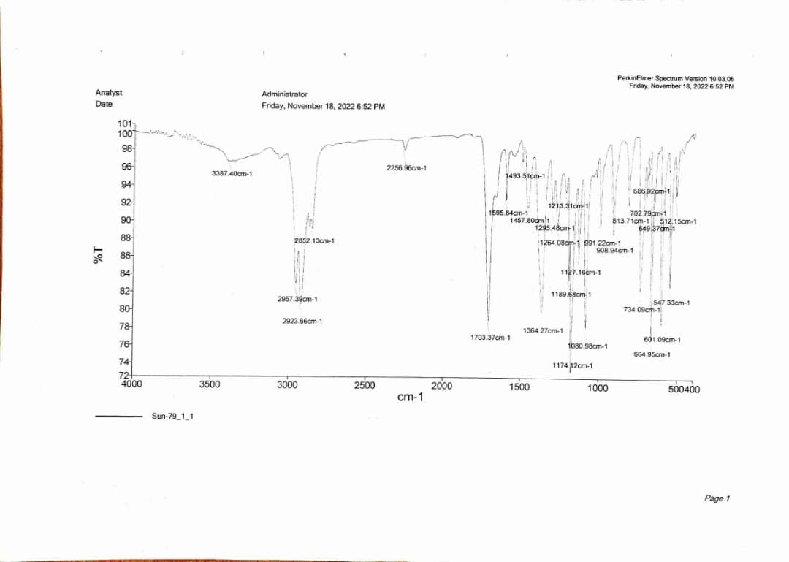

N-butyl-3-methyl-2-(2-(4-nitrophenylsulfonamido) propanamido)butanamide (3l)
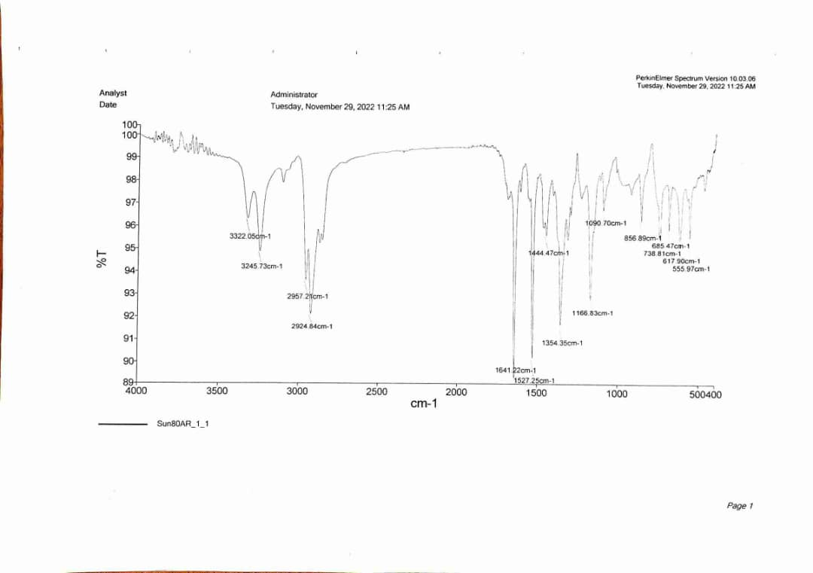

N-(3-methyl-1-oxo-1-(piperidin-1-yl)butan-2-yl)-2-(phenylsulfonamido)propanamide (3m)
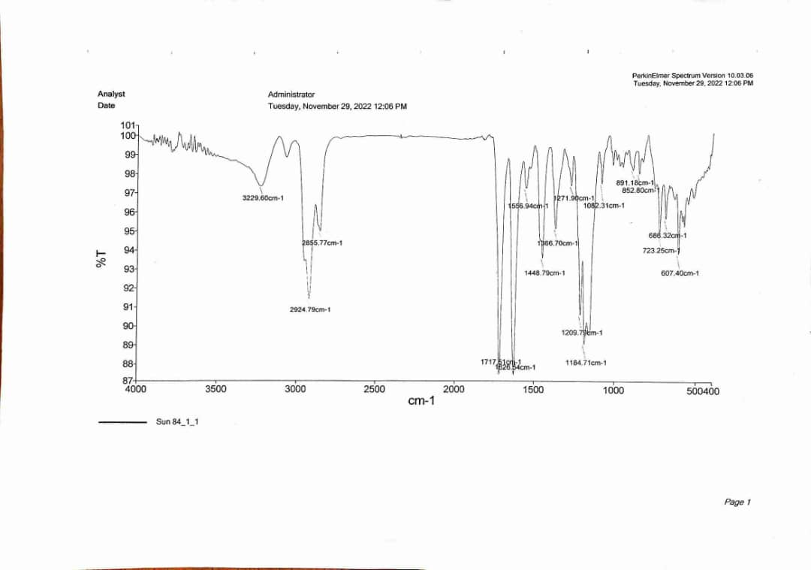

N-(3-methyl-1-oxo-1-(piperidin-1-yl)butan-2-yl)-2-(4-nitrophenylsulfonamido) propanamide (3n)
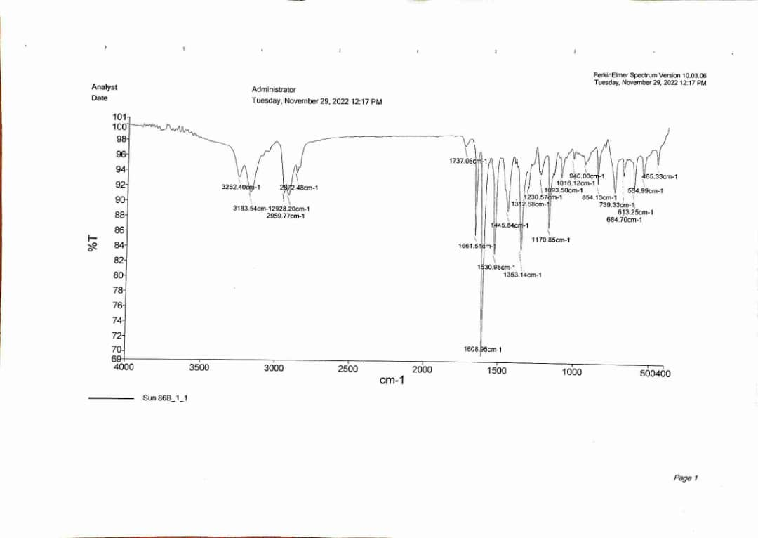

N-(3-methyl-1-oxo-1-(1H-pyrazol-1-yl)butan-2-yl)-2-(phenylsulfonamido) propanamide (3o)
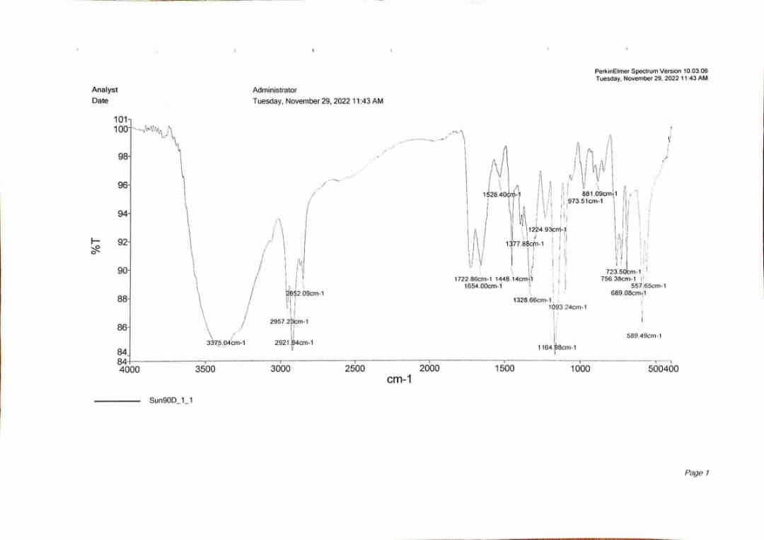

N-(3-methyl-1-oxo-1-(1H-pyrazol-1-yl)butan-2-yl)-2-(4-methylphenylsulfonamido) propanamide (3p)

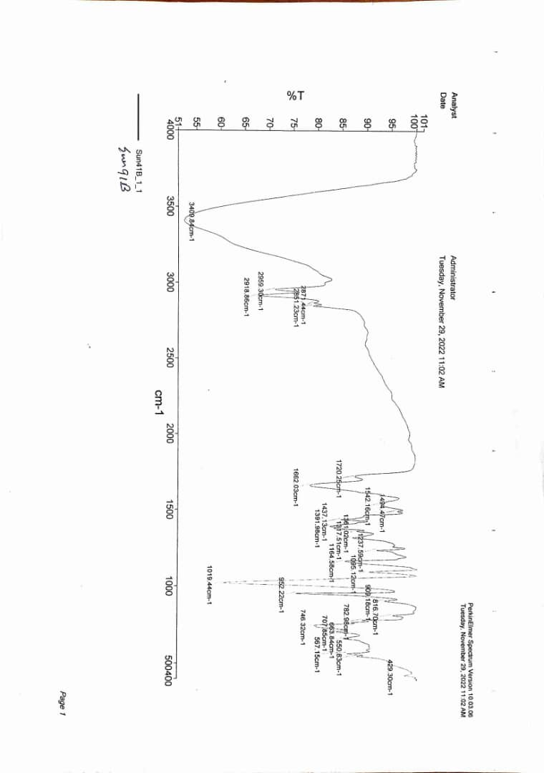
N-(3-methyl-1-oxo-1-(1H-pyrazol-1-yl)butan-2-yl)-2-(4-nitrophenylsulfonamido) propanamide (3q)
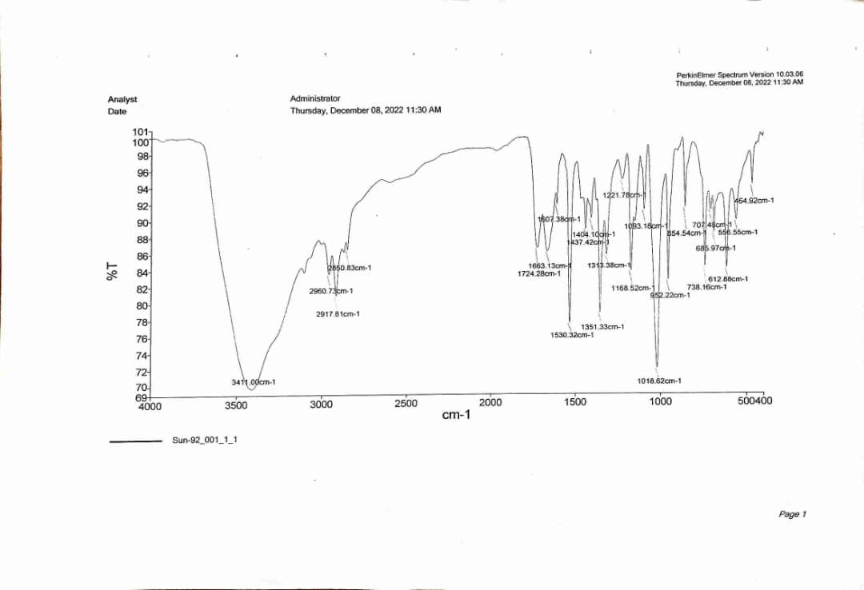
N-(3-methyl-1-oxo-1-(pyrrolidin-1-yl)butan-2-yl)-2-(phenylsulfonamido) propanamide (3r)

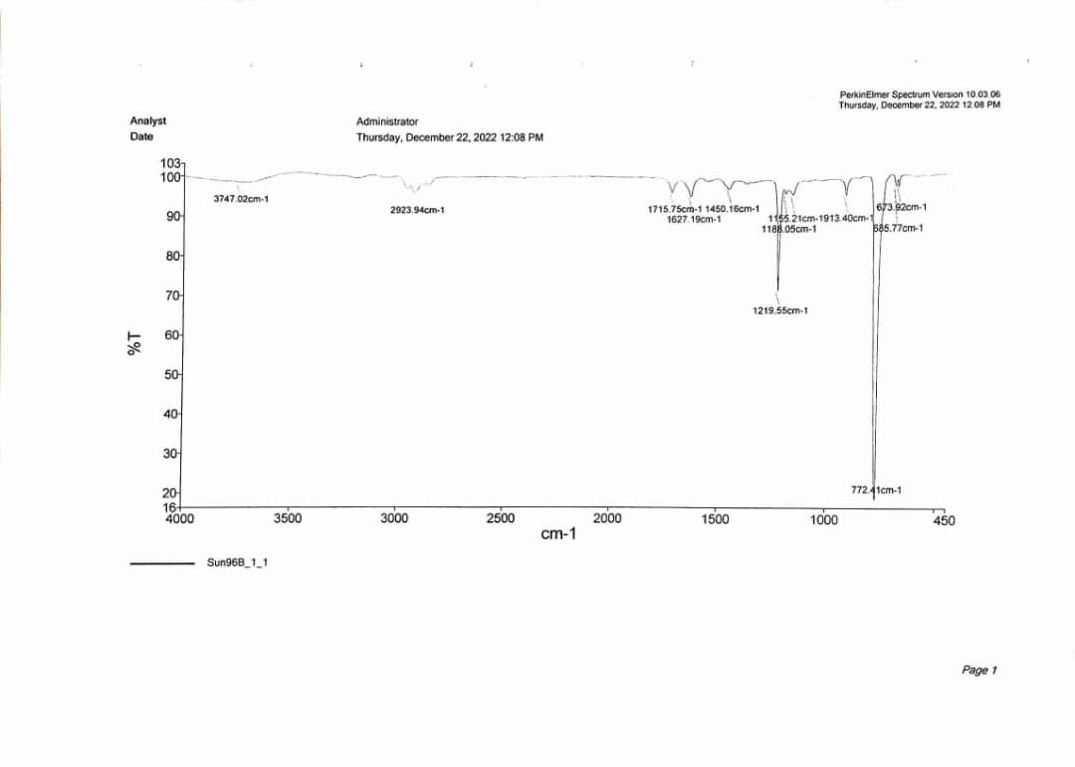
N-(3-methyl-1-oxo-1-(pyrrolidin-1-yl)butan-2-yl)-2-(4-methylphenylsulfonamido) propanamide (3s)
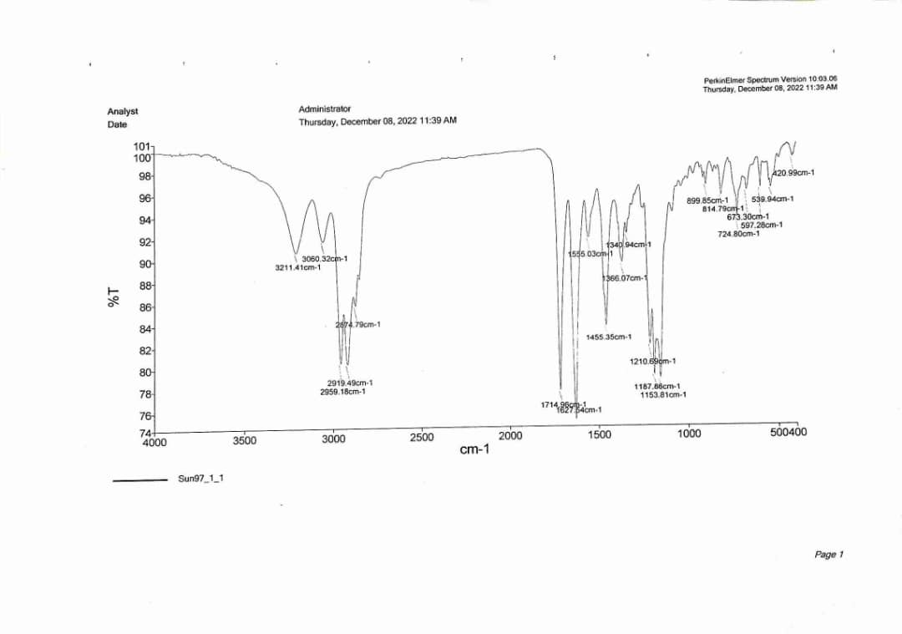
N-(3-methyl-1-oxo-1-(pyrrolidin-1-yl)butan-2-yl)-2-(4-nitrophenylsulfonamido) propanamide (3t)
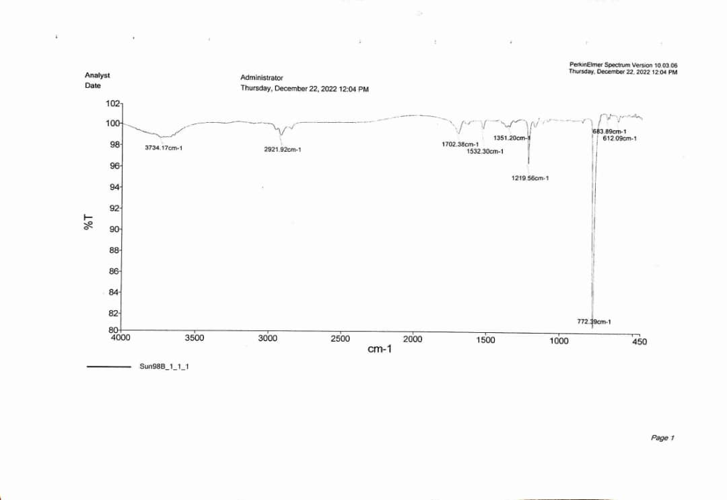

N,N-diethyl-3-methyl-2-(2-(phenylsulfonamido)propanamido)butanamide (3u)
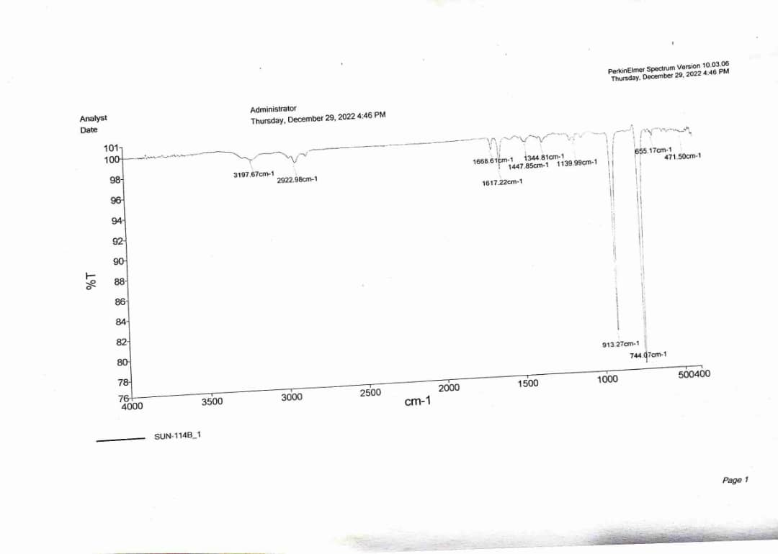
N,N-diethyl-3-methyl-2-(2-(4-methylphenylsulfonamido)propanamido)butanamide (3v)
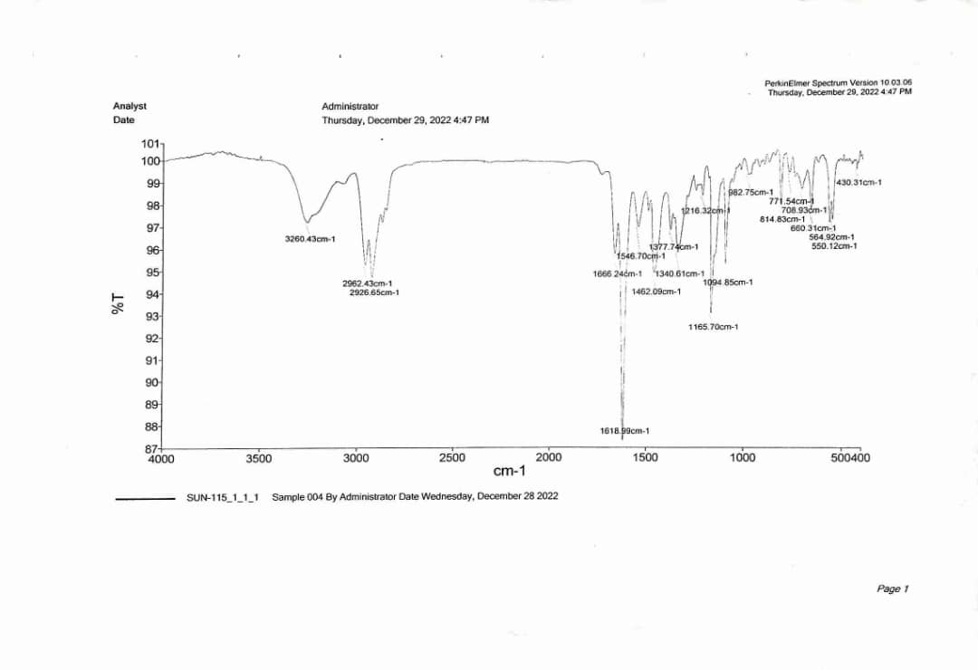

N,N-diethyl-3-methyl-2-(2-(4-nitrophenylsulfonamido)propanamido)butanamide (3w)
