Extended Data Figures and Tables
Extended Data Table 1. Sample numbers and mapping statistics for RNA-Seq datasets.

Dataset​ | Sample numbers (Total) | Uniquely mapped reads​
Influenza CHIM​ | n=138 from n=23 individuals​ | Mean: 24,381,075 (92.5%)​  Range: 18,566,465-29,205,267 (87.5-95.6%)​
SARS-CoV-2 CHIM​ | n=257 from n=26 individuals​​ | Mean: 57,575,110 (82.4%) ​  Range: 23,776,992-128,131,106 (74.0-90.3%)​
TB-IRIS ​ | n=95​ | Mean: 33,645,255 (79.2%)​  Range: 22,624,044-55,714,568 (57.9-89.1%)​
PERFORM​ | n=418​ | Mean: 18,229,656 (94.5%)​  Range: 2,991,328-79,250,659 (83.0-95.8%)​

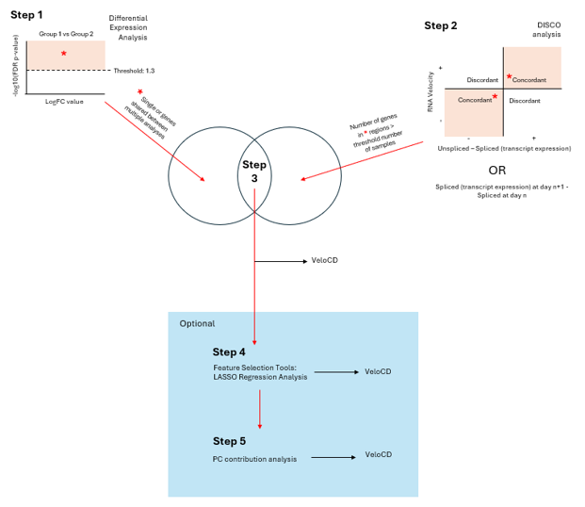
Extended Data Fig. 1: A framework for selecting genes suitable for RNA velocity-based prognosis prediction using VeloCD. The first three steps are non-optional, steps 4 and 5 are optional if a minimal gene signature is required and can include the use of feature selection tools such as least absolute shrinkage and selection operator (LASSO) regression and selection of genes contributing the most variation to a user-specified number of principal components. Step 1 is differential expression analysis between reference groups, with a user-selected FDR p-value threshold. Step 2 is Discordance-Concordance (DISCO) analysis of each gene’s RNA velocity value (y-axis) vs either its unspliced-spliced transcript abundance or its change in spliced transcript expression over the timescale of interest (day n+1). Genes with concordance of both metrics in at least a user-selected number of samples are taken forward for further analysis. The intersection of genes selected in steps 1 and 2 is calculated, and these are taken forward as the input for VeloCD.

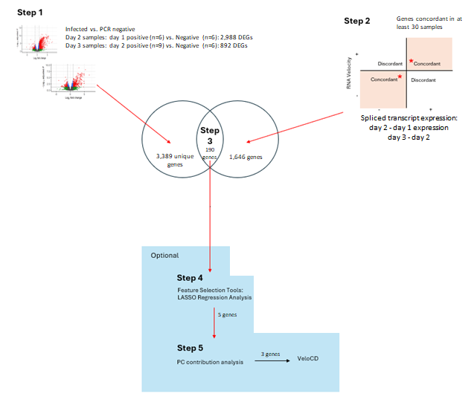
Extended Data Fig. 2: The application of the gene selection framework to the Influenza A CHIM RNA-Seq dataset.
Step 1 illustrates the results of the DEA between the infected subjects and subjects who remain PCR negative throughout the trial (stratified by the day the participant first tested positive). Step 2 illustrates the DISCO analysis of the day 1, 2 and 3 samples from this cohort. Step 3 shows the number of genes intersecting between these two analyses. These were then put through LASSO regression (step 4) and the genes that contribute the most to the top 3 PCs (step 5) were used for RNA Velocity analysis.
Extended Data Table 2. The contribution (%) of each gene in the Influenza A signature to the first three Principal Components (PCs) of a PCA constructed using the reference set of samples (n=22) and five genes.
Gene​ | PC1 Contribution​ (%) | PC2 Contribution​ (%) | PC3 Contribution​ (%)
SLC9A3-AS1​ | 51.1​ | 46.2​ | 0.32​
BAK1​ | 27.1​ | 35.8​ | 25.8​
APOL3​ | 9.95​ | 14.1​ | 8.09​

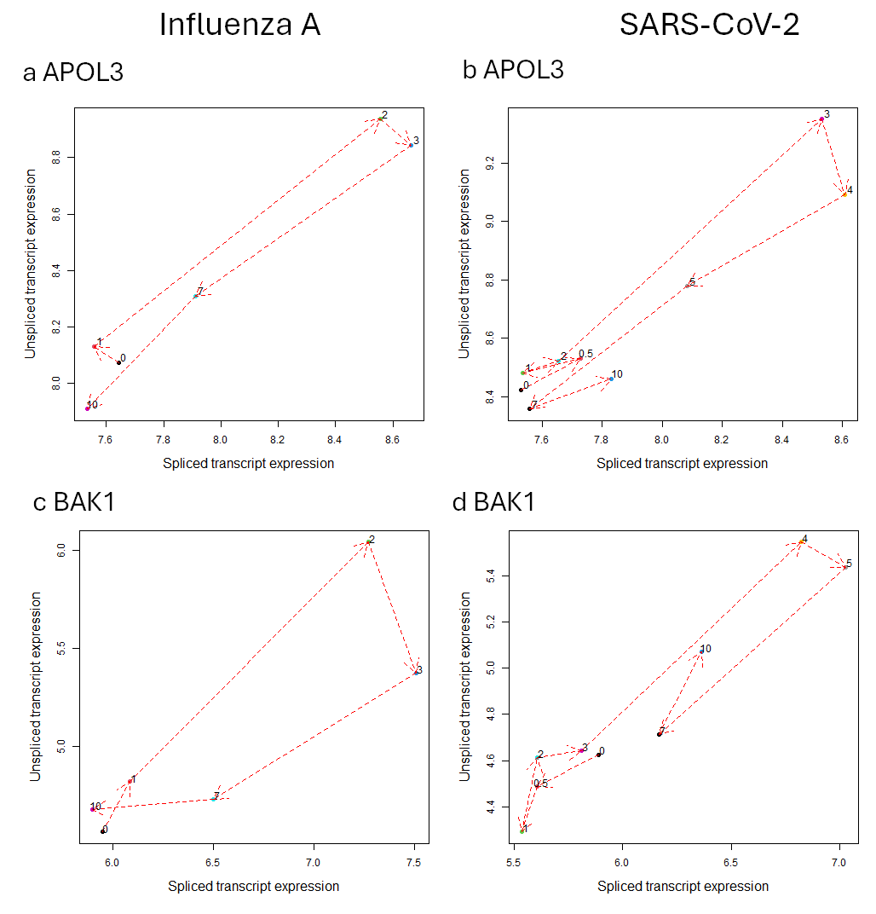
Extended Data Fig. 3: Phase Portraits of spliced and unspliced APOL3 and BAK1 mRNA expression during Influenza A and SARS-CoV-2 infection.
Representative plots from single individuals showing the expression dynamics of APOL3 (a-b) and BAK1 (c-d) in the Influenza A (n=6, a and c) and SARS-CoV-2 (n=9, b and d) cohorts. Timepoint “0.5” represents the post-inoculation day 0 time-point.
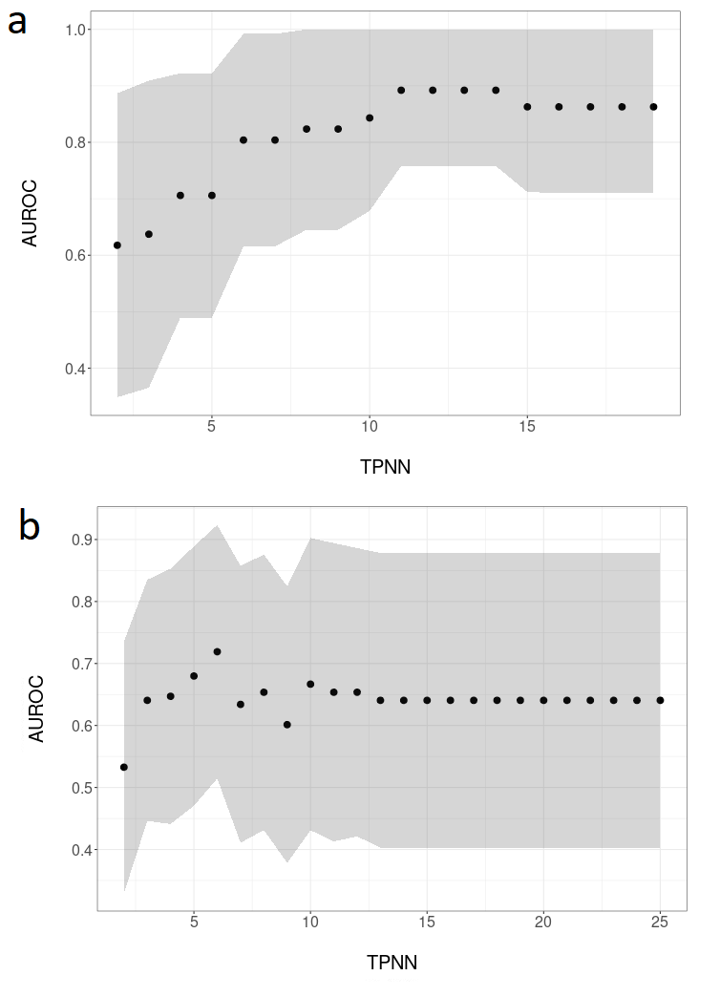
Extended Data Fig. 4: The range of AUROC values between TPNN runs for the CHIM RNA-Seq datasets.
Scatterplots showing the distribution of AUROC (with 95% confidence interval shading) across a range of TPNN values for the Influenza A (a) and SARS-Cov-2 cohort separately (b).
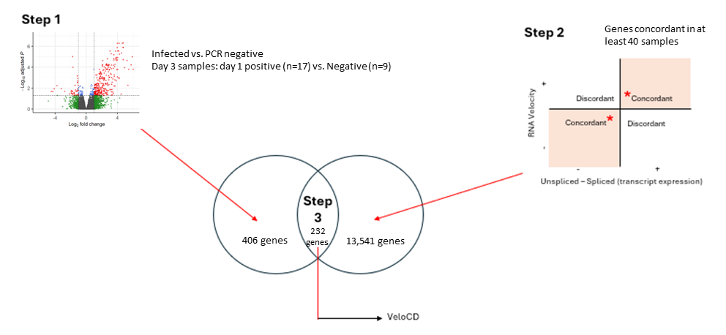
Extended Data Fig. 5: The application of the gene selection framework on the SARS-CoV-2 CHIM RNA-Seq dataset.
Step 1 illustrates the results of the DEA between the infected subjects and subjects who remain PCR negative throughout the trial. Step 2 illustrates the DISCO analysis of the day 0 (post-inoculation), 1, 2 and 3 samples from this cohort. Step 3 shows the number of genes intersecting between these two analyses, these were used for RNA velocity analysis.
Extended Data Table 3: The 232 genes used for VeloCD prediction of SARS-Cov-2 infection
NA denotes genes without gene symbols assigned
Ensembl ID | Gene Symbol
ENSG00000188290 | HES4
ENSG00000187608 | ISG15
ENSG00000224969 | NA
ENSG00000188157 | AGRN
ENSG00000116663 | FBXO6
ENSG00000285646 | NA
ENSG00000173372 | C1QA
ENSG00000173369 | C1QB
ENSG00000233975 | LINC02574
ENSG00000126709 | IFI6
ENSG00000242267 | NA
ENSG00000137959 | IFI44L
ENSG00000117228 | GBP1
ENSG00000213512 | GBP7
ENSG00000162654 | GBP4
ENSG00000154451 | GBP5
ENSG00000225492 | NA
ENSG00000228703 | NA
ENSG00000155363 | MOV10
ENSG00000198019 | NA
ENSG00000230806 | SRGAP2-AS1
ENSG00000265531 | FCGR1CP
ENSG00000196369 | SRGAP2B
ENSG00000215784 | FAM72D
ENSG00000150337 | FCGR1A
ENSG00000233875 | NA
ENSG00000160710 | ADAR
ENSG00000163565 | IFI16
ENSG00000133063 | CHIT1
ENSG00000276600 | RAB7B
ENSG00000266028 | SRGAP2
ENSG00000162772 | ATF3
ENSG00000286216 | NA
ENSG00000122861 | PLAU
ENSG00000287077 | NA
ENSG00000152766 | ANKRD22
ENSG00000107798 | LIPA
ENSG00000185745 | IFIT1
ENSG00000152778 | IFIT5
ENSG00000165806 | CASP7
ENSG00000142089 | IFITM3
ENSG00000185507 | IRF7
ENSG00000132109 | TRIM21
ENSG00000133805 | AMPD3
ENSG00000177112 | IRAG1-AS1
ENSG00000175274 | TP53I11
ENSG00000156587 | UBE2L6
ENSG00000149131 | SERPING1
ENSG00000168062 | BATF2
ENSG00000175550 | DRAP1
ENSG00000110057 | UNC93B1
ENSG00000255337 | TMEM123-DT
ENSG00000256377 | NA
ENSG00000089127 | OAS1
ENSG00000257452 | NA
ENSG00000111331 | OAS3
ENSG00000111335 | OAS2
ENSG00000257279 | LOC100506551
ENSG00000135114 | OASL
ENSG00000197653 | DNAH10
ENSG00000073060 | SCARB1
ENSG00000273628 | NA
ENSG00000133106 | EPSTI1
ENSG00000102794 | ACOD1
ENSG00000283384 | NA
ENSG00000100889 | PCK2
ENSG00000259321 | NA
ENSG00000100911 | PSME2
ENSG00000100918 | REC8
ENSG00000185880 | TRIM69
ENSG00000259709 | NA
ENSG00000140464 | PML
ENSG00000260096 | NA
ENSG00000172183 | ISG20
ENSG00000140511 | HAPLN3
ENSG00000283597 | FAM169BP
ENSG00000179044 | EXOC3L1
ENSG00000168404 | MLKL
ENSG00000103154 | NECAB2
ENSG00000285012 | NA
ENSG00000187741 | FANCA
ENSG00000183688 | RFLNB
ENSG00000132530 | XAF1
ENSG00000187870 | NA
ENSG00000266786 | NA
ENSG00000264164 | NA
ENSG00000108700 | CCL8
ENSG00000172123 | SLFN12
ENSG00000173786 | CNP
ENSG00000108771 | DHX58
ENSG00000068079 | IFI35
ENSG00000161692 | DBF4B
ENSG00000108387 | SEPTIN4
ENSG00000108932 | SLC16A6
ENSG00000154889 | MPPE1
ENSG00000130813 | SHFL
ENSG00000186529 | CYP4F3
ENSG00000186115 | CYP4F2
ENSG00000269720 | CCDC194
ENSG00000130303 | BST2
ENSG00000268658 | LINC00664
ENSG00000178904 | DPY19L3
ENSG00000167601 | AXL
ENSG00000239736 | NA
ENSG00000204936 | CD177
ENSG00000008438 | PGLYRP1
ENSG00000118162 | KPTN
ENSG00000205837 | LINC00487
ENSG00000225964 | NA
ENSG00000134321 | RSAD2
ENSG00000115155 | OTOF
ENSG00000158089 | GALNT14
ENSG00000055332 | EIF2AK2
ENSG00000136689 | IL1RN
ENSG00000224789 | NA
ENSG00000287742 | NA
ENSG00000232377 | LOC101928386
ENSG00000078098 | FAP
ENSG00000115267 | IFIH1
ENSG00000223960 | CHROMR
ENSG00000231858 | STAT4-AS1
ENSG00000135903 | PAX3
ENSG00000135899 | SP110
ENSG00000225493 | LINC01107
ENSG00000125826 | RBCK1
ENSG00000088827 | SIGLEC1
ENSG00000234265 | LINC01723
ENSG00000124201 | ZNFX1
ENSG00000227297 | NA
ENSG00000124256 | ZBP1
ENSG00000130589 | HELZ2
ENSG00000166265 | CYYR1
ENSG00000159228 | CBR1
ENSG00000157601 | MX1
ENSG00000228318 | NA
ENSG00000225731 | PDE9A-AS1
ENSG00000237989 | LINC01679
ENSG00000100228 | RAB36
ENSG00000128342 | LIF
ENSG00000221963 | APOL6
ENSG00000228587 | NA
ENSG00000128284 | APOL3
ENSG00000128335 | APOL2
ENSG00000100342 | APOL1
ENSG00000025708 | TYMP
ENSG00000177989 | CIMAP1B
ENSG00000273272 | NA
ENSG00000008735 | MAPK8IP2
ENSG00000279727 | LINC02033
ENSG00000172936 | MYD88
ENSG00000144655 | CSRNP1
ENSG00000163823 | CCR1
ENSG00000164054 | SHISA5
ENSG00000144730 | IL17RD
ENSG00000163666 | HESX1
ENSG00000198643 | FAM3D
ENSG00000243276 | NA
ENSG00000138496 | PARP9
ENSG00000163840 | DTX3L
ENSG00000173193 | PARP14
ENSG00000114698 | PLSCR4
ENSG00000188313 | PLSCR1
ENSG00000168811 | IL12A
ENSG00000223387 | LINC02068
ENSG00000078081 | LAMP3
ENSG00000136514 | RTP4
ENSG00000230266 | XXYLT1-AS2
ENSG00000224614 | NA
ENSG00000002549 | LAP3
ENSG00000251129 | NA
ENSG00000248165 | NA
ENSG00000169245 | CXCL10
ENSG00000138760 | SCARB2
ENSG00000163644 | PPM1K
ENSG00000287181 | LOC124900731
ENSG00000286978 | NA
ENSG00000138646 | HERC5
ENSG00000164099 | PRSS12
ENSG00000287188 | NA
ENSG00000137628 | DDX60
ENSG00000164175 | SLC45A2
ENSG00000113494 | PRLR
ENSG00000286193 | CPLANE1-AS1
ENSG00000164509 | IL31RA
ENSG00000249697 | NA
ENSG00000184838 | PRR16
ENSG00000137285 | TUBB2B
ENSG00000153162 | BMP6
ENSG00000137414 | FAM8A1
ENSG00000181126 | NA
ENSG00000204264 | PSMB8
ENSG00000168394 | TAP1
ENSG00000189325 | BNIP5
ENSG00000010030 | ETV7
ENSG00000224666 | NA
ENSG00000172432 | GTPBP2
ENSG00000124688 | MAD2L1BP
ENSG00000172426 | RSPH9
ENSG00000287485 | LOC105375082
ENSG00000146411 | SLC2A12
ENSG00000226004 | SIMALR
ENSG00000146425 | DYNLT1
ENSG00000285492 | LOC112267968
ENSG00000288696 | NA
ENSG00000227017 | NA
ENSG00000122547 | EEPD1
ENSG00000205628 | LINC01446
ENSG00000233073 | NA
ENSG00000205413 | SAMD9
ENSG00000177409 | SAMD9L
ENSG00000169871 | TRIM56
ENSG00000146859 | TMEM140
ENSG00000283648 | NA
ENSG00000013374 | NUB1
ENSG00000288580 | NA
ENSG00000038945 | MSR1
ENSG00000104213 | PDGFRL
ENSG00000175445 | LPL
ENSG00000165078 | CPA6
ENSG00000247317 | NA
ENSG00000160932 | LY6E
ENSG00000178685 | PARP10
ENSG00000287480 | NA
ENSG00000120217 | CD274
ENSG00000197646 | PDCD1LG2
ENSG00000287276 | NA
ENSG00000165023 | DIRAS2
ENSG00000231528 | FAM225A
ENSG00000157693 | TMEM268
ENSG00000148344 | PTGES
ENSG00000136816 | TOR1B
ENSG00000233785 | NA

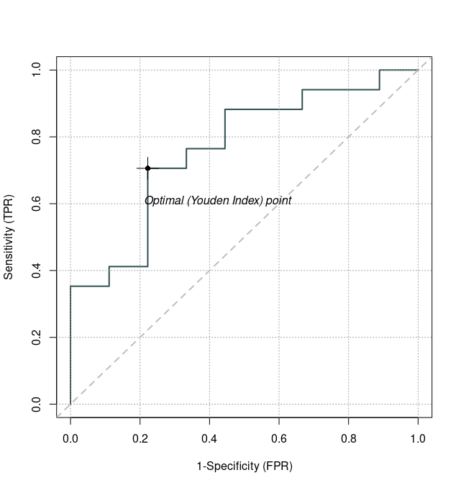
Extended Data Fig. 6: Performance of the Influenza derived 3-gene signature at predicting future disease onset from day 1 post-inoculation in the SARS-CoV-2 CHIM cohort (26 participants, TPNN: 16, PCA-based fate maps). AUROC is 0.76 (95% CI: 0.57-0.96).
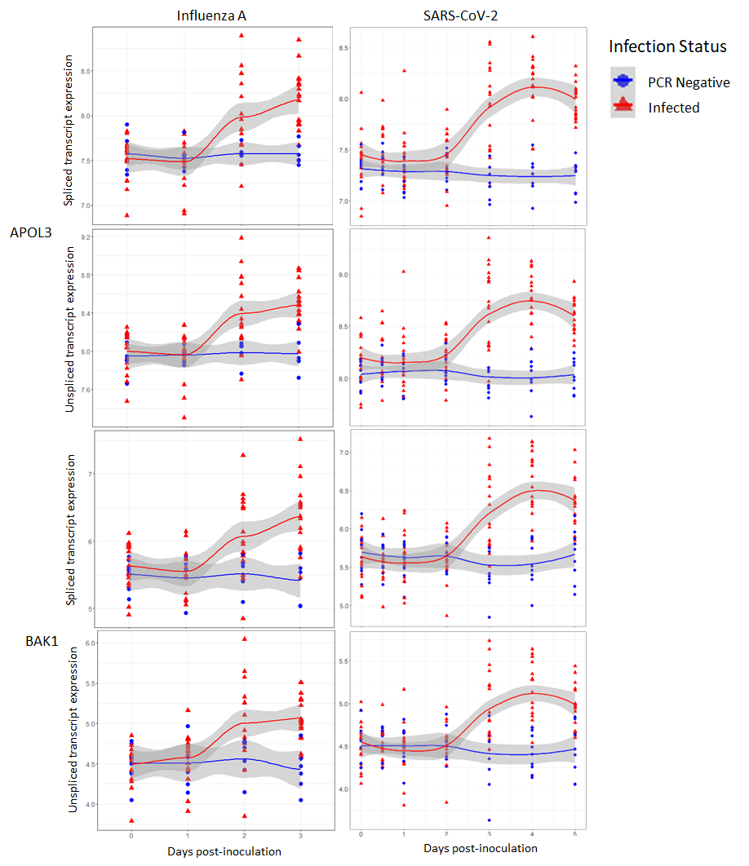
Extended Data Fig. 7: The temporal expression of spliced and unspliced transcripts of APOL3 and BAK1
The spliced and unsliced transcript expression of APOL3 and BAK1 over time in the Influenza (n=92: n=68 samples from the infected subjects, n=24 from the PCR negative subjects) and SARS-Cov-2 (n=180: n=117 samples from the infected subjects, n=63 from the PCR negative subjects) studies, showing infected (red triangles) and PCR negative participants (blue circles). Time-point “0.5” represents the day-0 post-inoculation samples. Shading represents 95% confidence intervals.
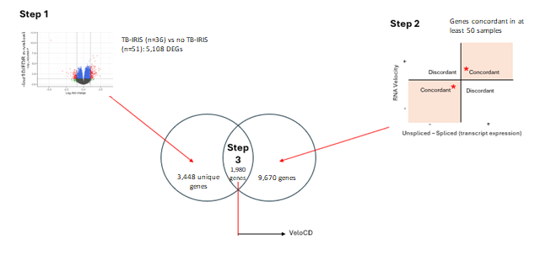
Extended Data Fig. 8: The application of the gene selection framework on the TB-IRIS study RNA-Seq dataset
Step 1 illustrates the results of the DEA between the subjects who developed TB-IRIS by the time of sampling and those who never developed the syndrome. Step 2 illustrates the DISCO analysis of this dataset, which compared the direction of the RNA velocity and “unspliced -spliced (transcript expression)”. Step 3 shows the number of genes intersecting between these two analyses, these were used for RNA velocity analysis.
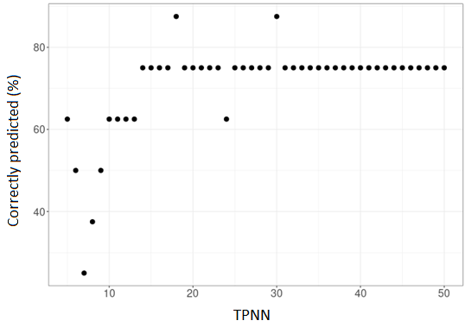
Extended Data Fig. 9: The relationship between the number of study participants correctly predicted to develop TB-IRIS in the future and the TPNN value in the TB-IRIS study RNA-Seq dataset.
The percentage of the study participants (n=8) correctly predicted to develop TB-IRIS in the future across a range of TPNN values.

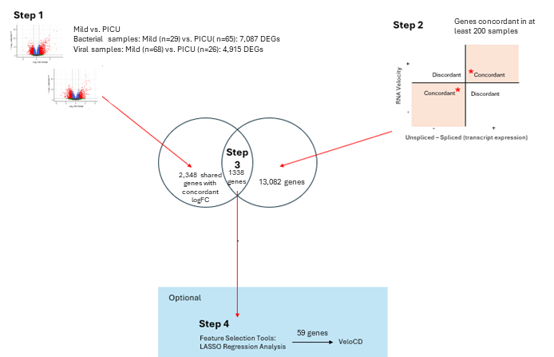

Extended Data Fig. 10: The application of the gene selection framework on the PERFORM RNA-Seq dataset
Step 1 illustrates the results of the DEA between the mild and PICU-recruited severe illness children stratified by diagnosis (bacterial or viral). Step 2 illustrates the DISCO analysis of this dataset, which compared the direction of the RNA velocity and “unspliced -spliced (transcript expression)”. Step 3 shows the number of genes intersecting between these two analyses, which was then input into LASSO regression analysis. The gene signature from the latter was then used for RNA velocity analysis.
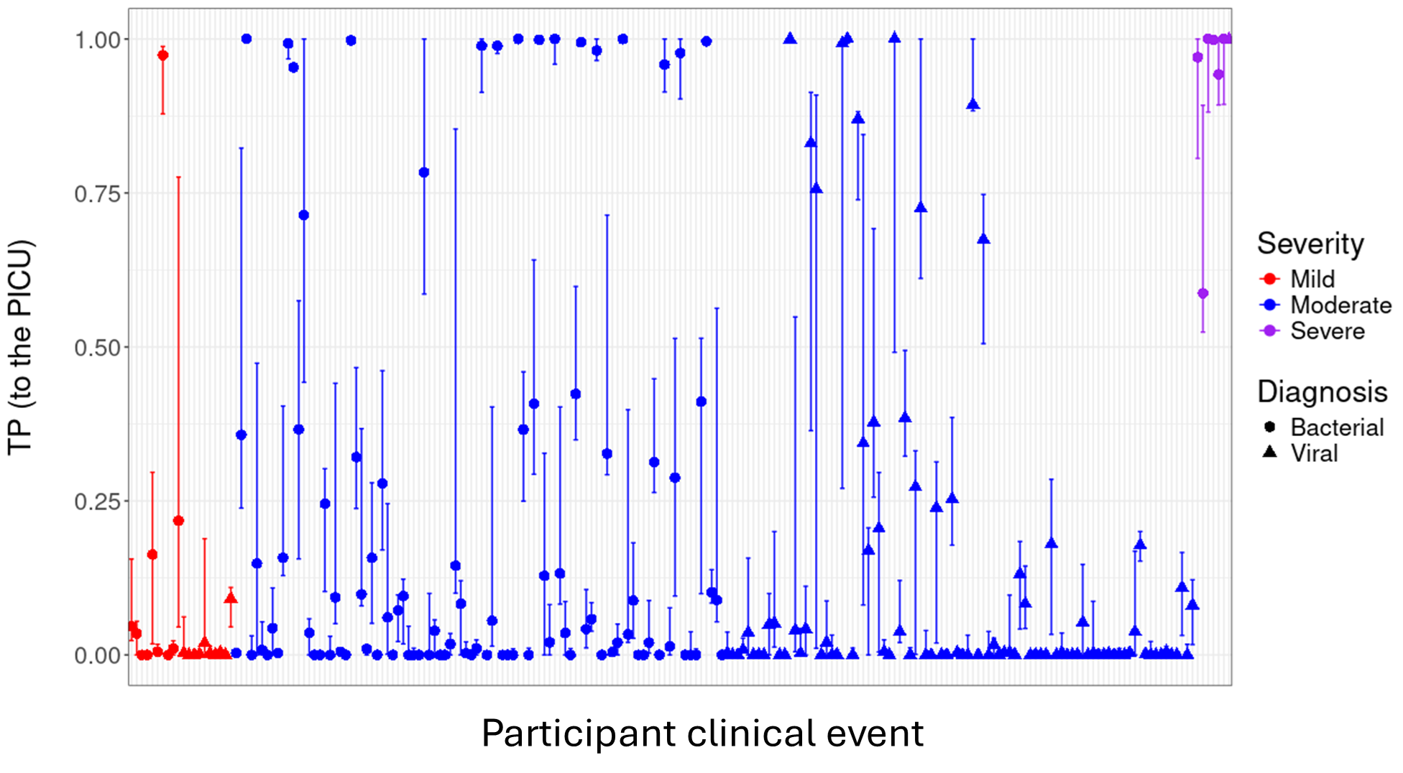Extended Data Fig. 11: Distribution of transition probability values for each test subject progressing to the severe illness group in the PEFORM dataset.
Lower and upper range, and median TP value for each subject in the test set (n=211) transitioning to the severe group across the full range of TPNN value runs, stratified by actual maximum severity of illness.
Extended Data Table 4: The association between clinical features and transition probabilities in the PERFORM subjects with moderate illness at presentation.
Clinical Feature | TP ≥ 0.25  N (%) | TP < 0.25  N (%) | Odds Ratio | 95% Confidence Interval |  | p-value
On-presentation
Gender  Female  Male | 19 (44.19)  24 (55.81) | 62 (43.97)  79 (56.03) | 1.01 | 0.48, 2.12 |  | 1.00
Triage Code  Very Urgent  Standard | 27 (69.23)  12 (30.77) | 79 (59.40)  54 (40.60) | 1.53 | 0.68, 3.63 |  | 0.35
Ill Appearance  Yes  No | 19 (51.35)  18 (48.65) | 60 (47.24)  67 (52.76) | 1.18 | 0.53, 2.62 |  | 0.71
Life Saving Intervention  Yes  No | 4 (9.30)  39 (90.70) | 13 (9.42)  125 (90.58) | 0.99 | 0.22, 4.44 |  | 1.00
Phenotype  Bacterial  Viral | 28 (65.12)  15 (34.88) | 66 (46.81)  75 (53.19) | 2.11 | 0.99, 4.65 |  | 0.038
Future Severity
Surgery Performed  Yes  No | 11 (25.58)  32 (74.42) | 11 (7.80)  130 (92.20) | 4.02 | 1.44, 11.28 | 0.0052
Transfer to the PICU
Yes  No | 4 (9.30)  39 (90.70) | 3 (2.13)  138 (97.87) | 4.67 | 0.76, 33.18 | 0.053
Odds Ratios (OR) were calculated using Fisher’s exact test, for being in the female, bacterial and more severe phenotypic groups. TP=Transition Probability, PICU=Pediatric Intensive Care Unit. Values are given to two decimal places. Rows with 95% Confidence Intervals used Fisher’s exact test. All subjects in this analysis were recruited in the ED and admitted to the ward, n=184.
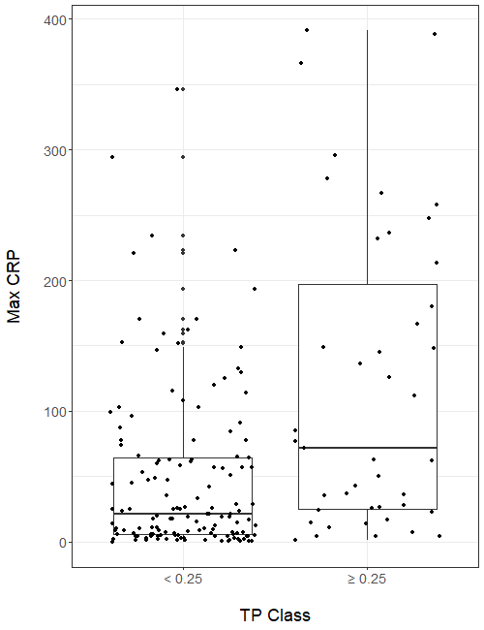
Extended Data Fig. 12 The relationship between the maximum CRP value during illness and the Transition Probability (TP) class in the PERFORM RNA-Seq dataset.
The distribution of the maximum C-Reactive Protein (CRP) values during illness for each mild clinical event with
these values available (n=180) in the PERFORM cohort (TP group composition <0.25, n=137; ≥0.25, n=43).

