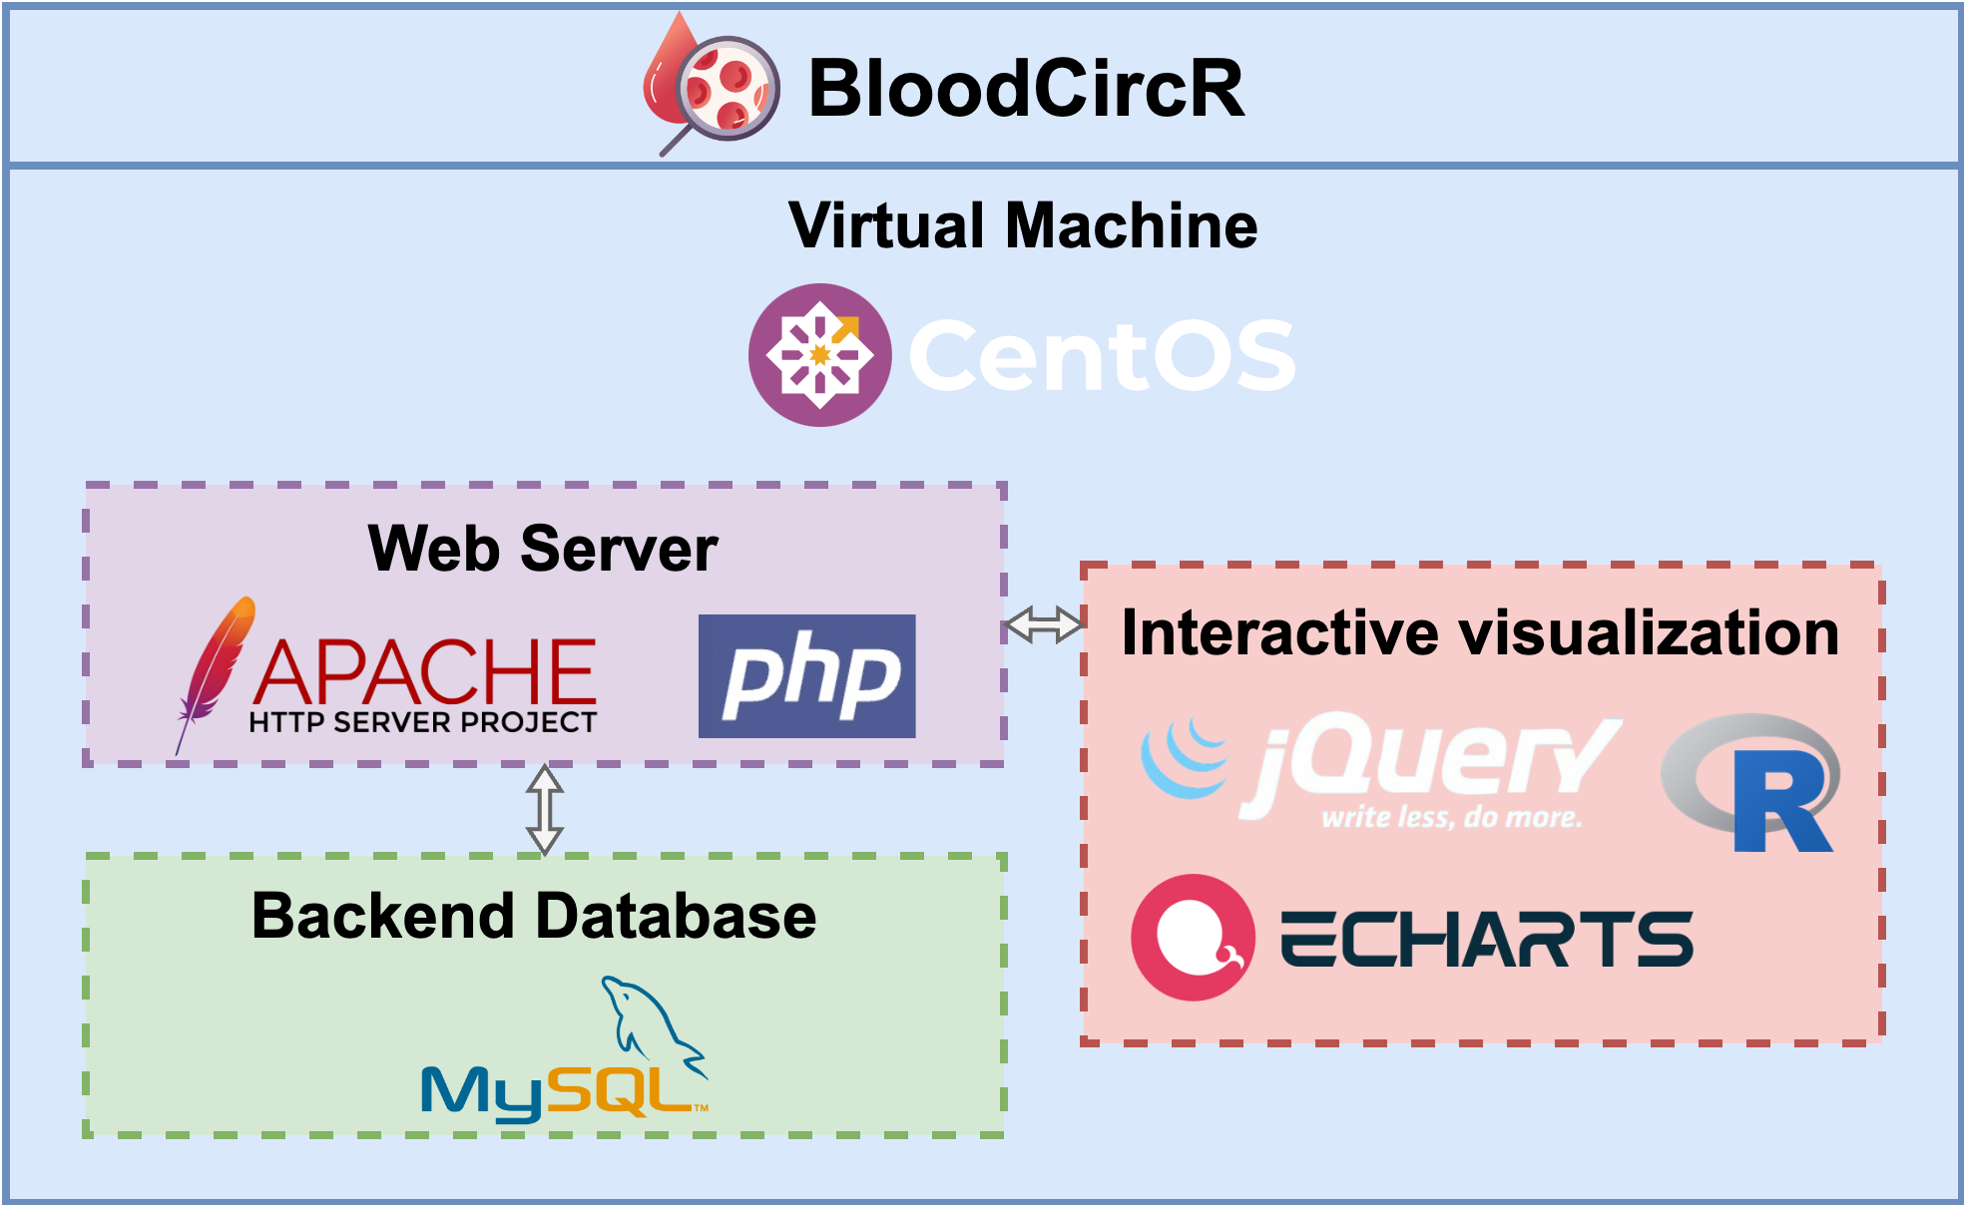

Supplementary Figure S1. Architecture of BloodCircR database.

