Supplemental Figures
Figure S1 COG/KOG enrichment on DEPs from three comparisons.
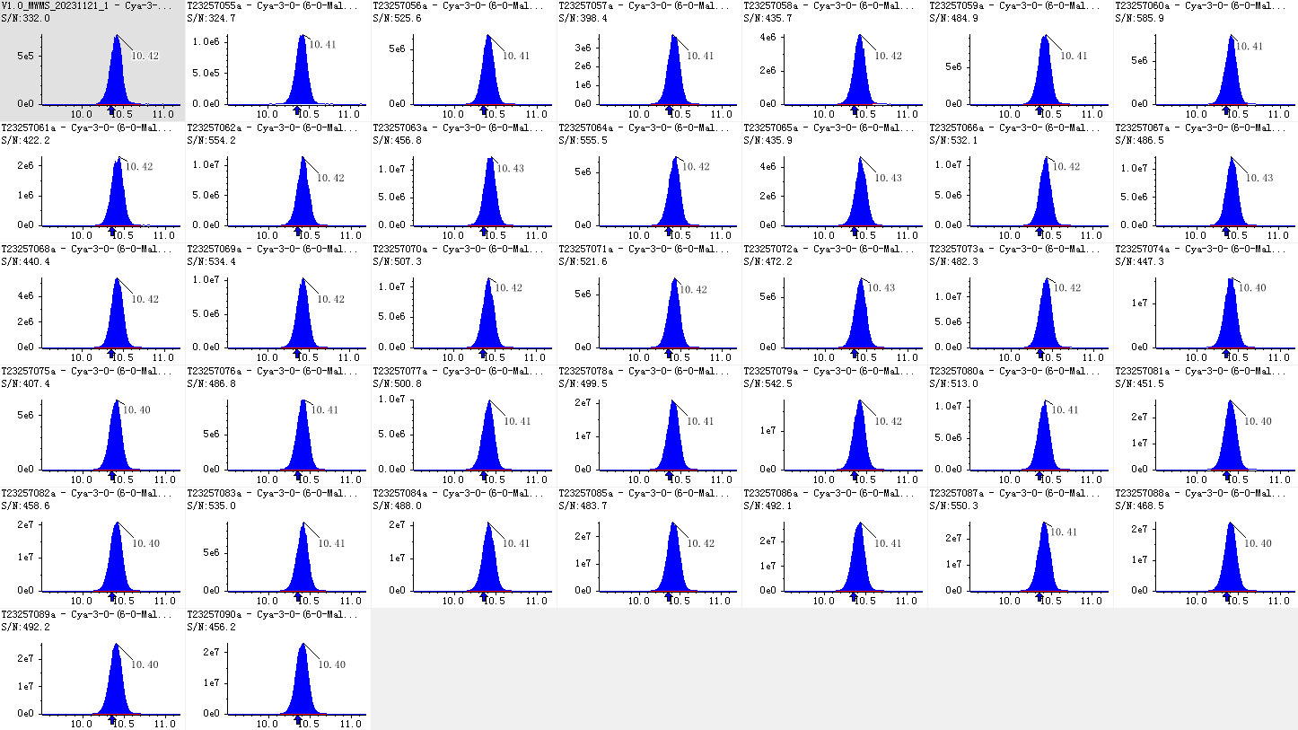
Figure S2 Identification of anthocyanins in LC-MS assay.
Figure S3 Construction of WGCNA network. A: Scale independence and mean connectivity analysis of WGCNA construction. B: Clustering dendrogram of hub genes, with dissimilarity based on topological overlap, together with assigned module colors.

