Supplementary Information for
Natural Carbonation of Alkaline Industrial Wastes: A Large-Scale, Unaccounted Sink for CO₂
Contents:
Supplementary Text
Supplementary Figures (Fig. S1 to Fig. S32)
Supplementary Tables (Table S1)

Other Supplementary Materials for this manuscript include the following:
Supplementary Data (Data S1 to Data S41)

Supplementary Text
- Carbonation mechanism of alkaline industrial wastes
Carbonation of alkaline industrial wastes is a complex physicochemical process. When alkaline industrial wastes are disposed or reused, their alkaline components such as calcium-magnesium oxides, hydroxides, and silicates, react with atmospheric CO₂ to form stable and insoluble carbonates, primarily calcium carbonate and magnesium carbonate^{1,2}. This process, known as "natural carbonation", is exothermic reaction. Over time, it leads to the gradual transformation of alkaline industrial wastes from an alkaline state to a neutral state^{3–5}. The carbonation process in the alkaline wastes, progressing from the surface to the interior over time, involves key reactions as follows:
$$CaO/MgO+{CO}_{2}\underset{→}{H_{2}O}{CaCO}_{3}/{MgCO}_{3}$$
$${Ca(OH)}_{2}/{Mg(OH)}_{2}+{CO}_{2}\underset{→}{H_{2}O}{CaCO}_{3}/{MgCO}_{3}+H_{2}O$$
$${(Ca,Mg)}_{x}{Si}_{y}O_{x+2y+z}H_{2z(s)}+x{CO}_{2}\underset{→}{H_{2}O}{x\left(Ca, Mg\right)CO}_{3(S)}+{ySiO}_{2(S)}+{zH}_{2}O$$
In the early stages of carbonation, CO₂ diffusion and carbonation reaction rate are fast. However, as carbonation progress from the surface to the interior of alkaline industrial wastes, the initial surface carbonation layer limits further internal carbonation, leading to a reduced carbonation reaction rate^{1,6}. Calcium carbonate formation also fills surface porosities of the wastes, slowing CO₂ diffusion and lowering the carbonation process (Supplementary Fig. S1)^{1,7}. Alkaline components in industrial wastes typically don't fully dissolve, and their conversion into carbonates usually remains below 90%⁸.

- Alkaline industrial wastes and carbon uptake accounting boundary
This study classifies alkaline industrial wastes into four categories: metallurgical slag (iron and steel slag, magnesium slag, and red mud), chemical waste (lime mud, yellow phosphorus slag, and calcium carbide slag), incineration ash (coal combustion ash, municipal waste incineration ash, oil shale ash, and biomass ash), and cement and lime waste (waste concrete, waste mortar, cement kiln dust, and lime kiln dust)^{9,10}. These wastes are primarily byproducts of various industrial activity processes related to raw materials production or consumption. The accounting boundary is defined as Supplementary Figure S2.

2.1 Metallurgical Slag
This category includes byproducts from diverse metallurgical processes, such as blast furnace slag (from blast furnace ironmaking), steel slag (from steelmaking), magnesium slag (from the silico-thermal production of magnesium), and red mud (from alumina production by the Bayer method).

2.2 Chemical Industry Wastes
This category comprises lime mud from paper-making, calcium carbide slag from processes related to calcium carbide production, and the yellow phosphorus slag as a byproduct during yellow phosphorus production.

2.3 Incineration Ash
This category comprises different types of ash generated from combustion processes, including coal combustion ash, municipal waste incineration ash, oil shale ash, and biomass ash from biomass power plant, open burning straw and wood fuel incineration.

2.4 Cement and Lime Wastes
This category primarily includes byproducts such as cement/lime kiln dust generated during the cement/lime production stage (CKD and LKD), mortar and concrete loss in construction stage, as well as waste concrete/mortar generated during building demolition and crushing.

- Carbon uptake by alkaline industrial wastes
We modeled the carbonation process of alkaline industrial wastes and estimated the amount of CO₂ absorption based on various disposal methods, such as backfilling^{8,11}, using them as supplementary cementitious material¹², agricultural use or landfilling¹³ (see Supplementary Data S15-S18). The carbonation parameters of the model are influenced by various factors, including the inherent characteristics of alkaline industrial wastes (such as composition, particle size, moisture content, and porosity) as well as environmental variables (such as exposure conditions, CO₂ concentration, relative humidity, and temperature)^{8,4,5,14}. Total CO₂ uptake by alkaline industrial wastes ($C_{AIW,uptake}$) can be calculated by Eq S1, where $C_{cem, uptake}$, ${\text{C}}_{\text{met, uptake}}$,${\text{C}}_{\text{chem, uptake}}$ and ${\text{C}}_{\text{incineration, uptake}}$ represent the uptake amounts of cement wastes, metallurgical wastes, chemical wastes, and incineration ash, respectively.
$$C_{AIW,uptake}=C_{cem, uptake}+{\text{C}}_{\text{met, uptake}}\text{+}{\text{C}}_{\text{chem, uptake}}\text{+}{\text{C}}_{\text{incineration, uptake}}$$ | Eq S1

3.1 Metallurgical slag
3.1.1 Iron and steel slag
Iron and steel slag contains blast furnace slag (BFS) originating from pig iron smelting and steel slag (SS) generated in crude steel production¹⁵. According to USGS, standard iron ore grades (60% to 66% iron) typically yield 0.25 to 0.30 metric tons (t) of slag per ton of pig iron in a blast furnace. However, with lower-grade ores, slag production can notably rise, sometimes reaching 1.0 to 1.2 t of slag per ton of crude iron. The production of steel slag typically amounts to approximately 0.2 t per ton of crude steel, with up to 50% of the melt containing recoverable entrained metal. Following metal removal, marketable steel slag commonly constitutes 10% to 15% of crude steel production in developed countries, with higher values in developing nations. Iron and steel slag production can be calculated by Eq S2, where $M_{s,i,t}$ represents the production of type $i$ slag in the year $t$, with $i$= BFS or SS, $m_{rm,i,t}$ represents the production of pig iron or crude steel, and $r_{s}$ represents the type $i$ slag output rates.
$$M_{s,i,t}=m_{rm,i,t}×r_{s}$$ | Eq S2

Generally, iron and steel slag take 4-5 years or longer for hydration, making it difficult to carbonate within a year^{11,16}. Taking a lifecycle perspective, carbon sequestration in iron and steel slag should include all carbon uptake by various disposal ways during its complete carbonation period^{11,16}. Thus, the whole carbon uptake by iron and steel slag can be calculated by Eq S3 to Eq S4, where $C_{s,total}$ represents the total
$$C_{s,total}=\sum{C_{s-disp,i,t}}+\sum{C_{s-su,i,t}}$$ | Eq S3
$$C_{s-disp,i,t}=M_{slag,i,t}×f_{s-disp,i,t}×{\text{R}}_{s,i}×ε_{s,i}$$ | Eq S4
carbon uptake by iron and steel slag under different disposal ways, $C_{s-disp,i,t}$ represents carbon uptake by waste disposal, and $C_{s-su,i,t}$ represents carbon uptake by secondary use. $f_{s-disp,i,t}$ represents the proportion of the type $i$ slag disposal through stacking or landfilling in the year t. ${\text{R}}_{s,i}$ is the annual carbonation degree of the type $i$ slag, and $ε_{s,i}$ represents the carbonation coefficient related to the proportion of alkaline components and their conversion into carbonates (Eq S5), where $f_{s,i}^{CaO}$ and $f_{s,i}^{MgO}$ represent the content of CaO and MgO in the type i iron and slag, respectively. $γ_{s,i}^{CaO}$ and $γ_{s,i}^{MgO}$ represent the fraction of CaO and MgO in fully carbonated slag of type $i$ that converts to CaCO₃ and MgCO₃, respectively^{16,17,18}. $M_{CaO}$ is the molar mass of CaO, $M_{MgO}$ is the molar mass of MgO and $M_{{CO}_{2}}$ is the molar mass of CO₂.
$$ε_{s,i}=f_{s,i}^{CaO}×γ_{s,i}^{CaO}×\frac{M_{{CO}_{2}}}{M_{CaO}}+f_{s,i}^{MgO}×γ_{s,i}^{MgO}×\frac{M_{{CO}_{2}}}{M_{MgO}}$$ | Eq S5

Carbonation degree of iron and steel slag can be by assessed by thermogravimetric analysis (TGA). Weight loss (${∆m}_{s}$) in the 500-850°C range primarily results from CaCO₃ decomposition, while additional weight loss fractions are associated with moisture loss (<105°C), gypsum decomposition (110–180°C), and portlandite decomposition (300–500°C) ¹⁹. The weight loss fraction ($∂_{s}$) from CaCO₃ decomposition based on dry weight ($m_{s0}$) was expressed as $∂_{s}$ (Eq S6).
$$∂_{s}=\frac{{∆m}_{s}}{m_{s0}}×100\%$$ | Eq S6
The degree of carbonation in iron and steel slag, CaO is the primary chemical component in the carbonation reaction. Although other alkaline oxides such as MgO, K₂O, and Na₂O can capture CO₂ to some extent, their lower content and the limited formation of K₂CO₃ and Na₂CO₃ in their natural state are considered ¹⁹. Therefore, when estimating iron and steel slag's carbonation degree (${\text{R}}_{s,i}$), the conversion of CaO to CaCO₃ is primarily used as an approximation. The calculation formula is showed in Eq S7.
$${\text{R}}_{s,i}\text{=}\frac{∂_{s}/\left(1-∂_{s}\right)}{f_{s,i}^{CaO}}\text{×}\frac{M_{CaO}}{M_{CO2}}\text{×100\%}$$ | Eq S7
Approximating iron and steel slag as uniformly distributed spheres with alkaline components for road base materials or waste disposal, the annual carbonation degree can be expressed as a volume ratio^{8,11}. The carbonation degree of iron and steel slag with different particle sizes can be calculated by Eq S8 and S9, in which D represents the particle size of slag i, with the distribution between a and b, $D_{sm,i}$ represents the maximum diameter of the type i slag particle, achieving complete carbonation. $t_{sm}$ is the time required for complete carbonation.
$$D_{sm,i}=2d_{sm,i}=2k_{s,i}×\sqrt{t_{sm}}$$ | Eq S8
$${\text{R}}_{s,i}=\left\{\begin{aligned}100\%-\int_{a}^{b}{{\frac{π}{6}\left(D-D_{sm,i}\right)}^{3}}dD/\int_{a}^{b}{{\frac{π}{6}D}^{3}} ×100\%dD (a≥D_{sm,i}) \\ 100\%-\int_{D_{sm,i}}^{b}{{\frac{π}{6}\left(D-D_{sm,i}\right)}^{3}}dD/\int_{a}^{b}{{\frac{π}{6}D}^{3}} ×100\%dD (a<D_{sm,i}≤b) \\ 100\% (b<D_{sm,i})\end{aligned}\right.$$
Eq S9

The carbonation during the secondary use of iron and steel slag primarily involves two situations: use as road base or backfill materials, and use as raw materials for cement production^{8,12}. The carbonation calculation formulas for alkaline industrial wastes used as road base or backfill material are showed in Eq S10 and S11, in which $f_{s-su,i,t}$the proportion of secondary use of slag i in the year t. $f_{s-su,i,t}^{rb}$represents the proportion of slag i used as road base or backfill materials in the year t.
$$C_{s-rb,i,t}\text{=}M_{s,i,t}×f_{s-su,i,t}×f_{s-su,i,t}^{rb}×{\text{R}}_{s,i}×ε_{ASW,i}$$ |  | Eq S10
 | $$f_{s-su,i,t}=1-f_{s-disp,i,t}$$ | Eq S11

In cement production, iron and steel slag is commonly used as a raw material or additive. It is mixed with other raw materials such as limestone and clay, and then subjected to high-temperature calcination to produce cement clinker^{12,20}. The utilization of iron and steel slag in cement production promotes waste recycling and reduces carbon emissions^{9,12}. The formulas Equations S12 and S13 can be used to estimate the carbon uptake of this utilization, in which $f_{s-su,i,t}^{cem}$represents the proportion of slag i
$$R_{CaO,i}=\frac{M_{s,i,t}×f_{s-su,i,t}×f_{s-su,i,t}^{cem}×f_{s,i}^{CaO}}{{M_{cem,t}×f}_{cem}^{clinker}×f_{clinker}^{CaO}}$$ | Eq S12
$$C_{s-cem,i,t}=R_{CaO,i}×C_{cem,t}^{service}$$ | Eq S13
used cement or concrete production in the year t. $M_{cem,t}$ is the annual production of cement. $f_{cem}^{clinker}$ represents the clinker to cement ratio. $f_{clinker}^{CaO}$ represents the CaO content in clinker. Given cement waste calculated above, we avoid duplicating in calculations and focus only on carbon uptake by iron and steel slag used for in-service cement materials ($C_{cem,t}^{service}$).

3.1.2 Magnesium slag
Magnesium slag, a byproduct of magnesium refining using the silicothermic method, shows similar chemical composition and physicochemical with iron and steel slag²¹. In contrast to iron and steel slag, magnesium slag has greater hygroscopicity and smaller particle size (typically 0.03 to 0.21 mm) ¹³. It usually undergoes hydration reactions to form alkaline Ca(OH)₂ and Mg(OH)₂ products under natural conditions²¹. The carbonation of magnesium slag can be calculated by Eq S14 and Eq S15, where $M_{mgS,t}$ is the mass of magnesium slag carbonated, $m_{Mg,t}$ is the production of primary
$$M_{mgs,t}=m_{Mg,t}×δ_{Mg}×r_{mgs}×f_{mgs-disp,t}$$ | Eq S14
magnesium, $δ_{Mg}$ the ratio of magnesium produced by silicothermic method, $r_{mgs}$ is the output of magnesium slag, and $f_{mgs-disp,t}$ is the disposal ratio. The utilization of slag is typically low, mainly ending up as wastes¹³. In Eq S15, $C_{mgs,total}$ represents the
$$C_{mgs,total}=\sum_{t=1}^{n}{M_{mgs,t}}×{\text{R}}_{mgs}×ε_{mgs}$$ | Eq S15
carbon uptake by magnesium slag under natural condition. ${\text{R}}_{mgs}$ and $ε_{mgs}$ represent the carbon degree of magnesium slag, and carbonation coefficient, respectively. The calculation method of ${\text{R}}_{mgs}$ and $ε_{mgs}$ aligns with the description in the iron and steel slag section.

3.1.3 Red mud
Red mud consists of fine particles, typically ranging from 0.088 to 0.25mm in diameter¹¹, and has a high-water content, generally around 60%. Currently, most red mud is primarily disposed of in stockpiles. Due to high moisture content and the dense arrangement of particles in the red mud stockpile, the diffusion rate of CO₂ is extremely low. As a result, the carbonation degree of red mud on the surface of the stockpile is high, while the carbonation degree in the interior is relatively lower ^{11,22,23}. Since newly generated red mud is continuously added to the stockpile, the exposed red mud is constantly covered by new red mud. Therefore, when calculating the carbon sink of red mud, factors such as red mud production, disposal ratio, alkaline oxide content, and the average carbonation coefficient of red mud at different depths must be considered. Red mud production ($M_{rm,t}$) can be calculated by equation S16, where $m_{rm,t}$ is the alumina
$$M_{rm,t}=m_{rm,t}×r_{rm}$$ | Eq S16
production in the t-th year. $r_{rm}$ is the output rate of the red mud.
The carbon uptake of red mud can be calculated by Eq S17, where $C_{rm,total}$ is the
$$C_{rm,total}=\sum_{t=1}^{n}{M_{rm,t}}×f_{rm-disp,t}×ε_{rm}$$ | Eq S17
carbon uptake of the red mud in the t-th year. $f_{rm-disp,t}$ is the waste disposal rate of red mud. $ε_{rm}$ is the average carbonation coefficient of red mud at different depths in the stockpile, calculated with reference to Eq S5.

3.2 Chemical waste
3.2.1 Calcium carbide slag
The particles in calcium carbide slag are predominantly between 10-50 μm. Typically, about 15 days of waste stacking can reduce CaO by approximately 50%^{11,24}. However, as the depth of the stockpile increases, the degree of carbonation of the carbide slag decreases. Therefore, when calculating the carbon sink capacity of carbide slag, it is necessary to consider the average carbonation coefficient of the stockpile at different depths.
In China, the production of carbide slag is estimated based on the production of calcium carbide and the yield rate of carbide slag. In EU countries, the United States, and other countries, due to the unavailability of direct statistical data on calcium carbide and carbide slag production, the production of carbide slag is estimated using parameters such as the production of lime (the upstream industrial product of calcium carbide), the proportion of lime used in calcium carbide production, and the amount of carbide produced per ton of lime consumed. The calculation formula for production estimation of the carbide slag is Eq S18, where $M_{ccs,t}$ is the production of carbide slag (Mt);
$$M_{ccs,t}=\left\{\begin{aligned}M_{cc,t}×r_{ccs} \\ M_{lime,t}×f_{lime}^{cc}×r_{lime}^{cc}×r_{ccs}\end{aligned}\right.$$ | Eq S18
$M_{cc,t}$​ is the production of calcium carbide (Mt); $M_{lime,t}$​ is the production of lime (Mt); $f_{lime}^{cc}$​ is the proportion of lime used for calcium carbide production (%); $r_{lime}^{cc}$​ is the amount of carbide produced per ton of lime consumed (t); $r_{ccs}$​ is the yield rate of carbide slag (t/t). The carbon sink of carbide slag includes two parts: the carbon sink during disposal and the carbon sink used for cement materials. The calculation formulas are Eq S19 and Eq S20, where $C_{ccs,uptake}$​ is the carbon sink of carbide slag (Mt),
$$C_{ccs,uptake}=C_{ccs-disp,uptake}+C_{ccs-cem,uptake}$$ | Eq S19
$$C_{ccs-disp,uptake}=\sum_{t=1}^{n}{M_{ccs,t}}×f_{ccs-disp,t}×ε_{ccs}$$ | Eq S20
$C_{ccs-disp,uptake}$ is the carbon sink of disposed carbide slag (Mt) and $C_{ccs-cem,uptake}$​ is the carbon sink of carbide slag used for cement production (Mt). Where $M_{ccs,t}$ is the lime production in the t-th year, $f_{ccs-disp,t}$ is the landfill rate of calcium carbide slag, $ε_{ccs}$ is the average carbonation coefficient of carbide slag at different depths in the stockpile, calculated with reference to Eq S5.

3.2.2 Lime mud
Papermaking white mud is an alkaline byproduct produced during the alkaline chemical pulping process, characterized by small particle size and high-water content, with most particles smaller than 40 μm and water content ranging from 39% to 60%^{11,25}. Similar to the carbonation of red mud, the carbonation process of papermaking white mud must also consider the average carbonation coefficient at different depths in the stockpile. The formula for estimating the yield of papermaking white mud is Eq S21,
$$M_{lm,t}=m_{lm,t}×r_{lm}$$ | Eq S21
where $m_{lm,t}$ is the alumina production in the t-th year. $r_{lm}$ is the output rate of the lime mud. Similar to the carbonation calculation model for red mud, the carbonation of white mud can be represented as the Eq S22, where $C_{lm,total}$ is the carbon sink capacity of
$$C_{lm,uptake}=\sum_{t=1}^{n}{M_{lm,t}}×f_{lm-disp,t}×ε_{lm}$$ | Eq S22
papermaking lime mud; $M_{lm,t}$ is the yield of papermaking lime mud (Mt); $f_{lm-disp,t}$ is the disposal ratio of papermaking lime mud (%); $ε_{lm}$ is the average carbonation coefficient of the lime mud stockpile, calculated with reference to Eq S5.
Carbide slag has a high CaO content and a relatively low decomposition temperature, which aids in the formation of silicate minerals during the cement sintering process. It is a high-quality raw material for producing cement clinker and an important avenue for the comprehensive utilization of carbide slag. The formulas for calculating the carbon sink of carbide slag used in cement production are Eq S23 and Eq S24, where
$$C_{ccs-cem,uptake}=R_{CaO,i}×C_{cem,t}^{service}$$ | Eq S23
$$R_{CaO,i}=\frac{M_{ccs,t}×f_{ccs-su,i,t}^{cem}×f_{s,i}^{CaO}}{{M_{cem,t}×f}_{cem}^{clinker}×f_{clinker}^{CaO}}$$ | Eq S24
$C_{ccs-cem,uptake}$ is the carbon sink of carbide slag used for cement production; $R_{CaO,i}$ is the alkaline contribution rate of carbide slag; $C_{cem,t}^{service}$ is the carbonation amount of cement during service life; $M_{ccs,t}$ is the production of carbide slag;$f_{ccs-su,i,t}^{cem}$ is the proportion of carbide slag used as a raw material for cement production; $f_{s,i}^{CaO}$ is the CaO content in carbide slag; $M_{cem,t}$ is the production of cement; $f_{cem}^{clinker}$ is the proportion of cement clinker; $f_{clinker}^{CaO}$ is the CaO content in cement clinker.

3.2.3 Yellow phosphorus slag
Phosphorus slag is derived from the electric furnace production of yellow phosphorus, consisting primarily of CaO, SiO₂, etc, which can absorb CO₂ under natural conditions^{26,27}. Approximately 8.5-9.5 tons of phosphorite are required to produce 1 ton of yellow phosphorus, resulting in the discharge of 8-10 tons of phosphorus slag²⁷. China leads the world in yellow phosphorus production capacity, accounting for over 73% of global production²⁷. In this study, for other countries where statistical data on yellow phosphorus production is lacking, the yellow phosphorus slag production was estimated based on phosphorite production, the proportion of phosphorite used in the yellow phosphorus industry, and the estimated phosphorite consumption for producing 1 ton of yellow phosphorus, along with phosphorus slag output rate, as shown in the Eq S25 and Eq S26. In Eq S25, $M_{yps,t}$ is the production of
 | $$M_{yps,t}=[(m_{yp,t}×p_{yp})/ơ_{yp}]×r_{yps}$$ | Eq S25
phosphorus slag, $m_{yp,t}$ is the production of phosphorus ore, $p_{yp}$ is the proportion of phosphorus ore used to produce yellow phosphorus, $ơ_{yp}$ is the output of yellow phosphorus, and $r_{yps}$ is the output of yellow phosphorus slag. In Eq S26, $f_{yps-disp,t}$ represents the proportion of the type $i$ slag disposal through stacking or landfilling in
$$C_{yps-disp,t}=\sum_{t=1}^{n}{M_{yps,t}}×f_{yps-disp,t}×ε_{yps}$$ | Eq $S\text{26}$
the year t. $ε_{yps}$ is the carbonation coefficient, calculated with reference to Eq S5.
Currently, the primary utilization pathway for phosphorus slag recycling is in the cement industry. The following formulas can be used to estimate the carbon uptake of this utilization (Eq S27 to Eq S29), where $f_{s-disp,i,t}$ represents the proportion of yellow
$$f_{yps-su,i,t}=1-f_{yps-disp,t}$$ |  | Eq S27
$$C_{yps-cem,i,t}=\frac{M_{yps,t}×f_{yps-su,i,t}×f_{yps-su,i,t}^{cem}×f_{yps,i}^{CaO}}{{M_{cem,t}×f}_{cem}^{clinker}×f_{clinker}^{CaO}}×C_{cem,t}^{service}$$ |  | Eq S28
$$C_{yps,total}=\sum{C_{yps-disp,i,t}}+\sum{C_{yps-cem,i,t}}$$ | Eq S29
phosphorus slag disposal through stacking or landfilling in the year t. $f_{yps-su,i,t}$ represents the proportion of secondary use of slag. $f_{yps-su,i,t}^{cem}$ represents the proportion of yellow phosphorus slag used cement or concrete production in the year t. $C_{yps,total}$ represents the total carbon uptake by yellow phosphorus slag under different disposal ways, $C_{yps-disp,i,t}$ represents carbon uptake by waste disposal, and $C_{yps-cem,i,t}$ represents carbon uptake by secondary use.

3.3 Incineration ash
3.3.1 Coal combustion ash
Mineralogically, fresh coal combustion ash mainly contain quartz, mullite, hematite, magnetite, lime, while weathered and carbonated industrial waste piles additionally feature calcite and aragonite^{3,28–30}. Coal combustion ash production can be calculated by Eq S30, where $M_{cca,t}$ represents the production of coal combustion ash
$$M_{cca,t}=m_{coal,t}×r_{cca}$$ | Eq S30
in the year $t$, $m_{coal,t}$ represents the production of coal, and ${r_{cca} }_{s}$ represents the output rate of coal combustion ash.
The total carbon sequestration of coal combustion ash involves three main methods: utilization in cement production, as road base and backfill material, or disposal as waste¹². Thus, the whole carbon uptake by coal combustion ash can be calculated by Eq S31, where $C_{cca,total}$ represents the total carbon uptake by coal
$$C_{cca,total}=\sum{C_{cca-disp,i,t}}+\sum{C_{cca-su,i,t}}$$ | Eq S31
combustion ash under different disposal ways, $C_{cca-disp,i,t}$ represents carbon uptake by waste disposal, and $C_{cca-su,i,t}$ represents carbon uptake by secondary use.
In coal combustion ash stockpiles, discarded or landfilled coal combustion ash has a small particle size, allowing the surface ash to quickly carbonate under the influence of moisture and CO₂ in the air. However, the densely packed particles in the interior of the stockpile restrict the diffusion of atmospheric CO₂, preventing complete carbonation. Over time, new layers of fly ash continually cover older ones, resulting in a "zigzag" distribution of carbonation coefficients at different depths ³⁰. The formulas for calculating the carbon sink under disposal conditions are the Eq S32 and Eq S33,
$$C_{cca-disp,i,t}=M_{cca,t}×f_{cca-disp,t}×ε_{cca}$$ | Eq S32
where$f_{cca-disp,t}$ represents the proportion of coal combustion ash disposal through stacking or landfilling in the year t, and $ε_{s,i}$ represents the carbonation coefficient.
$$ε_{cca,i}=f_{cca}^{CaO}×γ_{cca}^{CaO}×\frac{M_{{CO}_{2}}}{M_{CaO}}+f_{cca}^{MgO}×γ_{cca}^{MgO}×\frac{M_{{CO}_{2}}}{M_{MgO}}$$ | Eq S33
in which $f_{cca}^{CaO}$ and $f_{cca}^{MgO}$ represent the content of CaO and MgO in the coal combustion ash, respectively. $γ_{cca}^{CaO}$ and $γ_{cca}^{MgO}$ represent the fraction of CaO and MgO in fully carbonated slag of coal combustion ash that converts to CaCO₃ and MgCO₃, respectively.
The carbonation during the secondary use of coal combustion ash primarily involves two situations: use as road base or backfill materials, and use as raw materials for cement or concrete production. The carbonation calculation formulas for coal combustion ash used as road base or backfill material are the Eq S34 and Eq S35, in which $f_{cca-su,t}$ the proportion of secondary use of coal combustion ash in the year t.
$$C_{cca-rb,t}\text{=}M_{cca,t}×f_{cca,t}×f_{cca,t}^{rb}×ε_{cca,i}$$ |  | Eq S34
 | $$f_{cca-su,t}=1-f_{cca-disp,i,t}$$ | Eq S35
$f_{cca,t}^{rb}$represents the proportion of coal combustion ash used as road base or backfill materials in the year t.
The carbon sequestration through the use of coal combustion ash in cement production, as formulas shown in the Eq S36 and Eq S37, in which $f_{cca,t}^{cem}$represents the proportion of coal combustion ash used cement or concrete production in the year t.
 | $$C_{s-cem,i,t}=\frac{M_{cca,t}×f_{cca-su,t}×f_{cca,t}^{cem}×f_{cca}^{CaO}}{{M_{cem,t}×f}_{cem}^{clinker}×f_{clinker}^{CaO}}×C_{cem,t}^{service}$$ | Eq 3S6
 | $$C_{s-cem,i,t}=R_{CaO,i}×C_{cem,t}^{service}$$ | Eq S37

3.3.2 Biomass ash
Biomass ash is the residue generated from the direct combustion of biomass such as straw open burning and fuelwood burning. Due to processing limitations, it can currently only be either centrally piled up or locally buried, which can easily lead to environmental pollution issues. Biomass ash contains alkaline earth metal oxides such as CaO and MgO³¹. During the stacking process, it absorbs CO₂ from the air^{31,32}, and the calculation formulas are the Eq S38 and Eq S39, where $M_{ba,i,t}$ is the mass of $i$ type
 | $$M_{ba,i,t}=m_{b,t}×r_{ba}×f_{ba-disp,t}$$ | Eq S38
biomass ash carbonated (i=wood ash or straw ash, $m_{b,t}$ is the production of wood fuel or crop residue burned, $r_{ba}$ is the output of biomass, and $f_{ba-disp,t}$ is the waste disposal ratio. where $C_{ba,i,total}$ represents the carbon uptake by biomass ash under natural
 | $$C_{ba,i,total}=\sum_{t=1}^{n}{M_{ba,i,t}}×{\text{R}}_{ba}×ε_{ba}$$ | Eq $S\text{39}$
condition. ${\text{R}}_{ba}$ and $ε_{ba}$ represent the carbon degree of biomass ash, and carbonation coefficient, respectively.
In addition, there is a type of biomass ash generated from the incineration of municipal waste. Municipal waste incineration ash, comprising mainly fly ash and bottom ash, is mostly composed of the latter, making up approximately 80% of the total. Its physicochemical properties resemble those of coal combustion ash, with most particles ranging from 0.5 to 1000 μm³³. Initially, fresh municipal waste incineration ash is alkaline and undergoes hydration to form calcium hydroxide, causing an increase in the pH of the pore water in the bottom ash to a range of 11 to 13^{3,34}. During the waste stacking, municipal incineration ash absorbs CO₂ from the air, and the calculation formulas are the Eq S40 and Eq S41, where $M_{ba,i,t}$ is the mass of $i$ type municipal
 | $$M_{MSWI-A,i,t}=m_{MSW,t}×p_{inc}×r_{ash}×f_{ash-disp,t}$$ | Eq $S\text{40}$
 | $$C_{MSWI-A,i,total}=\sum_{t=1}^{n}{M_{MSWI-A,i,t}}×{\text{R}}_{ash}×ε_{ash}$$ | Eq S$\text{41}$
incineration ash ($i$ =fly ash and bottom ash) carbonated, $p_{inc}$ is the incineration ratio of municipal waste. $r_{ba}$ is the output of $i$ type municipal incineration ash, and $f_{ash-disp,t}$ is the waste disposal ratio. $C_{MSWI-A,i,total}$ represents the carbon uptake by biomass ash under natural condition. ${\text{R}}_{ash}$ and $ε_{ash}$ represent the carbon degree of municipal waste ash, and carbonation coefficient, respectively.

3.3.3 Oil shale ash
Oil shale ash, a residue from burning oil shale, shares physicochemical traits with coal combustion ash but boasts a higher average CaO content. Due to its small size, high chemical reactivity, oil shale ash undergoes carbonation mainly within the initial two months under exposure conditions, while oil shale ash stored in stockpiles requires consideration of the variation in its carbonation coefficient with depth¹⁴. The calculation formula is the Eq S42, where $M_{os,t}$ is the production of oil shale. $p_{inc}$ is
$$C_{osa,t}=\sum_{t=1}^{n}{M_{os,t}×p_{inc}×r_{osa}×f_{osa-disp,t}×ε_{osa}}$$ | Eq S42
the incineration ratio of oil shale. $r_{osa}$ is the output rate of oil shale ash. $f_{osa-disp,t}$ is the proportion of oil shale ash sent to landfills. $f_{osa-disp,t}$ represents the proportion of the oil shale ash through stacking or landfilling in the year t. $ε_{osa}$ is the carbonation coefficient.

3.4 Cement and lime wastes
The cement wastes for CO₂ uptake are mainly three types: waste concrete, loss cement waste in construction stage, cement kiln dust (CKD), and lime kiln dust (LKD) ³⁵. Thus, the whole carbon uptake by cement waste² ($C_{cem, uptake}$) can be calculated by the Eq S43, where $C_{con-w}$, $C_{cc-w}$, $C_{CKD}$, and $C_{LKD}$ are the uptakes of every type mentioned above, respectively.
 | $$C_{cem, uptake}=\sum{C_{wc}}+\sum{C_{cc-w}}+\sum{C_{CKD}} +\sum{C_{LKD}}$$ | Eq S43

3.4.1 Waste concrete
After serving as civil infrastructure, concrete structures typically enter the demolition stage, where they are often demolished and crushed into small particles³⁶. These wastes continue to absorb carbon dioxide during the demolition stage and secondary use stage³⁷. Globally, over 91% of crushed concrete particles are either buried in landfills or utilized in recycling applications like road base or backfill aggregates⁸. Additionally, there is another type of waste concrete, which generated from loss of construction processes, is often recycled as backfill or sent to landfills after project completion^{35,37}. Thus, carbon uptake by cement waste ($C_{wc}$) consists of the carbon uptake from demolished waste during the demolition stage ($C_{dw}^{t_{d}}$), carbon uptake during the secondary-use stage ($C_{su}^{t_{s}}$), and carbon uptake from concrete losses during construction processes ($C_{cl}$) (Eq S44).
 | $$\sum{C_{wc}}=\sum{C_{dw}^{t_{d}}}+\sum{C_{su}^{t_{s}}}+\sum{C_{cl}}$$ | Eq S44
Demolition stage. Based on Fick’s second law, the carbonation depths ($d)$are determined by the carbonation time ($t)$and the diffusion coefficient ($k$), as expressed by the equation 4. Assuming waste concrete particles are homogeneous spheres and carbonating from outside to inside gradually, the simplified demolition-stage carbonation degree ($R_{dw,i}$) model is described in Eq S45 and Eq S46, where three
$$D_{0,i}=2d_{d,i}=2k_{dw,i}\sqrt{t_{d}}$$ | Eq S45
$$R_{dw,i}\text{=}\left\{\begin{aligned}\text{ 100\%-}\int_{\text{a}}^{\text{b}}{\frac{\text{π}}{\text{6}}}({\text{D-}{\text{D}}_{0,i})}^{\text{3}}\text{ dD}\text{/}\int_{\text{a}}^{\text{b}}{\frac{\text{π}}{\text{6}}}{\text{D}}^{\text{3}}\text{×100\% }\text{dD}\text{ (a} \text{>} {\text{D}}_{0,i}\text{)} \\ \text{ 100\%-}\int_{{\text{D}}_{0,i}}^{\text{b}}{\frac{\text{π}}{\text{6}}}{（\text{D-}{\text{D}}_{0,i}）}^{\text{3}}\text{ dD}\text{/}\int_{\text{a}}^{\text{b}}{\frac{\text{π}}{\text{6}}}{\text{D}}^{\text{3}}\text{×100\%}\text{ dD}\text{ (a} \text{≤}{\text{D}}_{0,i}\text{＜}\text{b)} \\ \\ \text{ 100\%} \text{(b}\text{≤} {\text{D}}_{0,i}\text{)}\end{aligned}\right.$$ | Eq S46
separate situations were defined based on the maximum diameter ($D_{0,i}$) of crushed particles undergoing full carbonation in compressive strength class $i$: $\text{a>}D_{0,i}$, $\text{a} \text{≤}D_{0,i}\text{＜}\text{b}$, $b≤D_{0,i}$. D represents the diameter of crushed concrete, while a and b respectively represent the minimum and maximum diameters within the distribution range of D. $k_{dw,i}$ represents the diffusion coefficient of concrete in strength class $i$ during the demolition stage under open-air exposure conditions, and $t_{d}$ is the average duration of the demolition stage. To avoid double counting, the carbonated cement in the service stage should be excluded³⁷. Thus, the carbon uptake during the demolition stage ($C_{dw}^{t_{d}}$) can be calculated by Eq 47, where $M_{cc,i}$ represents the cement consumption for
$$C_{dw}^{t_{d}}=(M_{cc,i}-M_{ser,i})×R_{dw,i}×f_{cement}^{clinker}×f_{clinker}^{CaO} ×γ_{cw,CaO}× \frac{M_{{CO}_{2}}}{M_{CaO}}$$ | Eq S47
concrete in strength class $i$, $M_{ser,i}$is the concrete carbonated during service stage for concrete in strength class $i$, $f_{cement}^{clinker}$ is the cement clinker ratio, $f_{clinker}^{CaO}$ is the CaO content in clinker, $γ_{cw,CaO}$ is the fraction of CaO in fully carbonated concrete that converts to CaCO₃.
Secondary-use stage. Carbonation in the second-use stage is typically slower due to the presence of a carbonated layer on the particle surface^{38,39}. The carbonation depth in the second-use stage can be expressed as Eq S48, where $k_{su,i}$represents the
 | $$d_{su,i}=k_{su,i}×(\sqrt{t_{d}+t_{s}}-\sqrt{t_{d}})$$ | Eq S48
carbonation rate of concrete in class i during the second-use stage. $t_{s}$ is the duration in second-use stage. Similar to the demolition stage, particle size also influences the carbonation degree ($R_{su,i}$) and can be calculated by Eq S49 and Eq S50.
$${{\text{D}}_{t,i}=2d}_{t,i}={2(d}_{d,i}+d_{su,i})$$ | Eq S49
$$R_{su,i}\text{=}\left\{\begin{aligned}\text{ 100\%-}\int_{\text{a}}^{\text{b}}{\frac{\text{π}}{\text{6}}}{\text{（}\text{D-}{\text{D}}_{t,i}\text{）}}^{\text{3}}\text{dD}\text{/}\int_{\text{a}}^{\text{b}}{\frac{\text{π}}{\text{6}}}{\text{D}}^{\text{3}}\text{×100\% }\text{dD-}R_{dw,i}\text{ (a} \text{>} {\text{D}}_{t,i}\text{)} \\ \text{ 100\%-}\int_{{\text{D}}_{t,i}}^{\text{b}}{\frac{\text{π}}{\text{6}}}{（\text{D-}{\text{D}}_{t,i}）}^{\text{3}}\text{dD}\text{/}\int_{\text{a}}^{\text{b}}{\frac{\text{π}}{\text{6}}}{\text{D}}^{\text{3}}\text{×100\%}\text{ dD }{-R}_{dw,i}\text{ (a} \text{≤}{\text{D}}_{t,i}\text{＜}\text{b)} \\ \\ \text{ 100\%} {-R}_{dw,i} \text{(b} \text{≤} {\text{D}}_{t,i}\text{)}\end{aligned}\right.$$ | Eq S50

Then, the total waste concrete in secondary use stage can be expressed as the Eq S51,
$C_{su}^{t_{s}}=(M_{cc,i}-M_{ser,i}-M_{dw,i})×R_{su,i}×f_{cement}^{clinker}×f_{clinker}^{CaO} ×γ_{cw,CaO}× \frac{M_{{CO}_{2}}}{M_{CaO}}$ | Eq S51
where $M_{dw,i}$ concrete carbonated during the demolition stage for concrete in strength class $i$. $M_{cc,i}$ is the total amount of cement in concrete with strength grade i (Mt), and $M_{ser,i}$​ is the amount of cement in concrete with strength grade i that has undergone carbonation during service life (Mt).
Concrete losses during construction processes. Concrete losses during construction processes typically undergo full carbonation within 5 years (1-10 years) due to small particle size. The carbon sequestration for concrete loss during construction processes is calculated by the Eq S52, where $M_{cc,i}$is the cement used for
$$C_{cl}={(M}_{cc,i}×f_{con}×r_{con})×f_{cement}^{clinker} ×f_{clinker}^{CaO} ×γ_{cw,CaO}× \frac{M_{{CO}_{2}}}{M_{CaO}}$$ | Eq S52
concrete in strength class $i$, $f_{con}$ is the loss rate of cement for concrete during the construction stage, and $r_{con}$ represents the annual carbonation degree of concrete losses during construction.

3.4.2 Waste mortar
Cement losses during construction processes, typically accounting for 1~3% of total cement consumption, primarily comprise concrete losses (45%, mentioned above) and mortar losses (55%)^{40,41}. Mortar losses can be calculated by the Eq S53, where
$$C_{ml}=(M_{cm,i}×f_{mor}×r_{mor})×f_{cement}^{clinker} ×f_{clinker}^{CaO} ×γ_{1}× \frac{M_{{CO}_{2}}}{M_{CaO}}$$ | Eq S53
$M_{cm,i}$is the cement used for mortar in strength class i, $f_{mor}$ is the loss rate of mortar cement. $r_{mor}$ is the annual carbonation degree of mortar losses during construction processes.

3.4.3 Cement kiln dust
Cement kiln dust, a byproduct of the cement production process, is mostly disposed of in landfills and typically undergoes nearly complete carbonation within one year⁴². The carbon sequestration of cement kiln dust can be calculated by the Eq S54 based on cement production volume, kiln dust generation rate, and landfilling percentage, where $C_{CKD}$ is the cement production. $r_{CKD}$ is the output rate of CKD when
$$C_{CKD}=M_{cem}×r_{CKD}×β_{landfill}×f_{cement}^{clinker} ×f_{CKD}^{CaO} ×γ_{CKD}× \frac{M_{CO2}}{M_{CaO}}$$ | Eq S54
clinker production. $β_{landfill}$ is the proportion of CKD sent to landfills. $f_{CKD}^{CaO}$is the proportion of CaO in CKD. $γ_{CKD}$ is the fraction of CaO in fully carbonated CKD that converts to CaCO₃.

3.4.4 Lime kiln dust
Lime kiln dust, a byproduct of the lime production process, is mostly disposed of in landfills. The particle size of the LKD ranges in 0.005mm-2.0mm, and about 75% of that is 0.03mm(20). It typically undergoes nearly complete carbonation within one year^{11,43,44}. Based on lime production, output rate, and landfilling percentage, the carbon sequestration of lime kiln dust can be calculated by the Eq S55, where $M_{lime}$ is the lime production, $r_{LKD}$ is the output rate of CKD when clinker production, $β_{landfill}$ is the
$$C_{LKD}=M_{lime}×r_{LKD}×β_{landfill} ×f_{LKD}^{CaO} ×γ_{CKD}× \frac{M_{CO2}}{M_{CaO}}$$ | Eq S55
proportion of LKD sent to landfills, $f_{LKD}^{CaO}$is the proportion of CaO in LKD, $γ_{CKD}$ is the fraction of CaO in fully carbonated CKD that converts to CaCO₃.

4. Main activity level data and carbon absorption factors
4.1 Activity level data
4.1.1 Estimation of wastes production
Industrial raw materials production data for China, the U.S, Europe (i.e. EU27&UK), and the Rest of World (ROW) from 1930 to 2020 is from China Statistical Yearbook (CSY), United States Geological Survey (USGS), British Geological Survey (BGS), International Energy Agency (IEA), Organization for Economic Co-operation and Development (OECD), FAO (Food and Agriculture Organization of the United Nations), and relevant reports. Specifically, pig iron, magnesium, and yellow Phosphorus production data is from USGS & BGS. Coal production data is from BGS; Oil shale production data from 1930 to 2010 is from USGS & Dyni JR(2006) ⁴⁵. China's municipal waste incineration data is sourced from the National Bureau of Statistics of China, while the waste incineration figures for the United States, Europe, and other global countries are estimated based on waste-to-energy electricity generation data from the IEA. Production of wood fuel and crop straw burned from 1930 to 2020 is from FAO. China's crude steel production data is from the China Steel Yearbook. The United States and global crude steel production are from the USGS. Alumina and lime production data is from USGS. Paper and paperboard production is from FAO. China's calcium carbide production data is obtained from the China Chemical Industry Yearbook, while data for other countries is estimated based on the proportion of lime used in calcium carbide production, sourced from the USGS (Supplementary Table S1). The production of various alkaline industrial wastes is estimated based on raw material production or consumption data, along with the corresponding byproduct output rates from the processes (Supplementary Data S1-S13).
This study estimates the annual production of 14 types of alkaline industrial wastes globally from the metallurgical, chemical, energy, and construction sectors from 1930 to 2020, based on data on raw material output and consumption, input of raw materials, and alkaline waste output rates. The annual production of alkaline industrial wastes worldwide from 1930 to 2020 was showed in Data S14. The total production of alkaline industrial wastes from 1930 to 2020 is about 161.23 Gt.

4.1.2 Alkaline industrial wastes output rate
The output rate of blast furnace slag in China, the U.S.A, Europe, and rest of world are 0.296~1.00, 0.28~0.31, 0.28~0.31, and 0.296~1.00 t/t respectively (Supplementary Data S1). The output rate of steel slag in China, the U.S, Europe, and rest of world are 0.12~1.10, 0.16~0.92, 0.16~0.92, and 0.12~1.10t/t respectively (Supplementary Data S2). The output rate of oil shale ash, magnesium slag, yellow phosphorous slag, carbide slag, steel slag, red mud, lime mud, and lime kiln dust, are separately 0.6~0.8, 5.5~10.0, 6~12, 1.10~1.45, 0.08~0.20, 0.6~2.5, 0.5~1.5, and 0.09~0.10 t/t, with little variation among world regions (Supplementary Data S3-S11).
The output rate of coal combustion ash in China and the U.S are 0.132~0.170 and 0.046~0.094, respectively. Owing to a lack of data for other regions, we assume the output rate in Europe is similar with that in the U.S, and the output rate in the rest of the world refers to situation in the China (Supplementary Data S10).
The municipal waste incineration ash is divided into fly ash and bottom ash. The output rate of fly ash in China, the U.S.A, Europe, and rest of world are 0.03~0.05, 0.02~0.04, 0.02~0.05, and 0.02~0.05. The output rate of bottom ash is 0.2~0.3, 0.25~0.35, 0.125~0.308, and 0.125~0.350 respectively (Supplementary Data S12). The output rate of biomass ash - agricultural residue burning ash is 0.01~0.46, biomass ash - biomass power plant ash is 0.002~0.440, biomass ash - wood fuel burning ash is 0.001~0.109 (Supplementary Data S13).

4.1.3 Utilization rate of alkaline industrial wastes
The utilization rate of different pathways of alkaline industrial wastes is an important parameter for estimating its whole life cycle carbon sink, however, it is difficult to obtain historical data on the utilization rate of different wastes in different countries, so we collected background information on the utilization of the wastes with higher utilization rate of coal combustion ash, blast furnace slag, and steel slag, in different countries, and based on the utilization rate data of the available years, we used the Logistic Steele curves estimation to fit the utilization rate data of missing years. The available statistical data and the fitting process see in the Supplementary Data S15-S17, and the following is the background of the utilization of the three types of alkaline industrial wastes and the results of the fitting (Supplementary Fig. S33-S35).
(1) Blast Furnace Slag. The use of blast furnace slag has a long history, dating back to the 16th century. In 1830, Missouri in the United States first fully utilized blast furnace slag for road construction. By the late 19th century, Europe was using blast furnace slag not only for paving roads and as a base material but also in Portland cement concrete (data from Mysteel.com). The USGS recorded data on the utilization of blast furnace slag in the U.S. from 1947 to 2020. Utilization data for EU countries from 2000 to 2020 comes from the European Association representing metallurgical slag producers and processors (EUROSLAG). China officially began using blast furnace slag as an important raw material for slag cement in the 1970s. Data on the utilization rate of blast furnace slag in China is sourced from references, with other countries' data referencing China. The utilization rates of blast furnace slag in China, the U.S., and EU countries are shown in Figure S31, and detailed data sources can be found in Supplementary Data S15.
(2) Steel Slag. Steel slag has been utilized early in the U.S. and Europe, with the growth of the steel industry in the last century driving its recovery and reuse. Steel slag is primarily used as a road material and in cement production, helping to reduce the use of natural resources and lower costs. In the 1960s, the U.S. mainly used steel slag as road material and gradually expanded its applications. During the same period, China was in the early stages of utilizing steel slag. Utilization rate data for U.S. steel slag from 1966 to 2020 is sourced from the USGS, while EU countries' data from 2000 to 2020 comes from EUROSLAG. There is no statistical data for China's steel slag utilization rate, which mainly comes from references and World Metals Report (worldmetals.com.cn). Utilization rates for steel slag in various regions are shown in Figure S31. Detailed data sources can be found in Supplementary Data S16.
(3) Coal combustion ash. The application of coal combustion ash in concrete in the U.S. began with the construction of the Hungry Horse Dam in 1948. By 1960, the pozzolanic and cementitious properties of coal combustion ash, similar to natural volcanic ash, were recognized, allowing it to partially replace cement in concrete. In Europe, France started adding fly ash to cement as a mix in 1951, while in the UK, coal combustion ash was used in dam construction around 1954. In China, the application of fly ash began in the 1950s. By the 1980s, in addition to its use in construction materials, walls, cement, and concrete, China actively explored various large-scale applications, including using coal combustion ash as a base material and embankment filler in road engineering, as well as in backfill for engineering projects and agricultural uses. Utilization rate data for U.S. fly ash from 1966 to 2020 is sourced from the USGS and the American Coal Ash Association (ACAA). After 2000, EU countries' fly ash utilization data comes from the European Coal Combustion Products Association (ECOBA). Data on China's coal combustion ash utilization rate is sourced from the "Annual Report on Comprehensive Utilization of Resources" and various literature. Utilization rates for coal combustion ash in different regions are shown in Supplementary Fig. S32. Detailed data sources can be found in Supplementary Data S17.
(4) Other alkaline industrial wastes. At present, magnesium slag in most magnesium smelters is stacked or buried as waste, and the application of municipal waste incineration bottom ash is still in the research stage, and most of it is landfill. Part of calcium carbide slag is used to produce cement or concrete. Furthermore, oil shale ash, cement kiln dust, lime kiln dust, red mud, lime mud and biomass ash are mainly discarded and stacked. The proportions for different periods are detailed in Supplementary Data S23

4.1.4 Other activity level data
Additional data related to activity levels, such as cement usage in concrete and mortar, distribution of various alkaline industrial wastes, exposure duration, categories and ratios of mortar usage as surveyed in China, mortar usage distribution and associated parameters, secondary utilization and landfill proportions of cement kiln dust, and lime utilization in carbide production, can be found in Supplementary Data S18.

4.2. Carbon absorption factors
4.2.1 Carbonation rate
Concrete wastes, which have high alkaline content but larger particle sizes, require many years to complete carbonation. Concrete waste exhibited an annual carbonation rate ranging from 0.75 to 15.00 mm/year^{0.5}. For iron and steel slag, magnesium slag, coal combustion ash, and municipal waste incineration ash, Specifically, their carbonation rates were in the range of 0.11-0.36 mm/year^{0.5}, 0.04-0.15 mm/year^{0.5}, 0.15-0.41 mm/year^{0.5}, and 0.13-0.27 mm/year^{0.5}(Supplementary Data S28).

4.2.2 Proportion of CaO converted to CaCO₃
The lime kiln dust has CaO conversion rates refers to cement kiln dust, with the value of 100%. The average CaO conversion rates of blast furnace slag, steel slag, and magnesium slag respectively are 78% (67%-97%), 83.5% (75%-93.5%), and 40% (37%-44%). The CaO conversion rates of yellow phosphorus slag, calcium carbide slag, and lime/red mud are ranging from 59.0% to 98.2%, 66% to 88%, and 5.3% to 26.3% respectively, with the average value are 79.0%, 76.5%, and 16.9%. The CaO conversion rates of coal combustion ash, oil shale ash, municipal waste incineration fly ash, municipal waste incineration bottom ash, and biomass ash respectively fall in 57.4%~74.4%, 48.0%~98.0%, 60.0%~83.0%, 34.2%~56.5%, and 65.3%-97.1%, with average value of 66.0%, 80.0%, 71.5%, 45.6%, and 78.8% Due to the numerous data sources, detailed sources can be found in Supplementary Data S29.

Supplementary Figures

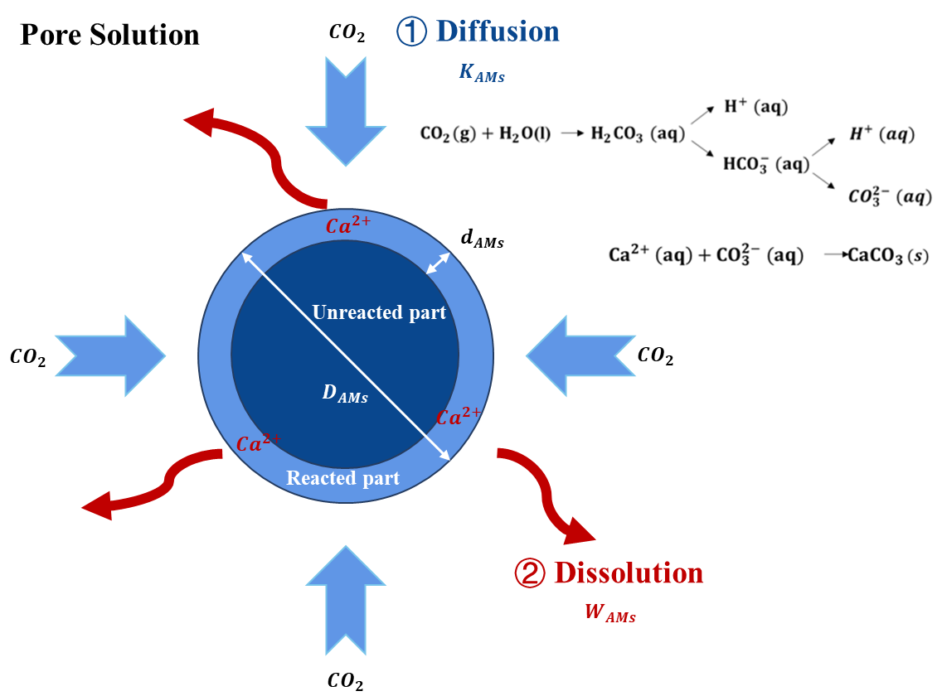Fig. S1. Conceptual diagram of the carbonation reaction of alkaline waste particles.

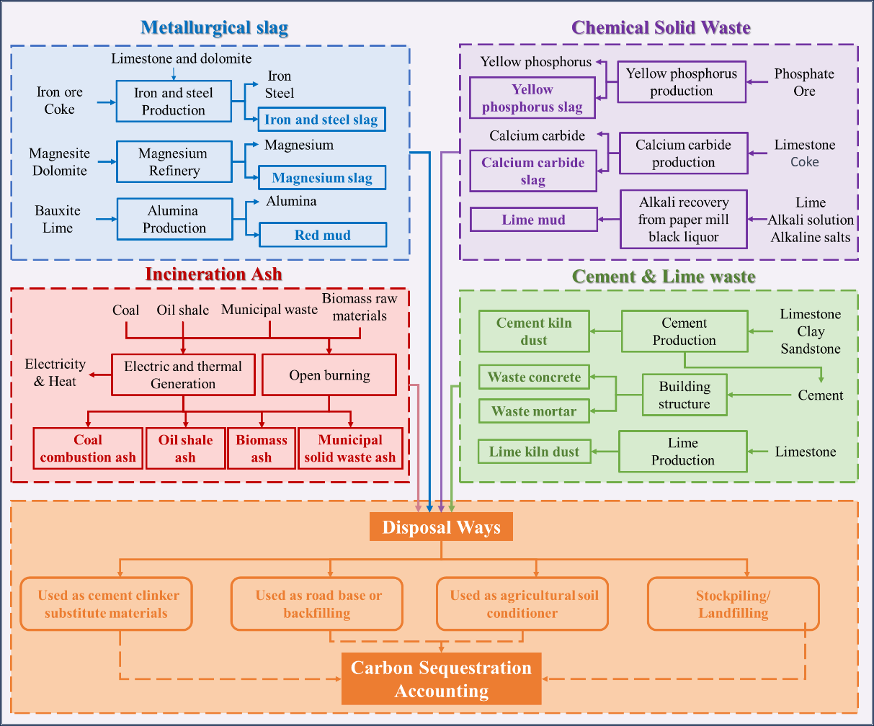

Fig. S2. The accounting boundary of alkaline industrial wastes carbon uptake

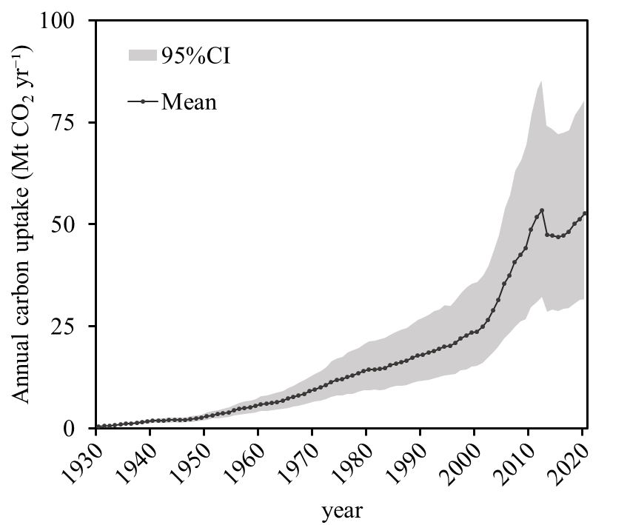

Fig. S3. Annual carbon uptake by blast furnace slag

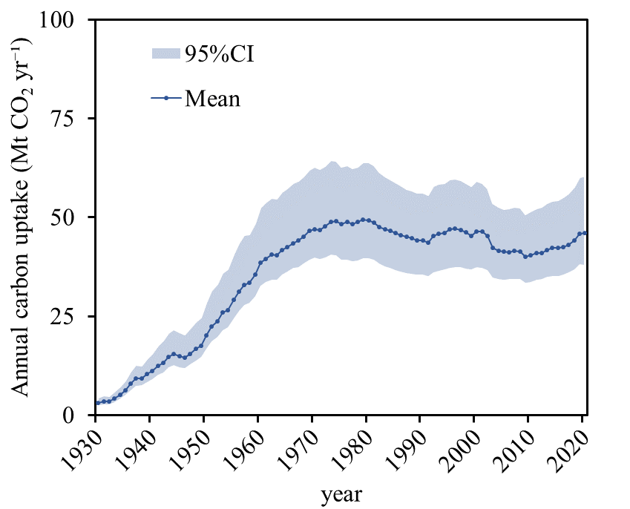

Fig. S4. Annual carbon uptake by blast furnace slag

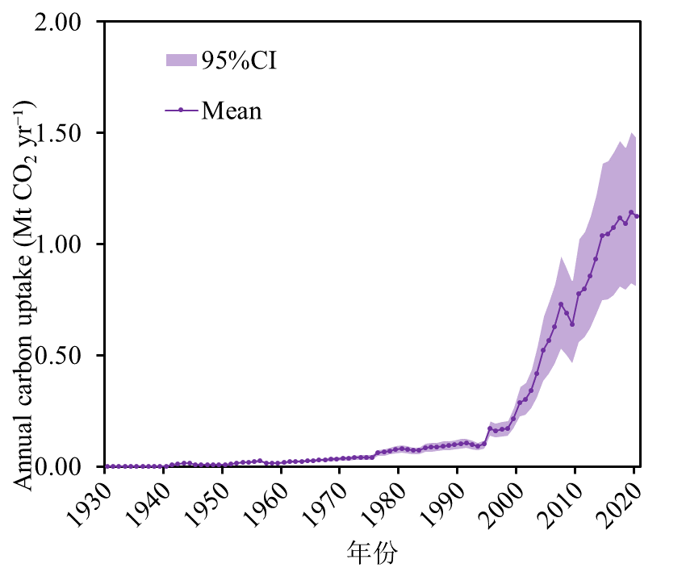

Fig. S5. Annual carbon uptake by magnesium slag

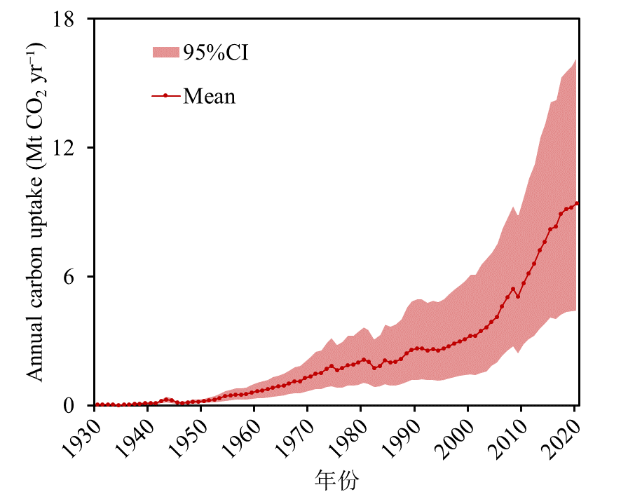

Fig. S6. Annual carbon uptake by red mud

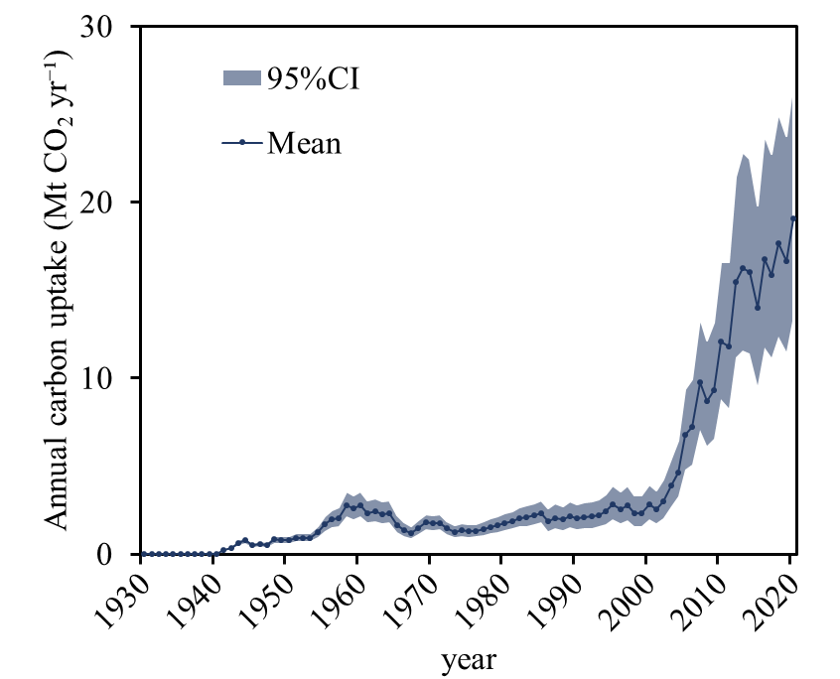

Fig. S7. Annual carbon uptake by calcium carbide slag

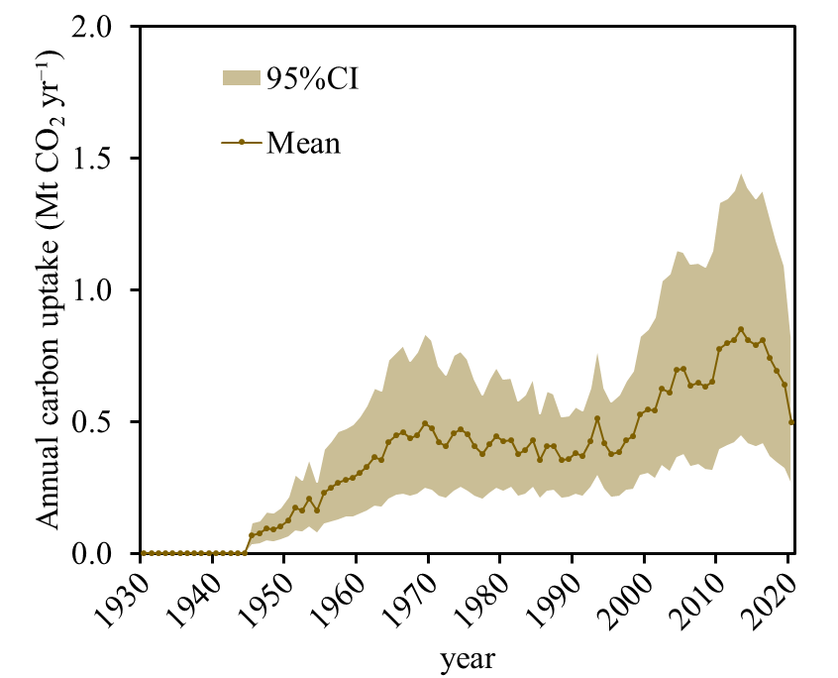

Fig. S8. Annual carbon uptake by yellow phosphorus slag

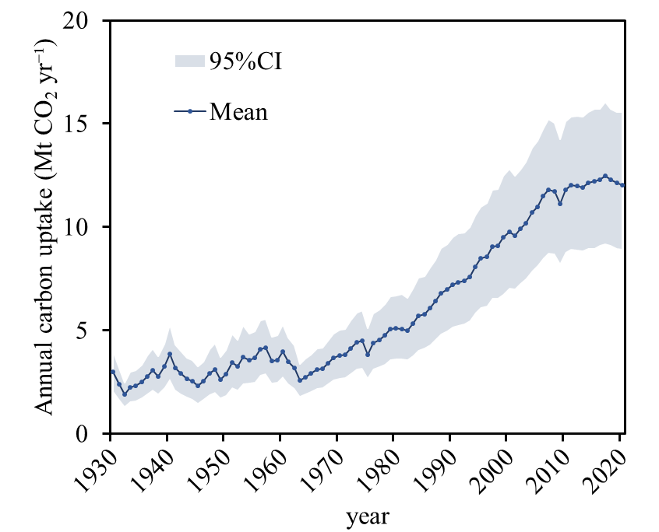

Fig. S9. Annual carbon uptake by lime mud

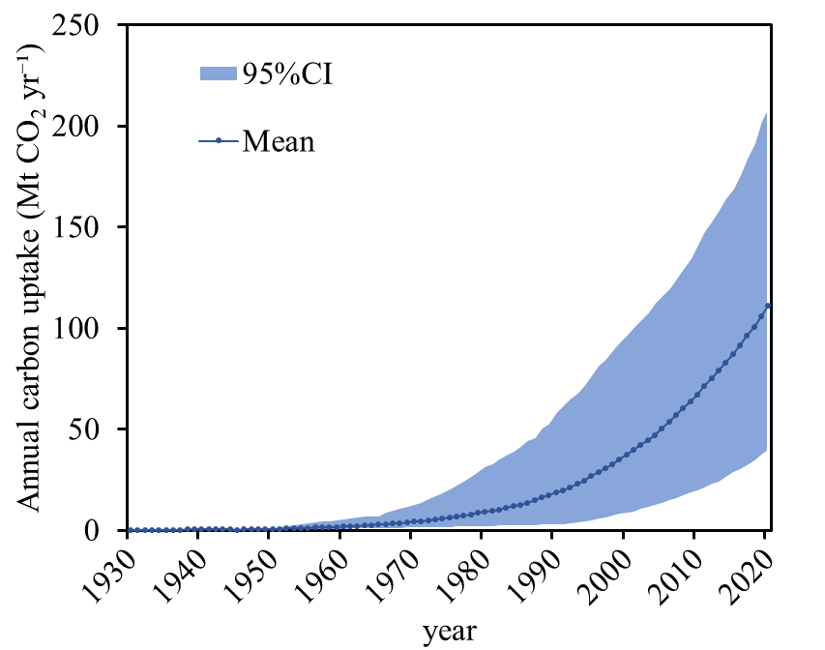

Fig. S10. Annual carbon uptake by waste concrete

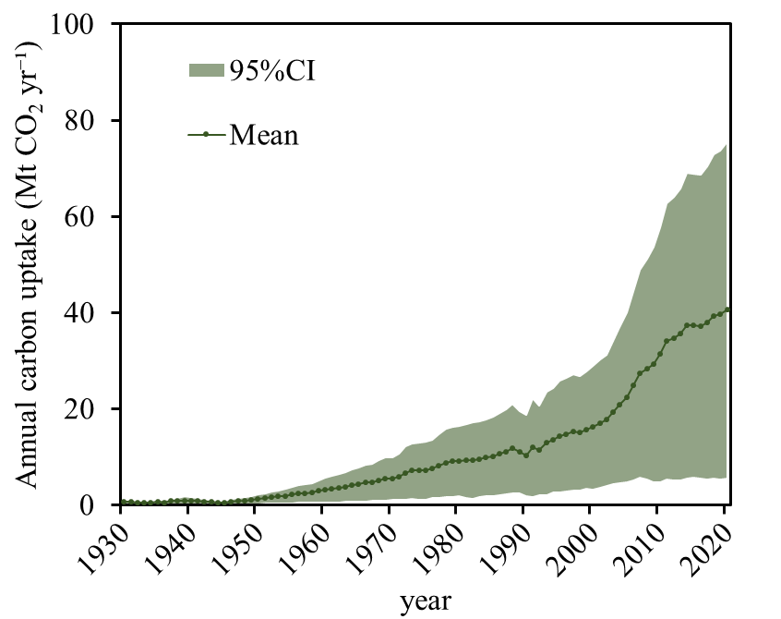

Fig. S11. Annual carbon uptake by waste mortar

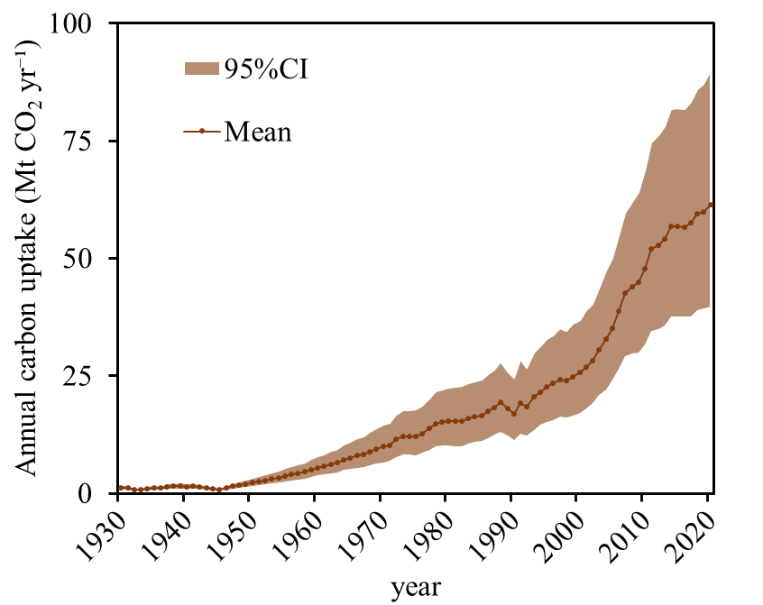

Fig. S12. Annual carbon uptake by cement kiln dust

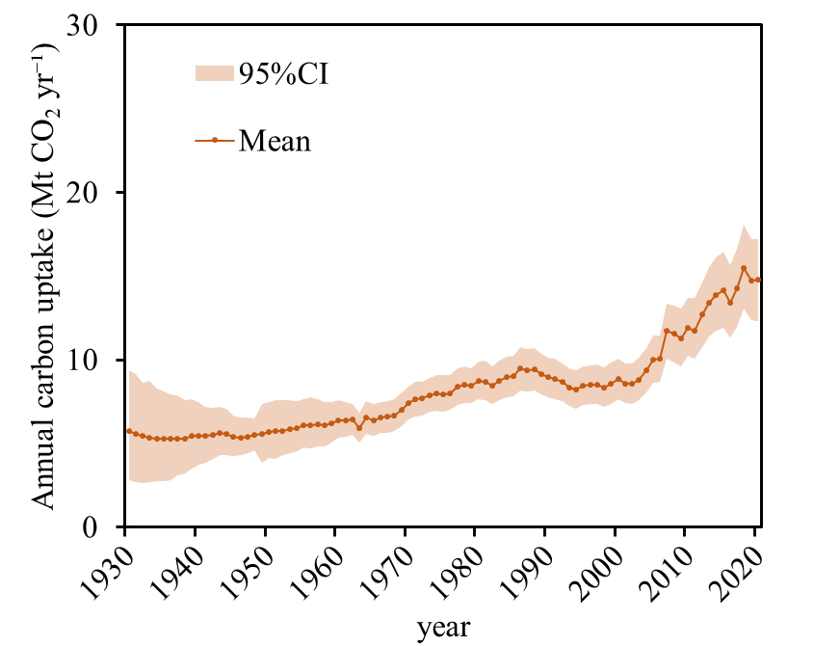

Fig. S13. Annual carbon uptake by cement kiln dust

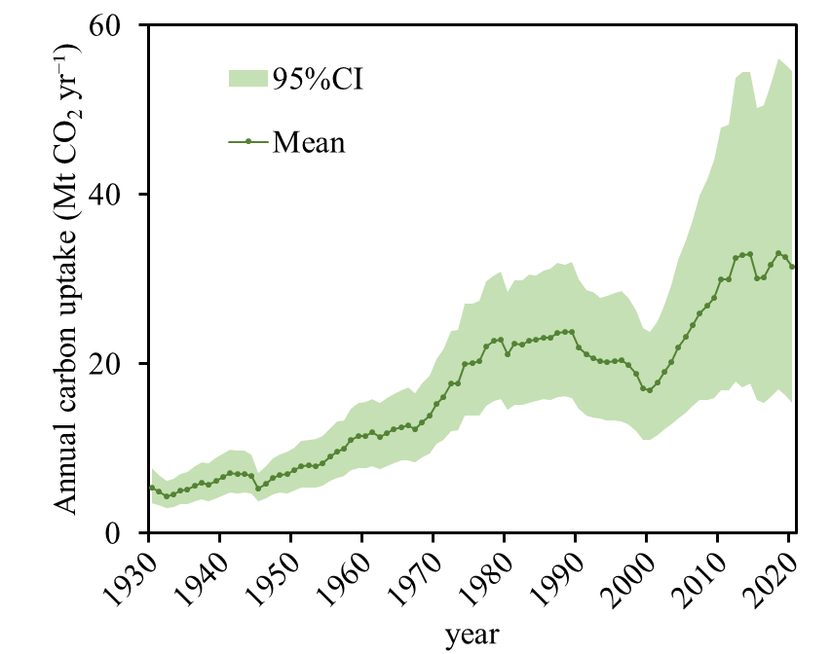

Fig. S14. Annual carbon uptake by coal combustion ash

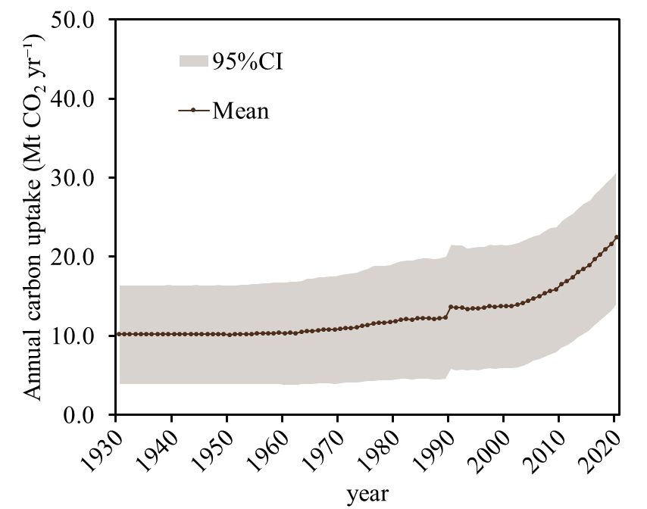

Fig. S15. Annual carbon uptake by biomass ash

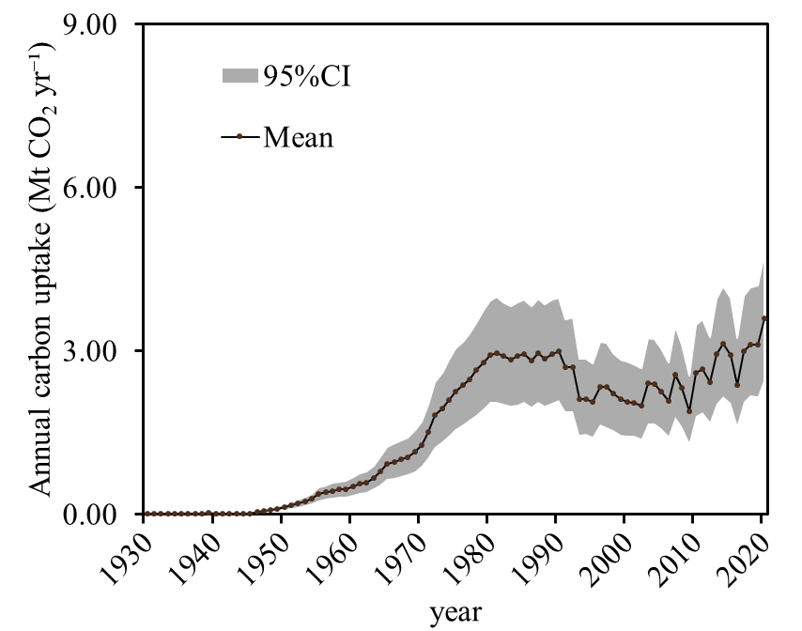

Fig. S16. Annual carbon uptake by oil shale ash

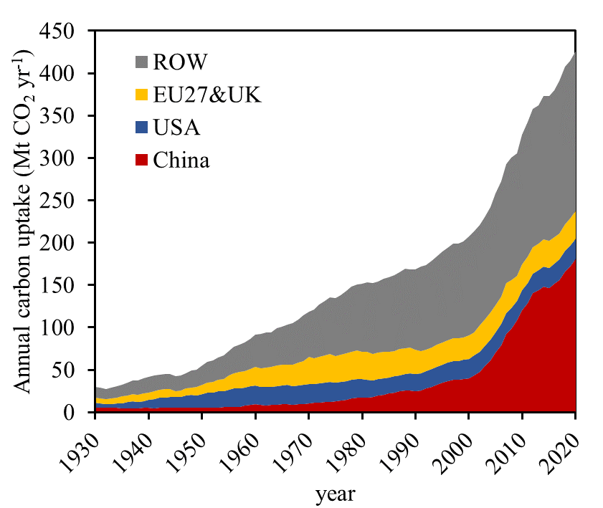

Fig. S17. Annual carbon uptake by different countries or regions (ROW, The Rest of World)

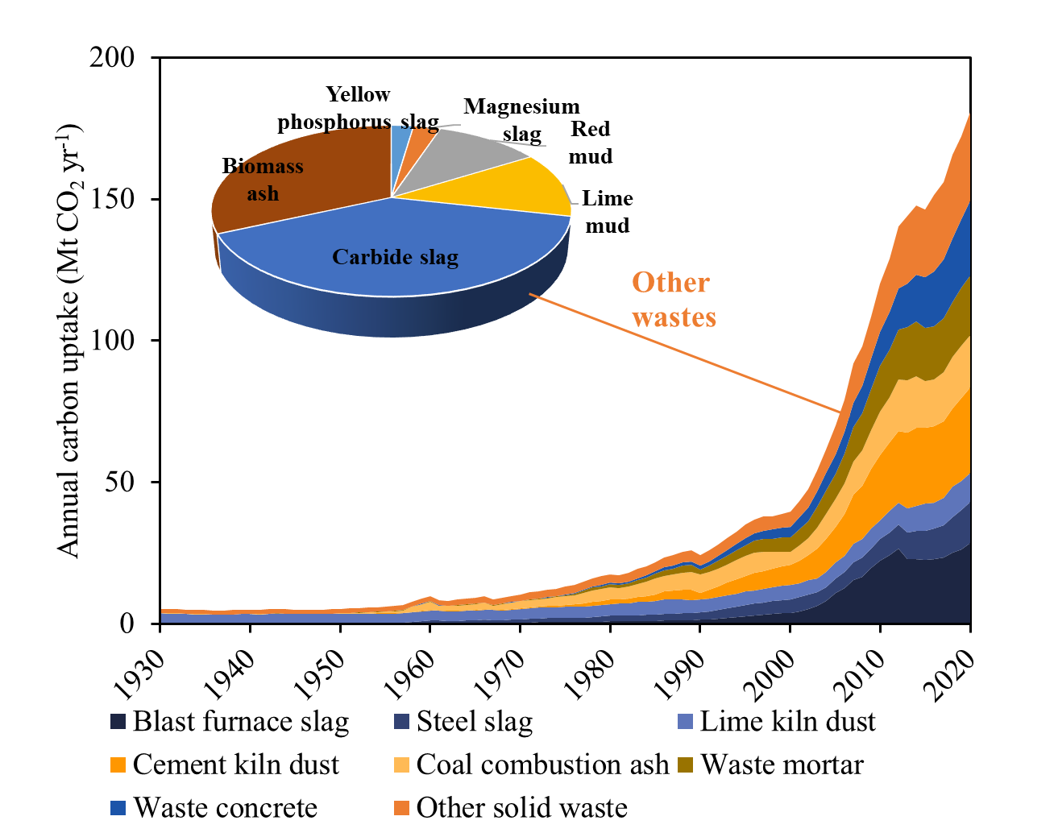

Fig. S18. Annual carbon uptake by various alkaline industrial wastes in China

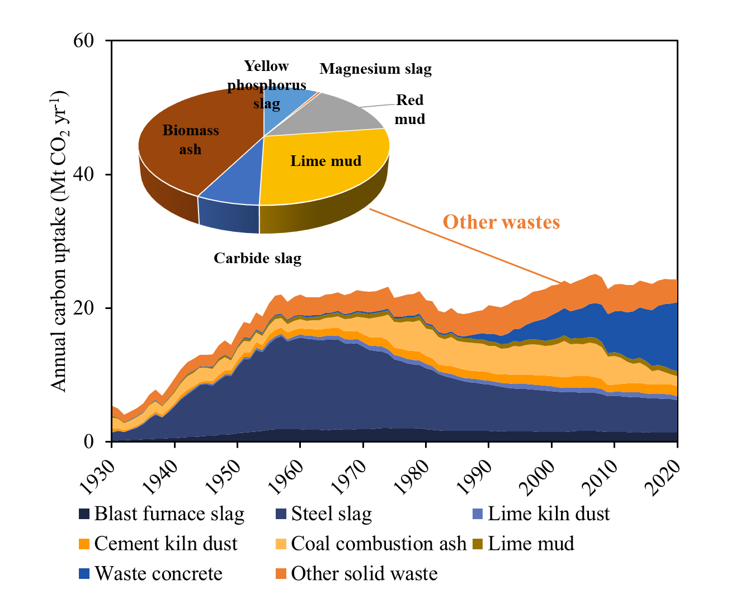

Fig. S19. Annual carbon uptake by various alkaline industrial wastes in U.S.

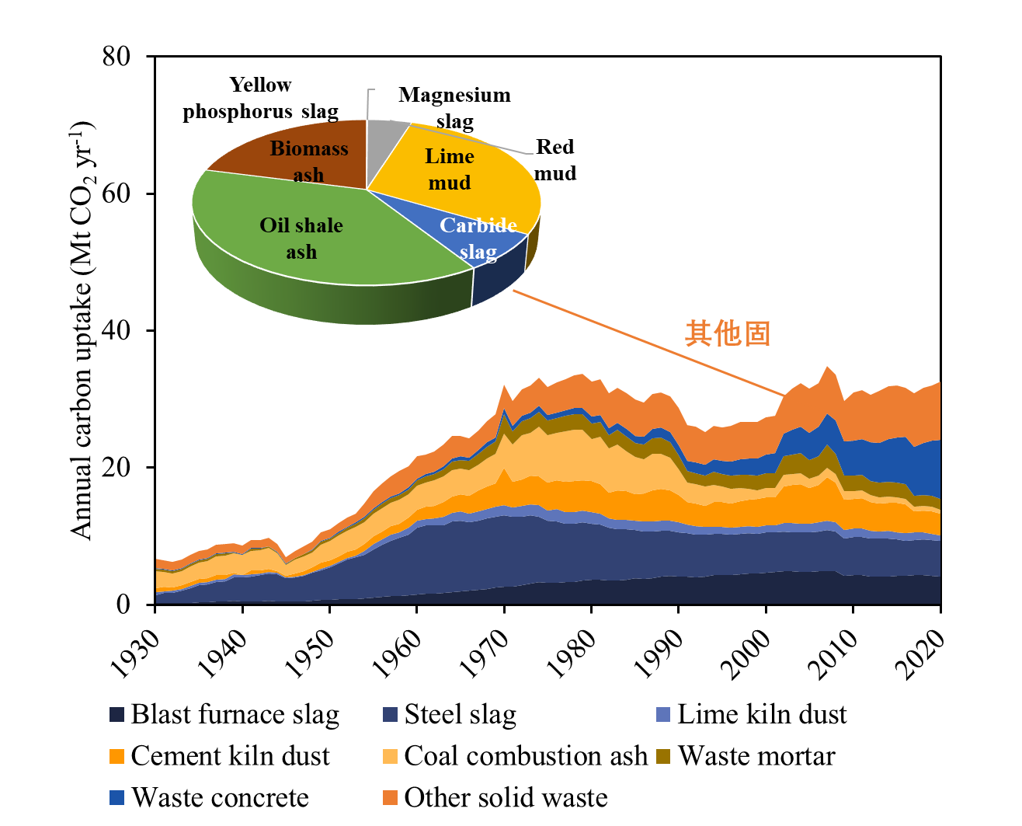

Fig. S20. Annual carbon uptake by various alkaline industrial wastes in EU27&UK

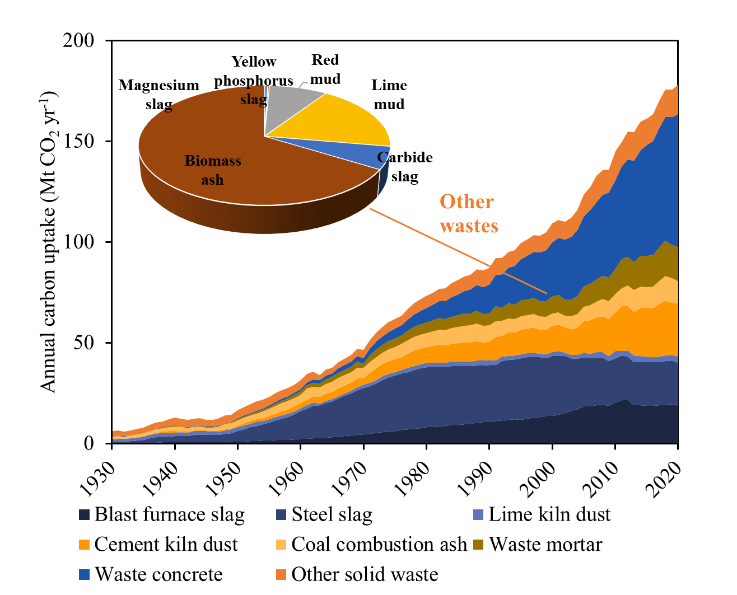

Fig. S21. Annual carbon uptake by various alkaline industrial wastes in the Rest Of World (ROW)

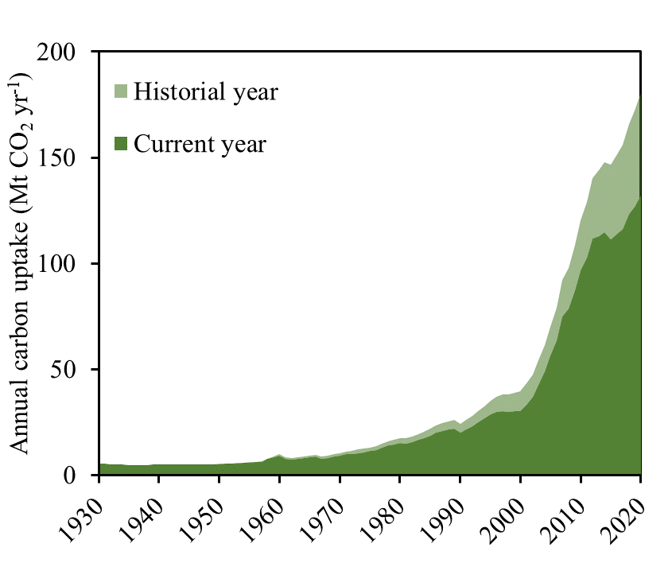

Fig. S22. Carbonation legacy effect of alkaline industrial wastes in China

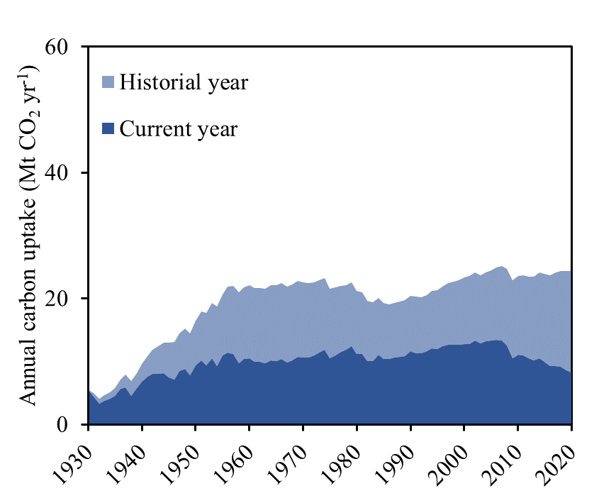

Fig. S23. Carbonation legacy effect of alkaline industrial wastes in U.S.

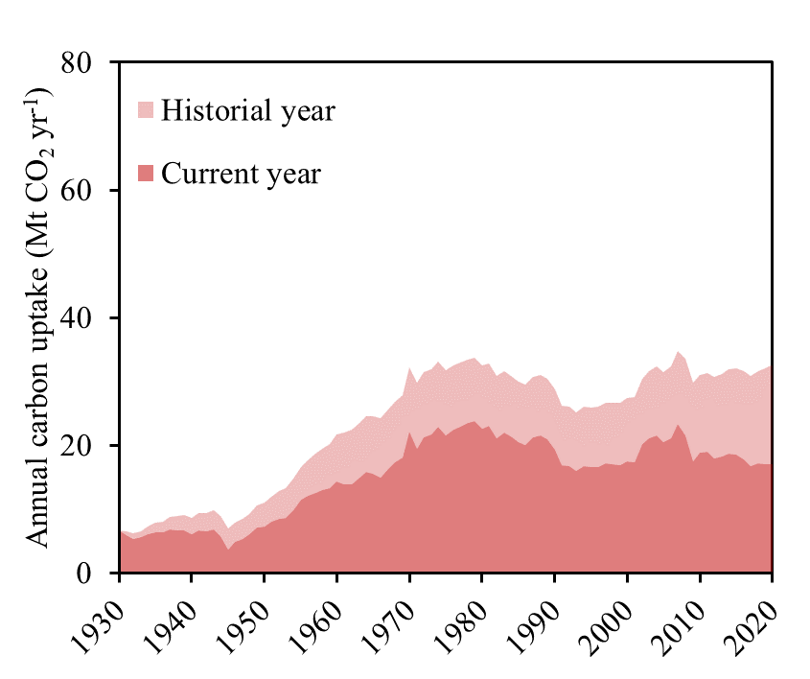

Fig. S24. Carbonation legacy effect of alkaline industrial wastes in EU27&UK

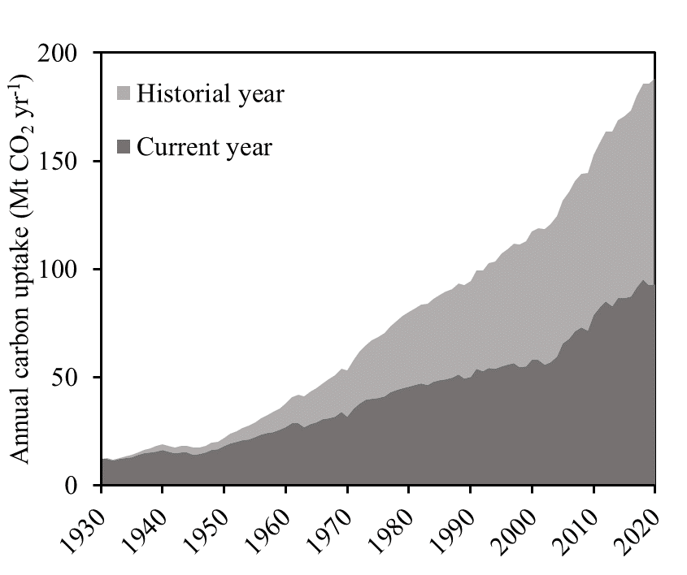

Fig. S25. Carbonation legacy effect of alkaline industrial wastes in the Rest Of World (ROW)

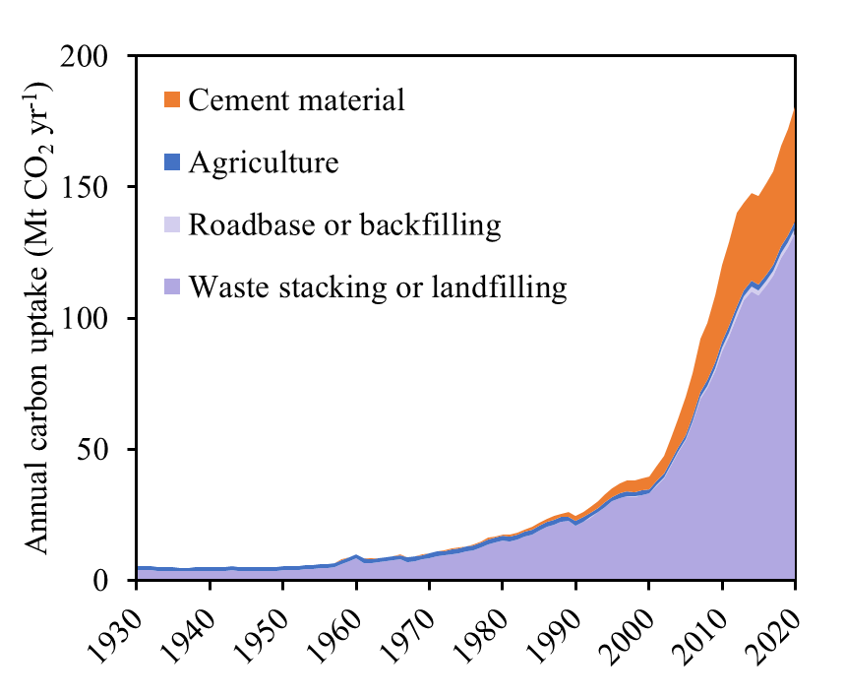

Fig. S26. Annual carbon uptake by alkaline industrial wastes under different disposal ways in China

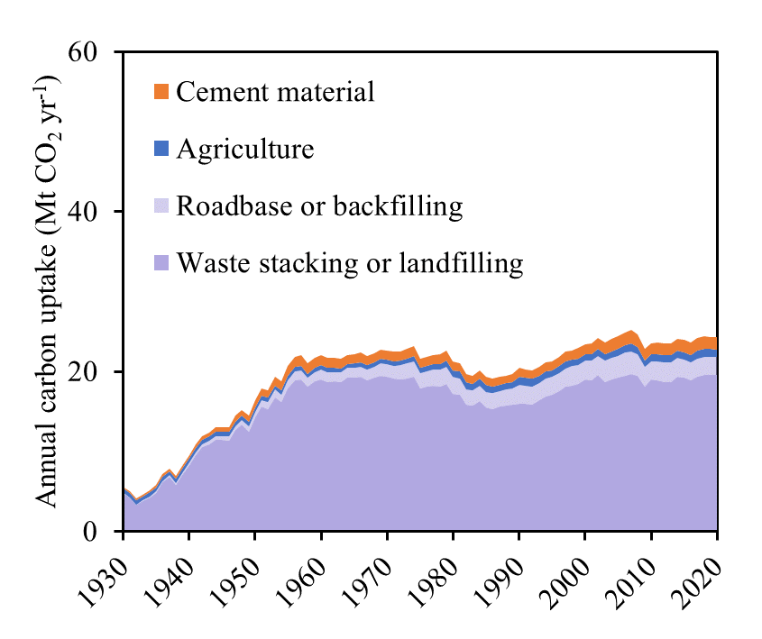

Fig. S27. Annual carbon uptake by alkaline industrial wastes under different disposal ways in U.S.

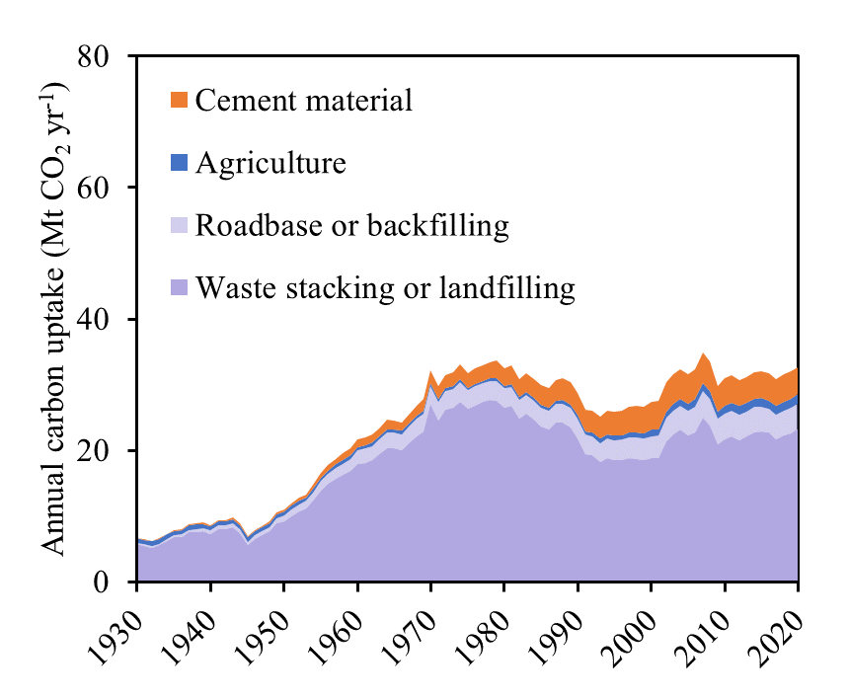

Fig. S28. Annual carbon uptake by alkaline industrial wastes under different disposal ways in EU27&UK

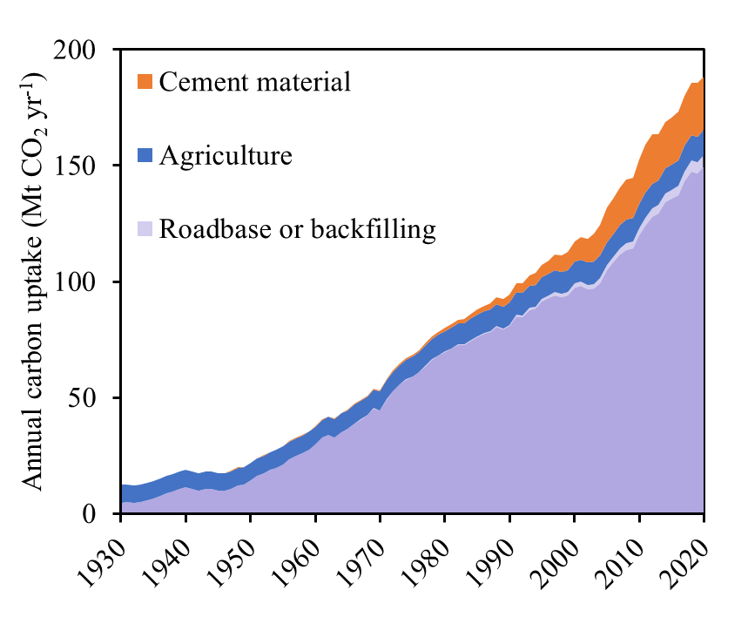

Fig. S29. Annual carbon uptake by alkaline industrial wastes under different disposal ways in the Rest Of World (ROW)

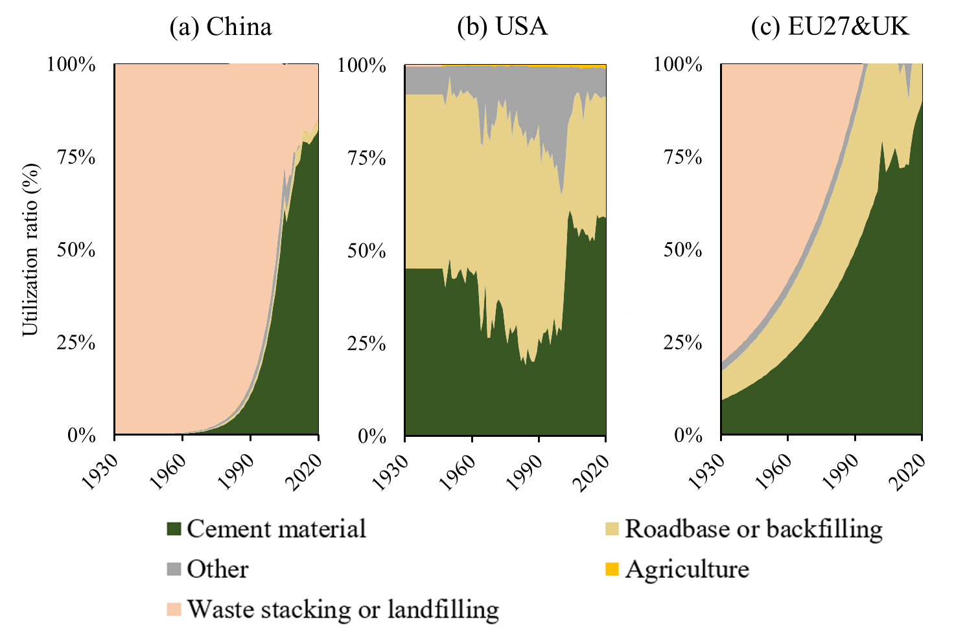

Fig. S30. Annual carbon uptake by alkaline industrial wastes under different disposal ways in the Rest Of World (ROW)

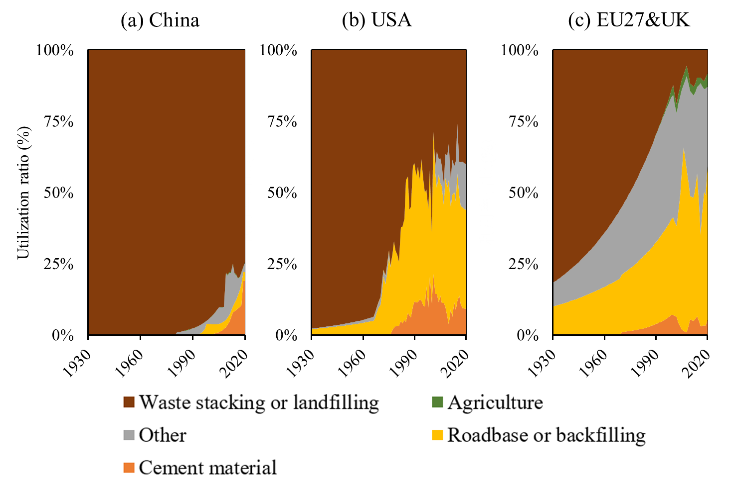

Fig. S31. Utilization rate of steel slag by different ways in different countries, 1930-2020

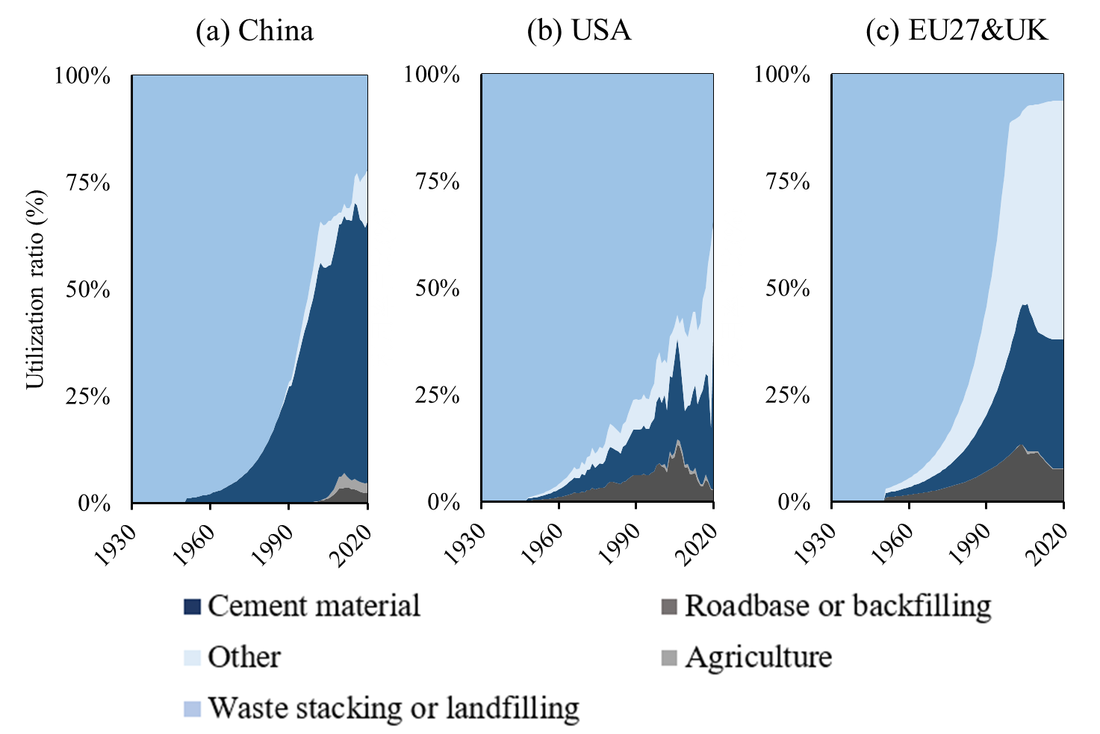

Fig. S32. Utilization rate of coal combustion ash by different ways in different countries, 1930-2020

Supplementary Tables

Table S1: Data description and sources
Data Description | Sources
Raw materials production (China, U.S., EU, RoW) | China Statistical Yearbook (CSY), USGS, BGS, IEA, OECD, FAO, reports
Pig iron, magnesium, yellow phosphorus production | USGS, BGS
Coal production | BGS
Oil shale production (1930-2010) | USGS, Dyni JR, 2006
China's municipal waste incineration data | National Bureau of Statistics of China
Waste incineration (U.S., Europe, global) | IEA (based on waste-to-energy data)
Wood fuel and crop straw burned (1930-2020) | FAO
China's crude steel production | China Steel Yearbook
U.S. and global crude steel production | USGS
Alumina and lime production | USGS
Paper and paperboard production | FAO
China's calcium carbide production | China Chemical Industry Yearbook
Other countries' calcium carbide data | USGS (based on lime used in production)
Alkaline industrial wastes production | Estimated from raw material data and byproduct output rates

Supplementary Data S1-S41
Data S1: Estimates of blast furnace slag (BFS) production by region
Data S2: Estimates of steel slag (SS) production by region
Data S3: Estimates of Magnesium slag (MgS) production by region
Data S4: Estimates of red mud (RM) production by region
Data S5: Estimates of cement waste (CW) production by region
Data S6: Estimates of lime kiln dust (LKD) production by region
Data S7: Estimates of calcium carbide slag (CCS) production by region
Data S8: Estimates of lime mud (LM) production by region
Data S9: Estimates of yellow Phosphorus slag (YPS) production by region
Data S10: Estimates of coal combustion products (CCP) production by region
Data S11: Estimates of oil shale ash (OSA) production by region
Data S12: Municipal solid waste incineration ash (MSWI-A) production by region
Data S13: Biomass ash (BA) production by region
Data S14: Summary of estimated global production of alkaline solid wastes
Data S15: Estimates of utilization of blast furnace slag by region, 1930-2020
Data S16: Estimates of utilization of steel slag by region, 1930-2020
Data S17: Estimates of utilization of coal combustion ash by region, 1930-2020
Data S18: Estimates of utilization of other alkaline solid wastes, by region
Data S19: Particle size distribution of alkaline solid wastes
Data S20: Estimates of cement used for concrete and mortar by region
Data S21: Distribution of concrete by strength class and region
Data S22: Exposure times of cement materials in service life by region
Data S23: Exposure times of cement materials in demolition stage by region (td)
Data S24: Waste concrete particle size distribution sruvey in China
Data S25: Categories of mortar use and their proportions as surveyed in China
Data S26: Distribution of mortar uses and related parameters
Data S27: Content of CaO and MgO of alkaline solid wastes by region
Data S28: Carbonation rate coefficients of Alkaline solid wastes
Data S29: CaO converted to CaCO₃ of alkaline solid wastes
Data S30: Concrete carbonation rate coefficients by region
Data S31: Mortar carbonation rate coefficients measured in China
Data S32: Measurements of CaO converted to CaCO₃ in Chinese mortars
Data S33: U.S. survey results of proportion of cement kiln dust (CKD) diverted to landfill
Data S34: Variables considered in the CO₂ uptake uncertainty analysis of alkaline solid wastes
Data S35: Variables considered in the CO₂ uptake uncertainty analysis of cement and concrete waste
Data S36: Estimation of the carbon sink potential of alkaline solid wastes
Data S37: Global CO₂ uptake by alkaline solid wastes, 1930-2020
Data S38: CO2 uptake by alkaline solid wastes in China, 1930-2020
Data S39: CO2 uptake by alkaline solid wastes in U.S., 1930-2020
Data S40: CO2 uptake by alkaline solid wastes in EU27&UK, 1930-2020
Data S41: CO2 uptake by alkaline solid wastes in ROW, 1930-2020

Supplementary References
1. Xi, F. et al. Substantial global carbon uptake by cement carbonation. Nat Geosci 9, 880–883 (2016).
2. Renforth, P., Washbourne, C. L., Taylder, J. & Manning, D. A. C. Silicate production and availability for mineral carbonation. Environ Sci Technol 45, 2035–2041 (2011).
3. Wang, L., Jin, Y. & Nie, Y. Investigation of accelerated and natural carbonation of MSWI fly ash with a high content of Ca. J Hazard Mater 174, 334–343 (2010).
4. Rahmanihanzaki, M. & Hemmati, A. A review of mineral carbonation by alkaline solidwaste. International Journal of Greenhouse Gas Control 121, (2022).
5. Liu, W. et al. CO₂ mineral carbonation using industrial solid wastes: A review of recent developments. Chemical Engineering Journal 129093 (2021).
6. Chiang, P. C. & Pan, S. Y. Carbon Dioxide Mineralization and Utilization. Carbon Dioxide Mineralization and Utilization (2017).
7. Park, S., Ahn, Y., Lee, S. & Choi, J. Calcium carbonate synthesis from waste concrete for carbon dioxide capture: From laboratory to pilot scale. J Hazard Mater 403, (2021).
8. Xi, F., Wang, J., Shi, T., Bing, L. & Liu, Z. Cement Carbon Sink and Its Contributions to Global Missing Carbon Sink. Science Press 189–193 (2018).
9. Pan, S. Y. et al. CO₂ mineralization and utilization by alkaline solid wastes for potential carbon reduction. Nat Sustain 3, 399–405 (2020).
10. Renforth, P. The negative emission potential of alkaline materials. Nat Commun 10, 1–8, (2019).
11. Bing, L. et al. An investigation of the global uptake of CO₂ by lime from 1930 to 2020. Earth Syst Sci Data 15, 2431–2444 (2023).
12. Shah, I. H., Miller, S. A., Jiang, D. & Myers, R. J. Cement substitution with secondary materials can reduce annual global CO₂ emissions by up to 1.3 gigatons. Nat Commun 13, (2022).
13. Ma, M. et al. Quantitative analysis of CO₂ uptake by alkaline solid wastes in China. J Clean Prod 363, (2022).
14. Sanna, A., Uibu, M., Caramanna, G., Kuusik, R. & Maroto-Valer, M. M. A review of mineral carbonation technologies to sequester CO₂. Chem Soc Rev 43, 8049–8080 (2014).
15. Gao, J. et al. Process simulation and energy integration in the mineral carbonation of blast furnace slag. Chin J Chem Eng 27, (2019).
16. Liu, L. et al. Analysis of carbon sink of steel slag in China. Chinese Journal of Applied Ecology 29, 3385–3390 (2018).
17. Huijgen, W. J. J., Witkamp, G. J. & Comans, R. N. J. Mineral CO₂ sequestration by steel slag carbonation. Environ Sci Technol 39, (2005).
18. Zhang, Y., Yu, L., Cui, K., Wang, H. & Fu, T. Carbon capture and storage technology by steel-making slags: Recent progress and future challenges. Chemical Engineering Journal 455, (2023).
19. Chang, E. E., Chen, C. H., Chen, Y. H., Pan, S. Y. & Chiang, P. C. Performance evaluation for carbonation of steel-making slags in a slurry reactor. J Hazard Mater 186, (2011).
20. Kang, S. K. et al. The recycling of inorganic industrial waste in cement industry. Clean Technology 6, 61–69 (2000).
21. Mo, L., Hao, Y., Liu, Y., Wang, F. & Deng, M. Preparation of calcium carbonate binders via CO₂ activation of magnesium slag. Cem Concr Res 121, 81–90 (2019).
22. Rai, S. B. et al. Sequestration of carbon dioxide in red mud. Desalination Water Treat 51, 2185–2192 (2013).
23. Sahu, R. C., Patel, R. K. & Ray, B. C. Neutralization of red mud using CO₂ sequestration cycle. J Hazard Mater 179, 28–34 (2010).
24. Lin, Q., Wang, X., Cao, J. & Zhang, J. Preparation of Nanosized Calcium Carbonate from Calcium Carbide Residue. Guizhou Chemical Industry 3, 5–7 (2006).
25. Ma, J. et al. Effects of Particle Size difference between White Mud and Limestone on Desulfurization Performance. Journal of Chinese Society of Power Engineering 6, 497–504 (2021).
26. Sanna, A., Dri, M., Hall, M. R. & Maroto-Valer, M. Waste materials for carbon capture and storage by mineralisation (CCSM) - A UK perspective. Appl Energy 99, 545–554 (2012).
27. Chen, Q., Ding, W., Sun, H. & Peng, T. Mineral carbonation of yellow phosphorus slag and characterization of carbonated product. Energy 188, (2019).
28. Ukwattage, N. L., Ranjith, P. G., Yellishetty, M., Bui, H. H. & Xu, T. A laboratory-scale study of the aqueous mineral carbonation of coal fly ash for CO₂ sequestration. J Clean Prod 103, (2015).
29. Ukwattage, N. L., Ranjith, P. G. & Wang, S. H. Investigation of the potential of coal combustion fly ash for mineral sequestration of CO₂ by accelerated carbonation. Energy 52, 230–236 (2013).
30. Muriithi, G. N. et al. Comparison of CO₂ capture by ex-situ accelerated carbonation and in in-situ naturally weathered coal fly ash. J Environ Manage 127, (2013).
31. Wang, W., Zheng, Y., Liu, X. & Wang, P. Characterization of typical biomass ashes and study on their potential of CO₂ fixation. Energy & fuels 26, 6047–6052 (2012).
32. Wang, W., Zheng, Y., Liu, X. & Wang, P. Characterization of typical biomass ashes and study on their potential of CO₂ fixation. Energy and Fuels 26, 6047–6052 (2012).
33. del Valle-Zermeño, R. et al. Biogas upgrading using MSWI bottom ash: An integrated municipal solid waste management. Renew Energy 80, 184–189 (2015).12.
34. Xu, J. Study on the Effect of MSWI Bottom Ash on the Mechanical Properties of Mortar and its Pretreatment. (2019).
35. Guo, R. et al. Global CO₂ uptake by cement from 1930 to 2019. Earth Syst Sci Data 13, 1791–1805 (2021).
36. Kikuchi, T. & Kuroda, Y. Carbon dioxide uptake in demolished and crushed concrete. Journal of Advanced Concrete Technology 9, (2011).
37. Huang, Z. et al. Global carbon uptake of cement carbonation accounts 1930-2021. Earth Syst. Sci. Data Discuss. 2023, (2023).
38. Yoon, I. S., Çopuroǧlu, O. & Park, K. B. Effect of global climatic change on carbonation progress of concrete. Atmos Environ 41, (2007).
39. Papadakis, V. G., Vayenas, C. G. & Fardis, M. N. Experimental investigation and mathematical modeling of the concrete carbonation problem. Chem Eng Sci 46, (1991).
40. Bossink, B. A. G. & Brouwers, H. J. H. Construction Waste: Quantification and Source Evaluation. J Constr Eng Manag 122, (1996).
41. Huang, T., Shi, F., Tanikawa, H., Fei, J. & Han, J. Materials demand and environmental impact of buildings construction and demolition in China based on dynamic material flow analysis. Resour Conserv Recycl 72, (2013).
42. Khanna, O. S. Characterization and Utilization of Cement Kiln Dusts (CKDs) as Partial Replacements of Portland Cement. Thesis for the degree of Doctor of Philosophy Department of Civil Engineering University of Toronto (2009).
43. Liu, L. L., Ling, J. H., Li, T., Wang, J. Y. & Xi, F. M. Review of lime carbon sink. Chinese Journal of Applied Ecology 29, 327–334 (2018).
44. Greco-Coppi, M., Hofmann, C., Ströhle, J., Walter, D. & Epple, B. Efficient CO₂ capture from lime production by an indirectly heated carbonate looping process. International Journal of Greenhouse Gas Control 112, 103430 (2021).
45. Dyni, J.R., 2006, Geology and resources of some world oil-shale deposits: U.S. Geological Survey Scientific Investigations Report 2005–5294, 42 p.

