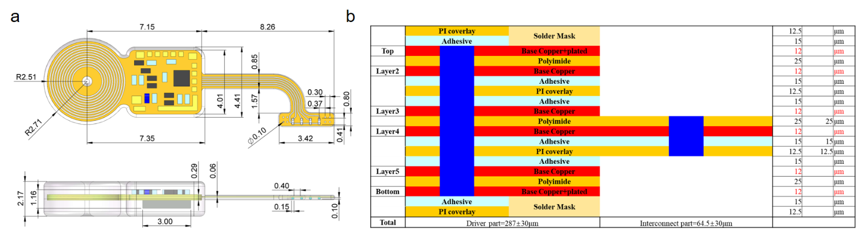
Fig.S1 FIMOSS implant engineering drawing, and FPC layer management. a Engineering drawing of the FIMOSS implant with key dimensions annotated. Units are in millimeter(mm). b Layer stacking of the FIMOSS implant’s printed circuit board

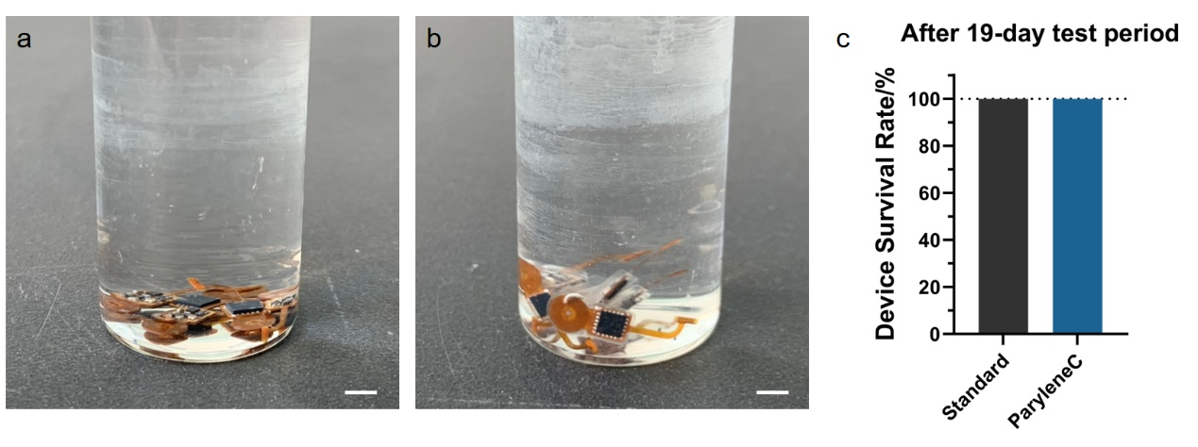
Fig.S2 Accelerated aging test of FIMOSS encapsulation in vitro. a 5 FIMOSS implants encapsulated only with 12μm Parylene C coating in 60℃ saline solution. b 5 FIMOSS implants encapsulated with standard encapsulation (12μm Parylene C coating and 500μm PDMS casing) in 60℃ saline solution. c Device survival rates after 19-day accelerated aging test showed the reliability of FIMOSS implants encapsulation.

Fig.S3 Pre-curling process of the MOSD II a,b,c During the pre-curling process of the MOSD II, copper wire with a diameter of 0.01mm was used to stitch the two suture eyelets to crimp the MOSD II into a cuff. d The FIMOSS implant was treated with plasma gas, and a layer of PDMS with a thickness of about 150μm was encapsulated on the interconnect and MOSD II, and cured in an oven at 85℃ for 30min. e,f After the FIMOSS implant is cooled to room temperature, use surgical microscissors to remove the copper knot and the lateral suture eyelets. Finally, new PDMS mixture was applied to the cut section and cured again in an oven at 85 °C for 30min. (scale bar=500μm)

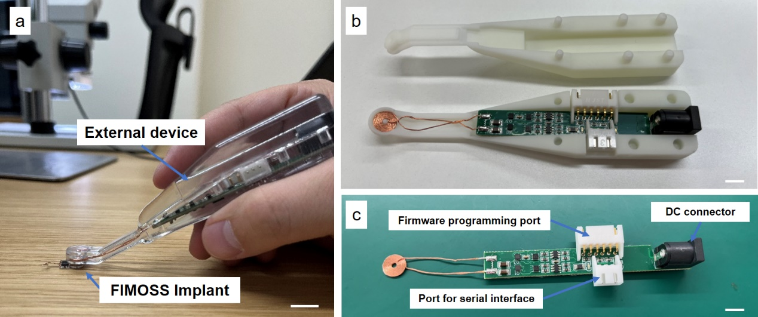
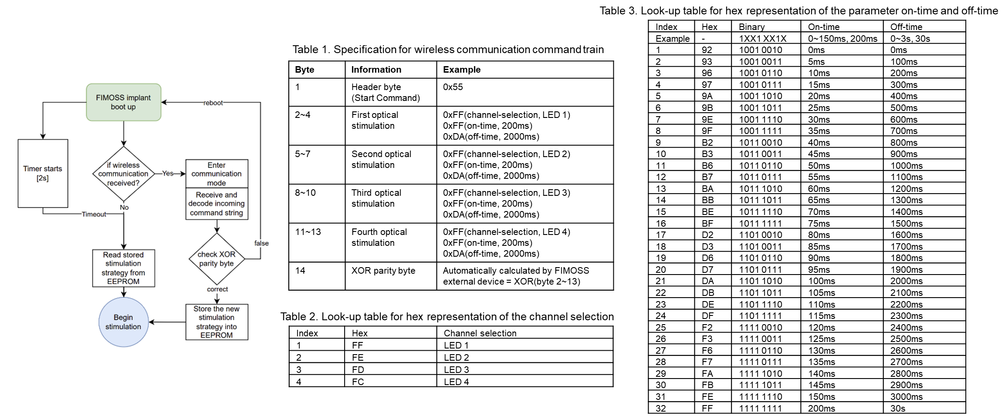
Fig.S4 FIMOSS external device. a The external device is designed to be hand-held for intraoperative hand-held use to power the implant. (scale bar=1cm) b The FIMOSS external device consists of a 3D printed housing and internal electronics (scale bar=5mm). c The FIMOSS external device includes a DC connector for DC power supply, and two other connectors for firmware programming and serial interface with a personal computer to set updated stimulation parameters. The left end of the PCB is connected with a transmitting coil for the wireless interface with the implant (scale bar=5mm).
Fig.S5 FIMOSS implant software schematics, and wireless communication protocol.
Fig.S6 Light intensity curve of μLEDs during activation interval
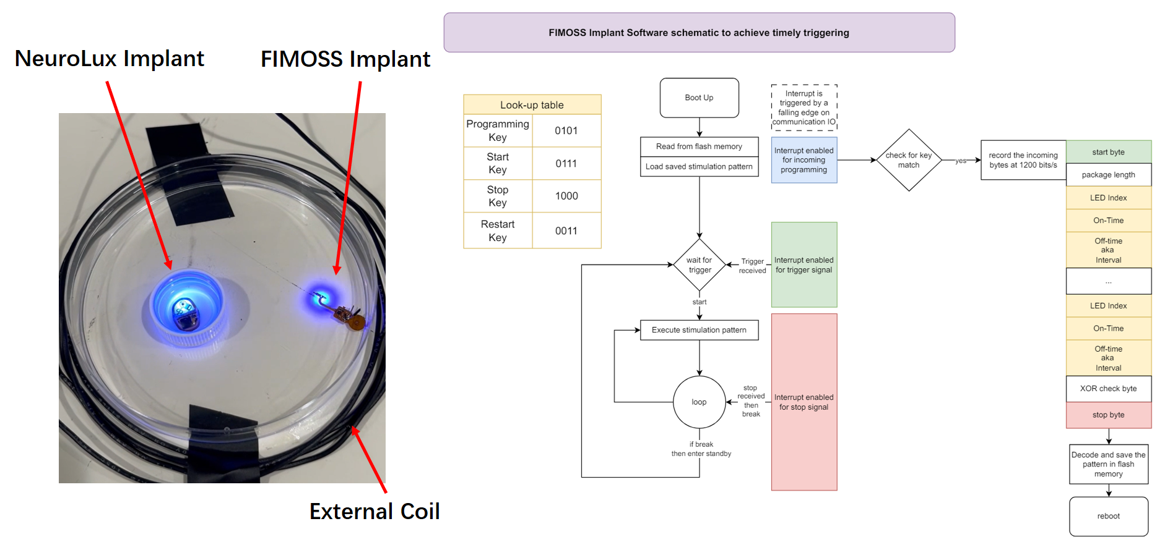
Fig.S7 The actuation of FIMOSS implant by NeuroLux external device

Fig.S8 Fabrication process of FIMOSS implant. a Electronic manufacturing process of FIMOSS implants involving the FPC manufacturing, μLEDs assembly and SMT assembly. b Program firmware and initial parameters into the MCU of the FIMOSS implant. c The ultrasonic cleaning of the device d~h The antennas and drivers were encapsulated by 12μm Parylene C(d) and then encapsulated by PDMS using a stainless steel mold(e~h) i~l Encapsulate the interconnect and MOSD II of several FIMOSS implants by PDMS. m Fixation of MOSD II by a 11-0 prolene suture. n A schematic diagram of the completely prepared FIMOSS implant.

