Supplementary material

A Stratified Precision Medicine Trial Targeting Selective Mechanisms of Alpha 2A Agonism as a Treatment for the Cognitive Biotype of Depression: The BIomarker Guided (BIG) Study for Depression

Laura M. Hack, MD, PhD^{1,2}*, Jenna Jubeir, BS¹*, Rachel Hilton, MSN, PMHNP-BC¹**, Leonardo Tozzi, MD, PhD¹**, Leyla Boyar, BA ¹, Xue Zhang, PhD¹, Timothy Lyons, BS¹, Booil Jo, PhD¹, Ruth O’Hara, PhD^{1,2}, Alan Schatzberg, MD¹, and Leanne M. Williams, PhD^{1,2}

¹Department of Psychiatry and Behavioral Sciences, Stanford University School of Medicine, Stanford, California.
²Sierra Pacific Mental Illness Research, Education, and Clinical Center (MIRECC), VA Palo Alto Health Care System, Palo Alto, California.

*These authors contributed equally
**These authors contributed equally as second authors

Table of Contents
Supplementary Methods 3
Weekly Monitoring 3
Treatment tolerability 4
Supplementary Tables 5
Supplementary Table 1: Treatment emergent adverse events for enrolled patients 6
Supplementary Table 2: Results of paired t-tests for the effect of GIR on primary and secondary outcome measures. 7
Supplementary Table 3. Baseline demographic and clinical information for cognitive biotype + subgroup 8
Supplementary Figures 9
Supplementary Figure 1: Improvements in self-reported quality of life following 8 weeks of GIR. 10
Supplementary Figure 2: CONSORT flow diagram for the Biomarker Guided (BIG) Study for Depression. 11
Supplementary Figure 3: Eligibility criteria for the BIomarker Guided (BIG) Study for Depression. 12
Supplementary Figure 4: Study flow for the BIomarker Guided (BIG) Study for Depression. 13

Supplementary Methods

Tapering and wash out of psychotropic medications
If a participant and usual care provider were agreeable and it was deemed safe, participants underwent tapering and wash out of 5 half-lives psychotropic medications under the care of their usual care provider while remaining in contact with study personnel. After tapering, the typical washout period was approximately one week given the typical half-life range of 4 to 36 hours¹.

Weekly Monitoring
Participants had weekly virtual or in-person visits, alternating each week between a trained, experienced research coordinator and a study clinician. During these visits, participants were carefully monitored for worsening depressive symptoms and suicidality via clinical interview and the 5-item ideation subscale of the Columbia-Suicide Severity Rating Scale (C-SSRS)². Depression severity was also assessed at Week 2 via the 17-item Hamilton Depression Rating Scale³. A thorough risk assessment was performed if a worsening of depression or an increase in suicidality occurred and the appropriate action taken. This action involved communication with participant’s regular physician, psychiatrist, and/or therapist, setting up evaluation for inpatient hospitalization, and/or withdrawal from the study. Furthermore, adherence to GIR, changes to concomitant medication(s), and adverse events (AEs) were assessed during each weekly visit by asking the participant what dose(s) of GIR they were taking over the past week and if they missed any doses, whether they started, stopped, or changed any concomitant medications(s), and if they experienced any AEs. Additionally birth control usage compliance and likelihood of pregnancy in female participants of childbearing potential was assessed. Finally, vital signs were taken if appropriate.

Treatment tolerability

Of the 28 enrolled participants, 26 were commenced on GIR. A total of 14 AEs were reported with the most common being dry mouth (64%) and daytime fatigue (43%), which is consistent with prior reports. Most AEs were mild in nature, well tolerated, and improved with time or over-the-counter remedies, such as lozenges for dry mouth. One participant had a serious AE, suicidal ideation without intent or plan which was present at baseline and increased in severity and frequency within two weeks after starting GIR; this caused the participant to be withdrawn from the study. The participant was safely tapered off GIR and concurrently monitored by their standing psychiatrist. Two other participants withdrew from the trial due to AEs, including daytime fatigue, heart palpitations, dizziness, shortness of breath, and difficulty sleeping. The AEs for participants are detailed in Supplementary Table 1.

Supplementary Tables

Supplementary Table 1: Treatment emergent adverse events for enrolled patients
Adverse Event | N (%)
Dry Mouth | 18/28 (64%)
Daytime Fatigue | 12/28 (43%)
Dizziness | 8/28 (29%)
Difficulty Sleeping | 7/28 (25%)
Headache | 6/28 (21%)
Paresthesias | 4/28 (14%)
Constipation | 4/28 (14%)
Heart Palpitations | 3/28 (11%)
Reduced Appetite | 3/28 (11%)
Transient Tinnitus | 1/28 (4%)
Shortness of Breath | 1/28 (4%)
Irritability | 1/28 (4%)
Acid reflux | 1/28 (4%)
Increased Suicidality | 1/28 (4%)

Supplementary Table 2: Results of paired t-tests for the effect of GIR on primary and secondary outcome measures.
Variable | t value |  | DF | P value | Cohen's d effect size | 95% CI
Primary Circuit Outcomes
dACC Activation | 2.334 |  | 16 | 0.033 | 0.566 | [0.021, 1.112]
Left dLPFC Activation | 1.718 |  | 16 | 0.105 | 0.417 | [0.084, 0.917]
Right dLPFC Activation | 1.193 |  | 16 | 0.250 | 0.289 | [0.184, 0.763]
L dLPFC – dACC Connectivity | 2.753 |  | 16 | 0.014 | 0.668 | [0.001, 1.337]
R dLPFC – dACC Connectivity | 0.888 |  | 16 | 0.388 | 0.215 | [0.518, 0.948]
Secondary Cognitive Behavioral Outcomes
Maze | 0.367 |  | 16 | 0.719 | 0.089 | [0.569, 0.747]
Digit Span | 1.016 |  | 16 | 0.325 | 0.246 | [0.294, 0.787]
Verbal Interference (Stroop) Word | 3.355 |  | 16 | 0.004 | 0.814 | [0.564, 1.063]
Verbal Interference (Stroop) Color | 0.434 |  | 16 | 0.670 | 0.105 | [0.259, 0.469]
Switching of Attention (Trails B) | 1.763 |  | 16 | 0.097 | 0.428 | [0.122, 0.978]
Go/NoGo NoGo Reaction Time | 2.894 |  | 13 | 0.013 | 0.773 | [0.047, 1.500]
Secondary Depression Symptom Outcome
17-item Hamilton Rating Scale for Depression | 12.996 |  | 16 | <0.001 | 3.152 | [2.757, 3.547]
Secondary Quality of Life and Suicidality Outcomes
WHOQoL: Physical Health | 3.159 |  | 16 | 0.006 | 0.881 | [0.324, 1.438]
WHOQoL: Psychological Health | 3.628 |  | 16 | 0.002 | 0.766 | [0.319, 1.214]
WHOQoL: Social Relationships | 2.445 |  | 16 | 0.026 | 0.88 | [0.288, 1.472]
WHOQoL: Environment | 1.252 |  | 16 | 0.229 | 0.593 | [0.250, 0.936]
Satisfaction With Life Scale | 3.633 |  | 16 | 0.002 | 0.304 | [0.033, 0.640]
Columbia Suicidality Severity Rating Scale | 0.824 |  | 16 | 0.422 | 0.2 | [0.242, 0.642]

Supplementary Table 3. Baseline demographic and clinical information for cognitive biotype+ subgroup
Sex at birth | N | % | Mean | s.d. | Median | Range
Female | 8 | 47
Age (years) |  |  | 31.4 | 11.1
Race
Asian | 7 | 41.2
Black or African American | 2 | 11.8
Caucasian | 5 | 29.4
More than 2 races | 1 | 5.9
Other | 2 | 11.8
Education level
High school | 1 | 5.9
Some college | 3 | 17.6
Two-year college | 1 | 5.9
Four-year college | 7 | 41.2
More than four-year college | 5 | 23.8
Employment status
Full-time | 8 | 47.1
Part-time | 2 | 11.1
Recently unemployed | 1 | 5.9
Unemployed for 6+ months | 1 | 5.9
Retired | 0 | 0.0
Full-time student | 5 | 23.8
Part-time student | 4 | 23.5
MDD diagnosis
Past | 16 | 94.1%
Current | 16 | 94.1%
Recurrent | 11 | 64.7%
17-item Hamilton Rating Scale for Depression |  |  |  |  | 15 | 14-27
Current Anxiety Disorder* | 5 | 23.8
Previous antidepressant treatment** failures |  |  |  |  | 2 | 0-7
Previous antidepressant medications*** failures |  |  |  |  | 2 | 0-5
Treatment naïve patients | 6 | 35.3
Final dosage of GIR |  |  |  |  | 2 | 0.25-2
*Anxiety disorders included social anxiety disorder and generalized anxiety disorder.
**Treatments included selective serotonin reuptake inhibitors, selective serotonin and norepinephrine reuptake inhibitors, tricyclic antidepressants, atypical antidepressants, transcranial magnetic stimulation, cognitive behavioral therapy, and ketamine lozenges.
***Medications included selective serotonin reuptake inhibitors, selective serotonin and norepinephrine reuptake inhibitors, tricyclic antidepressants, and atypical antidepressants.

Supplementary Figures

Supplementary Figure 1: Improvements in self-reported quality of life following 8 weeks of GIR.
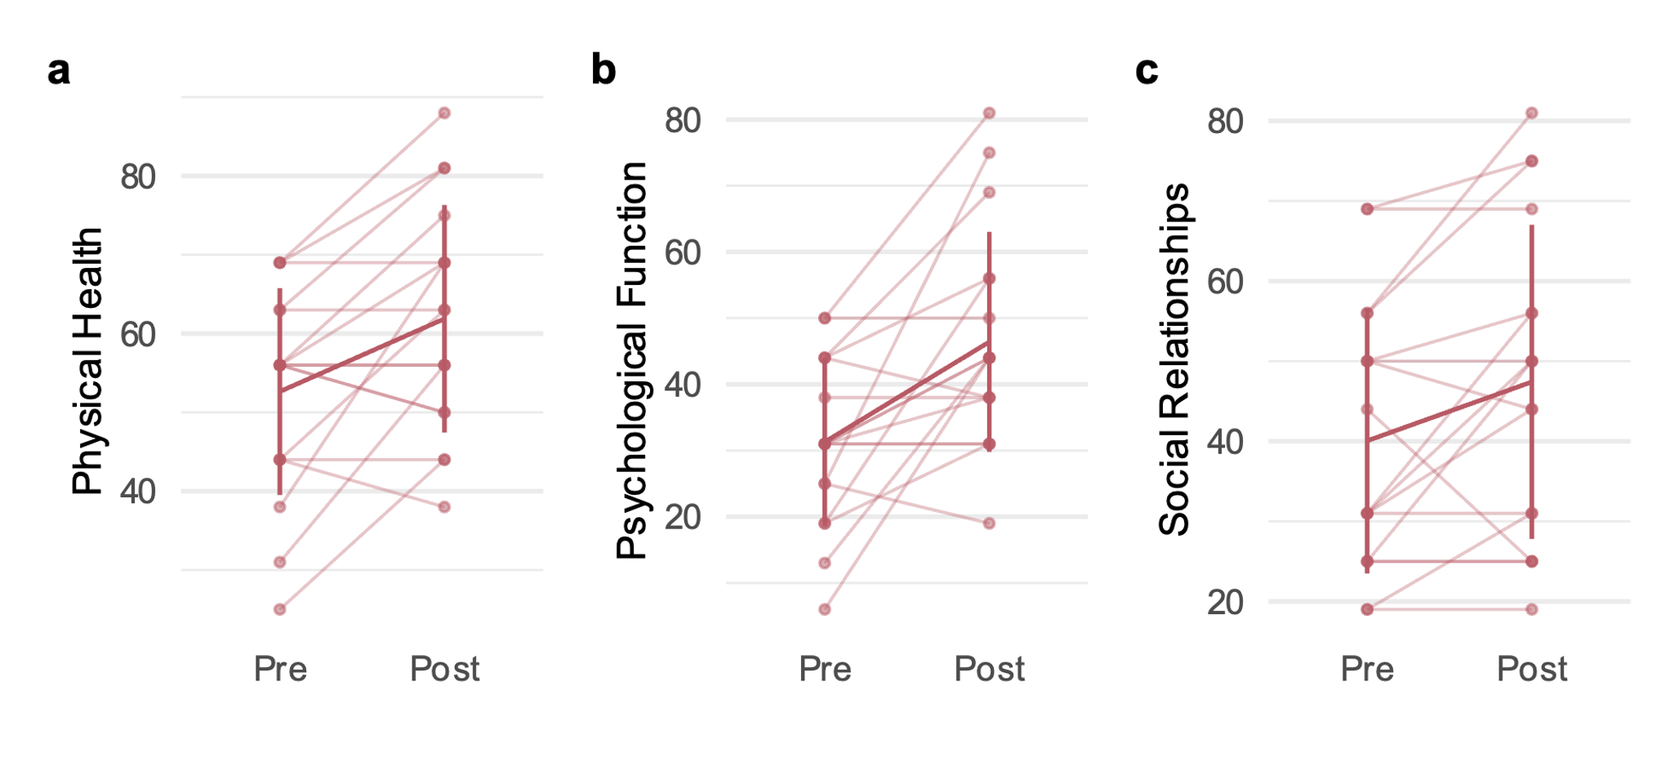
Quality of life was measured using the self-reported World Health Organization Quality of Life – Brief Scale. Score on domains of a, Physical Health (t(16)=3.159, P=0.006, d=0.881, 95% CI=[0.324; 1.438]); b, Psychological Function (t(16)=3.628, P=0.002, d=0.766, 95% CI=[0.319; 1.214]); and c, Social Relationships (t(16)=2.445, P=0.026, d=0.880, 95% CI=[0.288; 1.472]) improved from pre-treatment to post-treatment. Scores are shown for individual participants, indicated by individual data points and connected by faint lines with a bolded line for sample mean. Error bars represent standard deviation. All statistical tests were two-sided and not adjusted for multiple comparisons. Abbreviation: GIR = guanfacine immediate release.

Supplementary Figure 2: CONSORT flow diagram for the Biomarker Guided (BIG) Study for Depression.

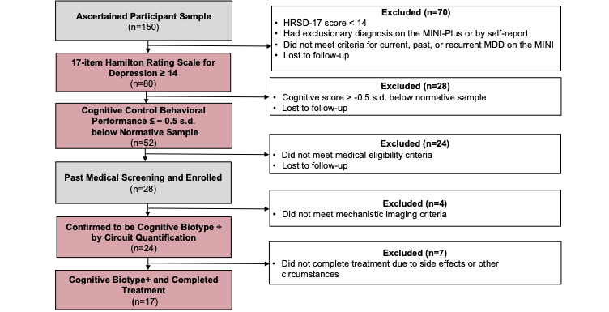
Boxes colored in pink show the selection criteria specific to the cognitive biotype + subgroup of depression. Of the 150 participants who met initial eligibility criteria and signed informed consent for the BIG Study for Depression, 80 participants had a Hamilton Rating Scale for Depression (HRSD-17) score ≥ 14, which was the first criterion for defining the cognitive biotype. The second criterion was behavioral cognitive control dysfunction, which was displayed by 52 participants and defined as performance ≤ -0.5 standard deviations (s.d.) below the normative mean on at least one of the following tasks: an executive Maze task assessing goal selection, a Digit Span task assessing working memory, and/or a Verbal Interference (Stroop) task assessing inhibition of irrelevant information. To prevent treatment delays, 28 participants who passed medical screening were enrolled in the study prior to quantification of their cognitive control circuit metrics. Of these, 24 participants met the criteria for the cognitive biotype + subgroup as defined by the circuit quantification. The final analysis group consisted of 17 patients who met both circuit and behavioral criteria for the cognitive biotype and completed treatment. Refer to Supplementary Figure 3 for all medical eligibility criteria. Abbreviations: dACC = dorsal anterior cingulate cortex; dLPFC = dorsolateral prefrontal cortex; s.d. = standard deviation.

Supplementary Figure 3: Eligibility criteria for the BIomarker Guided (BIG) Study for Depression.
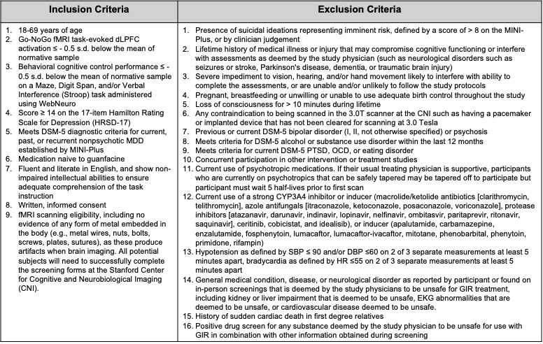
Abbreviations: fMRI = functional magnetic resonance imaging; dLPFC = dorsolateral prefrontal cortex; SD = standard deviation; HRSD-17 = 17-item Hamilton Rating Scale for Depression; CNI = Center for Cognitive and Neurobiological Imaging; MINI-plus = Mini-International Neuropsychiatric Interview; DSM-5-TR = The Diagnostic and Statistical Manual of Mental Disorders, Fifth Edition, Text Revision; PTSD = post-traumatic stress disorder; OCD = obsessive-compulsive disorder; CYP3A4 = Cytochrome P450 3A4; SBP = systolic blood pressure; DBP = diastolic blood pressure; HR = heart rate; GIR = guanfacine immediate release; EKG = electrocardiogram.

Supplementary Figure 4: Study flow for the BIomarker Guided (BIG) Study for Depression.
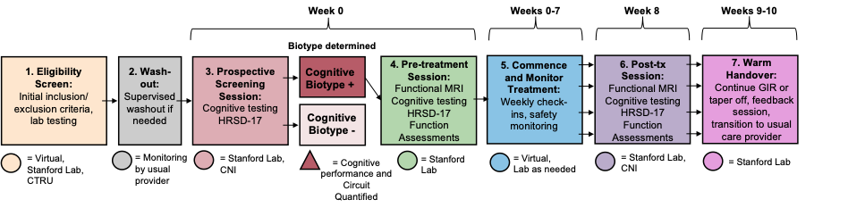
Participants who passed the eligibility screen underwent a psychotropic washout of 5 half-lives (if necessary) with their usual provider while remaining in communication with study personnel. At Week 0, participants underwent a cognitive testing and assessment of depression severity as part of a prospective screening session to ascertain criteria for the presence or absence of the cognitive biotype of depression. Those who met criteria for the cognitive biotype + subgroup had a pre-treatment session in which biotype assignment was confirmed with functional MRI and baseline measures of circuit, behavioral cognitive control performance, depression severity, and function were determined. Participants then commenced treatment with GIR, which was monitored by study personnel for 8 weeks (Weeks 0-7). Following 8 weeks of treatment, a post-treatment session was held in which participants completed post-treatment assessments of circuit, behavioral cognitive control performance, depression severity, and function. During Weeks 9 and 10, GIR was continued or down-titrated, and clinical personnel completed feedback sessions with participants and organized a warm handover to usual care providers. Abbreviations: CNI = Center for Cognitive and Neurobiological Imaging; HRSD-17 = 17-item Hamilton Rating Scale for Depression; MRI = functional magnetic resonance imaging.

References

1. Zoppi, L. Half-Life and Withdrawal Symptoms of Antidepressants. (2021).
2. Posner K, et al. Columbia–suicide severity rating scale (C-SSRS). (Columbia University Medical Center, New York, NY, 2009).
3. Hamilton, M. A rating scale for depression. J Neurol Neurosurg Psychiatry 23, 56-62 (1960).

