Supplementary information
Fabrication of sustainable graphene composite for heterocyclization of anti-inflammatory and antibacterial derivatives
K. S. Patil • S. T. Mane*
Department of Chemistry, Bharati Vidyapeeth’s Dr. Patangrao Kadam Mahavidyalaya, Sangli, Maharashtra, India – 416416.
E-mail: kajalpatiljuly06@gmail.com; stm2011.mane@gmail.com*

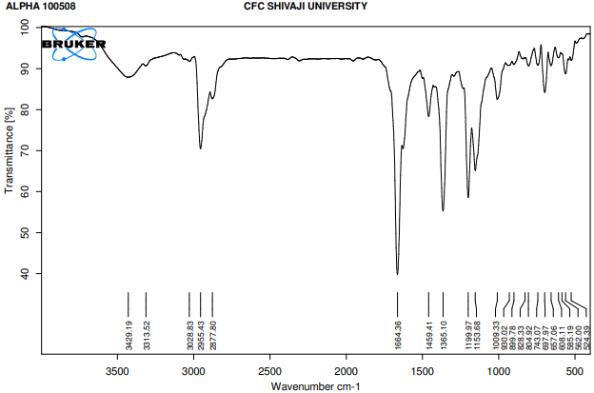
Fig. 1. FTIR of 9-aryl-1,8-dioxo-octahydroxanthene derivative (R: –H)

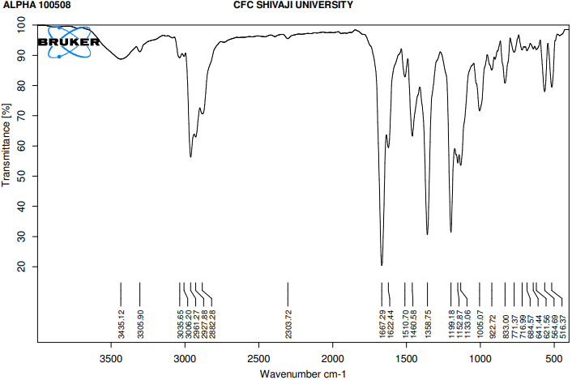
Fig. 2. FTIR of 9-aryl-1,8-dioxo-octahydroxanthene derivative (R: –CH₃)

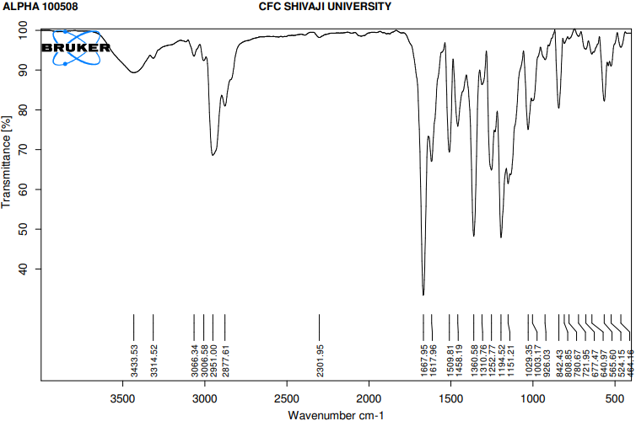
Fig. 3. FTIR of 9-aryl-1,8-dioxo-octahydroxanthene derivative (R: –OCH₃)

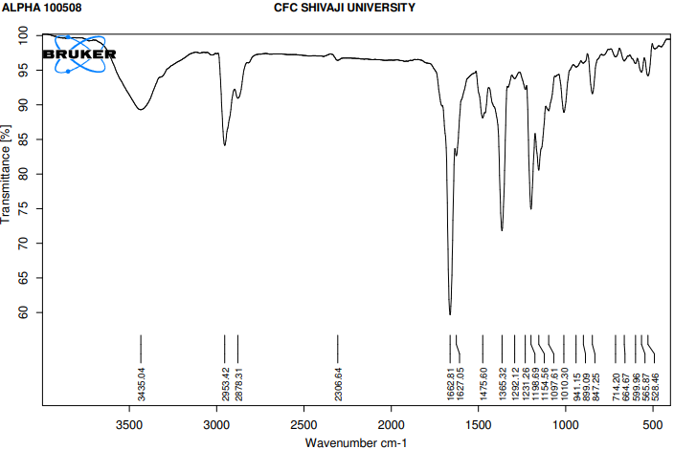
Fig. 4. FTIR of 9-aryl-1,8-dioxo-octahydroxanthene derivative (R: –Cl)

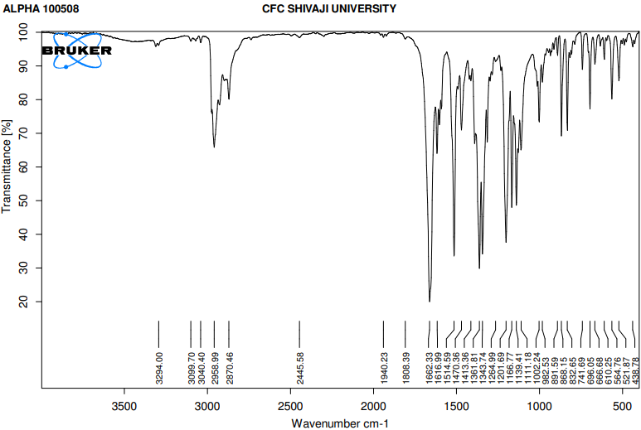
Fig. 5. FTIR of 9-aryl-1,8-dioxo-octahydroxanthene derivative (R: –NO₂)

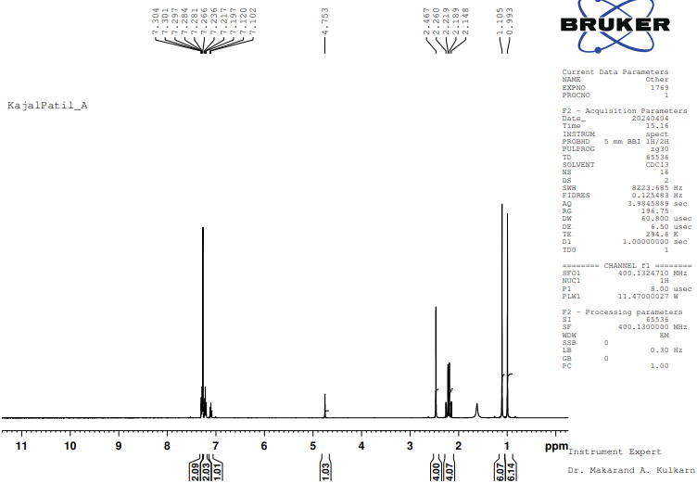
Fig. 6. NMR of 9-aryl-1,8-dioxo-octahydroxanthene derivative (R: –H)

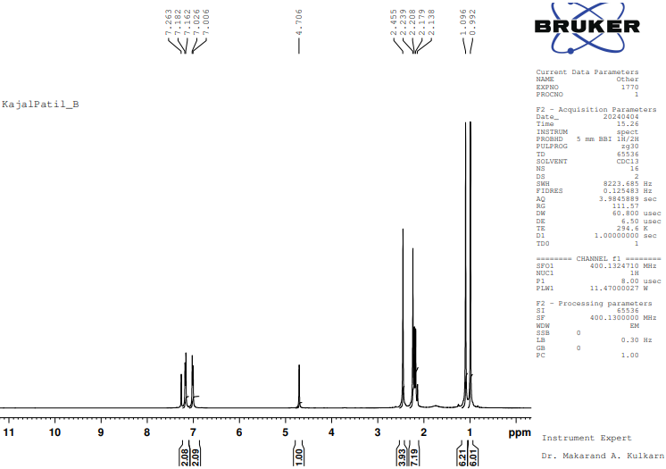
Fig. 7. ¹H NMR of 9-aryl-1,8-dioxo-octahydroxanthene derivative (R: –CH₃)

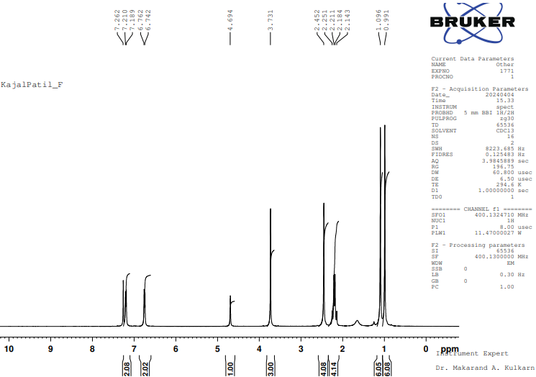
Fig. 8. ¹H NMR of 9-aryl-1,8-dioxo-octahydroxanthene derivative (R: –OCH₃)

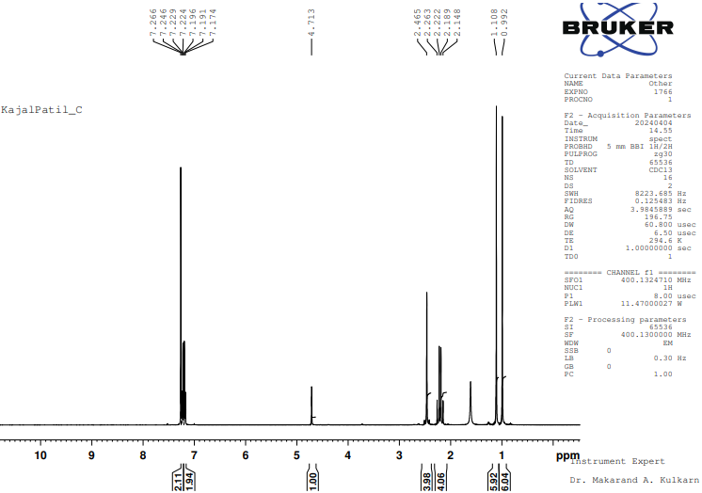
Fig. 9. ¹H NMR of 9-aryl-1,8-dioxo-octahydroxanthene derivative (R: –Cl)

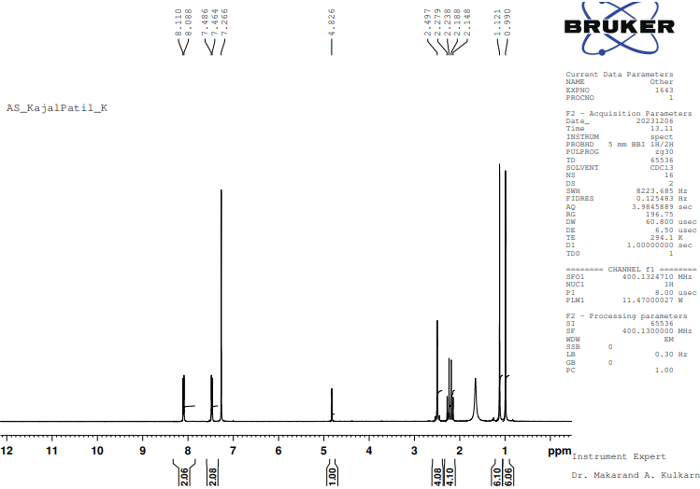
Fig. 10. ¹H NMR of 9-aryl-1,8-dioxo-octahydroxanthene derivative (R: –NO₂)

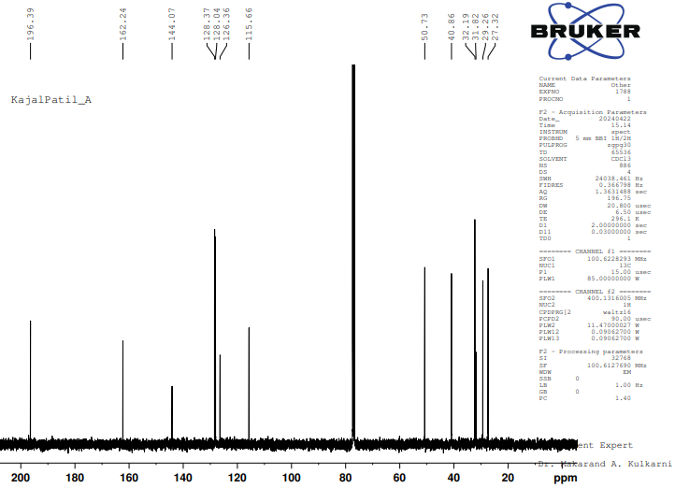
Fig. 11. ¹³C NMR of 9-aryl-1,8-dioxo-octahydroxanthene derivative (R: –H)

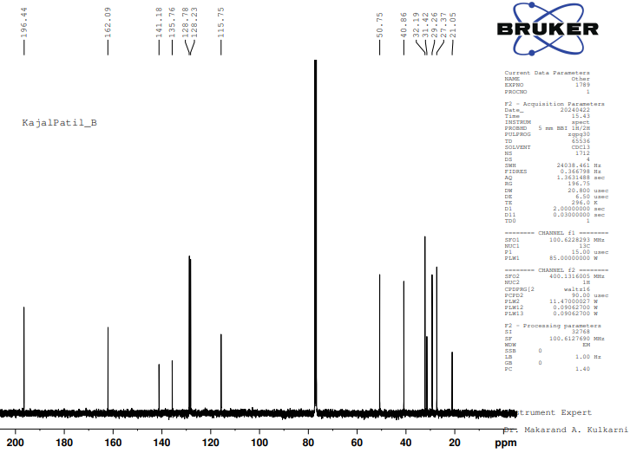
Fig. 12. ¹³C NMR of 9-aryl-1,8-dioxo-octahydroxanthene derivative (R: –CH₃)

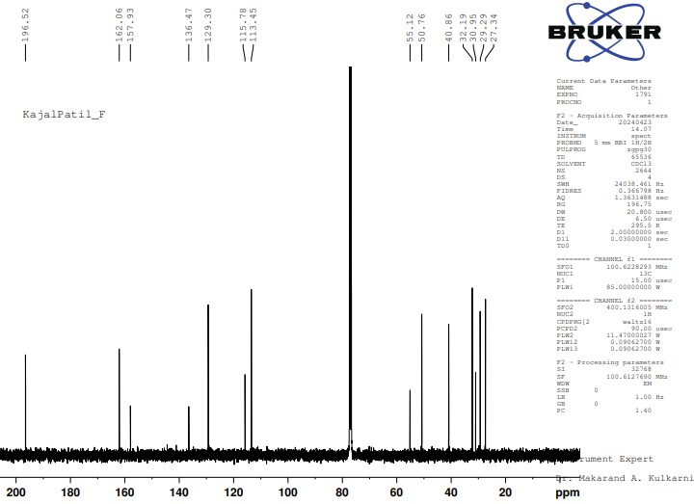
Fig. 13. ¹³C NMR of 9-aryl-1,8-dioxo-octahydroxanthene derivative (R: –OCH₃)

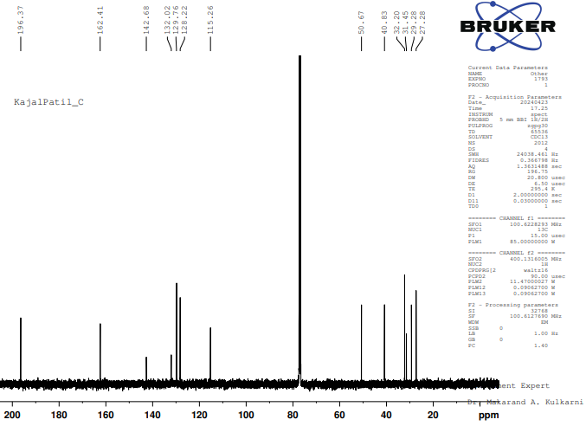
Fig. 14. ¹³C NMR of 9-aryl-1,8-dioxo-octahydroxanthene derivative (R: –Cl)

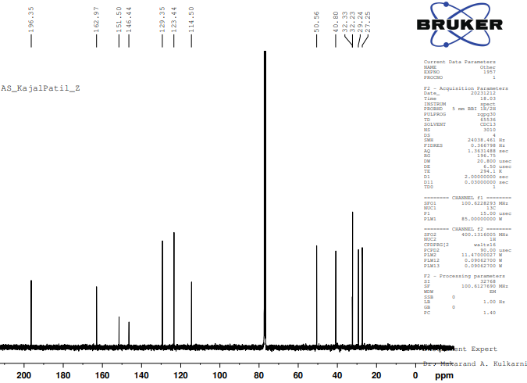
Fig. 15. ¹³C NMR of 9-aryl-1,8-dioxo-octahydroxanthene derivative (R: –NO₂)

