Supplementary Information

Anchoring Copper Single Atoms on Porous Boron Nitride Nanofiber to Boost Selective Reduction of Nitroaromatics
Jianli Liang¹, Qianqian Song³, Jianghua Wu⁴, Qi Lei⁵, Zhongming Huang¹, Tianxing Kang¹, Hui Xu², Peng Wang⁴, Xingtai Zhou⁵, Po Keung Wong⁶, Zhifeng Jiang^{1,2,*} & Chun-Sing Lee^{1,*}

¹ Department of Chemistry & Center of Super-Diamond and Advanced Films (COSDAF), City University of Hong Kong, Hong Kong SAR 999077, P. R. China
² Institute for Energy Research, Jiangsu University, Zhenjiang 212013, P. R. China
³ Department of Materials Science and Engineering, Sun Yat-Sen University, Guangzhou, Guangdong 510275, P. R. China
⁴ National Laboratory of Solid State Microstructures, Jiangsu Key Laboratory of Artificial Functional Materials, College of Engineering and Applied Sciences and Collaborative Innovation Center of Advanced Microstructures, Nanjing University, Nanjing 210093, P. R. China
⁵ Shanghai Synchrotron Radiation Facility, Shanghai Institute of Applied Physics, Chinese Academy of Sciences, Shanghai 201800, P. R. China
⁶ School of Life Sciences, The Chinese University of Hong Kong, Shatin, New Territories, Hong Kong SAR 999077, P. R. China

*Correspondence and requests for materials should be addressed to Z. F. Jiang (Email: ntjiangzf@sina.com) or to C. S. Lee (E-mail: apcslee@cityu.edu.hk)

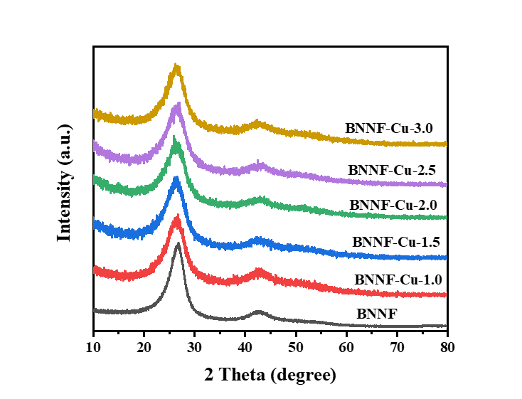
Fig. 1 XRD patterns of the as-prepared catalysts with different Cu amount.

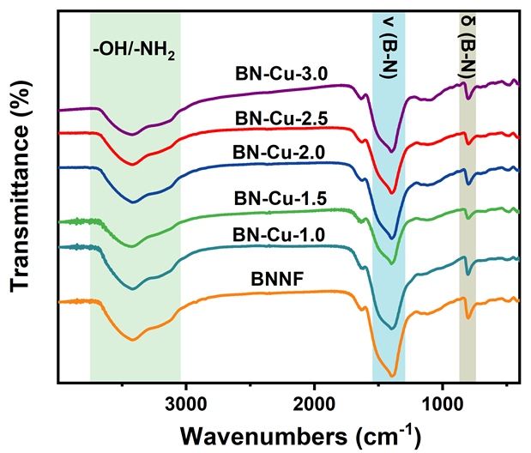
Fig. 2 FTIR spectra of the as-prepared catalysts with different Cu amount.

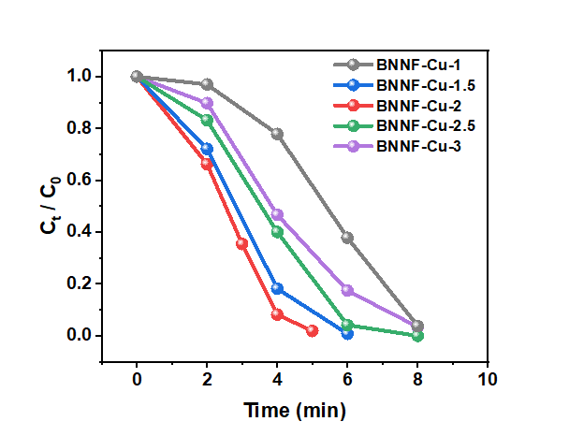
Fig. 3 Time-dependent PNP conversion of the as-prepared catalysts with different Cu amount under full spectrum.
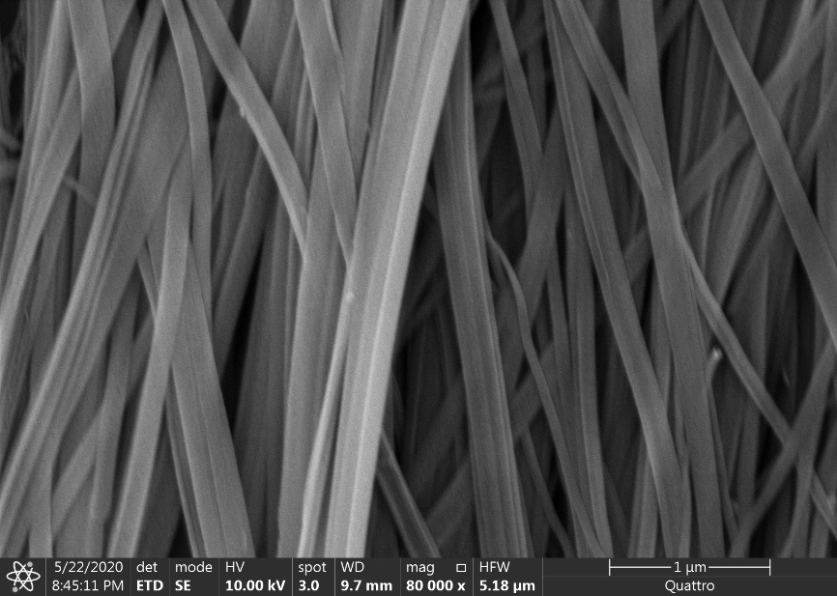
Fig. 4 SEM image of BNNF-Cu.

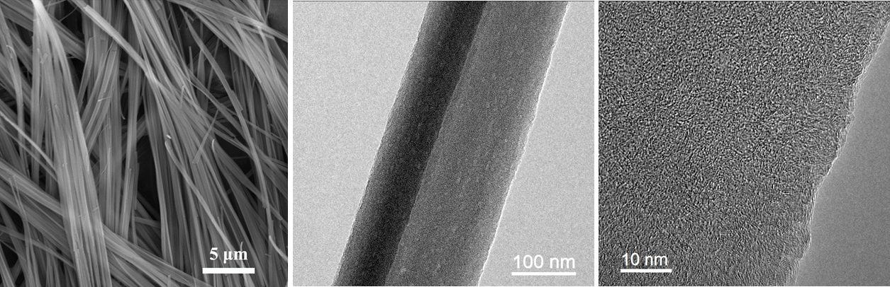
Fig. 5 SEM, typical TEM and HRTEM images of BNNF.

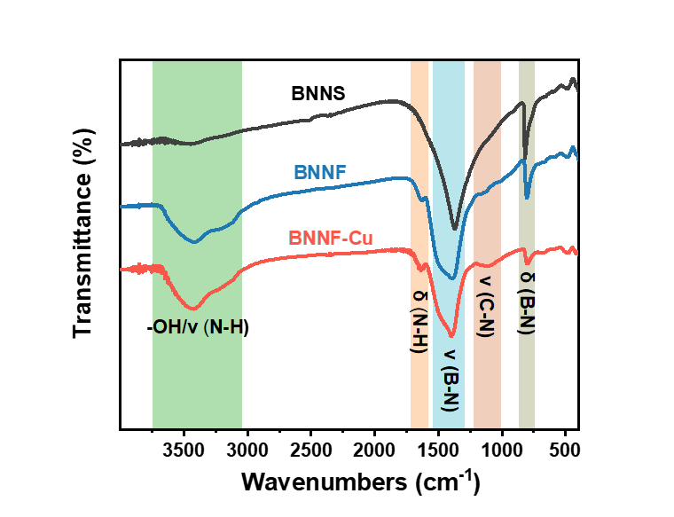
Fig. 6 FTIR spectra of BNNS, BNNF and BNNF-Cu.

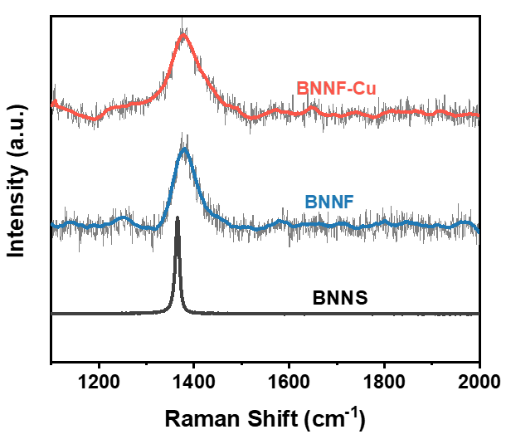
Fig. 7 Raman spectra of BNNS, BNNF and BNNF-Cu.
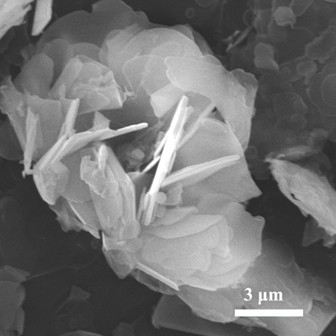
Fig. 8 SEM image of BNNS.

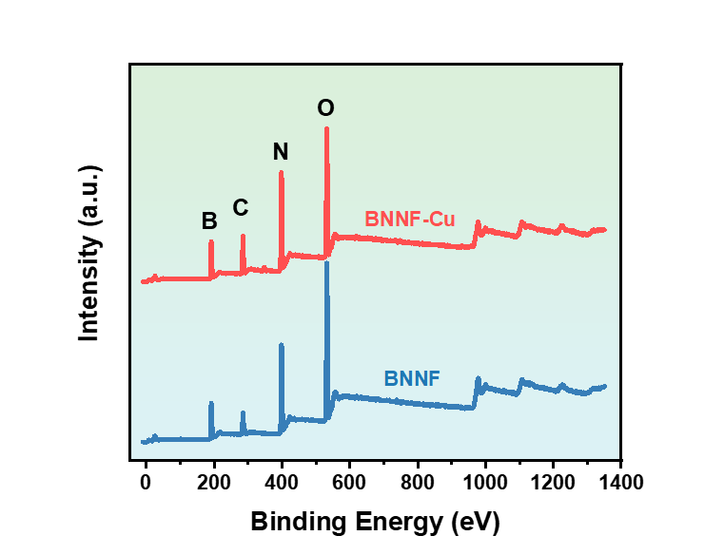
Fig. 9 XPS survey spectra of BNNF and BNNF-Cu.

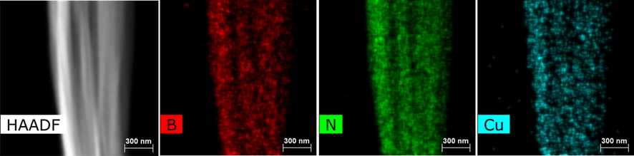
Fig. 10 The element HAADF mapping of B, N, Cu in BNNF-Cu.

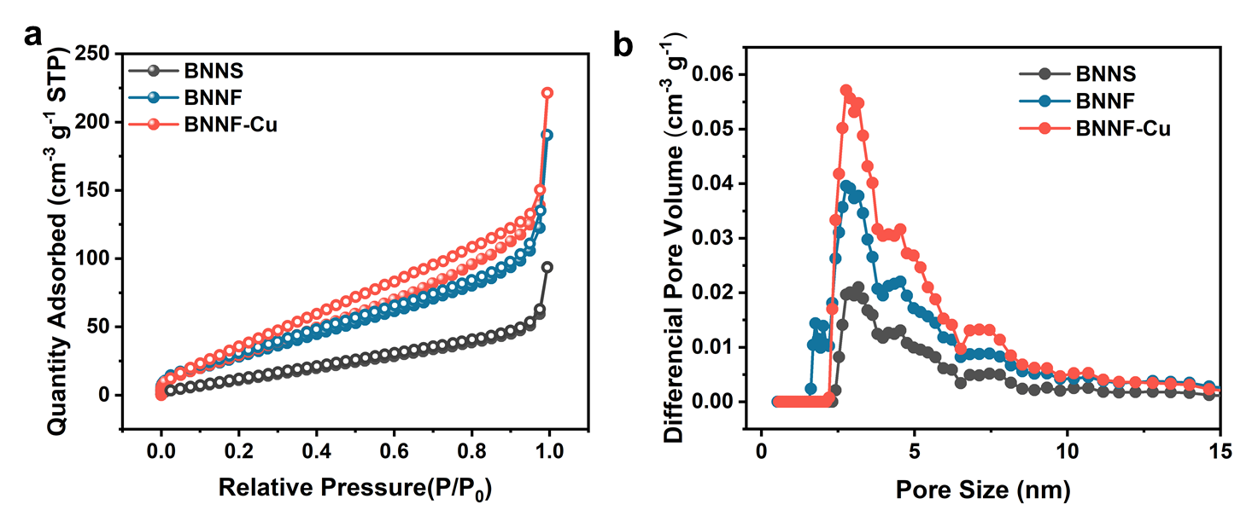
Fig. 11 N₂ adsorption−desorption isotherms at 77 K and pore size distributions of BNNS, BNNF and BNNF-Cu

Table 1 The specific surface area of BNNS, BNNF and BNNF-Cu.

Materials | BNNS | BNNF | BNNF-Cu
Specific surface area (m² g⁻¹) | 67 | 132 | 153

Table 2 Values Range of fitting space.
 | k space | R space
Cu foil | 3.0≤k≤12.5 | 1.0≤R≤3.0
Sample Cu | 3.0≤k≤11.2 | 1.0≤R≤3.0
CuO | 3.0≤k≤12.0 | 1.0≤R≤3.0
Cu₂O | 3.0≤k≤12.0 | 1.0≤R≤3.0

Table 3 Fitting results.
 | Path | CN | ΔE (eV) | R (Å) *10² | σ² (Å²) *10³ | R-factor
Cu foil | Cu-Cu | 12 | 3.42(0.56) | 253.8(0.4) | 8.54(0.46) | 0.003
Sample-Cu | Cu-B | 2.56(0.74) | 4.54(1.28) | 264.1(2.2) | 3.33(1.29) | 0.004
Sample-Cu | Cu-N | 6.26(0.97) | 5.08(1.59) | 199.5(1.5) | 3.25(1.35) | 0.004
CuO | Cu-O | 4 | 2.44(0.36) | 194.4(1.2) | 5.23(1.24) | 0.009
Cu₂O | Cu-O | 2 | 4.44(1.29) | 183.5(0.9) | 5.23(1.27) | 0.006
Cu₂O | Cu-Cu | 12 | 8.94(0.86) | 305.0(1.2) | 6.94(1.63) | 0.006
Note: S₀²= 0.84, coordination number (CN), bond distance (R), Debye-Waller factor (σ²), inner potential shift (ΔE0).
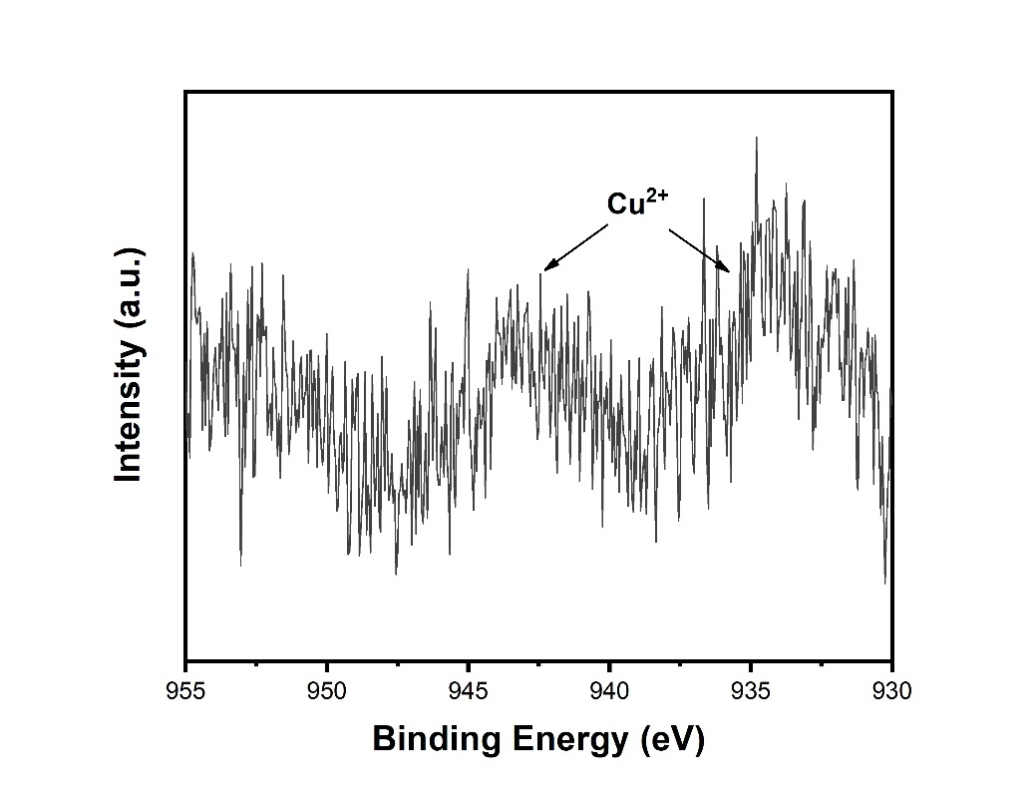
Fig. 12 The high-resolution spectra of Cu for BNNF-Cu.
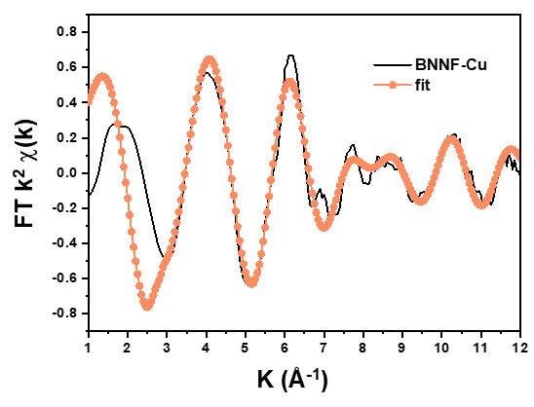
Fig. 13 EXAFS fitting curve in K space.

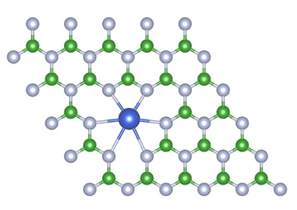
Fig. 14 Structure model of BNNF-Cu.

Fig. 15 The UV-Vis absorption spectra of initial PNP and after addition of NaBH₄.
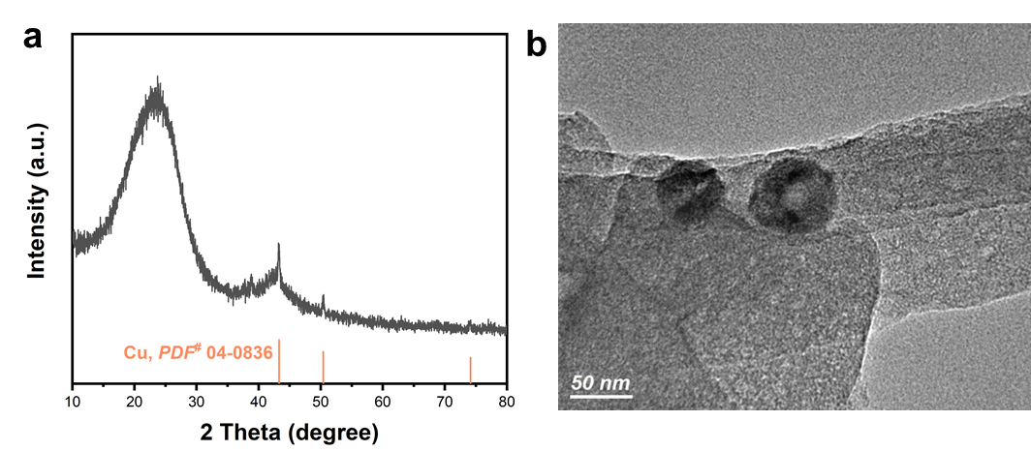
Fig. 16 XRD pattern and TEM image of BNNF-Cu NP. Cu NP were prepared referring to the method reported by Liu Q. et al.¹ and the BNNF-Cu NP were obtained by physical mixing BNNF with Cu nanoparticles in water.

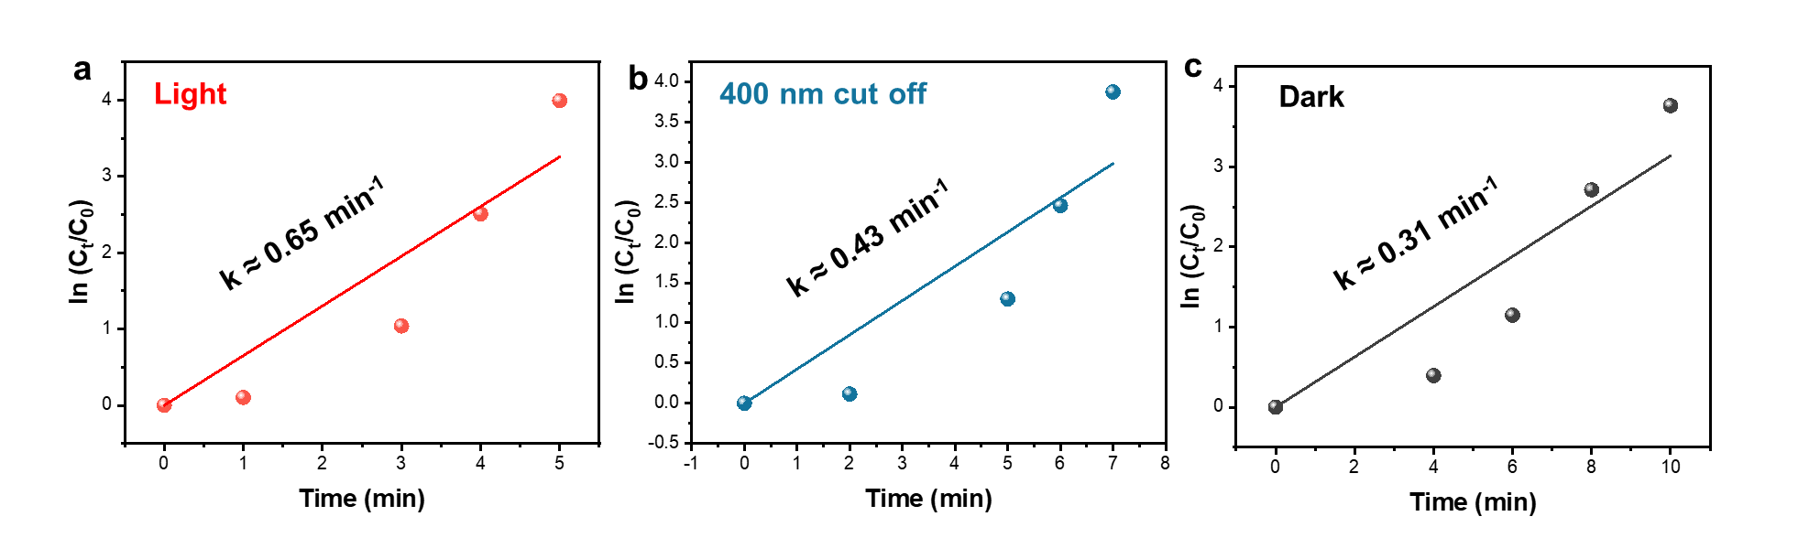
Fig. 17 Kinetic curves of PNP reduction of BNNF-Cu a under full spectrum light, b light with a 400 nm filter and c in darkness.
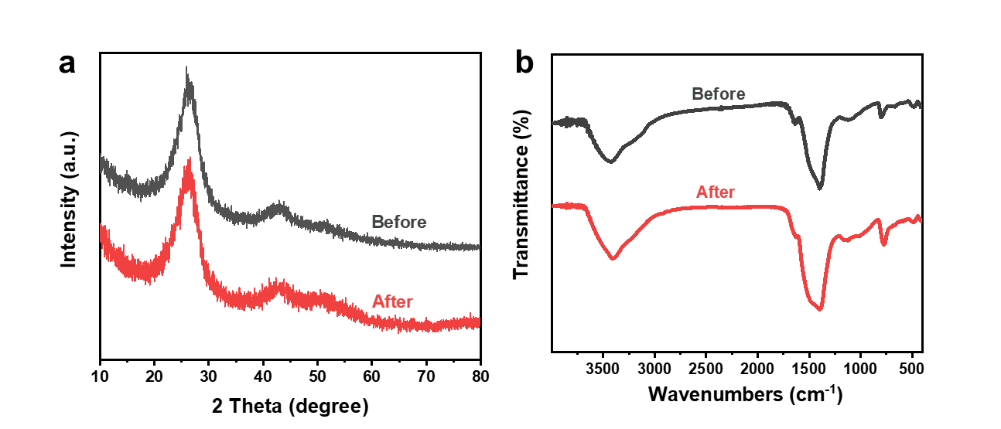
Fig. 18 a XRD patterns of BNNF-Cu before and after reaction. b FTIR spectra of BNNF-Cu before and after reaction.

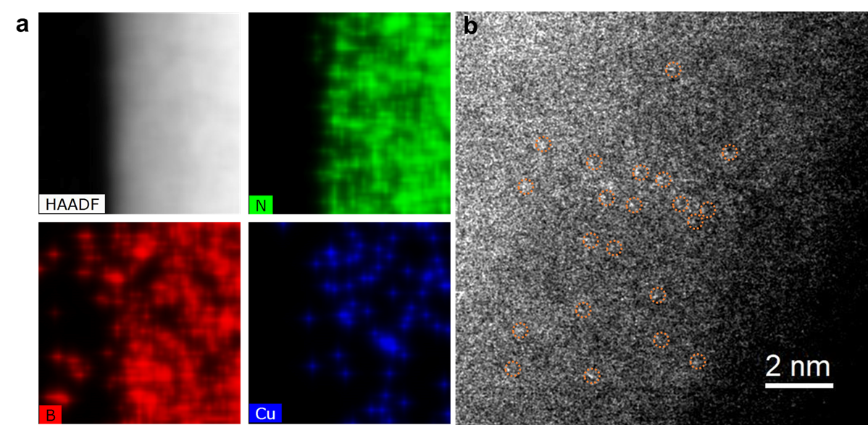
Fig. 19 a The element HAADF mapping of B, N, Cu and b HAADF-STEM image of BNNF-Cu after reaction.

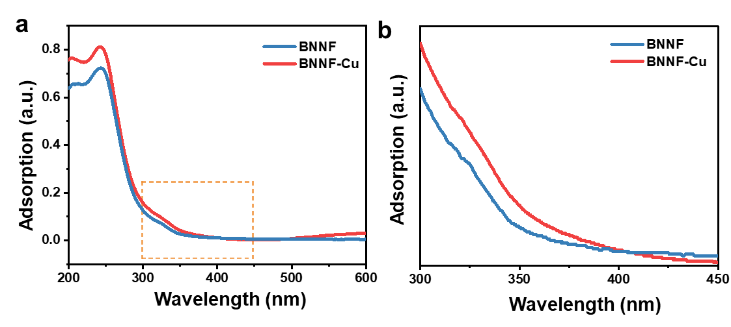
Fig. 20 Typical UV-vis spectra of BNNF and BNNF-Cu.

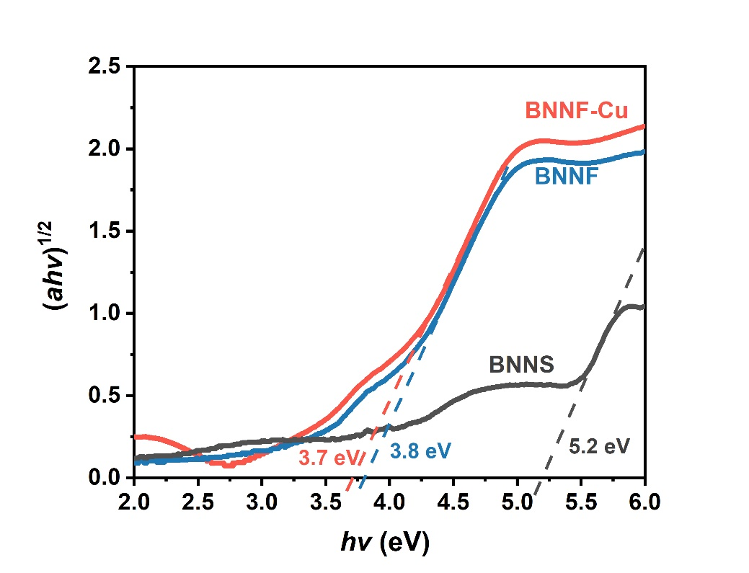
Fig. 21 Bandgap energies of BNNS, BNNF and BNNF-Cu.

Fig. 22 XPS valence band (VB) spectra of BNNF and BNNF-Cu.

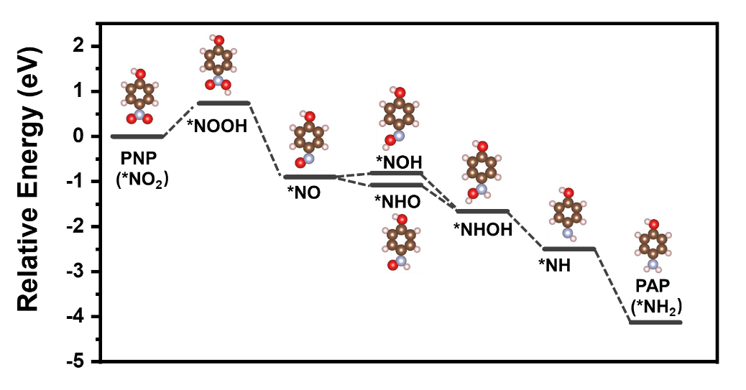
Fig. 23 The free-energy diagram of PNP reduction of BNNF
Table 4 Comparison of the catalytic activities of some reported catalysts for PNP reduction

Compared with nonprecious-metal-based catalysts
Catalysts | Reductant | Reductant/PNP  (molar ratio) | Reaction  Time (min) | Conversion (%) | K_{app}  (min⁻¹ or s⁻¹) | Metal content (wt%) | TOF  (mmol g⁻¹ min⁻¹) | Irridiation | Ref.
BNNF-Cu | NaBH₄ | 50 | 5 | ~100 | 0.65 min⁻¹ | 1 | 11.59 | Y | This work
Cu₂O@ZIF-8 | NaBH₄ | 320 | 14 | ~99 | 0.28 min⁻¹ | 20.7 | 0.70 | N | ²
Nanoscale zero-valent iron | NaBH₄ | 433 | 20 | ~100 | 7.1×10⁻⁴ min⁻¹ | 100 | 1.43 | N | ³
Cu/C | NaBH₄ | 320 | 2.5 | ~100 | 26.7 × 10⁻³ s⁻¹ | 49.1 | 1.28 | N | ⁴
Cu/α-Fe₂O₃ | NaBH₄ | 1000 | 0.83 | ~100 | 90 × 10⁻³ s⁻¹ | 20 | 0.9 | N | ⁵
Cu₂O@h-BN | NaBH₄ | 70 | 12 | ~100 | － | 67.5 | 0.13 | N | ⁶
Faceted Cu NCs | NaBH₄ | 165 | 3 | ~100 | 8.2 × 10⁻³ s⁻¹ | 100 | 0.59 | N | ⁷
Ni/C | NaBH₄ | 835 | 3 | ~100 | 1.239 | 45.8 | 1.97 | N | ⁸
DE/Ni/N-C-800 | NaBH₄ | 400 | 1.5 | ~100 | 35 × 10⁻³ s⁻¹ | 21.82 | 0.34 | N | ⁹
Co_{0.5}Ni_{0.5}/C-600 | NaBH₄ | 835 | 4 | ~100 | 1.349 min⁻¹ | 39.29 | 3.82 | N | ¹⁰
Ni/Ni₃S₂@C | NaBH₄ | 791 | 6 | 99.9 | 8.34 × 10⁻³ s⁻¹ | 39.37 | 3 | N | ¹¹
MCNF@NiCo₂O₄ | NaBH₄ | 100 | 45 | ~100 | 0.604 × 10⁻³ s⁻¹ | 55 | 0.05 | N | ¹²
CdS/NS- rGO | NH₄HCO₂ | 110 | 6 | ~100 | － | 3.89 | 1.54 | Y | ¹³
MoS₂/SnO₂ | NaBH₄ | 140 | 13 | ~100 | 4.2 × 10⁻³ s⁻¹ | 67 | 0.02 | N | ¹⁴
Compared with precious-metal-based catalysts
Catalysts | Reductant | Reductant/PNP  (molar ratio) | Reaction  Time (min) | Conversion (%) | K_{app}  (min⁻¹ or s⁻¹) | Metal content (wt%) | TOF  (mmol g⁻¹ min⁻¹) | Cost per TOF (US$) | Ref.
BNNF-Cu | NaBH₄ | 50 | 5 | ~100 | 0.65 min⁻¹ | 1 | 11.59 | 0.8*10⁻³ | This work
AuNPs | NaBH₄ | 60 | 2 | ~ 100 | 1.51 min⁻¹ | 100 | 2.91 | 21.7 | ¹⁵
Au/graphene | NaBH₄ | 714 | 12 | ~ 100 | 3.17 × 10⁻³ s⁻¹ | 2.4 | 1.76 | 35.8 | ¹⁶
AuNP-SPEG_{30K} | NaBH₄ | 150 | 0.4 ± 0.1 | ~ 100 | 2.1 ± 0.5 min⁻¹ | 65 | 0.74 | 85.1 | ¹⁷
Au@TpPa-1 | NaBH₄ | 1589 | 18 | ~ 100 | 5.35 × 10⁻³ s⁻¹ | 1.2 | 0.63 | 100.8 | ¹⁸
Au/g-C₃N₄ | NaBH₄ | 55 | 8 | ~100 | 7.99×10⁻³ s⁻¹ | 5.56 | 8.08 | 7.8 | ¹⁹
Naked-Au–γ-Fe₂O₃ | NaBH₄ | 40 | 2 | ~100 | 2.43 min⁻¹ | 15 | 13.33 | 4.7 | ²⁰
Pd@Ru nanosheets | NaBH₄ | 67 | 14 | － | 0.22 min⁻¹ | 100 | 3.4 | 4.58 | ²¹
Pd/GDYO | NaBH₄ | 1283 | 12 | ~100 | 0.32 min⁻¹ | 17.5 | 25.52 | 4 | ²²
NCT@Pd | NaBH₄ | 1:100 | 0.67 | ~ 100 | － | 0.324 | 27.8 | 3.67 | ²³
Ni-Pd/NrGO | NaBH₄ | 100 | 2.67 | ~ 100 | 17 × 10⁻³ s⁻¹ | 40.6 | 1.17 | 87.1 | ²⁴
AgPd NC/rGO | NaBH₄ | 1428 | 3 | 95.8 | 36.5 × 10⁻³ s⁻¹ | 76.9 | 2.9 | 33.3 | ²⁵
Commerical Pd/C | NaBH₄ | 1428 | 9 | ~100 | 7.67 × 10⁻³ s⁻¹ | 20 | 3.89 | 26.2 | ²⁵
AgNPs/SiNSs | NaBH₄ | 167 | 0.67 | ~100 | 80.19 × 10⁻³ s⁻¹ | 3.26 | 27.5 | 0.03 | ²⁶
AC-Ag | NaBH₄ | 1200 | 6 | ~100 | 0.4 min⁻¹ | 2.7 | 9.26 | 0.1 | ²⁷
Ag/Fe oxide | NaBH₄ | 100 | 28 | ~100 | 0.351 min⁻¹ | 8.35 | 8.34 | 0.11 | ²⁸
Fe₃O₄@PPy-MAA/Ag | NaBH₄ | 400 | 25 | ~100 | 0.143 min⁻¹ | 28.3. | 0.47 | 2 | ²⁹
GO-DAP- AgNPs | NaBH₄ | 1000 | 12 | ~100 | 0.7548 × 10⁻³ s⁻¹ | 20 | 0.08 | 11 | ³⁰
Ag/C | NaBH₄ | 80 | 5 | ~ 100 | 20.2 × 10⁻³ s⁻¹ | 14.8 | 4.5 | 0.2 | ³¹
Pt@Ag | NaBH₄ | 111 | 8 | ~100 | 0.355 min⁻¹ | 100 | 0.67 | 1.37 | ³²
MSNCs-MH₂-Ag | NaBH₄ | 1:833 | 4.83 | ~ 100 | 17×10⁻³ s⁻¹ | 15.43 | 20.13 | 0.46 | ³³
PtNPs@COF | NaBH₄ | 1670 | 8 | ~100 | － | 34.36 | 4.37 | 10.1 | ³⁴
PtO₂/ZnO | NaBH₄ | 100 | 6.25 | ~ 100 | 0.521 min⁻¹ | 2.8 | 0.48 | 91.7 | ³⁵
Pt/CeO₂ | NaBH₄ | 324 | 10 | ~100 | － | 38 | 0.04 | 1100 | ³⁶
PtRh | NaBH₄ | 1250 | 20 | 94.02 | 0.209 min⁻¹ | 100 | 1.0 | 44 | ³⁷
Ru/porous carbon | NaBH₄ | 781 | 5 | ~100 | 1.29 min⁻¹ | 3.49 | 10.18 | 1.5 | ³⁸
*Metal prices (US $ per gram): Cu ($ 9.5*10⁻³), Ag ($ 9.2*10⁻¹), Au ($ 6.3*10¹), Pt ($ 4.4*10¹), Pd ($ 1.02*10²), Ru ($1.56*10¹).
*Relative price: Ag/Cu= 97, Au/Cu= 6608, Pt/Cu= 4630, Pd/Cu=10703 & Ru/Cu=1642.

Reference
1. Liu, Q. M., Zhou, D. B., Yamamoto, Y., Ichino, R. & Okido, M. Preparation of Cu nanoparticles with NaBH₄ by aqueous reduction method. Trans. Nonferrous Met. Soc. China 22, 117–123 (2012).
2. Li, B., Ma, J. G. & Cheng, P. Silica-protection-assisted encapsulation of Cu₂O nanocubes into a metal–organic framework (ZIF-8) to provide a composite catalyst. Angew. Chemie - Int. Ed. 57, 6834–6837 (2018).
3. Bae, S., Gim, S., Kim, H. & Hanna, K. Effect of NaBH₄ on properties of nanoscale zero-valent iron and its catalytic activity for reduction of p-nitrophenol. Appl. Catal. B Environ. 182, 541–549 (2016).
4. Bai, Y. et al. Three-dimensional Cu/C porous composite : Facile fabrication and efficient catalytic reduction of 4-nitrophenol. J. Colloid Interface Sci. 553, 768–777 (2019).
5. Elfiad, A., Galli, F., Boukhobza, L. M., Djadoun, A. & Boffito, D. C. Low-cost synthesis of Cu/α-Fe₂O₃ from natural HFeO₂: Application in 4-nitrophenol reduction. J. Environ. Chem. Eng. 8, (2020).
6. Huang, C., Ye, W., Liu, Q. & Qiu, X. Dispersed Cu₂O octahedrons on h-BN nanosheets for p -nitrophenol reduction. ACS Appl. Mater. Interfaces 6, 14469–14476 (2014).
7. Zhang, P. et al. Facile fabrication of faceted copper nanocrystals with high catalytic activity for p-nitrophenol reduction. J. Mater. Chem. A 1, 1632–1638 (2013).
8. Wu, G. et al. Highly stable and sub-3 nm Ni nanoparticles coated with carbon nanosheets as a highly active heterogeneous hydrogenation catalyst. Catal. Commun. 79, 63–67 (2016).
9. Jiang, D. Bin et al. Biotemplated top-down assembly of hybrid Ni nanoparticles/N doping carbon on diatomite for enhanced catalytic reduction of 4-nitrophenol. Chem. Eng. J. 383, 123156 (2020).
10. Zhao, Y., Cao, B., Wang, X., Wang, X. & Al-mamun, M. Facile synthesis of ultra-thin Co_{x}Ni_{(1-x )}/C nano-sheets and their remarkable catalytic properties in 4-nitrophenol reduction. J. Environ. Chem. Eng. 6, 5239–5248 (2018).
11. Wang, X. et al. Facile fabrication of nickel/heazlewoodite@Carbon nanosheets and their superior catalytic performance of 4-nitrophenol reduction. ChemCatChem 10, 4143–4153 (2018).
12. Yang, Y. et al. Construction of core-shell mesoporous carbon nanofiber @ nickel cobaltite nanostructures as highly efficient catalysts towards 4-nitrophenol reduction. J. Colloid Interface Sci. 538, 377–386 (2019).
13. Han, W. et al. Synthesis of nitrogen and sulfur co-doped reduced graphene oxide as efficient metal-free cocatalyst for the photo-activity enhancement of CdS. Appl. Catal. B Environ. 236, 212–221 (2018).
14. Qiao, X. Q. et al. Tunable MoS₂/SnO₂ P-N heterojunctions for an efficient trimethylamine gas sensor and 4-Nitrophenol reduction catalyst. ACS Sustain. Chem. Eng. 6, 12375–12384 (2018).
15. Shen, W. et al. Catalytic reduction of 4-nitrophenol using gold nanoparticles biosynthesized by cell-free extracts of Aspergillus sp . WL-Au. J. Hazard. Mater. 321, 299–306 (2017).
16. Li, J., Liu, C. Y. & Liu, Y. Au/graphene hydrogel: Synthesis, characterization and its use for catalytic reduction of 4-nitrophenol. J. Mater. Chem. 22, 8426–8430 (2012).
17. Ansar, S. M. & Kitchens, C. L. Impact of gold nanoparticle stabilizing ligands on the colloidal catalytic reduction of 4-nitrophenol. ACS Catal. 6, 5553–5560 (2016).
18. Pachfule, P., Kandambeth, S., Díaz Díaz, D. & Banerjee, R. Highly stable covalent organic framework-Au nanoparticles hybrids for enhanced activity for nitrophenol reduction. Chem. Commun. 50, 3169–3172 (2014).
19. Fu, Y., Huang, T., Jia, B., Zhu, J. & Wang, X. Reduction of nitrophenols to aminophenols under concerted catalysis by Au/g-C₃N₄ contact system. Appl. Catal. B Environ. 202, 430–437 (2017).
20. Shang, L. et al. “Naked” magnetically recyclable mesoporous Au–γ-Fe₂O₃ nanocrystal clusters: A highly integrated catalyst system. Adv. Funct. Mater. 27, 1–7 (2017).
21. Zhang, Z. et al. Submonolayered Ru deposited on ultrathin Pd nanosheets used for enhanced catalytic applications. Adv. Mater. 28, 10282–10286 (2016).
22. Qi, H. et al. Graphdiyne oxides as excellent substrate for electroless deposition of Pd clusters with high catalytic activity. J. Am. Chem. Soc. 137, 5260–5263 (2015).
23. Duan, X. et al. Ultrafine palladium nanoparticles supported on nitrogen-doped carbon microtubes as a high-performance organocatalyst. Carbon 119, 326–331 (2017).
24. Liu, L., Chen, R., Liu, W., Wu, J. & Gao, D. Catalytic reduction of 4-nitrophenol over Ni-Pd nanodimers supported on nitrogen-doped reduced graphene oxide. J. Hazard. Mater. 320, 96–104 (2016).
25. Zhu, X. et al. Controlled fabrication of well-dispersed AgPd nanoclusters supported on reduced graphene oxide with highly enhanced catalytic properties towards 4-nitrophenol reduction. J. Colloid Interface Sci. 516, 355–363 (2018).
26. Yan, Z., Fu, L., Zuo, X. & Yang, H. Green assembly of stable and uniform silver nanoparticles on 2D silica nanosheets for catalytic reduction of 4-nitrophenol. Appl. Catal. B Environ. 226, 23–30 (2018).
27. Shui, L. et al. Photocatalytic one-step synthesis of Ag nanoparticles without reducing agent and their catalytic redox performance supported on carbon. J. Energy Chem. 36, 37–46 (2019).
28. Chiou, J. R., Lai, B. H., Hsu, K. C. & Chen, D. H. One-pot green synthesis of silver/iron oxide composite nanoparticles for 4-nitrophenol reduction. J. Hazard. Mater. 248–249, 394–400 (2013).
29. Das, R., Satyanarayana, V. & Kamdem, H. Silver decorated magnetic nanocomposite ( Fe₃O₄ @ PPy-MAA / Ag ) as highly active catalyst towards reduction of 4-nitrophenol and toxic organic dyes. Appl. Catal. B Environ. 244, 546–558 (2019).
30. Jebaranjitham, J. N., Mageshwari, C., Saravanan, R. & Mu, N. Fabrication of amine functionalized graphene oxide – AgNPs nanocomposite with improved dispersibility for reduction of 4-nitrophenol. Compos. Part B 171, 302–309 (2019).
31. Ji, T., Chen, L., Schmitz, M., Bao, F. S. & Zhu, J. Hierarchical macrotube/mesopore carbon decorated with mono-dispersed Ag nanoparticles as a highly active catalyst. Green Chem. 17, 2515–2523 (2015).
32. Lv, Z., Zhu, X., Meng, H., Feng, J. & Wang, A. One-pot synthesis of highly branched Pt @ Ag core-shell nanoparticles as a recyclable catalyst with dramatically boosting the catalytic performance for 4-nitrophenol reduction. J. Colloid Interface Sci. 538, 349–356 (2019).
33. Cui, G. et al. Synthesis and characterization of magnetic elongated hollow mesoporous silica nanocapsules with silver nanoparticles. J. Mater. Chem. A 4, 1771–1783 (2016).
34. Lu, S. et al. Synthesis of ultrafine and highly dispersed metal nanoparticles confined in a thioether-containing covalent organic framework and their catalytic applications. J. Am. Chem. Soc. 139, 17082–17088 (2017).
35. Yang, X. et al. Photoinduced in situ deposition of uniform and well-dispersed PtO₂ nanoparticles on ZnO nanorods for efficient catalytic reduction of 4-nitrophenol. ACS Appl. Mater. Interfaces 10, 23154–23162 (2018).
36. Yu, T., Zeng, J., Lim, B. & Xia, Y. Aqueous-phase synthesis of Pt/CeO₂ hybrid nanostructures and their catalytic properties. Adv. Mater. 22, 5188–5192 (2010).
37. Yan, Q., Wang, X., Feng, J., Mei, L. & Wang, A. Simple fabrication of bimetallic platinum-rhodium alloyed nano- multipods : A highly effective and recyclable catalyst for reduction of 4-nitrophenol and rhodamine B. J. Colloid Interface Sci. 582, 701–710 (2021).
38. Ding, R. et al. Salt template-assisted: In situ construction of Ru nanoclusters and porous carbon: Excellent catalysts toward hydrogen evolution, ammonia-borane hydrolysis, and 4-nitrophenol reduction. Green Chem. 22, 835–842 (2020).

