APPENDIX
Tensile Strength, Cellular Content, and Degradation Properties in Three Generations of Concentrated Growth Factor

Authors and Affiliations
- Akram Alshirah, Periodontology Department, College of Medicine and Dentistry, School of Pharmacy and Pharmaceutical Sciences, Faculty of Life & Health Sciences, Ulster University, Coleraine BT52 1SA, United Kingdom.
- Mohamed Elnaem, School of Pharmacy and Pharmaceutical Sciences, Faculty of Life & Health Sciences, Ulster University, Coleraine BT52 1SA, United Kingdom.
- Ziad Al-Ani, School of Medicine, Dentistry & Nursing, Glasgow Dental Hospital & School, G14 Level 5, 378 Sauchiehall Street, Glasgow G2 3JZ, United Kingdom.
- Malik Hudieb, Department of Advanced Prosthodontics, Tokyo Medical and Dental University, 1-5-45 Yushima, Bunkyo-ku, Tokyo 113-8549, Japan.
- Jeremy Hamilton, School of Engineering, Faculty of Computing, Engineering and Build Environment, Ulster University, 25-51 York Street, Belfast, BT15 1ED, United Kingdom.
- Deborah Lowry, School of Pharmacy and Pharmaceutical Sciences, Faculty of Life & Health Sciences, Ulster University, Coleraine, BT52 1SA, United Kingdom.
- Paul McCarron, School of Pharmacy and Pharmaceutical Sciences, Faculty of Life & Health Sciences, Ulster University, Coleraine BT52 1SA, United Kingdom.
Corresponding Author Name: Paul McCarron Affiliation: Professor of Pharmaceutics, School of Pharmacy and Pharmaceutical Sciences
Full Professor, Faculty of Life & Health Sciences, Ulster University, Coleraine BT52 1SA, United Kingdom.
Email: p.mccarron@ulster.ac.uk

Appendix the Abbreviations Arranged Alphabetically
A-PRF - Advanced Platelet-Rich Fibrin; Alb-CGF - Albumin-Concentrated Growth Factor; Alb-CGF-SNP - Albumin-Concentrated Growth Factor with Silver Nanoparticles; ANOVA - Analysis of Variance; APAG® - Activated Plasma Albumin Gel; APCs - Autologous Platelet Concentrates; CBC - Complete Blood Count; CGF - Concentrated Growth Factor; CI - Confidence Interval; CO₂ - Carbon Dioxide; DMEM - Dulbecco’s Modified Eagle Medium; EDTA - Ethylenediaminetetraacetic Acid; HISU - Human Intervention Studies Unit; HSD - Honestly Significant Difference; IGF - Insulin-like Growth Factor; L-PRF® - Leukocyte-Platelet Rich Fibrin; MIC - Minimum Inhibitory Concentration; PDGF - Platelet-Derived Growth Factor; PLT - Platelet; PPP - Platelet-Poor Plasma; PRF - Platelet-Rich Fibrin; PRGF - Plasma Rich in Growth Factors; PRP - Platelet-Rich Plasma; REC - Research Ethics Committee; RBCs - Red Blood Cells; SNP - Silver Nanoparticle; TA-XT2 - Texture Analyzer XT2; TGF - Transforming Growth Factor; UTS - Ultimate Tensile Strength; VEGF - Vascular Endothelial Growth Factor; WBCs - White Blood Cells.

Appendix Tables and Figures
Appendix Table 1 elaborates on the inclusion and exclusion criteria for study participants.
Inclusion Criteria | Exclusion Criteria
Systemically healthy individuals aged between 25 and 50 years. | Pregnant or lactating women, and those menstruating at the time of the study.
No use of local or systemic antibiotics or antiseptics within three months prior to the study. | Individuals with blood-borne infections (e.g., HIV, Hepatitis B or C).
Willing to consent to donating blood for the research. | Individuals are unable to provide informed consent.
Able to comprehend the study's objectives and provide informed consent. | Those with medical conditions or a history of systemic disorders.
Non-smokers and free from infections or systemic disorders. | Recent use of anticoagulants or other medications in the past three months.
No use of non-steroidal anti-inflammatory drugs. | Smokers and individuals who consumed alcohol within the previous 72 hours.
Hemoglobin levels greater than 11g/dl and platelet count exceeding 150,000/mm³. | Men who have donated more than 500ml of blood or women who have donated more than 250ml of blood within the past six months.

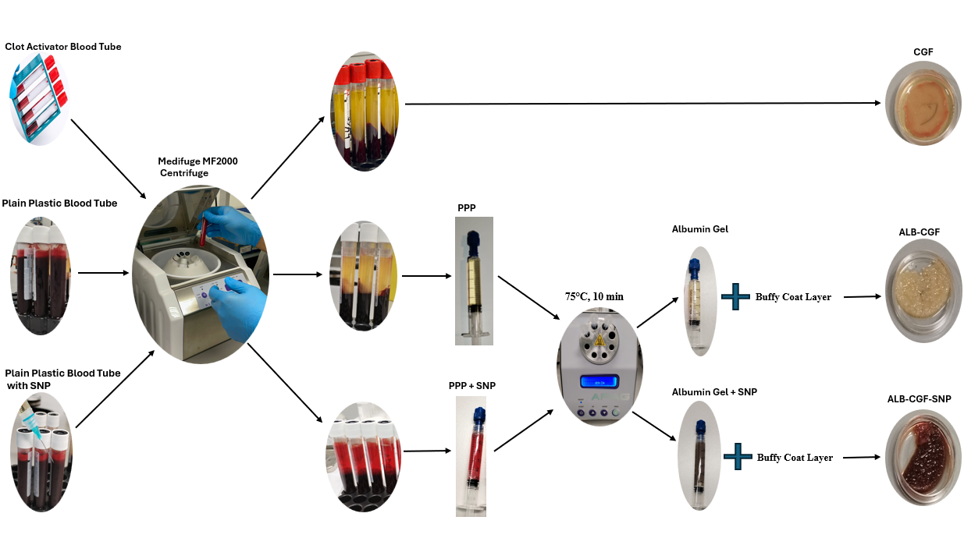
Appendix Figure 1 elaborates on the CGF, ALB-CGF, and ALB-CGF-SNP preparation sequence.
Appendix Figure 2 illustrates the workflow of mechanical study preparation of CGF membranes.
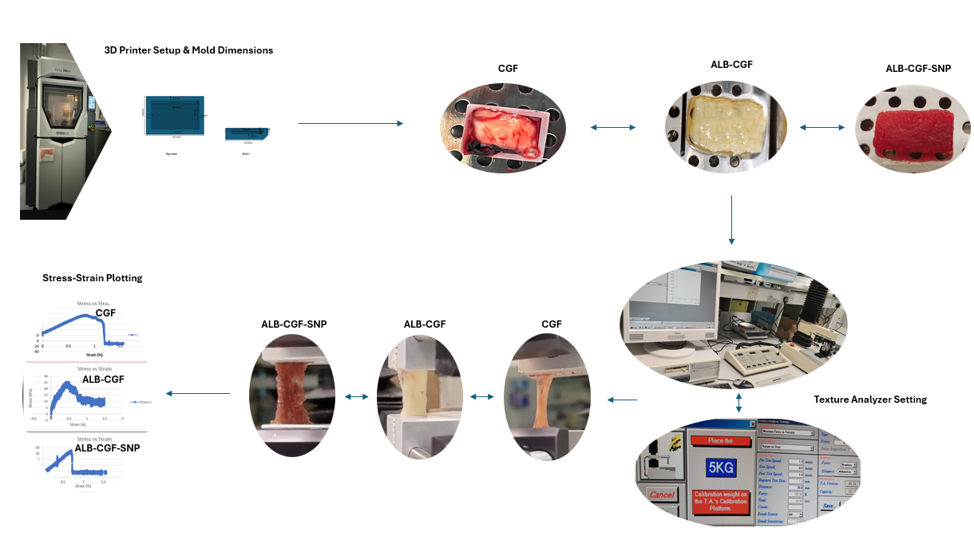
Appendix Figure 3 illustrates the process for blood sample preparation and flow cytometry analysis for cell count, comparing whole blood with CGF, ALB-CGF, and ALB-CGF-SNP samples.
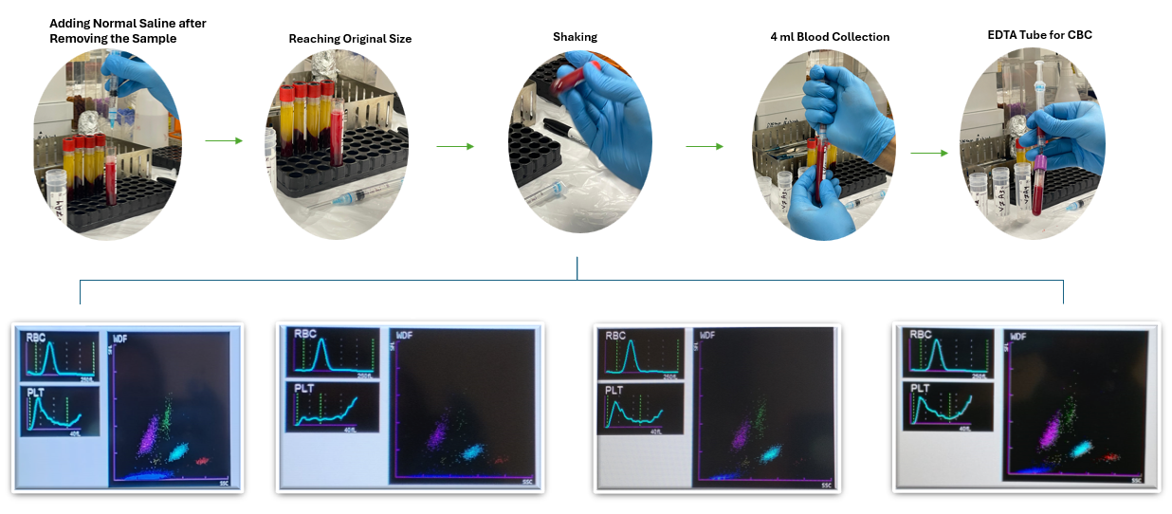
Appendix Figure 4 illustrates the degradation study process, covering sample preparation, incubation, and measurement intervals.
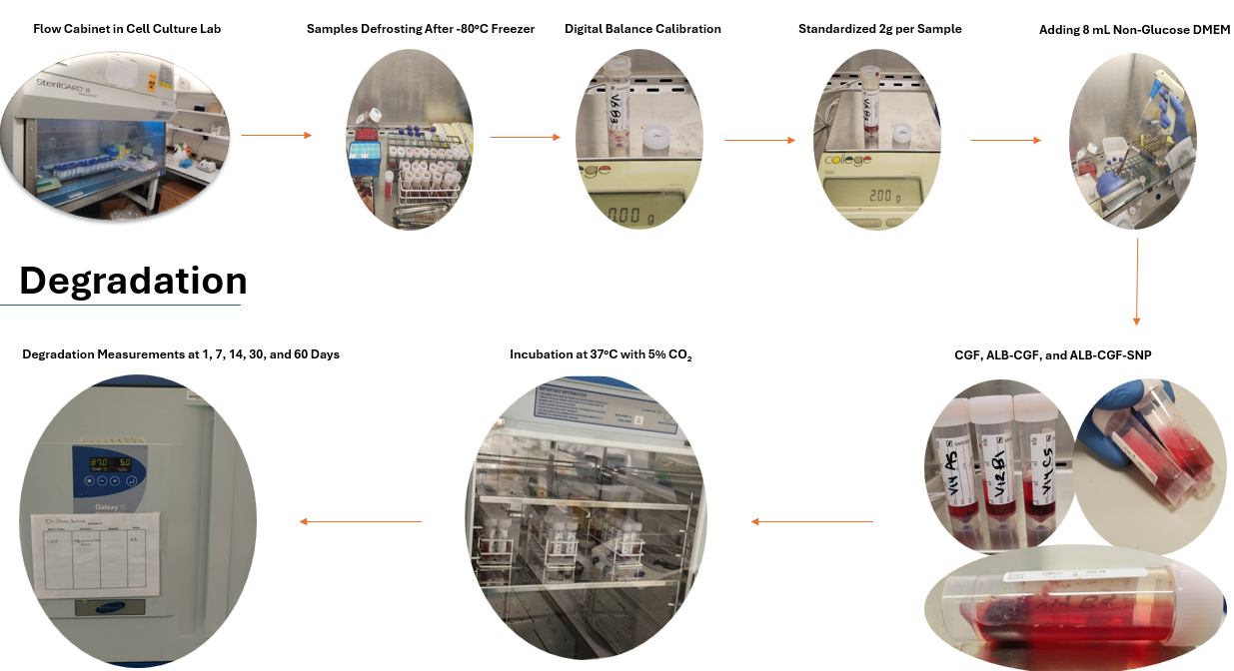

Appendix Figure 5 illustrates the mean percentage degradation of CGF, Alb-CGF, and Alb-CGF-SNP membranes over time intervals (Day 1, 7, 14, 30, and 60).
