Supplementary Information

Coastal Inorganic Mercury Time Series Reveals Interannual and Seasonal Variability Driven by Regional Climate Factors
Hannah M. Adams,¹* Peipei Wu,¹ Iris Kübler-Dudgeon, ¹ Carl H. Lamborg,² Jeff S. Bowman,¹ Amina T. Schartup¹*
Corresponding Authors: Hannah M. Adams, hadams@ucsd.edu and Amina T. Schartup, aschartup@ucsd.edu

¹Scripps Institution of Oceanography, University of California San Diego, La Jolla, CA, USA
²Department of Ocean Sciences, University of California Santa Cruz, Santa Cruz, CA, USA

Summary: 10 pages, 1 table, and 10 figures

Table of Contents
Supplementary Figure 1: Time series of oceanographic measurements from Scripps Pier in La Jolla, California from January 2021 to December 2024. 3
Supplementary Figure 2: Seasonal Precipitation Anomaly for San Diego, California. 4
Supplementary Figure 3: Box plots of inorganic mercury (Hg) concentrations during wet and dry winters. Wet and dry conditions were defined based on the seasonal precipitation anomaly. 2021 and 2022 exemplified dry winter conditions, while 2023 and 2024 exemplified wet winter conditions. Scatter plot overlaid on the box plots represents the spread of the dataset. 4
Supplementary Figure 4: Bar plots indicating large-scale climate anomalies that impact San Diego, California. 5
Supplementary Figure 5: Box Plots of Inorganic mercury (Hg) concentrations during La Niña and El Niño Dry Seasons (April-September). 6
Supplementary Figure 6: Trend decomposition of the surface (< 0.5 m) Inorganic Mercury (Hg) time series at Scripps Pier in La Jolla, California. 7
Supplementary Figure 7: Inorganic mercury (Hg) concentration plotted against wave height. 8
Supplementary Figure 8: Inorganic mercury (Hg) concentration plotted against Coastal Upwelling Transport Index at 33°N. 8
Supplementary Table 1: Final Model Parameters for Surface Inorganic Mercury Concentrations at Scripps Pier. 9
Supplementary Figure 9: Residual Diagnostics for Surface Inorganic Mercury Model. 9
Supplementary Figure 10: Modeled predicted concentrations plotted against measured concentrations of inorganic mercury at Scripps Pier. 10
References 10

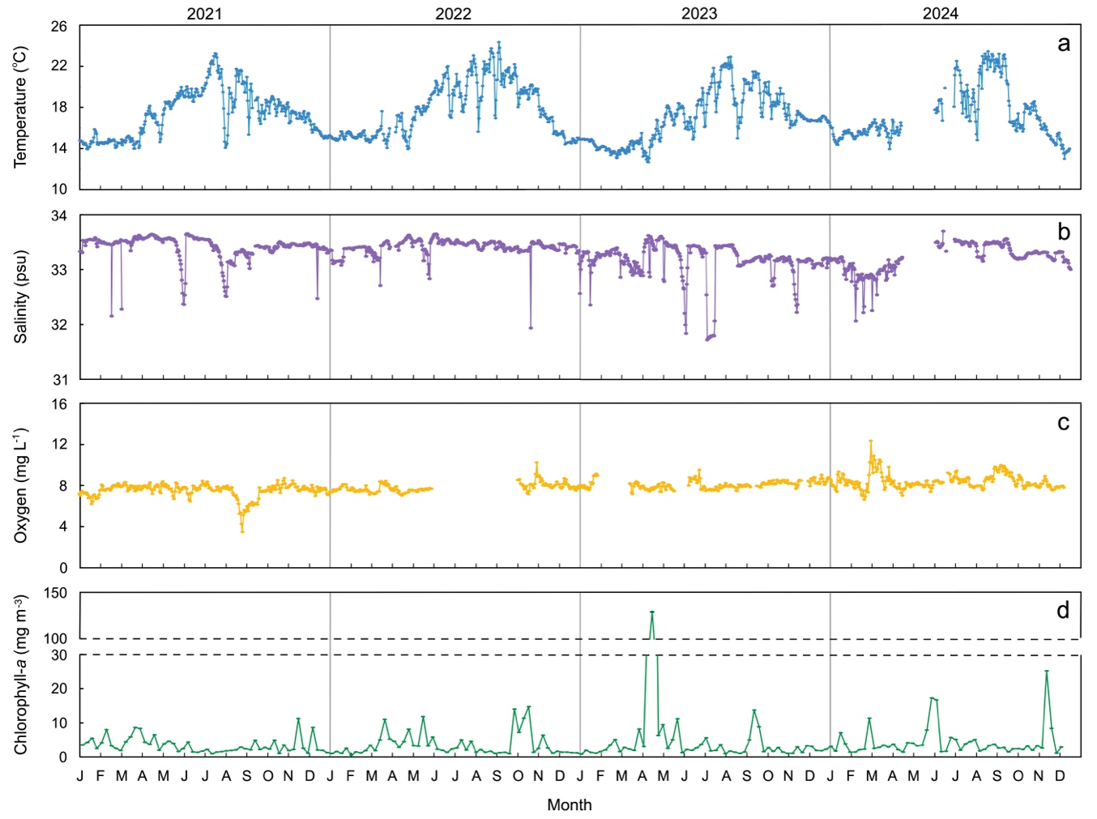
Supplementary Figure 1: Time series of oceanographic measurements from Scripps Pier in La Jolla, California from January 2021 to December 2024. Average daily temperature (a), average daily salinity (b), average daily oxygen concentration (c), and weekly chlorophyll-a concentration (d). Data for temperature, salinity, and chlorophyll-a are publicly available through SCCOOS,^{1,2} and data for oxygen concentrations were obtained from the Scripps Ocean Acidification Real-Time Monitoring Program.³

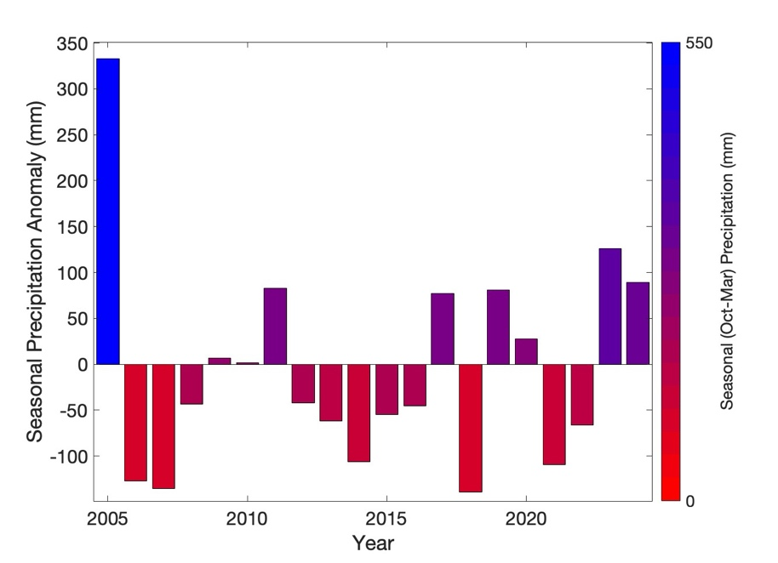
Supplementary Figure 2: Seasonal Precipitation Anomaly for San Diego, California. Bars represent the seasonal precipitation anomaly for each wet season, defined as October of the previous year to March of the current year, calculated since 1940. The color bar represents the total amount of seasonal precipitation in mm. Data from National Centers for Environmental Information Station USW00023188.⁴

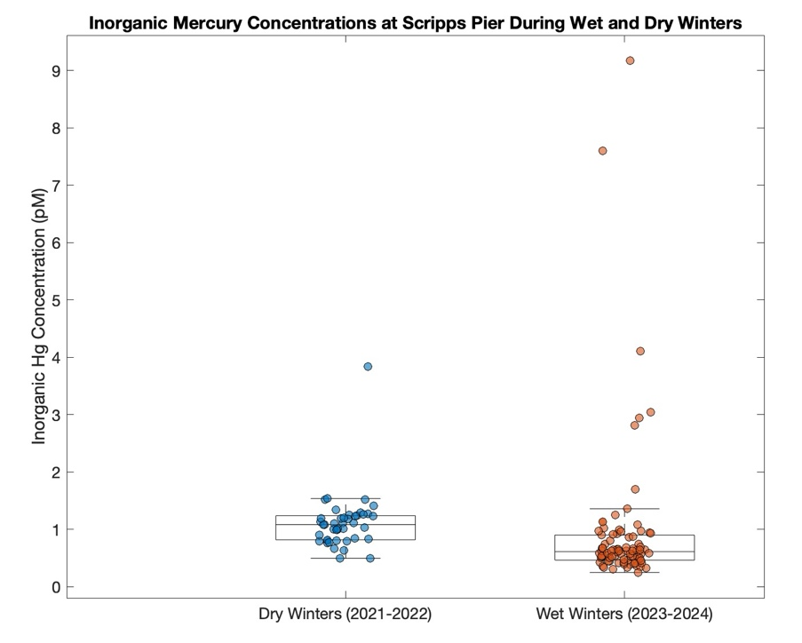

Supplementary Figure 3: Box plots of inorganic mercury (Hg) concentrations during wet and dry winters. Wet and dry conditions were defined based on the seasonal precipitation anomaly. 2021 and 2022 exemplified dry winter conditions, while 2023 and 2024 exemplified wet winter conditions. Scatter plot overlaid on the box plots represents the spread of the dataset.

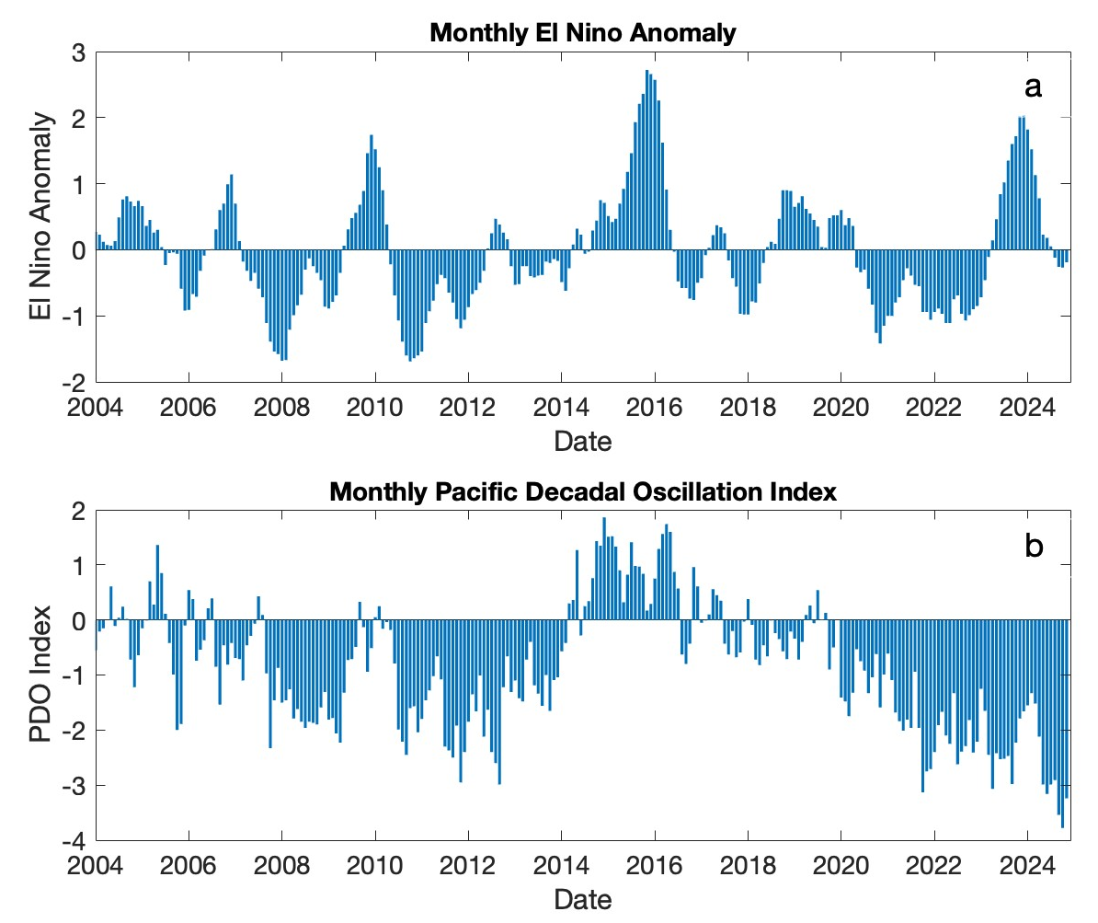
Supplementary Figure 4: Bar plots indicating large-scale climate anomalies that impact San Diego, California. a) El Niño Anomaly from NINO3.4.⁵ b) Pacific Decadal Oscillation Index.⁶

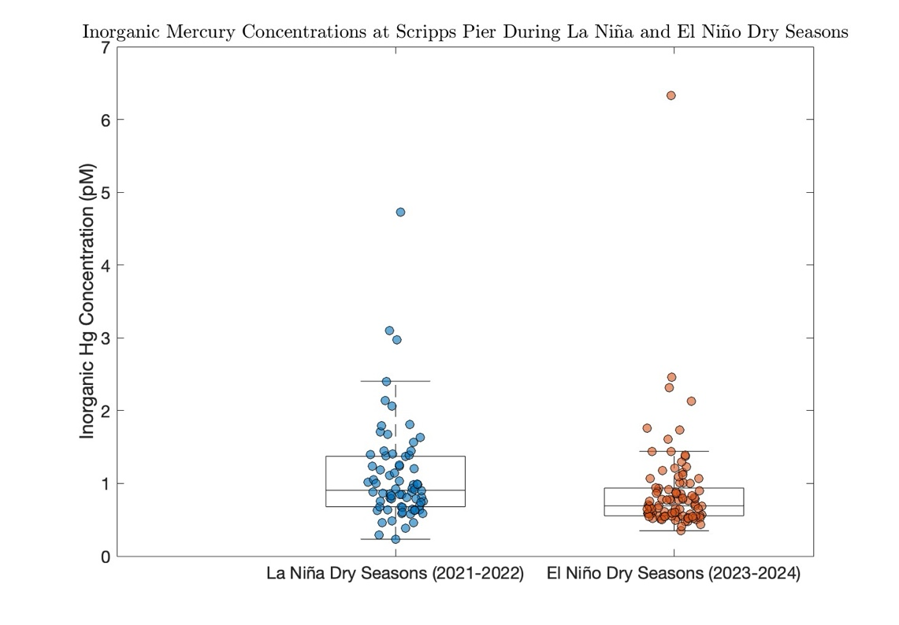
Supplementary Figure 5: Box Plots of Inorganic mercury (Hg) concentrations during La Niña and El Niño Dry Seasons (April-September). The dry seasons of 2021 and 2022 exemplified La Niña conditions, while 2023 and 2024 exemplified El Niño conditions. Scatter plot overlaid on the box plots represents the spread of the dataset.

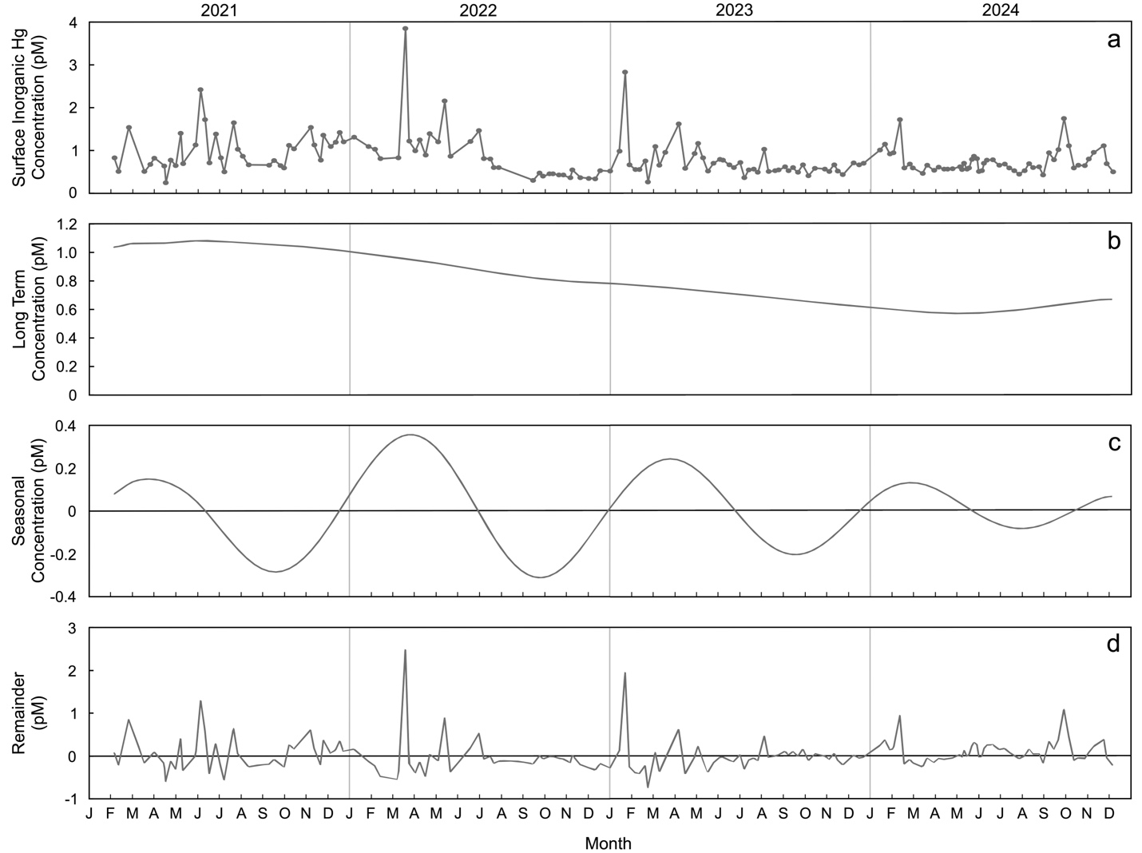
Supplementary Figure 6: Trend decomposition of the surface (< 0.5 m) Inorganic Mercury (Hg) time series at Scripps Pier in La Jolla, California. a) Full weekly time series of surface inorganic Hg concentrations (pM) collected from 0.5 m at Scripps Pier. b) Long term trend of inorganic Hg concentrations (pM) calculated using singular spectrum analysis in MATLAB. c) Seasonal trend in inorganic Hg concentrations (pM) calculated using singular spectrum analysis in MATLAB. d) Remainder concentrations not explained by the seasonal and long term trends from a and b.

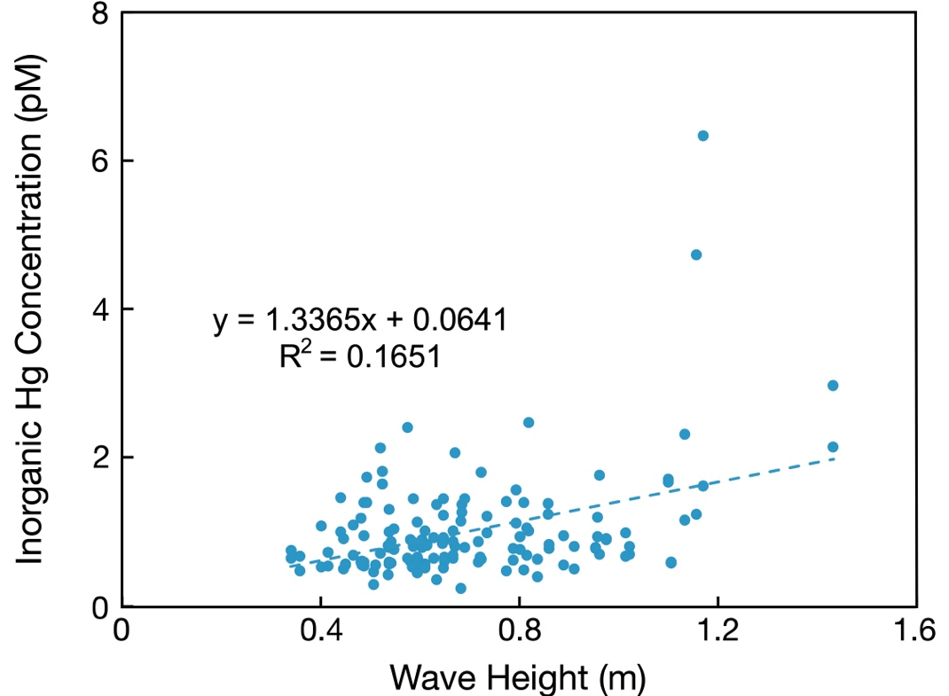
Supplementary Figure 7: Inorganic mercury (Hg) concentration plotted against wave height. Data points are from the dry season (April to September) when precipitation values are equal to 0. Dashed line is the linear regression.

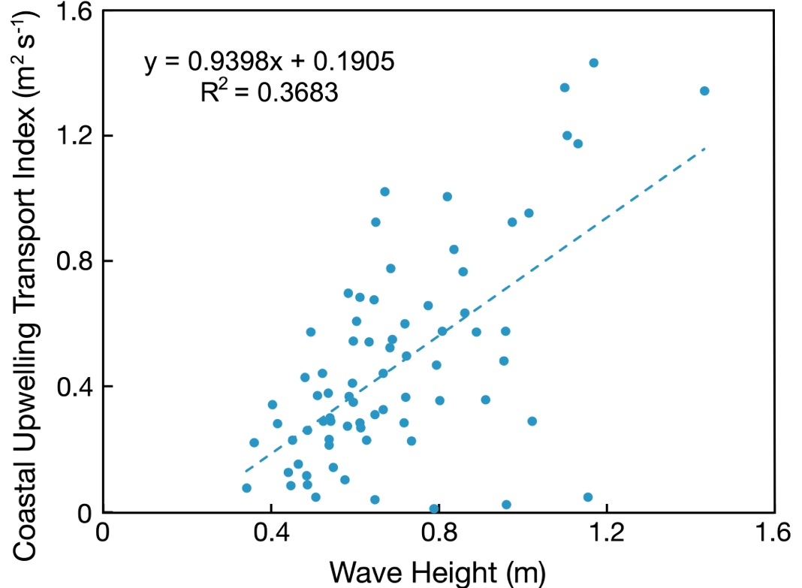
Supplementary Figure 8: Inorganic mercury (Hg) concentration plotted against Coastal Upwelling Transport Index at 33°N. Data points are from the dry season (April to September), and the Coastal Upwelling Transport Index is a modeled output from Jacox et al.⁷ Dashed line is the linear regression.

Supplementary Table 1: Final Model Parameters for Surface Inorganic Mercury Concentrations at Scripps Pier.
Parameter | Units | Estimate | Standard Error | p-value
Intercept | pmol L⁻¹ | 0.3473 | 0.1344 | 0.0110
Wave Height | m | 0.6291 | 0.1820 | 0.0008
Weekly Average Streamflow | ft³/s | 0.0054 | 0.0018 | 0.0026
Model Statistics | Training Dataset (2021-2023) | Validation Dataset (2024)
Autoregressive Order | 3
Moving Average Order | 3
Regression Model R² | 0.193
Regression Root Mean Squared Error | 0.466
Regression Model p-value | 5.67x10⁻⁶
Overall Model R² | 0.82 | 0.1792
Overall Root Mean Squared Error | 0.2186 | 0.3063
AIC | 131.3
Dataset n | 116 | 45

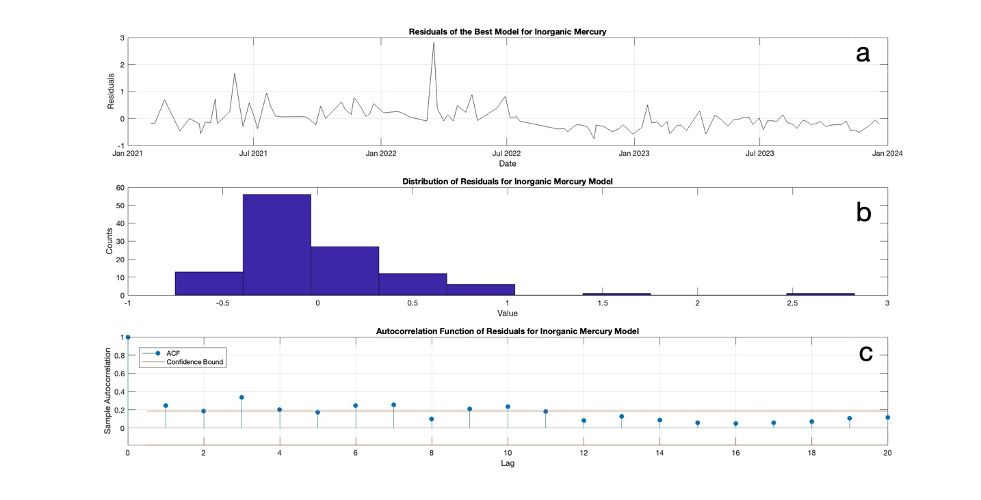
Supplementary Figure 9: Residual Diagnostics for Surface Inorganic Mercury Model. a) Residuals for the model of surface inorganic mercury, calculated from the measurement value minus regression model output. b) Distribution of residuals from the regression model. c) Autocorrelation function of residuals from the model.

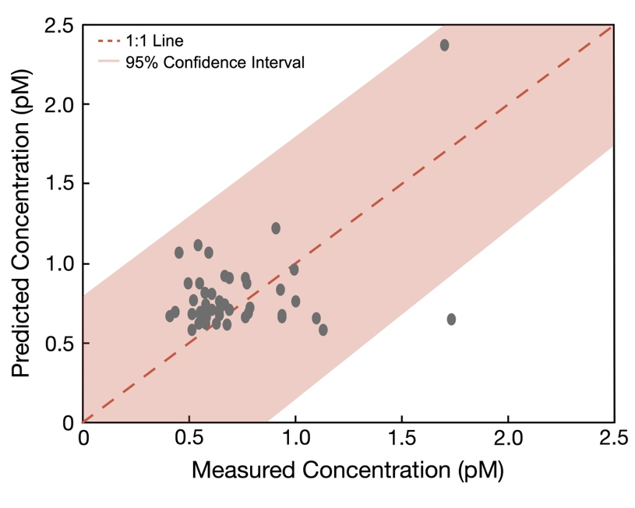
Supplementary Figure 10: Modeled predicted concentrations plotted against measured concentrations of inorganic mercury at Scripps Pier. All but one point falls within the 95% confidence interval for the model.

References

(1) McGowan, J. A.; Deyle, E. R.; Ye, H.; Carter, M. L.; Perretti, C. T.; Seger, K. D.; de Verneil, A.; Sugihara, G. Predicting Coastal Algal Blooms in Southern California. Ecology 2017, 98 (5), 1419–1433. https://doi.org/10.1002/ecy.1804.
(2) Carter, M. L.; Flick, R. E.; Terrill, E.; Beckhaus, E. C.; Martin, K.; Fey, C. L.; Walker, P. W.; Largier, J. L.; McGowan, J. A. Shore Stations Program - La Jolla, Scripps Pier (La Jolla Archive, 2024-07-24). In Shore Stations Program Data Archive: Current and Historical Coastal Ocean Temperature and Salinity Measurements from California Stations. UC San Diego Library Digital Collections 2022. https://doi.org/10.6075/J06T0K0M.
(3) Clements, S. C.; Kram, S. L.; Takeshita, Y.; Dickson, A.; Martz, T.; Smith, J. E. Scripps Ocean Acidification Real-time (SOAR) Dataset. Scripps Institution of Oceanography, La Jolla, CA.
(4) NOAA National Centers for Environmental Information. Precipitation Data for Station USW00023188.
(5) National Oceanic and Atmospheric Administration Physical Sciences Laboratory. Monthly Climate Timeseries: Nino 3.4 SST. https://psl.noaa.gov/data/timeseries/monthly/NINO34/.
(6) National Centers for Environmental Information. Pacific Decadal Oscillation (PDO). National Oceanographic and Atmospheric Administration.
(7) Jacox, M. G.; Edwards, C. A.; Hazen, E. L.; Bograd, S. J. Coastal Upwelling Revisited: Ekman, Bakun, and Improved Upwelling Indices for the U.S. West Coast. J Geophys Res Oceans 2018, 123 (10), 7332–7350. https://doi.org/10.1029/2018JC014187.

