Author information
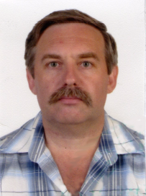
Aleksandr Rudnev is a Ph.D in mechanical engineering, Associate Professor at the Department of Integrated Technologies of Mechanical Engineering, named after M.F. Semko, at the National Technical University “Kharkiv Polytechnic Institute”, Kharkiv, Ukraine. He received his Ph.D in Technical Sciences at the same institution. His research interests include the processing of difficult-to-machine materials in diamond grinding.

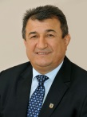
Magomedemin Gasanov is the Vice-Rector for Scientific and Pedagogical Work, Doctor of Technical Sciences, Professor at the National Technical University “Kharkiv Polytechnic Institute”, Kharkiv, Ukraine. He received his Doctor of Technical Sciences degree from the same institution. His research interests include the processing of large gears and the grinding of difficult-to-machine materials.

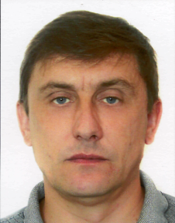
Alexey Kotliar is a Ph.D in mechanical engineering, Associate Professor at the Department of Mechanical Engineering Technology and Metal-Cutting Machines at the National Technical University “Kharkiv Polytechnic Institute”, Kharkiv, Ukraine. He received his Ph.D in Technical Sciences at the same institution. His area of professional interest is the development, design and modernization of metal-cutting machine tools, as well as the optimization of technological processes and systems.

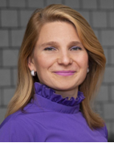
Oksana Titarenko (corresponding author) is a Ph.D in mechanical engineering, Head and Associate Professor at the Department of Mechanical Engineering at the National Academy of the National Guard of Ukraine, Kharkiv, Ukraine. She received her Ph.D in Technical Sciences at the National Technical University “Kharkiv Polytechnic Institute”. Her professional interests include surface engineering and the evaluation of surface quality formed by cutting.

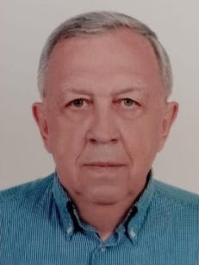
Pavel Kalinin is a Ph.D in mechanical engineering, Associate Professor at the Department of Mechanical Engineering at the National Academy of the National Guard of Ukraine, Kharkiv, Ukraine. He received his Ph.D in Technical Sciences at the National Technical University “Kharkiv Polytechnic Institute”. His professional interests include issues of applied mechanics, the optimal and rational design of technical devices, taking into account mass and dimensions; dynamic, ecological and economic characteristics and their manufacturing technology.

