Fig. S1A
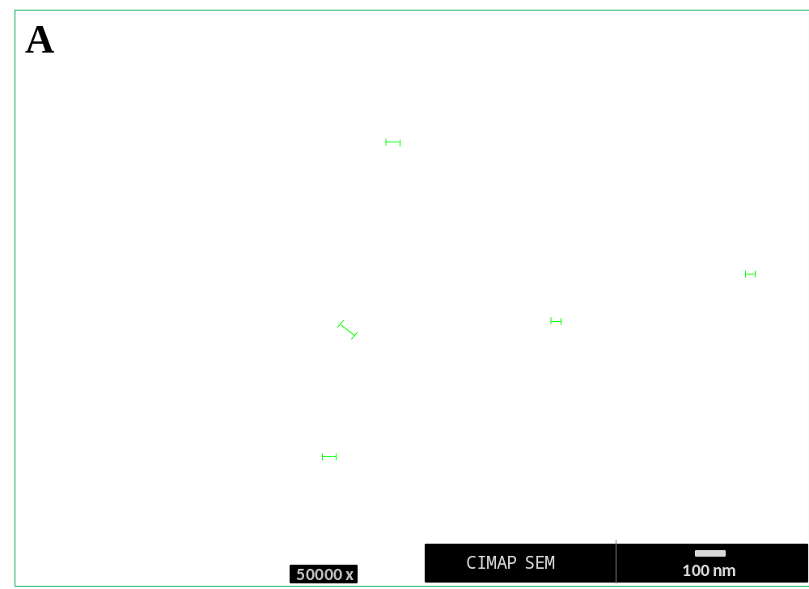
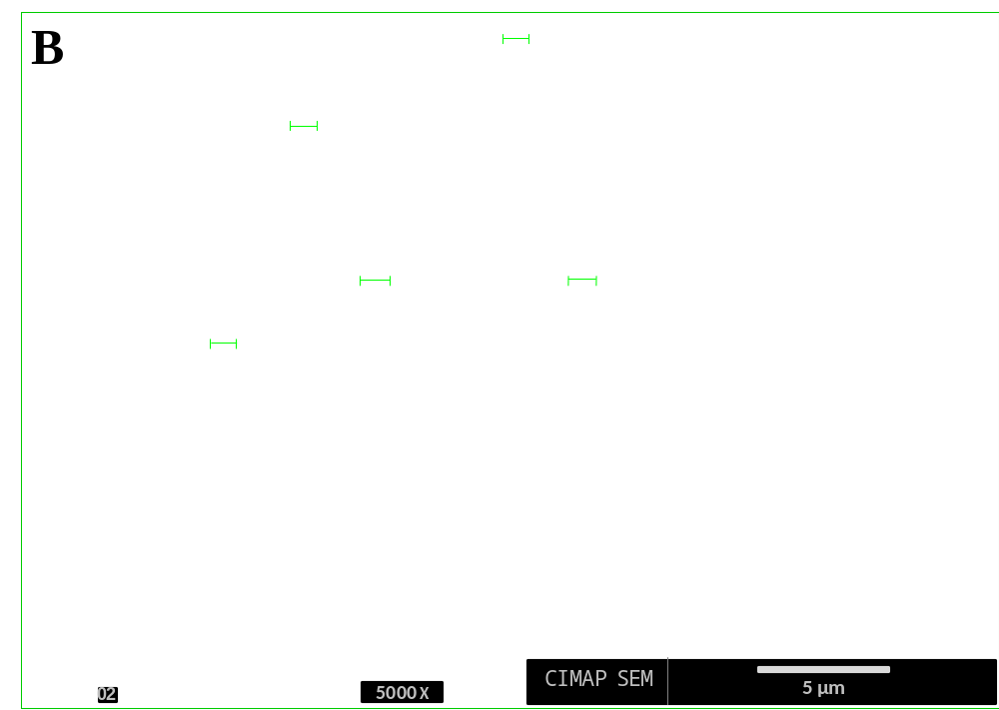
Fig. S1 Characterization of CuO nanoparticles (A) and bulk particles (B) through scanning electron microscope.

Fig. S2
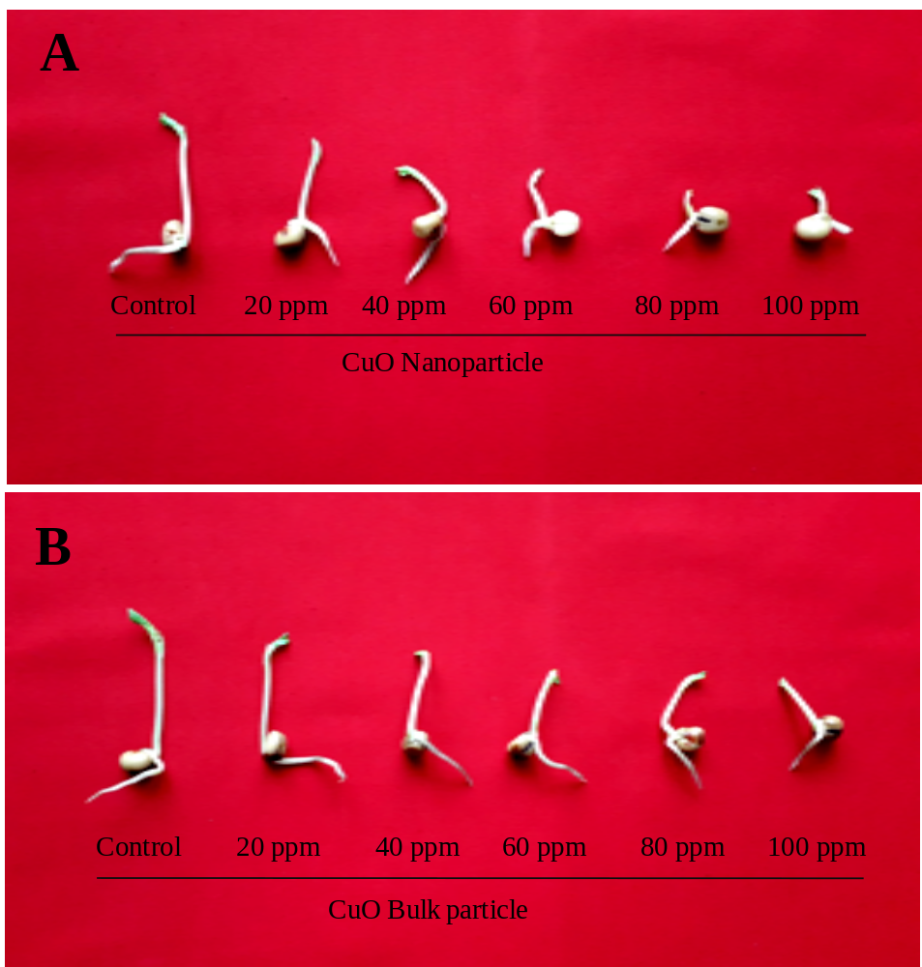
Fig. S2 Effect of different concentrations of CuO nanoparticles (A) and bulk particles (B) on growth of 10 days old seedlings of V. faba var. Pusa Sumit.

Fig. S3
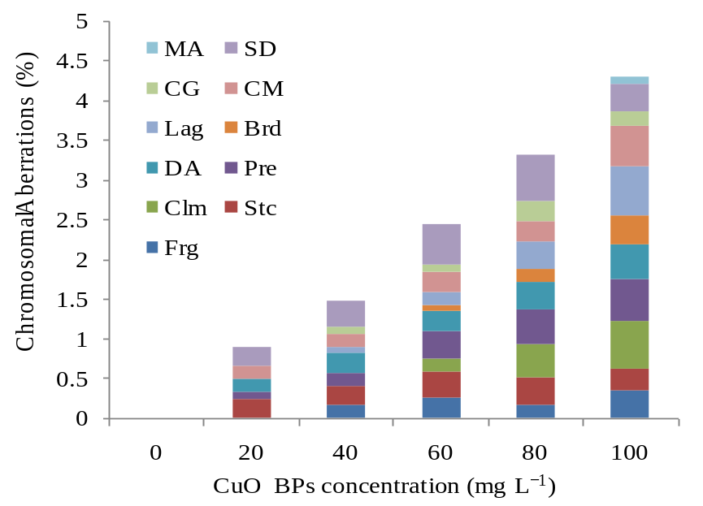
Fig. S3 Scoring of individual chromosomal aberration on each concentration of CuO bulk particles in V. faba var. Pusa Sumit (MA multiple aberration, CG chromosome gap, Lag laggards, DA disoriented anaphase, Clum clumping, Frg fragmentation, SD spindle disorientation, CM clumped metaphase, Brd bridge, Pre Precocious chromosome and Stc stickiness)

Fig. S4
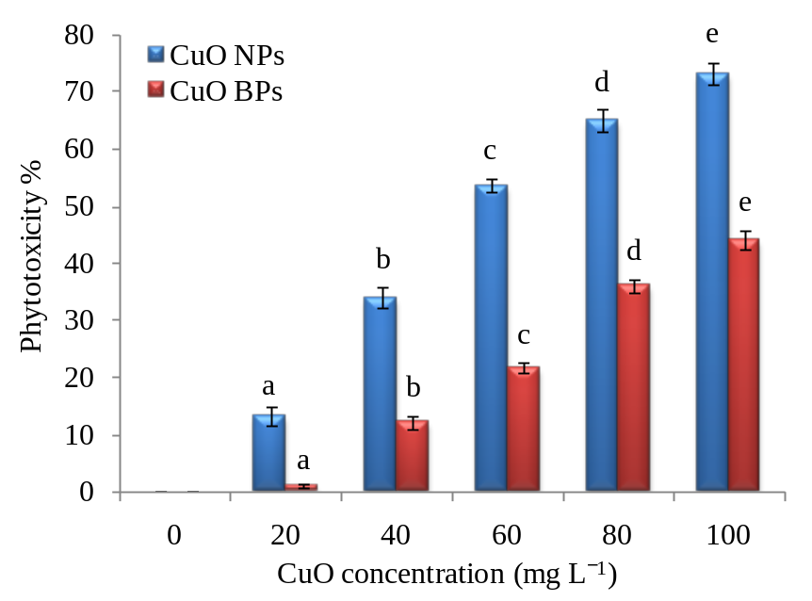
Fig. S4 Effect of different concentrations of CuO nanoparticles and bulk particles on phytotoxicity in V. faba var. Pusa Sumit.

