Supporting information for the paper:

Ground Motion Models for Campi Flegrei (Italy)
Scala A.1*, Strumia C. 1, Cito P.2, Scotto di Uccio F. 1, Festa G. 1*, Iervolino I. 2**, Zollo A. 1, Bobbio A. 3, Convertito V. 3, Elia L.3***, Emolo A. 1, Iaccarino A. G.1

1 Dipartimento di Fisica Ettore Pancini, Università degli Studi di Napoli Federico II, Naples, Italy.
2 Dipartimento di Strutture per l’Ingegneria e l’Architettura, Università degli Studi di Napoli Federico II, Naples, Italy.
3 Istituto Nazionale di Geofisica e Vulcanologia, Osservatorio Vesuviano, Naples, Italy.

Corresponding author: Antonio Scala, Dipartimento di Fisica Ettore Pancini, University of Napoli Federico II, Via Cinthia Naples, Italy. antonio.scala@unina.it
*also at Istituto Nazionale di Geofisica e Vulcanologia, Osservatorio Nazionale Terremoti, Rome, Italy,
** also at IUSS – Scuola Universitaria Superiore di Pavia, Pavia, Italy
*** also at Dipartimento di Fisica Ettore Pancini, Università degli Studi di Napoli Federico II, Naples, Italy

*also at Istituto Nazionale di Geofisica e Vulcanologia, Rome, Italy
** also at IUSS – Scuola Universitaria Superiore di Pavia, Pavia, Italy
*** also at Dipartimento di Fisica “Ettore Pancini”, Università di Napoli Federico II, Naples, Italy
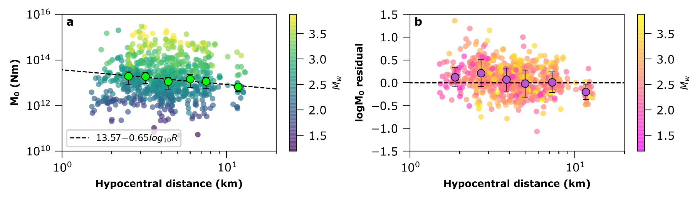

Figure S1: (a) single station estimates of the seismic moment $M_{0}$ as a function of hypocentral distance with the colour scale representing the moment magnitude $M_{w}$. Binned values (green markers) are obtained as mean estimates in uniform spaced intervals and the error bars are representative of the standard deviation of the estimates in each distance range. The observed decay suggests stronger attenuation than the assumption of geometrical spreading (b) Residuals (difference) between single station estimates and event averages of $M_{0}$ as a function of hypocentral distance with the colour scale representing the moment magnitude. Binned values (purple markers) of residuals are used to correct the $M_{0}$ estimate at each station for every event in the dataset.

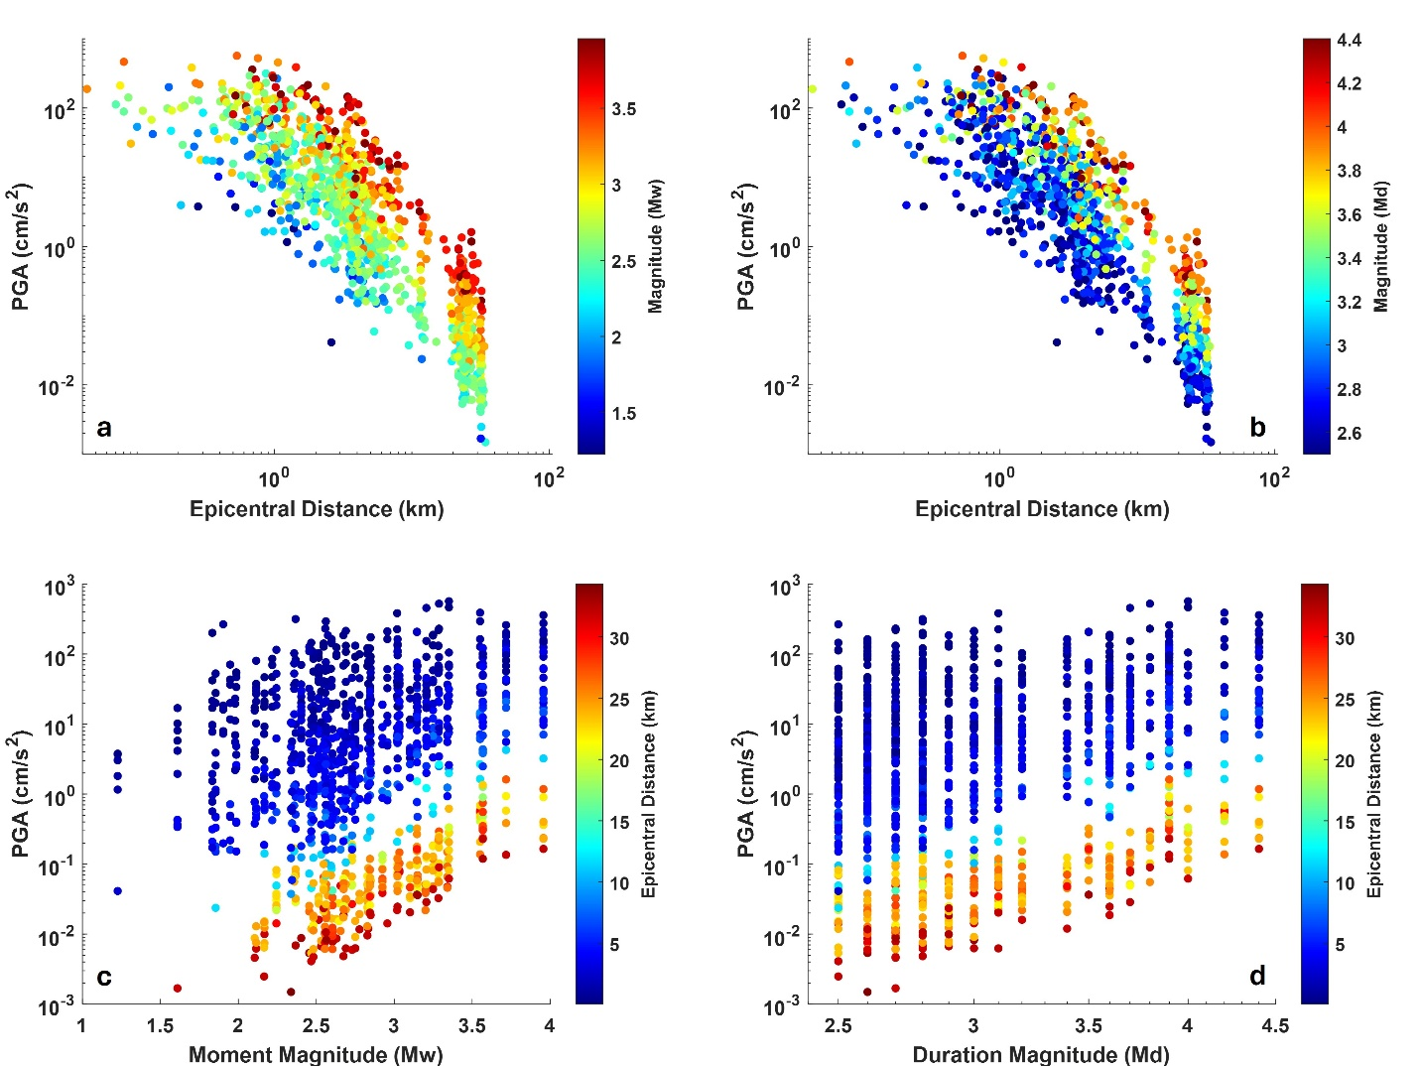
Figure S2: PGA records as a function of magnitude and epicentral distance (a) PGA as a function of epicentral distance with the colour scale representing the moment magnitude of the events. (b) PGA as a function of epicentral distance with the colour scale representing the duration magnitude of the events. (c) PGA as a function of moment magnitude with the colour scale representing the epicentral distance. (d) PGA as a function of duration magnitude with the colour scale representing the epicentral distance.
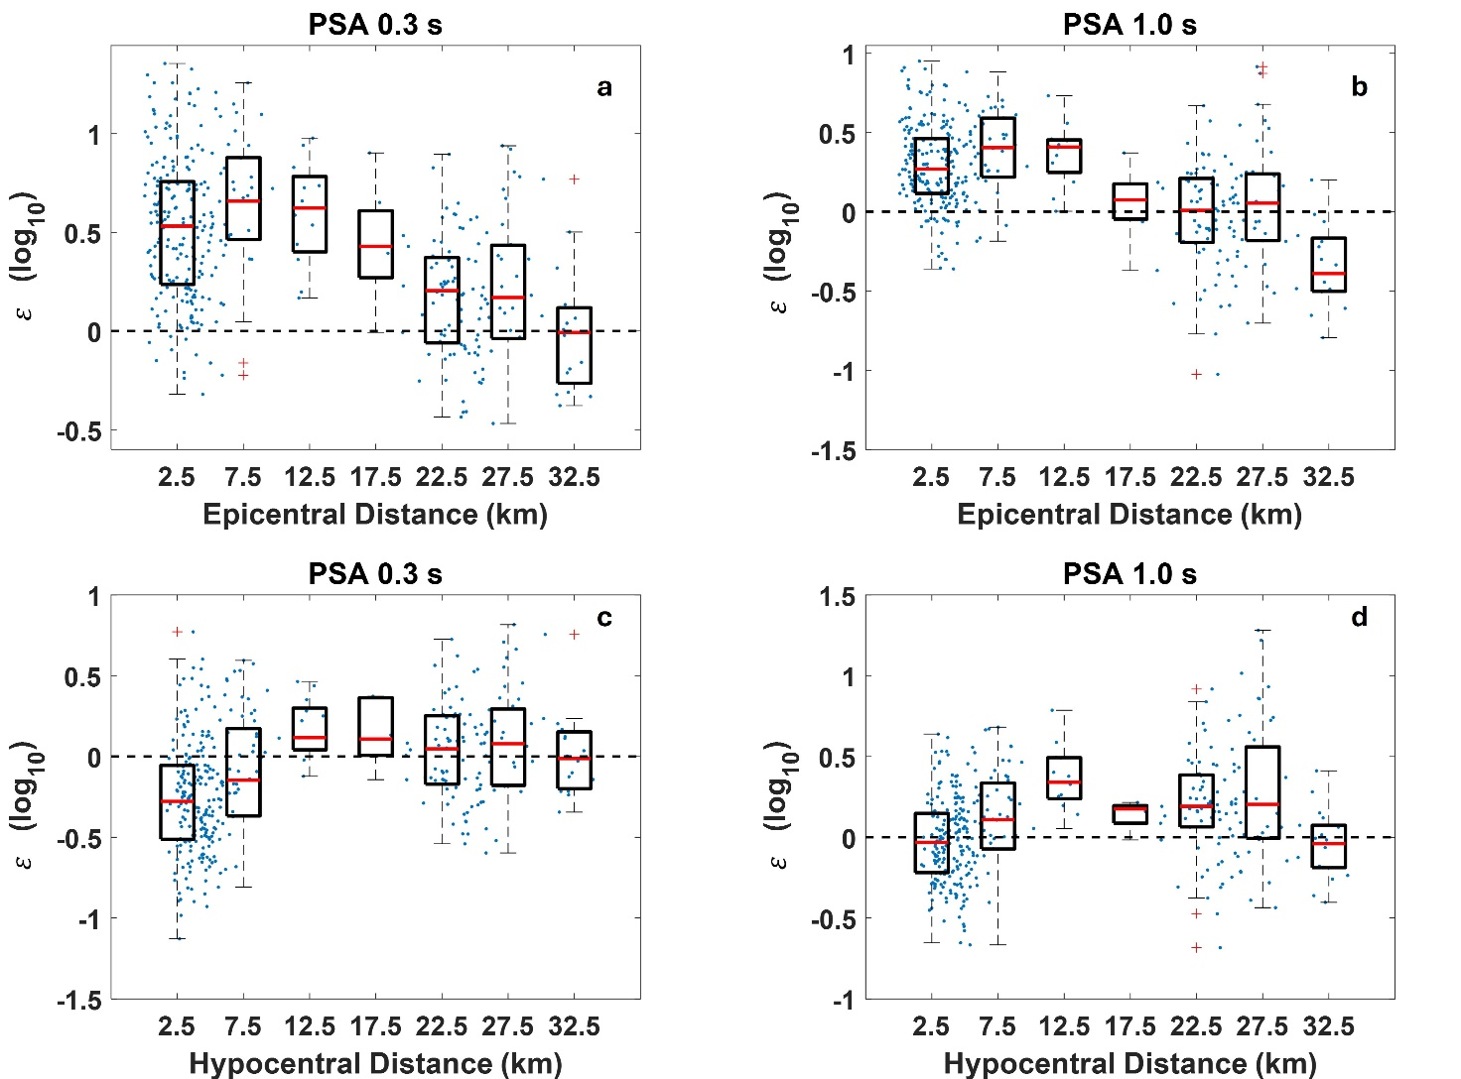
Figure S3 - Residuals (blue dots) and boxplots of observed shaking parameters as compared to the predicted values from available models. Within all the panels the horizontal red lines represent the median, the boxes contain values between 25th and 75th percentiles while the red crosses mark the outliers, that are more than 1.5 times the interquartile range away from the bottom or top of the box. (a) $ε$ for $SA\left(T=0.3s\right)$ as a function of epicentral distance with prediction from TL16 GMPE. (b) $ε$ for $SA\left(T=0.3s\right)$ as a function of epicentral distance with prediction from TL16 GMPE. (c) $ε$ for $SA\left(T=1.0s\right)$ as a function of hypocentral distance with prediction from RLS23 GMPE. (d) $ε$ for $SA\left(T=1.0s\right)$ as a function of hypocentral distance with prediction from RLS23 GMPE.

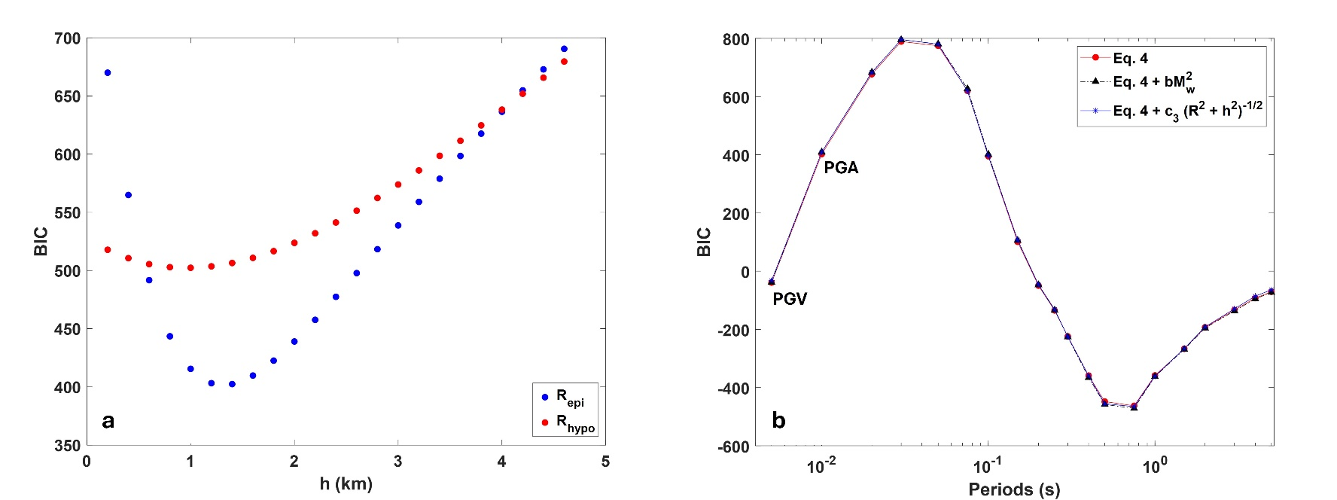
Figure S4 – Results of the Bayesian Information Criterion (BIC) tests. (a) Comparison between the BIC values obtained for different h values, when either epicentral (blue dots) or hypocentral (red dots and line) distances are used. In this test the PGA has been used as IM. (b) Comparison of the BIC values obtained for different functional forms for the GMPEs. In panel (b), the first two points on the left correspond to PGV and PGA, respectively. The remaining points represent 5%-damped SAs with corresponding periods shown on the x-axis.

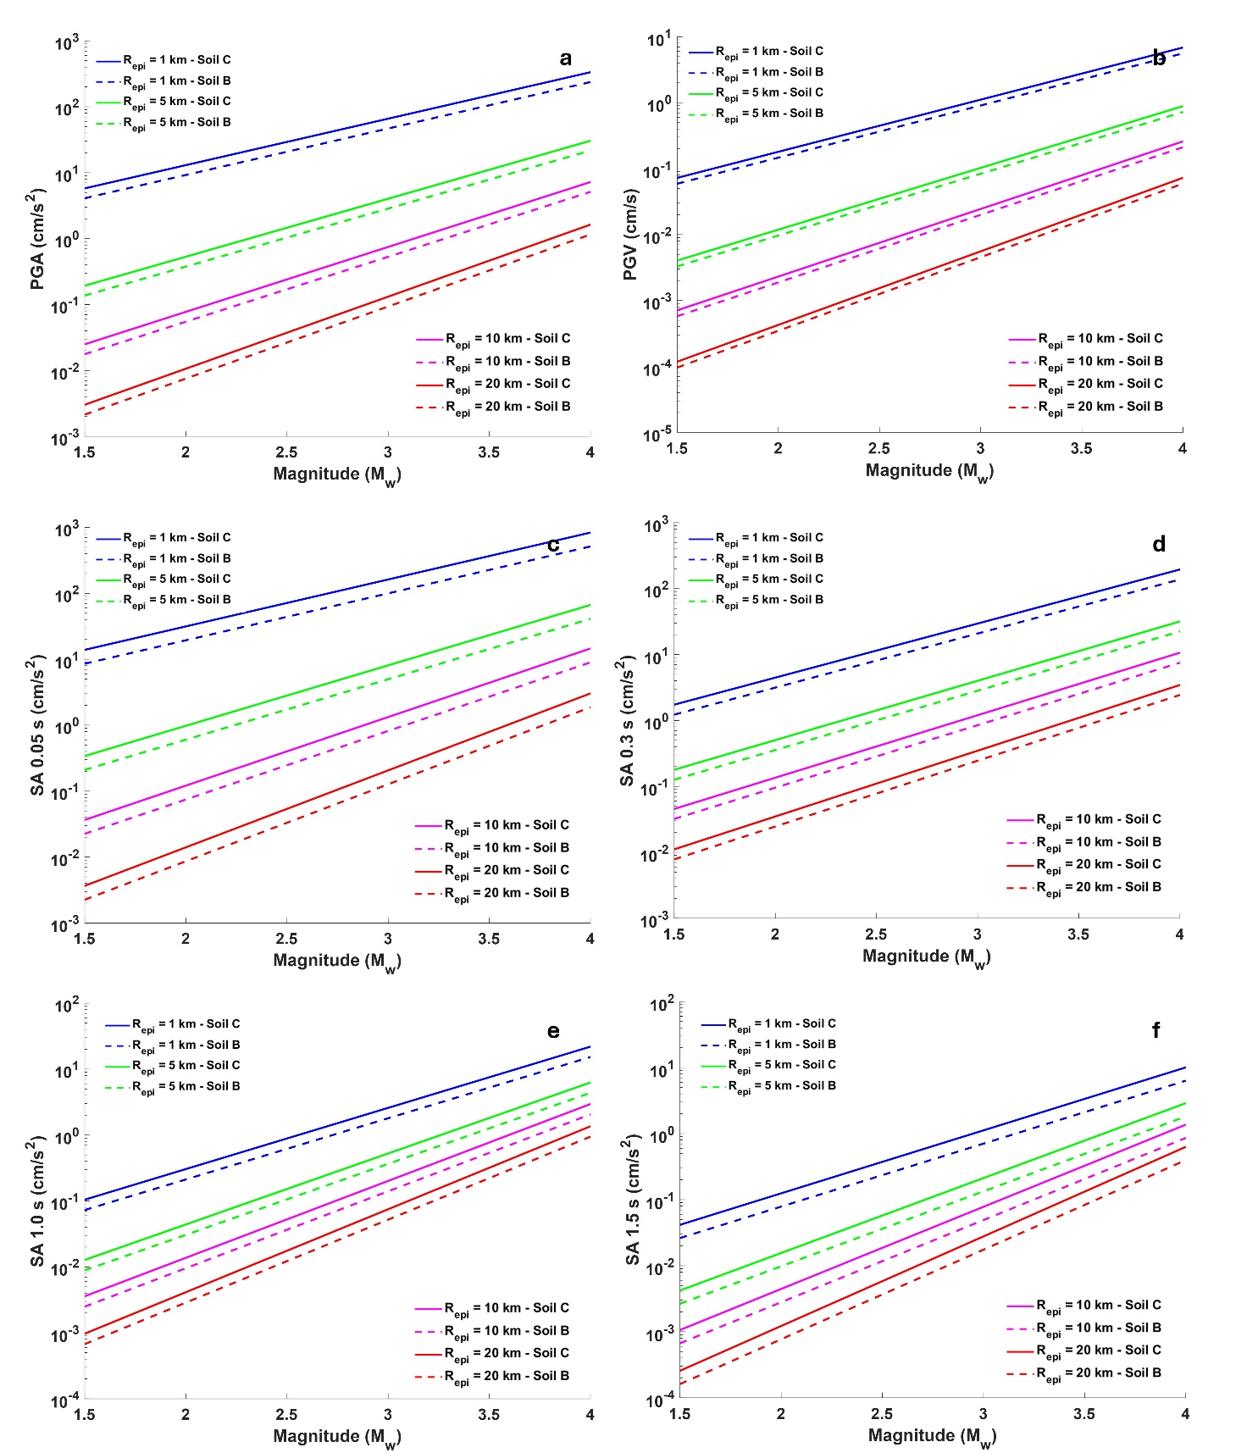
Figure S5: Ground shaking predicted through the calibrated model (Table 1) as a function of moment magnitude for: (a) PGA; (b) PGV; (c) SA with $T=0.05 s$; (d) SA with $T=0.3 s$; (e) SA with $T=1.0 s$; (f) SA with $T=1.5 s$. The models are plotted for four epicentral distances, as indicated in the legend. Solid and dashed lines represent the GMMs for soil C and soil B, respectively.
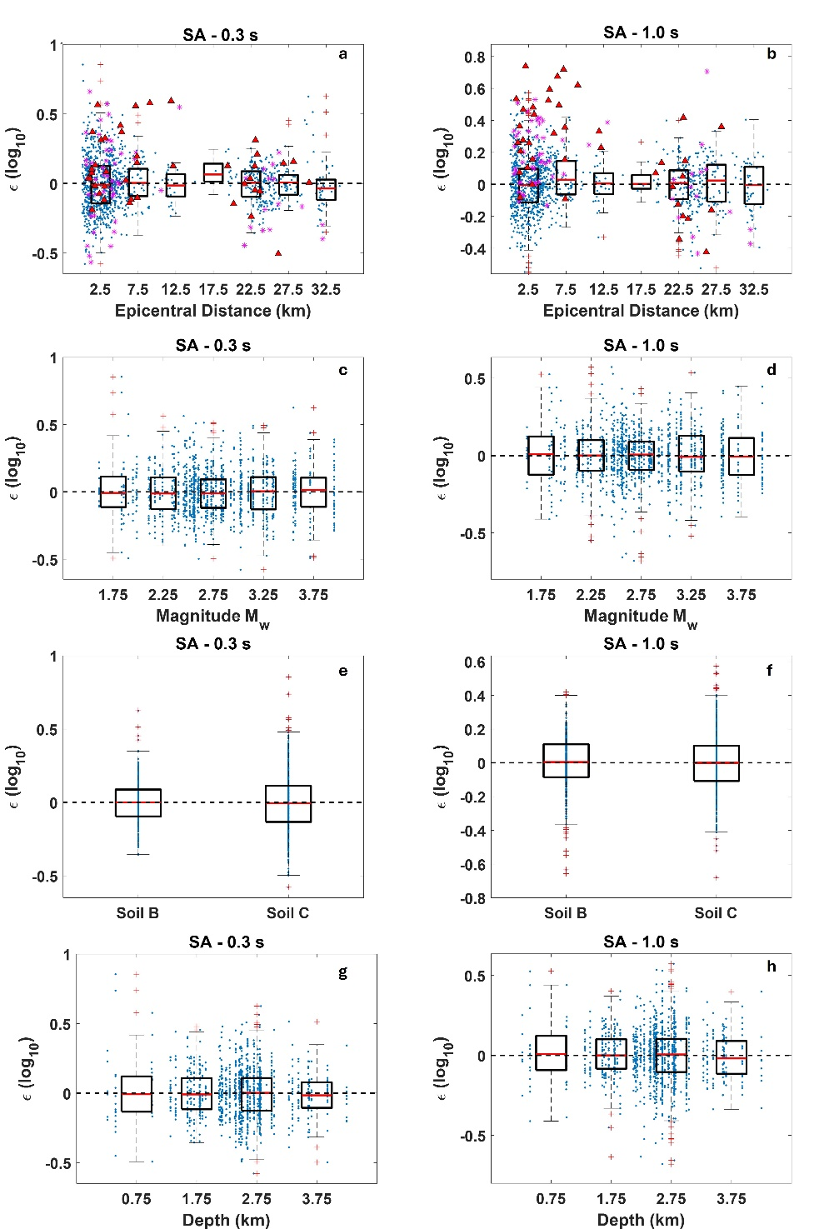
Figure S6: Residuals (blue dots) and boxplots of observed shaking parameters as compared to the predicted values from the new calibrated models. Within all the panels the horizontal red lines represent the median, the boxes contain values between 25th and 75th percentiles while the red crosses mark the outliers, that are more than 1.5 times the interquartile range away from the bottom or top of the box (a,c,e,g) $ϵ$ for $SA$at $T=0.3$ s as a function of the epicentral distance, $M_{w},$Soil class and depth, respectively (b,d,f,h) $ϵ$ for $SA at T=1.0 s$ as a function of epicentral distance, $M_{w}$, Soil class and depth respectively. In panels (a) and (b), the residuals for the two events not included in the calibration, as well as for the event of $M_{w} = 4.0$ ($M_{d} = 4.6$) that occurred on 16 March 2025, are also shown by magenta stars and red triangles, respectively.

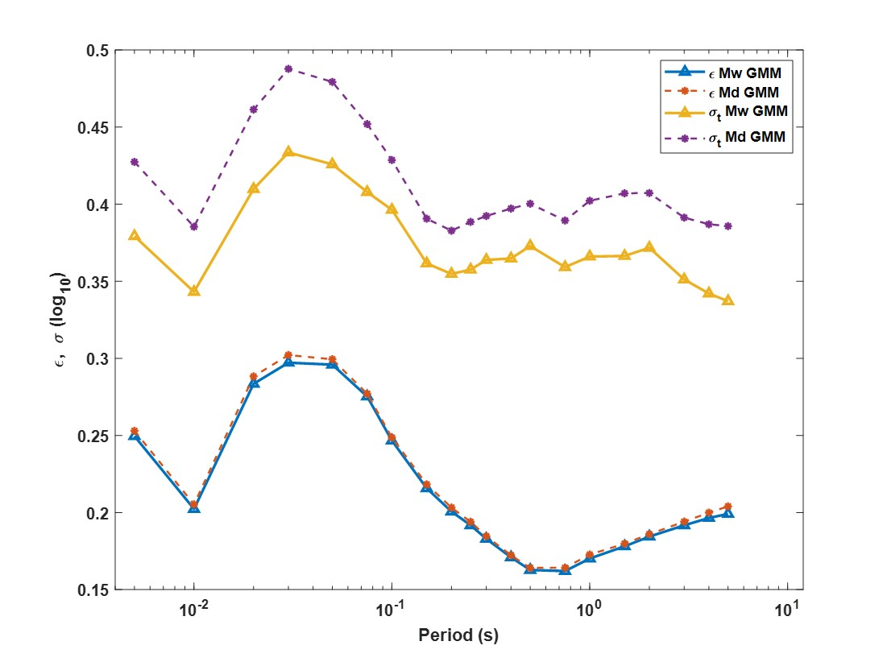
Figure S7: Comparison between residual $ϵ$ and standard deviation $σ_{T}$ for GMPEs calibrated using the moment magnitude $M_{w}$ and the duration magnitude $M_{d}$

