Supplementary Material for the paper:

Ground Motion Prediction Equations for Campi Flegrei (Italy)
Scala A.^{1*}, Strumia C. ¹, Cito P.², Scotto di Uccio F. ¹, Festa G. ^{1*}, Iervolino I. ^{2**}, Zollo A. ¹, Bobbio A. ³, Convertito V. ³, Elia L.^{3***}, Emolo A. ¹, Iaccarino A. G.¹

¹ Dipartimento di Fisica Ettore Pancini, Università degli Studi di Napoli Federico II, Naples, Italy
² Dipartimento di Strutture per l’Ingegneria e l’Architettura, Università degli Studi di Napoli Federico II, Naples, Italy
³ Istituto Nazionale di Geofisica e Vulcanologia, Osservatorio Vesuviano, Naples, Italy

Corresponding author: Antonio Scala, Dipartimento di Fisica Ettore Pancini, University of Napoli Federico II, Via Cinthia Naples, Italy. antonio.scala@unina.it
*also at Istituto Nazionale di Geofisica e Vulcanologia, Rome, Italy,
** also at IUSS – Scuola Universitaria Superiore di Pavia, Pavia, Italy
*** also at Dipartimento di Fisica Ettore Pancini, Università degli Studi di Napoli Federico II, Naples, Italy

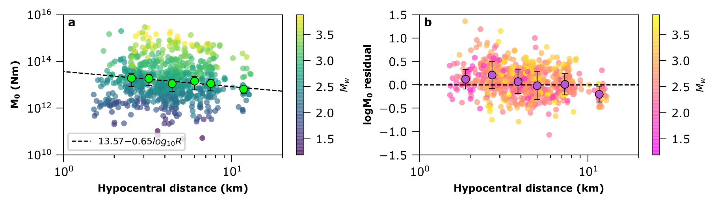

Figure S1: (a) single station estimates of the seismic moment $M_{0}$ as a function of hypocentral distance with the colour scale representing the moment magnitude $M_{w}$. Binned values (green markers) are obtained as mean estimates in uniform spaced intervals and the error bars are representative of the standard deviation of the estimates in each distance range. The observed decay suggests stronger attenuation than the assumption of geometrical spreading (b) Residuals (difference) between single station estimates and event averages of $M_{0}$ as a function of hypocentral distance with the colour scale representing the moment magnitude. Binned values (purple markers) of residuals are used to correct the $M_{0}$ estimate at each station for every event in the dataset.

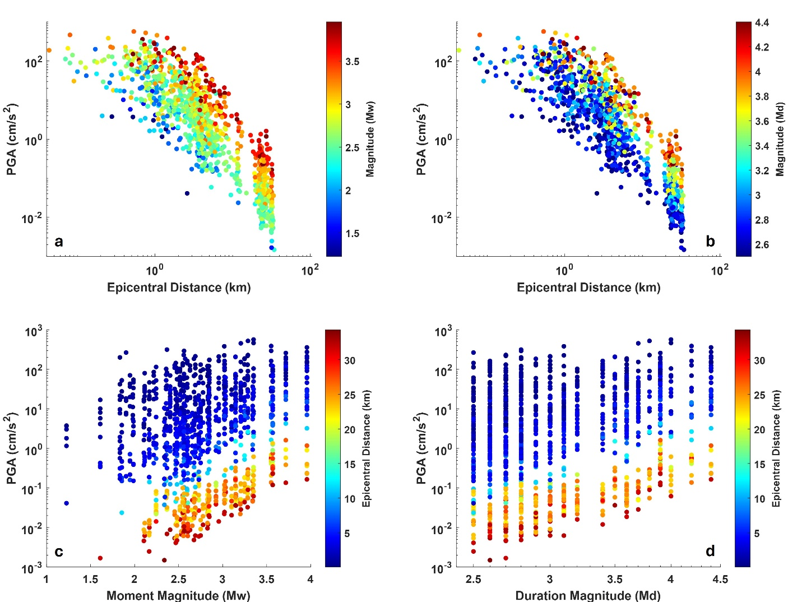
Figure S2: PGA records as a function of magnitude and epicentral distance (a) PGA as a function of epicentral distance with the colour scale representing the moment magnitude of the events. (b) PGA as a function of epicentral distance with the colour scale representing the duration magnitude of the events. (c) PGA as a function of moment magnitude with the colour scale representing the epicentral distance. (d) PGA as a function of duration magnitude with the colour scale representing the epicentral distance.
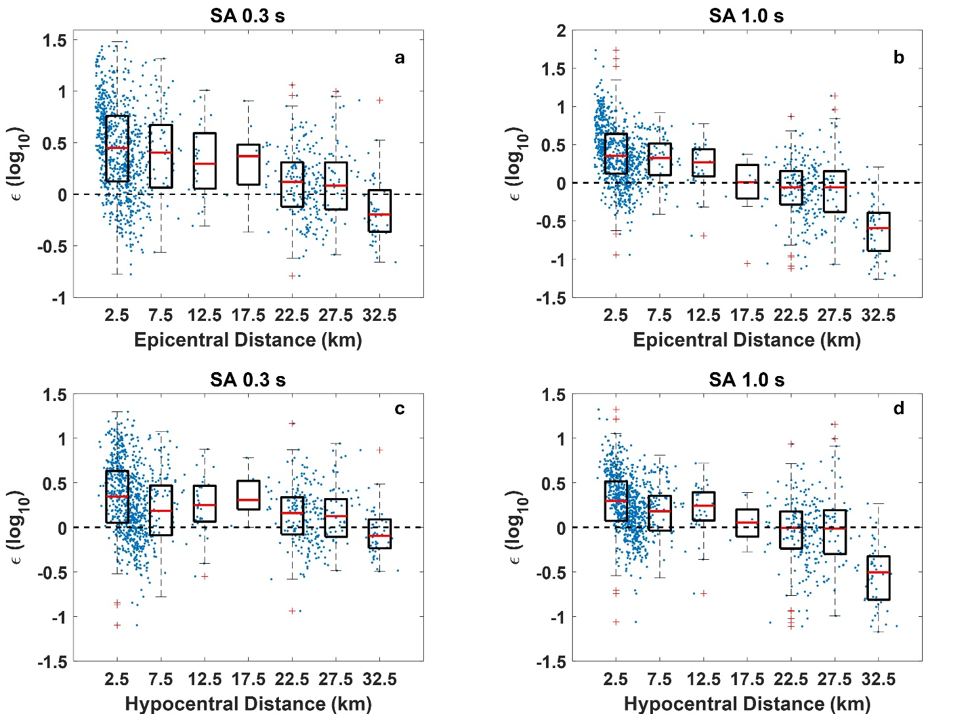
Figure S3 - Residuals (blue dots) and boxplots of observed shaking parameters as compared to the predicted values from available models. Within all the panels the horizontal red lines represent the median, the boxes contain values between 25% and 75% while the red crosses mark the outliers, that are more than 1.5 times the interquartile range away from the bottom or top of the box. (a) $ϵ$ for $SA\left(T=0.3s\right)$ as a function of epicentral distance with prediction from TL16 GMPE. (b) $ϵ$ for $SA\left(T=0.3s\right)$ as a function of epicentral distance with prediction from TL16 GMPE. (c) $ϵ$ for $SA\left(T=1.0s\right)$ as a function of hypocentral distance with prediction from LL20 GMPE. (d) $ϵ$ for $SA\left(T=1.0s\right)$ as a function of epicentral distance with prediction from LL20 GMPE.

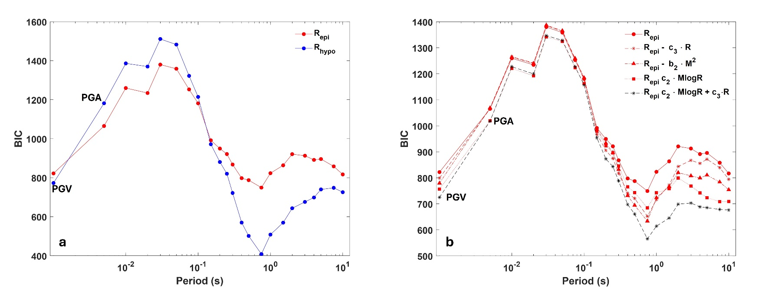
Figure S4 – Results of the Bayesian Information Criterion (BIC) tests. (a) Comparison between the BIC values obtained when either epicentral (red dots and line) or hypocentral (blue dots and line) distances are used. (b) Comparison of the BIC values obtained for different functional forms for the GMPEs. In both panels, the first two points on the left correspond to PGV and PGA, respectively. The remaining points represent 5%-damped SAs at the corresponding periods shown on the x-axis.

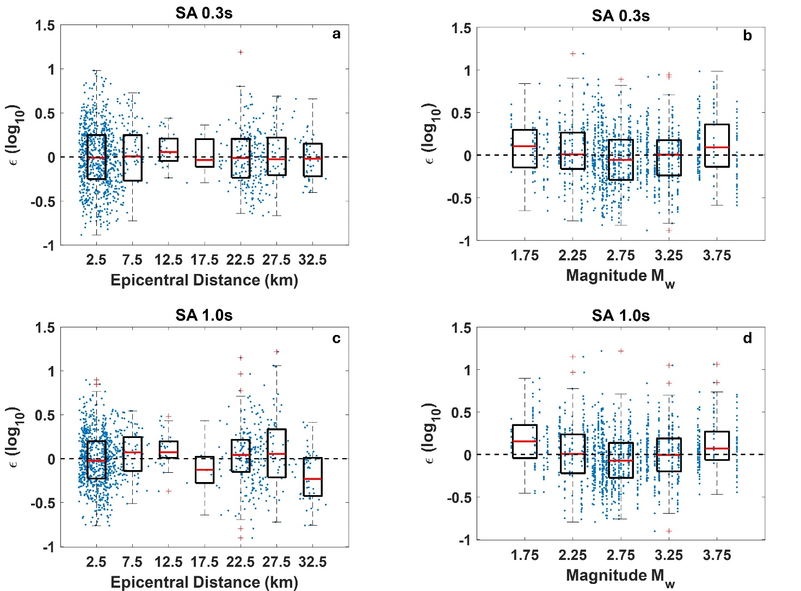
Figure S5: Residuals (blue dots) and boxplots of observed shaking parameters as compared to the predicted values from the new calibrated models. Within all the panels the horizontal red lines represent the median, the boxes contain values between 25% and 75% while the red crosses mark the outliers, that are more than 1.5 times the interquartile range away from the bottom or top of the box (a) $ϵ$ for $SA\left(T=0.3s\right)$ as a function of epicentral distance. (b) $ϵ$ for $SA\left(T=0.3s\right)$ as a function of moment magnitude $M_{w}.$ (c) $ϵ$ for $SA\left(T=1.0s\right)$ as a function of epicentral distance. (d) $ϵ$ for $SA\left(T=1.0s\right)$ as a function of moment magnitude $M_{w}.$

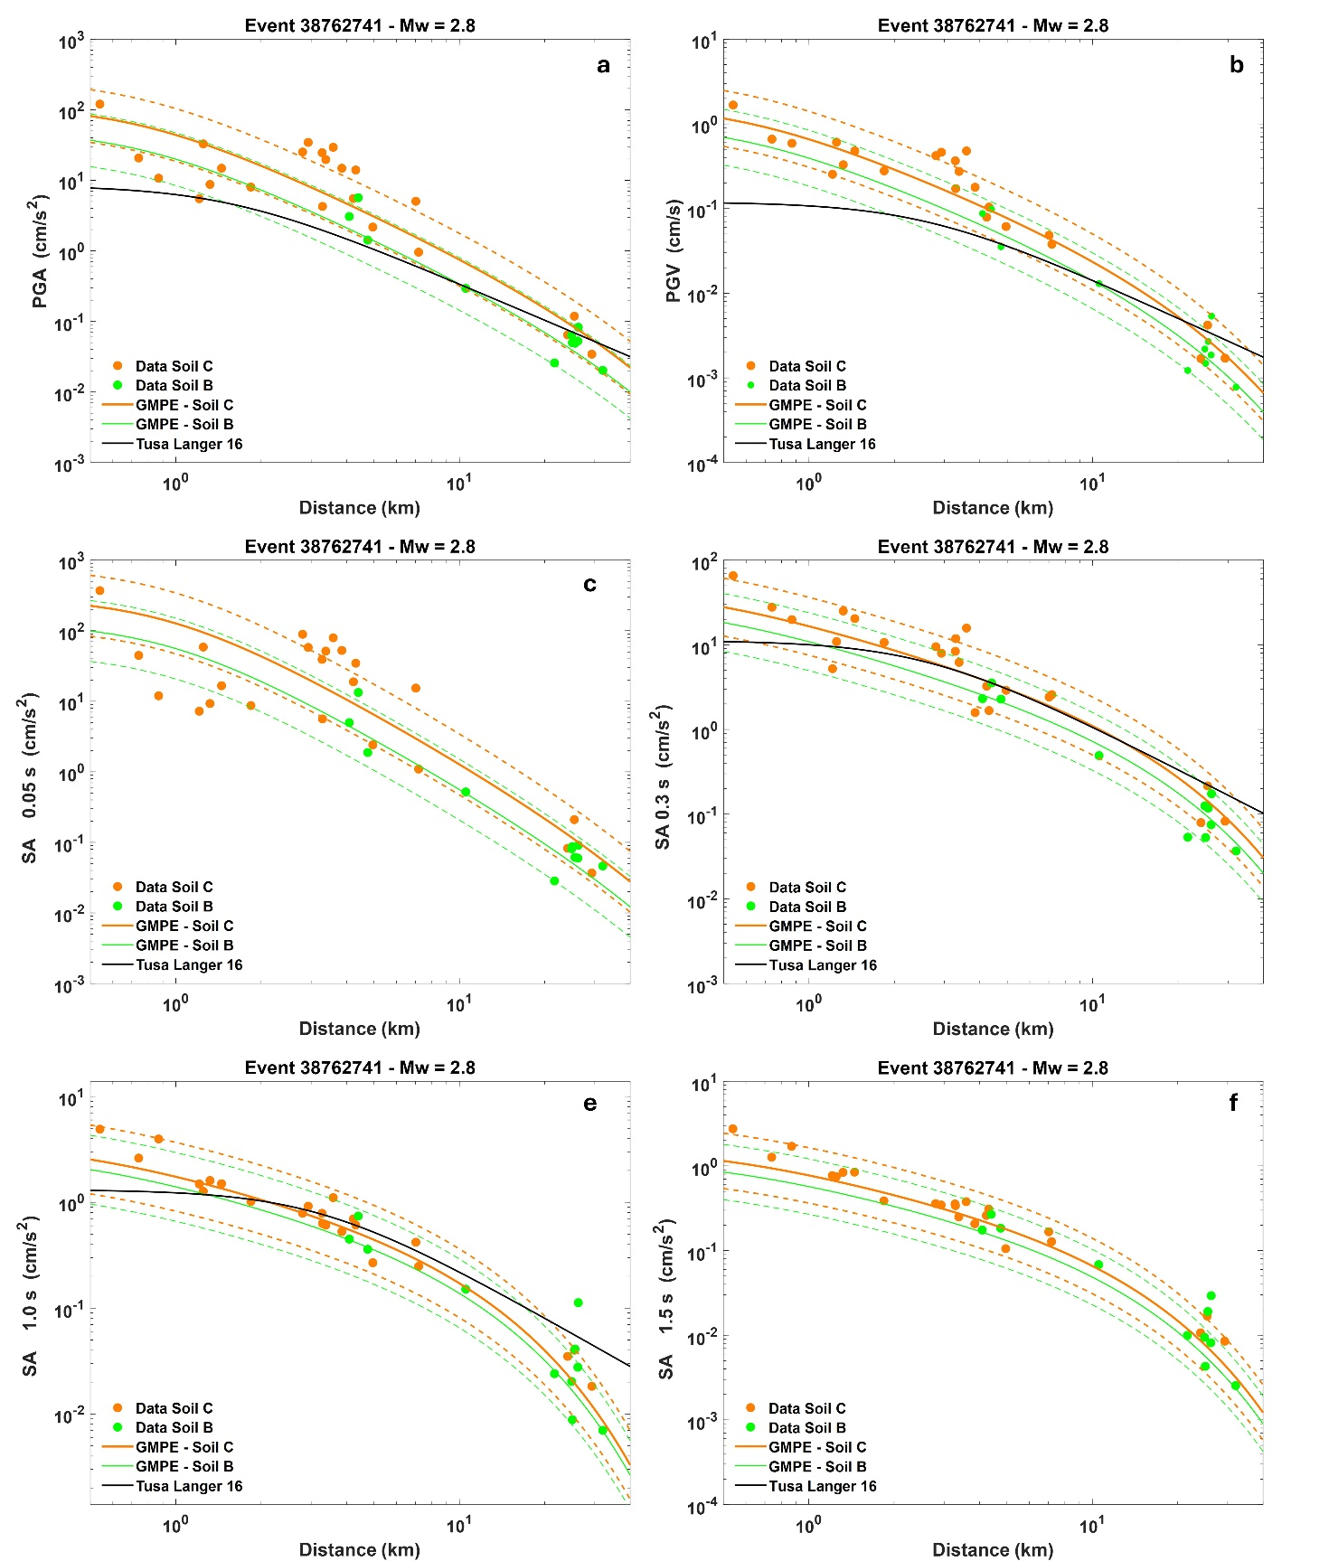
Figure S6 Ground motion data and GMPEs for (a) PGA; (b) PGV; (c) SA, $T=0.05 s$; (d) SA, $T=0.3 s$; (e) SA, $T=1.0 s$; (f) SA, $T=1.5 s$ The GMPEs are based on parameters collected in Table 2 and calibrated using the epicentral distance. The comparisons refer to the $M_{w}=2.8$ event with ID 38762741, which has been excluded from the calibration. Data and GMPEs are separated between soil B (green dots and curves) and soil C (orange dots and curves). Dashed lines mark the interval $±σ_{T}$ interval from the expected value of the GMPE. Solid black lines mark the expected shaking according to the TL16 GMPEs.

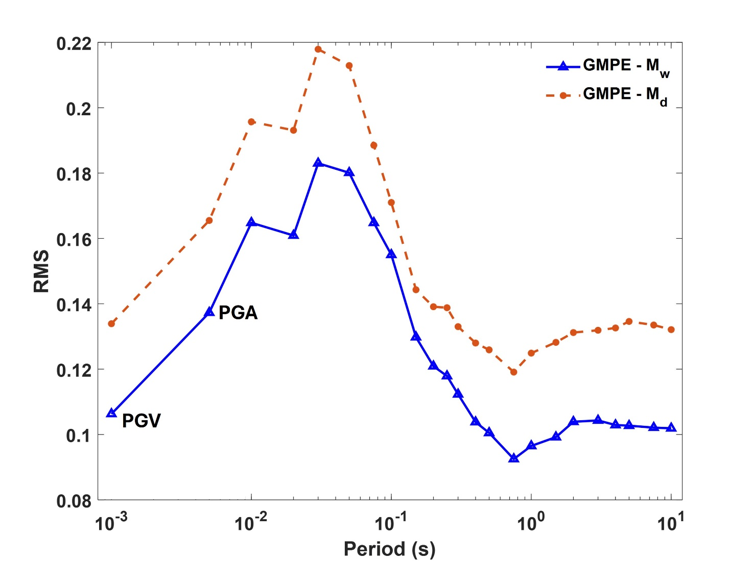
Figure S7: Comparison between RMS for GMPEs calibrated using the moment magnitude $M_{w}$ and the duration magnitude $M_{d}$

