Supporting Information

A High-Conductivity and Adhesive Ionogel Strain Sensor for Monitoring Stimulus-Response Behavior of Aquatic Organism

Yahui Wen^{1,2}, Xinghai Wang^{1,2}, Jinxue Zhao^{1,2}, Xuejing Zhai^{2,3}, Wei Xia ^{2,4}, Peiyi Li², Keqiang Lai ^{1*}, Meiwen Zhu⁵, Zhengde Lin⁶, Tuyan Luo⁷, Lidong Wu^{1,2*}

¹College of Food Science and Technology, Shanghai Ocean University, Shanghai, 201306, China

²Chinese Academy of Fishery Sciences, Beijing, 100141, China

³College of Food Science and Engineering, Dalian Ocean University, Dalian, 116023, China

⁴College of Environmental Science and Engineering, Beijing University of Technology, Beijing, 100020, China

⁵Chongqing Academy of Metrology and Quality Inspection, Chongqing 401123, China

⁶Ningbo Institute of Materials Technology and Engineering, Chinese Academy of Sciences, Ningbo 315201, China

⁷Institute of Agricultural Quality Standards and Testing Technology, Fujian Academy of Agricultural Sciences, Fuzhou 350002, China

*Corresponding author: kqlai@shou.edu.cn; wuld@cafs.ac.cn

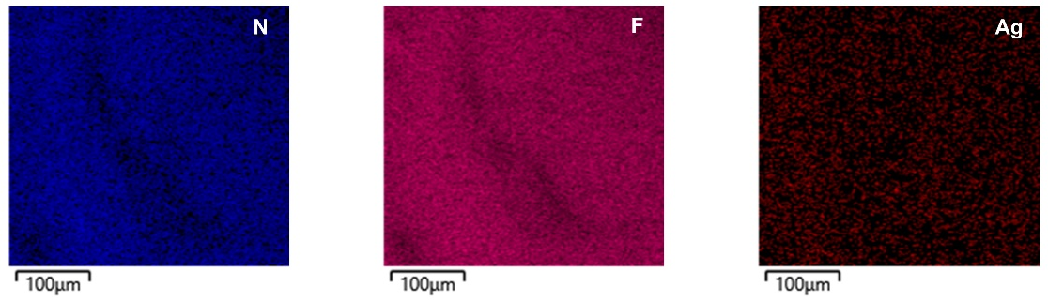

Figure S1. TEM-EDS analysis confirmed the distribution of N, F, and Ag elements in the AgILgel. The element N, unique to the cation of the ionic liquid, and the element F, unique to the anion of the ionic liquid, are uniformly dispersed along with the Ag element. AgNWs are uniformly interconnected within the AgILgel.

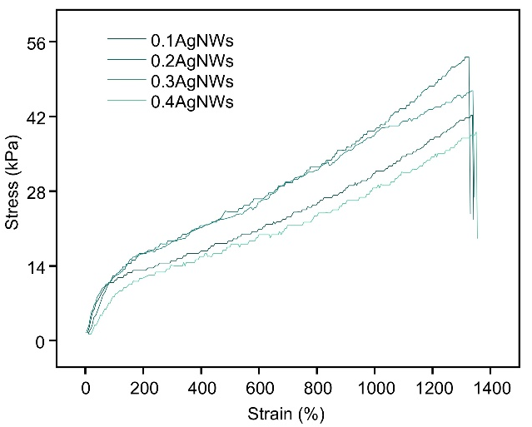

Figure S2. The stress-strain curve changes with the addition of AgNWs. As the amount of AgNWs gradually increases, the fracture strain properties of AgILgel do not show a significant reduction.

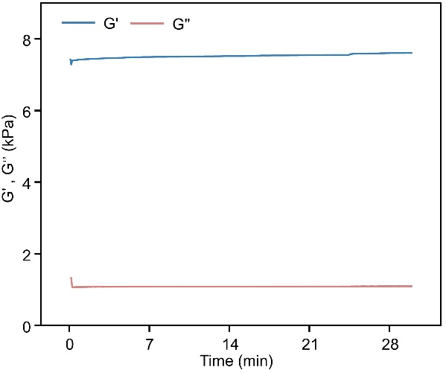

Figure S3. Graph of the variation of storage modulus and loss modulus over time. During the 30-minute test period, the storage modulus remained consistently stable and significantly higher than the loss modulus.

Figure S4. Figure showing the adhesion of AgILgel to various substrates. AgILgel has adhered to chicken liver, chicken heart, snail shells, clamshells, stone, ceramic, wood blocks, iron sheets, and foam.

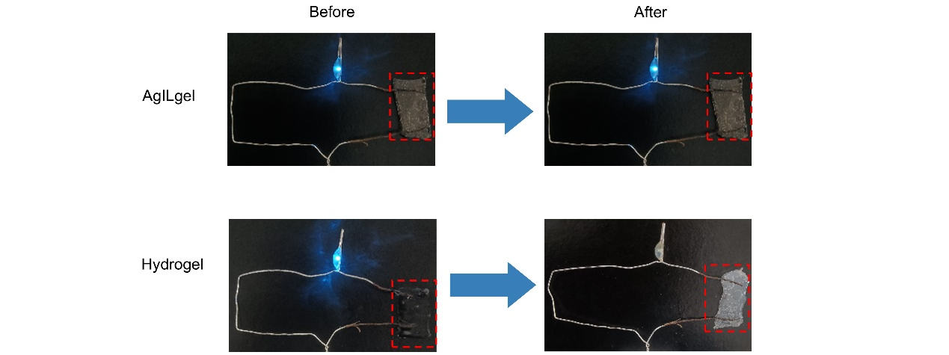
Figure S5. Testing the ability of AgILgel and hydrogel to light up a small bulb before and after oven treatment. After oven treatment, AgILgel can still light up the small bulb, while hydrogel cannot light up the small bulb.
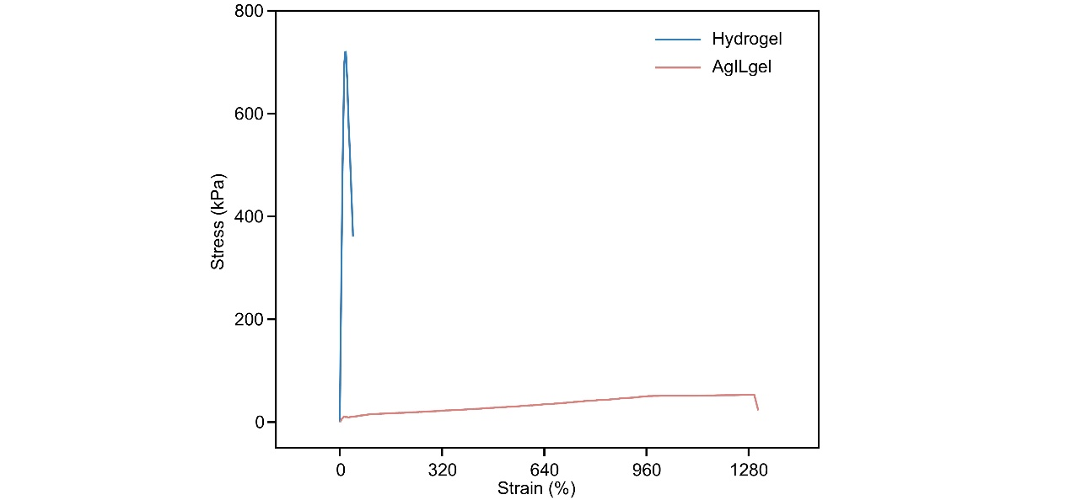
Figure S6. Comparison of tensile properties of the two materials before and after heating. The significant loss of water in the hydrogel resulted in a decrease in tensile properties. AgILgel, however, retained good tensile performance.
Figure S7. Electrical self-healing process of AgILgel. After being severed, AgILgel can still function as a conductive medium to light up a small bulb device. The resistance of AgILgel instantly recovers to its original value.

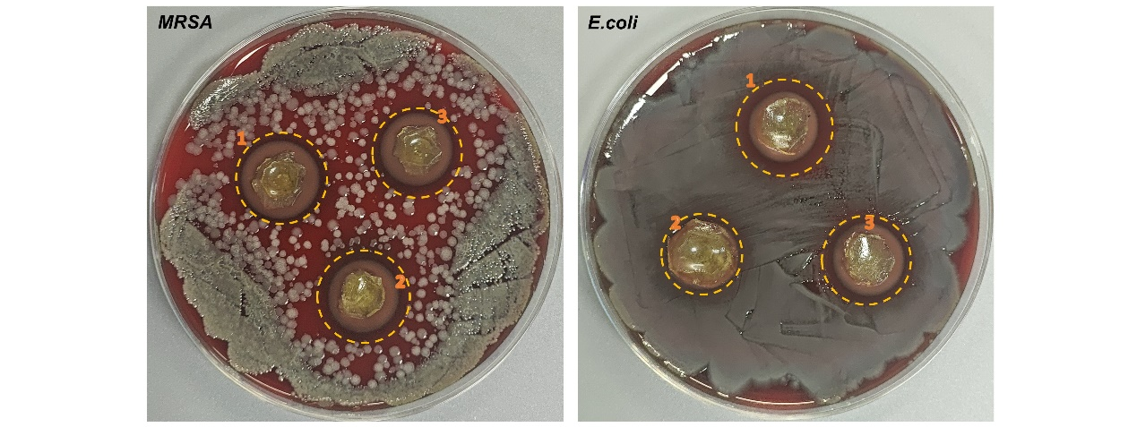
Figure S8. AgILgel exhibits excellent antibacterial properties. The diameter of the antibacterial zone 1 against MRSA : 16.5mm; The diameter of the antibacterial zone 2 against MRSA : 16.7mm; The diameter of the antibacterial zone 3 against MRSA : 16.2mm; The diameter of the antibacterial zone 1 against E.coli : 17.4mm; The diameter of the antibacterial zone 2 against E.coli :14.6mm; The diameter of the antibacterial zone 3 against E.coli :16.1mm

Figure S9. AgILgel used for monitoring sturgeon tail movement. AgILgel is attached to the fishtail and connected to a Bluetooth transmission device to monitor the tail's movements in real time.

Figure S10. AgILgel for Monitoring Bullfrog Vocal Sac Movements. AgILgel was applied to the bullfrog's vocal sac and connected to a Bluetooth wireless transmission device. The movement of the bullfrog's vocal sac exhibited regular patterns with considerable amplitude, and the resulting data demonstrated consistent and reproducible results.

Figure S11. AgILgel used for monitoring bullfrog movements. AgILgel is attached to the frog's leg and connected to a Bluetooth transmission device to monitor the bullfrog's movements in real time.

Table S1. The composition of AgILgel with different contents of AgNWs
w% | AgNws (g) | AA (g) | Ils (g) | BIS (g) | APS (g)
0.1 | 0.03 | 0.9 | 2.1 | 0.0045 | 0.0045
0.2 | 0.06 | 0.9 | 2.1 | 0.0045 | 0.0045
0.3 | 0.09 | 0.9 | 2.1 | 0.0045 | 0.0045
0.4 | 0.12 | 0.9 | 2.1 | 0.0045 | 0.0045

