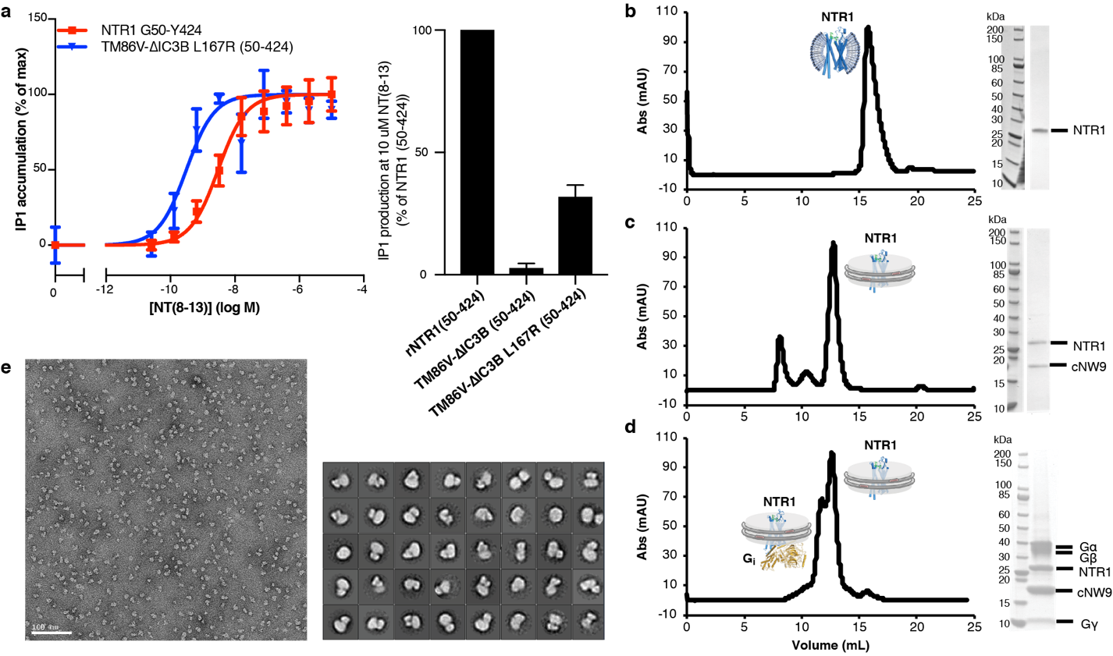
Extended Data Fig. 1 | Signaling competency and preparation of NT-NTR1-G_{i} complex in cNDs. a, Signaling competency of NTR1 constructs. Wild-type NTR1 (50-424) or NTR1 variants were transiently transfected into HEK293T/17 cells, and activation of Gα_{q} signaling was quantified by measuring of inositol-1-phosphate (IP1) accumulation after stimulation with NT_{8–13}. Data were normalized to receptor expression at the cell surface and represented as mean ± SEM of 4 independent experiments performed in duplicate. Left, dose dependent IP1 production expressed as percentage of IP1 accumulation at maximal ligand concentration. Fitting of the curves result in EC50 of 2.664 nM for wild-type NTR1 and 0.2188 nM for TM86V ΔIC3B L167R. Right, bar graph showing IP1 production level at 10 μM agonist NT₈₋₁₃. The NTR1 variant TM86V ΔIC3B lacking the L167R back mutation exhibits no IP1 production, suggesting the critical role of R167^{3.50} in signal transduction. b-d, Size-exclusion chromatograms and corresponding SDS-PAGE gels for NTR1 in DH₇PC detergent micelles (b), NTR1 in POPC/POPG cNW9 nanodiscs (c) and NTR1-G_{i} complex in POPC/POPG cNW9 nanodiscs (d). e, Fractions corresponding to the NT-NTR1-G_{i} complex in (d) were analyzed by negative-stain EM, and then used for cryo-EM structure determination. Top, representative negative-stain EM micrograph of NT-NTR1-G_{i} complexes in cNDs. Bottom, 2D class averages.

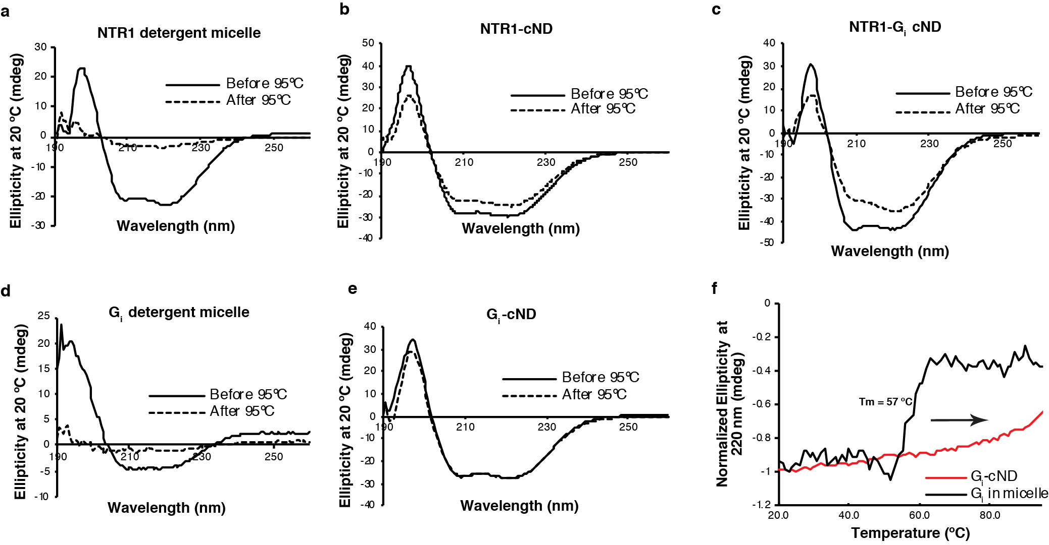
Extended Data Fig. 2 | Thermostability enhancement of NTR1, G_{i}, and NTR1-G_{i} complexes by incorporation into cNDs. a-e, Circular Dichroism (CD) spectra at 20 ºC before (solid line) and after (dashed line) treatment at 95 ºC of (a) NTR1 in DH₇PC detergent micelles; (b) NTR1 in cNDs; (c) NTR1-G_{i} complex in cNDs; (d) G_{i} in detergent micelle; (e) G_{i} in cNDs. G_{i} was reconstituted into cNDs by incubation with POPC/POPG lipid, cNW9, and cholate, followed by detergent removal and size-exclusion chromatography. f, Temperature-dependent CD signals of G_{i} in detergent micelles (black) and cNDs (red) at 220 nm. The melting temperature (Tm) of cNDs is 93 ºC (data not shown) and therefore does not affect transitions before this temperature. NTR1 and G_{i} account for at least 50% of CD signals even in the presence of cNDs. NTR1 in detergent micelles irreversibly unfolds during temperature increase with a Tm of 62 ºC. In contrast, NTR1-cND changes structure around 80 ºC and does not lose much secondary structure after decreasing temperature to 20 ºC. Similar observations were made for G_{i}, where the protein irreversibly and completely unfolds with Tm of 57 ºC in detergent micelles but displays no clear transition temperature in cNDs even until 95 ºC. For the NTR1-G_{i} complex in cND, only mild unfolding was observed around 82 ºC. These observations indicate that lipid bilayers improve the stability of NTR1, G_{i} and NTR1-G_{i} complexes relative to detergent micelles.

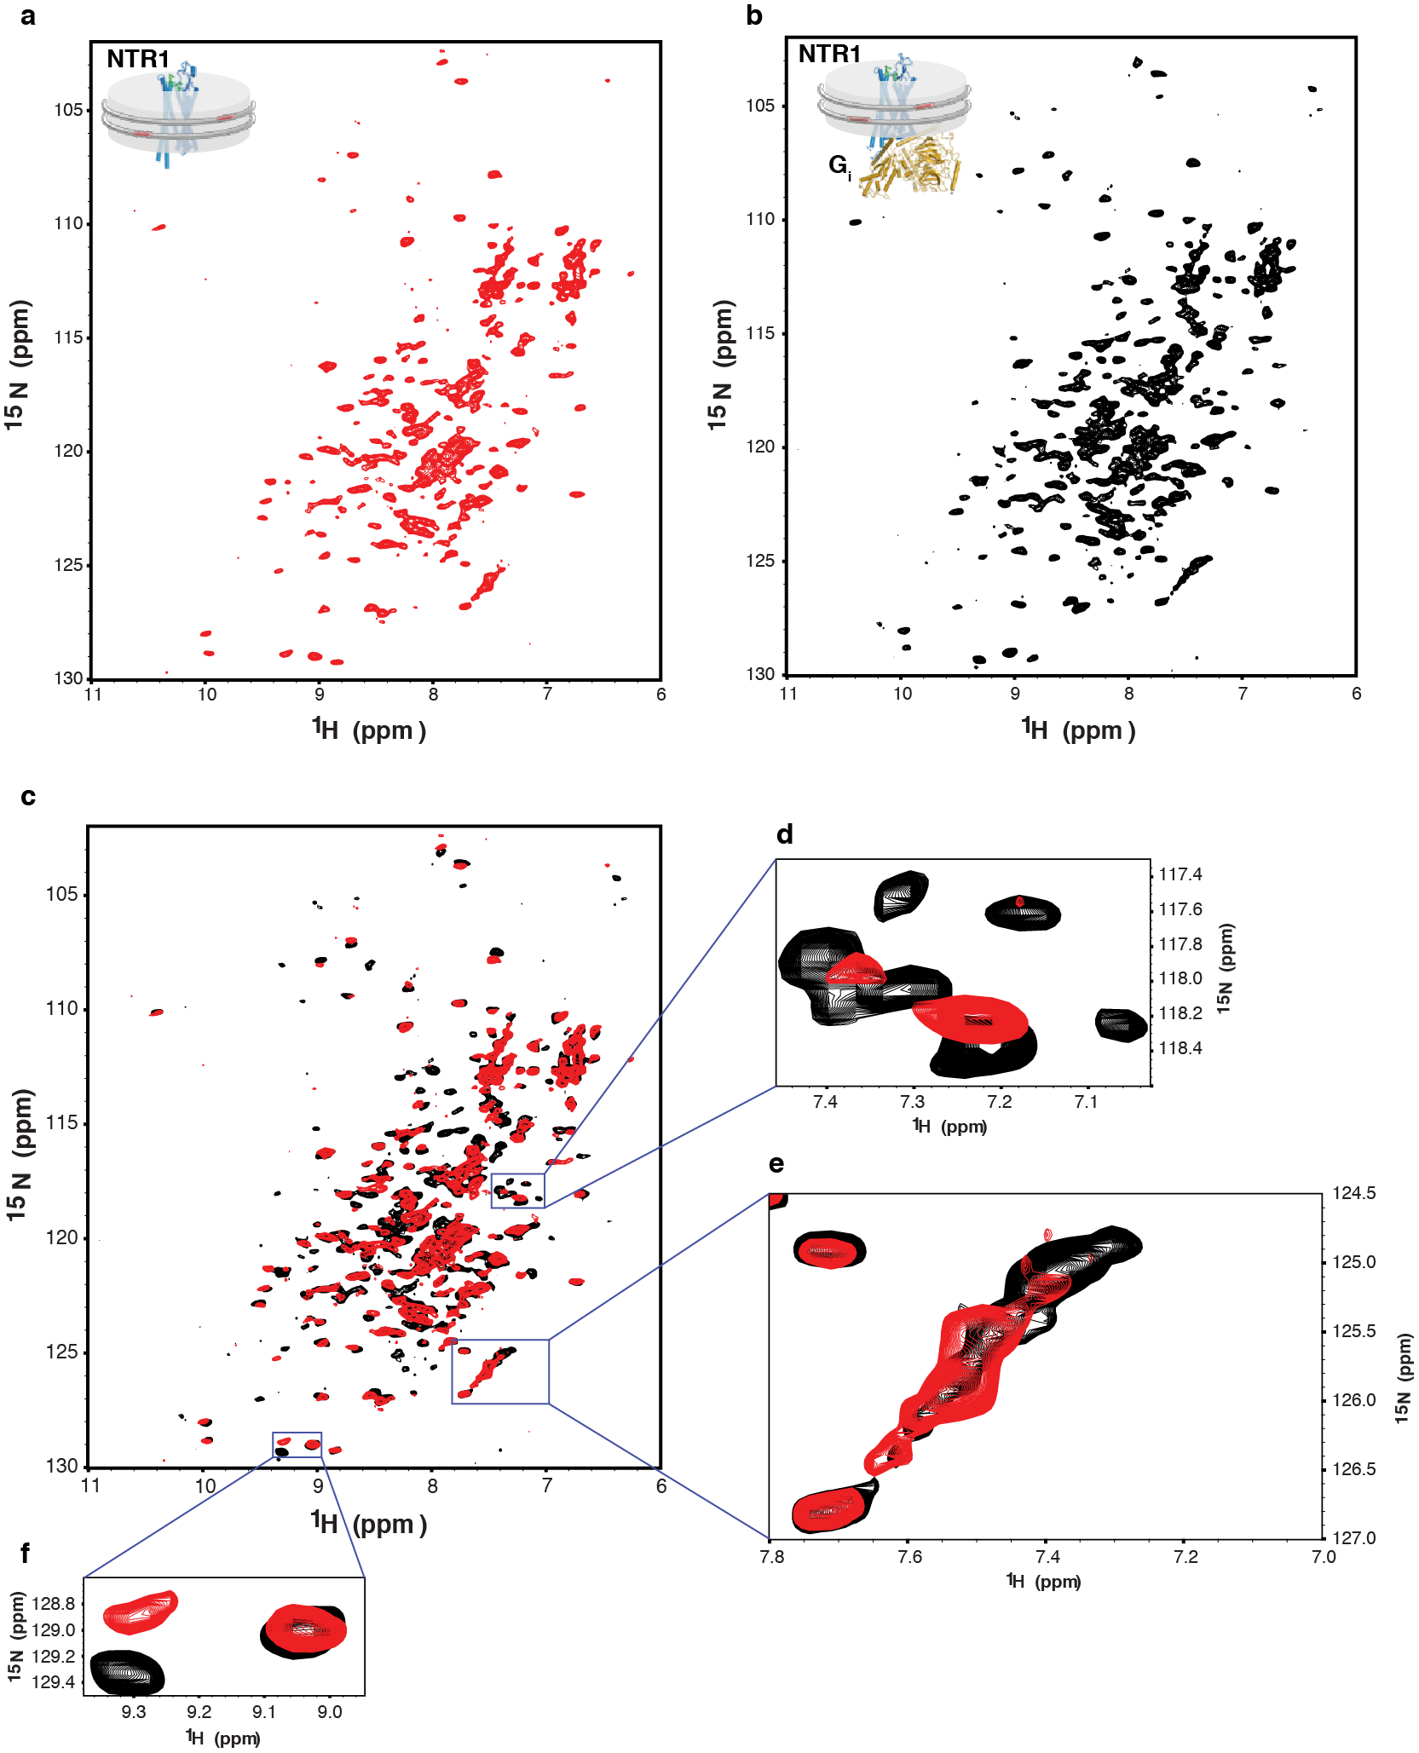
Extended Data Fig. 3 | Characterization of the interaction between NT-NTR1 and G_{i} in cNDs by two-dimensional ¹H, ¹⁵N-TROSY HSQC NMR spectroscopy. a-b, NMR spectrum of ¹⁵N-labeled NT-NTR1 in cNDs in the absence (a) and presence (b) of G_{i}. c, Overlay of (a) (red) onto (b) (black) showing structural and dynamical changes of NT-NTR1 upon binding to G_{i} in cNDs. d, A region showing conformational stabilization of NTR1. More peaks could be observed in the presence of G_{i}, suggesting that NTR1 is highly dynamic in the absence of G_{i} and resonances are averaged out among a wide range of conformers resulting in low signal-to-noise ratio and even disappeared peaks. Upon interaction with G_{i}, NTR1 is stabilized into fewer conformers and becomes less dynamic, which leads to better signal-to-noise ratio and more resonances being observable. e, A region showing dynamically slow-exchange shift of NTR1 upon interaction with G_{i}. f, A region showing chemical shift perturbation of NTR1, suggesting conformational change of NTR1 upon binding to G_{i} in cNDs.

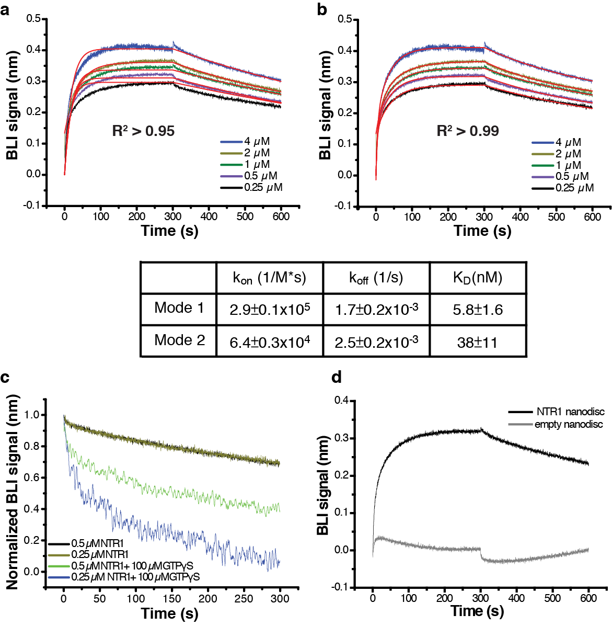
Extended Data Fig. 4 | Characterization of the binding kinetics between NT-NTR1 and G_{i} in cNDs. a-b, Fitting of Bio-Layer Interferometry (BLI) traces of G_{i} binding to NT-NTR1-cND using one binding mode (a) and two binding mode (b) shows better fitting using two binding mode. Below, a table showing k_{on}, k_{off} and K_{D} from the two binding mode fitting. c, Dissociation between G_{i} and NT-NTR1-cND in the absence (black and brown) and presence (green and blue) of GTPγS, showing faster dissociation of the complex in the presence of GTPγS, suggesting the capability of the NTR1-Gα_{i1}β₁γ₁ complex in cNDs to perform GDP/GTP exchange. d, Association and dissociation kinetics of G_{i} binding to NT-NTR1-cND (dark) and empty cND (gray), showing much slower association and faster dissociation of G_{i} binding to empty cND compared to NT-NTR1-cND, suggesting that interaction between G_{i} and NT-NTR1-cND is driven by G_{i} binding to NTR1 rather than to the nanodisc.

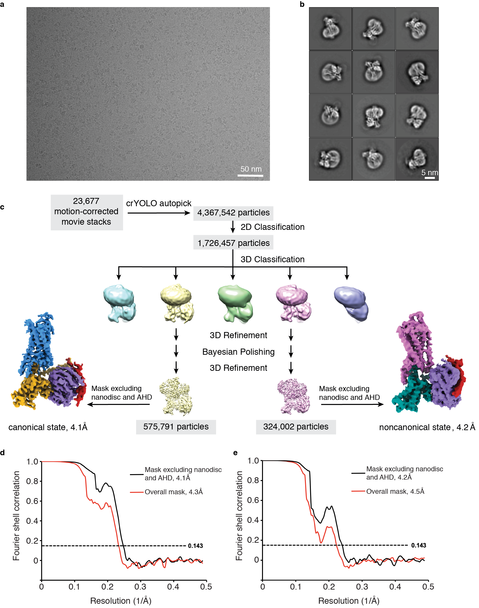
Extended Data Fig. 5 | Cryo-EM data processing. a, Representative micrograph showing the distribution of NT-NTR1-G_{i}-cND particles in vitreous ice. b, Selected two-dimensional class averages showing secondary structure features. The cND has an approximate diameter of 9 nm. c, Simplified flow chart of the cryo-EM processing. Two datasets were collected and processed similarly; the number of particles shown here are a conflation of both datasets. Two well-resolved classes corresponding to canonical and noncanonical states were identified. Further rounds of classification did not improve the resolution or map quality. d-e, Fourier shell correlation (FSC) curves for the canonical state (d) and noncanonical state (e) with masks that either include or exclude the cND and AHD.

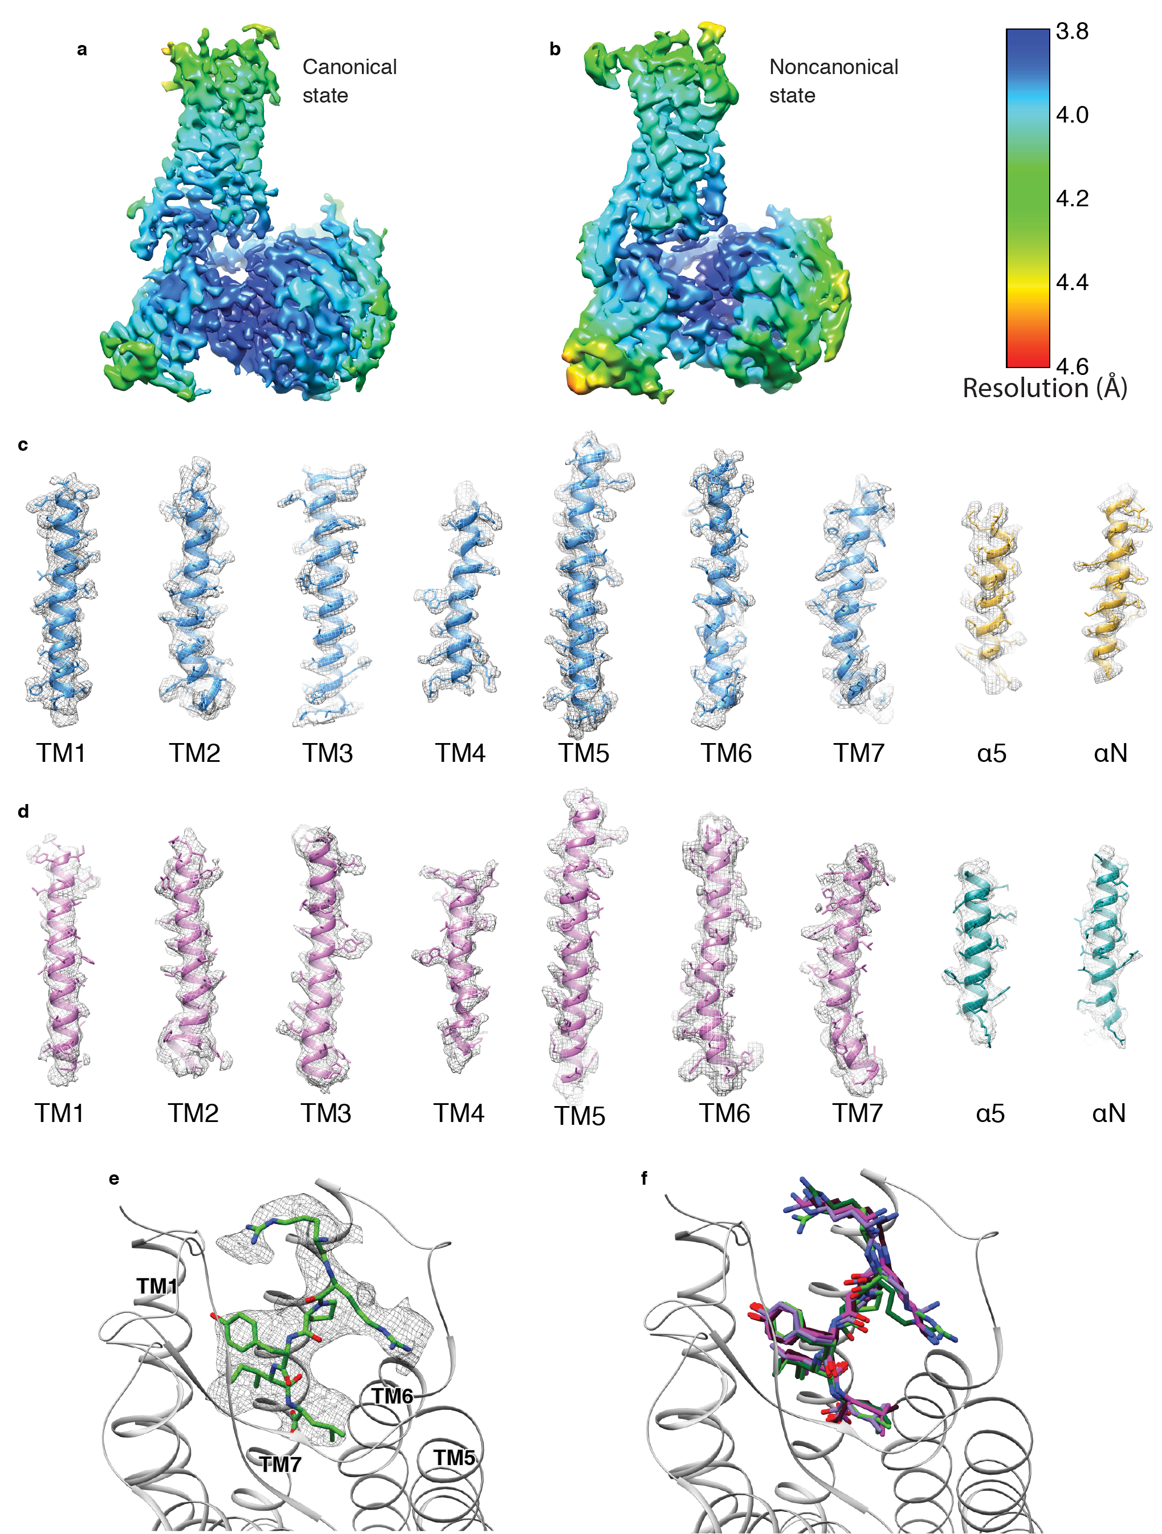
Extended Data Fig. 6 | Cryo-EM density. a-b, Local resolution of the NT-NTR1-G_{i} complex in the canonical state (a) and noncanonical state (b). The local resolution is calculated in Relion. c-d, Density and model for the transmembrane helices of NTR1 and theα5 and αN helices of Gα_{i1} in the canonical state (c) and noncanonical state (d). e, Density and model for NT₈₋₁₃. f, Superposition of the atomic models of NT₈₋₁₃ from the NT-NTR1-G_{i}-cND complex in the canonical (light green), and noncanonical state (dark green) with NT from the NT-NTR1 crystal structure (purple; PDB 4XEE) and JMV449 (a NT analog) from the NTR1-G_{i}-micelle complex in the canonical (magenta; PDB 6OS9) and noncanonical state (dark red; PDB 6OSA).

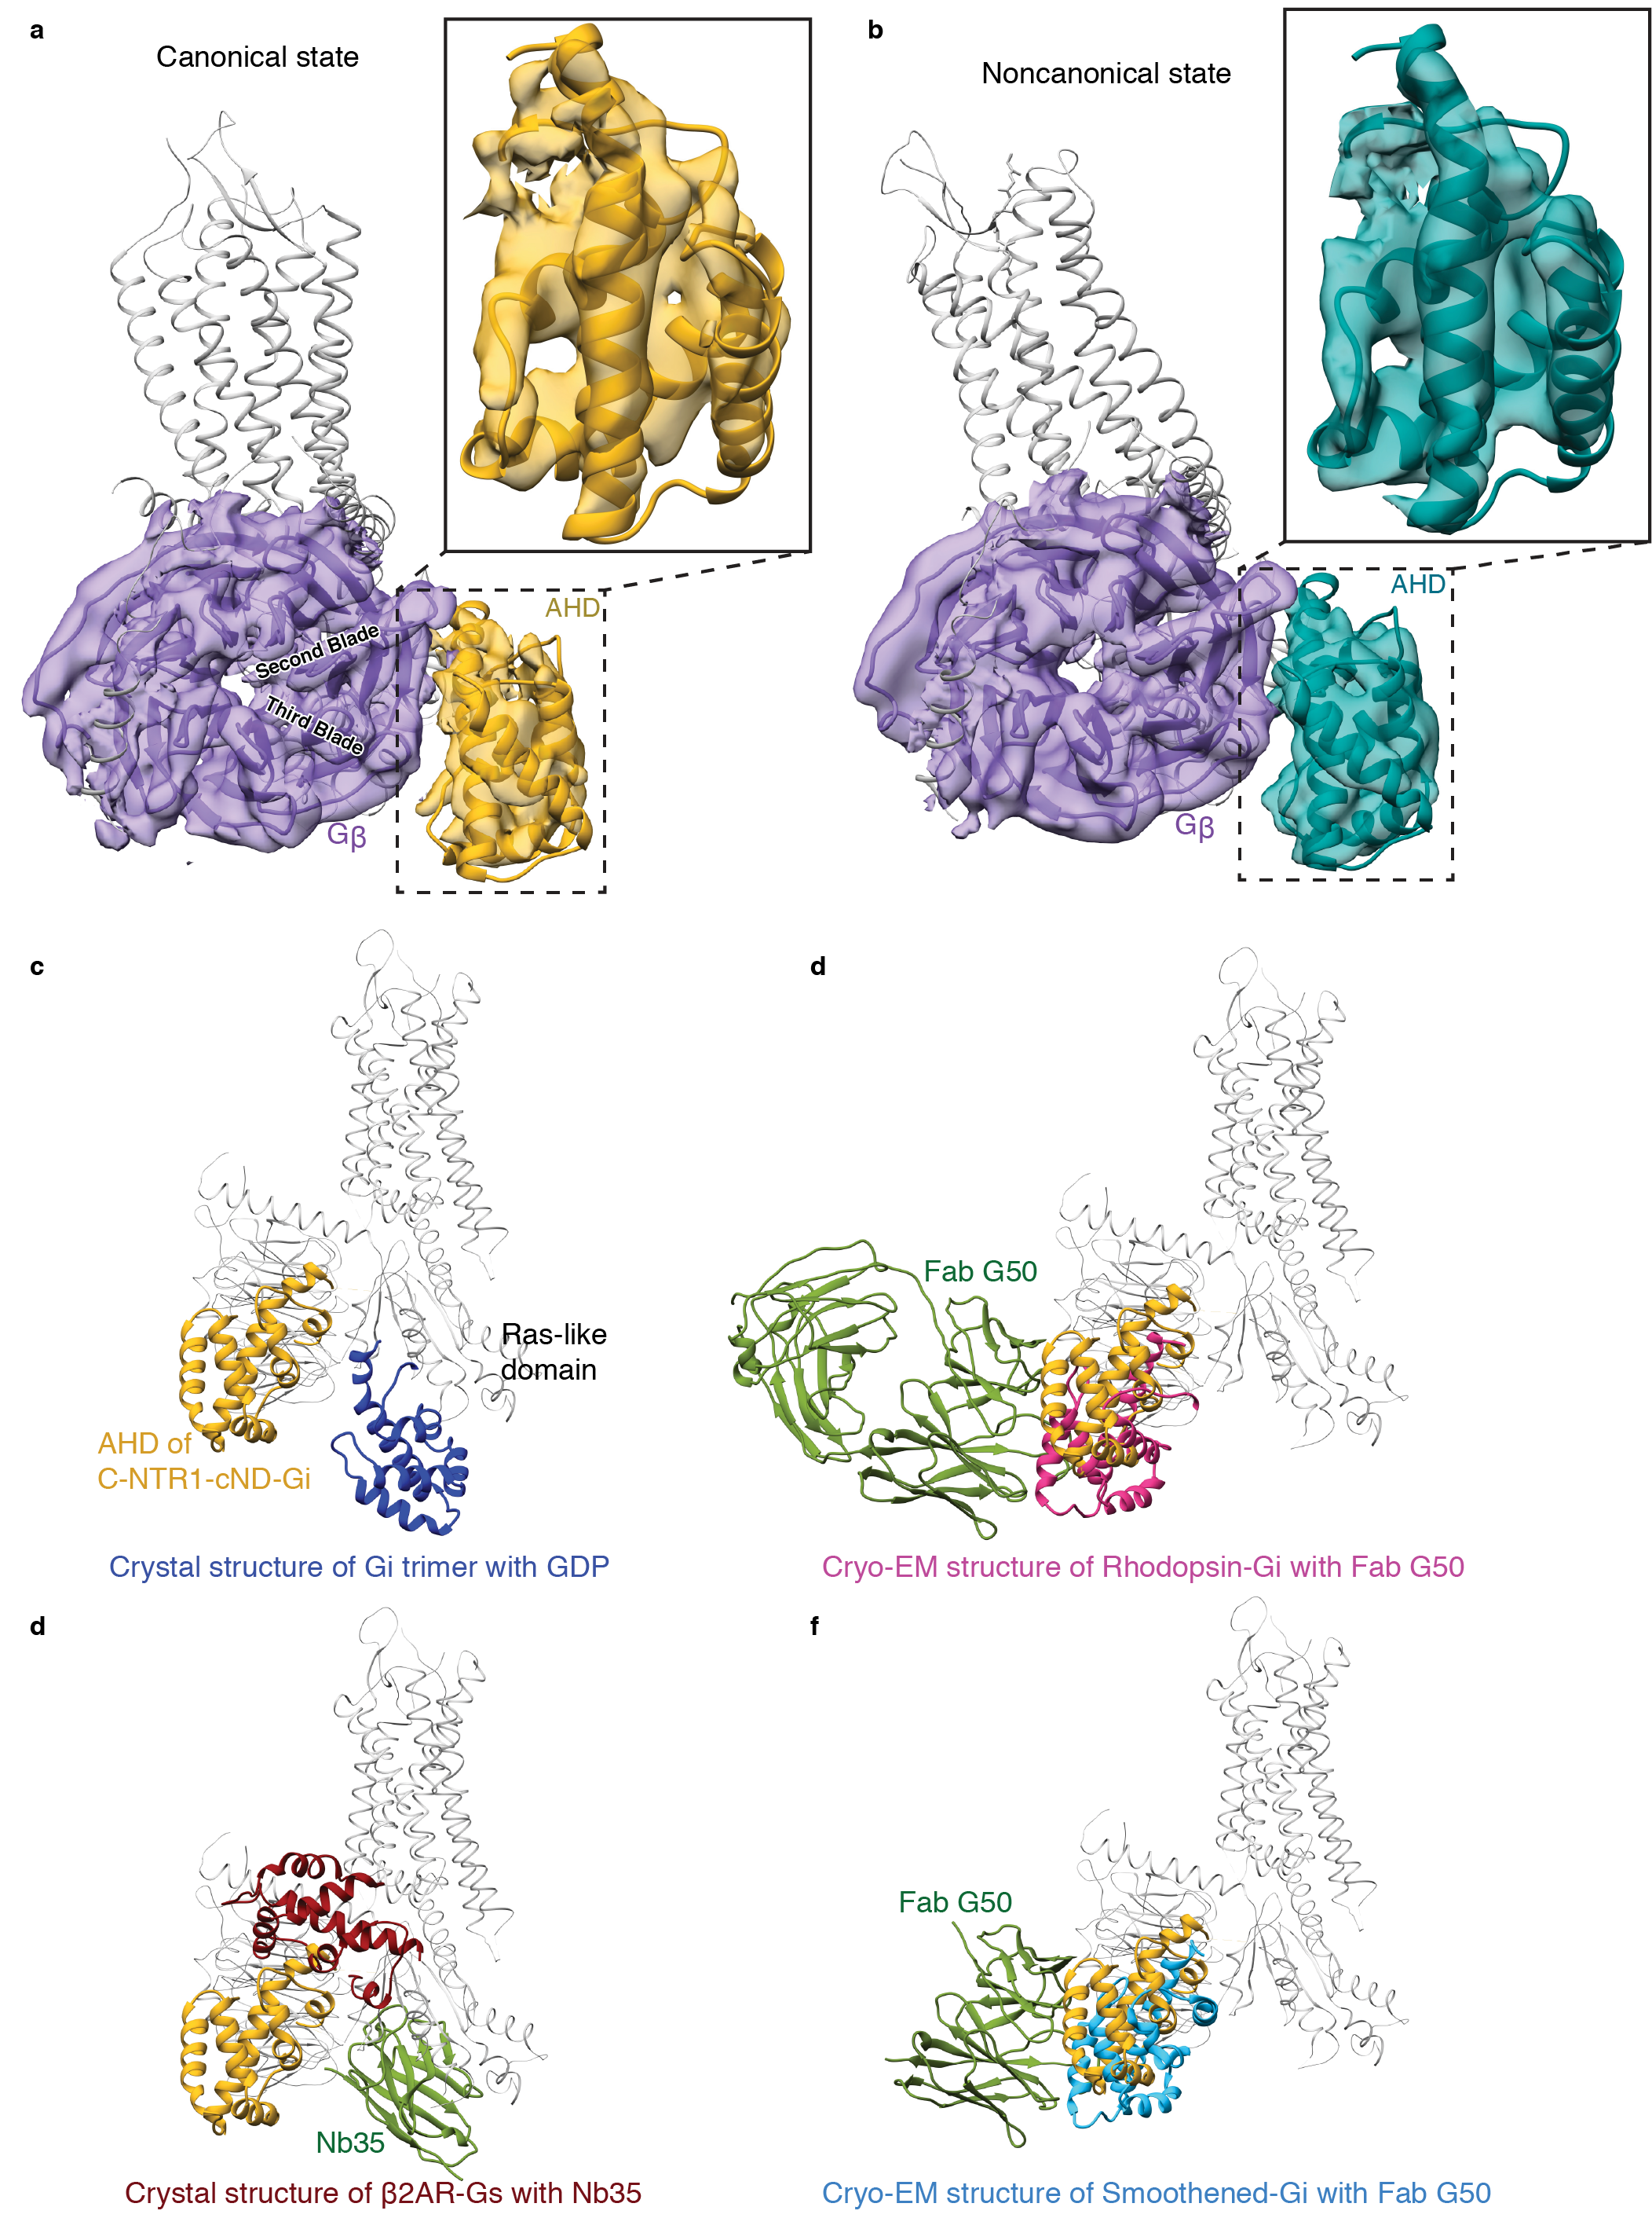

Extended Data Fig. 7 | Structure of the α-helical domain (AHD). a, Density maps and models showing the interaction between Gβ₁ (purple) and Gα_{i1} AHD (gold) in the canonical state. Zoom-in view of the Gα_{i1} AHD is shown. b, Density maps and models showing the interaction between Gβ₁ (purple) and Gα_{i1} AHD (dark green) in the noncanonical state. Zoom-in view of the Gα_{i1} AHD is shown. The models in (a) and (b) are superposed on the Gβ₁ subunits and are shown in the same view. AHD in both states interacts with the second and third blades of Gβ₁. c-f, Comparison of the AHD of the canonical state NT-NTR1-Gi-cND (gold) with c, A crystal structure of GDP-G_{i} (blue; PDB 1GP2), d, A crystal structure of β₂AR-G_{s} with nanobody Nb35 (AHD is dark red and Nb35 is green; PDB 3SN6), e, A cryo-EM structure of Rhodopsin-G_{i} with Fab G50 (AHD is pink and Fab G50 is green; PDB 6CMO), and f, A cryo-EM structure of Smoothened-G_{i} with Fab G50 (AHD is light blue and Fab G50 is green; PDB 6OT0). The models are superposed on the Gα Ras-like domain.

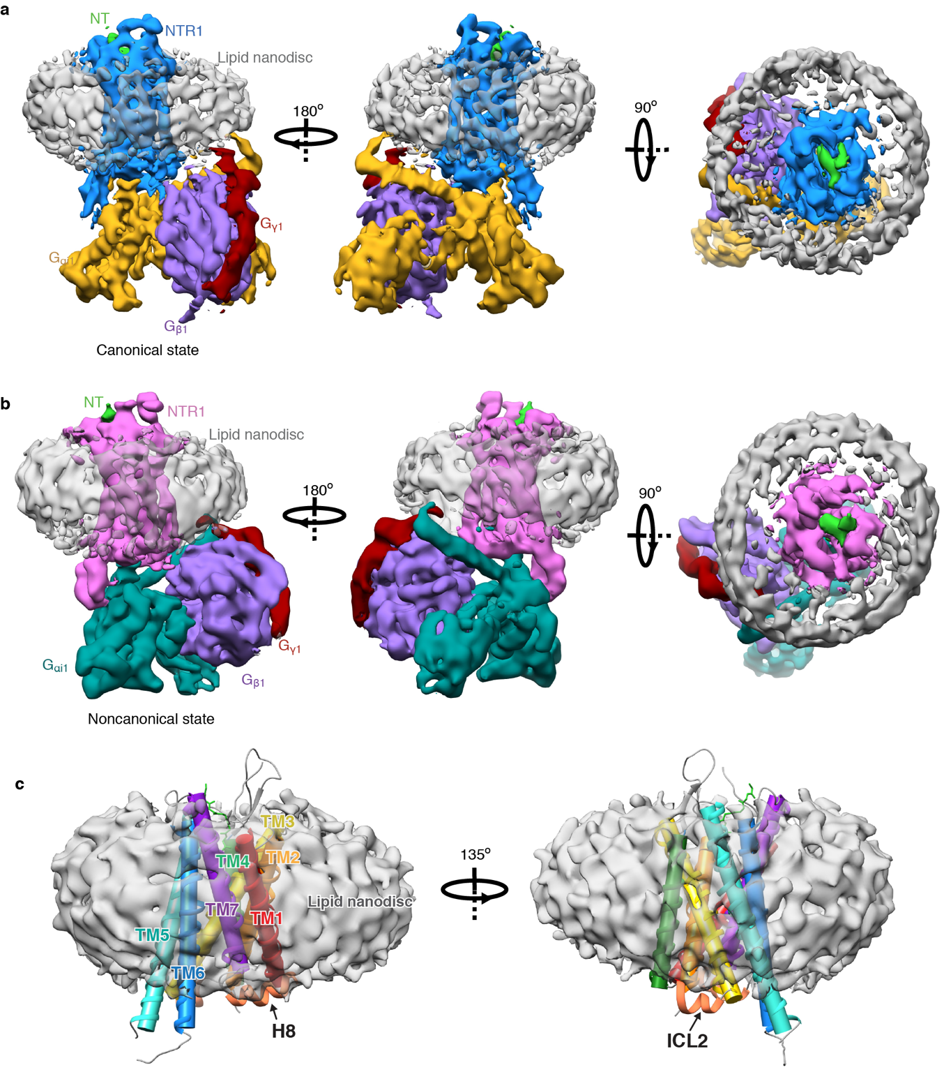

Extended Data Fig. 8 | Cryo-EM structure of the NT-NTR1-G_{i} complex in lipid nanodiscs and the interaction with lipid. a, Three views of the cryo-EM density map of the NT-NTR1-G_{i}-cND complex in the canonical state. b, Three views of the cryo-EM density map of the NT-NTR1-G_{i}-cND complex in the noncanonical state. The maps in panels (a) and (b) are low-pass filtered to 5 Å and colored by subunit. c, Two views of NT-NTR1 surrounded by nanodisc density. The transmembrane helices are shown in cylinder representation using the rainbow coloring scheme. ICL2 and helix H8 are partially submerged in lipid.

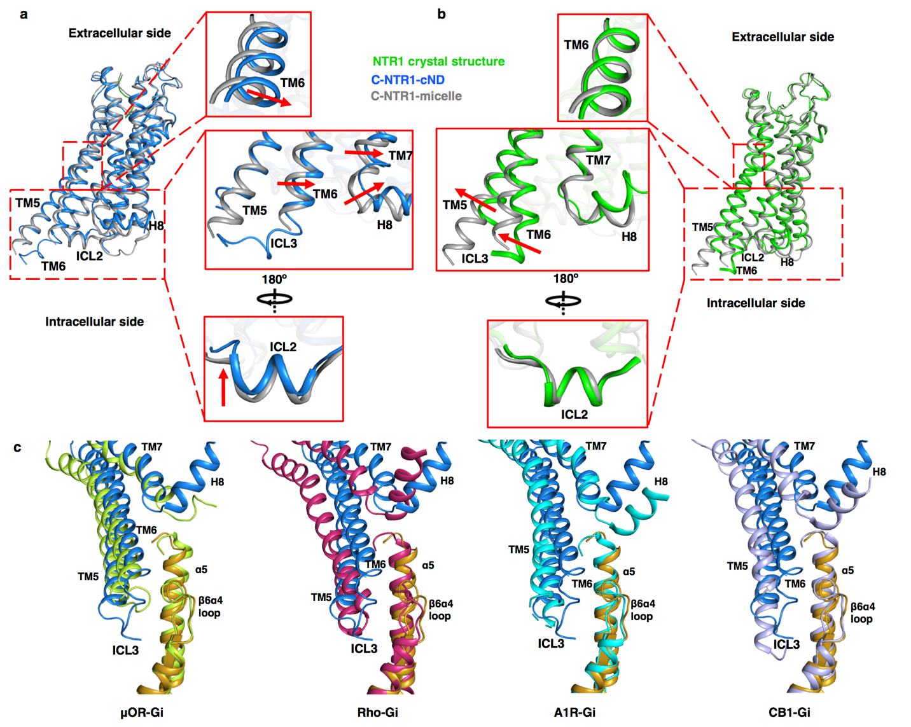

Extended Data Fig. 9 | Impact of lipid bilayer on the structure of NTR1. a, Comparison between the cryo-EM structures of the canonical states of NTR1 (with G_{i}) in lipid bilayer (blue) and detergent (gray). b, Structural comparison between the crystal structure of NTR1 in detergent (green) and the cryo-EM structure of the canonical state of NTR1 in complex with G_{i} in detergent (gray). The atomic models in (a) and (b) are superposed on NTR1. c, Comparison of the localization of TM5-TM6 relative to α5 helix of Gα in class A GPCR-G_{i} complex structures, including the canonical state NTR1 (blue) in complex with G_{i} (gold) structure reported in the current study, μOR-G_{i} (lime green; PDB 6DDE), Rho-G_{i} (hot pink; PDB 6CMO), A₁R-G_{i} (cyan; PDB 6D9H), and CB1-G_{i} (purple; PDB 6N4B). The models are superposed on the Ras-like domain of Gα.

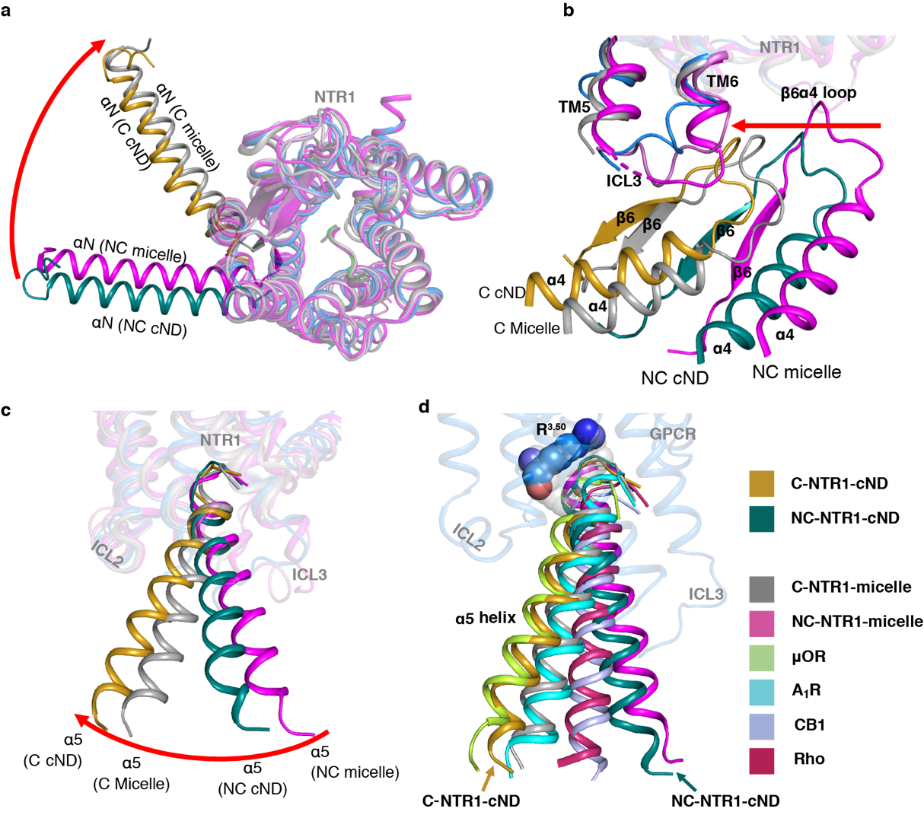
Extended Data Fig. 10 | Comparison of NTR1-G_{i} interaction in lipid bilayer with detergent micelles. a-c, Superposed structure of C-state NTR1 (blue) and Gα (gold), NC-state NTR1 (orchid) and Gα (dark cyan), C-state NTR1 and Gα in micelle (gray), NC-state NTR1 and Gα in micelle (magenta). The models are superposed on NTR1. a, extracellular view of NTR1 and αN helix; b, side view of NTR1 ICL3 and β6α4 loop; c, side view of NTR1 and α5 helix. d, Comparison of the localization of α5 helix relative to GPCR in class A GPCR-G_{i} complex structures, including the canonical (gold) state and noncanonical (dark cyan) state structure reported in the current study, canonical (gray) and noncanonical (magenta) state of NTR1-G_{i} in detergent micelle, μOR-G_{i}, Rho-G_{i}, A₁R-G_{i}, and CB1-G_{i} in the same colors as panel (b). The structures are superposed on the GPCR. Residue R^{3.50} is shown as colored spheres in C-state NTR1 and as partially transparent gray spheres in the other GPCRs.

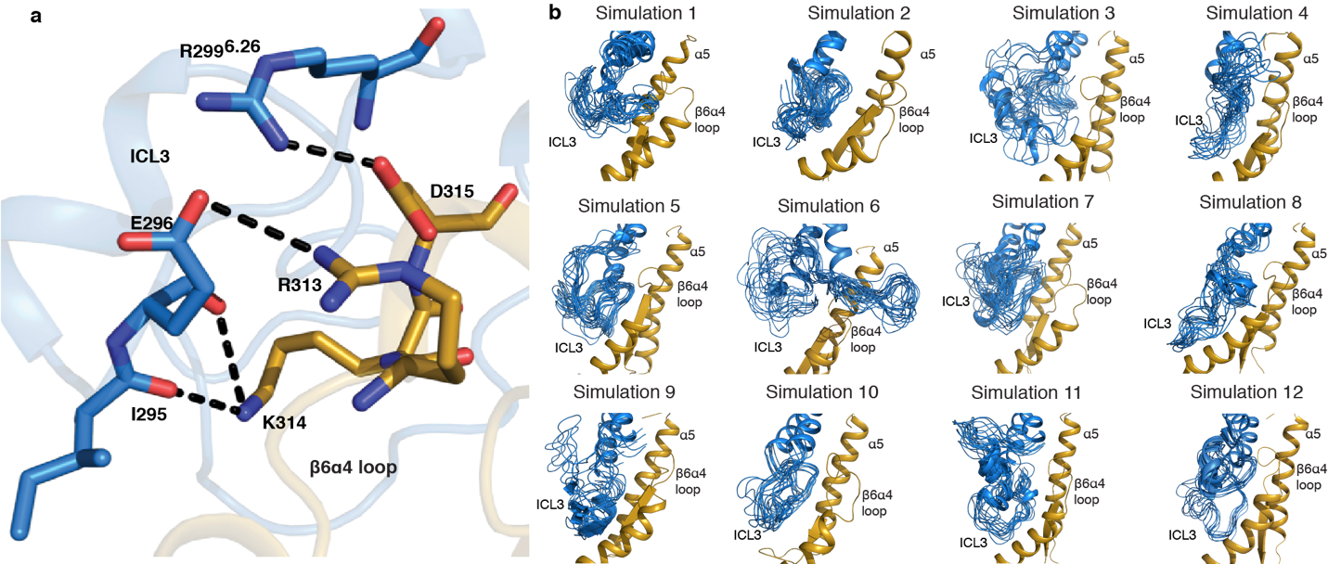
Extended Data Fig. 11 | Molecular dynamics (MD) simulation for the interaction between ICL3 and the β6α4 loop. a, MD simulation showing salt bridges and hydrogen bonds form between TM6-ICL3 and β6α4-loop in the canonical state of NT-NTR1-Gi-cND represented by simulation 12. b, Dynamics of ICL3 for each independent simulation of the canonical state of NT-NTR1-G_{i}-cND. Frames are sampled every 40 ns from each individual simulation. All 12 simulations show various interactions including salt bridges/hydrogen bonds between ICL3 and the β6α4-loop. An example of detailed interactions is shown in (a). NTR1 is colored in blue and G_{i} in gold in (a-b).

