Supplemental Material

Appendix A: Flowchart of the study sample

Individuals between 2008-2017 who were on metformin and went onto have second-line add on treatment, fulfilling inclusion and exclusion criteria of the study (N=32,820)

Removed cases with other second-line add on treatment than Sulphonylureas or DPP-4 inhibitors:
Thiazolidinediones (N=2,363, 7.2% of 32,820)
Insulin (N=984, 3.0% of 32,820)
GLP-1 analogues (N=605, 1.8% of 32,820)
SGLT-2 inhibitors (N=475, 1.4% of 32,820)

Cases removed due to missing data*, for performing a complete case analysis:
Missing data in HbA1c (N= 2,665, 8.1% of 32,820)
Missing data in systolic blood pressure (N= 560, 1.7% of 32,820)
Missing data in weight (N= 1,331, 4.1% of 32,820)

Study Cohort (N= 23,837)

(*) Smoking is a binary variable showing current and non-current smokers (i.e., ex-smoker or never smoker) and missing data on smoking were recoded as non-current smoker. This approach resulted in a prevalence of current smoker consistent with others reported elsewhere ,.

Appendix B: Kaplan Meier curves with risk tables for Figure 2.

Appendix C: Sensitivity Analysis for Figure 2 (including all-cause mortality in MACE)
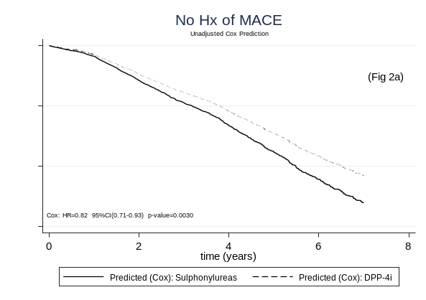
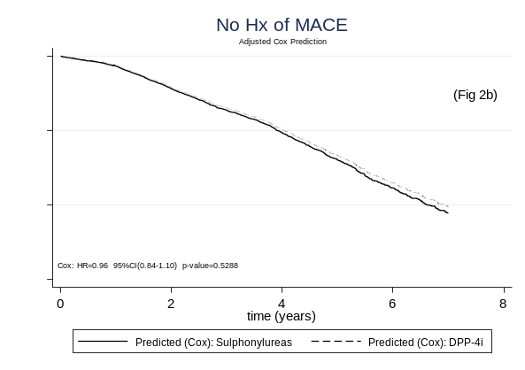
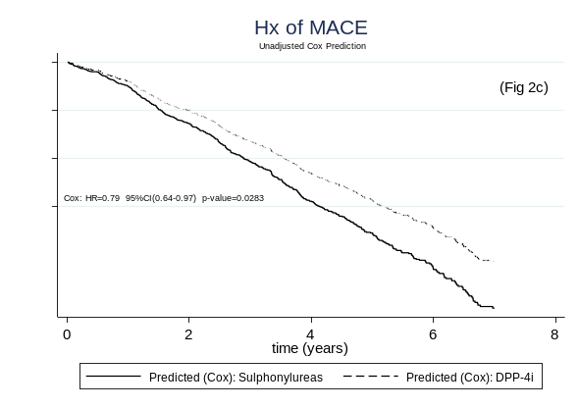
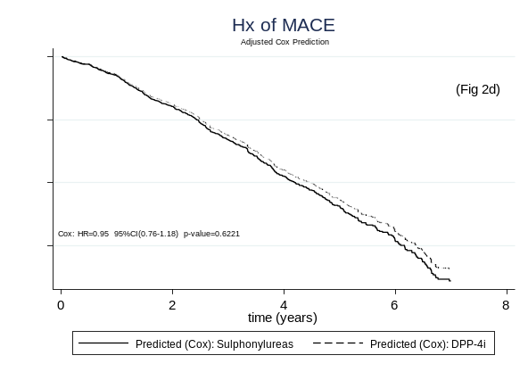
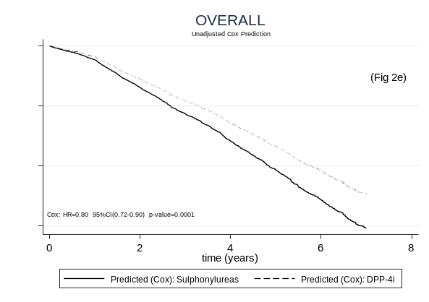
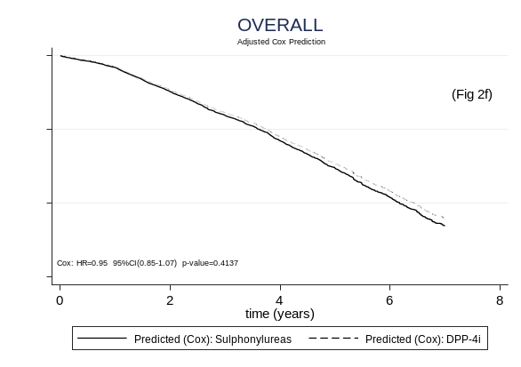

Sensitivity Analysis for Figure 2. Cox regression survival predictions on major adverse cardiovascular events (MACE) and all-cause mortality (composite outcome), comparing Sulphonylureas and DPP-4i cohorts for people with no history of MACE (No Hx of MACE), with history of MACE (Hx of MACE) and overall, unadjusted (left column: Fig 2a, Fig 2c, Fig 2e) and adjusted for baseline covariates (right column: Fig 2b, Fig 2d, Fig 2f). Event-free survival over time, hazard ratios with 95% confidence intervals and p-values are reported.

Patorno E, Goldfine AB, Schneeweiss S, Everett BM, Glynn RJ, Liu J, Kim SC. Cardiovascular outcomes associated with canagliflozin versus other non-gliflozin antidiabetic drugs: population based cohort study. Bmj. 2018 Feb 6;360.
Hippisley-Cox J, Coupland C. Diabetes treatments and risk of heart failure, cardiovascular disease, and all cause mortality: cohort study in primary care. bmj. 2016 Jul 13;354.

