Competing Orbital Magnetism and Superconductivity in electrostatically defined Josephson Junctions of Alternating Twisted Trilayer Graphene
Vishal Bhardwaj¹, Lekshmi Rajagopal¹, Lorenzo Arici¹, Matan Bocarsly¹, Alexey Ilin¹, Gal Shavit⁵, Kenji Watanabe³, Takashi Taniguchi⁴, Yuval Oreg¹, Tobias Holder⁶, Yuval Ronen^{1*}
¹Department of Condensed Matter Physics, Weizmann Institute of Science, Rehovot 7610001, Israel
³Research Center for Functional Materials, National Institute for Materials Science, Tsukuba 305-0044, Japan
⁴International Center for Materials Nanoarchitectonics, National Institute for Materials Science, Tsukuba 305-0044, Japan
⁵Department of Physics and Institute for Quantum Information and Matter, California Institute of Technology, Pasadena, California 91125, USA
⁶School of Physics and Astronomy, Tel Aviv University, Tel Aviv 69978, Israel
*yuval.ronen@weizmann.ac.il

- Stacking and fabrication of device
The stacks are prepared using flakes exfoliated on Si/SiO₂ substrates. The dome shaped stamps are prepared using polydimethylsiloxane (PDMS) and 6% (by weight) polycarbonate (PC) solution dissolved in chloroform. A big monolayer of graphene around 100×30um is identified using optical microscope and further confirm by analyzing 2D peak of Raman spectra (532nm laser of Witec Raman system). Raman 1064nm laser is used to cut the monolayer into 3 pieces of ~30um length. The hBNs are also exfoliated on Si/SiO₂ and clean areas are identified using optical microscope. The stack is prepared using commercial transfer stage. The top hBN of thickness ~ 25nm is picked at $100°$ C by Z movement of the stamps. The first graphene layer is picked at $40°$ C also using Z movement of the stamp. The stage is rotated to around +1.45$°$ and second layer is also picked at same parameters. Subsequently the stage is rotated to -1.45$°$and third layer is picked. The bottom hBN (~30nm) is picked at $50°$ C using Z movement of stamps, the stamp wavefront is moved away from stack area and the stage temperature is raised to $180°$ C to melt the PC with stack on chip. The stack is cleaned using chloroform to remove PC residues. The stack is annealed at $350°$ C for 2hr in vacuum furnace with base pressure of 5×10⁻⁸ Torr to release strain and remove any residues on top of stack. The flake thickness is measured, and the topography of stack is cleaned using Bruker AFM. See fig. S1 (a) for a 100X resolution picture of the stack before nanofabrication. The Jeol JBX 9300FS e-beam lithography is used to prepare Hall bar geometry. Double layer PMMA is used in every step of nano fabrication. In the first step, metal top gate is deposited with Cr (5nm) Au (20nm) using e-gun evaporator. In the second step, stack etching is performed using CHF₃/O₂ gas mixture in reactive ion etching machine. Metal bridges (Ti (25nm)/Au (250nm)) are prepared to avoid shorting of top gate leads to the graphene at the edges of stack. The edge contacts to the graphene are made by first etching stack using CHF₃/O₂ gas and subsequently depositing Cr (2nm)/ Au (65nm) metals on $15°$ angle using e-gun evaporator while rotating the sample holder. The final device consists of three Hall bar devices A, B and C. There are two Josephson junctions, first between device A and B of width ~200nm (JJ1) and second between device B and C of width ~100nm (JJ2). See fig. S2 (b) for the image of the final device, after fabrication process.
The transport properties are measured in LD400 Bluefors dilution refrigerator. The fridge has thermo-coax lines and low pass RC and RF filters. It has 9-1-1 magnet with base temperature of 7mK. Standard 830SRS and 865SRS lock in amplifiers are used to measure transport properties. Femto DLPVA-101-F-D room temperature voltage amplifiers (1TΩ input impedance) are used before feeding signal to lock in amplifiers. Keithley 2400 voltage source meters are used for controlling voltages of gates. For dV/dI characteristics, Yokogawa is used as dc source meter and lock in as AC source. The carrier density (n) and displacement field (D) are calculated using electrostatics equations $n=\frac{ε_{b}ε_{0}V_{bg}}{ed_{b}}$ + $\frac{ε_{t}ε_{0}V_{tg}}{ed_{t}}$ and $D=\frac{ε_{b}ε_{0}V_{bg}}{d_{b}}$ - $\frac{ε_{t}ε_{0}V_{tg}}{d_{t}}$ respectively. Here, $ε_{0}$is the dielectric constant of vacuum and is equal to$8.854×{10}^{-12 }CV^{-1}m^{-1}$, $ε_{t}\left(ε_{b}\right)$are the relative dielectric constant of the top (bottom) hBN ~ 3.9, $d_{t}\left(d_{b}\right)$are thickness of the top hBN (Si/SiO₂ +bottom hBN) which we estimated to be$25 nm$(285nm +30 nm), $V_{tg}(V_{bg})$ are the voltages of top (bottom) gates. The moiré super lattice carrier density ($n_{s}$) for device A, B and C are $4.4×{10}^{12}, 4.65×{10}^{12}$and $4.8×{10}^{12}{cm}^{-2}$ $respectively.$ The twist angles are estimated using equation $n_{s}=8θ^{2 }/\sqrt{3}$ $a^{2}$ (a=0.234nm) and are found to be $1.38°,1.41°,$ and $1.44°$ for A, B and C device, respectively.
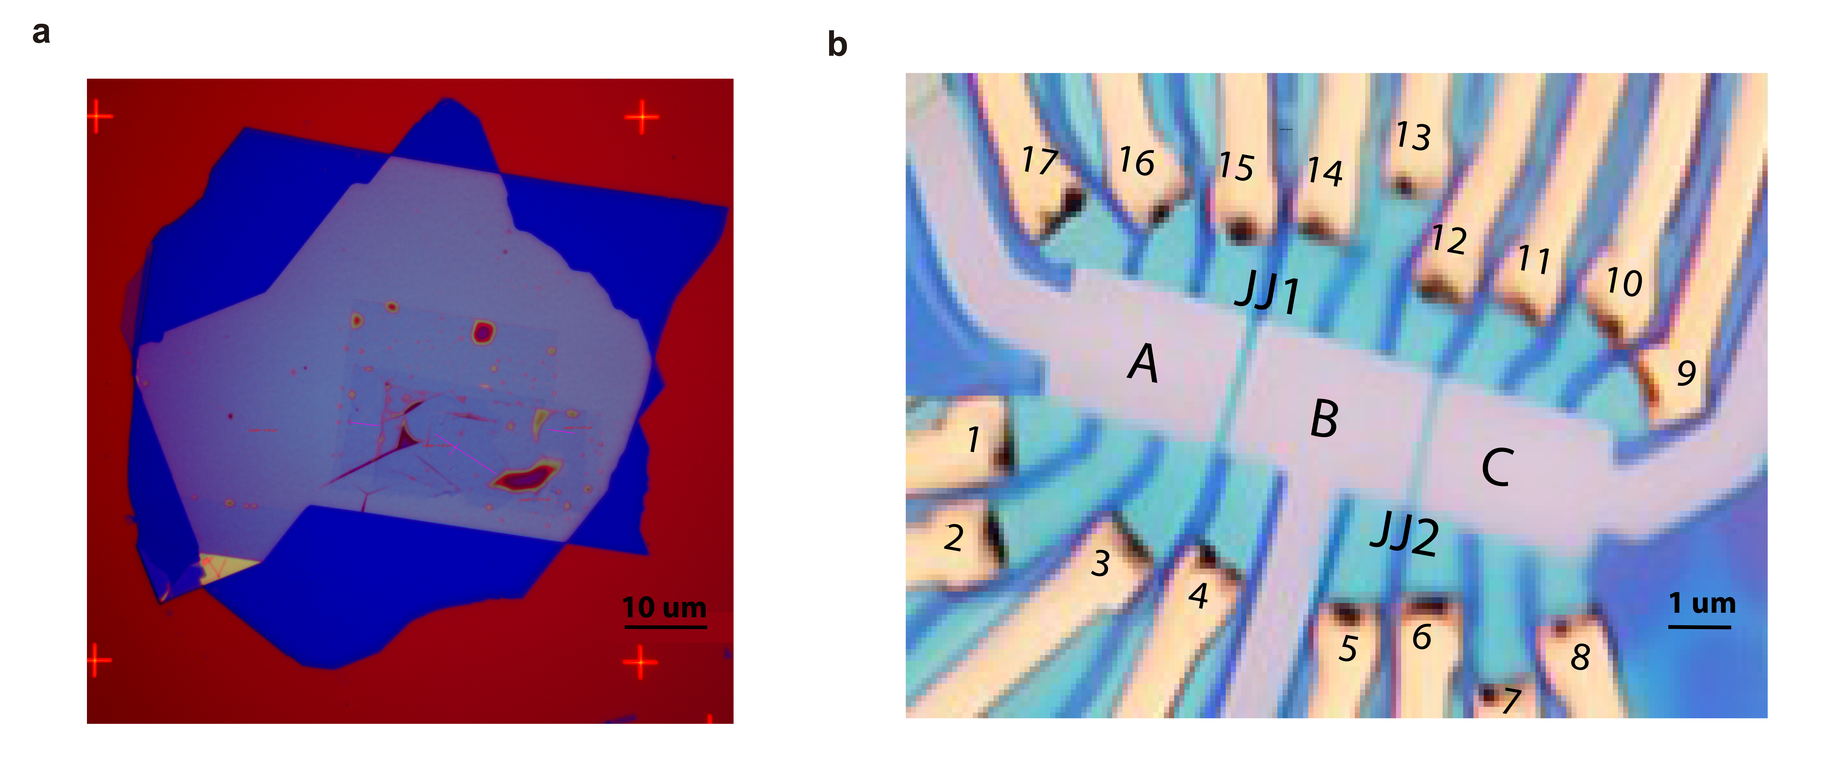
Figure S1: (a) 100X zoomed optical image of the stack before nanofabrication. Color scale is 10um. (b) Optical image of the final devices after nanofabrication. The Josephson junctions, JJ1 and JJ2 have weak link of ~200nm and 100nm respectively. The width of the Hall bar is ~2μm, see the scale ~1μm.

- Transport characterization of hall bar devices:
When we dope, the electrons (holes) to the conduction (valence) bands of the TTG are distributed between the flat bands and ML Dirac cone. Most of the charge carriers are filled in the flat bands due to high density of state (DOS) and the rest goes to ML Dirac cone^{1,2}. The mini-Brillouin zone of TTG has four-fold degenerate bands with flavors $K,K^{'},↑, ↓$. When we start doping electrons(holes) from v=0, all four flavors start filling the conduction (valence) bands equally, and hence a linear (unity) slope between Hall carrier density ($n_{H}$) and v is expected in the vicinity of CNP³. At v=±1 (±3), the symmetry of four-fold degenerate bands breaks and out of four anyone (three) flavor is filled completely which result in resets towards zero. Similarly at v=±2, due to symmetry breaking of spin and valley isospin degenerate bands, two flavors of either spin or valley isospin are filled completely, and a reset is observed. At v=±4 all four flavors are filled and Fermi energy ($E_{F}$) exits the flat bands and we observe reset toward zero again. This symmetry breaking of degenerate bands results in Chern insulator states at integer v, as seen in Landau fan diagrams of $R_{xx}$ and $R_{xy}$ at D=0V/nm (see extended Fig1).
We calculated the normalized Hall carrier density using equation $v_{H}$ =$1/{(e*\frac{dR_{xy}}{{dB}_{z}}*n_{s})}$ ; (here, e is elementary charge, $n_{s}$ moiré superlattice density), the $\frac{dR_{xy}}{{dB}_{z}}$ is calculated at low $B_{z}$ range (-0.1T ≤$B_{z}$≤0.1T) and high $B_{z}$ range (-0.5T ≤$B_{z}$≤0.5T) around $B_{z}$= 0T. The variation of quantity $(v_{H}-v)$ with $v$ shed light on the evolution of TTG DOS with varying $E_{F}$^{4,5}. Fig. S2 (a) and (b) shows the $(v_{H}-v)$ vs $v$ plot for high B (red) and low B (blue) ranges at D=0V/nm and 0.6V/nm, respectively. The integer values of $(v_{H}-v)$ are expected at integer v corresponding to symmetry breaking and we observe this condition at v=+1, ±2, +3 and ±4, see red curve in fig. S2 (a). However, in addition to that a pronounced kink is observed in the vicinity of CNP towards hole doping and two small kinks are observed just before v=+2 and -2 as shown by black arrows in fig. S2 (a). These kinks are also associated with the symmetry breaking of flavors and presence of isospin ferromagnetic state^{5,6}. The behavior of sample at high displacement field looks completely different, as seen in fig. S2 (b). The kinks near the CNP vanishes and strong van hove singularities are observed at v=±2 and v=±3, i.e. on the boundary of superconductivity region. This signifies the strengthening of superconductivity at high displacement field in 2≤$|v|$≤3⁴. The Landau fan diagrams of $\frac{dR_{xy}}{{dB}_{z}}$ at high displacement fields (0.6V/nm) is shown in fig. S2(c)-(d) for devices A and C respectively. The jumps in $R_{xy}$ around $B_{z}$=0 in both devices has vanished. An interesting note is that in Device C ($θ=1.44°$), v=3 becomes visible which is absent in device A ($θ=1.38°$).
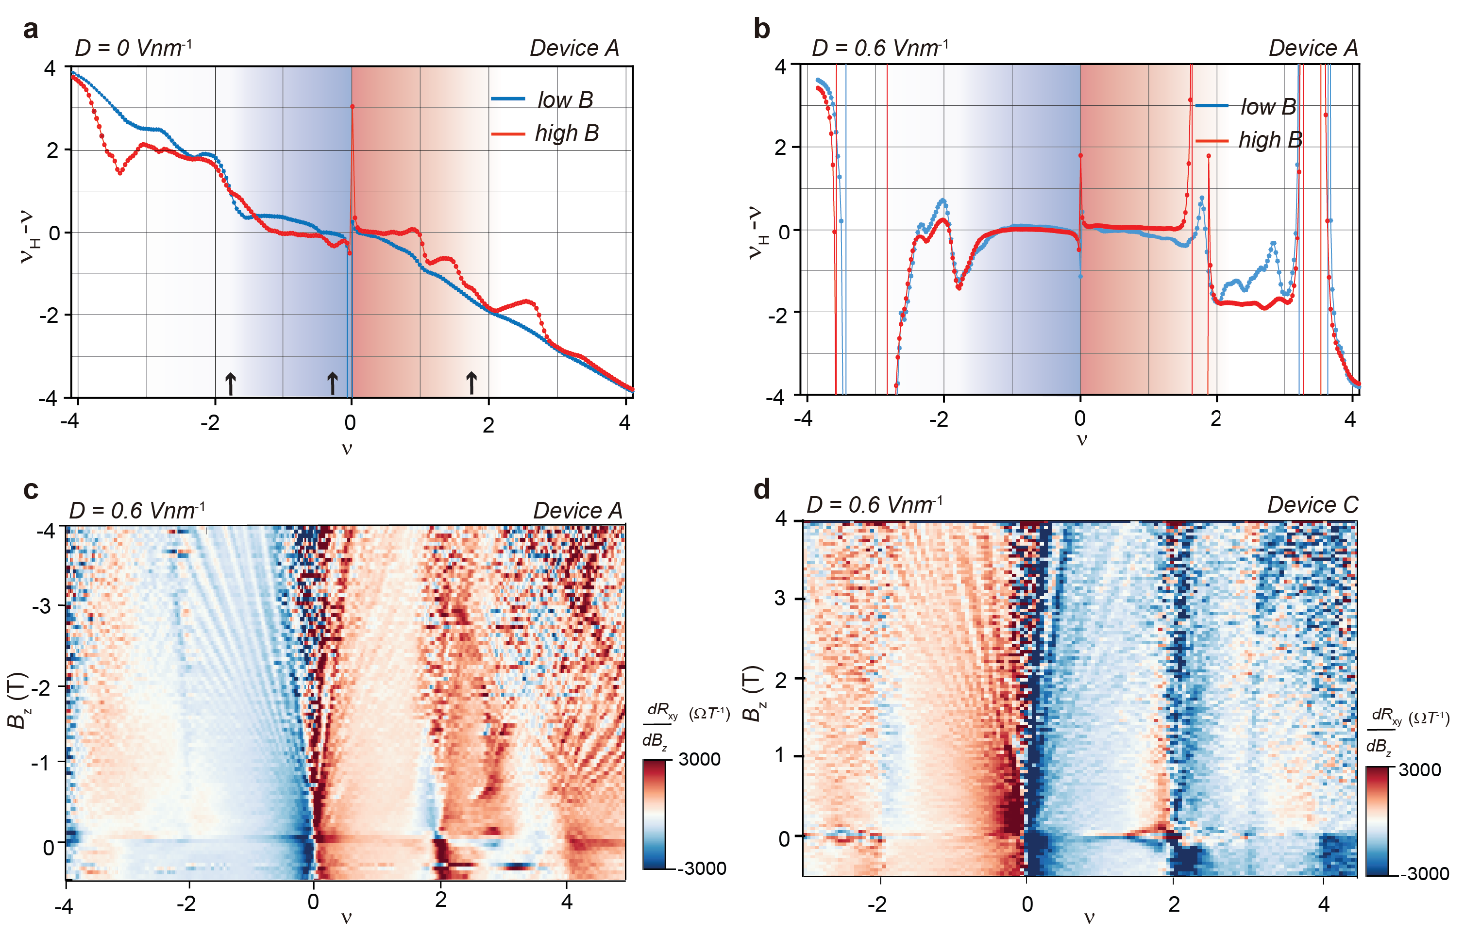
Figure S2: The moiré filing factor (v) subtracted from renormalize Hall density $v_{H}=B_{z} /eρ_{xy}n_{s}$ vs v plots at low $B_{z}$ (-0.1T ≤$B_{z}$≤0.1T) and high $B_{z}$ (-0.5T ≤$B_{z}$≤0.5T) shown by blue and red colors, respectively at (a) D=0V/nm and (b) D=0.6V/nm. Landau level fan diagram of $\frac{dR_{xy}}{{dB}_{z}}$ at D=0.6V/nm for device (c) A and (d) C.

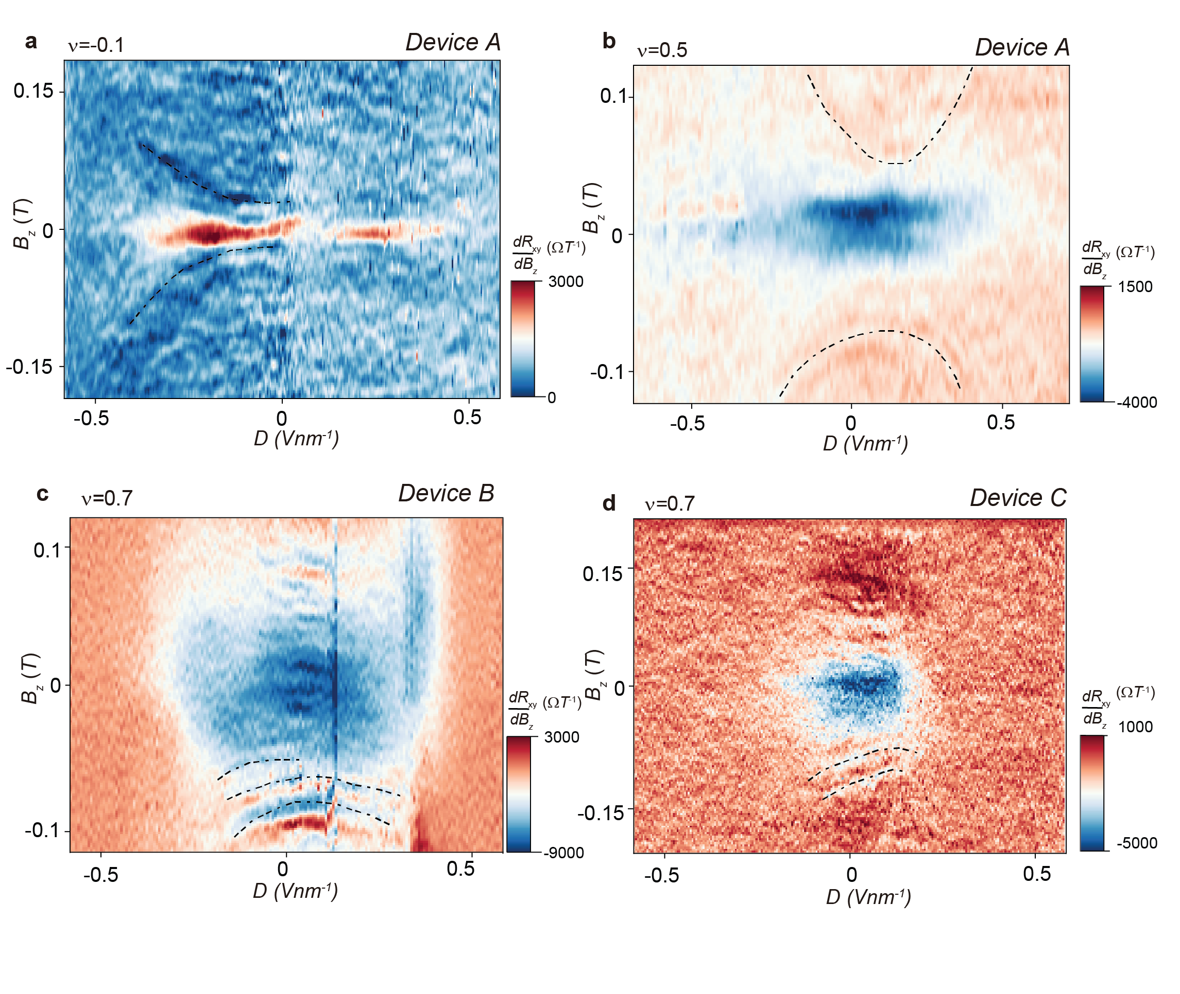Figure S3: The 2D plots of $\frac{dR_{xy}}{{dB}_{z}}$ for $B_{z}$ vs D at fixed (a) v =-0.1 (device A), (b) v =0.5 (device A) (c) v=0.7 (device B) and (d) v=0.7 (device C).

The TTG band structure consist of flat bands of TBG at $\sqrt{2}$ times the twist angle and a bystander monolayer Dirac cone. The mirror symmetric configuration of TTG means the localization of wavefunction on top/bottom layers can be tuned by the application of displacement field. At D=0V/nm, flat bands and Dirac cone are decoupled, however with application of D the flat bands and Dirac cone start hybridizing. This hybridization can result in rich physics. Here we are utilizing the ML Dirac cone Landau levels and their hybridization as a probe to estimate the $E_{F}$ of flat bands^{1,2}. We observe large value of $\left|\frac{dR_{xy}}{{dB}_{z}}\right|$ near by $B_{z}=0T$ due to orbital magnetism (OM) which disappear with the increase in hybridization (D). The parabolic shaped curves in the figures represent the Landau levels (${LL}_{s}$) of monolayer graphene at constant Fermi energy ($E_{F}$) defined by v. The most prominent feature is the upward curvature of these curves with increasing D, which results from the hybridization between the MLG Dirac cone and the flat bands¹. As D, and therefore hybridization increases, the slope of the MLG Dirac cone, i.e. Fermi velocity, ${v_{F}=dE}/{dk}$ decreases. Since $E_{F}$ is fixed, the ${LL}_{s}$ appear at higher B. To quantify the change in the $v_{F}$, we estimate Fermi energy $E_{F}$ by employing a single-particle equation for the MLG ${LL}_{s}$ spectrum, $E_{F}=sgn(L_{n})v_{F}√(2eħ |L_{n }|×B)$; where $L_{n}$ is Landau level index, $v_{F}$ is Fermi velocity of the monolayer Dirac cone, e is the elementary charge, and $ħ$ is reduced Planck’s constant. We estimated $E_{F}$~-8meV for ${LL}_{1}$ and ~-9meV for ${LL}_{2}$ at v ~-0.45 (see Fig 2 (a) main file) and $E_{F}$~-4meV at v ~-0.10 we, see fig. S3(a). As we tune $E_{F}$ to electron doped v~0.70 we estimated $E_{F}$~11meV for LL₁ and $E_{F}$~13meV for LL₂, see Fig 2 (b) main file. These values of $E_{F}$ at corresponding v matches exactly with the estimation made using squid on tip scanning experiments¹. The upward curvature of ${LL}_{s}$ lines with D indicate the hybridization of monolayer Dirac cone with flat bands, with the increase in D the slope of ${dE}/{dk}$ decreases and hence $v_{F}$ decreases, since the $E_{F}$ is fixed the ${LL}_{s}$ are observed at higher $B_{z}$ in higher D. The estimated $v_{F}$ change at v=-0.10 and -0.45 is ~67% and 45% for D change from 0 to 0.5V/nm. At v=0.70 $v_{F}$ change by ~15% for D change from 0 to 0.25V/nm.
Fig. S4 (a) and (c) shows the $R_{xy}$ jumps in forward and backward sweeping of magnetic field at v=-0.45 and v=0.7 respectively at D=0 V/nm. We note the absence of hysteresis in these plots, despite the presence of a clear jump. The corresponding $R_{xy}-B_{z}$ sweeps at higher displacement, D=0.6 V/nm shows that these jumps have vanished, see fig. S4 (b) and (d). We explicitly show the dependence of $R_{xy}$ jumps in 0º to 90º direction of the applied magnetic field ${(B_{x}^{2}+B_{z}^{2}) }^{1/2}$ for device B and C respectively in fig. S5 (a) and (b). The $R_{xy}$ jumps are present in all devices but are most prominent in device A (main fig. 3 and extended fig. 2) and decreases as we move to twist angles closer to the magic angle. We characterize the SC in our near magic angle device, Device C. From $R_{xx}$-T plot of Device C, $T_{C}$ ~ 1.3 K estimated corresponding to the 90% drop in resistance, see fig. S6 (a). We show the linecuts of dV/dI characteristics of the JJ2 taken at $B_{Z}$=0G, with configuration S|X|S, where S corresponds to v~2.7 and X corresponds to $v_{j}$, which is varied from ~-3 to 2.5. We see asymmetricity in the $dV/dI$ w.r.t $I_{dc}$ in $v_{j}$ close to the CNP, but this dies off at higher $v_{j}$. See fig. S6(b). Figure S6 (c) shows the temperature dependence of $dV/dI$ characteristics across the JJ2 at $v_{j}=-0.45$. The curve becomes approximately symmetric at 650mK.

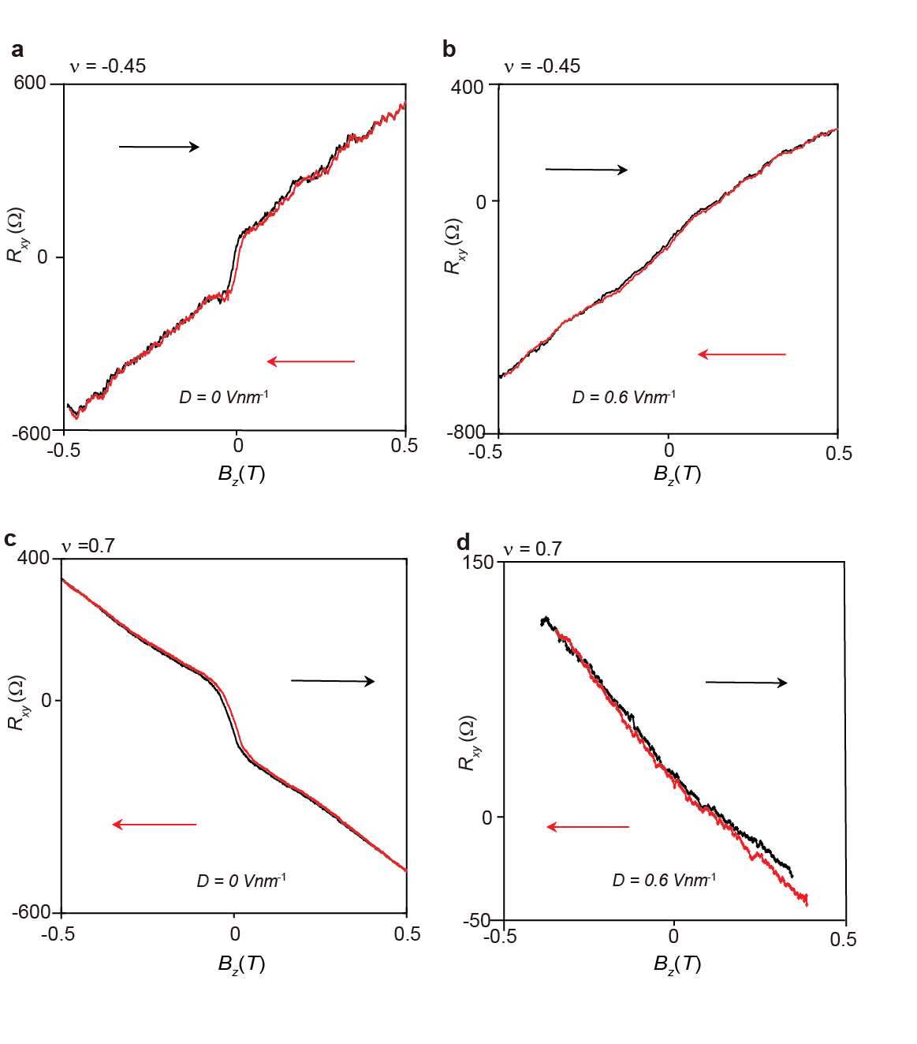
Figure S4: Line cuts of $R_{xy}$ for $B_{z}$ sweep directions -0.5T to 0.5T (black) and 0.5T to -0.5T (red) at (a) v = -0.45, D=0V/nm, (b) v = -0.45 and D=0.6V/nm; (c) v =0.70, D=0V/nm and (b) v = 0.70and D=0.6V/nm for device A.

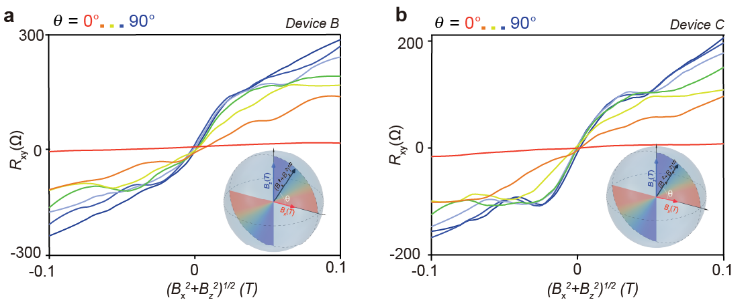
Figure S5: The $R_{xy}$ vs $B={(B_{x}^{2}+B_{z}^{2}) }^{1/2}$ at varying θ between sample and $B$ from 90º (blue) to 0º(red) in steps of 15º measured at 15mk for (a) device A and (b) device B.

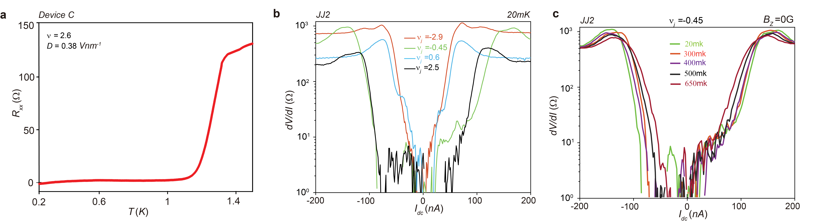
Figure S6: (a) The $R_{xx}$-T plot of device C measured at $B_{z}=0T$, v=2.35 and D=0.42V/nm. (b) The $dV/dI$ vs $I_{dc}$ characteristics for SC state tuned to v~2.7 across JJ2 and weak link tuned to different $v_{j}$ shown in figure legends. (c) Temperature dependence of $dV/dI$ vs $I_{dc}$ characteristics $v_{j}$ ~-0.45 across JJ2.

We can switch between superconducting (SC) and non-SC states by alternating $I_{dc}$between $±I_{c}^{-}$ on the asymmetric curve of dV/dI at $B_{z}$=0 G. Fig. S7a shows the ${dV}/{dI}$ (Ω) characteristics measured by alternating between $I_{c}^{-}$ (${dV}/{dI}$=0 Ω) and -$I_{c}^{-}$ every 20 seconds and plotted over time in the temperature range 20mK to 650mK. The resistance $R$ in the non-SC state decreases with increasing temperature. We fitted the temperature dependence of $R$ to a Curie Bloch law, viz. $R=m{(1-T/{T_{OM3}})}^{γ}$, and estimated m= 30.05±1.5Ω, $γ$ ~0.24±0.05 and $T_{OM3}$~650mK as seen in Fig. S7b. The exponent of Curie Bloch law is expected to contain information about the magnetic moments, for example for a magnetic state of 2D Ising nature a critical exponent of 0.125 is expected^{7,8} . However, in our case we measure the exponent 0.24±0.05 from resistance of the diode-like effect, 0.45±0.05 from the $R_{xy}$ data and 0.6±0.2 from the asymmetry in critical currents. The scaling behaviors are consistent provided the resistance of diode effect is coupled to ~M², $R_{xy}$ to ~M³ and $η$ to ~M^{4 9,10}. However, we believe a microscopic picture is needed to clarify this point.
We show the Fraunhofer patterns in two e-h Josephson junction configurations, Fig. S7 (a) S`|OM|S`` and (b) S`|N|S`` in JJ2, here S` and S`` correspond to h and e side SC, respectively. We see that while S`|N|S`` ($v_{L}=-2.5, v_{j}=1.8,{ v}_{R}\sim 2.7 )$shows a clear Fraunhofer pattern with clear dips in interference, we do not see a clear pattern in S`|OM|S`` ($v_{L}=-2.4, v_{j}=0.5, { v}_{R}\sim 2.7)$. Moreover, the weak Fraunhofer is also slightly asymmetric about $I_{dc}=0$, owing to the OM.

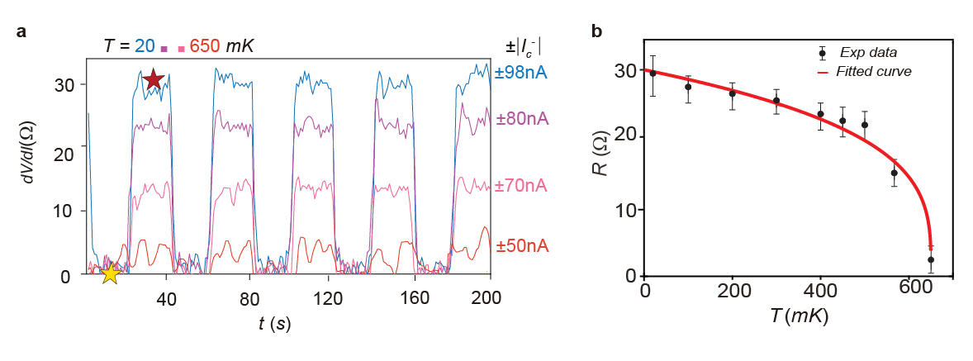
Figure S7: (a) ) The ${dV}/{dI}$ (Ω) characteristics of S|OM|S JJ measured at $B_{z}$=0 G while alternating $I_{dc}$ between $I_{c}^{-}$ (${dV}/{dI}$=0 Ω, SC state) and $-I_{c}^{-}$ (non-SC) after every 20 seconds in a temperature range of 20mK to 650mK. (b) Resistance of the non-SC state ($R$) calculated from Fig 4e and plotted as a function of temperature (black data points). The red line corresponds to fits of the Curie Bloch equation $ΔR=m{(1-T/{T_{OM3}})}^{γ}$. The error bars depict the standard deviations in $R$.

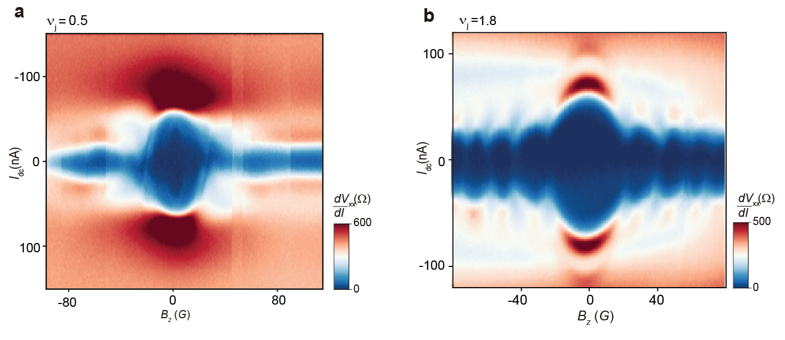
Figure S8: The Fraunhofer pattern measurements at (a) The S`|OM|S`` JJ configuration (BG=3.8V, TgL=-4.4, TgR=2.8) the left side of JJ SC state tuned to $v_{L}\sim -2.5$, right side SC $v_{R}\sim 2.7$ and weak link tuned $v_{j}\sim 0.5$. (b) The S`|N|S`` JJ configuration (BG=27.6V, TgL=-6.2, TgR=0.7) corresponding to hole side SC on left side (S`) $v_{L}\sim -2.4$ and electron side SC on right side (S``) $v_{R}\sim 2.7$ of the JJ with weak link tuned to $v_{j}\sim 1.8$.

- Transport characteristics of devices with 1.3º and 1.5º twist angles
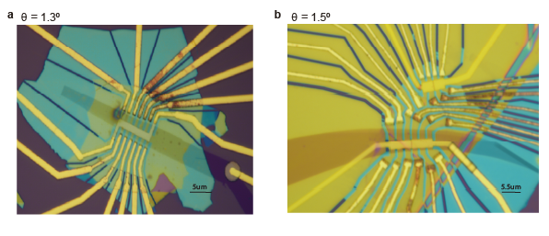
Figure S9: The additional TTG devices with twist angles (a) 1.3⁰ and (b) 1.5⁰.
We stacked two other samples with twist angle 1.30º and 1.50º to explore OM in region above and below 1.40º regime, see fig. S8. Sample with 1.30º twist angle has top hBN~32nm and bottom hBN~55nm thickness. This sample has graphite as bottom gate. Sample with twist angle 1.50º has top hBN~60nm and bottom hBN~36 nm. This sample has two different Josephson junction devices, one has graphite as bottom gate and other has Si as bottom gate.
Fig. S9 (a) and (c) shows the Landau fan diagram of $R_{xx}/▢$and $R_{xy}$ respectively for sample 1.30º at D=0V/nm. We observe correlated insulators at v=+2, ±4 only in this sample. Interestingly SC is observed only in electron side in this sample. Fig. S9 (b) and (d) shows the Landau Fan of $R_{xx}$ and $R_{xy}$ for sample with twist angle 1.50º, respectively at D=0V/nm. In this sample we observe Chern insulator states at v=±2, +3 and ±4. A wide pocket of SC is observed on electron doping side in comparison to hole doping. No jumps in $R_{xy}$are observed in both samples around $B_{z}$= 0.
Next, we analyzed the SC in both samples. Fig. S10 (a)-(c) shows the characterization of SC in sample with twist angle 1.30º. Fig. S10 (a) shows the temperature dependence (10mK to 1.2K) of dV/dI vs $I_{dc}$ characteristics. The $T_{C}$ of ~1.0 K is estimated from the $R_{xx}/▢$ vs T plot, corresponding to the 90% drop in resistance, see Fig. S10 (b). The Ginzburg Landau equation, $B_{c2}=(φ_{0}/2π{ξ^{2}}_{GL})(1-\frac{T}{T_{c}})$ ,(where $φ_{0}=h/2e$is superconducting flux quantum, $ξ_{GL}$ is coherence length) is fitted to the temperature dependence of $B_{c2}$ taken at 90% drop in $R_{xx}$ at that temperature, see fig. S10 (c). The upper critical field at 0K i.e $B_{c2}$ $(0)$ ~ 0.13T is estimated from fitting which corresponds to $ξ_{GL}$ ~50nm. Fig. S10 (d) shows the Fraunhofer pattern measured in e-S| N |h-SC configuration of 1.50º device.
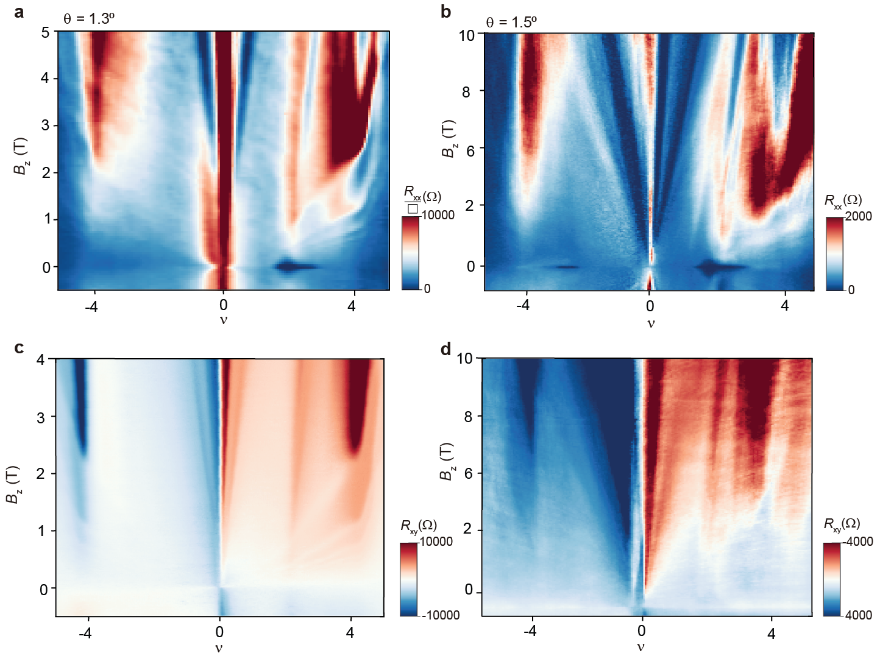
Figure S10: The Landau fan diagram (a) of $R_{xx}/▢$ for TTG with twist angle 1.30º and (b) of${ R}_{xx}$ for TTG with 1.50º measured at D=0V/nm and 15mk. The Landau fan diagram of $R_{xy}$ (c) for 1.30º TTG device at 300mK and (d) for 1.50º TTG device at 15mK and D=0V/nm.
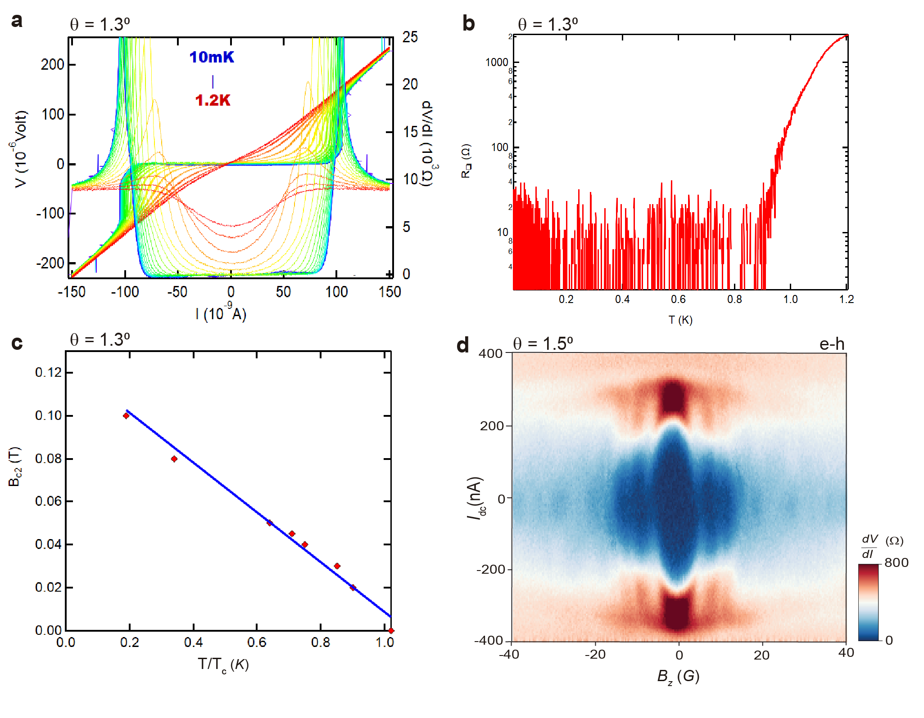
Figure S11: (a) IV characteristics of TTG device twist angle of 1.3⁰ as the temperatures are varied from 10mK to 1.2K. (b)The $R_{xx}/▢$ vs T curve for the same device with critical temperature T_{c}=1K. (c) The critical magnetic field B_{c2} is plotted as a function of T/T_{c} and the B_{c2} (0 K) is estimated to be approximately 0.13 T. (d) Fraunhofer pattern of e-h doped superconducting pockets for the device with twist angle 1.5⁰.
References:

1. Bocarsly, M. et al. Imaging Coulomb interactions and migrating Dirac cones in twisted graphene by local quantum oscillations. arXiv (2024).
2. Shen, C. et al. Dirac spectroscopy of strongly correlated phases in twisted trilayer graphene. Nat. Mater. 22, 316–321 (2023).
3. Zondiner, U. et al. Cascade of phase transitions and Dirac revivals in magic-angle graphene. Nature 582, 203–208 (2020).
4. Hao, Z. et al. Electric field–tunable superconductivity in alternating-twist magic-angle trilayer graphene. Science 371, 1133–1138 (2021).
5. Saito, Y. et al. Isospin Pomeranchuk effect in twisted bilayer graphene. Nature 592, 220–224 (2021).
6. Xie, M. & MacDonald, A. H. Weak-Field Hall Resistivity and Spin-Valley Flavor Symmetry Breaking in Magic-Angle Twisted Bilayer Graphene. Phys. Rev. Lett. 127, 196401 (2021).
7. Moshe, M., Kogan, V. G. & Mints, R. G. Edge-type Josephson junctions in narrow thin-film strips. Phys Rev B 78, 020510 (2008).
8. Chen, S. et al. Current induced hidden states in Josephson junctions. Nat. Commun. 15, 8059 (2024).
9. Fei, Z. et al. Two-dimensional itinerant ferromagnetism in atomically thin Fe3GeTe2. Nat. Mater. 17, 778–782 (2018).
10. Li, Y. & Baberschke, K. Dimensional crossover in ultrathin Ni(111) films on W(110). Phys. Rev. Lett. 68, 1208–1211 (1992).

