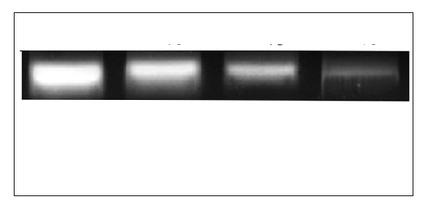

Figure 6a represents the expression level of nucleolin as determined by RT-PCR in MCF-7 cells treated with different concentration of chloroform extract of F1 of CCG

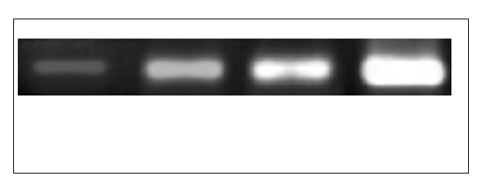

Figure 6b represents the expression level of Bax as determined by RT-PCR in MCF-7 cells treated with different concentration of chloroform extract of F1 of CCG

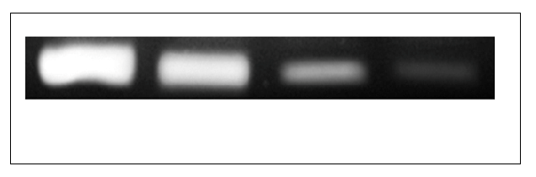

Figure 6c represents the expression level of Bcl₂ as determined by RT-PCR in MCF-7 cells treated with different concentration of chloroform extract of F1 of CCG

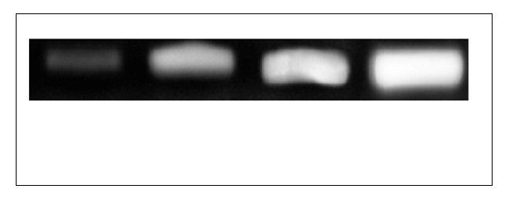

Figure 6d represents the expression level of cytochrome as determined by RT-PCR in MCF-7 cells treated with different concentration of chloroform extract of F1 of CCG

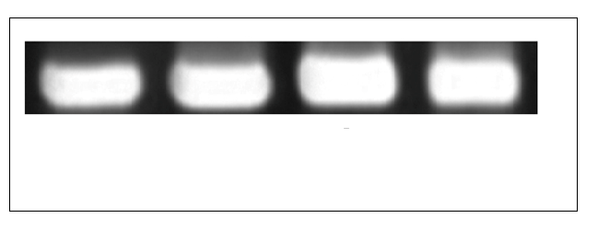

Figure 6e represents the expression level of β-actin as determined by RT-PCR in MCF-7 cells treated with different concentration of chloroform extract of F1 of CCG

