Supplementary File
Methods
A) Determination of shape and size of exosome by transmission electron microscopy (TEM)
1. Preparation of uranyl acetate (counter stain)
2g of uranyl acetate was dissolved in 50 ml ddH2O and filtered with a 0.22μm filter. The final solution was kept in amber or dark coloured conical bottom tube made up of non-reactive plastic and stored at 4°c for future use.
2. Sample processing
The exosome containing pellet was suspended in 50-100μl of 2% paraformaldehyde (PFA). A Formvar carbon-coated electron microscopy (EM) grid was kept on a clean surface. A drop (5-10 μl) of the suspended pellet was poured onto the coarse surface of the EM grid. 2-3 grids for each exosome preparation were prepared. After pouring, the grid was kept undisturbed for 20 minutes in a dry environment and covered by a clean glass lid. Alternatively, a drop of 5-10μl exosome preparation was put on a clean parafilm strip. The EM grid was gently placed over the drop with their coated side facing the suspension and kept floating undisturbed for 20 minutes to get soaked with the suspension.
3. Washing
5 drops of (100μl each) of sterile PBS was put on a clean strip of parafilm. The EM grids (membrane side down) were transferred to each drop one after another with clean forceps. Care was taken that during each washing step, the membrane side of the grid should be wet but dry on the opposite side.
4. Fixation
Following washing, grids were transferred to a 50μl drop of 1% glutaraldehyde and kept for 5 minutes.
5. Washing
The grid was further washed by placing it onto a drop of 100μl of sterile ddH2O. The grid was kept floating onto the drop for 2 minutes. The step was repeated for 4-5 times.
6. Counter Staining
The grid was transferred to a 50μl drop of 4% uranyl acetate (pH=7) and kept floating for 5 minutes.
7. Visualization
Using a stainless steel loop, the grid was lifted and any extra fluid was deflated by gently moving the loop sideways across Whatman no. 1 filter paper until a thin layer remained covering the sample side of the grid. The grid was left on the loop and allowed to air dry for five to ten minutes. At 80kV, the grid was displayed under Hitachi (H-7500).
B) Loading of ligands into exosome
Four approaches were employed to incorporate chosen ICM ligands into the PPI-Treg derived exosome: the simple incubation at RT (method I), incubation at RT with saponin treatment (method II), sonication (method III), and freeze-thaw cycles (method IV). For each method, 1 μg of ligand dissolved in 1X PBS was incubated with 50 μg (250 μl) of total exosomes (determined by protein concentration) and subjected to various methods of loading. Based on our immunophenotyping data we have chosen the following ligands: CD155, PD-L1 and HVEM and also checked their molecular weight (MW) from the data sheet provided by the manufacturer. The MW of CD155, PD-L1, and HVEM are 45.3 kDa, 26 kDa, and 19 kDa respectively. As ligand loading into a nano-sized biological vesicle-like exosome is dependent on the molecular weight of the ligand, therefore, here we have chosen PD-L1 to standardize our loading process as its MW lies between that of the other two ligands. For Method I, naive exosomes released from PPI pulsed Tregs were diluted in PBS, then ICM ligand solution in PBS (0.5 mg/mL) was added to 250 μl of exosomes and incubated at RT for 6 hrs. 12 hrs. and 18 hrs. ‘In the case of a saponin treatment (method II), a mixture of ICM ligands and exosomes was supplemented with 0.2%, 0.5%, and 1% saponin and placed on a shaker for 20 min at RT. For Method III, the ICM ligand mixed with exosomes was sonicated (500 v, 2 kHz, 20% power, 6 cycles of 4-sec pulse /2-sec pause), cooled down on ice for 2 min, and then sonicated again using Qsonica Sonicator Q700 (Fisher Scientific, Hampton, NH, USA). For method IV, the ICM ligand solution was added to exosomes as described above, incubated for 30 min, then rapidly froze at −80° C, and thawed at RT. The freeze-thaw cycle was repeated three times. The exosome-ligand formulation was purified by Amicon Ultracel-10 regenerated cellulose membrane size exclusion column (Cut off: 10 kDa MWCO) to remove unbound ligand. Following centrifugation through the column the retentate was collected and to confirm the purity of loading, a fraction of it was checked by western blotting using antibodies against corresponding ligands (for example, anti-PD-L1). Filtrate was used as negative loading control. At the end of purification exosomes-ligand formulation was kept at 4°c for immediate use and at -80°c for long term storage.’
Results
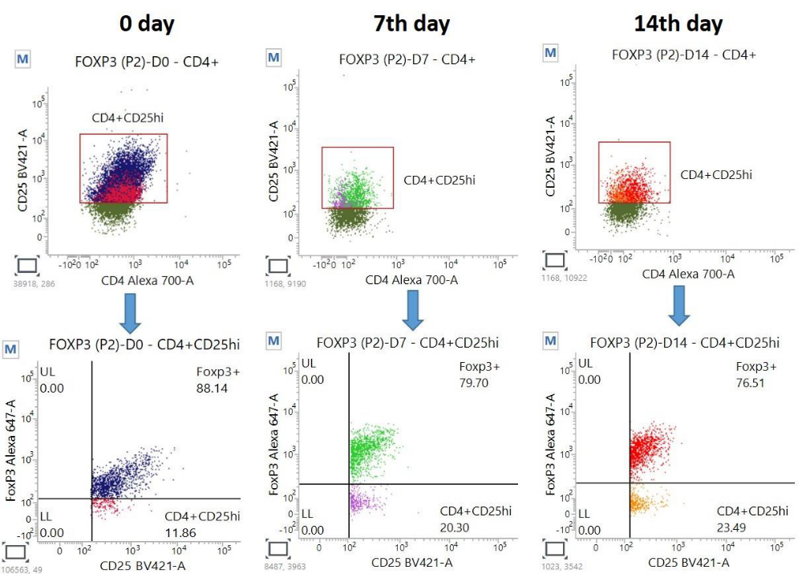
Supplementary Figure S1

Figure S1: Assessment of pure population of CD4+CD25highFOXP3+ during A) isolation and at Day 0, B) at Day 7, and, C) at Day 14.

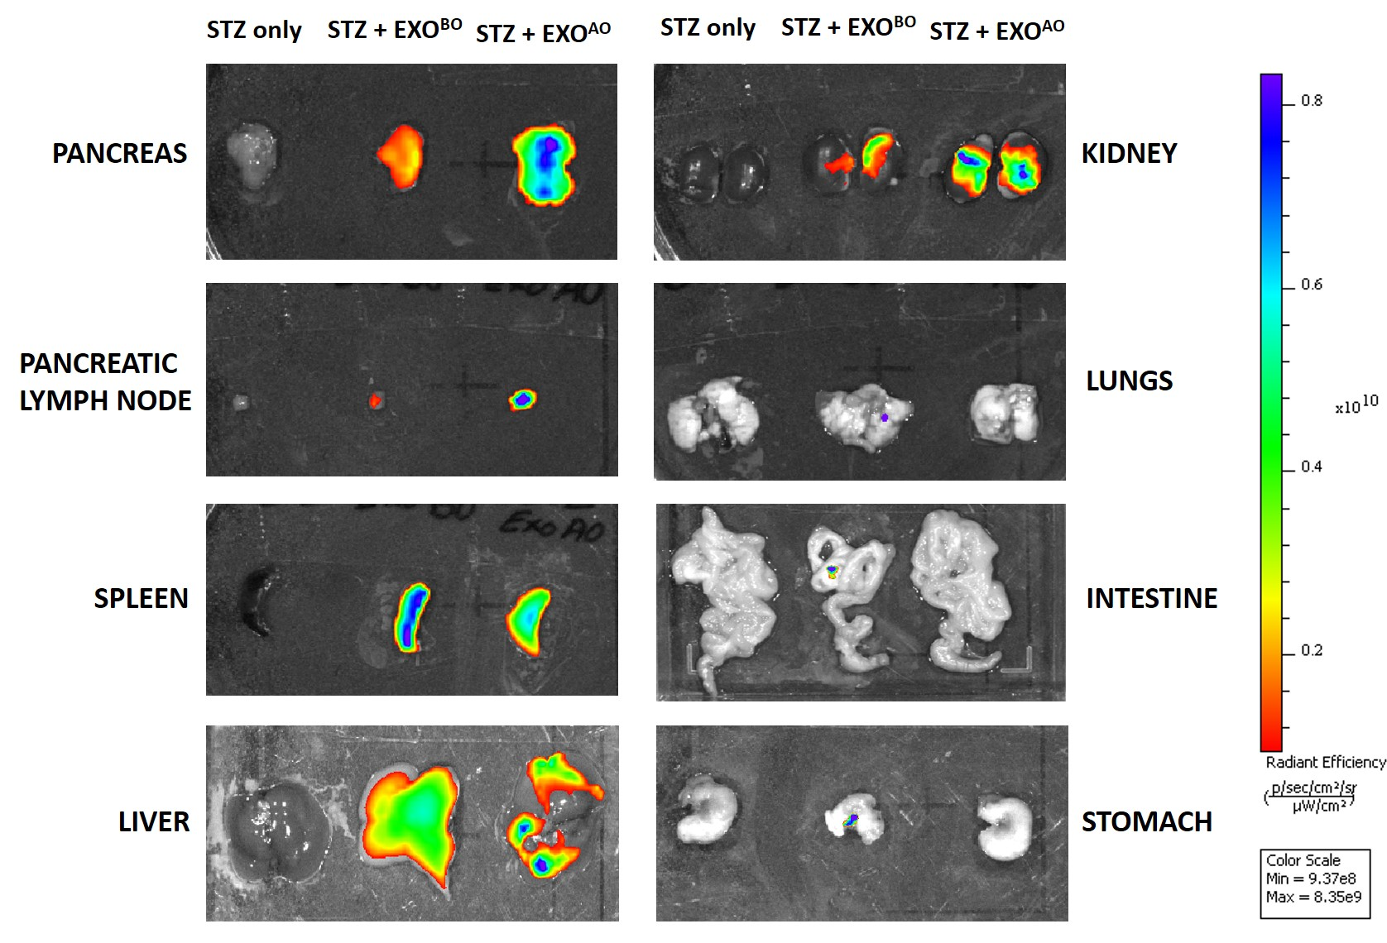
Figure S2: The biodistribution of DiR-labeled exosomes was examined by in vivo imaging of DiR fluorescence. The scale bar is in arbitrary units and is a colorimetric representation of the minimum and maximum signals; all the depicted images are reconstructed with the same scale.

Supplementary table 1
The antibodies and the fluorochromes used in the study for assessment of expression of immune checkpoint molecules on peripheral CD8+T cells
Antibodies | Fluorochrome
Anti-CD3 | PerCP-Cy5.5
Anti-CD4 | AF 700
Anti-CD8 | APC-H7
Anti-LAG3 | PE
Anti-CD160 | PE-Cy7
Anti-CTLA4 | APC
Anti-PD-1 | BV605
Anti-TIGIT | BV480
Anti-TIM3 | BB515
Anti-BTLA | BV421

Supplementary Table 2
Peripheral T cell subsets in the study subjects
T Cell type | Frequency%
T Cell type | T1D | HC
CD3+ T cells | 64.99 (59.92-69.32) | 60.82 (54.47-69.14)
CD3+ CD4+ T cells | 54.31 (46.76-59.77) | 52.7 (48.54-57.79)
CD3+ CD8+ T cells | 36.18 (31.25-43.87) | 36.36 (32.88-42.2)
T1D: Type-1 Diabetes, HC: Non-Diabetic Healthy Controls. Data represented as median with IQR.

