To whom it may concern:

Manuscript ID: EJRE-D-24-00386
We are resubmitting the manuscript, entitled, “Radionuclide-aided improvement of therapeutic efficacy of novel antibody drug conjugates against HER2-expressing cancers”, which we previously submitted to EJNMMI Research for publication. We are grateful for the valuable comments and advice provided by the editor and reviewers that has helped us to improve our manuscript. We hope that you will deem this second version of manuscript worthy of publication in EJNMMI Research. Our point-by-point responses to all the comments and questions are provided below. Changes in the revised manuscript are highlighted in yellow.

Responses to Reviewer
Comment 1:
While the proposed model shows good performance in predicting binding affinity, a direct comparison with state-of-the-art computational approaches, such as molecular docking, molecular dynamics simulations, or existing deep learning models, is necessary. How does your model perform against conventional docking methods?
Response 1:
Thank you for your comment. We have compared Ki values of our model, AutoDock Vina with experimental results for radiolabelled compounds, including ⁶⁸Ga-PSMA-617, ¹⁷⁷Lu-PSMA-617, ⁶⁸Ga-dotatate and ¹⁷⁷Lu-dotatate (Table 4). Additionally, we have expanded the cases to include ⁶⁸Ga-Dotatoc, ⁶⁸Ga-Dotanoc, and ¹⁷⁷Lu-Dotanoc [1] which are new data that has not been used to train our model. Our model consistently outperformed AutoDock and normal CPI model showing closer Ki value to experimental result (attached Table 1).
Attached Table 1. Comparison of Experimental, AutoDock Vina, Radiopharmaceutical-Protein Interactions (RPI) obtained Ki (nm) using specific pairs.
Target protein | Compound | Experiment | AutoDock Vina | RPI model
PSMA | ⁶⁸Ga-PSMA-617 | 6.40±1.02 | 32.11 | 6.292
PSMA | ¹⁷⁷Lu-PSMA-617 | 6.9±1.32 | 1.59×10³ | 5.747
SSTR2 | ⁶⁸Ga-dotatate | 0.7±0.2 | 1.77×10⁸ | 5.325
SSTR2 | ¹⁷⁷Lu-dotatate | 3.84 ± 0.30 | 531.48 | 5.737
SSTR2 | ⁶⁸Ga-Dotatoc | 2.326 | 180.45 | 1.47
SSTR2 | ⁶⁸Ga-Dotanoc | 1.768 | 33.37 | 2.231
SSTR2 | ¹⁷⁷Lu-Dotanoc | 3.163 | 14.77 | 2.166

[1] Antunes P, Ginj M, Zhang H, Waser B, Baum RP, Reubi JC, Maecke H. Are radiogallium-labelled DOTA-conjugated somatostatin analogues superior to those labelled with other radiometals?. European journal of nuclear medicine and molecular imaging. 2007 Jul; 34:982-93.

Comment 2:
The model evaluation relies on metrics such as Pearson’s correlation coefficient, R², and MAE. It would be beneficial to include additional evaluation measures, such as ROC-AUC, to assess classification performance.
Response 2:
Thank you for your valuable comment. We have employed other evaluation matrices such as Area Under the Curve (AUC), Confidence Interval (CI), and Mean Squared Error (MSE). Furthermore, we have revised the manuscript to add these evaluation methods and its corresponding results to Methods (Page 7) and results sections Table 2).
Changes to manuscript comment 2:
Training and Evaluation
To evaluate the pre-trained model, the data were randomly split into training and test sets at a ratio of 9:1. The accuracy of the predicted K_{i} was assessed using three evaluation metrics: Pearson’s correlation coefficient (PCC), R-squared (R²), Mean Absolute Error (MAE), Area Under the Curve (AUC), Confidence Interval (CI), and Mean Squared Error (MSE).
Results
PCC of K_{i} and K_{d} between the predicted and ground-truth values were 0.875 and 0.866, respectively. Other evaluation matrices results are presented in table 2.
Table 2. Evaluation of the pre-training results of the prediction model with the normal test dataset (n=48,986).
Binding affinity | R² | MAE | PCC | AUC | CI | MSE
K_{i} | 0.755 | 1.27 | 0.875 | 0.937 | 0.855 | 3.529
K_{d} | 0.746 | 0.985 | 0.866 | 0.933 | 0.859 | 4.452

Comment 3:
The study uses a dataset from BindingDB for pre-training, but radiopharmaceutical data is much more limited. Given the small sample size of radiopharmaceutical-protein pairs (only 73 pairs), how do you ensure that the model generalizes well?
Response 3:
Thank you very much for your insightful comment. We agree that the radiopharmaceutical (RP) dataset is considerably smaller compared to standard compound datasets such as those from BindingDB. However, we have implemented several strategies such as cross-validation and the incorporation of dropout layers to enhance the robustness and generalizability of the model and to avoid overfitting. No signs of overfitting were observed during the training process.
Furthermore, to ensure model generalizability, we conducted an external test using unseen data that were never been used in the training. The test data included ⁶⁸Ga-Dotatoc, ⁶⁸Ga-Dotanoc, and ¹⁷⁷Lu-Dotanoc [1]. Attached Table 2 shows Ki (nm) values obtained by AutoDock, CPI model, and RPI compered to experimental data.
Attached Table 2. Ki (nm) obtained with AutoDock, CPI and RPI DL models compared to experiment [1].
Compound | Experiment | AutoDock | CPI model | RPI model
⁶⁸Ga-Dotatoc | 2.326 | 180.45 | 0.2021 | 1.47
⁶⁸Ga-Dotanoc | 1.768 | 33.37 | 0.236 | 2.231
¹⁷⁷Lu-Dotanoc | 3.163 | 14.77 | 0.335 | 2.166

These results demonstrate that the predicted Ki values from the RPI model are reasonably close to the experimentally reported values and more accurate than those obtained using AutoDock or a general CPI deep learning model. Our RPI model’s show its capacity to generalize to radiopharmaceutical-protein interactions outside of the training set.
[1] Antunes P, Ginj M, Zhang H, Waser B, Baum RP, Reubi JC, Maecke H. Are radiogallium-labelled DOTA-conjugated somatostatin analogues superior to those labelled with other radiometals?. European journal of nuclear medicine and molecular imaging. 2007;34:982-93.

Changes to manuscript comment 3:
No change to manuscript

Comment 4:
More discussion on the impact of data limitations and strategies to mitigate overfitting is necessary.
Response 4:
Thank you for your comment. Among a large number of radioisotopes, around 16 major radioisotopes are primarily used in clinical studies. In this study, we gathered and used 73 radiopharmaceutical pairs from six widely used radioisotopes for training and validation (Table S1). We acknowledge that the model was trained on only six different radioisotopes, which we have noted as a limitation of this study in discussion section (page 11).
To mitigate overfitting, we employed cross-validation, regularization, and dropout layers in our deep learning model. As a result, no signs of overfitting were observed during training. Despite the relatively limited dataset, the 73 data points from six different radionuclides were sufficient to achieve stable model performance.
Additionally, we assessed the model's robustness through external validation using an independent dataset, ensuring that the model’s performance was not overly dependent on the training data. Our model demonstrated similar Kᵢ values on unseen data compared to experimental results, reinforcing its generalizability. We have revised the manuscript to address data limitations and the strategies implemented to prevent overfitting.
Changes to manuscript comment 4:
Discussion
Although the prediction model effectively utilised radioactive properties that affect compound-protein interactions, there were limitations to this study. The most critical issue was the lack of data. Among the many available radioisotopes, approximately 16 radioisotopes are predominantly uses in form of radiopharmaceuticals for internal therapy and diagnosis. In this study, we gathered and utilized 73 radiopharmaceutical pairs radiolabelled with six widely used radioisotopes for training and validation (Table S1). However, to enhance the model’s applicability, a broader range of clinically used radioisotopes should be included. To mitigate overfitting, we employed cross-validation, regularization, and dropout layers in our DL model.

Comment 5:
The paper states that the attention module identifies significant substructures within compounds. However, it is unclear how interpretable these outputs are in real-world drug discovery scenarios. I request the authors to provide a case study where your model's interpretation aligns with experimental findings.

Response 5:
Thank you for your insightful comment. We acknowledge the importance of ensuring that our model's interpretability aligns with real-world drug discovery scenarios. To address this, we have conducted a case study demonstrating how the attention module identifies significant substructures within compounds and how these align with known experimental findings. Our attention model was applied to known compound-protein interactions (CPI), such as PSMA-617 binding to PSMA and DOTATATE binding to SSTR2. By analyzing attention weights, we identified atom-wise importance, revealing that the oxygen atom in the carboxyl group (R-COOH) and the hydrogen atom in the amino group (R-NH2) played key roles in binding. In our model, carboxyl and amino groups have received significant attention (attached figure 1). These findings were corroborated by docking simulations, which confirmed that these substructures were essential for ligand binding. Moreover, previously published studies have demonstrated that carboxyl and amino groups form key interactions at the active site [1-2]. The manuscript has been revised and these results are presented in the manuscript, results section, Model Interpretation (page 9-10).
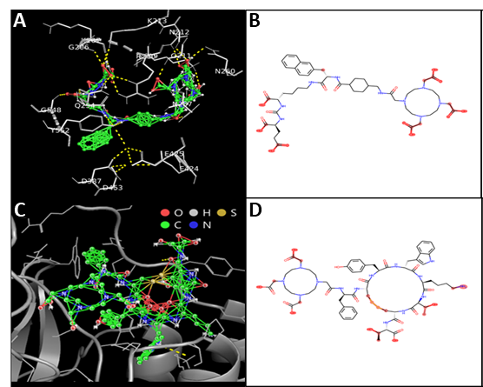
Attached Figure 1. A and C Docking simulation results using AutoDock Vina (dotted yellow line indicates the docking site of the pair) of (A) PSMA-617; (C) dotatate. B and D Molecular structure of the same compounds. Atoms with high attention scores are highlighted in red. The attention score is extracted from the attention module in the prediction model.

[1] Kopka, K., Benešová, M., Bařinka, C., Haberkorn, U., & Babich, J. (2017). Glu-ureido–based inhibitors of prostate-specific membrane antigen: lessons learned during the development of a novel class of low-molecular-weight theranostic radiotracers. Journal of Nuclear Medicine, 58(Supplement 2), 17S-26S.
[2] Gervasoni, S., Öztürk, I., Guccione, C., Bosin, A., Ruggerone, P., & Malloci, G. (2023). Interaction of radiopharmaceuticals with somatostatin receptor 2 revealed by molecular dynamics simulations. Journal of Chemical Information and Modeling, 63(15), 4924-4933.

Changes to manuscript comment 5:
Results
Model Interpretation
We calculated the atom-wise importance for a given pair by integrating the attention weights with respect to the amino acid residue to estimate the significant atoms that were closely related to binding. Docking simulation results showed that the oxygen atom in the carboxyl group (R-COOH) and the hydrogen atom in the amino acid group (R-NH₂) were involved in binding of the drug to the protein. Results from our model showed that there was a tendency for the carboxyl and amino groups to receive significant attention. These results align with previous findings [41-42].

Comment 6:
Could the model predictions be visualized with molecular docking simulations to confirm the biological relevance of predicted binding sites? The study identifies BDBM210829 as the top candidate, but no experimental validation is provided to confirm its binding affinity and effectiveness. If experimental validation is outside the study's scope, the authors should provide literature support or computational validations that reinforce the credibility of the predicted top candidates.
Response 6:
Thank you for your valuable comment. We have conducted computational validation using AutoDock 4 to validate our binding affinity (Ki) and visualize binding site of compounds binding to NDUFS1 protein. The tested compounds were BDBM210829, BDBM214042, and rotenone. AutoDock has revealed a ki vales of 4.12, 11.72, and 1030 nm for BDBM210829, BDBM214042, and rotenone. Our model showed very good agreement with AutoDock results. The Ki values of BDBM210829, BDBM214042, and rotenone were 4.47, 11.72 and 873.20 nm, respectively. Binding sites and mechanism of each compound to NDUFS1 were visualized using biovia discovery studio visualizer (Figure 5). We have revised manuscript to include computational validation in method (Page 8), results (Page 11), and discussion (Page 13) sections.

Changes to manuscript comment 6:
Methods
Computational validation
Computational validation was conducted using AutoDock 4 to assess binding affinity (Kᵢ) and visualize the binding sites of compounds binding to NDUFS1 protein. The tested compounds included BDBM210829, BDBM214042, and rotenone. The 2D structure files (.sdf) of the ligands were obtained from BindingDB and subsequently converted to “.mol2” format using Open Babel., BIOVIA Discovery Studio Visualizer was utilized to visualize the binding sites of each compound within NDUFS1. AutoDock Kᵢ values were compared with Ki values predicted by DL model.
Results
Computational validation
Computational validation of the proposed model’s binding affinity results was conducted using AutoDock 4 for three compounds binding to NDUFS1 protein. AutoDock predicted Ki values of 4.12 nM, 11.72 nM, and 1030 nM for BDBM210829, BDBM214042, and rotenone, respectively. Our model showed strong agreement with these results, with Ki values of 4.47 nM, 11.72 nM, and 873.20 nM for BDBM210829, BDBM214042, and rotenone, respectively. The binding sites of each compound with NDUFS1 are illustrated in Figure 5. BDBM210829 exhibits strong electrostatic interactions with negatively charged residues such as Asp551, Asp698, and Glu369 of NDUFS1. hydrogen bond was formed with ARG702, while a repulsive interaction is noted with LYS592 due to positive–positive charge conflict.
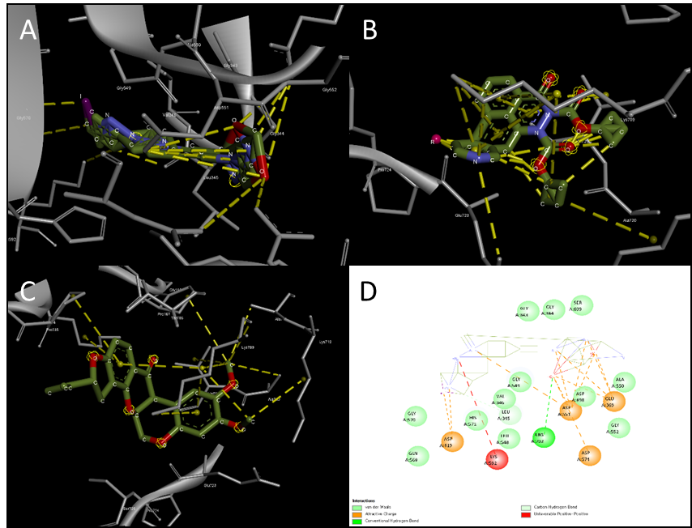
Fig 5. Docking simulation results using AutoDock 4 of compounds binding to NDUFS1 protein. Dotted yellow line indicates the docking site of the pair. (A) BDBM210829; (B) BDBM214042; (C) Rotenone; (D) BDBM210829-NDUFS1 interactions.

Discussion
BDBM210829 was identified by the DL model as the top candidate for binding to the NDUFS1 protein. To validate this finding, computational validation was performed using physics-based docking simulation with AutoDock 4. The analysis included BDBM210829, BDBM214042—the second top candidate—and the well-known MC-1 inhibitor, rotenone. Both the DL model and AutoDock produced similar Ki values for all tested compounds, demonstrating the high accuracy of the proposed model.

Comment 7:
The figures and tables should be more self-explanatory. Some key numerical results (such as Kd values and ranking comparisons) are discussed in the text but are not clearly referenced in figures.
Response 7:
Thank you for your comment. We have made modifications to figures and tables to be more self-explanatory. Ki and binding rank are presented in Figure 3.
Changes to manuscript comment 7:
Changes has been made on figures and tables.
Reviewer’s comment #8:
The study mentions future work in developing a model for radiolabeled antibodies. Could you provide a preliminary discussion on how your current approach might be adapted for antibody-based radiopharmaceuticals?
response comment #8:
Thank you for your comment. Adapting our approach for radiolabeled antibodies would require accounting for their larger size and structural complexity compared to small molecules. While GCNs and LSTMs worked well for modeling atom-residue interactions in small-molecule–protein pairs, antibodies involve longer sequences, domain-specific structures, and heavy/light chain dynamics that may not be fully captured by the current architecture. Using alternative encoding and interaction strategies such as transformer-based cross-attention could better reflect the nature of antibody–antigen binding. Radioactive properties, previously encoded as node features, might need to be integrated differently.
Text change re comment 8:
No changes have been made to manuscript.

