Manuscript ID: EJRE-D-24-00386
We are resubmitting the manuscript, entitled, “Radionuclide-aided improvement of therapeutic efficacy of novel antibody drug conjugates against HER2-expressing cancers”, which we previously submitted to EJNMMI Research for publication. We are grateful for the valuable comments and advice provided by the editor and reviewers that has helped us to improve our manuscript. We hope that you will deem this second version of manuscript worthy of publication in EJNMMI Research. Our point-by-point responses to all the reviewer’s comments is provided in “response_to_reviewers” file. Additionally, response to editor’s assessment is provided below. Changes in the revised manuscript are highlighted in yellow.

Editor assessment:
An experimental validation and/or litertaure references and/or computational experiments (e.g. for BDBM210829) have to be added to the manuscript, to confirm the predicted results (i.e. binding affinity) of the deep-learning-based method. Authors should pay particular attention to this point when preparing a revised manuscript for re-submission.
Response:
Thank you for your valuable comment. We have conducted computational validation using AutoDock 4 to validate our binding affinity (Ki) and visualize binding site of compounds binding to NDUFS1 protein. The tested compounds were BDBM210829, BDBM214042, and rotenone. AutoDock has revealed a ki vales of 4.12, 11.72, and 1030 nm for BDBM210829, BDBM214042, and rotenone. Our model showed very good agreement with AutoDock results. The Ki values of BDBM210829, BDBM214042, and rotenone were 4.47, 11.14 and 873.20 nm, respectively. Binding sites and mechanism of each compound to NDUFS1 were visualized using biovia discovery studio visualizer. We have revised manuscript to include computational validation in method, results, and discussion section.

Changes to manuscript comment:
Methods
Computational validation
Computational validation was conducted using AutoDock 4 to assess binding affinity (Kᵢ) and visualize the binding sites of compounds binding to NDUFS1 protein. The tested compounds included BDBM210829, BDBM214042, and rotenone. The 2D structure files (.sdf) of the ligands were obtained from BindingDB and subsequently converted to “.mol2” format using Open Babel., BIOVIA Discovery Studio Visualizer was utilized to visualize the binding sites of each compound within NDUFS1. AutoDock Kᵢ values were compared with Ki values predicted by DL model.
Results
Computational validation
Computational validation of the proposed model’s binding affinity results was conducted using AutoDock 4 for three compounds binding to NDUFS1 protein. AutoDock predicted Ki values of 4.12 nM, 11.72 nM, and 1030 nM for BDBM210829, BDBM214042, and rotenone, respectively. Our model showed strong agreement with these results, with Ki values of 4.47 nM, 11.72 nM, and 873.20 nM for BDBM210829, BDBM214042, and rotenone, respectively. The binding sites of each compound with NDUFS1 are illustrated in Figure 5. BDBM210829 exhibits strong electrostatic interactions with negatively charged residues such as Asp551, Asp698, and Glu369 of NDUFS1. hydrogen bond was formed with ARG702, while a repulsive interaction is noted with LYS592 due to positive–positive charge conflict.
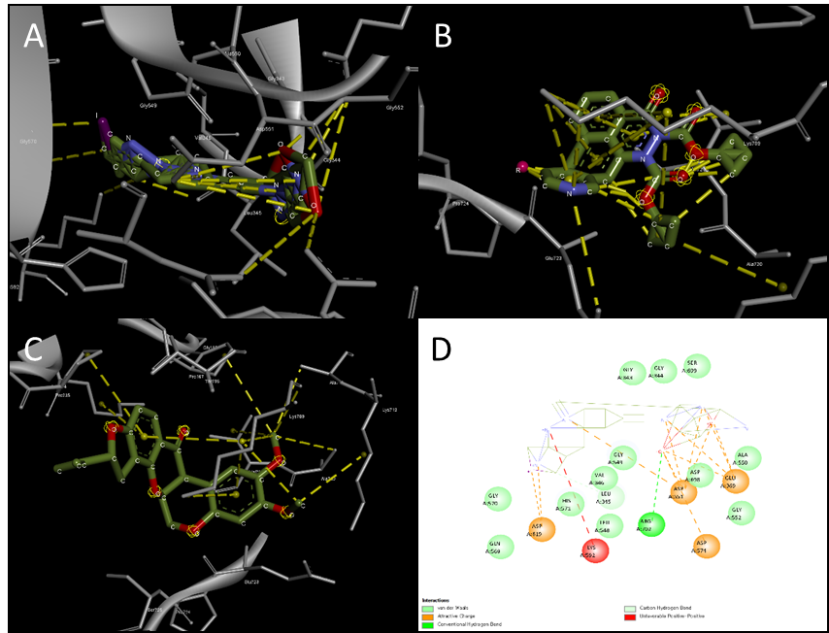
Fig 5. Docking simulation results using AutoDock 4 of compounds binding to NDUFS1 protein. Dotted yellow line indicates the docking site of the pair. (A) BDBM210829; (B) BDBM214042; (C) Rotenone; (D) BDBM210829-NDUFS1 interactions.

Discussion
BDBM210829 was identified by the DL model as the top candidate for binding to the NDUFS1 protein. To validate this finding, computational validation was performed using physics-based docking simulation with AutoDock 4. The analysis included BDBM210829, BDBM214042—the second top candidate—and the well-known MC-1 inhibitor, rotenone. Both the DL model and AutoDock produced similar Ki values for all tested compounds, demonstrating the high accuracy of the proposed model.

