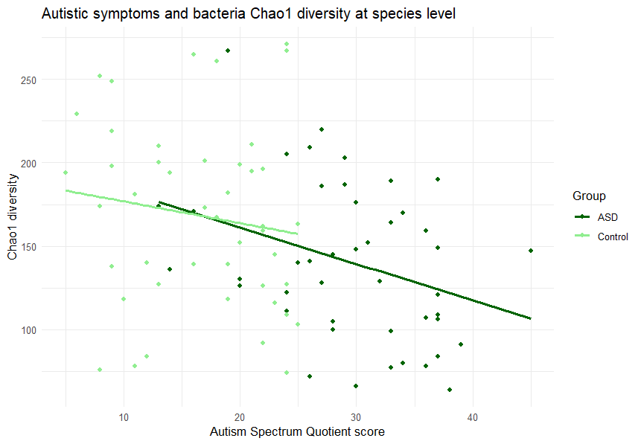
Figure S1. The correlations between Autism Spectrum Quotient scores and Chao1 Index values. P <0.001 as measured by Pearson’s correlation test across both ASD and control groups.

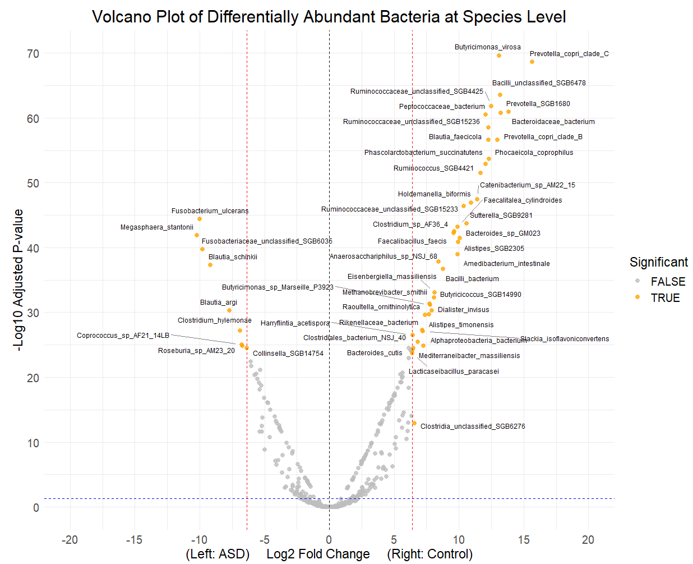

Figure S2. Volcano plot of differentially abundant bacterial species between ASD and control groups. Dots with yellow color represent the top 50 bacterial species with the largest log2 fold change.

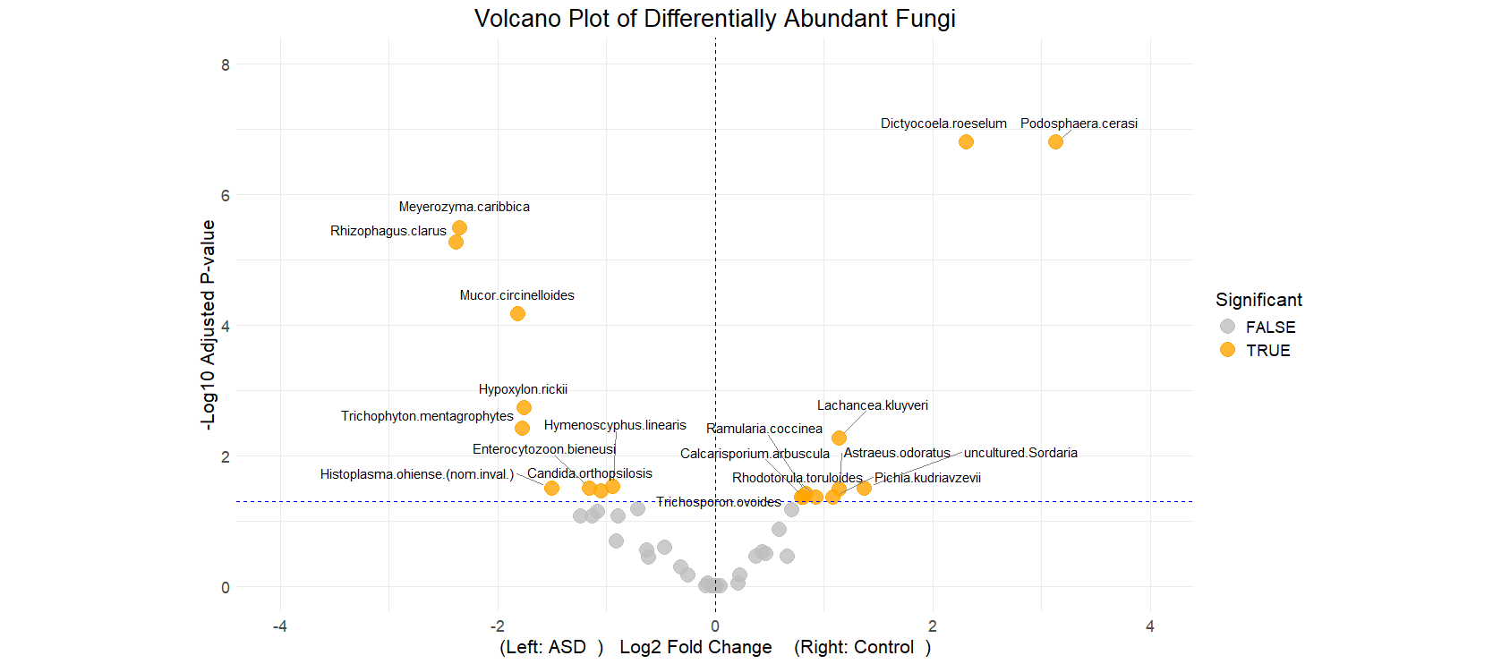

Figure S3. Volcano plot presents differentially abundant fungal species between ASD and control groups. Dots with yellow color represent the fungal species with adjusted p value < 0.05.

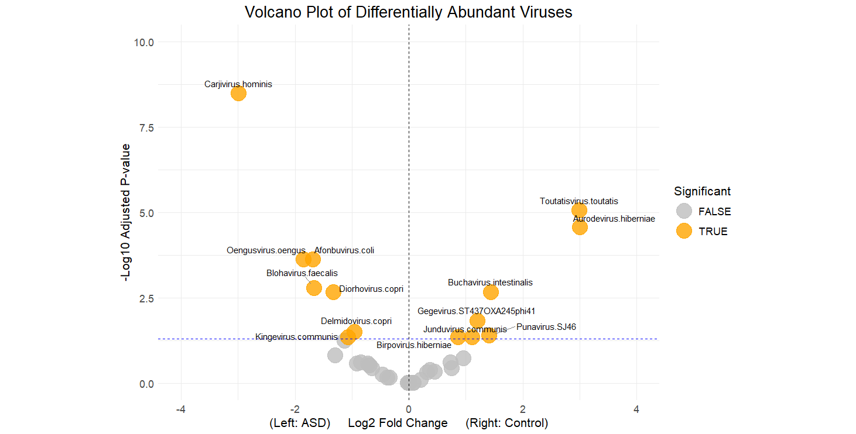
Figure S4. Volcano plot presents differentially abundant viral species between ASD and control groups. Dots with yellow color represent the viral species with adjusted p value < 0.05.

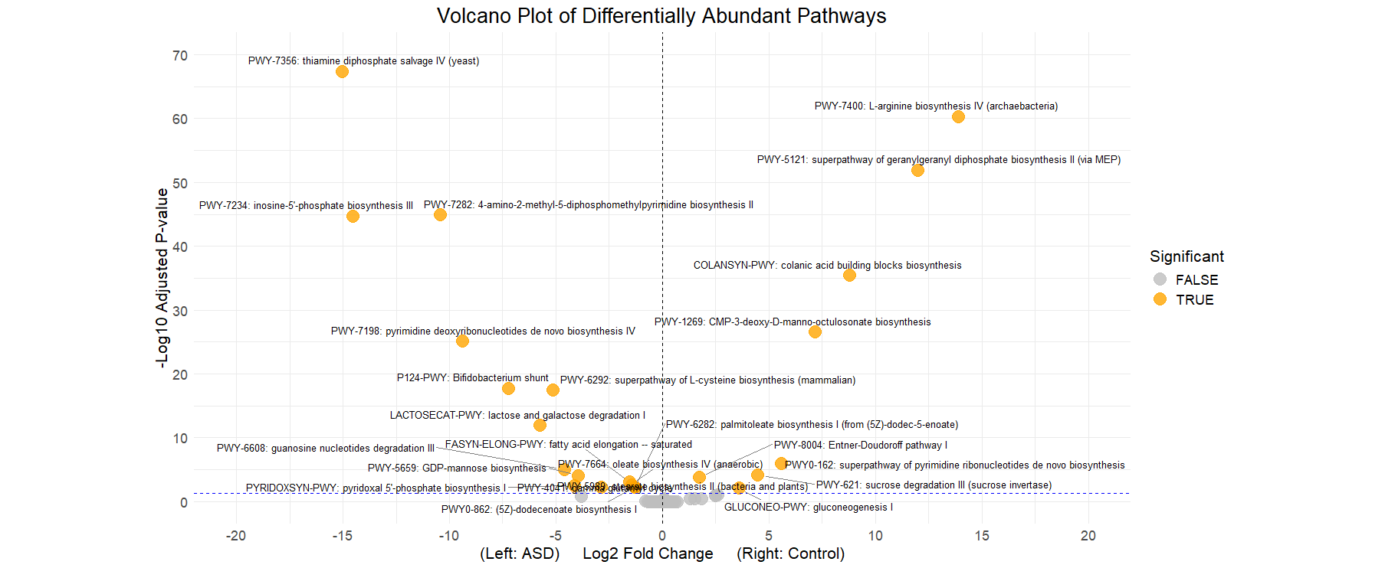

Figure S5. Volcano plot presents differentially abundant pathways between ASD and control groups. Dots with yellow color represent the pathways with adjusted p value < 0.05.

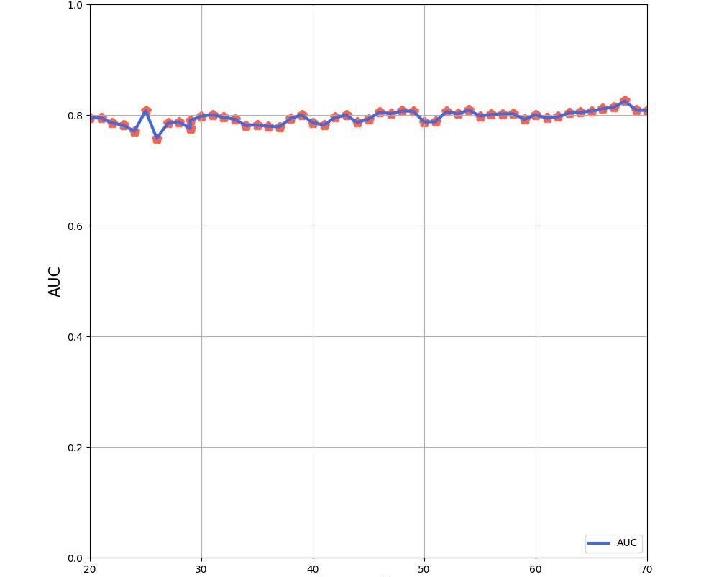
Number of features

Figure S6. The associations between numbers of features selected and mean AUC values.

Table S1. List of features selected in the prediction model

Group | Name of feature
Bacteria | Anaerostipes hadrus  Ruminococcaceae bacterium  Butyricimonas virosa  Bacteroides salyersiae  Ruminococcaceae bacterium AM07-15  Anaerotruncus rubiinfantis  Anaeromassilibacillus sp. An250  Oscillospiraceae bacterium NSJ64  Bifidobacterium longum  Actinomyces oris  Rothia mucilaginosa  Isoptericola variabilis  Streptococcus mutans  Clostridiales unclassified SGB15145  Corynebacterium durum  Peptococcaceae bacterium  Prevotella copri clade A  Clostridiaceae unclassified SGB4769  Mediterraneibacter massiliensis  Massilimaliae massiliensis
Fungi | Meyerozyma caribbica  Dictyocoela roeselum  Mucor circinelloides
Pathways | PWY-7234: inosine-5’-phosphate biosynthesis III  PWY-4041: gamma-glutamyl cycle

