Structural insights of Quercetin and its derivatives against multi-drug resistant Proteus mirabilis: In silico approach
Charu Jaiswal¹, Medha Chakraborty¹, Priti Choudhary², Kiran Bharat Lokhande^{1,#*}
¹Bioinformatics Centre, Dr. D. Y. Patil Biotechnology & Bioinformatics Institute, Dr. D. Y. Patil Vidyapeeth, Pune, India.
²School of Medical and Allied Sciences, K. R. Mangalam University, Gurugram, Haryana, India.
*Corresponding author details:
Dr. Kiran Bharat Lokhande,
Bioinformatics Research laboratory,
Dr. D. Y. Patil Biotechnology and Bioinformatics Institute,
Dr. D. Y. Patil Vidyapeeth (Deemed to be University),
Pune – 411033.
Email: kiran.lokhande.bioinfo@gmail.com; kiran.lokhande@dpu.edu.in

#Present Affiliation and Adress:
Dr. Kiran Bharat Lokhande,
Junior Research Scientist,
Computational Biophysics and CADD Group, Computational and Mathematical Biology Center, Translational Health Science and Technology Institute, Faridabad, India.

Structural insights of Quercetin and its derivatives against multi-drug resistant Proteus mirabilis: In silico approach
Charu Jaiswal¹, Medha Chakraborty¹, Priti Choudhary², Kiran Bharat Lokhande^{1,#*}
Abstract:
Aims: This study aims to explore natural compounds as potential inhibitors against multidrug-resistant Proteus mirabilis hemolysin, a key virulence factor contributing to catheter-associated urinary tract infections (CAUTIs). The emergence of multidrug-resistant bacterial strains poses a significant threat to global public health, with Proteus mirabilis being a notable contributor to hospital-acquired infections such as CAUTIs. Hemolysin, a toxin produced by P. mirabilis, plays a crucial role in its pathogenesis, making it an attractive target for antimicrobial therapy. The objective of this study is to investigate the binding affinity and stability of natural compounds, particularly derivatives of quercetin, with P. mirabilis hemolysin through molecular docking and dynamics simulations. Crystal structure retrieval of hemolysin from P. mirabilis was conducted, and the protein was prepared for molecular docking studies. Molecular docking analysis was performed to evaluate the binding affinity of natural compounds with hemolysin. Molecular dynamics simulations were then employed to assess the stability and dynamics of protein-ligand complexes. Molecular docking analysis revealed several lead compounds, including derivatives of quercetin, exhibiting strong binding affinity with P. mirabilis hemolysin. Molecular dynamics simulations demonstrated stable interactions between the lead compounds and hemolysin, with certain compounds showing reduced structural deviations and increased stability within the binding cavity. Natural compounds, particularly derivatives of quercetin, show promising antimicrobial activity against multidrug-resistant Proteus mirabilis hemolysin. These findings highlight the potential of natural compounds as effective inhibitors for combating multidrug-resistant bacterial infections, offering new avenues for therapeutic development in the fight against antibiotic resistance. Further research and clinical trials are warranted to validate the efficacy and safety of these compounds for clinical use.
Keywords: Antimicrobial resistance, Proteus mirabili, drug discovery, molecular docking, dynamic simulation, h bond network.

- Introduction:
One of the most significant threats to global public health revolves around the rapid surge in multi-drug resistance (MDR) among bacterial strains. This phenomenon is primarily fueled by the pervasive issue of antibiotics being excessively employed. These misguided practices have emerged as the primary reason behind the emergence of drug-resistant bacteria. Concurrently, other factors such as like long duration of stay in the hospital, intense surgical procedures, presence of immunosuppressive patients, and the incapability to control the spread of infections from one patient to other have further contributed to this concerning trend (Boev, 2017; Prestinaci et al., 2015). In a study conducted recently, it was found that there 30% of unnecessary outpatient antibiotics were prescribed along with acute respiratory infections at 50% of unnecessary use of antibiotics (Eggermont et al., 2018). As per the National Healthcare Safety Network, Enterobacter, Klebsiella pneumoniae, Proteus mirabilis, Enterococcus, E Coli, Pseudomonas aeruginosa, Staphylococcus aureus, coagulase-negative Staphylococcus are the causative organisms for nosocomial infections. The World Health Organization (WHO) has published a list of MDR bacteria that urgently require the development of novel antibiotics. P. mirabilis falls under the urgent category of amoxillin resistant (CR) Enterobacteriaceae (Girlich et al., 2020). The gram-negative bacteria including P. mirabilis use LuxI/LuxR type quorum sensing (QS) systems (Ruby, 1996; Hastings & Greenberg, 1999). Here the reaction between S-adenosylmethionine (SAM) and acyl carrier protein (ACP) is catalyzed by autoinducer (AI) synthase which is homologous to LuxI. This reaction produces acyl-homoserine lactone (AHL) AI (Engebrecht & Silverman, 1984; More et al., 1996; Schaefer et al., 1996; Ng & Bassler, 2009). High concentrations result in the binding of AHL AIs to cognate cytoplasmic LuxR- like transcription factors (TFs). On the other hand, LuxR-type proteins are degraded if not bound to AI, this prevents QS short-circuiting in bacteria. Often the binding of AI stabilizes the LuxR-type proteins, ultimately resulting in the activation of target genes transcription (Engebrecht et al., 1983; Engebrecht & Silverman, 1984; Stevens et al., 1994; Zhu & Winans 1999, 2001). Different bacteria produce AHLs possessing different length side chains and side-chain arrangements (Fuqua et al., 2001; Ng & Bassler., 2009) allowing bacteria to interact with a diverse population (Watson et al., 2002; Gould et al., 2004; Rutherford & Bassler, 2012). The mechanism of QS i.e., the cell-to-cell communication is regulated by the membrane components and the cytoplasmic factors (Rutherford & Bassler., 2012). Thus, the expression of the virulence factor responsible for the pathogenesis of P.mirabilis is controlled by QS (Stankowska et al., 2012). Rauprich et al., 1996 suggested a tremendously ordered swarm cycle that coordinates the mechanism in a multicellular organism and the fact that P. mirabilis is involved in biofilm formation which shows the mechanism of QS making CAUTI complex to treat.
Catheter-associated urinary tract infection (CAUTI) is a disease that is typically caused by the bacterial species of Escherichia coli (E. coli), Candida, Enterococcus, Pseudomonas, Proteus, and Klebsiella (Majumder et al., 2018). However, the bacteria of Proteus species are one of the major causes of the disease i.e., around 10-44% of cases of CAUTI are caused by P. mirabilis (Jacobsen & Shirtliff., 2011; Schaffer & Pearson., 2015) due to the causes of catheter blockage and development of urinary stone. According to a report published by Centres for Disease Control and Prevention (CDC), CAUTI has been considered the most frequently occurring hospital-acquired infection, which includes around 75% cases from long-term catheterization, and 15-25% during hospital bid. P. mirabilis has the innate ability to develop crystalline biofilms which are formed majorly by virulence factors such as urease enzyme and capsule polysaccharides (CPSs) (Jacobsen & Shirtliff, 2011), ultimately giving rise to blocked and encrusted catheters causing difficulties in such infections (Jones et al., 2007). As a result, they could lead to reflux and retention of urine and, in critical conditions, in addition to trauma, endotoxic shock, and septicemia to the urethra and bladder mucosa as a consequence of removing the catheter (Chen et al., 2012; Vaidyanathan et al., 2010; Wasfi et al., 2020). As per the 2019 report of the CDC, the Standardized Infection Ratio for CAUTI was 0.74 across general acute care hospitals (Majumder et al., 2018). The attachment of fimbriae such as mannose-resistant hemagglutinins on the fluid-derived protein coat of the catheter surface is widely responsible for the initial biofilm formation stages (Jacobsen et al., 2008; Donlan, 2002). Mannose-resistant/Proteus-like (MR/P) mutants fimbriae have also been found to play a major role in biofilm formation (Scavone et al., 2016) to the resistance to antibiotics in P. mirabilis is conferred by the means of genes present in plasmids, transposons, and integrons and further expand by the means of horizontal gene transfer thus resulting in swift spreading and treatment failure (Hall et al., 2003; Mirzaei et al., 2021). The Beta-lactam resistance pattern in P. mirabilis is of grave concern.
In a recent study, it has been reported that clinical isolates of P. mirabilis carried (intI1, intI2, intI3, blaTEM, blaCTX-M, blaSHV, mcr1, and mcr2) antibiotic resistance genes among which intI1 and blaTEM genes were found most abundantly in the ESBL and integrase gene family (Mirzaei et al., 2021). The frequent and inappropriate use of antibiotics has also contributed to the development of multidrug resistance (MDR) in P. mirabilis, so the generation of novel therapeutics against MDR bacteria is the need of the hour. Developing novel health interventions to block the action of the gene, protein, or enzyme responsible for the MDR, can aid with the treatment of the diseases. Hemolysin is such a protein that contributes to MDR in bacteria, so blocking their function through the use of inhibitors derived from natural compounds namely, Quercetin can help combat the complications related to MDR. We have used Quercetin in our experiment as it is a naturally occurring compound mainly present in plants and fungi. and hence it can serve as a clinically potent medicine. It has a phenolic hydroxyl group as well as contained a double bond due to which it shows a high antioxidant property. Quercetin has been clinically identified to possess the antibacterial activity and diminish the bacterial biofilm formation by inhibiting the expression of the genes involved in its formation (Yang et al., 2020).
This study is also intended to look for natural alternatives since they have fewer side effects than chemical drugs. Moreover, they form complexes due to the presence of various compounds, such as polysaccharides, mucilage, and tannins that contribute to the modification of the active component’s effect making them more favorable (Kopaei., 2012, 2013). We aimed to develop a lead compound against multidrug-resistant P. mirabilis and found pertinent alternative compounds to that of small drugs by docking the available drug molecules (acting as inhibitors), against our target proteins. This study also aids to find a potential drug lead for the MDR bacterial disease, by using the binding affinity scores of the ligand to the protein.
- Material and methods:
  - Crystal structure retrieval of hemolysin A from P. mirabilis and its preparation:
The structural analysis of the hemolysin protein was conducted utilizing the Uniprot database, accessible through the link: https://www.uniprot.org/uniprot/P16466#structure. Within this repository, a total of thirteen distinct structures of the hemolysin protein from P. mirabilis were subjected to thorough examination. These analyses were undertaken employing methodologies such as X-ray crystallography or NMR spectroscopy. The primary objectives of this investigation were to assess the protein's length and resolution quality. From the collection of thirteen examined structures, one particular structure, denoted as 4W8Q, emerged as the preferred choice. This selection was predicated on specific criteria, including its superior resolution quality, characterized by a low-resolution value. In comparison to the remaining structures, 4W8Q exhibited a greater length, rendering it an ideal candidate for further in-depth investigation. This truncated hemolysinA structure from P. mirabilis, bearing the designation 4W8Q, boasted a resolution of 1.43 Å within the positional range of 30 – 265.
The origin of this structure was traced back to the literature, with a corresponding DOI of 10.2210/pdb4w8q/pdb. It is noteworthy that the hemolysin protein exclusively comprises a single chain, designated as ChainA. Subsequently, the isolated hemolysin structure, defined by the single ChainA protein, underwent meticulous preparation using the Schrodinger Protein Preparation Wizard. This software tool occupies a pivotal role in facilitating modeling applications. The rationale underlying protein preparation stems from the inherent complexity of PDB structures, often containing co-crystallized components, heavy atoms, and occasionally multimeric entities. These factors necessitate streamlining for analytical efficacy. The preparatory steps encompass the integration of missing elements, simplification of intricate components, and removal of redundancies. This process compensates for disruptions that may have transpired during X-ray crystallization, such as hydrogen atom crystallization, sulfide bond disruption, and altered amino acid properties. Given that protein preparation serves as a prerequisite for subsequent docking studies, it encompasses tasks such as hydrogen addition, bond order assignment, zero bond order establishment for metals, incorporation of absent loops or chains, formation of disulfide bonds, and selenomethionine-to-methionine conversion. A final phase entails a comprehensive review and adjustment for structural integrity for further use.
  - Structure retrieval of the quercetin and its derivatives:
The molecular structure of Quercetin, exhibiting a remarkable 94% similarity to an inhibitor of our designated target protein, hemolysin, has been sourced from the PubChem database (https://pubchem.ncbi.nlm.nih.gov/), which provides access to structures presented in the SDF format, characterized by a three-dimensional configuration. The process of retrieval involved identifying molecules that bear resemblance to Quercetin, resulting in the procurement of a total of 605 analogous compounds. This selection was governed by the application of the Lipinski Rule of Five, an established criterion initially formulated by Lipinski in 2004 and subsequently highlighted by Jayaram et al. in 2012. The application of this rule serves the purpose of differentiating molecules with potential as drug candidates from those that are less amenable to drug development. Furthermore, it contributes to the prognostication of success rates or potential setbacks in the realm of drug discovery. The Quercetin compound, distinguished by the DrugBank accession number DB04216, underwent a process of verification within the DrugBank database. This verification, conducted via the link: https://go.drugbank.com/drugs/DB04216, enabled the comprehensive acquisition of information pertaining to the Quercetin compound itself and its associated drug target. This step serves to augment our comprehension of the specific attributes and implications linked to the Quercetin compound, particularly concerning its role as a potential inhibitor of the target protein, hemolysin.
  - Molecular docking analysis by FlexX:
The molecular docking of 605 retrieved inhibitors that serves as our ligand was docked against the target protein hemolysin whose structure was retrieved using Schrodinger's Maestro 12.8 tool. By using FlexX software, the small molecules were docked into the active site of the protein (Rarey et al., 1996). The binding cavity of the receptor was defined with the help of the FlexX receptor preparation wizard. The active sites within the hemolysin structure were delineated by the following residues: ASN-30-A, ALA-83-A, GLU-85-A, ALA-86-A, GLY-87-A, GLN-88-A, SER-89-A, GLN-90-A, GLU-126-A, VAL-127-A, PHE-128-A, GLY-129-A, ILE-130-A, ILE-150-A, and ASN-151-A. The ligand-binding was driven by Enthalpy and Entropy (Hybrid Approach) with a maximum allowed overlap volume of 2.9 Å between protein-ligand clashes, and a clash -factor of 0.6 within the ligands. All 606 compounds (1 compound of Quercetin and 605 similar compounds) were docked against the binding site of hemolysin to find the best binding pose. The ligand is docked on the receptor after the ligand’s conformational expansion, resulting in the generation of various conformations (Lokhande et al., 2020).
The molecular docking of 116 retrieved inhibitors that serves as our ligand was docked against the target protein hemolysin whose structure was retrieved using Schrodinger's Maestro 12.8 tool. By using the FlexX software, the small molecules were docked into the active site of the protein (Rarey et al., 1996). The binding cavity of the receptor was defined with the help of the FlexX receptor preparation wizard. The ligand-binding was driven by Enthalpy and Entropy (Hybrid Approach) with a maximum allowed overlap volume of 2.9 Å between protein-ligand clashes, and a clash -factor of 0.6 within the ligands. FlexX considers the following factors for determining the best configuration that including -loss of entropy upon ligand binding, hydrogen bond interaction, solvation energy, Van der Waals, and electrostatic interaction (Bursulaya et al., 2003). By determining the binding and docking energy, the optimal binding pose is determined (Lokhande et al., 2020).

  - Molecular dynamic simulation:
The Desmond software developed by D. E. Shaw was employed to conduct extensive 100 nanoseconds (ns) all-atom molecular dynamics (MD) simulations, aiming to assess the binding affinity and the interactions between the top five best-docked ligands with the target protein Haemolysin (4W8Q), alongside a standard reference compound. Each complex system was immersed within a solvated cubic box spanning 10 angstroms (Å), incorporating periodic boundary conditions to mimic a realistic environment. Solvation was achieved using the TIP3P water model, ensuring a realistic representation of the solvent environment. To maintain overall system neutrality, counter ions were added to neutralize the total charges present in the system. The number of water molecules added, along with the concentration of counter ions in the complex, are tabulated in Table 1 for reference. During the 100 ns MD simulations, the OPLS 2005 force field was employed, with initial energy minimization performed using the steepest descent approach. The systems underwent linear heating within the NVT ensemble for the first 400 picoseconds (ps), gradually raising the temperature from 0 to 300 Kelvin (K). Subsequently, equilibration of the systems was achieved utilizing an NPT ensemble at a pressure of 1 bar and a temperature of 300 K. Temperature and pressure regulation throughout the simulations was facilitated by the Noose-Hoover chain thermostat method and the Martyna-Tobias-Klein barostat method, respectively, employing an isotropic coupling style. Integration of the equations of motion was executed using the leap-frog approach with a time step of 2 femtoseconds (fs). Additionally, coulomb short-range interactions were maintained within a cut-off radius of 9.0 Å.
Following the production run, trajectory analysis was conducted to evaluate structural dynamics throughout the simulation period. Root Mean Square Deviation (RMSD) and Root Mean Square Fluctuation (RMSF) analyses were performed to elucidate any significant conformational changes within the protein-ligand complexes, indicating stability and equilibration of the simulation. RMSD provided insights into the stability of compound structures, while RMSF highlighted fluctuations in specific regions of the complexes, aiding in the characterization of dynamic behavior during the simulation.
Table 1: Number of water molecules and ions required for MD simulation study.
Complex | Number of water molecules added | Number of counterions | Concentration of counterions
4W8Q_5280343 | 5213 | 3 | 10.463
4W8Q_9814421 | 5223 | 3 | 10.443
4W8Q_9966216 | 5212 | 3 | 10.465
4W8Q_140034695 | 5213 | 3 | 10.463
4W8Q_688798 | 5212 | 3 | 10.465
4W8Q_676310 | 5212 | 3 | 10.465
- Result and Discussion
  - Molecular docking analysis:
Binding energies:
Based on the comprehensive investigation conducted, the molecules listed in Table 2 have emerged as promising hit compounds following docking studies and molecular dynamics (MD) simulations. The reference compound, along with the top five hits, exhibited robust docking scores (DDRC: -21.898 kcal/mol; DHFC: -21.567 kcal/mol; THDF: -21.536 kcal/mol; DHTC: -21.417 kcal/mol; TTDF: -21.117 kcal/mol). These scores indicate a strong binding affinity between the compounds and the target receptor, suggesting favorable interactions within the binding pocket. The high docking scores imply that the derivatives are well-suited for binding within the active site of the hemolysin protein, a significant toxin responsible for virulence in P. mirabilis. This finding is particularly promising as hemolysin contributes significantly to virulence and poses a challenge in combating multidrug resistance (MDR) in P. mirabilis infections.
The strong interaction observed between the hit compounds and the active site residues of the target receptor underscores their potential as effective therapeutic agents against MDR in P. mirabilis. The robust binding affinity displayed by these compounds suggests their ability to disrupt crucial molecular pathways associated with virulence, thus offering a promising avenue for the development of novel antimicrobial agents.
Table 2: Docking score and intermolecular interaction analysis of Quercetin and the selected lead compounds with Hemolysin.
Compound Name | PubChem CID | Binding Affinity (Kcal/mol) | Interacting Amino Acids | Polarity | Type of Inter-molecular Bond | Bond Distance (Å)
Quercetin | 5280343 | -15.053 | GLU 85 | Hydrophilic | H -Bond | 2.05, 2.06
Quercetin | 5280343 | -15.053 | GLN 88 | Hydrophilic | H -Bond | 1.91
Quercetin | 5280343 | -15.053 | GLU 126 | Hydrophilic | H -Bond | 1.77
Quercetin | 5280343 | -15.053 | GLY 129 | Hydrophobic | H -Bond | 2.13
2-(2,4-Dihydroxyphenyl)-7,8-dihydroxychromen-4-one | 9814421 | -21.898 | GLU 85 | Hydrophilic | H -Bond | 2.27
2-(2,4-Dihydroxyphenyl)-7,8-dihydroxychromen-4-one | 9814421 | -21.898 | GLU 126 | Hydrophilic | H -Bond | 1.94
2-(2,4-Dihydroxyphenyl)-7,8-dihydroxychromen-4-one | 9814421 | -21.898 | GLY 129 | Hydrophobic | H -Bond | 2.06,  2.08,  2.13
2-(2,4-Dihydroxyphenyl)-7,8-dihydroxychromen-4-one | 9814421 | -21.898 | PHE 128 | Hydrophobic | Pi-Pi Stacking | 5.47
2-(3,4-Dihydroxyphenyl)-3-fluoro-7,8-dihydroxychromen-4-one | 9966216 | -21.567 | GLU 85 | Hydrophilic | H -Bond | 1.67,  1.67
2-(3,4-Dihydroxyphenyl)-3-fluoro-7,8-dihydroxychromen-4-one | 9966216 | -21.567 | GLU 126 | Hydrophilic | H -Bond | 1.57,  1.60
2-(3,4-Dihydroxyphenyl)-3-fluoro-7,8-dihydroxychromen-4-one | 9966216 | -21.567 | GLY 129 | Hydrophobic | H -Bond | 1.89
2-(3,4-Dihydroxyphenyl)-3-fluoro-7,8-dihydroxychromen-4-one | 9966216 | -21.567 | PHE 128 | Hydrophobic | Pi-Pi Stacking | 4.80
7,8,3'-Trihydroxyflavone | 676310 | -21.536 | GLU 85 | Hydrophilic | H -Bond | 1.67,  1.67
7,8,3'-Trihydroxyflavone | 676310 | -21.536 | GLU 126 | Hydrophilic | H -Bond | 1.57,  1.60
7,8,3'-Trihydroxyflavone | 676310 | -21.536 | GLY 129 | Hydrophobic | H -Bond | 1.89
7,8,3'-Trihydroxyflavone | 676310 | -21.536 | PHE 128 | Hydrophobic | Pi-Pi Stacking | 4.80
2-(2,3-dihydroxyphenyl)-5,7,8-trihydroxychromen-4-one | 140034695 | -21.417 | GLU 85 | Hydrophilic | H -Bond | 1.58,  1.78,  2.39
2-(2,3-dihydroxyphenyl)-5,7,8-trihydroxychromen-4-one | 140034695 | -21.417 | GLN 88 | Hydrophilic | H -Bond | 2.07
2-(2,3-dihydroxyphenyl)-5,7,8-trihydroxychromen-4-one | 140034695 | -21.417 | VAL 127 | Hydrophobic | H -Bond | 1.52,  1.92
7,8,3',4'-Tetrahydroxyflavone | 688798 | -21.117 | GLU 85 | Hydrophilic | H -Bond | 1.65,  1.65
7,8,3',4'-Tetrahydroxyflavone | 688798 | -21.117 | GLY 129 | Hydrophobic | H -Bond | 1.88
7,8,3',4'-Tetrahydroxyflavone | 688798 | -21.117 | GLU 126 | Hydrophilic | H -Bond | 1.55,  1.60
7,8,3',4'-Tetrahydroxyflavone | 688798 | -21.117 | PHE 128 | Hydrophobic | Pi-Pi Stacking | 1.60,  4.78
Interaction study:
Quercetin: Quercetin (PubChem CID: 5280343) was a reference ligand that has antimicrobial activity. It inhibits the pathogenesis of P.mirabilis by acting on the haem receptor of the hemolysin protein. However, we worked to check out the efficacy of other derivatives against hemolysin as well, along with the Quercetin. Henceforth, a comparison of Quercetin with other hit compounds was performed along with studying the efficacy of Quercetin.
Quercetin binds in the cavity of protein with an affinity of -15.053kcal/mol. In the 2D structure of Quercetin, 4 functional groups are present that facilitate this binding are GLU-85, GLN 88, GLU 126, and GLY 129 are bound to the cavity of the hemolysin via hydrogen bonds. The GLU 85 and GLN 88 forms 2 hydrogen bonds each. GLU 85 forms the hydrogen bonds of bond lengths 2.06 Å and 2.05 Å, and the GLN 88 forms hydrogen bond of lengths 1.89 Å and 1.91 Å, while, GLU 126 and GLY 129 form only 1 hydrogen bond with the target protein of bond length 1.77 Å and 2.13 Å respectively. As the GLN 88 forms 2 hydrogen bond that is more than GLU 126, therefore, the functional group GLN 88 in the ligand majorly contributes to the binding with hemolysin (Figure 1).
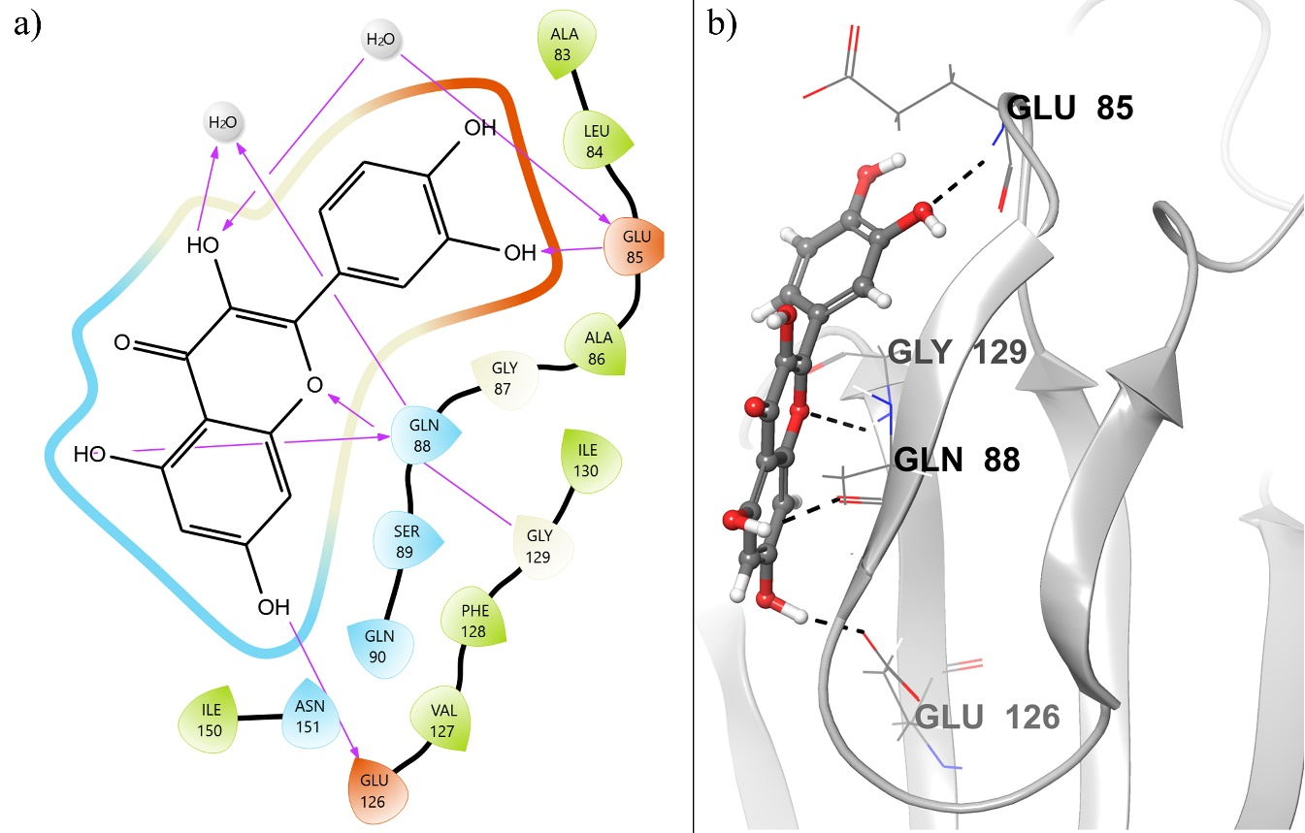
Figure 1: (a) 2-D representation of hemolysin (protein)- Quercetin (ligand) interaction at a width of 1200 Å and height of 1668 Å, where the hydrogen bonding is represented by purple. (b) 3-D representation of hemolysin(protein)- Quercetin (ligand) interaction, where the hydrogen bond is represented in black. The lead compound is represented by the ball and stick model while the protein is represented in ribbon form. Here, the hydrogen bonds are represented in black.
2-(2,4-Dihydroxyphenyl)-7,8-dihydroxychromen-4-one (DDRC): The compound 2-(2,4-Dihydroxyphenyl)-7,8-dihydroxychromen-4-one (PubChem CID: 9814421) is a derivative of Quercetin was observed to be a potential lead compound to inhibit the activity of P.mirabilis because it shows higher binding affinity than Quercetin and other derivatives. Figure 3 shows the binding pose of 2-(2,4-Dihydroxyphenyl)-7,8-dihydroxychromen-4-one within the cavity of hemolysin. The docking score of 2-(2,4-Dihydroxyphenyl)-7,8-dihydroxychromen-4-one is -21.898 kcal/mol, which suggests strong binding of this compound within the binding cavity of hemolysin in P.mirabilis. It forms 5 hydrogen bonds and a pi-pi stacking with the protein, of which GLU 85 forms a hydrogen bond of a bond length of 2.27 Å, GLU 126 forms a hydrogen bond of 1.94 Å, and the GLY 129 forms 3 hydrogen bonds of bond length 2.13 Å, 2.06 Å, and 2.08 Å. A pi-pi stacking is often observed with PHE 128 having a bond length of 5.47 Å. Therefore, this structure has a high affinity, due to the presence of both strong intermolecular bonds that ensures efficient binding and non-covalent pi-pi stacking which provides stability to this compound. The GLY 129 is a major residue, significantly involved in the bonding of the lead compound to a receptor. Moreover, the comparison of its affinity to that of Quercetin shows it binds more efficiently.
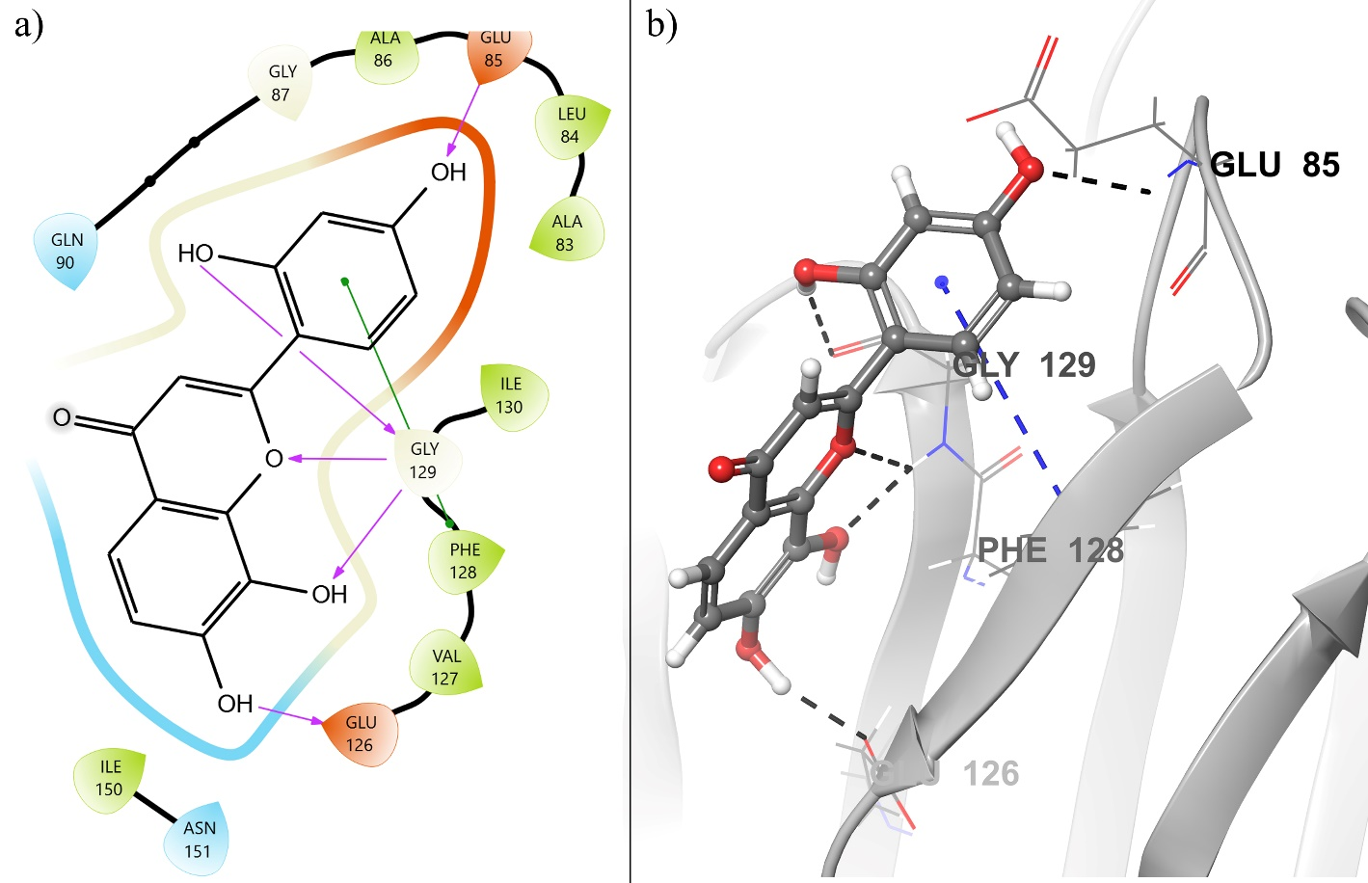
Figure 2: (a) The intermolecular interaction between hemolysin(protein) and 2-(3,4-Dihydroxyphenyl)-3-fluoro-7,8-dihydroxychromen-4-one (ligand), where the purple-colored arrow represents the hydrogen bond while green color arrow represents the pi-pi stacking. (b) The intermolecular interaction between hemolysin(protein) and 2-(3,4-Dihydroxyphenyl)-3-fluoro-7,8-dihydroxychromen-4-one(ligand) in 3D. The lead compound is represented by the ball and stick model while the protein is represented in ribbon form. Here, the hydrogen bonds and pi-pi stacking are represented by black and blue colors respectively.
2-(3,4-Dihydroxyphenyl)-3-fluoro-7,8-dihydroxychromen-4-one (DHFC): The compound 2-(3,4-Dihydroxyphenyl)-3-fluoro-7,8-dihydroxychromen-4-one (PubChem CID: 9966216) a derivative of Quercetin was observed to be a potential lead compound to inhibit the activity of P.mirabilis because it shows high binding affinity with the hemolysin. Figure 3 shows the binding pose of 2-(2,4-Dihydroxyphenyl)-7,8-dihydroxychromen-4-one within the cavity of hemolysin. It forms 6 hydrogen bonds and a pi-pi stacking with the protein, of which the GLU 85 forms two hydrogen bonds of 1.67 Å and 1.67 Å; GLU 126 forms two hydrogen bonds of 1.57 Å and 1.60 Å, while GLY 129 forms one hydrogen bond of 1.89 Å, along with a pi-pi stacking formed of 4.80 Å by PHE 128.
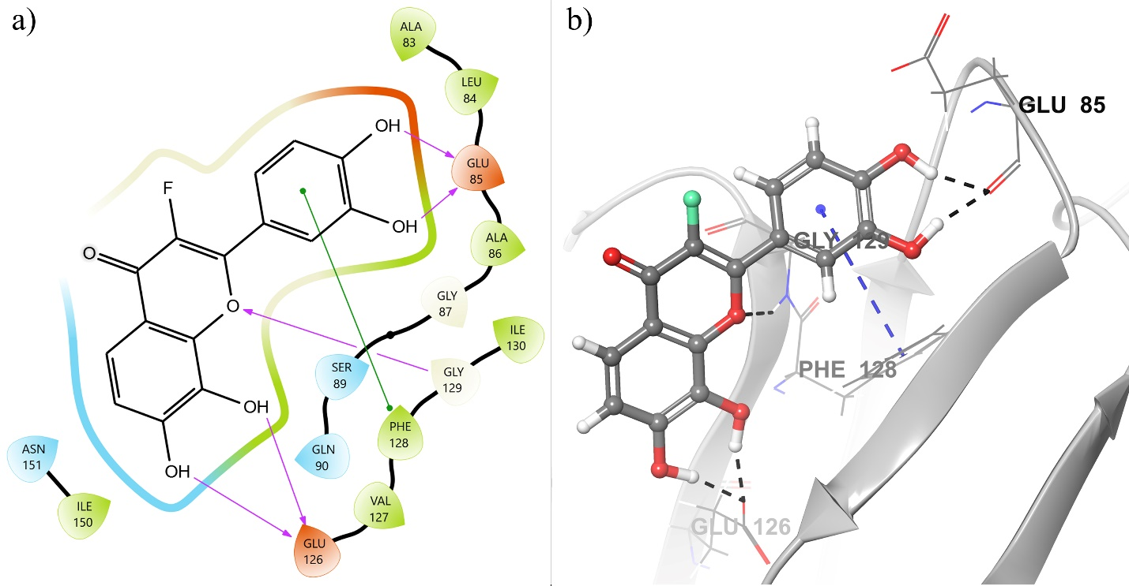
Figure 3: (a) The intermolecular interaction between hemolysin (protein) and 2-(3,4-Dihydroxyphenyl)-3-fluoro-7,8-dihydroxychromen-4-one (ligand), where the purple-colored arrow represents the hydrogen bond while green color arrow represents the pi-pi stacking. (b)The intermolecular interaction between hemolysin(protein) and 2-(3,4-Dihydroxyphenyl)-3-fluoro-7,8-dihydroxychromen-4-one(ligand) in 3D. The lead compound is represented by the ball and stick model while the protein is represented in ribbon form. Here, the hydrogen bonds and pi-pi stacking are represented by black and blue colors respectively.
7,8,3'-Trihydroxyflavone (THDF): The docking score of Trihydroxyflavone (PubChem CID: 676310) is -21.536 which suggests a strong bonding of this compound from Quercetin but less than 2-(3,4-Dihydroxyphenyl)-3-fluoro-7,8-dihydroxychromen-4-one, within the binding cavity of hemolysin. It has 5 hydrogen bonds of length 1.67 Å, and 1.67 Å, for GLU 85, 1.57 Å, and 1.60 Å, for GLU 126, and 1.89 Å, for GLY 129 as well as consists of 1 pi-pi stacking with PHE 128 with a bond distance of 4.80 Å. GLU is the major contributing residue in this compound (Figure 4).
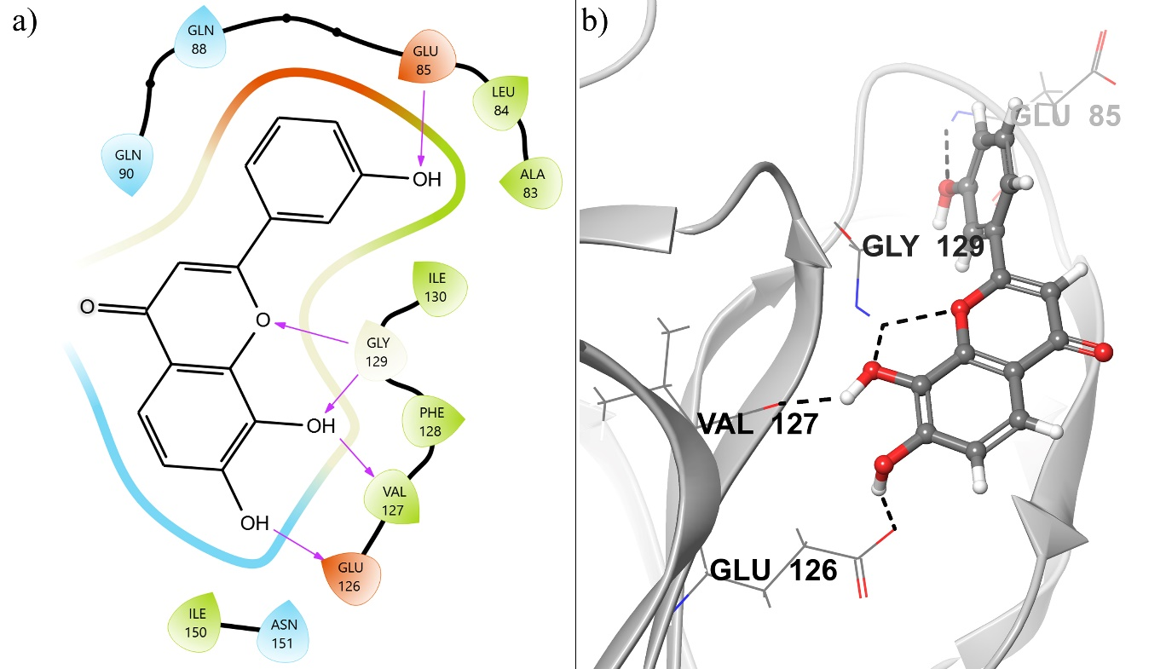
Figure 4: (a) The intermolecular interaction between hemolysin(protein) and 7,8,3'-Trihydroxyflavone (ligand) in 2D, where the purple-colored arrow represents the hydrogen bond while the green color arrow represents the pi-pi stacking (b)The intermolecular interaction between hemolysin(protein) and 7,8,3'-Trihydroxyflavone(ligand) in 3D structure. The lead compound is represented by the ball and stick model while the protein is represented in ribbon form. Here, the hydrogen bonds and pi-pi stacking are represented by black and blue colors respectively.
2-(2,3-dihydroxyphenyl)-5,7,8-trihydroxychromen-4-one (DHTC): The docking score of 2-(2,3-dihydroxyphenyl)-5,7,8-trihydroxychromen-4-one (PubChem CID:140034695) is -21.4177. It forms a total of 6 hydrogen bonds of which GLU 85 forms hydrogen bonds of length 2.39 Å, 1.58 Å, and 1.78 Å; GLU 85 forms a hydrogen bond of 2.07 Å in GLN 88, as well as hydrogen bonds of bond length 1.52 Å, and 1.92 Å is formed by VAL 127 (Figure 5). From here we inferred GLU is a major residue, significantly involved in the bonding of the lead compound to a receptor. Moreover, the comparison of its affinity to that of Quercetin shows it binds more efficiently.
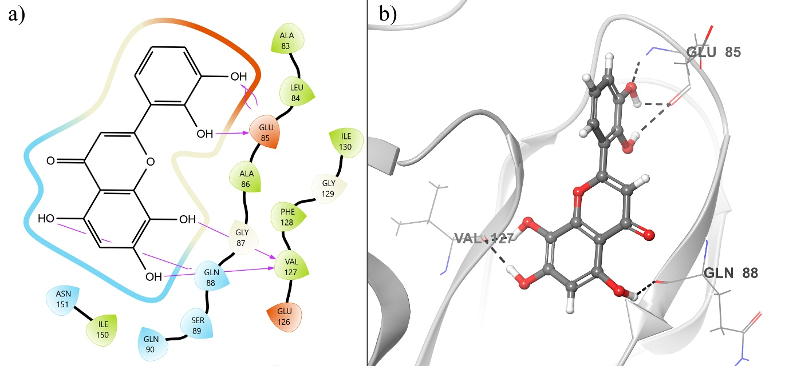
Figure 5: (a) The intermolecular interaction between hemolysin (protein) and 2-(2,3-dihydroxyphenyl)-5,7,8-trihydroxychromen-4-one (ligand), where the purple-colored arrow represents the hydrogen bond.(b) The intermolecular interaction between hemolysin (protein) and 2-(2,3-dihydroxyphenyl)-5,7,8-trihydroxychromen-4-one (ligand) in 3D. The lead compound is represented by the ball and stick model while the protein is represented in ribbon form. Here, the hydrogen bonds are represented by black color.

7,8,3',4'-Tetrahydroxyflavo (TTDF): In the 2D workspace 5 hydrogen bonds and 1 pi -pi stacking were observed in 7,8,3',4'-Tetrahydroxyflavone (PubChem CID: 688798) having a binding energy of -21.117Kcal/mol. The GLU 85 forms 2 hydrogen bonds of length 1.65 Å, GLY 129 forms a hydrogen bond of 1.88 Å, and GLU 126 forms a 2hydrogen bond of length 1.55 Å and 1.60 Å. GLU is the major binding group here. A pi-pi stacking of bond length 4.78 was often observed in PHE 128 (Figure 6).
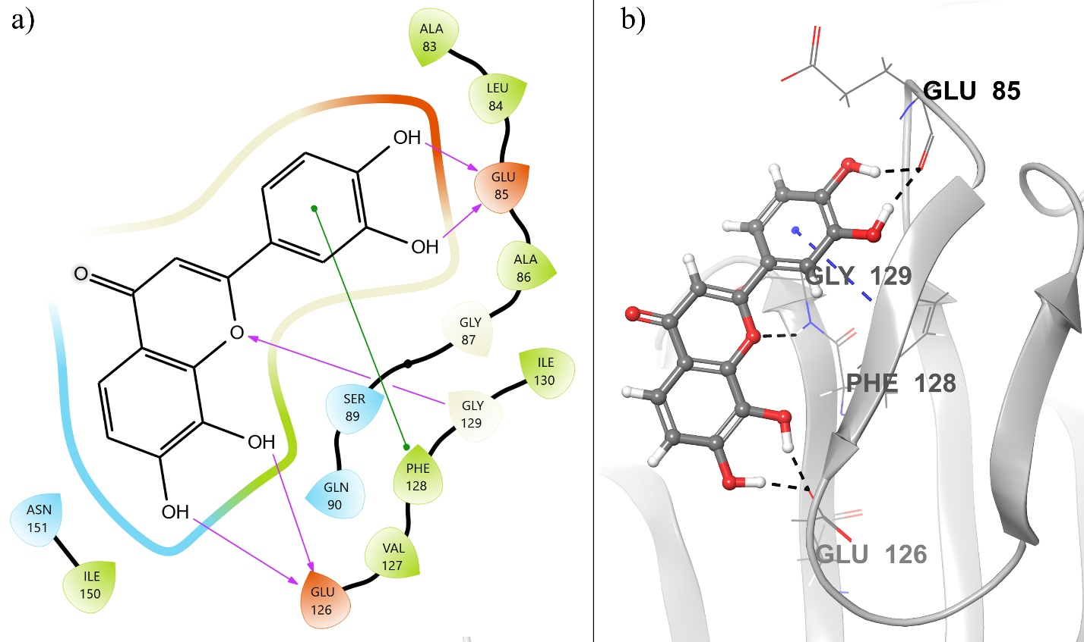
Figure 6: (a) The intermolecular interaction between hemolysin (protein) and 7,8,3',4'-Tetrahydroxyflavone (ligand) in 2D, where the purple-colored arrow represents the hydrogen bond while the green color arrow represents the pi-pi stacking. (b) The intermolecular interaction between hemolysin(protein) and 7,8,3',4'-Tetrahydroxyflavone in 3D. The lead compound is represented by the ball and stick model while the protein is represented in ribbon form. Here, the hydrogen bonds and pi-pi stacking are represented by black and blue colors respectively.
  - MD simulation
The molecular dynamic simulation was carried out to explore the protein-ligand dynamic conformational perturbation of the best five docked ligands. A run of 100ns simulations was performed using the OPLS-2005 force field for the hemolysin receptor. For the purpose of visualization of the interaction among the selected ligand derivatives and their reference compound, the Desmond MD system was used. The net charge of all the systems of standard reference complex of Hemolysin protein with the reference ligand (4W8Q: Quercitin) and complex systems of the lead compounds (4W8Q: DDRC, 4W8Q: DHFC, 4W8Q: THDF, 4W8Q: DHTC, 4W8Q: TTDF) was equilibrated by the incorporation of sodium ions (Na+) and was solvated by the means of explicit TIP3P water molecules in the filledcubicboxof1Å spacing detailed in Table 3. Figure 7. Is a representation of the strength and stability of the ligand with the protein receptor. 50ns was the time taken by DDRC to reach a state of convergent equilibrium as compared to THDF which required only 25ns, followed by TTDF with a time of 10ns to reach equilibrium and showing most stability throughout the process. DHFC displayed stability from 10 to 55ns and was observed to show minor fluctuations from 60-100ns whereas DHTC was found to be stable during the entire process. A decline in the potential energy was observed which indicates the system is stable. RMSD (Root mean square deviation) was calculated once the conformation analysis was done. The shift in selected atoms can be calculated by observing the average change for the particular frame with respect to the reference frame.
RMSD
Figure 7 illustrates the Root Mean Square Deviation (RMSD) of the protein throughout the simulation period. Observationally, it is evident that the fluctuations experienced by the atoms reached a maximum peak limit of 2.2-2.5 Å across all complex systems, as depicted in the network processing frame. This observation suggests potential helical winding and unwinding of the protein receptor, indicating dynamic structural changes occurring within the protein environment. In general, compounds demonstrating lower RMSD values are considered satisfactory, indicating stable binding interactions with the protein target. Analyzing the RMSD for the complex systems of derivatives of quercetin, it was observed that 4W8Q: TTDF exhibited the least variation in RMSD, followed by 4W8Q: TTDF, 4W8Q: THDF, and 4W8Q: THDF. Conversely, 4W8Q: DHFC displayed minor fluctuations in RMSD.
These findings suggest that certain compounds, particularly 4W8Q: TTDF, exhibit more stable interactions within the binding cavity of hemolysin compared to others. The lower RMSD values indicate reduced structural deviation from the initial conformation, indicating a higher degree of stability in the protein-ligand complex. This stability is crucial for the development of effective inhibitors targeting hemolysin, as it ensures sustained binding interactions essential for therapeutic efficacy against multidrug-resistant pathogens like P. mirabilis.
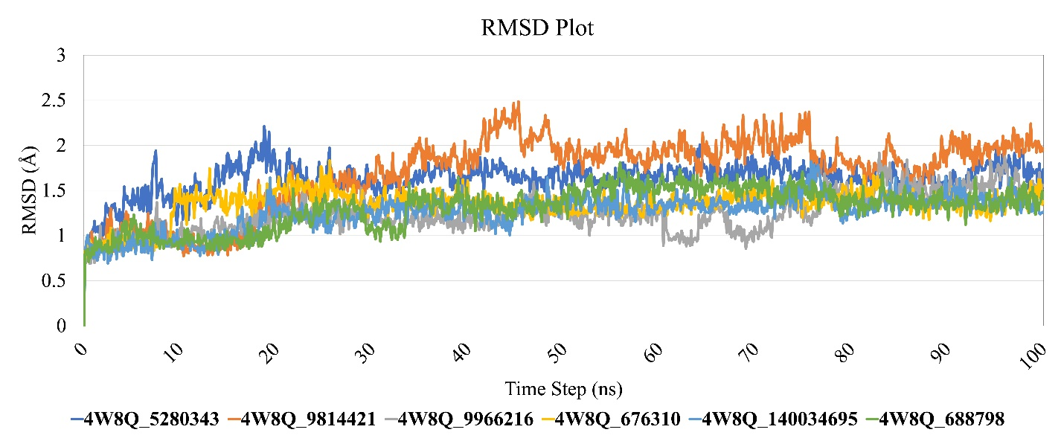
Figure 7: Protein-Ligand root mean square deviation (RMSD) graphs for reference compound and its respective docked hits during 100ns molecular dynamic simulation.
RMSF
An in-depth analysis was conducted by comparing the Root Mean Square Fluctuation (RMSF) of C-alpha atoms of all residues using trajectories generated during 100 ns of MD simulations. This analysis aimed to elucidate structural alterations in the hemolysin protein upon binding to the anti-bacterial compounds. The RMSF of each complex system provided insights into residue mobility and ligand flexibility within the receptor network. A rigid protein structure suggests minimal fluctuations and increased flexibility of the ligand within the receptor, reflected by lower RMSF values. Conversely, higher RMSF values indicate a loosely bonded structure, suggesting greater flexibility within the complex (Pathak et al., 2018). The RMSF trajectories of the receptor-ligand complex stability correlate with rigid and stable conformations. The RMSF graph revealed that upon ligand binding, notable changes were observed primarily in the region spanning residues 247 to 254, with a shift ranging from 1 to 3.5 angstroms (Å). Specifically, the complex 4W8Q: DHFC exhibited the highest fluctuations, indicating increased flexibility within this particular complex (Figure 8).
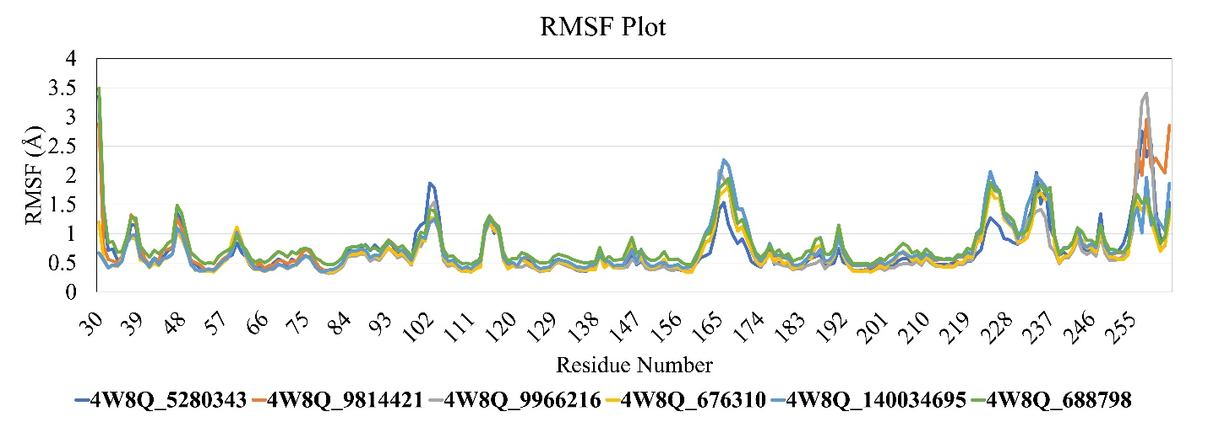
Figure 8: Protein-Ligand root mean square fluctuation RMSF graphs of reference compound and its respective docked hits during 100ns molecular dynamic simulation. Peaks are indicative of the areas of protein that undergo the most fluctuation during the simulation.
Table 3: RMSF values of hemolysin binding pocket residues after binding of lead compounds.
Residue | 5280343 | 9814421 | 9966216 | 676310
GLU85 | 0.713 | 0.689 | 0.62 | 0.644
GLU86 | 0.672 | 0.693 | 0.616 | 0.643
GLN88 | 0.814 | 0.708 | 0.642 | 0.659
GLU126 | 0.364 | 0.388 | 0.347 | 0.37
VAL127 | 0.363 | 0.405 | 0.368 | 0.374
PHE128 | 0.396 | 0.415 | 0.369 | 0.382
GLY129 | 0.524 | 0.493 | 0.466 | 0.478
GLU185 | 0.581 | 0.659 | 0.473 | 0.571
The analysis suggests that the lead compounds form stable complexes with the hemolysin protein and exhibit thermodynamic stability. The observed structural changes, particularly in specific regions of the protein, highlight the dynamic nature of the receptor-ligand interactions. These findings underscore the potential of the lead compounds as effective inhibitors against multidrug-resistant pathogens, such as P. mirabilis, by targeting key proteins involved in virulence pathways.
H-Bond monitoring Reports
To assess the stability of the binding between the lead compounds and hemolysin, we conducted an analysis of intermolecular hydrogen bond (H-bond) interactions. Utilizing Maestro software, 1000 frames were extracted from the 100 nsMD simulation trajectory data to evaluate the H-bonding patterns. Figure 9 depicts the presence of intermolecular H-bonding between the lead compounds and the hemolysin receptor. Figure 12(a) illustrates that the quercetin-hemolysin complex initially stabilizes with 1 to 3 H-bonds, maintaining stability with a single H-bond until 50,000 ns, followed by bond breakage.
In Figure 9(b), the main lead compound, DDRC, forms 3 to 5 H-bonds initially, with some trajectories forming up to 6 H-bonds during the 50 ns MD simulation. However, bond breakage is observed over time. Figure 9(c) demonstrates that the lead compound DHFC maintains stability by forming 3 to 5 H-bonds initially, followed by 4 to 5 H-bonds in the middle phase, and eventually 2 to 5 H-bonds towards the end of the dynamics, thereby ensuring complex stability. Figure 9(d) depicts the hydrogen bonds between the ligand THDF and hemolysin. Initially, 1 to 3 H-bonds stabilize the complex, increasing to 2 to 4 H-bonds, maintaining stability throughout. Figure 9(e) shows the TTDF-hemolysin complex stabilized by 1 to 7 H-bonds initially, maintaining the same number of bonds throughout the 1000 ns simulation. Figure 9(f) indicates that the TTDF-hemolysin complex forms 3 to 5 H-bonds initially, maintaining stability throughout the simulation.
Overall, the results suggest that the lead compounds form stable complexes with hemolysin, maintaining stability over the 100 ns MD simulation period. This stability is crucial for the development of effective inhibitors against multidrug-resistant pathogens like P. mirabilis.
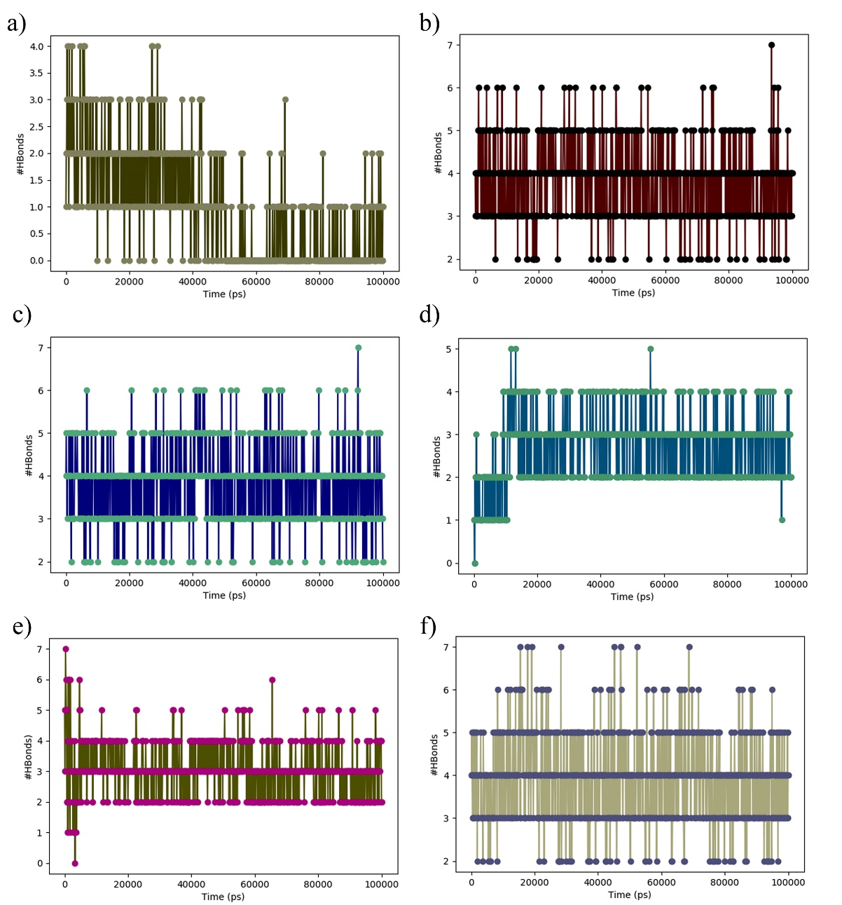
Figure 9: H-bond monitoring report of (a) Quercetin (5280343), (b) DDRC (9814421), (c) DHFC (9966216), (d) THDF (676310), (e) DHTC (140034695), (f) TTDF (688798) complexes during 100 ns MD simulation.
- Conclusion:
The escalating threat of multidrug-resistant (MDR) bacterial strains, particularly Proteus mirabilis, poses a significant challenge to global public health. The overuse and misuse of antibiotics, coupled with other factors such as prolonged hospital stays and invasive medical procedures, have exacerbated the proliferation of drug-resistant bacteria. The emergence of MDR strains like P. mirabilis in catheter-associated urinary tract infections (CAUTIs) underscores the urgent need for novel therapeutic approaches. This study investigates the molecular mechanisms underlying P. mirabilis virulence, particularly focusing on the role of hemolysin, a crucial toxin contributing to its pathogenesis. Molecular docking analysis revealed several lead compounds, including derivatives of quercetin, which demonstrated strong binding affinity with the hemolysin protein. These compounds exhibited promising antimicrobial activity against MDR P. mirabilis, highlighting their potential as therapeutic agents. Furthermore, molecular dynamics simulations provided valuable insights into the stability and dynamics of the protein-ligand complexes. The analysis revealed stable interactions between the lead compounds and hemolysin, suggesting their efficacy as inhibitors against MDR pathogens. Notably, certain compounds exhibited reduced structural deviations and increased stability within the binding cavity of hemolysin, indicating their potential for therapeutic development.
Overall, this study underscores the importance of exploring natural alternatives and novel therapeutic strategies to combat MDR bacterial infections effectively. The identification of lead compounds with potent antimicrobial activity against P. mirabilis hemolysin represents a significant step towards developing targeted therapies for CAUTIs and other MDR-related infections. Further research and clinical trials are warranted to validate the efficacy and safety of these compounds for clinical use, ultimately addressing the pressing global health challenge posed by antibiotic resistance.
Acknowledgements:
The authors are thankful to Dr. D. Y. Patil Biotechnology and Bioinformatics Institute, Dr. D. Y. Patil Vidyapeeth, Pune for the physical infrastructure and Department of Science and Technology Science and Engineering Research Board (DST-SERB), Govt. of India, New Delhi, (File Number: YSS/2015/002035) for utilizing an Optimized Supercomputer for docking and dynamics calculations.
Disclosure statement:
There is no conflict of interest declared by all authors.
Funding:
The author(s) reported there is no funding associated with the work featured in this article.

Data availability statement:
The docking structures are available upon request from the corresponding author.
References
1) Friis, S. D., Johansson, M. J., & Ackermann, L. (2020). Cobalt-catalysed C-H methylation for late-stage drug diversification. Nature chemistry, 12(6), 511–519. https://doi.org/10.1038/s41557-020-0475-7
2) Lokhande, K. B., Ballav, S., Yadav, R. S., Swamy, K. V., & Basu, S. (2022). Probing intermolecular interactions and binding stability of kaempferol, quercetin and resveratrol derivatives with PPAR-γ: docking, molecular dynamics and MM/GBSA approach to reveal potent PPAR- γ agonist against cancer. Journal of biomolecular structure & dynamics, 40(3), 971–981. https://doi.org/10.1080/07391102.2020.1820380
3) Boev, C., & Kiss, E. (2017). Hospital-Acquired Infections: Current Trends and Prevention. Critical care nursing clinics of North America, 29(1), 51–65. https://doi.org/10.1016/j.cnc.2016.09.012
4) Prestinaci, F., Pezzotti, P., & Pantosti, A. (2015). Antimicrobial resistance: a global multifaceted phenomenon. Pathogens and global health, 109(7), 309–318. https://doi.org/10.1179/2047773215Y.0000000030
5) Eggermont, D., Smit, M.A.M., Kwestroo, G.A. et al. The influence of gender concordance between general practitioner and patient on antibiotic prescribing for sore throat symptoms: a retrospective study. BMC Fam Pract 19, 175 (2018). https://doi.org/10.1186/s12875-018-0859-6
6) Girlich, D., Bonnin, R. A., Dortet, L., & Naas, T. (2020). Genetics of Acquired Antibiotic Resistance Genes in Proteus spp. Frontiers in microbiology, 11, 256. https://doi.org/10.3389/fmicb.2020.00256
7) Ruby E. G. (1996). Lessons from a cooperative, bacterial-animal association: the Vibrio fischeri-Euprymna scolopes light organ symbiosis. Annual review of microbiology, 50, 591–624. https://doi.org/10.1146/annurev.micro.50.1.591
8) Hastings, J. W., & Greenberg, E. P. (1999). Quorum sensing: the explanation of a curious phenomenon reveals a common characteristic of bacteria. Journal of bacteriology, 181(9), 2667–2668. https://doi.org/10.1128/JB.181.9.2667-2668.1999
9) Engebrecht, J., & Silverman, M. (1984). Identification of genes and gene products necessary for bacterial bioluminescence. Proceedings of the National Academy of Sciences of the United States of America, 81(13), 4154–4158. https://doi.org/10.1073/pnas.81.13.4154
10) Moré, M. I., Finger, L. D., Stryker, J. L., Fuqua, C., Eberhard, A., & Winans, S. C. (1996). Enzymatic synthesis of a quorum-sensing autoinducer through use of defined substrates. Science (New York, N.Y.), 272(5268), 1655–1658. https://doi.org/10.1126/science.272.5268.1655
11) Schaefer, A. L., Val, D. L., Hanzelka, B. L., Cronan, J. E., Jr, & Greenberg, E. P. (1996). Generation of cell-to-cell signals in quorum sensing: acyl homoserine lactone synthase activity of a purified Vibrio fischeri LuxI protein. Proceedings of the National Academy of Sciences of the United States of America, 93(18), 9505–9509. https://doi.org/10.1073/pnas.93.18.9505
12) Ng, W. L., & Bassler, B. L. (2009). Bacterial quorum-sensing network architectures. Annual review of genetics, 43, 197–222. https://doi.org/10.1146/annurev-genet-102108-134304
13) Engebrecht, J., Nealson, K., & Silverman, M. (1983). Bacterial bioluminescence: isolation and genetic analysis of functions from Vibrio fischeri. Cell, 32(3), 773–781. https://doi.org/10.1016/0092-8674(83)90063-6
14) Engebrecht, J., & Silverman, M. (1984). Identification of genes and gene products necessary for bacterial bioluminescence. Proceedings of the National Academy of Sciences of the United States of America, 81(13), 4154–4158. https://doi.org/10.1073/pnas.81.13.4154
15) Stevens, A. M., Dolan, K. M., & Greenberg, E. P. (1994). Synergistic binding of the Vibrio fischeri LuxR transcriptional activator domain and RNA polymerase to the lux promoter region. Proceedings of the National Academy of Sciences of the United States of America, 91(26), 12619–12623. https://doi.org/10.1073/pnas.91.26.12619
16) Zhu, J., & Winans, S. C. (1999). Autoinducer binding by the quorum-sensing regulator TraR increases affinity for target promoters in vitro and decreases TraR turnover rates in whole cells. Proceedings of the National Academy of Sciences of the United States of America, 96(9), 4832–4837. https://doi.org/10.1073/pnas.96.9.4832
17) Zhu, J., & Winans, S. C. (2001). The quorum-sensing transcriptional regulator TraR requires its cognate signaling ligand for protein folding, protease resistance, and dimerization. Proceedings of the National Academy of Sciences of the United States of America, 98(4), 1507–1512. https://doi.org/10.1073/pnas.98.4.1507
18) Fuqua, C., Parsek, M. R., & Greenberg, E. P. (2001). Regulation of gene expression by cell-to-cell communication: acyl-homoserine lactone quorum sensing. Annual review of genetics, 35, 439–468. https://doi.org/10.1146/annurev.genet.35.102401.090913
19) Ng, W. L., & Bassler, B. L. (2009). Bacterial quorum-sensing network architectures. Annual review of genetics, 43, 197–222. https://doi.org/10.1146/annurev-genet-102108-134304
20) Watson, W. T., Minogue, T. D., Val, D. L., von Bodman, S. B., & Churchill, M. E. (2002). Structural basis and specificity of acyl-homoserine lactone signal production in bacterial quorum sensing. Molecular cell, 9(3), 685–694. https://doi.org/10.1016/s1097-2765(02)00480-x
21) Gould, T. A., Schweizer, H. P., & Churchill, M. E. (2004). Structure of the Pseudomonas aeruginosa acyl-homoserinelactone synthase LasI. Molecular microbiology, 53(4), 1135–1146. https://doi.org/10.1111/j.1365-2958.2004.04211.x
22) Rutherford, S. T., & Bassler, B. L. (2012). Bacterial quorum sensing: its role in virulence and possibilities for its control. Cold Spring Harbor perspectives in medicine, 2(11), a012427. https://doi.org/10.1101/cshperspect.a012427
23) Stankowska, D., Czerwonka, G., Rozalska, S., Grosicka, M., Dziadek, J., & Kaca, W. (2012). Influence of quorum sensing signal molecules on biofilm formation in Proteus mirabilis O18. Folia microbiologica, 57(1), 53–60. https://doi.org/10.1007/s12223-011-0091-4
24) Rauprich, O., Matsushita, M., Weijer, C. J., Siegert, F., Esipov, S. E., & Shapiro, J. A. (1996). Periodic phenomena in Proteus mirabilis swarm colony development. Journal of bacteriology, 178(22), 6525–6538. https://doi.org/10.1128/jb.178.22.6525-6538.1996
25) Jacobsen, S. M., & Shirtliff, M. E. (2011). Proteus mirabilis biofilms and catheter-associated urinary tract infections. Virulence, 2(5), 460–465. https://doi.org/10.4161/viru.2.5.17783
26) Jones, S. M., Yerly, J., Hu, Y., Ceri, H., & Martinuzzi, R. (2007). Structure of Proteus mirabilis biofilms grown in artificial urine and standard laboratory media. FEMS microbiology letters, 268(1), 16–21. https://doi.org/10.1111/j.1574-6968.2006.00587.x
27) Chen, C. Y., Chen, Y. H., Lu, P. L., Lin, W. R., Chen, T. C., & Lin, C. Y. (2012). Proteus mirabilis urinary tract infection and bacteremia: risk factors, clinical presentation, and outcomes. Journal of microbiology, immunology, and infection = Wei mian yu gan ran za zhi, 45(3), 228–236. https://doi.org/10.1016/j.jmii.2011.11.007
28) Vaidyanathan, S., Soni, B. M., Hughes, P. L., Singh, G., & Oo, T. (2010). Severe ventral erosion of penis caused by indwelling urethral catheter and inflation of Foley balloon in urethra-need to create list of "never events in spinal cord injury" in order to prevent these complications from happening in paraplegic and tetraplegic patients. Advances in urology, 2010, 461539. https://doi.org/10.1155/2010/461539
29) Wasfi, R., Hamed, S. M., Amer, M. A., & Fahmy, L. I. (2020). Proteus mirabilis Biofilm: Development and Therapeutic Strategies. Frontiers in cellular and infection microbiology, 10, 414. https://doi.org/10.3389/fcimb.2020.00414
30) Scavone, P., Iribarnegaray, V., Caetano, A. L., Schlapp, G., Härtel, S., & Zunino, P. (2016). Fimbriae have distinguishable roles in Proteus mirabilis biofilm formation. Pathogens and disease, 74(5), ftw033. https://doi.org/10.1093/femspd/ftw033
31) Jacobsen, S. M., Stickler, D. J., Mobley, H. L., & Shirtliff, M. E. (2008). Complicated catheter-associated urinary tract infections due to Escherichia coli and Proteus mirabilis. Clinical microbiology reviews, 21(1), 26–59. https://doi.org/10.1128/CMR.00019-07
32) Donlan R. M. (2002). Biofilms: microbial life on surfaces. Emerging infectious diseases, 8(9), 881–890. https://doi.org/10.3201/eid0809.020063
33) Majumder, M. M. I. , Ahmed, T., Ahmed, S., & Khan, A. R. (2018). Microbiology of Catheter Associated Urinary Tract Infection. In (Ed.), Microbiology of Urinary Tract Infections - Microbial Agents and Predisposing Factors. IntechOpen. https://doi.org/10.5772/intechopen.80080
34) Leverstein-van Hall, M. A., M Blok, H. E., T Donders, A. R., Paauw, A., Fluit, A. C., & Verhoef, J. (2003). Multidrug resistance among Enterobacteriaceae is strongly associated with the presence of integrons and is independent of species or isolate origin. The Journal of infectious diseases, 187(2), 251–259. https://doi.org/10.1086/345880
35) Mirzaei, A., Nasr Esfahani, B., Raz, A., Ghanadian, M., & Moghim, S. (2021). From the Urinary Catheter to the Prevalence of Three Classes of Integrons, β-Lactamase Genes, and Differences in Antimicrobial Susceptibility of Proteus mirabilis and Clonal Relatedness with Rep-PCR. BioMed research international, 2021, 9952769. https://doi.org/10.1155/2021/9952769
36) Yang, D., Wang, T., Long, M., & Li, P. (2020). Quercetin: Its Main Pharmacological Activity and Potential Application in Clinical Medicine. Oxidative medicine and cellular longevity, 2020, 8825387. https://doi.org/10.1155/2020/8825387
37) Jacobsen, S. M., & Shirtliff, M. E. (2011). Proteus mirabilis biofilms and catheter-associated urinary tract infections. Virulence, 2(5), 460–465. https://doi.org/10.4161/viru.2.5.17783
38) Schaffer, J. N., & Pearson, M. M. (2015). Proteus mirabilis and Urinary Tract Infections. Microbiology spectrum, 3(5), 10.1128/microbiolspec.UTI-0017-2013. https://doi.org/10.1128/microbiolspec.UTI-0017-2013
39) Rafieian-Kopaei, M., Baradaran, A., & Rafieian, M. (2013). Oxidative stress and the paradoxical effects of antioxidants. Journal of research in medical sciences : the official journal of Isfahan University of Medical Sciences, 18(7), 629.
40) Rarey, M., Kramer, B., Lengauer, T., & Klebe, G. (1996). A fast flexible docking method using an incremental construction algorithm. Journal of molecular biology, 261(3), 470–489. https://doi.org/10.1006/jmbi.1996.0477
41) Lokhande, K. B., Doiphode, S., Vyas, R., & Swamy, K. V. (2021). Molecular docking and simulation studies on SARS-CoV-2 Mpro reveals Mitoxantrone, Leucovorin, Birinapant, and Dynasore as potent drugs against COVID-19. Journal of biomolecular structure & dynamics, 39(18), 7294–7305. https://doi.org/10.1080/07391102.2020.1805019
42) Lipinski C. A. (2004). Lead- and drug-like compounds: the rule-of-five revolution. Drug discovery today. Technologies, 1(4), 337–341. https://doi.org/10.1016/j.ddtec.2004.11.007
43) Jayaram, B., Singh, T., Mukherjee, G., Mathur, A., Shekhar, S., & Shekhar, V. (2012). Sanjeevini: a freely accessible web-server for target directed lead molecule discovery. BMC bioinformatics, 13 Suppl 17(Suppl 17), S7. https://doi.org/10.1186/1471-2105-13-S17-S7
44) Bursulaya, B. D., Totrov, M., Abagyan, R., & Brooks, C. L., 3rd (2003). Comparative study of several algorithms for flexible ligand docking. Journal of computer-aided molecular design, 17(11), 755–763. https://doi.org/10.1023/b:jcam.0000017496.76572.6f
45) Pathak, R. K., Gupta, A., Shukla, R., & Baunthiyal, M. (2018). Identification of new drug-like compounds from millets as Xanthine oxidoreductase inhibitors for treatment of Hyperuricemia: A molecular docking and simulation study. Computational biology and chemistry, 76, 32–41. https://doi.org/10.1016/j.compbiolchem.2018.05.015

