Table 1 Botanical family and species accessed and respective identification codes.

Plant species | Botanic family | Site | *Soil type | Botanic accesses | DNA accesses
Euploca salicoides (ES) | Boraginaceae | Ultramafic | SAP5 | ES-P5 | 1
Euploca salicoides (ES) | Boraginaceae | Ultramafic | SAP7 | ES-P7 | 2
Euploca salicoides (ES) | Boraginaceae | Ultramafic | SAP9 | ES-P9 | 3
Euploca salicoides (ES) | Boraginaceae | Ultramafic | LAT6 | ES-P6
Euploca salicoides (ES) | Boraginaceae | Typical Cerrado | CAM | ES-CAM1 | 12
 |  |  |  | ES-CAM2 | 14
Euploca salicoides (ES) | Boraginaceae | Typical Cerrado | LV | ES-LV
Oxalis hirsutissima (OH) | Oxalidaceae | Ultramafic | SAP5 | OH-P5 | 4
Oxalis hirsutissima (OH) | Oxalidaceae | Ultramafic | SAP7 | OH-P7 | 5
Oxalis hirsutissima (OH) | Oxalidaceae | Ultramafic | SAP9 | OH-P9 | 6
Oxalis hirsutissima (OH) | Oxalidaceae | Typical Cerrado | CAM | OH-CAM1 | 11
 |  |  |  | OH-CAM2 | 13
Justicia lanstyakii (JL) | Acanthaceae | Ultramafic | SAP5 | JL-P5 | 7
Justicia lanstyakii (JL) | Acanthaceae | Ultramafic | SAP7 | JL-P7 | 8
Justicia lanstyakii (JL) | Acanthaceae | Ultramafic | SAP9 | JL-P9 | 9
Justicia lanstyakii (JL) | Acanthaceae | Typical Cerrado | CAM | JL-CAM | 10
*Soils derived from serpentinic ultramafic rocks: SAP5, SAP7, and SAP9 associated to saprolites, and LAT6 of laterititic formation; CAM: Cambisol, and LV (Ferralsol). A voucher specimen of each species sampled in the field was deposited at the Herbarium of Embrapa Genetic Resources and Biotechnology (Cenargen), in Brasília, FD.

Table 2 Characteristics of the sites selected for soil chemical, DNA, and metal content analysis and for Ni localization in leaf structures:

Landscape | Characteristics of the sites | Plant accesses
Ultramafic environment
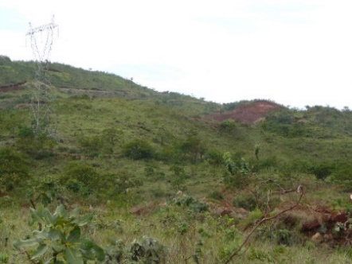  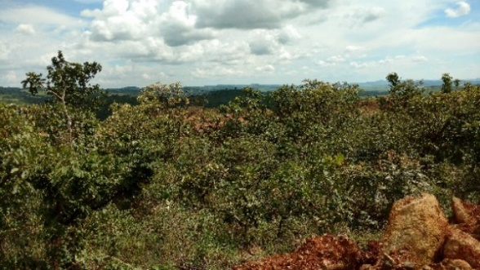  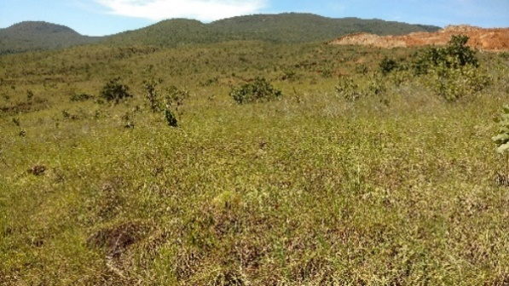  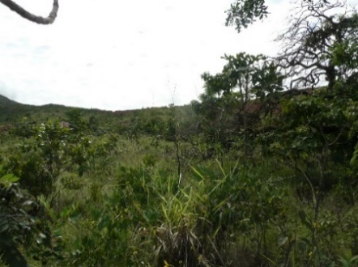  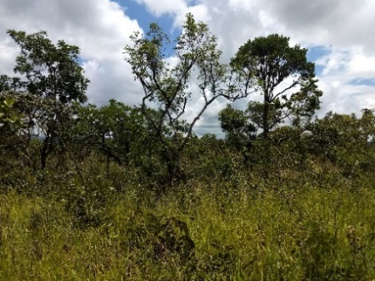 | SAP5  Vegetation: Campo Sujo with Cerrado Ralo; Relief: strong wavy to wavy, with outcrops;  Soil: rocky and shallow (< 0.50 m depth);  Bedrock: ultramafic  Latitude: 15° 06’07.2” S  Longitude: 49⁰ 00’39.3” W  Altitude: 903 m | ES-P5;  JL-P5;  OH-P5
 | SAP7  Vegetation: Cerrado  Relief: strong wavy; high levels of outcrops  Soil: shallow (< 0.50 m depth)  Bedrock: ultramafic Cambisol  Latitude: 5° 06’20.6” S  Longitude: 49° 01’02.0” W  Altitude: 836 m | ES-P7;  JL-P7;  OH-P7
 | SAP9  Vegetation: discontinuous from Cerrado Ralo to patches of Campo Sujo  Relief: wavy, hillside base; frequent outcrops, dark brown color  Soil: shallow (< 0.50 m)  Bedrock: saprolitic Cambisol (?)  Latitude: 15° 06’10.57” S  Longitude: 49° 01’54.8” W  Altitude: 822 m | ES-P9;  JL-P9;  OH-P9
 | LAT6  Vegetation: Campo Sujo  Relief: gently undulating with sparse outcrops  Soil: deep B horizon (> 1 m depth).  Bedrock: ultramafic/clayey rocks, with presence of laterite  Latitude: 15° 06’29” S  Longitude: 49° 01’14.7" W  Altitude: 860 m | ES-P6
typical Cerrado environment
 | Vegetation: Cerrado sensu strictu, anthropized area, close to the Lago Paranoá reservoir (CAM, photo) and UnB Campus (LV), in Brasília, FD;  Relief: CAM - wavy, middle of the slope, with sparse outcrops (~ 0.50 m depth); LV – flat; deep B horizon (> 1 m depth).  CAM: Latitude: 15° 48’17.8” S  Longitude: 47° 47’34.6” W; Altitude: 1028 m;  LV: Latitude: 15° 46’02” S  Longitude: 47° 51’55” W; Altitude: 1032 m. | ES-CAM1; ES-CAM2;  JL-CAM;  OH-CAM1; OH-CAM2;  ES-LV

Table 3 Primers tested and used to obtain the ISSR markers, for 14 accesses sequence 5 '→ 3' and the number of polymorphic bands (BP).

Primer ISSR | Sequencie 5’→3’ | PB
1-TriAAG3’RC | AAGAAGAAGAAGAAG | -
2-TriACA3’RC | ACAACAACAACAACA | -
3-RriCAA3’RC | CAACAACAACAACAA | -
*4-TriAAC3’RC | AACAACAACAACAAC | 15
*5-TriAGC3’RC | AGCAGCAGCAGCAGC | 13
*6-TriAGG3’RC | AGGAGGAGGAGGAGG | 16
7-TriCAG3’RC | CAGCAGCAGCAGCAG | -
8-DiGA5’C | CGAGAGAGAGAGAGA | -
*9-DiCA3’YG | CACACACACACACAC | 7
*10-DiCA5’CR | CACACACACACACAC | 8
11-DiGT3’YG | GTGTGTGTGTGTGTG | -
12-DiCA3’G | CACACACACACACAC | -
*13-DiGA3’C | GAGAGAGAGAGAGAG | 21
*14-DiGA5’CY | AGAGAGAGAGAGAGA | 12
15-DiGT5’CY | GTGTGTGTGTGTGTGT | -
*16-DiGA3’YC | GAGAGAGAGAGAGAG | 16
17-DiGA3’T | GAGAGAGAGAGAGAG | -
18-DiCA3’RG | CACACACACACACAC | -
Total |  | 108
* Primers selected and used to generate ISSR markers in the 14 accesses tested.

Table 4 Soil fertility and availability of metals in the collection sites of accessions of native species in the ultramafic zone (SAP) of Barro Alto and in the typical Brazilian savanna (Cerrado) (CAM).

Soil environment |  |  | Ultramafic |  |  |  |  | Cerrado
Soil attribute | Unit |  | SAP5 | SAP7 | SAP9 | LAT6 |  | CAM
pH | H₂O |  | 6.29 d | 6.52 c | 6.80 a | 6.68 b |  | 5.60 e
sd | H₂O |  | 0.067 | 0.05 | 0.08 | 0.04 |  | 0.11
OM | % |  | 5.50 a | 4.27 a | 2.77 b | 2.43 bc |  | 2.05 c
sd | % |  | 0.17 | 0.1 | 0.37 | 0.59 |  | 0.08
H+Al | cmol_{c} dm⁻³ |  | 5.65 a | 4.74 a | 3.52 b | 2.49 c |  | 3.86 b
sd | cmol_{c} dm⁻³ |  | 0.56 | 0.13 | 0.91 | 0.22 |  | 0.1
Al³⁺ | cmol_{c} dm⁻³ |  | 0.02 bc | 0.02 b | 0.01 bc | 0.00 c |  | 0.60 a
sd | cmol_{c} dm⁻³ |  | 0.01 | 0.01 | 0.01 | 0.01 |  | 0.14
Ca²⁺ | cmol_{c} dm⁻³ |  | 1.70 a | 0.63 c | 0.77 b | 0.90 b |  | 0.51 c
sd | cmol_{c} dm⁻³ |  | 0.27 | 0.08 | 0.06 | 0.19 |  | 0.14
Mg²⁺ | cmol_{c} dm⁻³ |  | 5.65 ab | 7.13 a | 6.99 a | 5.93 a |  | 0.17 b
sd | cmol_{c} dm⁻³ |  | 0.98 | 0.59 | 1.68 | 0.86 |  | 0.08
K⁺ | cmol_{c} dm⁻³ |  | 0.25 a | 0.13 b | 0.09 c | 0.07 c |  | 0.13 b
sd | cmol_{c} dm⁻³ |  | 0.02 | 0.01 | 0.02 | 0.02 |  | 0.02
P | mg dm⁻³ |  | 0.64 a | 0.44 bc | 0.48 ab | 0.34 c |  | 0.52 ab
sd | mg dm⁻³ |  | 0.02 | 0.02 | 0.06 | 0.1 |  | 0.15
Co | mg dm⁻³ |  | 2.21 b | 5.08 a | 4.78 a | 1.70 b |  | 0.01 c
sd | mg dm⁻³ |  | 0.42 | 0.27 | 0.96 | 0.51 |  | 0,00
Cu | mg dm⁻³ |  | 3.61 b | 2.97 b | 5.86 a | 3.03 b |  | 0.15 c
sd | mg dm⁻³ |  | 0.65 | 0.72 | 1.19 | 0.28 |  | 0.03
Fe | mg dm⁻³ |  | 16.27 e | 27.58 d | 47.44 b | 34.05 c |  | 398.78 a
sd | mg dm⁻³ |  | 7.8 | 1.75 | 3.52 | 1.57 |  | 11.55
Mn | mg dm⁻³ |  | 11.12 c | 43.03 b | 111.44 a | 33.46 b |  | 1.79 d
sd | mg dm⁻³ |  | 7.8 | 17.6 | 25.13 | 10.57 |  | 0.26
Ni | mg dm⁻³ |  | 461.03 b | 1025.44 a | 394.63 b | 107.96 c |  | < 0.01 d
sd | mg dm⁻³ |  | 69.86 | 27.81 | 131.7 | 13.64 |  | -
Zn | mg dm⁻³ |  | 3.48 b | 5.48 a | 2.81 c | 1.06 d |  | 0.81 e
sd | mg dm⁻³ |  | 0.57 | 0.09 | 0.6 | 0.14 |  | 0.03
T | cmol_{c} dm⁻³ |  | 13.25 a | 12.63 a | 11.36 ab | 9.39 bc |  | 4.66 c
sd | cmol_{c} dm⁻³ |  | 1.62 | 0.69 | 2.52 | 1.14 |  | 0.27
SB | cmol_{c} dm⁻³ |  | 7.60 a | 7.88 a | 7.84 a | 6.90 ab |  | 0.81 b
sd | cmol_{c} dm⁻³ |  | 1.09 | 0.56 | 1.75 | 0.99 |  | 0.22
CEC | cmol_{c} dm⁻³ |  | 7.61 a | 7.90 a | 7.85 a | 6.90 ab |  | 1.41 b
sd | cmol_{c} dm⁻³ |  | 1.09 | 0.56 | 1.75 | 0.99 |  | 0.08
V | % |  | 57.26 d | 60.99 c | 69.14 b | 73.32 a |  | 16.76 e
sd | % |  | 1.55 | 1.2 | 3.81 | 2.26 |  | 3.8
m | % |  | 0.20 bc | 0.33 ab | 0.13 bc | 0.08 c |  | 43.24 a
sd | % |  | 0.15 | 0.15 | 0.07 | 0.09 |  | 12.42
Mg/T |  |  | 42.47 c | 56.39 b | 61.43 a | 63.07 a |  | 3.61 d
sd |  |  | 2.18 | 1.7 | 3.18 | 2.85 |  | 1.25
Mg/Ca |  |  | 3.35 d | 11.38 a | 9.07 b | 6.70 c |  | 0.33 e
sd |  |  | 0.59 | 2.18 | 1.53 | 1.07 |  | 0.05
Results correspond to the average obtained from three composite samples per site, 0-20 cm depth: one composite sample was constituted by 10-30 subsamples; sd = standard deviation. OM = organic matter; H + Al = titratable acidity; Al, Ca, Mg extractable by 1N KCl; K and P extractable with Mehlich-1 solution; Co, Cu, Fe, Ni, Mn, and Zn extractable with DTPA solution; SB = sum of bases; CEC = Cation exchange capacity at soil pH; T = CEC at pH 7; V = base saturation; m = Al³⁺ saturation; means followed by the same letters within the same line are not statistically different, according to the Kruskal-Wallis test (p ≥ 0.05).

Table 5 Elements concentration (mg or g kg⁻¹ DW) in above-ground tissues of native plants in ultramafic (SAP) and non-ultramafic soils (CAM).

*Site | N | Ca | Mg | K | P | S | Mg:  Ca |  | Al | Co | Cu | Fe | Mn | Ni | Zn | Ca:  Ni
 | g kg DW⁻¹ |  |  |  |  |  | Mg:  Ca |  | mg kg DW⁻¹ |  |  |  |  |  |  | Ca:  Ni
 | Euploca salicoides (ES)
SAP | 13.8 | 21.7 | 8.5 | 9.3 | 0.9 | 2.4 | 0.44 |  | 245 | 9.3 | 12.8 | 2244 | 79 | 1154 | 43 | 24.73
sd (8) | 1.6 | 9.0 | 1.6 | 2.8 | 0.1 | 0.4 | 0.07 |  | 106 | 3.4 | 3.8 | 1604 | 24 | 112 | 12 | 13.88
CAM | 16.6 | 16.0 | 4.5 | 10.8 | 0.8 | 1.64 | 0.29 |  | 340 | 0.1 | 9.3 | 279 | 126 | 28 | 24 | -
sd (3) | - | 9.6 | 2.6 | 6.2 | 0.33 | 0.8 | 0.05 |  | 275 | - | 5.6 | 253 | 79 | - | 23 | -
 | Justicia lanstyakii (JL)
SAP | 17.4 | 5.5 | 10.6 | 9.9 | 1.2 | 2.3 | 2.36 |  | 188 | 6.0 | 0.1 | 1290 | 104 | 1874 | 43 | 2.88
sd (12) | 1.5 | 0.2 | 3.4 | 1.9 | 0.2 | 0.7 | 0.44 |  | 31 | 0.9 | 0.1 | 147 | 14 | 615 | 3 | 0.91
CAM | 19.1 | 23.1 | 10.1 | 17.4 | 1.0 | 1.4 | 0.47 |  | 525 | 0.2 | 7.4 | 521 | 365 | 4 | 16 | -
sd (4) | - | 11.5 | 4.2 | 4.8 | 0.1 | 0.3 | 0.19 |  | 205 | 0.1 | 4.9 | 296 | 46 | 4 | 16 | -
 | Oxalis hirsutissima (OH)
SAP | 20.2 | 1.0 | 5.7 | 9.5 | 1.5 | 3.1 | 6.17 |  | 115 | 6.5 | 7.9 | 966 | 61 | 699 | 31 | 1.46
sd (9) | 3.31 | 0.2 | 1.2 | 3.3 | 0.3 | 0.9 | 0.44 |  | 96 | 3.6 | 0.9 | 1106 | 30 | 34 | 3 | 0.27
CAM | 22.1 | 5.6 | 2.4 | 10.5 | 1.5 | 2.2 | 0.45 |  | 387 | 0.4 | 16.9 | 357 | 139 | 25 | 27 | -
sd (4) | 8.6 | 1.9 | 1.0 | 6.2 | 0.5 | 0.9 | 0.27 |  | 136 | 0.1 | 4.4 | 100 | 105 | 30 | 5 | -
*SAP: Values are means of element concentration in plants of samples collected in the ultramafic area, independent of the site (SAP5, SAP7, or SAP9). Each sample was composed of at least three plants; sd (n) = standard deviation (number of samples).

Table 6 Genetic dissimilarity matrix between 14 accessions calculated based on the complement of the Nei and Li similarity coefficient, using 108 ISSR markers.

Acesses | ES-P7 | ES-P9 | OH-P5 | OH-P7 | OH-P9 | JL-P5 | JL-P7 | JL-P9 | JL- CAM | OH- CAM1 | ES-  CAM1 | OH- CAM2 | ES-  CAM2
ES-P5 | 0.18 | 0.33 | 0.80 | 0.83 | 0.87 | 0.95 | 0.85 | 0.81 | 0.88 | 1.00 | 0.57 | 0.92 | 1.00
ES-P7 |  | 0.18 | 0.81 | 0.84 | 0.88 | 0.96 | 0.88 | 0.85 | 0.89 | 0.93 | 0.60 | 0.85 | 1.00
ES-P9 |  |  | 0.74 | 0.77 | 0.80 | 0.88 | 0.88 | 0.86 | 0.95 | 0.94 | 0.56 | 0.87 | 1.00
OH-P5 |  |  |  | 0.40 | 0.38 | 0.70 | 0.66 | 0.68 | 0.92 | 1.00 | 1.00 | 1.00 | 1.00
OH-P7 |  |  |  |  | 0.17 | 0.83 | 0.73 | 0.79 | 0.88 | 0.95 | 1.00 | 1.00 | 0.94
OH-P9 |  |  |  |  |  | 0.82 | 0.74 | 0.78 | 0.96 | 0.95 | 1.00 | 1.00 | 0.94
JL-P5 |  |  |  |  |  |  | 0.34 | 0.40 | 0.58 | 0.89 | 1.00 | 0.94 | 1.00
JL-P7 |  |  |  |  |  |  |  | 0.19 | 0.55 | 0.93 | 1.00 | 1.00 | 0.92
JL-P9 |  |  |  |  |  |  |  |  | 0.48 | 0.91 | 1.00 | 0.95 | 0.89
JL-CAM |  |  |  |  |  |  |  |  |  | 0.85 | 1.00 | 1.00 | 0.79
OH-CAM1 |  |  |  |  |  |  |  |  |  |  | 1.00 | 0.50 | 1.00
ES-CAM1 |  |  |  |  |  |  |  |  |  |  |  | 0.87 | 1.00
OH-CAM2 |  |  |  |  |  |  |  |  |  |  |  |  | 1.00

