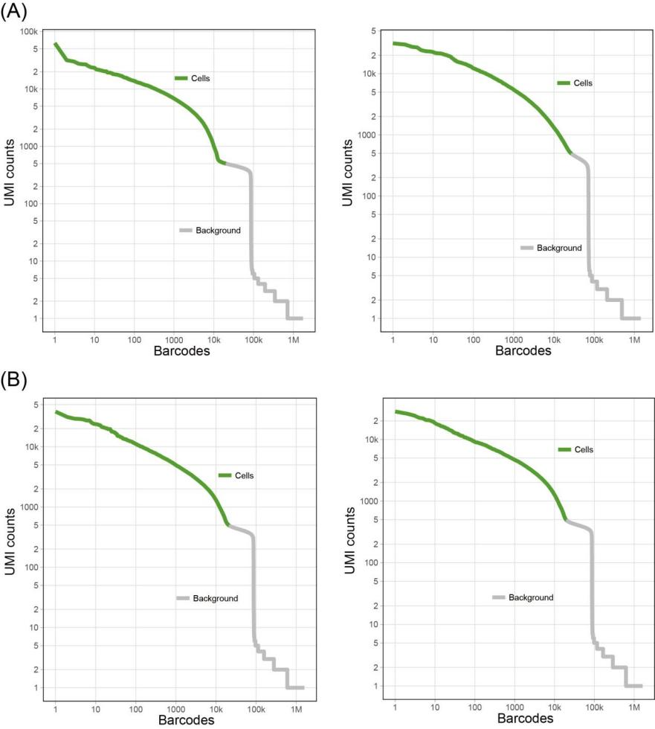
Fig. S1 Knee plots and empty drop cutoffs identified by the Cell Ranger filtering algorithms in aerial and subterranean pegs. A Two replicates in aerial pegs; B Two replicates in subterranean pegs

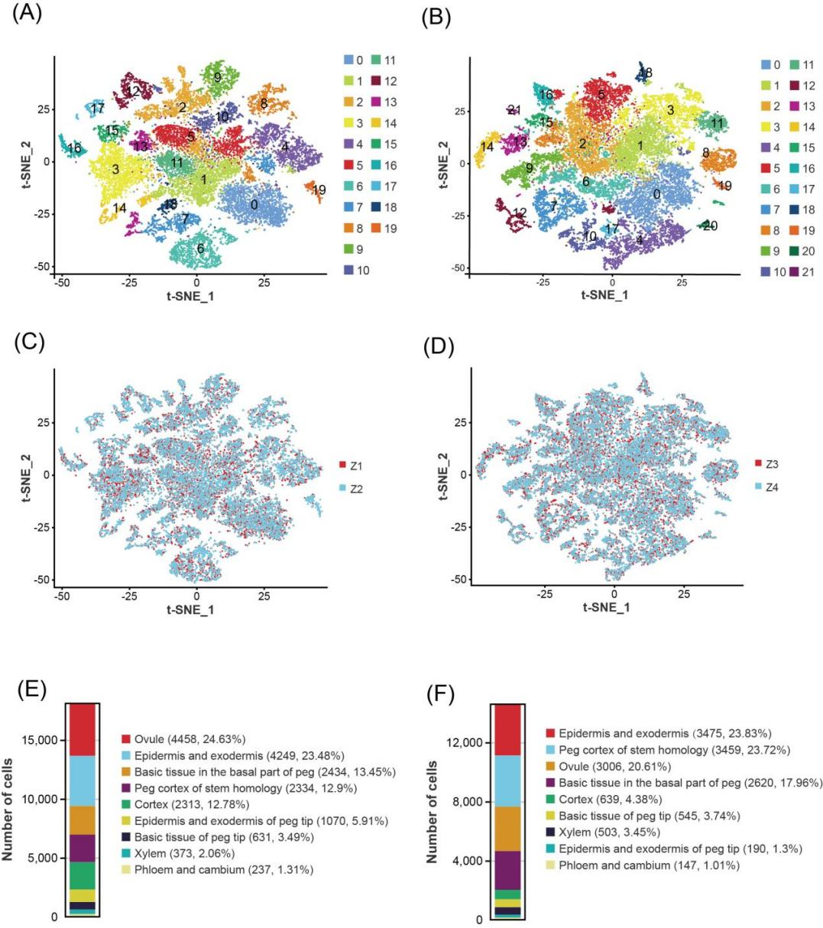
Fig. S2 t-distributed Stochastic Neighbor Embedding (t-SNE) visualization identifying 20 and 22 putative cell clusters in aerial and subterranean pegs, respectively. A, B t-SNE plot of nuclei according to transcriptomic profiles in aerial (A) and subterranean (B) pegs; C, D Two replicates in aerial (C) and subterranean (D) pegs; E, F The number of cells in each cell cluster in in aerial (E) and subterranean (F) pegs

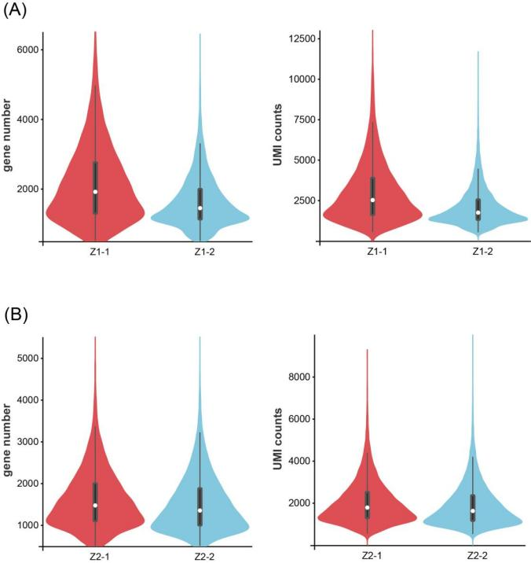
Fig. S3 Medium number of gene and filtered UMI in different samples determined by data quality control. A aerial pegs; B subterranean pegs

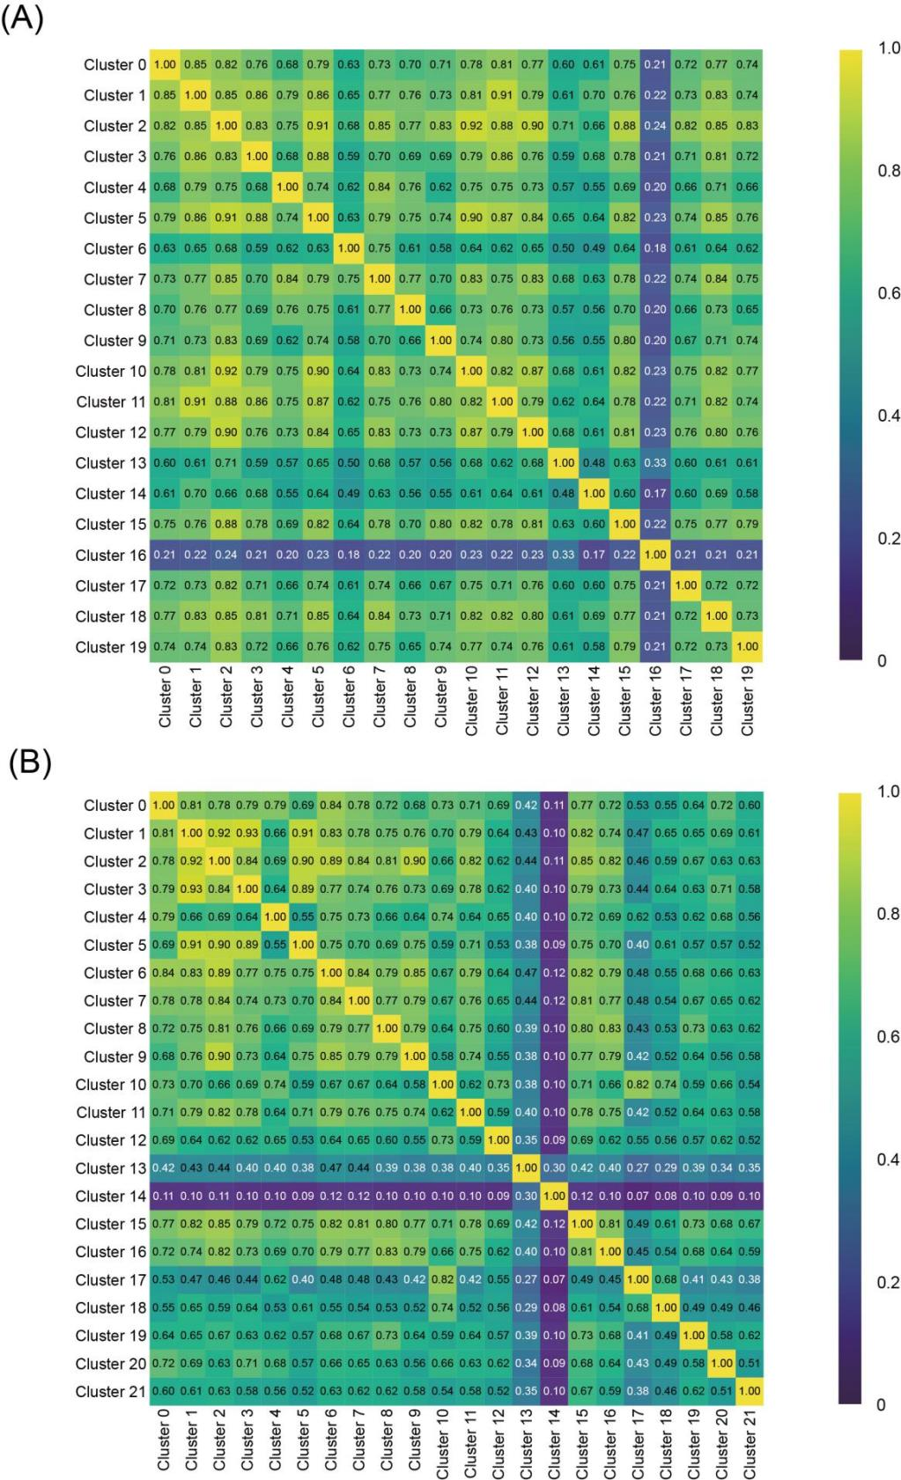
Fig. S4 The correlation between different cell clusters in aerial and subterranean pegs. A 20 clusters in aerial pegs; B 22 clusters in subterranean pegs
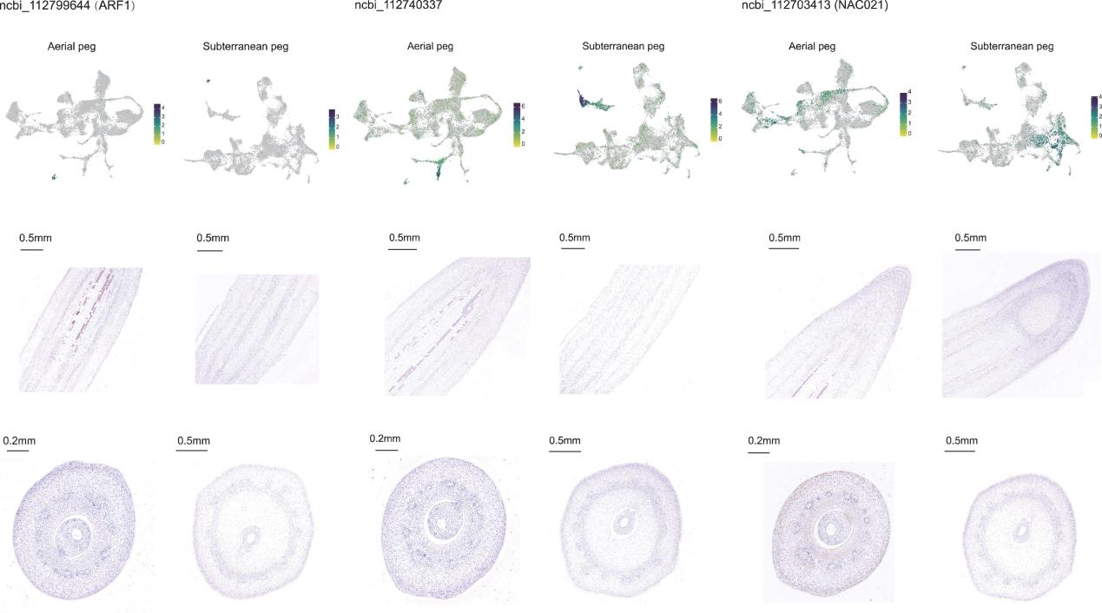

Fig. S5 RNA in situ hybridization assays to validate the expression pattern of marker genes.

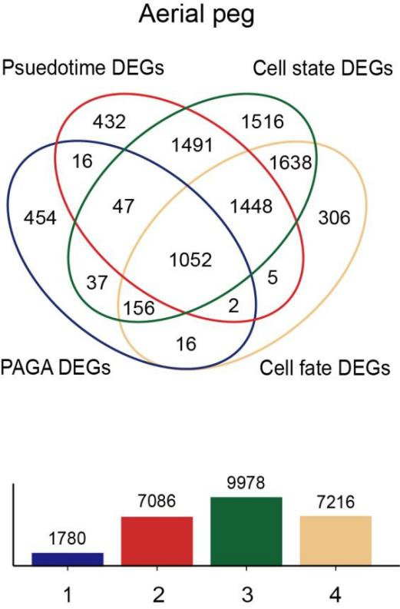
Fig. S6 Venn diagram showing DEGs of aerial peg cell differentiation trajectory, cell differentiation states, cell fate, and PAGA

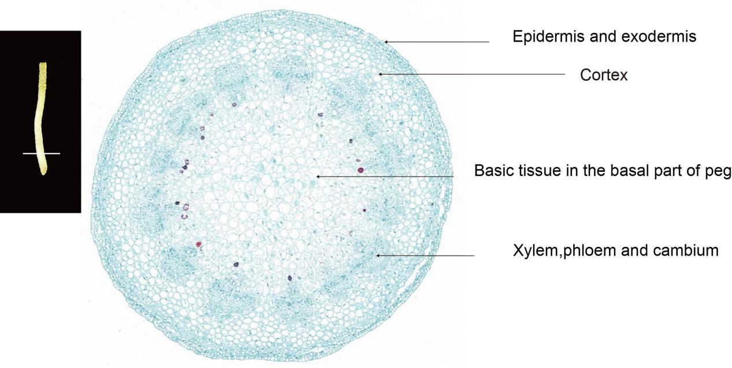

Fig. S7 Transverse section of subterranean peg

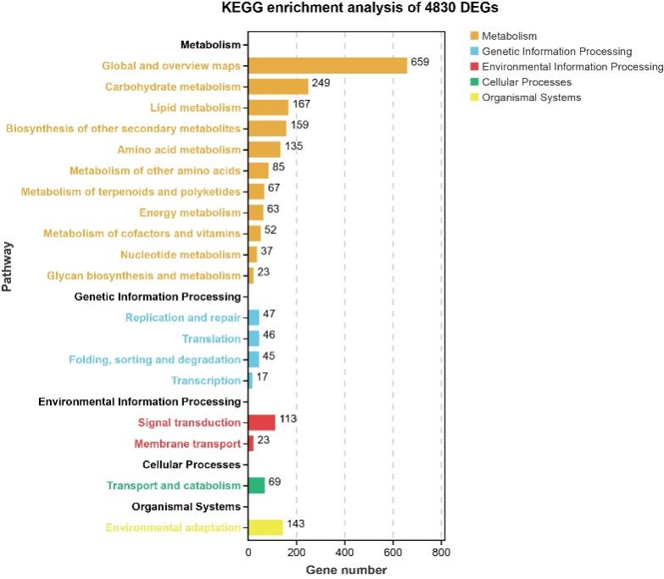
Fig. S8 KEGG pathway enrichment analysis of 4,830 DEGs in subterranean pegs trajectory

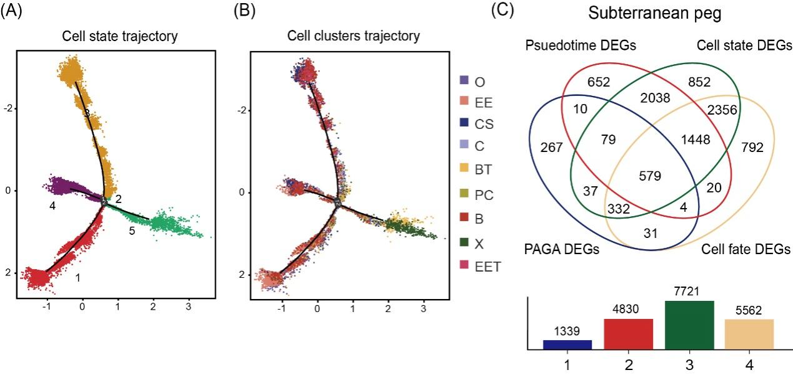

Fig. S9 Venn diagram showing DEGs of subterranean peg cell differentiation trajectory, cell differentiation states, cell fate, and PAGA. A, B Cell state trajectory (A) and cell state trajectory (B) in subterranean pegs; C Venn diagram showing DEGs of subterranean peg in different comparisons

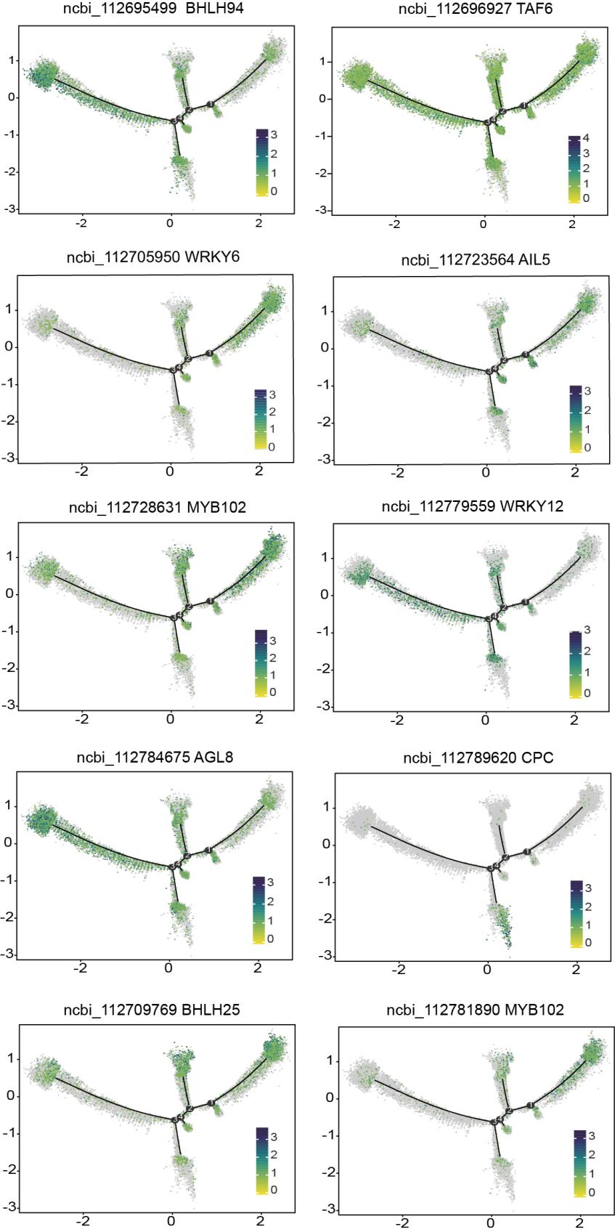
Fig. S10 The expression patterns of ten TFs along the subterranean peg cell differentiation trajectory

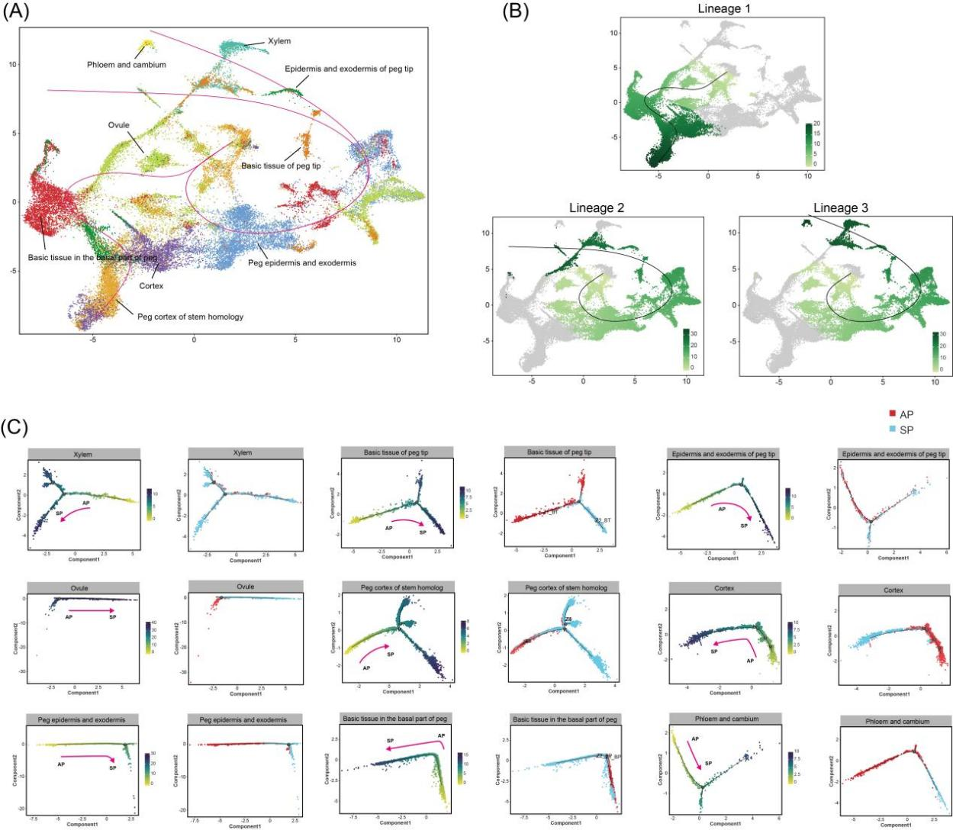
Fig. S11 Analysis of the cell differentiation and developmental trajectory of identical cell types combining datasets from aerial and subterranean pegs. A Representation of slingshot mapping onto the UMAP plot. B Visualization of three lineages. C Pseudotime trajectory of the same cell types from aerial pegs (AP, colored in red) and subterranean pegs (SP, colored in green). Each sub-plot represents a different cell type, showing the developmental paths and transitions of cells from aerial and subterranean pegs.

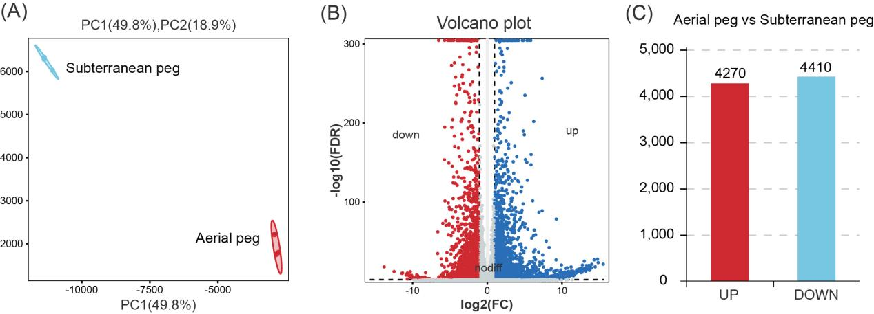
Fig. S12 Analysis of upregulated and downregulated genes with bulk transcriptome between aerial and subterranean pegs. A Principal component analysis (PCA) of transcriptomes of 6 RNA-seq libraries; B, C Volcano plot of DEGs (4270 upregulated and 4410 downregulated genes) in between aerial and subterranean pegs
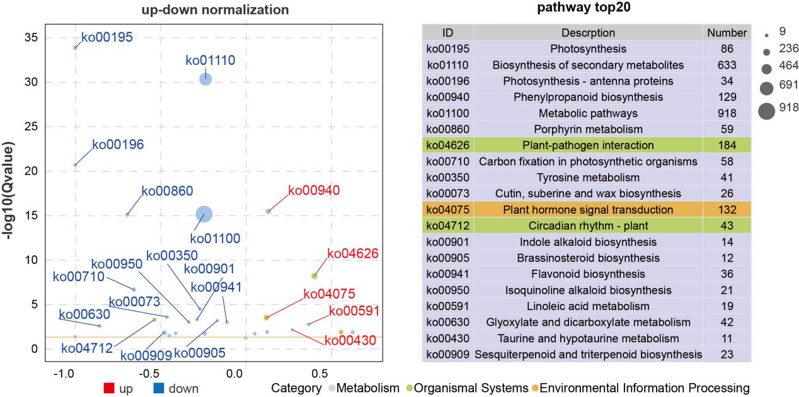

Fig. S13 KEGG analysis categorized bulk RNA-seq and snRNA-seq DEGs related to various biological process

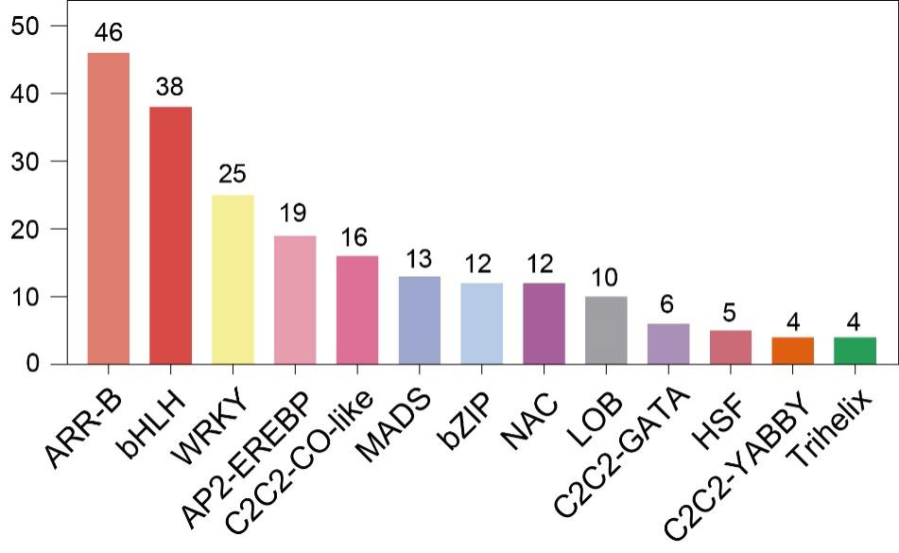
Fig. S14 The number of TFs of simultaneously upregulated or downregulated in bulk RNA-seq and snRNA-seq profiles in the pseudo-time trajectory of aerial and subterranean pegs

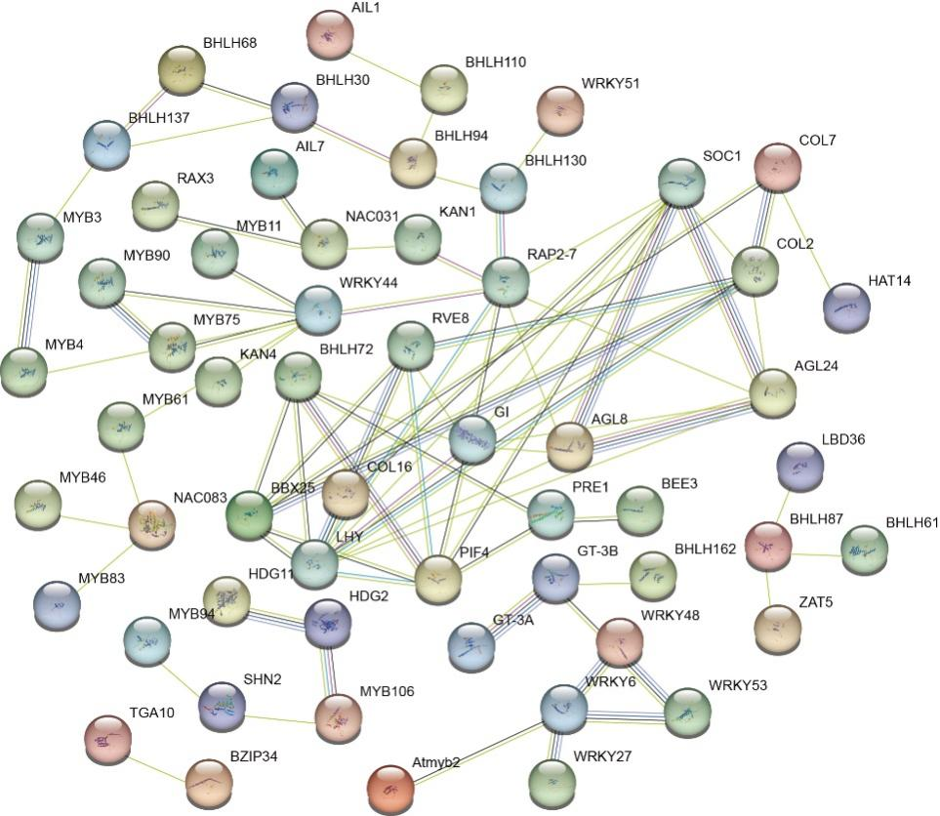

Fig. S15 Interaction network analysis of 177 TFs in aerial and subterranean pegs

