Supporting information
Insights into the nuclearity and local environment of transition metal species in ion-exchanged CHA zeolites and effects on the oxidation of methane
Peipei Xiao ª, Lizhuo Wang ^{b}, Maiko Nishibori ^{c}, Kengo Nakamura ª, Yong Wang ª, Jun Huang ^{b}, Hermann Gies ª, Toshiyuki Yokoi ^{a,d}*
ª Institute of Integrated Research, Institute of Science Tokyo, 4259 Nagatsuta, Midori-ku, Yokohama 226-8501, Japan
^{b} School of Chemical and Biomolecular Engineering, the University of Sydney, Sydney, New South Wales 2006, Australia
^{c} International Center for Synchrotron Radiation Innovation Smart, Tohoku University, 2-1-1 Katahira, Aoba-ku, Sendai, Miyagi, 980-8572, Japan
^{d} iPEACE223 Inc., Konwa Building, 1-12-22 Tsukiji, Chuo-ku, Tokyo, 104-0045, Japan
*E-mail: yokoi@cat.res.titech.ac.jp

Supplementary Methods

Catalyst characterization
XRD pattern was collected on a Rint-Ultima III (Rigaku) using a Cu Kα X-ray source (40 kV, 40 mA).
Elemental analyses of the samples were performed on an inductively coupled plasma-atomic emission spectrometer (ICP-AES, Shimadzu ICPE-9000).
Field-emission scanning electron microscopic (FE-SEM) images of the powder samples were obtained on SU-9000 (Hitachi) microscope operating at 1 kV.
High-angle annular dark field scanning transmission electron microscopy (HAADF-STEM) imaging, integrated differential phase contrast STEM (STEM-iDPC) imaging, and energy dispersive spectrometry (EDS) mapping were performed on a FEI Themis Z microscope equipped with an XFEG field electron source and double aberration corrector operated on 300 keV. The HAADF-STEM images were acquired with a camera length of 115 mm while the beam convergence was 25.1 mrads. The pixel size is 37 pm and the dwell time is 2 us/pixel. The collection angle of the HAADF detector was set to 48–200 mrads. STEM-EDS elemental maps were acquired with 4 us/pixel acquisition time using Velox software. High-resolution transmission electron microscopy (HRTEM) images were acquired on the same image operated on 300 keV.
Nitrogen adsorption and desorption measurements to obtain the information on the micro- and meso-porosities were conducted at -196 ºC on a Belsorp-mini II (MicrotracBEL).
The carbon deposit amount of the spent samples was determined by the weight loss from 250 to 800 ºC in a thermogravimetric (TG) profile, which was performed on a thermogravimetric-differential thermal analyzer (TG-DTA, RigakuThermo plus EVO II).
Temperature-programmed ammonia desorption (NH₃-TPD) profiles were recorded on Multitrack TPD equipment (Japan BEL). Typically, 25 mg of catalyst was pretreated at 600 ºC in He flow (50 mL min⁻¹) for 1 h and then cooled to 100 ºC. Prior to the adsorption of NH₃, the sample was evacuated at 100 ºC for 1 h. Approximately 2500 Pa of NH₃ was allowed to contact with the sample at 100 ºC for 10 min. Subsequently, the sample was evacuated to remove weakly adsorbed NH₃ at the same temperature for 30 min. Finally, the sample was cooled to 100 ºC and heated from 100 to 600 ºC at a ramping rate of 10 ºC min⁻¹ in a He flow (50 mL min⁻¹). A thermal conductivity detector (TCD) was employed to monitor desorbed NH₃. The amount of acid sites was determined by the fitting peak area.
UV-vis spectra were collected in the range of 190-800 nm on a V-650DS spectrometer (JASCO). The diffuse reflectance spectra were converted into the absorption spectra using the Kubelka-Munk function.
UV-vis spectra at different temperatures were measured on a V-750 spectrometer (JASCO). The sample was purged by 20 mL·min⁻¹ Ar in the measurement. The diffuse reflectance spectra were converted into the absorption spectra using the Kubelka-Munk function.
Fe, Co, and Cu K-edge X-ray absorption spectroscopy (XAS) were conducted with a transmission mode to characterize the oxidation state and the local structure of Fe, Co and Cu species, respectively. Spectra were obtained using synchrotron radiation at the SPring-8 BL01B1 beamline in Hyogo, Japan, equipped with a Si(111) double-crystal monochromator, 100% N₂ for I₀ ion chamber and 15% Ar/N₂ for I₁ ion chamber. The obtained XAS spectra were analyzed using Athena software version 0.9.26.¹ The oscillations of k²-weighted Fe K-edge extended X-ray absorption fine structure (EXAFS) were Fourier-transformed (FT) in the k range from 3.0 to 10.0 Å⁻¹.¹
The N₂O adsorption FTIR was carried out in the FTIR system by using a JASCO 4100 FTIR spectrometer equipped with a triglycine sulfate (TGS) detector. IR spectra of the clean disk were recorded in vacuo at 25 ºC to obtain background spectrum. The sample was pressed into a self-supporting disk (20 mm diameter, 30−60 mg) and placed in an IR cell attached to a closed-gas circulation system. The sample was pretreated by evacuation at 500 ºC for 1 h, followed by adsorption of 5−250 Pa N₂O at 25 ºC.

Catalytic activity test
The continuous oxidation of methane reaction was performed in a fixed-bed flow reactor (Fig. S6). Typically, 100 mg of catalyst in a pellet form (pellet size 500−1000 μm) was charged into a quartz tube (inner diameter 4 mm), which was placed in an electric tube furnace. The catalyst was pretreated at 500 °C for 1 h. The reaction was conducted at typically 350 °C. The outlet gas, containing the products, unreacted CH₄ and N₂O were analyzed using two on-line gas chromatographs (GC; GC-2014, Shimadzu). One of the GCs was equipped with a Shincarbon ST 50/80 packed column (3 mm×6 m) and a TCD detector. Specifically, GC-TCD with a methanizer was employed to detect H₂, N₂O, CO, CO₂, and CH₄. The other GC was equipped with a HP-PLOT Q packed column (0.53 mm×30 m×40 μm), a flame ionization detector (FID). The GC-FID was used to investigate CH₄, and the produced methanol (MeOH), dimethyl ether (DME), low olefins and alkanes. The yield of each carbon-containing product was calculated by considering the number of carbon atoms. The methane conversion in this study was defined as the total obtained products, and calculated as:
C_{CH4} =$\frac{\sum{(i*Ci})}{\sum{(i*Ci)+CH4}}$
where C_{CH4} is the CH₄ conversion, i is the number of carbon atoms in product C_{i}, meanwhile, C_{i} is the carbon amount of product C_{i}, Σ(i*C_{i}) is the total carbon amount of all the carbon-containing products, and CH4 is the amount of CH₄ detected at the same time.
The N₂O conversion was calculated as:
C_{N2O} =$\frac{ni-na}{ni}$
where C_{N2O} is the N₂O conversion, n_{i} is the initial N₂O molar weight, n_{a} is the N₂O molar weight after reaction.
The product selectivity is calculated as:
S_{Ci} =$\frac{i*Ci}{\sum{(i*Ci)}}$
where S_{Ci} is the selectivity of the product C_{i}, i is the number of carbon atoms in product C_{i}, Σ(i*C_{i}) is the total carbon amount of all the products.
The product yield is calculated as:
Y_{Ci} =$\frac{i*Ci}{\sum{(i*Ci)+CH4}}$
where Y_{Ci} is the yield of the product C_{i}, i is the number of carbon atoms in product C_{i}, Σ(i*C_{i}) is the total carbon amount of all the products, and CH4 is the amount of CH₄ detected at the same time.
The product formation rates are calculated as:
R_{Ci} = Y_{Ci *}F_{CH4}/m_{cat}
where R_{Ci} is the formation rate of product C_{i}, Y_{Ci} is the yield of the product C_{i}, F_{CH4} is the initial flow rate of CH₄, m_{cat} is the mass of the catalyst.

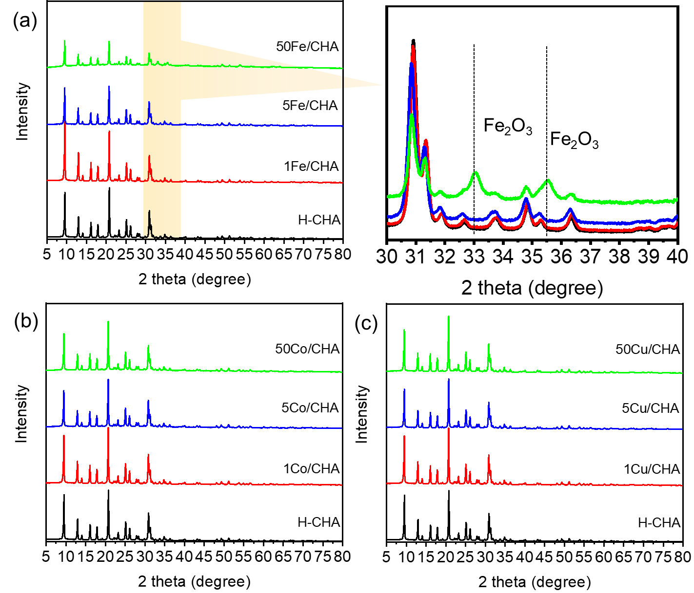Fig. S1 XRD patterns of (a) xFe/CHA, (b) yCo/CHA, and (c) zCu/CHA zeolite catalysts.
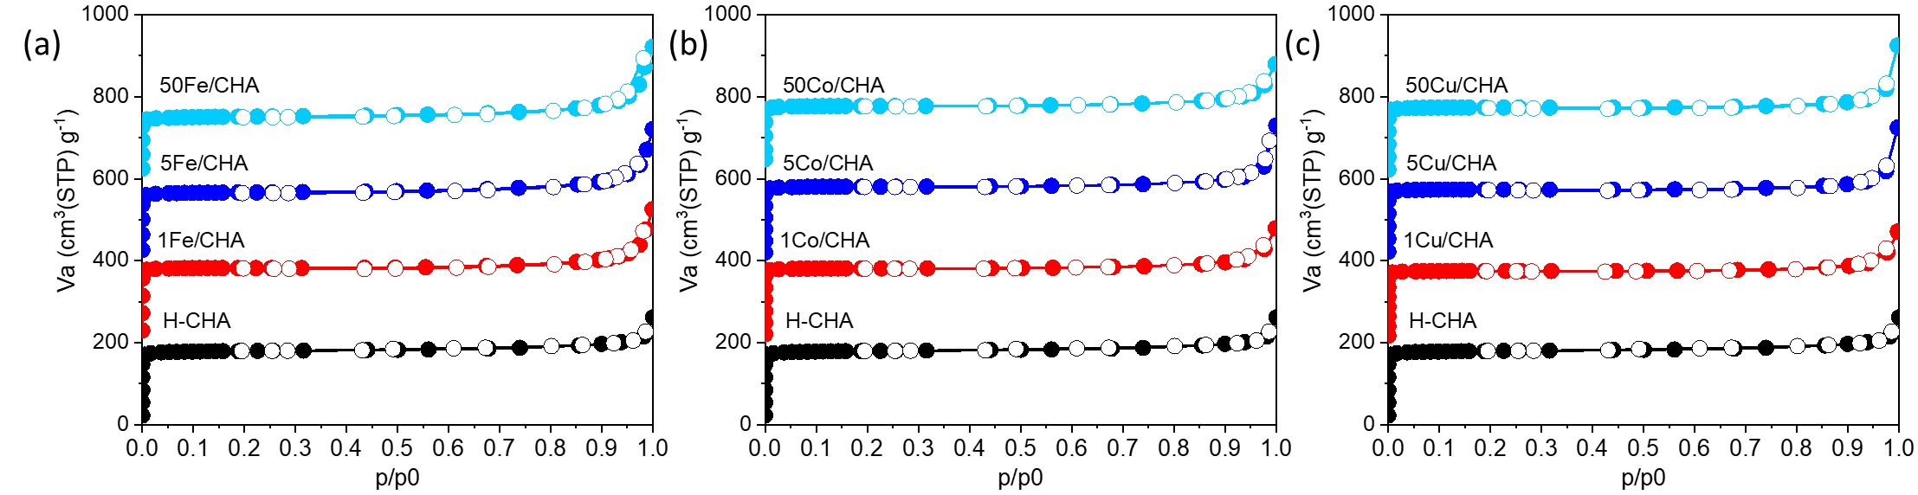Fig. S2 N₂ adsorption and desorption isothermals of (a) xFe/CHA, (b) yCo/CHA, and (c) zCu/CHA zeolite catalysts.

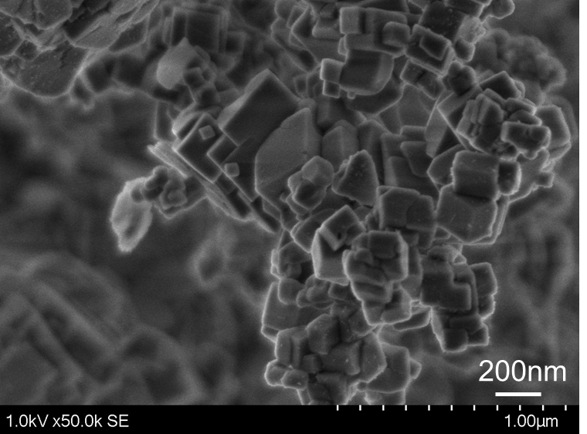
Fig. S3 SEM image of parent CHA zeolite (H-SSZ-13, ACS-MSZ13021).
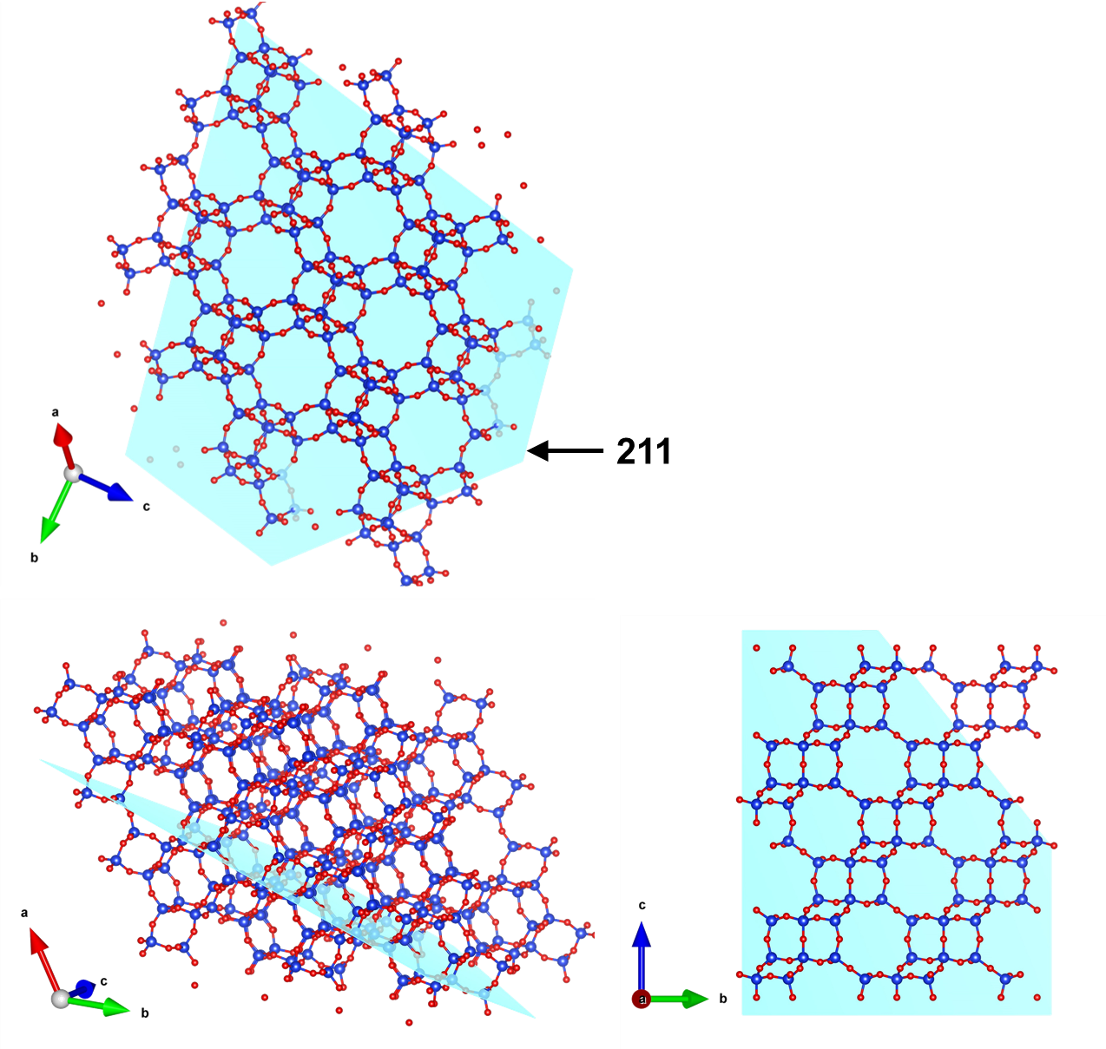Fig. S4 [211] crystal face of CHA zeolite from different directions.
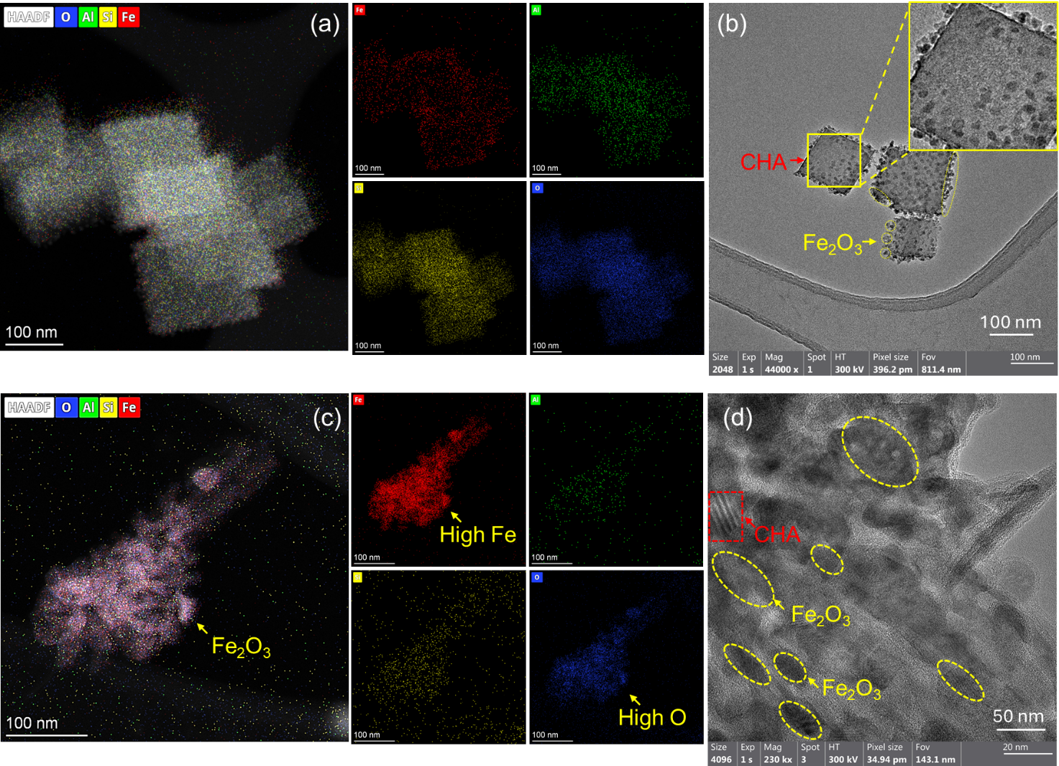
Fig. S5 HAADF-STEM images and the corresponding EDS elemental mapping images of (a) 5Fe/CHA and (c) 50Fe/CHA zeolite catalysts. HRTEM images of (b) 5Fe/CHA and (d) 50Fe/CHA zeolite catalysts.
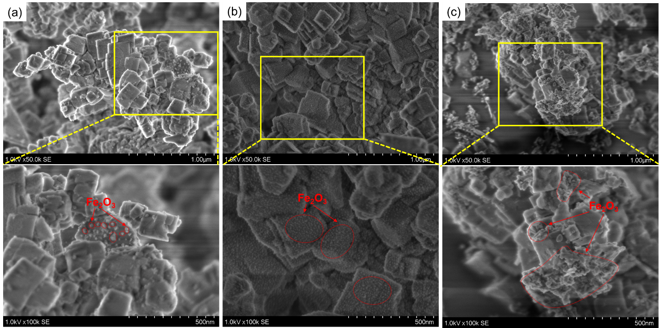
Fig. S6 SEM images of (a) 1Fe/CHA, (b) 5Fe/CHA, (c) 50Fe/CHA zeolite catalysts.
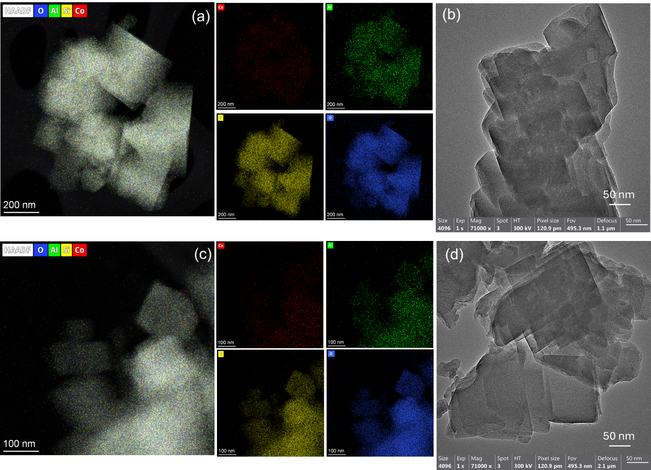
Fig. S7 HAADF-STEM images and the corresponding EDS elemental mapping images of (a) 1Co/CHA and (c) 5Co/CHA zeolite catalysts. HRTEM images of (b) 1Co/CHA and (d) 5Co/CHA zeolite catalysts.
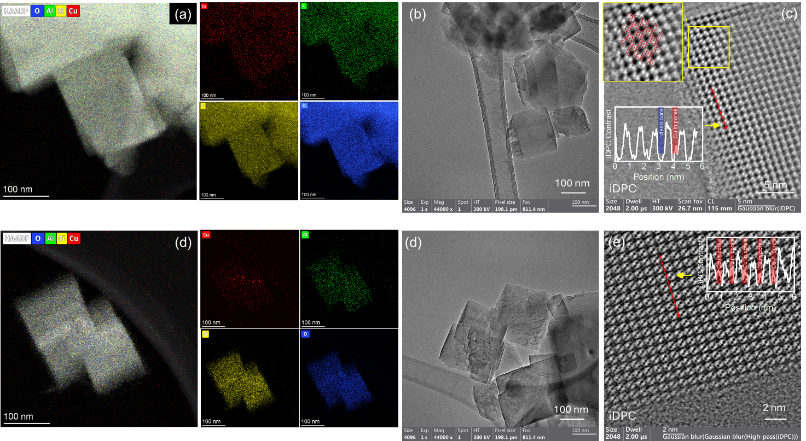
Fig. S8 HAADF-STEM images and the corresponding EDS elemental mapping images of (a) 1Cu/CHA, (d) 5Cu/CHA zeolite catalysts. HRTEM images of (b) 1Cu/CHA, (d) 5Cu/CHA zeolite catalysts. iDPC STEM images of (c) 1Cu/CHA and (e) 5Cu/CHA zeolite catalysts.
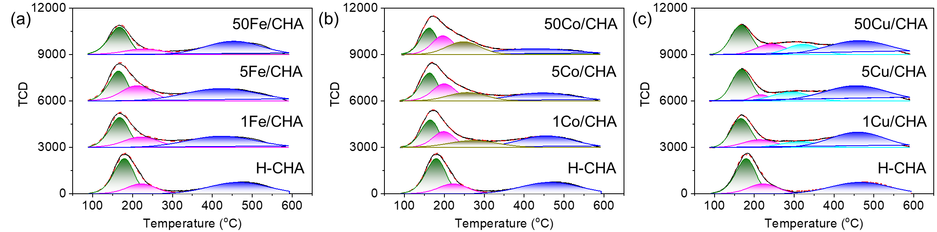
Fig. S9 NH₃-TPD curves of (a) xFe/CHA, (b) yCo/CHA, and (c) zCu/CHA zeolite catalysts in comparison with parent H-CHA zeolite.

Fig. S10 Variation of the strong acid amount with Fe/Al ratio for Fe/CHA zeolite with low Fe content.
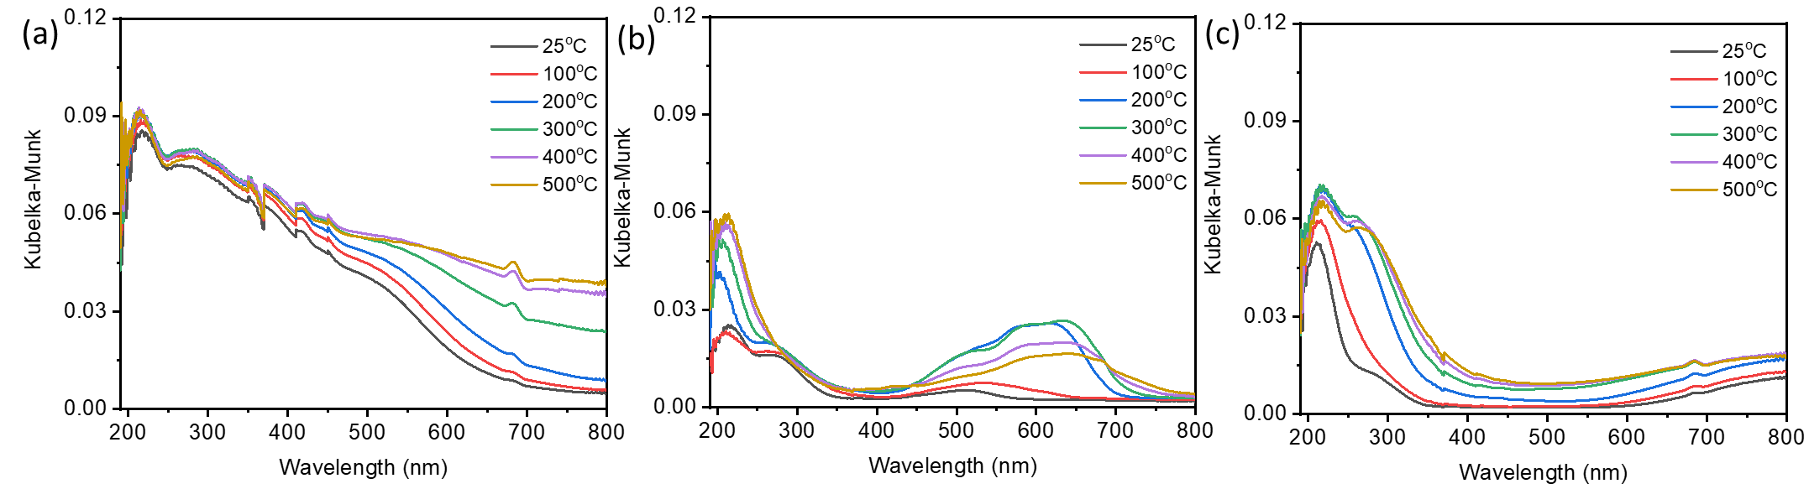Fig. S11 In situ UV-vis spectra of (a) 5Fe/CHA, (b) 5Co/CHA, and (c) 5Cu/CHA zeolite catalyst at 25-500 ºC under the purge of Ar (20 ml/min).
Fig. S12 Product selectivity of M/CHA zeolites in methane conversion reaction at 250 ºC. Reaction conditions: 100 mg catalyst, 250 ºC, CH₄/N₂O/H₂O/Ar=10/10/2/3 ml·min⁻¹, WHSV=15000 ml·(g·h)⁻¹.
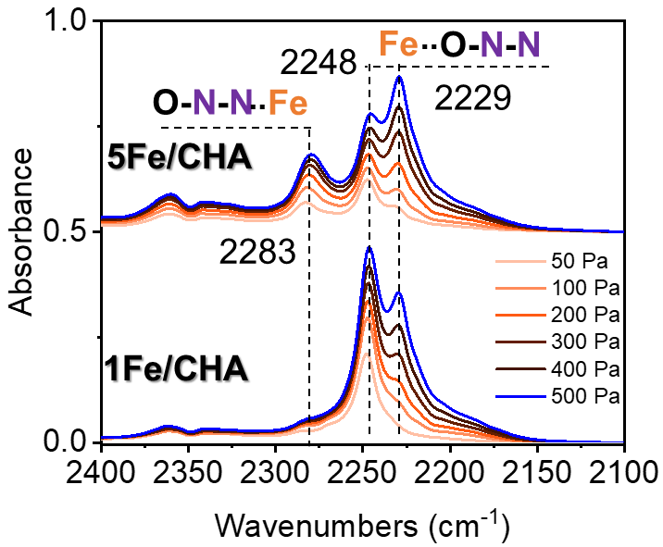
Fig. S13 Compare N₂O adsorption FTIR spectra of 1Fe/CHA and 5Fe/CHA zeolite catalyst at 25 ºC after activation at 500 ºC for 1 h.
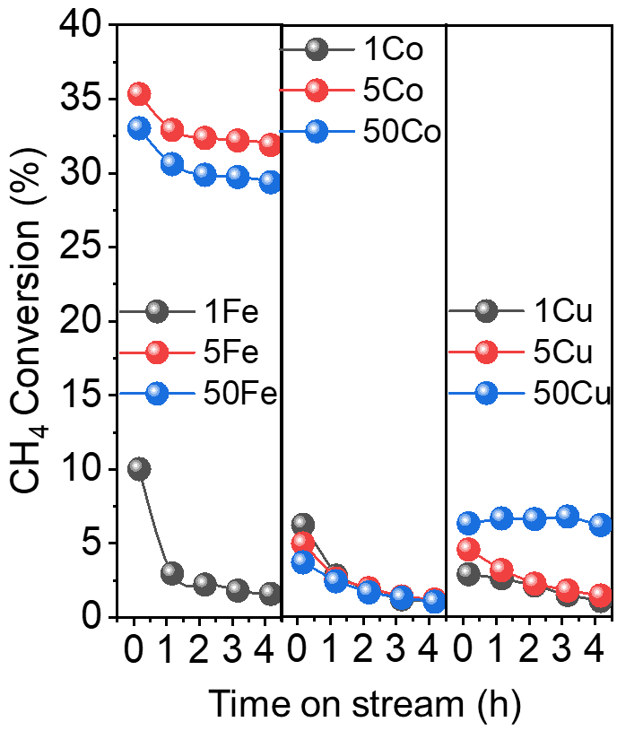
Fig. S14 CH₄ conversion of M/CHA zeolites in methane conversion reaction at 350 ºC. Reaction conditions: 100 mg catalyst, CH₄/N₂O/H₂O/Ar=10/10/2/3 ml·min⁻¹, WHSV=15000 ml·(g·h)⁻¹.
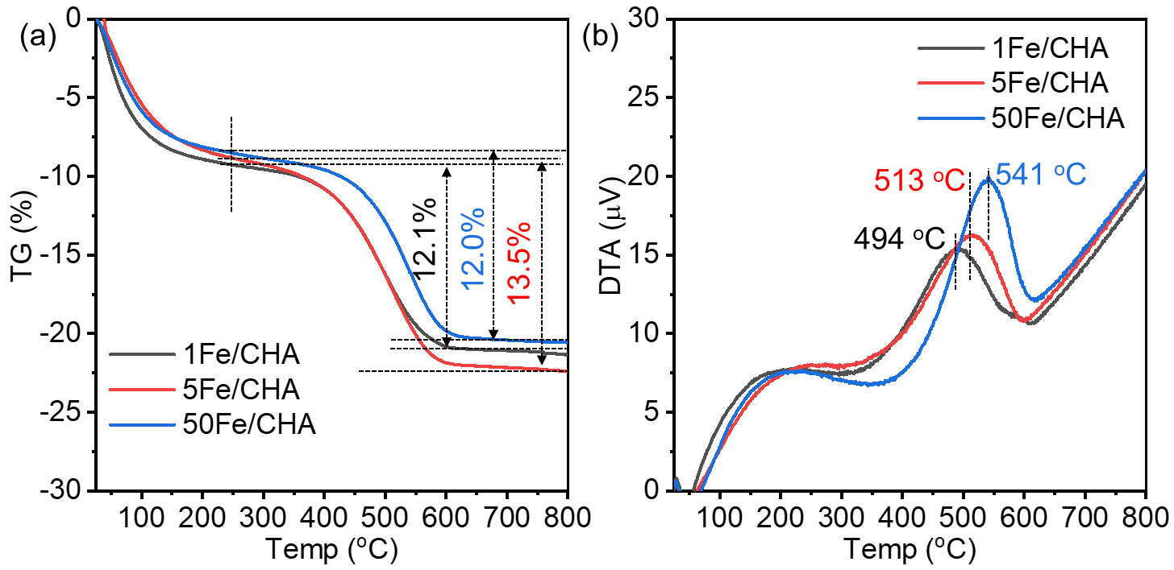Fig. S15 (a) TG and (b) DTA curves of the spend xFe/CHA zeolites in direct oxidation of methane reaction at 350 ºC. Reaction conditions: 100 mg catalyst, CH₄/N₂O/H₂O/Ar = 10/10/2/3 ml·min⁻¹, WHSV =15000 ml·g⁻¹·h⁻¹.

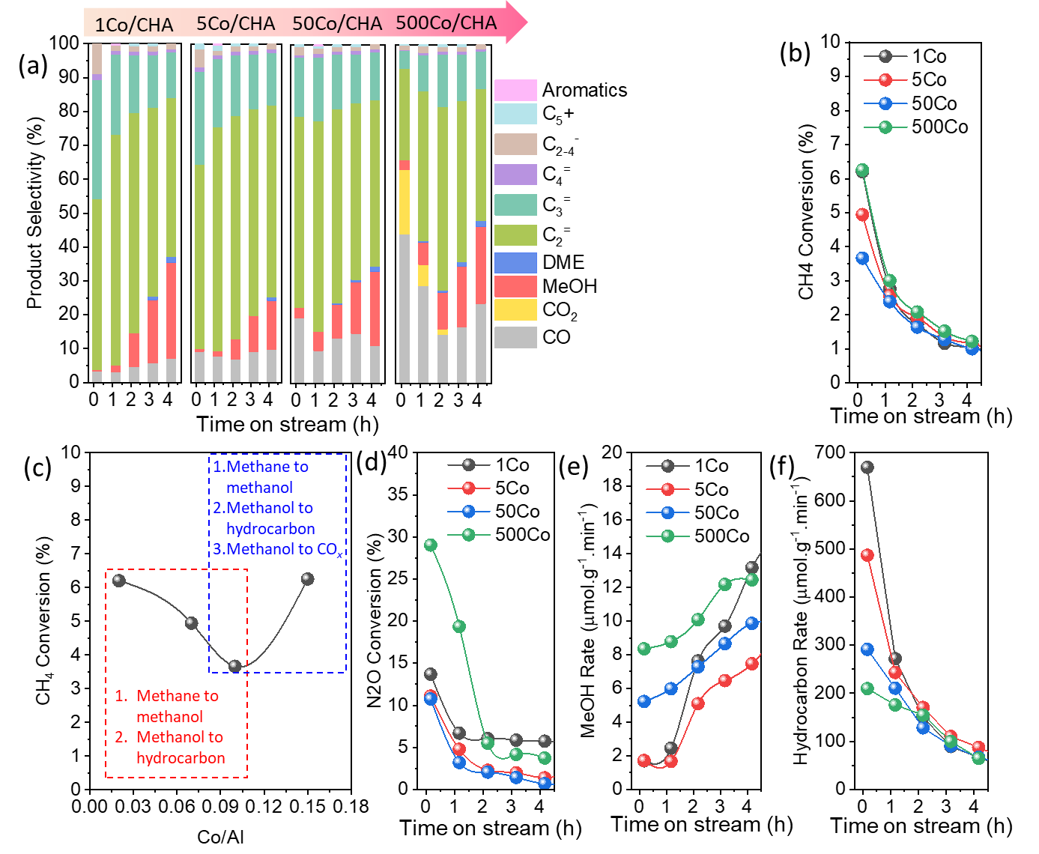
Fig. S16 (a) Product selectivity, (b) CH₄ conversion, (d) N₂O conversion, (e) MeOH formation rate, (f) hydrocarbon formation rate of yCo/CHA zeolite catalysts at 350 ºC. (c) CH₄ conversion as a function of Co/Al. Reaction conditions: 100 mg catalyst, CH₄/N₂O/H₂O/Ar=10/10/2/3 ml·min⁻¹, WHSV =15000 ml·g⁻¹·h⁻¹.

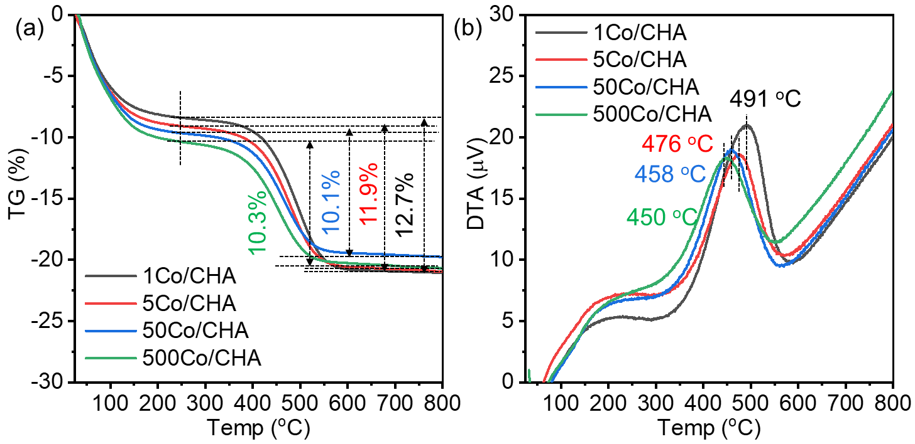Fig. S17 (a) TG and (b) DTA curves of the spend yCo/CHA zeolites in the direct oxidation of methane reaction at 350 ºC. Reaction conditions: 100 mg catalyst, CH₄/N₂O/H₂O/Ar = 10/10/2/3 ml·min⁻¹, WHSV =15000 ml·g⁻¹·h⁻¹.
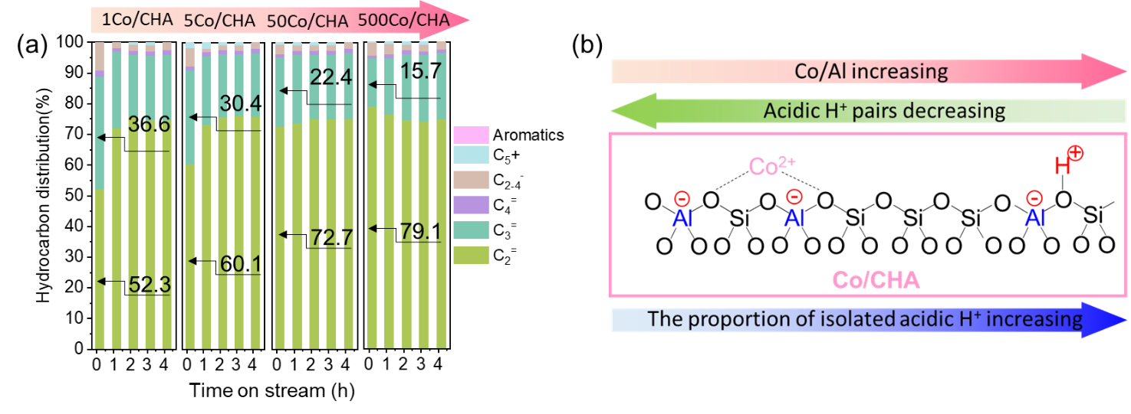
Fig. S18 (a) Hydrocarbon distribution of yCo/CHA zeolite at 350 ºC. Reaction conditions: 100 mg catalyst, CH₄/N₂O/H₂O/Ar=10/10/2/3 ml·min⁻¹. (b) Schematic diagram of Co²⁺ exchange with protons from Al pairs of zeolites.
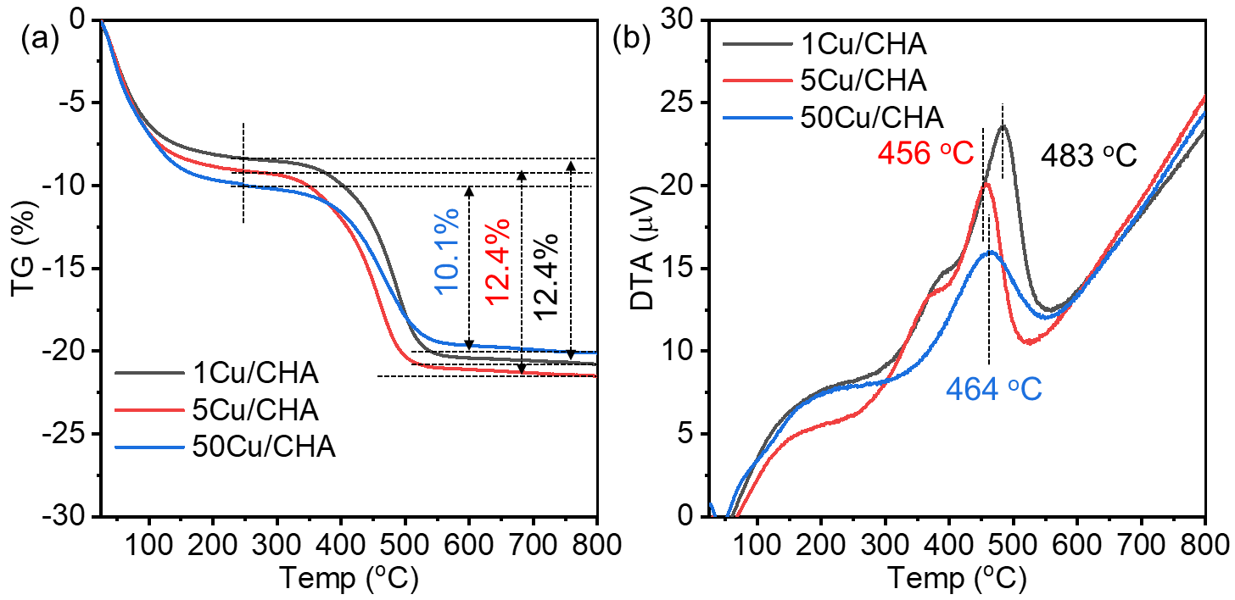
Fig. S19 (a) TG and (b) DTA curves of the spend zCu/CHA zeolites in the direct oxidation of methane reaction at 350 ºC. Reaction conditions: 100 mg catalyst, CH₄/N₂O/H₂O/Ar = 10/10/2/3 ml·min⁻¹, WHSV =15000 ml·g⁻¹·h⁻¹.
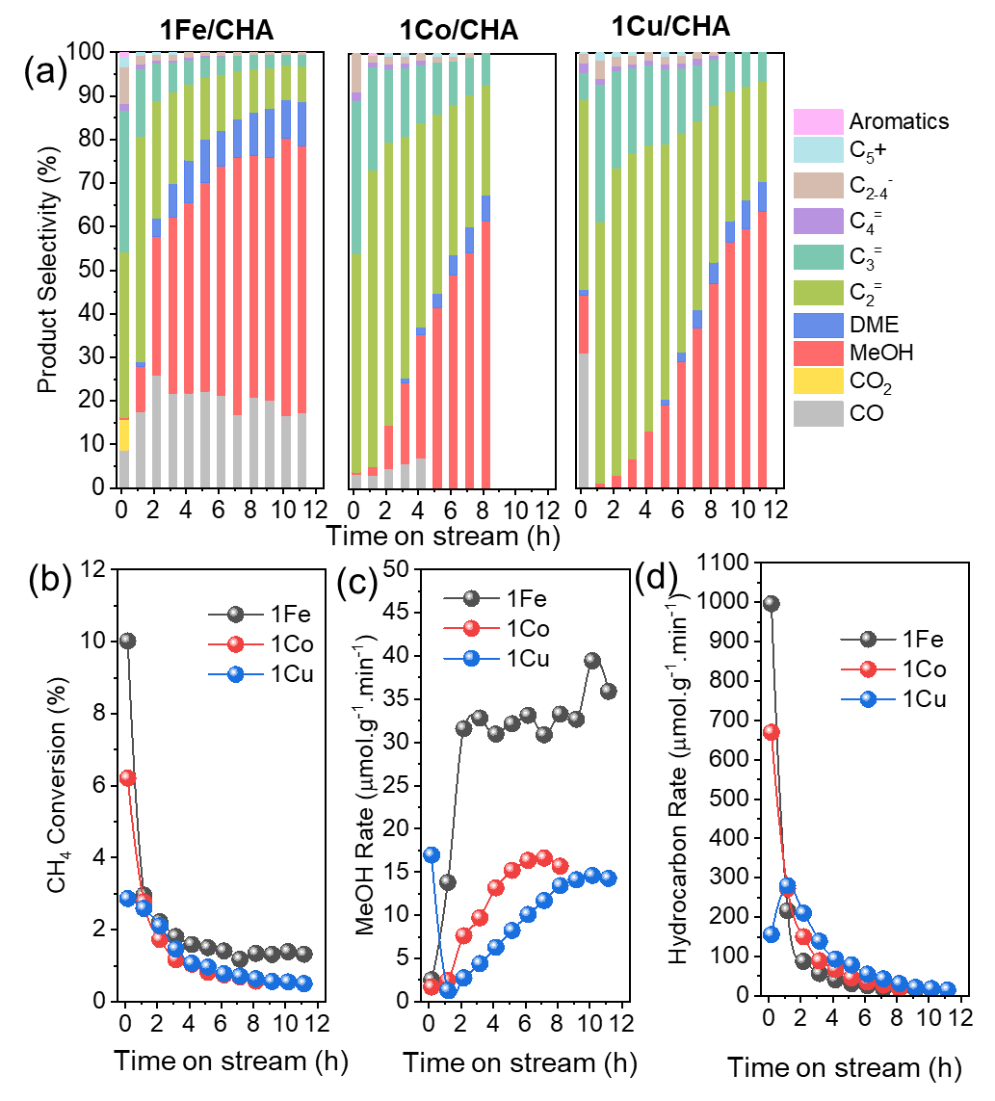
Fig. S20 (a) Product selectivity, (b) CH₄ conversion, (c) MeOH formation rate, (d) hydrocarbon formation rate of 1Fe/CHA, 1Co/CHA, and 1Cu/CHA at 350 ºC. Reaction conditions: 100 mg catalyst, CH₄/N₂O/H₂O/Ar=10/10/2/3 ml·min⁻¹, WHSV =15000 ml·g⁻¹·h⁻¹.

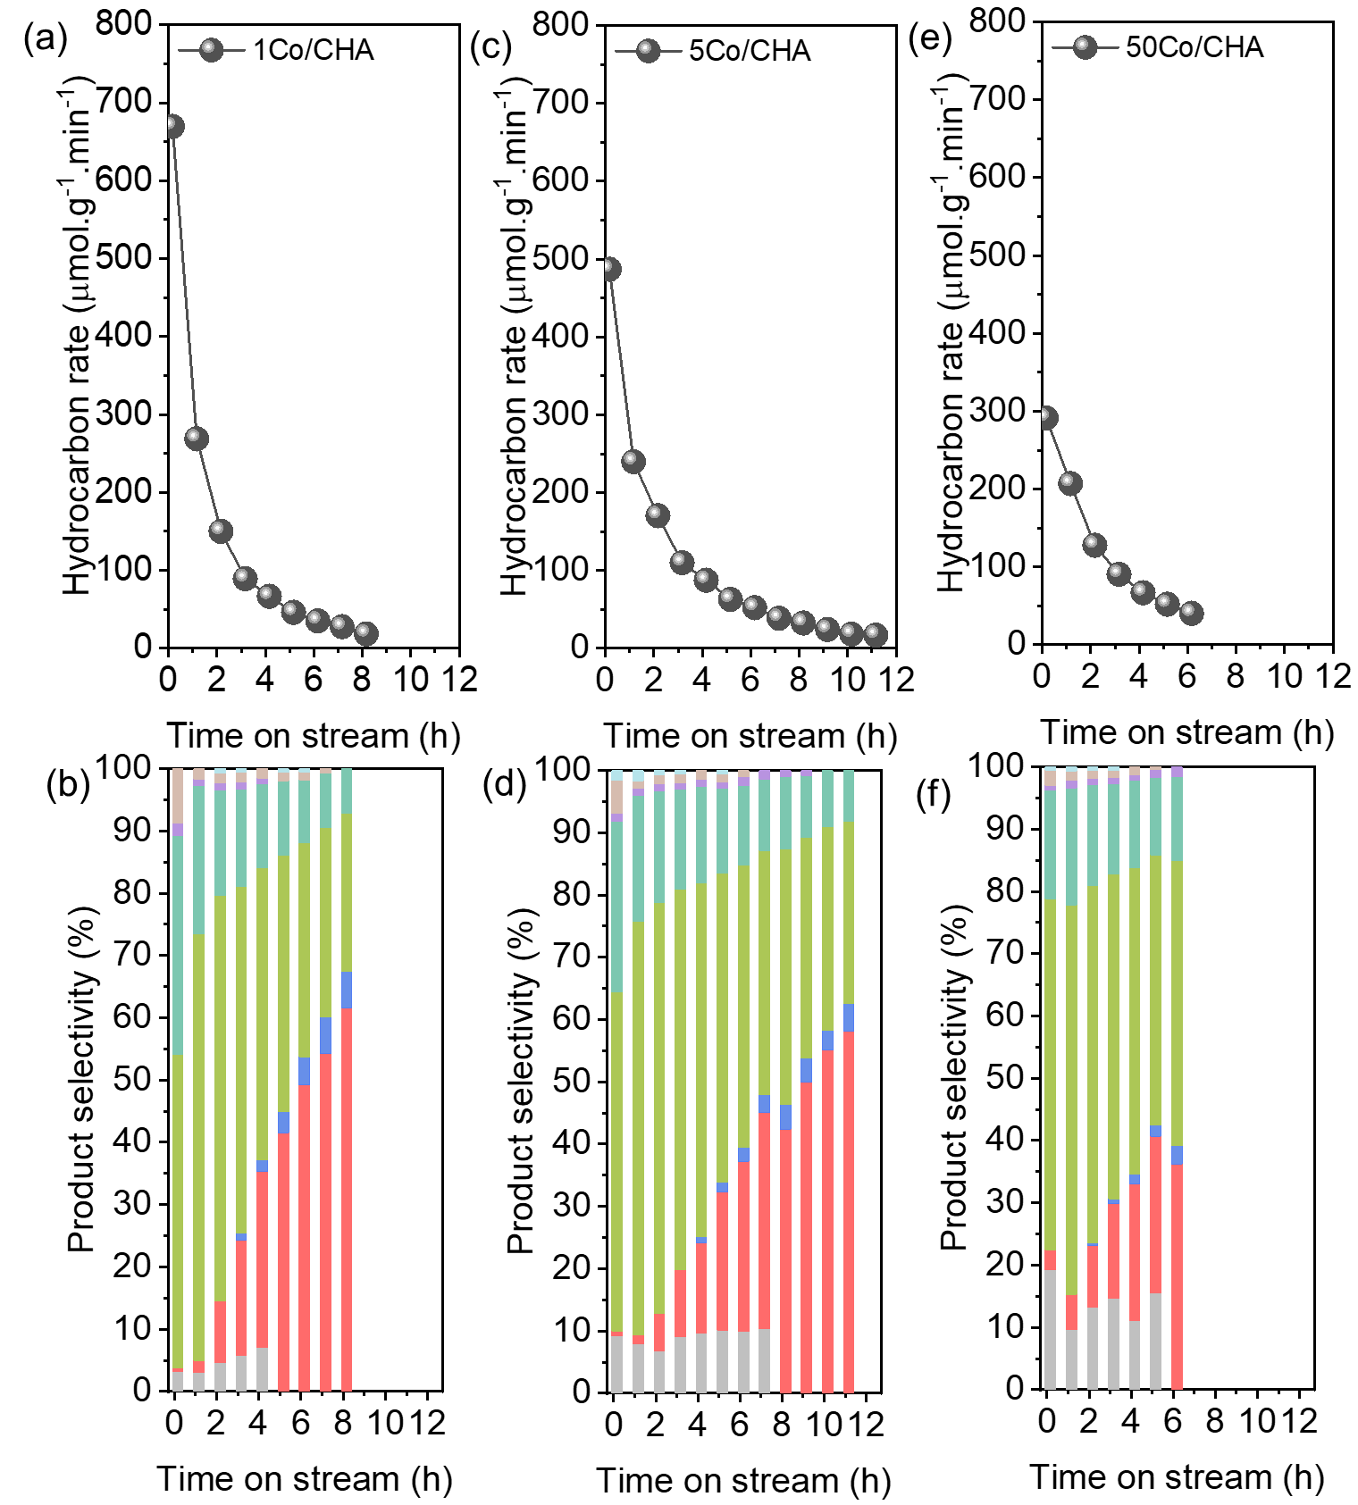
Fig. S21 Stability test of yCo/CHA zeolites at 350 ºC. Hydrocarbon formation rate of (a) 1Co/CHA, (c) 5Co/CHA, and (e) 50Co/CHA. Product selectivity of (b) 1Co/CHA, (d) 5Co/CHA, and (f) 50Co/CHA. Reaction conditions: 100 mg catalyst, CH₄/N₂O/H₂O/Ar=10/10/2/3 ml·min⁻¹, WHSV =15000 ml·g⁻¹·h⁻¹.

Fig. S22 CH₄ conversion and MeOH formation rate of 1Co/CHA zeolite. Reaction conditions: 100 mg catalyst, CH₄/N₂O/H₂O/Ar=10/10/2/28 ml·min⁻¹, WHSV =30000 ml·g⁻¹·h⁻¹.

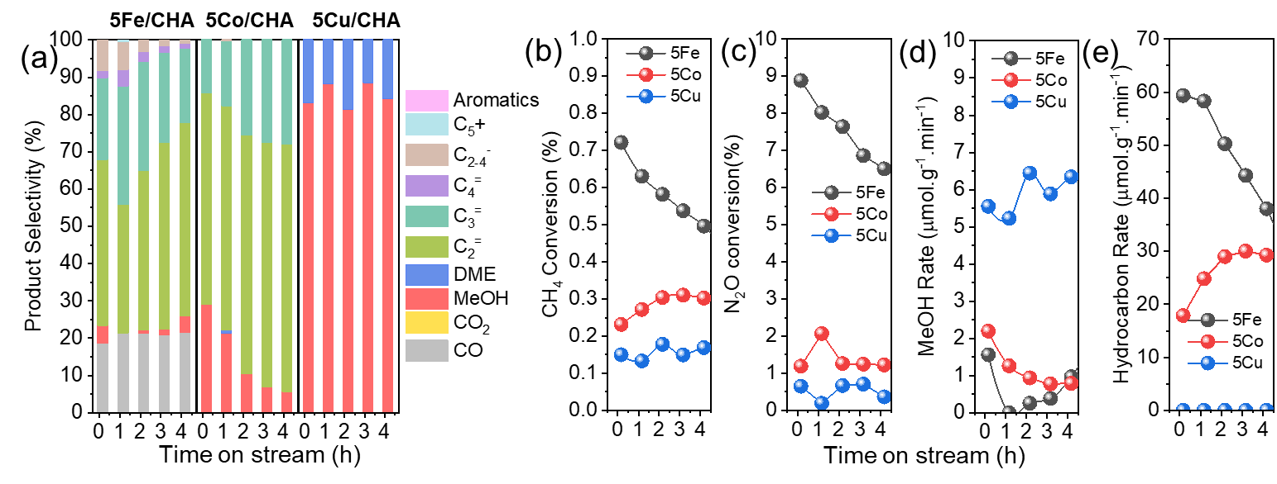Fig. S23 (a) Product selectivity, (b) CH₄ conversion, (c) N₂O conversion, (d) MeOH formation rate, (e) hydrocarbon formation rate of 5M/CHA zeolite catalysts at 300 ºC. Reaction conditions: 100 mg catalyst, CH₄/N₂O/H₂O/Ar=10/10/2/3 ml·min⁻¹, WHSV =15000 ml·g⁻¹·h⁻¹.

Table S1. Texture properties of xFe/CHA, yCo/CHA and zCu/CHA zeolite catalysts.
Sample | Textual Properties
Sample | S_{BET}(m²·g⁻¹) ª | S_{EXT}(m²·g⁻¹) ^{b} | V_{Total}(cm³·g⁻¹) ª | V_{Mic}(cm³·g⁻¹) ^{b}
H-CHA | 614 | 35 | 0.36 | 0.26
1Fe/CHA | 623 | 49 | 0.45 | 0.25
5Fe/CHA | 570 | 55 | 0.43 | 0.23
50Fe/CHA | 519 | 57 | 0.45 | 0.20
1Co/CHA | 617 | 33 | 0.40 | 0.26
5Co/CHA | 617 | 38 | 0.45 | 0.26
50Co/CHA | 605 | 38 | 0.40 | 0.25
1Cu/CHA | 597 | 30 | 0.39 | 0.25
5Cu/CHA | 595 | 31 | 0.40 | 0.25
50Cu/CHA | 592 | 33 | 0.45 | 0.25
ª by the Brunauer–Emmett–Teller (BET) equation on the N₂ adsorption isotherms.
^{b} by the t-plot method based on the adsorption isotherms.
Table S2 Density of Al and transition metals in CHA zeolite.
Sample | Al content ª |  | M content ^{b}
Sample | Al/unit cell | Al/cage | M/unit cell | M/cage
H-CHA | 3.1 | 1.02 | - | -
1Fe/CHA | 3.0 | 0.90 | 0.3 | 0.10
5Fe/CHA | 2.7 | 0.77 | 0.9 | 0.32
50Fe/CHA | 2.3 | 0.94 | 3.4 | 1.12
1Co/CHA | 2.8 | 0.90 | 0.1 | 0.02
5Co/CHA | 2.7 | 0.87 | 0.2 | 0.06
50Co/CHA | 2.6 | 0.93 | 0.3 | 0.09
1Cu/CHA | 2.8 | 0.90 | 0.1 | 0.02
5Cu/CHA | 2.7 | 0.90 | 0.1 | 0.05
50Cu/CHA | 2.7 | 1.00 | 0.3 | 0.10
ª Unit cell of the CHA framework contains 36-T atoms and three CHA cages.
^{b} M means Fe, Co, and Cu in Fe/CHA, Co/CHA, and Cu/CHA, respectively.

Table S3 Chemical composition and acid amount of M/CHA zeolite catalysts.
Sample | Chemical composition ª |  |  | Acid amount by NH₃-TPD (mmol·g⁻¹)
Sample | Si/Al | M/Al ^{b} | M content(wt.%) | LT ^{c} | MT ^{d} | HT ^{e} | Total
0.1Fe/CHA | 11.0 | 0.05 | 0.39 | 0.71 | - | 0.59 | 1.30
500Co/CHA | 12.2 | 0.15 | 1.04 | 0.39 | 0.54 | 0.23 | 1.16
ª Measured by ICP-AES
^{b} M means Fe, Co, and Cu in Fe/CHA, Co/CHA, and Cu/CHA, respectively.
^{c} Low temperature (LT), calculated at ca. 100-250 ºC
^{d} Medium temperature (MT), calculated at ca. 250-350C
^{e} High temperature (HT), calculated at ca. 400-600 ºC

Reference
- Ravel, B.; Newville, M.; J. Synchrotron Radiat. 2005, 12, 537-541.
- Bello, E.; Ferri, P.; Nero, M.; Willhammar,T.; Millet,I.; Schütze, F. W.; van Tendeloo, L.; Vennestrøm, P.N.R.; Boronat, M.; Corma, A.; Moliner, M.; NH3-SCR catalysts for heavy-duty diesel vehicles: Preparation of CHA-type zeolites with low-cost templates, Appl. Catal. B, 2022, 303,120928.

