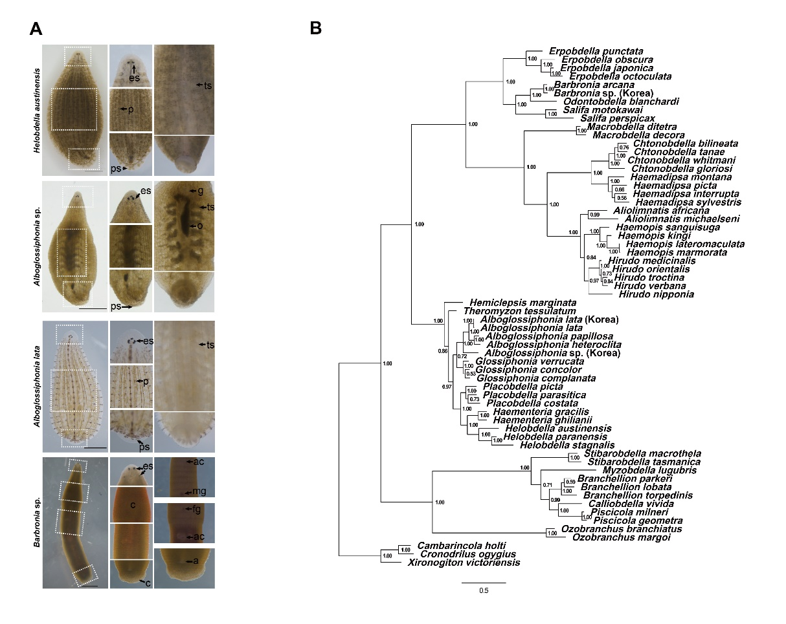
Figure S1. Morphological characters and Bayesian analysis for detail classification
(A) The external morphological comparison is based on previous studies [1-6]. White dotted boxes indicate for zoomed morphological comparison. Simplified external descriptions show the typical characteristics of each species, and the characterization of H. austinensis and A. lata is consistent with previous studies [5, 7, 8]. Alboglossiphonia sp. has characteristics of the genus Alboglossiphonia [2]. It has three pairs of eyes, with a typical heteroclite pattern, with the first pair located close together, and gonopores separated by zero annuli (data is not shown). It has six pairs of crop caeca (Fig 1C). Barbronia sp. shows a “worm-like” body shape similar to B. weberi [6, 9], and typical features of genus Barbronia [2]. It has three pairs of cerebral eyes, with a pair of large labial eyes, followed by two pairs of eyespots. Male and female gonopores are distinguished by 4.5 annuli. The leech has two accessory copulatory pits one anterior and one posterior to the male and female gonopores, similar to B. weberi. a, anus; ac, accessory copulatory pit; c, clitellum; es, eyespot; fg, female gonopore; g, gonopore; mg, male gonopore; o, ovary; p, papillae; ps, posterior sucker; ts, testisac. Scale bars 2mm.
(B) Bayesian Inference (BI) phylogenetic tree reconstructed based on the concatenated sequences of CO1 and 18S rRNA. The numbers near branches indicate Bayesian Posterior Probabilities (BPP, in probability)

Figure S2. Phylogenetic analysis of leeches and Histological analysis in different section series
(A) A maximum likelihood (ML) phylogenetic tree reconstructed based on the concatenated sequences of CO1 and 18S rRNA including Hemiclepsis sp. and Glossiphonia sp. The numbers near branching points indicate the transfer bootstrap expectation (TBE) supports (BS, in percentage) and Bayesian Posterior Probabilities (PP, in probability) and are presented in order of “BS/PP”. Dashes (-) after BS indicate PP that has not been applicable for the ML tree mainly due to the topological discrepancies between ML and Bayesian Inference (BI) trees.
(B) The distribution of compartmentalized muscle layers can be observed in continuous tissue sections in the proboscis of fluid-ingesting leeches. Alboglossiphonia sp. has a proboscis but does not have a clear distribution of muscle layers in histological analysis. CM, circular muscle; LM, longitudinal muscle; PC, proboscis cavity; PS, proboscis sheath; RM, radial muscle; VNC, ventral nerve cord. Scale bars 150μm.

Figure S3 Foregut specific st-mhc identification and sequence similarity between st-mhc orthologs
(A) Phylogenetic analysis of Myosin Heavy chain. H. austinensis MHC (protein id: 129847) and H. nipponia MHC were clustered (red branches) in the same group, and two orthologous sequences show similarity between the two species.
(B) The two candidate st-mhc genes show differential expression pattern in H. austinensis embryo. White arrows indicate the expression regions. Protein ID 64397 was expressed in axial longitudinal muscle within ventral region and posterior sucker muscle, whereas ID 129847 was expressed in proboscis and gut boundary. The protein ID is accessible at JGI for Helobdella robusta (http://genome.jgi.doe.gov/Helro1/Helro1.home.html) [10, 11] Scale bar 200 μm.
(C) Alignment result using ClustalW implemented in sequence editor BioEdit (Available online: http://www.mbio.ncsu.edu/BioEdit/bioedit.html) of sequences designed for probe synthesis show sequence similarity between two mhc orthologs.

Figure S4 Expression of muscle components and spatial confirmation of the sense probes of orthologous st-mhc in ingestion organs
Fluorescence expressions in esophagus indicate different muscle in fluid sucking and Alboglossiphonia sp. Fluorescence-labeled Troponin T proteins (top left rows) and H. nipponia st-mhc (Hni st-mhc) transcripts (top right rows) in the feeding organs of the fluid ingestion leeches were visualized in the entire muscle layers, showing typical features. In Alboglossiphonia sp., partial circular muscle and spacious lumen are observed. In Barbronia sp., a layer of circular muscles surrounding the lumen, radial muscles extending in and out of the circular muscles, and longitudinal muscles are shown. Fluorescence-labeled two orthologous st-mhc sense probes show no specific expression in the foregut of each leech species. DAPI staining (blue) was performed to visualize the distribution of nuclei in the entire proboscis structure. CM, circular muscle; LM, longitudinal muscle; PC, proboscis cavity; PS, proboscis sheath; RM, radial muscle. Scale bars 150μm

Species name | GenBank accession number |  | Species name | GenBank accession number
Species name | CO1 | 18S rRNA | Species name | CO1 | 18S rRNA
Xironogiton victoriensis | AF116014.1 | JQ821515.1 | Piscicola milneri | DQ414337.1 | DQ414292.1
Cambarincola holti | AF116012.1 | JQ821507.1 | Calliobdella vivida | AF003260.1 | AF115992.1
Cronodrilus ogygius | AF116013.1 | JQ821497.1 | Macrobdella decora | AF003271.1 | AF116007.1
Ozobranchus margoi | HM590711.1 | KF728217.1 | Macrobdella ditetra | DQ097215.1 | DQ097208.1
Ozobranchus branchiatus | MK386572.1 | KF728214.1 | Haemadipsa sylvestris | AF003266.1 | HQ203102.1
Theromyzon tessulatum | MN393259.1 | AF115980.1 | Haemadipsa interrupta | HQ203166.1 | HQ203091.1
Hemiclepsis sp. (Korea) | MT823271 | n/a | Haemadipsa montana | HQ203182.1 | KC762968.1
Hemiclepsis marginata | MH643798.1 | AF115981.1 | Haemadipsa picta | HQ203177.1 | HQ203100.1
Helobdella paranensis | AF329037.1 | AF115987.1 | Chtonobdella bilineata | HQ203159.1 | KT592372.1
Helobdella stagnalis | AF116018.1 | AY962416.1 | Chtonobdella tanae | HQ203164.1 | HQ203088.1
Helobdella austinensis | KC812736.1 | MT010331* | Chtonobdella whitmani | HQ203163.1 | HQ203087.1
Haementeria gracilis | AF003276.1 | AF115984.1 | Chtonobdella gloriosi | HQ203187.1 | HQ203110.1
Haementeria ghilianii | AF329035.1 | AF115985.1 | Aliolimnatis michaelseni | AF116029.1 | AF116010.1
Placobdella parasitica | AF003261.1 | AF115990.1 | Aliolimnatis africana | AY425451.1 | AY425469.1
Placobdella picta | AF116020.1 | AF115988.1 | Hirudo medicinalisª | KU672396.1 | AY786464.1
Placobdella costata | MF067142.1 | AY962436.1 | Hirudo verbanaª | KU672397.1 | HQ691212.1
Glossiphoia sp. (Korea) | MT823272* | n/a | Hirudo nipponiaª | KC667144.1 | AY425468.1
Glossiphonia complanata | AF003277.1 | JQ821519.1 | Hirudo orientalis | EF405599.1 | GQ368792.1
Glossiphonia verrucata | MK479264.1 | AY962432.1 | Hirudo troctina | GQ368751.1 | GQ368793.1
Glossiphonia concolor | KM095098.1 | AY962431.1 | Haemopis lateromaculata | AF116028.1 | AF116009.1
Alboglossiphonia sp. (Korea) | MN503262* | MT010328* | Haemopis marmorata | AF003270.1 | AF116008.1
Alboglossiphonia lata (Korea) | MN961660* | MT010329* | Haemopis kingi | KM611858.1 | AY425466.1
Alboglossiphonia lata | MN393287.1 | AY962411.1 | Haemopis sanguisuga | AF462021.1 | X91401.1
Alboglossiphonia heteroclita | AF116016.1 | AF103730.1 | Erpobdella japonica | AF116026.1 | AB663648.1
Alboglossiphonia papillosa | MH286267.1 | MH286273.1 | Erpobdella octoculata | AF003274.1 | AF116001.1
Myzobdella lugubris | AF003269.1 | AF115994.1 | Erpobdella obscura | JQ821638.1 | JQ821523.1
Branchellion torpedinis | AF003265.1 | AF115993.1 | Erpobdella punctata | AF003275.1 | HQ336380.1
Branchellion parkeri | DQ414308.1 | DQ414262.1 | Barbronia sp. (Korea) | MN503261* | MT010330*
Branchellion lobata | DQ414307.1 | DQ414261.1 | Barbronia arcana | DQ235598.1 | DQ235608.1
Stibarobdella macrothela | AF116022.1 | DQ414296.1 | Odontobdella blanchardi | AB675016.1 | AB663651.1
Stibarobdella tasmanica | DQ414343.1 | DQ414298.1 | Salifa perspicax | HQ336343.1 | HQ336377.1
Piscicola geometra | AF003280.1 | AF115995.1 | Salifa motokawai | LC029431.1 | LC029434.1
Table S1. List of leech species used for phylogenetic analysis with GenBank accession numbers.
* Accession numbers for newly obtained sequences in bold. n/a – not available
ª Some partial or complete mitochondrial genomes

Supplemental References.
1. Davies RW, Singhal R, Blinn D: Erpobdella montezuma (Hirudinoidea: Erpobdellidae), a new species of freshwater leech from North America. Canadian Journal of Zoology 1985, 63:965-969.
2. Sawyer RT: Leech biology and behaviour. Clarendon Press Oxford; 1986.
3. el-Shimy NA: Description of a new species of Alboglossiphonia Lukin, 1976 (Hirudinea: Glossiphoniidae) from Egypt. Zoology in the Middle East 1990, 4:93-102.
4. Kutschera U: The Golden Gate Leech Helobdella californica (Hirudinea: Glossiphoniidae): Occurrence and DNA‐Based Taxonomy of a Species Restricted to San Francisco. International review of Hydrobiology 2011, 96:286-295.
5. Kutschera U, Langguth H, Kuo DH, Weisblat D, Shankland M: Description of a new leech species from North America, Helobdella austinensis n. sp.(Hirudinea: Glossiphoniidae), with observations on its feeding behaviour. Zoosystematics and Evolution 2013, 89:239-246.
6. Sawyer RT, Sawyer DR: The alien Asian leech Barbronia weberi (Blanchard, 1897)(Hirudinea: Salifidae) reported from two disjunct localities in North Carolina, United States, with observations on its biology and potential for laboratory research. BioInvasions Records 2018, 7:61-64.
7. Jiménez BIM, Kwak H-J, Park J-S, Kim J-W, Cho S-J: Developmental biology and potential use of Alboglossiphonia lata (Annelida: Hirudinea) as an “Evo-Devo” model organism. Frontiers in zoology 2017, 14:60.
8. Lai Y-T, Chen J-H: Leech fauna of Taiwan. National Taiwan University Press Taipei; 2010.
9. Pavluk T, Pavluk E, Rasines R: First record of the Asian leech Barbronia weberi (Blanchard, 1897)(Hirudinea: Arhynchobdellida: Erpobdelliformes: Salifidae) in the Iberian Peninsula. Aquatic Invasions 2011, 6:S61-S64.
10. Kuo D-H, Weisblat DA: A new molecular logic for BMP-mediated dorsoventral patterning in the leech Helobdella. Current Biology 2011, 21:1282-1288.
11. Kwak H-J, Park J-S, Medina Jiménez BI, Park SC, Cho S-J: Spatiotemporal Expression of Anticoagulation Factor Antistasin in Freshwater Leeches. International journal of molecular sciences 2019, 20:3994.

