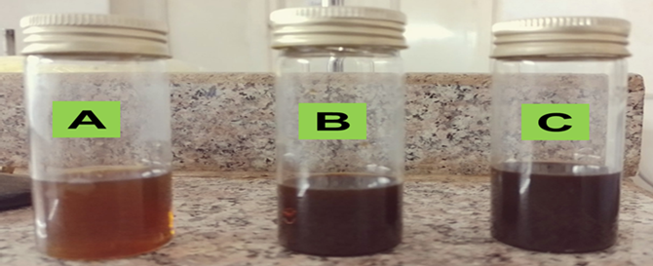
Fig S 1: The color change during the biosynthesis of the AgNPs colloidal solution reflects different concentrations: A (AgNPs-L, low), B (AgNPs-M, medium), and C (AgNPs-H, high)

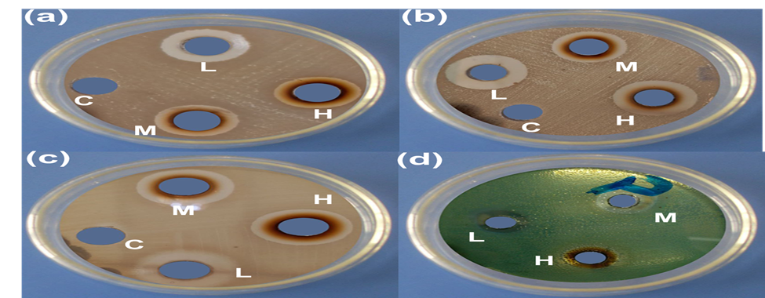
Fig S. 2. Digital images showing clear inhibition zones for antibacterial activity against (a) E. coli (ATCC 43890), (b) E. faecalis (MTCC 2729), (c) S. aureus (MTCC 96), and (d) P. aeruginosa (ATCC). The labels represent C (control), L (low concentration), M (medium concentration), and H (high concentration).

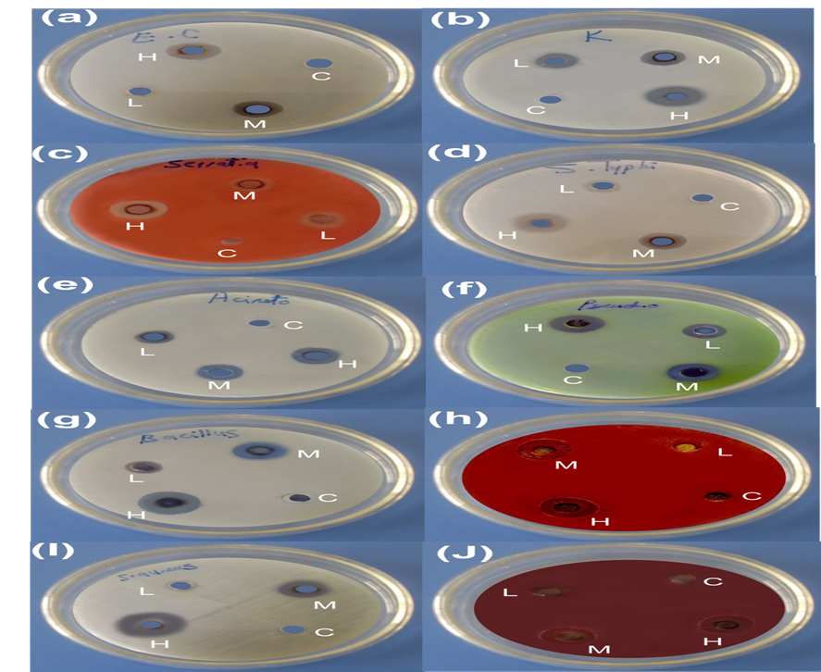

Fig S, 3. Inhibitory effect of AgNPs against resistant bacterial species: (a) E. coli, (b) K. pneumoniae, (c) P. aeruginosa, (d) A.baumannii, (e) Serratia marcescens, (f) S. typhi, (g) S. aureus, (h) Enterococcus faecalis, (i) Listeria monocytogenes, and (j) Bacillus cereus. The discs represent different concentrations of AgNPs: C (control), L (low concentration), M (medium concentration), and H (high concentration).

