Table 1 Optimization of iron-catalyzed transfer hydrogenation of methyl benzoate.ª
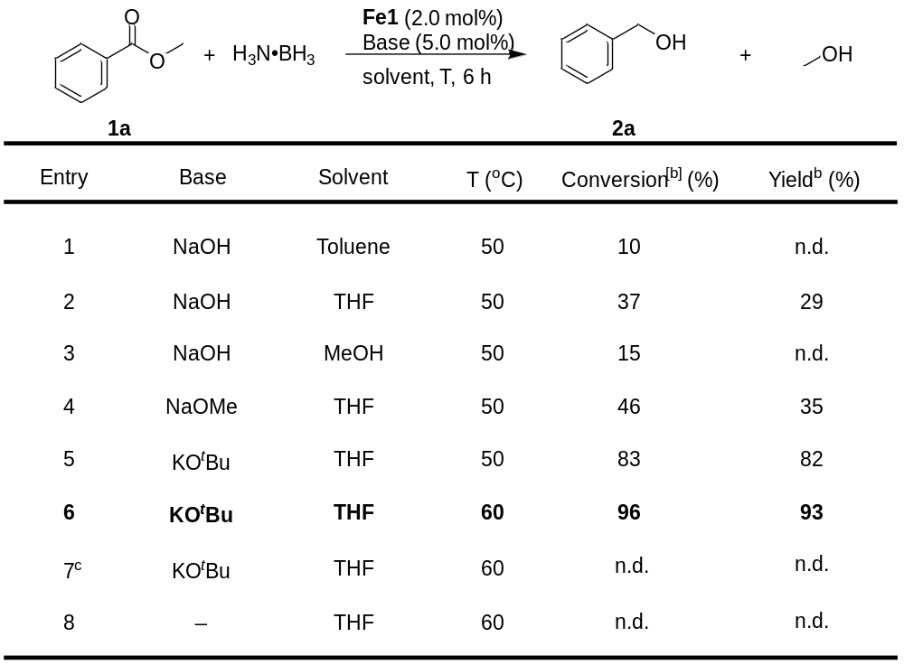
ª Reaction conditions: methyl benzoate (1.0 mmol), H₃N·BH₃ (1.0 mmol), Fe1 (0.02 mmol), base (0.05 mmol), solvent (2 mL), and 6 h. ^{b} Conversions and Yields were determined via ¹H NMR spectroscopy with an internal standard (xylene). ^{c} without Fe1.
Table 2 Catalytic transfer hydrogenation of esters using iron precatalyst 1.ª
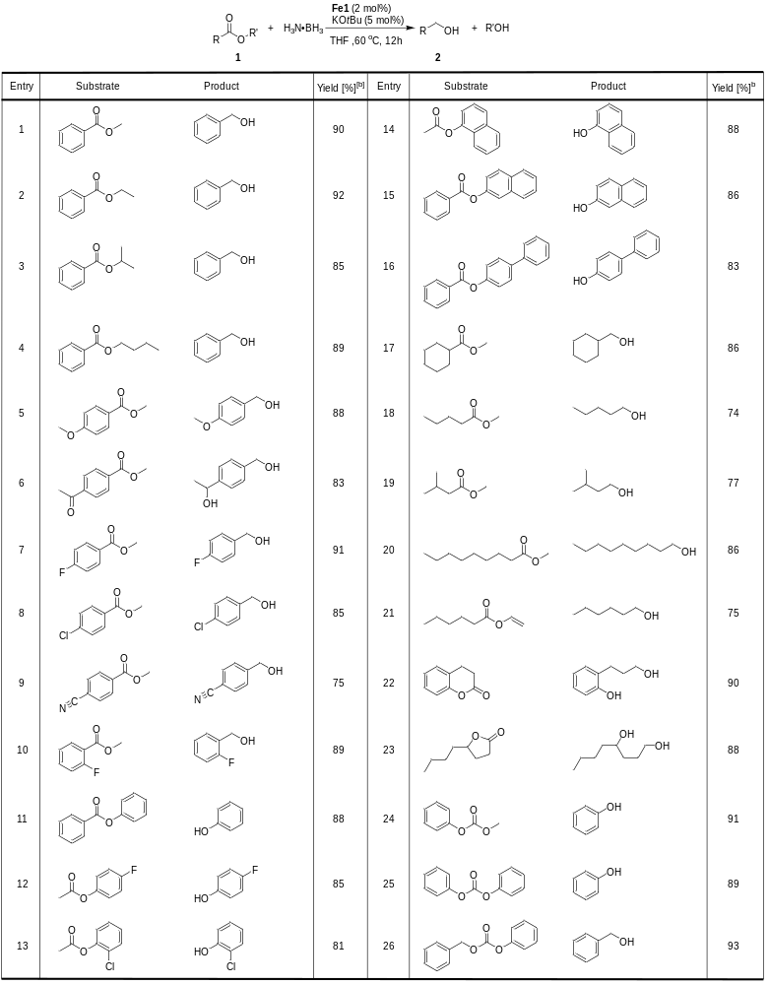
ª Reaction conditions: substrate (1.0 mmol), H₃N·BH₃ (1.0 mmol), Fe1 (0.02 mmol), KO^{t}Bu (0.05 mmol), THF (2 mL), 60°C, and 12 h. ^{b} Isolated yields are given.
Table 3 Optimization of iron-catalyzed methanolysis of PET.ª
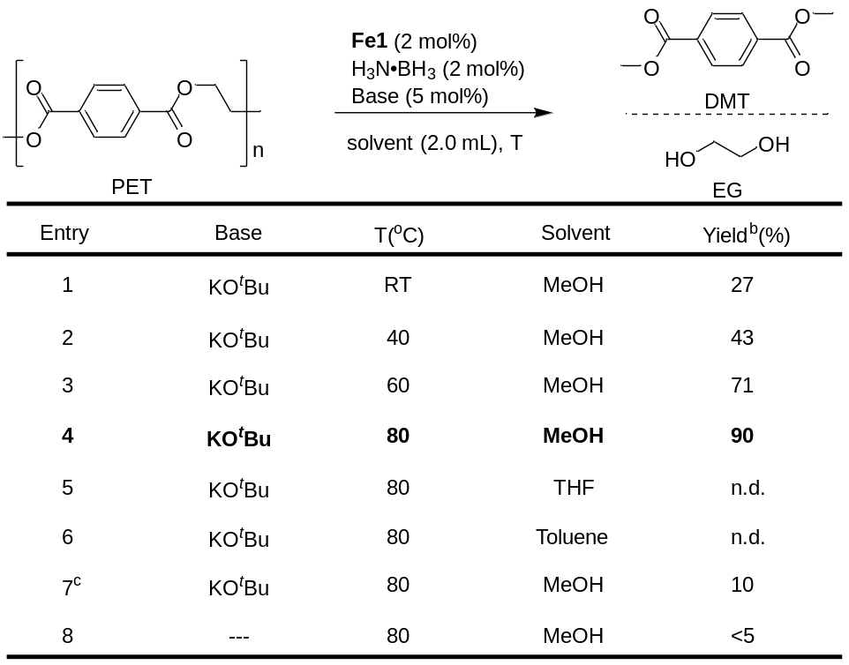
ª Reaction conditions: PET (1.0 mmol), H₃N·BH₃ (0.02 mmol), Fe1 (0.02 mmol), solvent (2 mL), (RT~80°C), and 12 h. ^{b} Isolated yields of DMT are given. ^{c} Without Fe1 and H₃N·BH₃.
Table 4. Hydrogenolysis of consumer polymer products using [Fe(NNHN)Cl₂] and KO^{t}Bu.ª
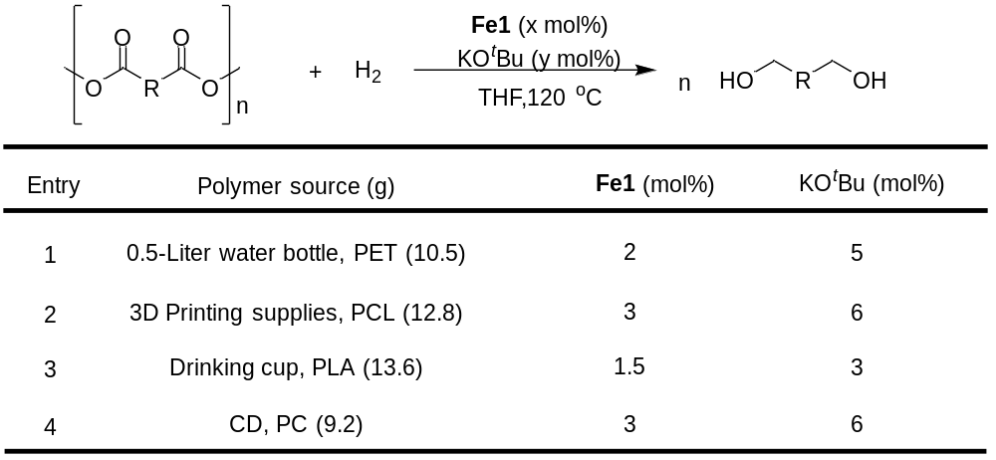
ª Reaction conditions: The reactions were performed in a 250-mL steel autoclave within a 24 h reaction time at 120°C using x mol % Fe1 and y mol % KO^{t}Bu, 100 mL of THF, and a 20-bar constant hydrogen pressure.

