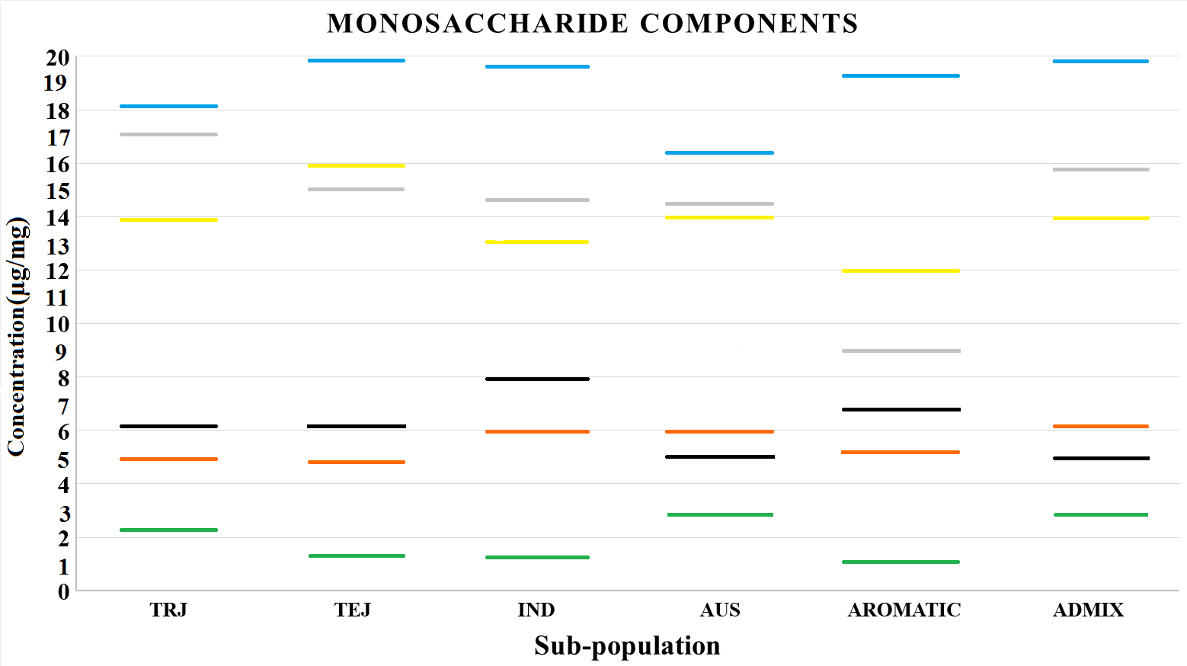 Supplementary figure S1. Phenotypic variation in monosaccharide content among six sub-populations of rice. The accessions included in the study were from the following sub-populations (as defined by Zhao et al., 2011): TEJ (Temperate Japonica), IND (Indica), AUS (aus), ARO (Aromatic), TRJ (Tropical Japonica) and ADMIX. Xylose: blue line, arabinose: gray line, focuse: yellow line, mannose: black line, galactose: orange line and rhamnose: green line.

Supplementary figure S2. Pathways for monosaccharid biosynthesis. The pathway starts with sucrose. UDP-glucose is being produced by sucrose synthase and UDP-glucose is substrate for making other monosaccharides. UDP-Glc pyrophosphorylase is responsible for UDP rhamnose biosynthesis. UDP-glucose 4-epimerase is responsible for UDP galactose biosynthesis. Alternatively, UDP-D-glucuronate can be produced by UDP-Glc dehydrogenase from UDP-glucose and UDP-D-glucuronate is the substrate for the production of UDP-xylose by the UDP-glucuronate decarboxylases. UDP-xylose can be transferred to the Golgi apparatus where it can be converted to arabinose by UDP-Ara 4-epimerase. Sucrose can also be converted to fructose by the invertase. The fructokinase, mannose 6-phosphate isomerase, phosphomannomutase and mannose-1-phosphate guanylyltransferase are responsible for converting fructose to mannose. Finally, mannose is a substrate for the production of focus from GDP-Man 4,6-dehydratase and GDP-4-keto-6-deoxy-D-mannose-3,5-epimerase-4-reductase. SUS sucrose synthase; INV: invertase; UDP Glc: UDP-glucose; UDP Rha: UDP rhamnose; UDP Gal: UDP galactose; URS: UDP-Glc pyrophosphorylase, UGE: UDP-glucose 4-epimerase, UGD: UDP-Glc dehydrogenase; UXS: UDP-glucuronate decarboxylases; FK: fructokinase; MPI: mannose 6-phosphate isomerase; PMM: phosphomannomutase; MGP: mannose-1-phosphate guanylyltransferase; Fru6p: fructose 6-phosphate; Man6p: mannose 6- phosphate; Man1p: mannose 1- phosphate; GDP-Man: GDP-D-mannose; GDP-Fus: GDP-L-fucose; GMD: GDP-Man 4,6-dehydratase; GER: GDP-4-keto-6-deoxy-D-mannose-3,5-epimerase-4-reductase.

