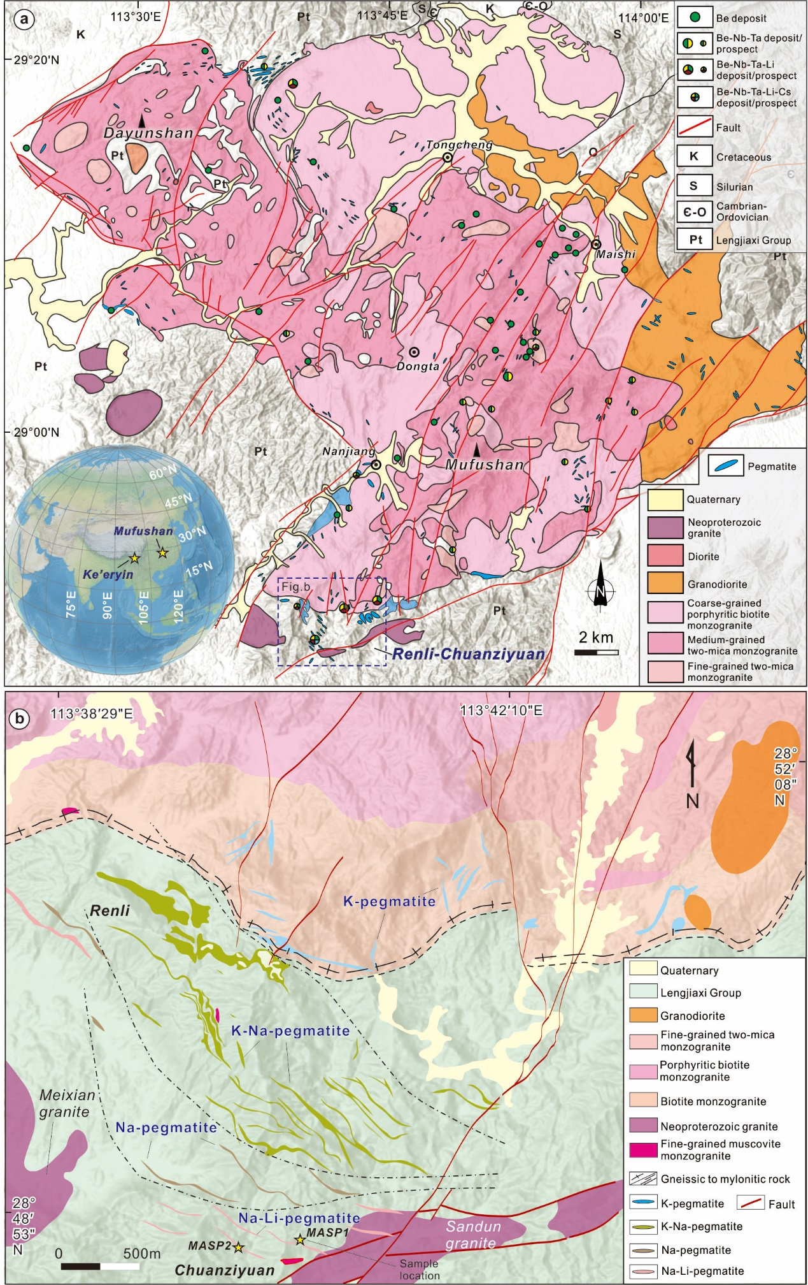
Extended data Fig. 1| (a) Geological map of the Mufushan batholith (modified after Ji et al. 2018). (b) Geological map of the Renli-Chuanziyuan granite-pegmatite field (modified after Xiong et al., 2020). The yellow pentacle indicates the sample location.

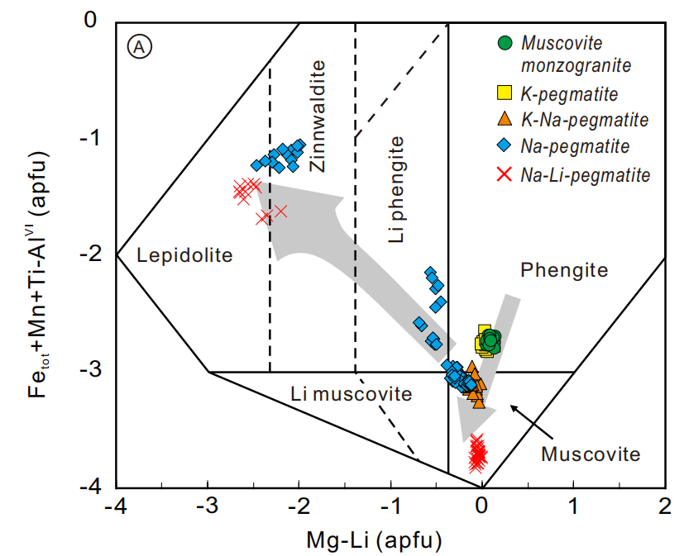
Extended data Fig. 2| The composition of mica in different lithological units in the Mufushan pegmatite field.
Extended Data Fig. 3| The theoretic relationship between Rb and the K/Rb ratio in micas during fractional crystallization of magmas parental to the Mufushan and Ke’eryin granite-pegmatite system.

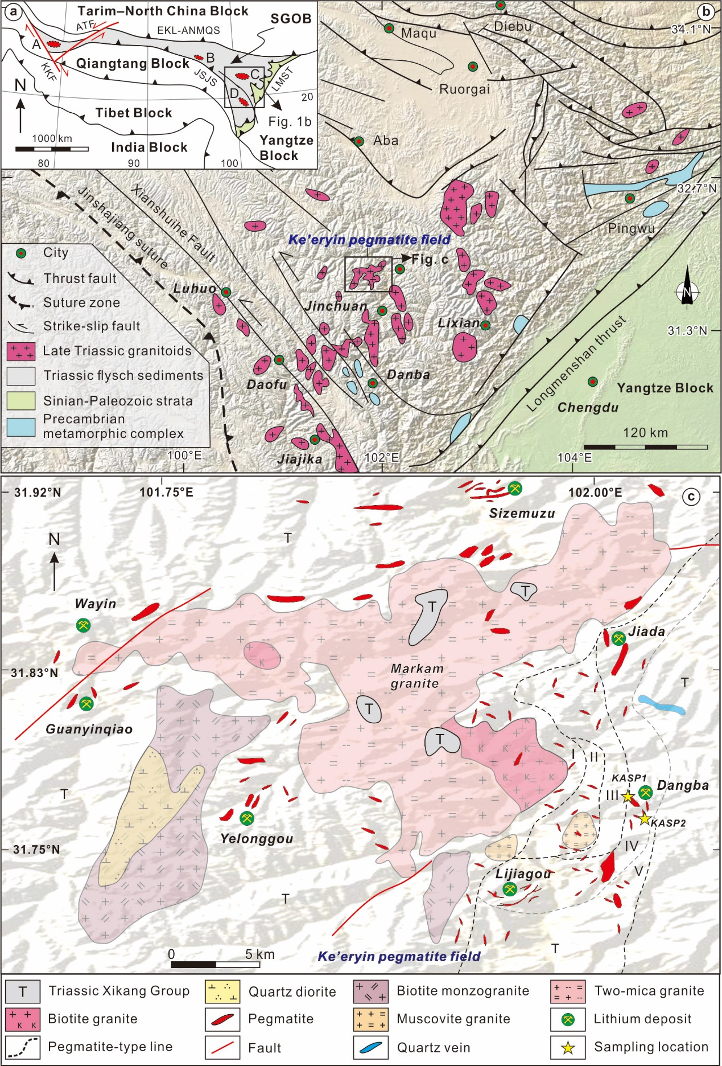
Extended data Fig. 4| (a) Simplified continent-scale location map (upper left) of the Songpan-Ganze orogenic belt (SGOB), China (modified after Xiao et al. 2005). Red ovals show areas with major granitic pegmatite-type Li deposits. A: Dahongliutan (including Bailongshan Li deposit), B: Zhawulong, C: Ke'eryin, and D: Jiajika. ATF = Altyn Tagh Fault, KKF = Karakunram Fault, EKL–ANMQSZ = East Kunlun–Anyemaqen suture zone, JSJS = Jinshajiang suture zone, and LMST = Longmenshan thrust. (b) Regional geological map of the eastern SGOB (center and lower right) showing the location of the Ke’eryin pegmatite field (modified after Roger et al. 2010).(c)Geological map of the Ke'eryin pegmatite field showing the distributions of granites and pegmatites (modified after Yan et al. 2024). I–V denote the microcline, microcline–albite, albite, albite–spodumene, and lepidolite pegmatite zones.

Extended Data Fig. 5| The crystallization sequence of the main minerals during cooling of magmas parental to the Mufushan and Ke’eryin granite-pegmatite system.

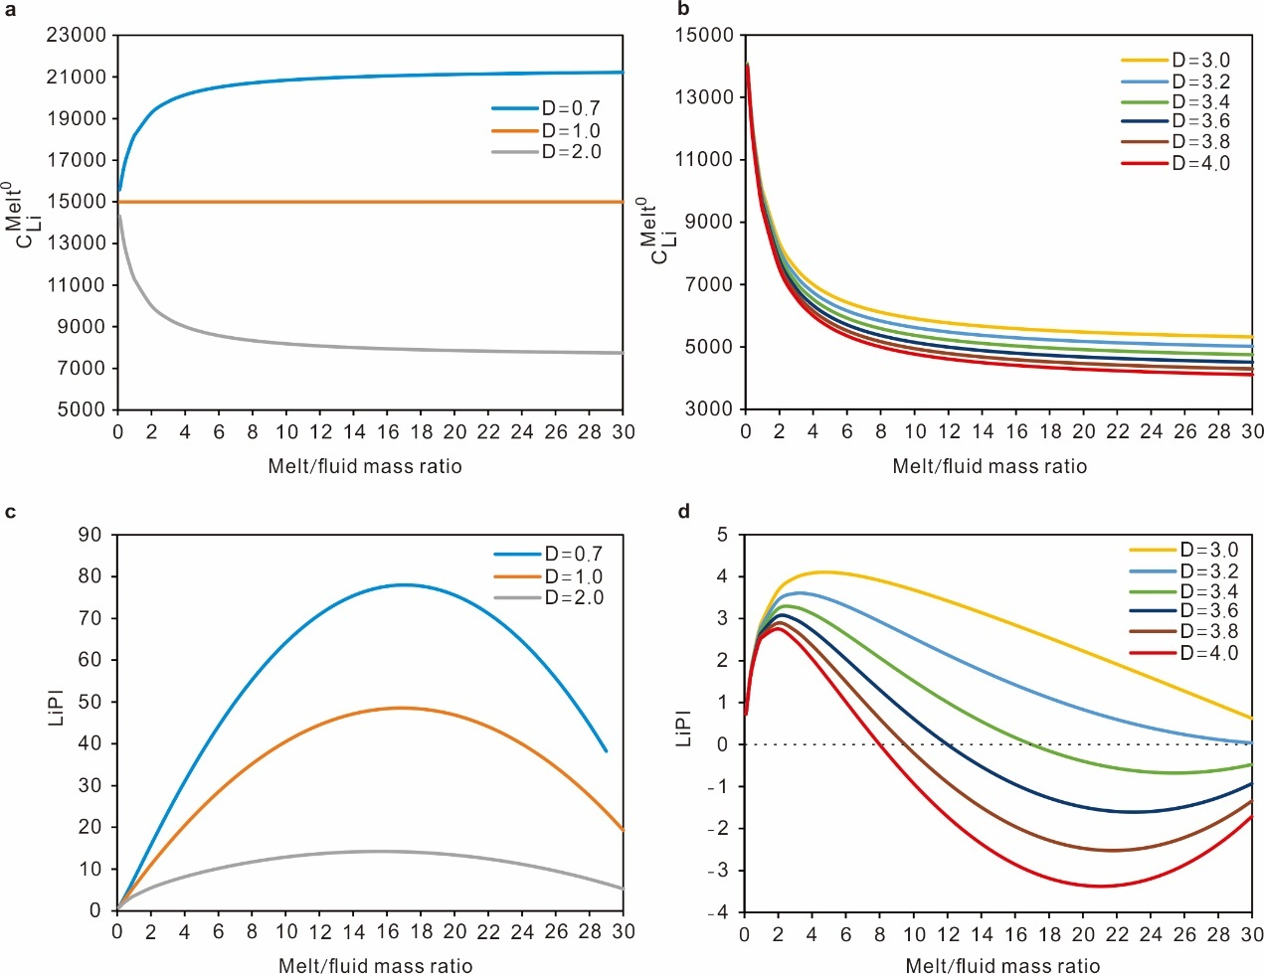
Extended Data Fig. 6| Model curves illustrate the relationship of $C_{Li}^{{Melt}^{0}}$ (a, b) and LiPI values (c, d) with the melt/fluid mass ratios. These curves were constructed with various partition coefficients of Li between fluid and magma.

