Supplementary Materials

S.1 Water storage system variables
The chart of water storage system variables has been prepared to understand the variables including ‎inputs and outputs of the water storage system of the case study accurately (Figure S.1).‎
- Groundwater System in this system includes Aquifer #1 and Aquifer #2 (neighbouring Aquifer). All inflows and outflows of Aquifer #1 set into the model because this system is our main water resource and the local aquifer. The aim of this paper is to provide limitation strategies for protecting the groundwater resource of Aquifer #1. Also, Aquifer #2 contributes to supplying domestic supply by adding 11 MCM into the groundwater storage System.
- Surface Water System includes Dam#1 and transferred water from Dam #2. This system contributes to Surface Water System through inter-basin water transfer and supply water for domestic and agricultural purpose. The first priority of this sector is to supply domestic water demands. The transferred water from Dam #2 inflows into the reservoir of Dam #1. Therefore, this volume of water is defined as an inflow of Dam #1.
- Water Distribution System is responsible for transferring water in the network, but it has been estimated that 35 % of this water is lost in the system. Therefore, leakage rate volume is set in the model as the outflow of water Distribution System.
- Developing Wastewater and Sewage System associated with a water reuse plant can increase the possibilities of water supply for agricultural, landscape, service and industrial purposes. This system also is developed in the model.
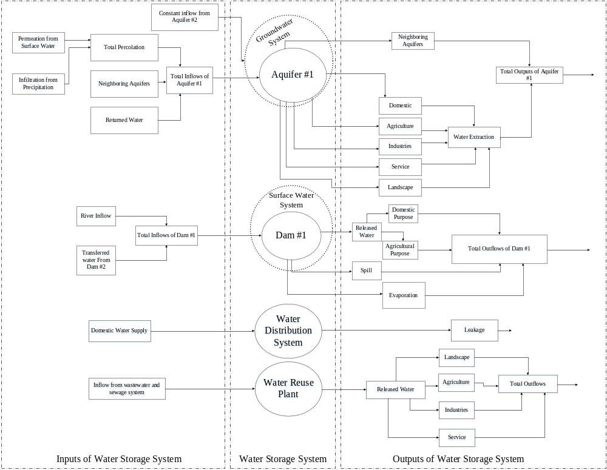
Figure S.1: Schematic chart of the model development

S.2 Results of statistical tests for model calibration and validation
Once the SD model is built, it is necessary to conduct a model calibration and validation by using statistical tests via comparing the simulated results with corresponding observed data collected from the case study. To that end, coefficient of determination (R2), Relative Root Mean Square Error (RMSE), Nash- Sutcliffe have been used for this purpose.
Coefficient of Determination (R²) is a correlation indicator ranging between 0 and 1 in which the closer the value is to 1, the better the fit, or relationship, between the two factors (Di Bucchianico and Alessandro 2008). Relative Root Mean Square Error (RMSE) is a quadratic scoring rule that also measures the average magnitude of the error. It can range from 0 to ∞ and be indifferent to the direction of errors but it is negatively-oriented score, which means lower values are better. Nash–Sutcliffe efficiency (NSE) can range from −∞ to 1. An efficiency of 1 (NSE = 1) corresponds to a perfect match of modelled discharge to the observed data. An efficiency of 0 (NSE = 0) indicates that the model predictions are as accurate as the mean of the observed data, whereas an efficiency less than zero (NSE < 0) occurs when the observed mean is a better predictor than the model or, in other words, when the residual variance (described by the numerator in the expression above), is larger than the data variance (described by the denominator) (Chai & Draxler 2014). These two indicators can be expressed as follows:
$$R^{2}=\frac{{[Σ\left(y_{m,i}-\overline{y_{m,i}}\right)\left(y_{s,i}-\overline{y_{s,i}}\right)]}^{2}}{Σ{\left(y_{m,i}-\overline{y_{m,i}}\right)}^{2}{\left(y_{s,i}-\overline{y_{s,i}}\right)}^{2}}$$ | (1)
$$NSE=1-\frac{{Σ\left(y_{m,i}-y_{s,i}\right)}^{2}}{Σ{\left(y_{s,i}-\overline{y_{s,i}}\right)}^{2}}$$ | (2)
$$RMSE=\sqrt{\frac{1}{n}(\sum{({\frac{y_{m,i}-y_{s,i}}{y_{m,i}})}^{2}}}$$ | (3)

where y_{m.i} is the value of calculated data, y_{s.i} is value of observed data and $\overline{y_{m,i}}$ و $\overline{y_{s,i}}$ are mean value of calculated and observed data and n is the number of data. Table 1 presents the results of the statistical tests for the case study aquifer.
Table 1: The results of statistical tests for the case study aquifer
$$R^{2}$$ | RMSE | NSE
0.98 | 0.07 | 0.87

S.3 Extreme Condition Tests
The extreme condition tests are conducted to evaluate the ability of a model to function properly under extreme conditions that can be required as a policy for tool evaluation or user confidence. Overlooking these tests may degrade model performance and result in subtly under normal conditions and significantly when the model is used to answer "What if?" questions that fall outside the operating regions emphasised in early development (Shreckengost 1985; Holmes et al. 2014). The main goal of this test is to control the output values of the model under the limited conditions. In general, this test along with other model response tests are applied as effective tools to discover the flaws in models and model improvement (Holmes et al. 2014). Hence, the following extreme condition tests were conducted that are discussed below:
a) The available volume of the main surface water resources (i.e. Safarood dam) in the absence of inflow: As the Safarood dam is considered in the SD model from time step 373 (October 2018), the sub-system related to the dam should be studied to validate the model to the natural conditions. It is expected that the volume of the water in the reservoir equals 0 by assuming the absence of inflow (Figure 2a).

b) The available volume of surface water resources (i.e. Safarood dam) in the case of unusual inflow conditions: This test was carried out in the Safarood Dam during the simulation period in the case of an unusual increase of inflow into the source (Figure 2b). It is expected that the volume of the water resource has a high upward gradient and the volume of its reservoir increases rapidly, and the overflow of the dam spilled out the excess water from the dams’ reservoir (Figure 2c).

c) Assuming no demand for agricultural water in the case study aquifer: This test is carried out in the time interval from the year 1987-88 to the year 2011-2012. It is expected that the volume of groundwater resource undergoes an upward gradient by assuming the volume of extraction from the aquifer equal to zero (Figure 2d).

d) Assuming population growth rate equal to zero: The population growth rate as the variable for domestic water demands in Kerman is assumed to be zero. The output behavior of the water demand variable illustrates a steady state as shown in Figure 2e.

a | 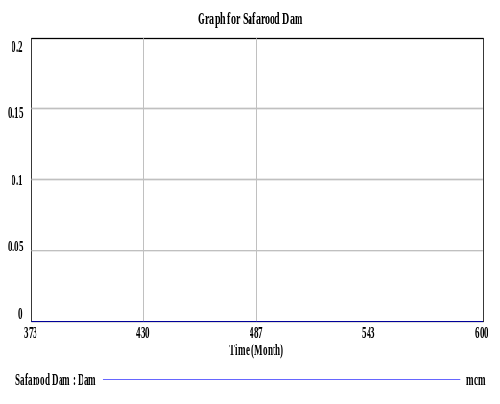 | b | 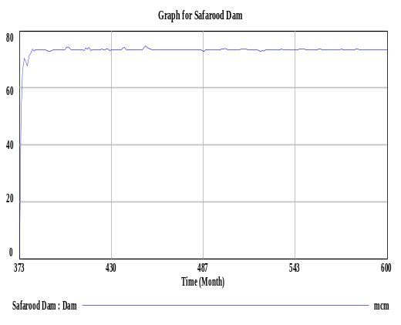 |  |  | e | 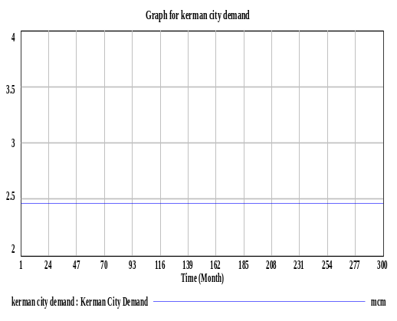
c | 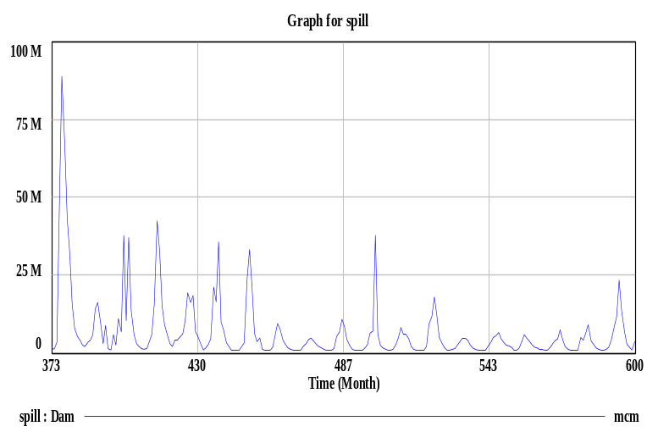 |  |  | d | 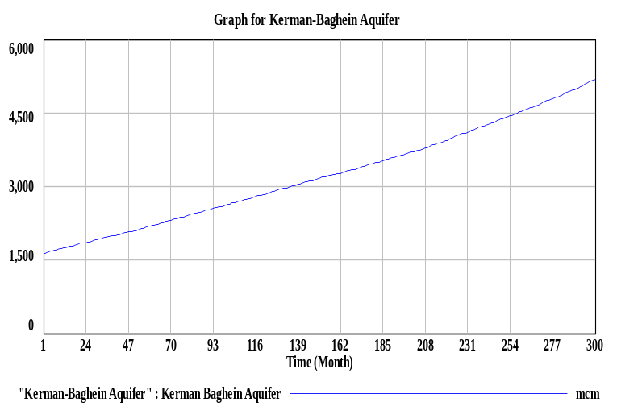
Figure 2: The extreme condition tests for a) the reservoir volume of the Safarood Dam (inflow equal to zero (MCM)), b) the reservoir volume of Safarood Dam (unusual increase in inflow (MCM)), c) overflow (spill) of the Safarood Dam (unusual increase in inflow (MCM)), d) The volume of the Kerman-Baghein Aquifer (in the absence of water demand for Agriculture), e) The volume of domestic water demand variable (population growth rate equal to zero (%))

References
Chai, T., Draxler, R. R. 2014. Root mean square error (RMSE) or mean absolute error (MAE)?–Arguments against avoiding RMSE in the literature, Geoscientific Model Development, 7(3), 1247-1250, https://doi.org/10.5194/gmd-7-1247-2014.
Di Bucchianico, Alessandro, 2008. Coefficient of determination (R2). In: Encyclopedia of Statistics in Quality and Reliability. John Wiley & Sons, Ltd, 9780470061572, pp. 1–2. https://doi.org/10.1002/9780470061572.eqr173.

