Concurrent Warming and Freshening Led to a Record-High Sea Level in the Labrador Sea

Igor Yashayaev¹, Yang Zhang²
¹Bedford Institute of Oceanography, Dartmouth, N.S., Canada.
²School of Marine Science and Policy, University of Delaware, Lewes, Delaware, USA.

Corresponding author: Igor Yashayaev (Igor.Yashayaev@dfo-mpo.gc.ca)

Supplementary Information

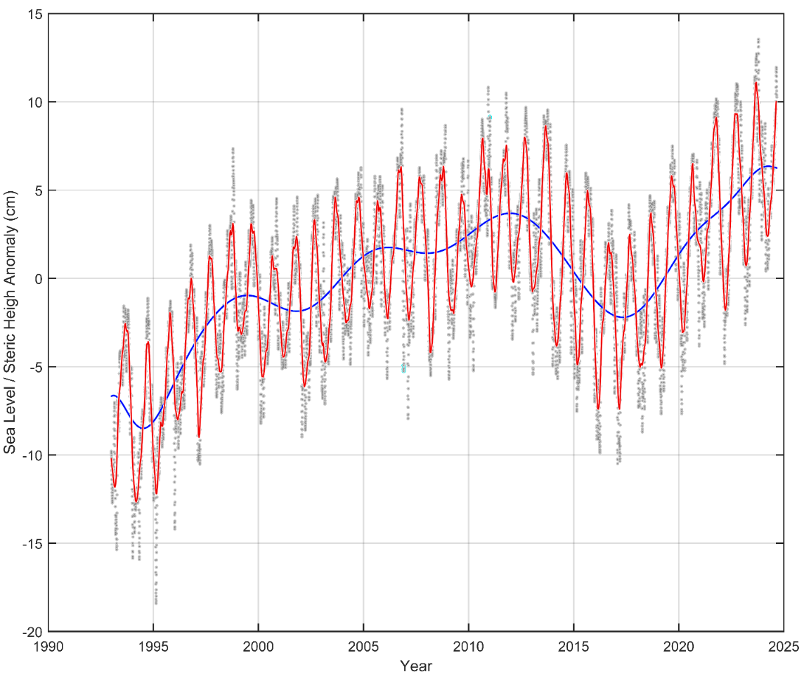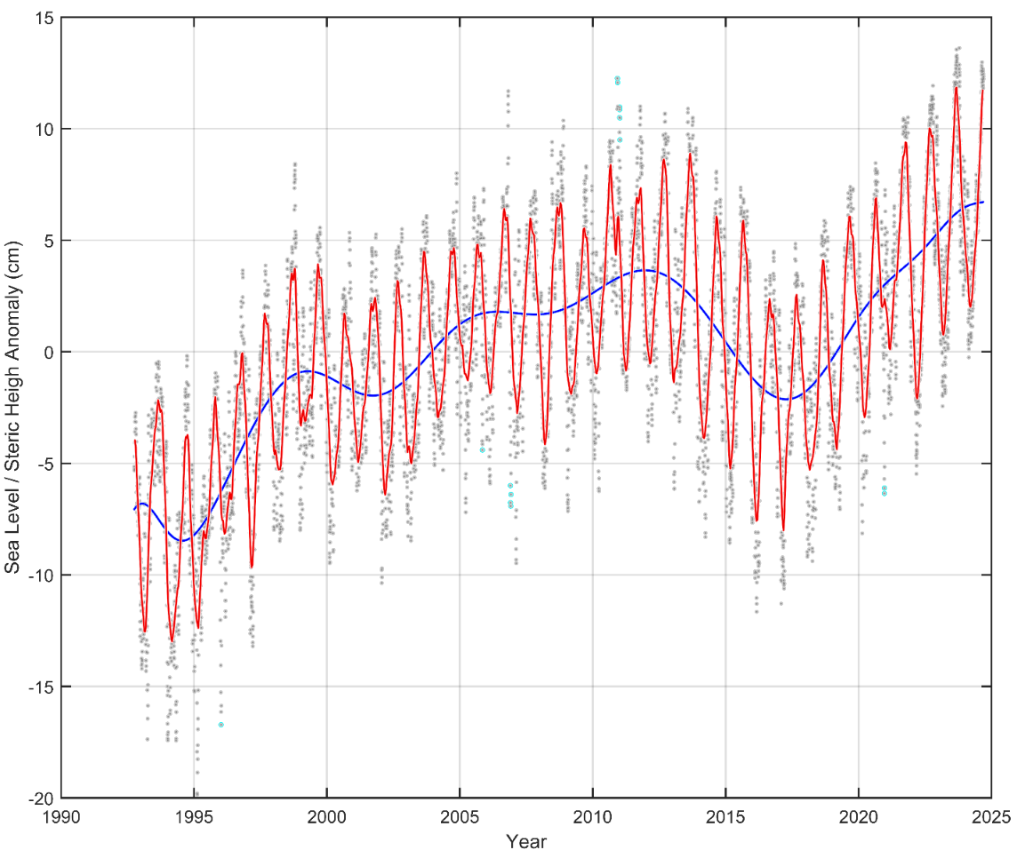

Supplementary Figure 1a. Gridded (upper) and along-track (lower) altimetry-based sea level anomalies (SLA) in the central Labrador Sea (CLS). Blue and red lines represent polynomial fits of deseasoned SLA without and with the regular and irregular seasonal signals.

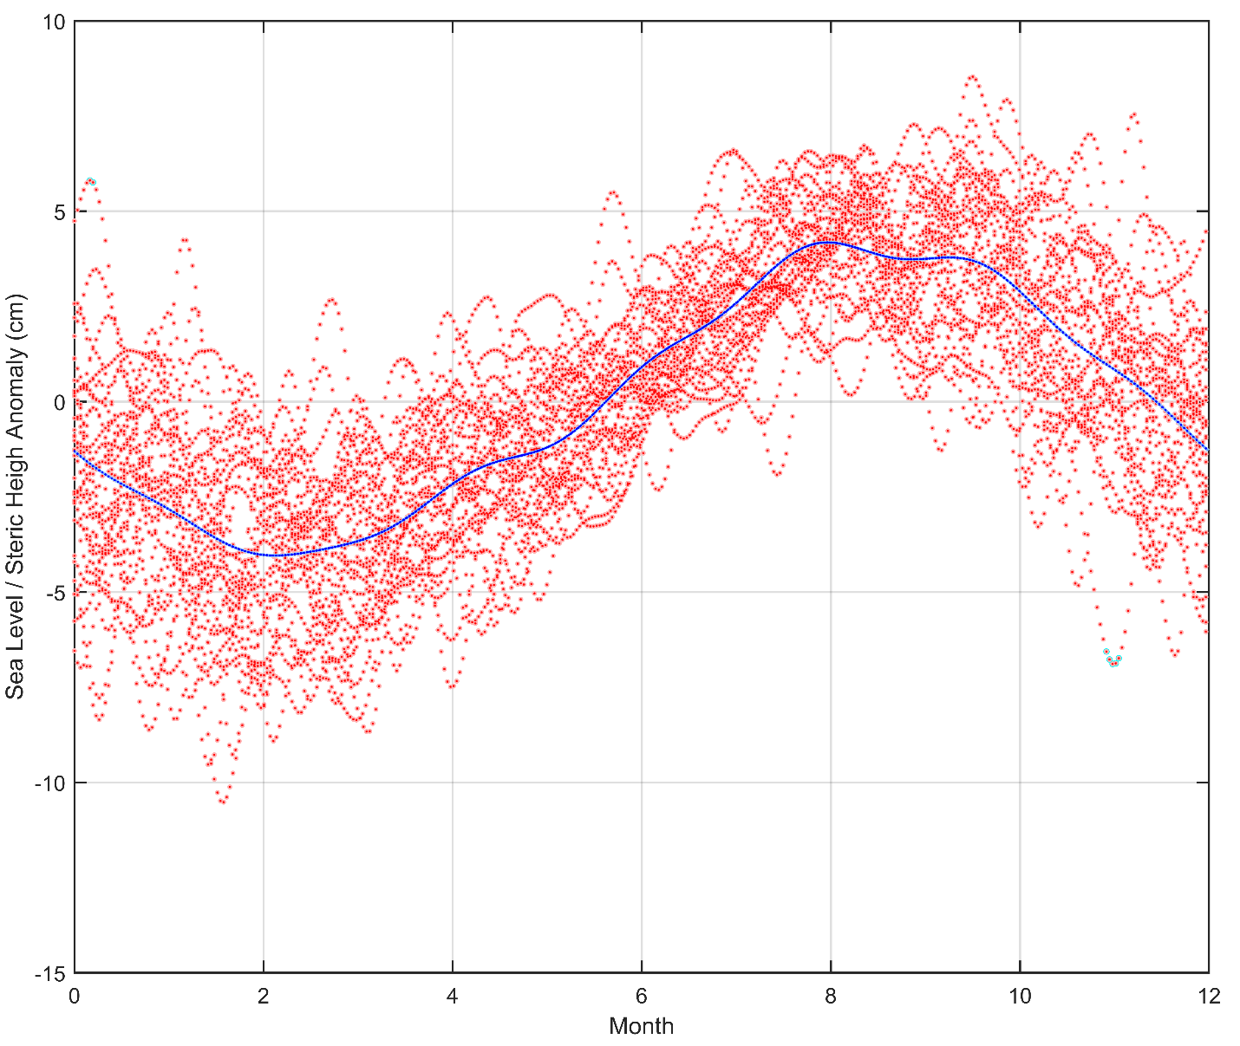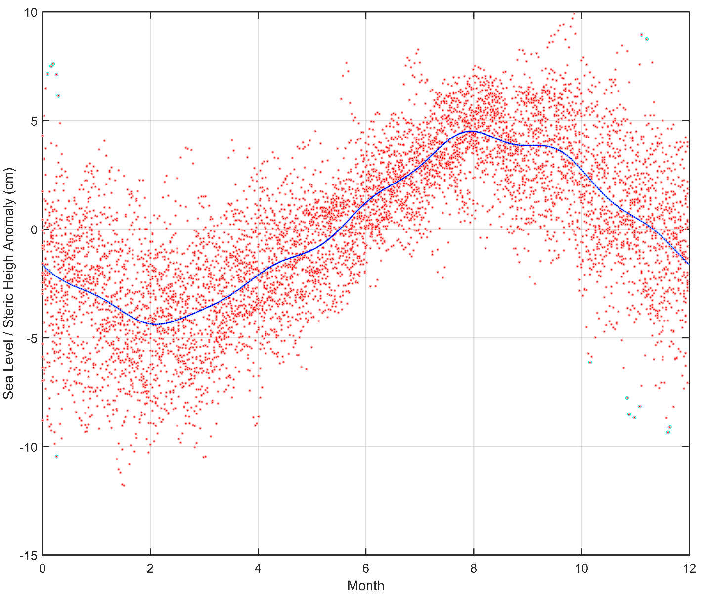

Supplementary Figure 1b. Seasonal cycle of the gridded (upper) and along-track (lower) altimetry-based SLA in the CLS with the polynomial SLA anomaly trend removed from individual data values (red dot clouds). Blue lines represent the regular seasonal cycle.

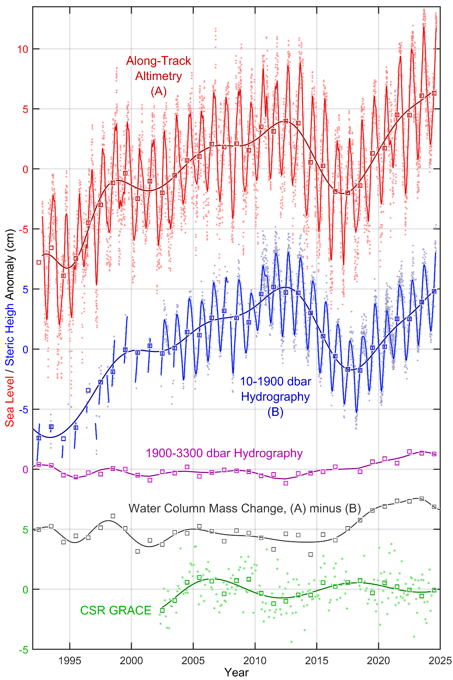

Supplementary Figure 2. Interannual variability of SLA and steric height anomaly (SHA) in the CLS. Top-down (cm): the along-track satellite altimetry-based SLA (red), upper layer (10-1900 dbar) SHA (blue) and deep layer SHA (purple); water column mass change derived by subtracting full-depth SHA from SLA (grey/black); and CSR and GPL GRACE mass change. Squares indicate yearly averaged deviations from the regular seasonal cycles underlined by fits.
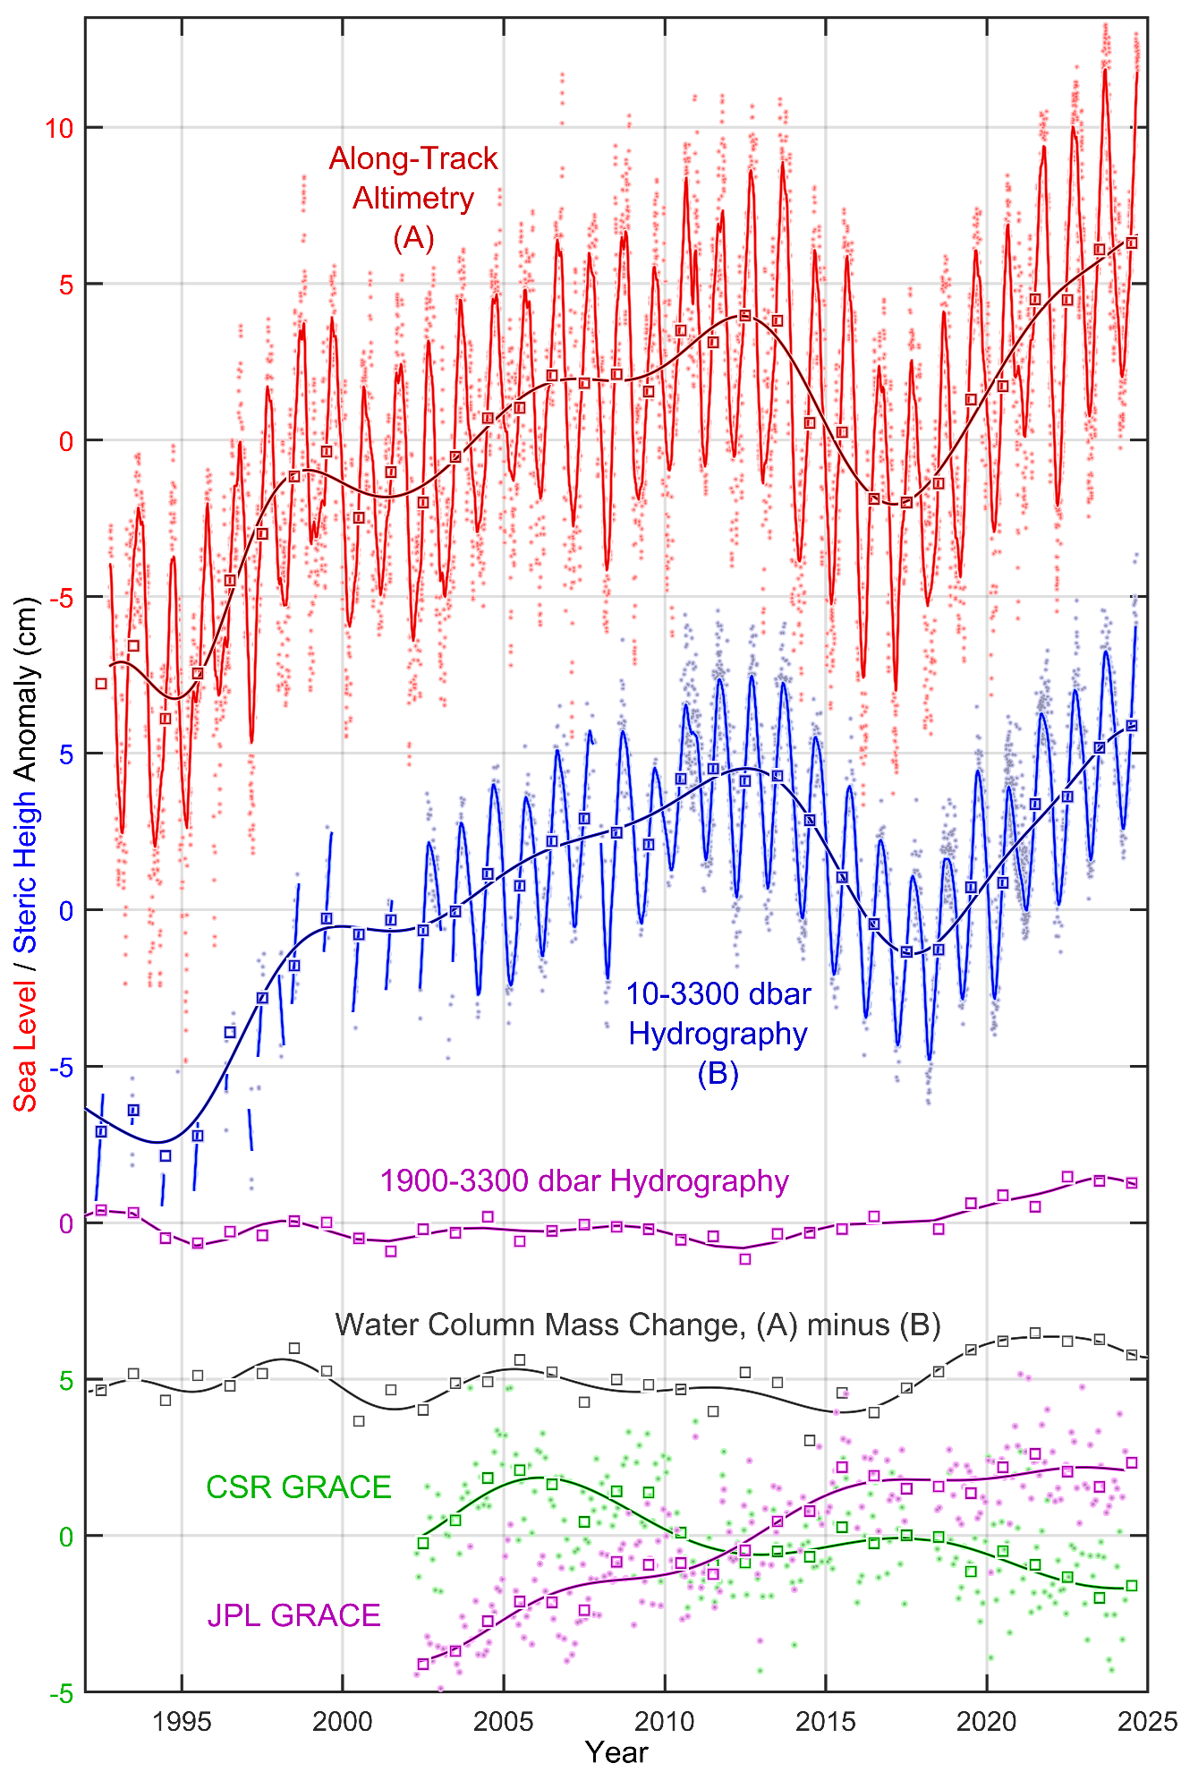

Supplementary Figure 3. Interannual variability of SLA and steric height anomaly (SHA) in the CLS. Top-down (cm): the along-track satellite altimetry-based SLA (red), full-depth SHA (blue) and deep layer SHA (purple); water column mass change derived by subtracting full-depth SHA from SLA (grey/black); and CSR and GPL GRACE mass change. Squares indicate yearly averaged deviations from the respective regular seasonal cycles underlined by optimal fits.

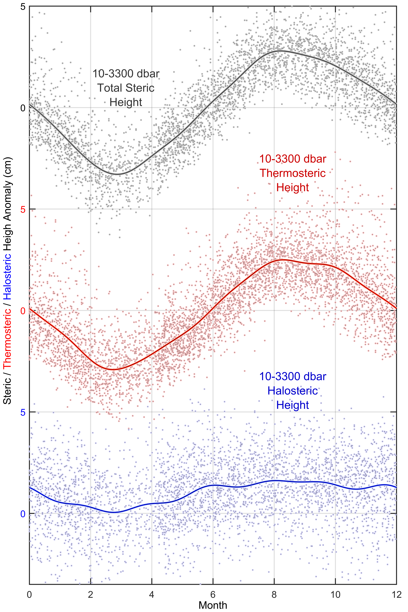

Supplementary Figure 4. Regular seasonal cycles of the CLS steric, thermosteric and halosteric heights. Top-down (cm): upper layer (10-1900 dbar) steric, thermosteric and halosteric seasonal and sub-seasonal changes (dot clouds) and regular seasonal cycles (grey/black, red and blue, respectively).

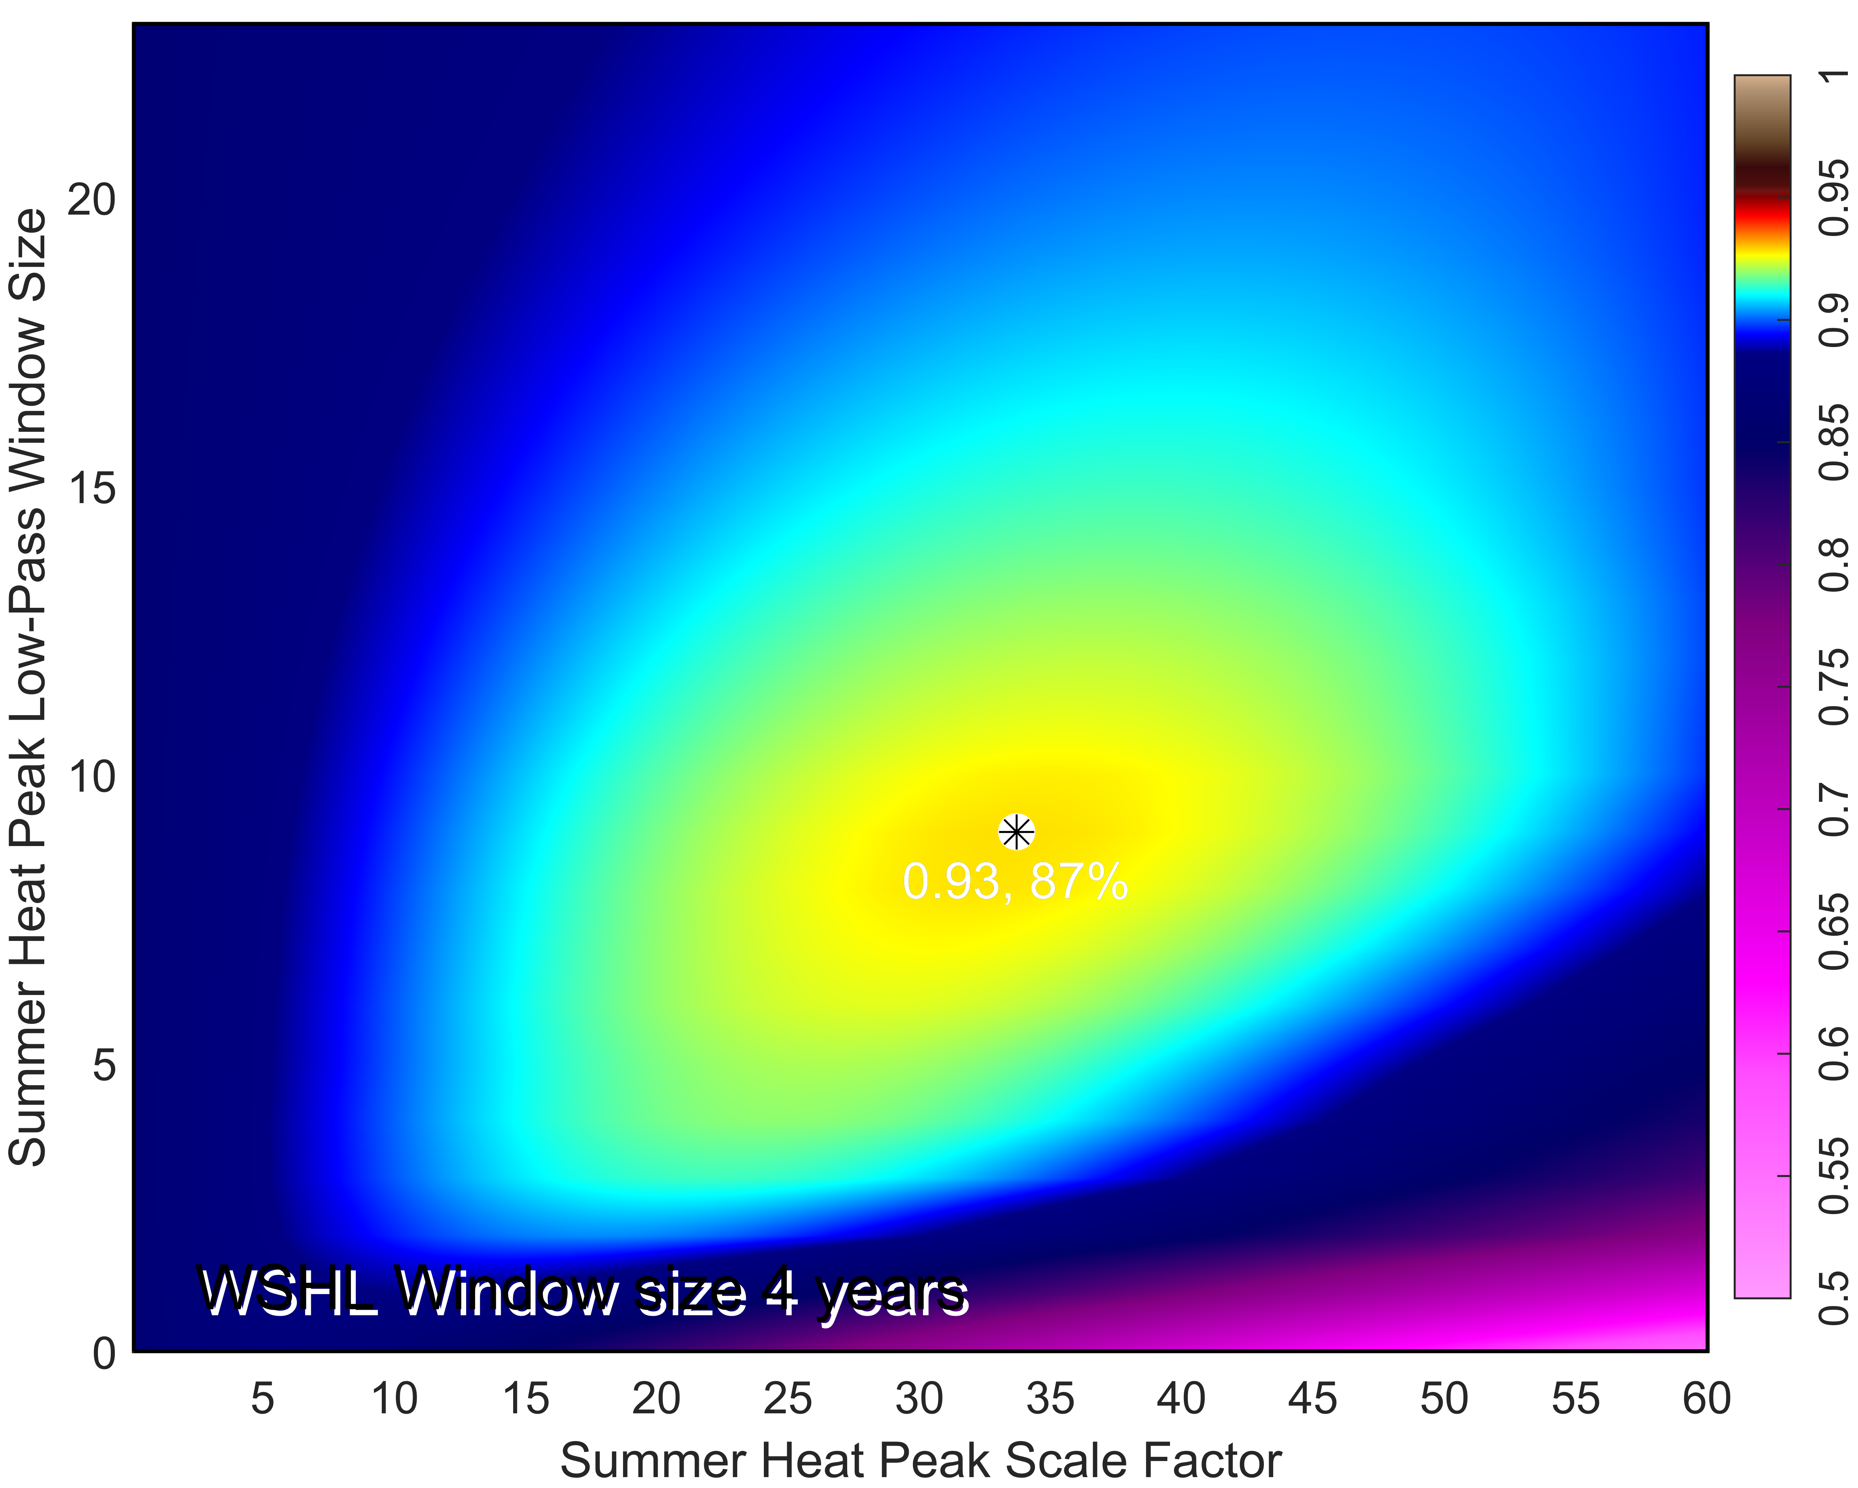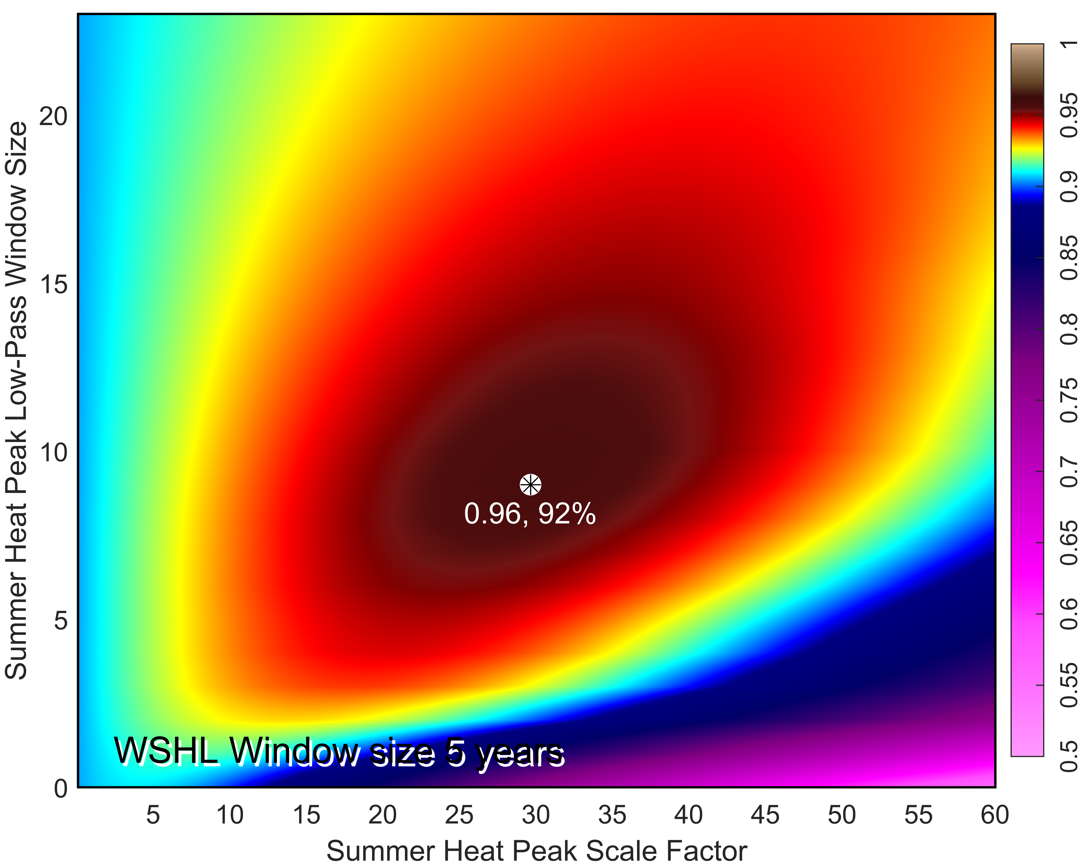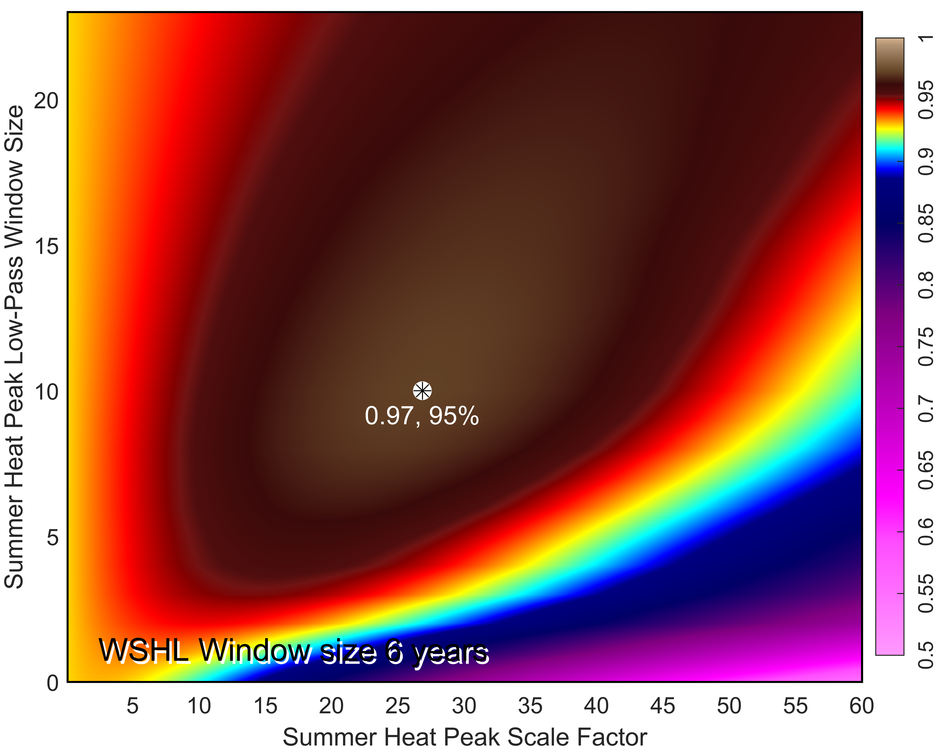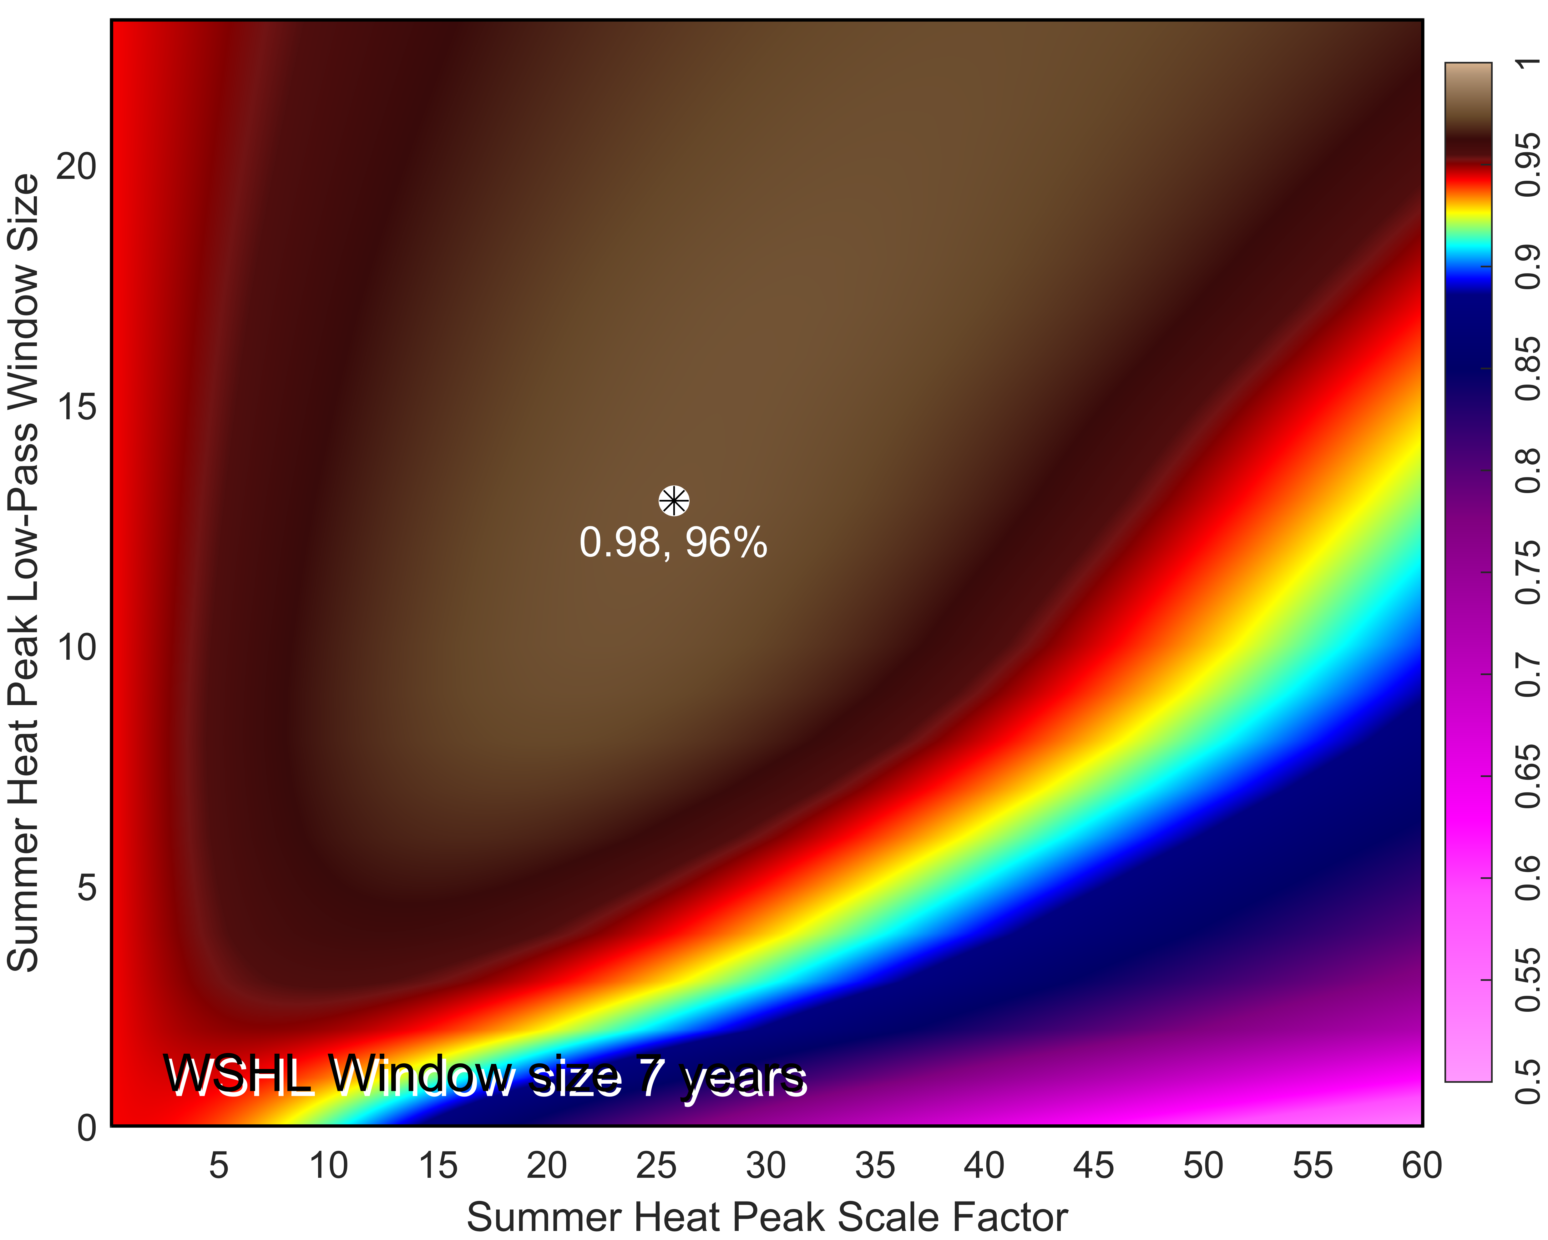

Supplementary Figure 5. Results of four steps of the multistep thermosteric height reconstruction optimization process. Total Winter Surface Heat Loss (WSHL) and total Summer Surface Heat Gain (SSHG), or, alternatively to SSHG, mean Summer Heat Peak (SHP), have been low-pass filtered with independently-varying left-side triangular window sizes forming 625 window-size combinations. The low-pass filtered WSHL and SSHG|SHP have then been added together with SSHG|SHP multiplied by relative weight, labeled here as Summer Heat Peak Scale Factor. Each of the resulting series is correlated with the yearly-averaged thermosteric heights to find the optimal configuration of the input variables. As examples of output from this optimization procedure, we show color-mapped correlation coefficients for 4, 5, 6 and 7 year-long WSHL left-side triangular filter windows. The corresponding correlation (coefficient of determination) peaks are indicated and labeled with the respective correlation and coefficient of determination values. Extensively repeated iterations reveal a distinct unique stable solution of the optimization problem. All tested combinations of WSHL and SSHG|SHP window sizes and Summer Heat Peak Scale Factor converge on a single and strong correlation high representing the best (closest) fit of the yearly-averaged thermosteric height series. The highest correlation is achieved by combining 7 and 13 year low pass filtered WSHL and SHP/SSHG, respectively, after multiplying SHP by ~26. Please note that the results shown in this figure are for SHP. The optimizations with SSHG and SHP-SSHG hybrid yield similar results.

As explained in the main text, unlike SSHG, found by integrating net surface heat flux (NSHF) over entire warming periods of different duration, SHP is computed by averaging NSHF over fixed-length time intervals (e.g., 15, 21, 31 days) centered on annual NSHF highs (peaks). Switching between SSHG and SHP does not really alter the result of the thermosteric reconstructive optimization, although SHP gives slightly higher correlations than SSHG. We assume that even better results can be achieved by adding SSHG and SHP together with different weights and, particularly, by using different spatial domains for computing SSHG and WSHL as SSHG has a much broader spatial signature than WSHL according to our extended results.

