Supplementary materials
Methodological investigations of semi-quantitative ¹H qNMR analysis of potential chemical markers in Danshen’s ethanol precipitation supernatant is displayed in Table S1. The ¹H NMR spectrum was integrated by the deconvolution method using line fitting. The data from 6 times of analysis using a same ethanol precipitation supernatant sample were calculated to evaluate the precision of the instrument. The data from 6 spectra of 6 parallel ethanol precipitation supernatant samples were calculated to evaluate the method repeatability. Within the range of the concentration variation of ethanol precipitation supernatant samples, the concentrated representative supernatant was gradually diluted with H₂O containing 10% D₂O to obtain 5 samples with relative concentration gradients of 1, 2, 4, 8, and 16. The data from these 5 samples were calculated to evaluate the linear relationship of the method and the correlation coefficients (R²) were used to evaluate the linear relationship. Finally, a representative ethanol precipitation supernatant sample was injected at 0, 2, 4, 8, 16, and 24 h respectively at room temperature (≈ 22 ℃) to investigate the stability of the sample.
The indicators of instrument precision, repeatability and sample stability are less than 3.0 %, as well as the determining coefficient of the regressive equation of all the indicators are more than 0.999, indicating that the analysis results of semi-quantitative ¹H NMR are reliable.
Table S1 Methodological investigations of semi-quantitative ¹H NMR analysis of potential chemical markers in Danshen’s ethanol precipitation supernatant
Chemical Markers | Methodology Indicator
Chemical Markers | Instrument precision/  RSD% | Repeatability/  RSD% | Sample stability/  RSD% | Linearity/  R²
Rosmarinic acid | 0.706 | 1.821 | 0.818 | 0.9995
Lithospermic acid | 0.993 | 2.043 | 0.945 | 0.9999
Salvianolic acid A | 0.720 | 1.499 | 0.763 | 0.9998
Salvianolic acid B | 0.499 | 1.982 | 0.320 | 0.9999
Danshensu | 2.023 | 2.790 | 2.938 | 0.9996
Protocatechuic aldehyde | 2.525 | 1.694 | 2.718 | 0.9997
Manninotriose | 2.815 | 1.946 | 2.552 | 0.9992
Stachyose | 0.669 | 2.447 | 0.422 | 0.9997
Sucrose | 0.424 | 2.987 | 0.618 | 0.9995
Fructose | 0.318 | 2.296 | 0.455 | 0.9999
Raffinose | 0.447 | 2.329 | 0.556 | 0.9998
Malonate | 1.461 | 0.797 | 1.000 | 0.9995
Acetate | 1.835 | 0.813 | 1.840 | 0.9997
γ-aminobutyrate | 0.951 | 1.916 | 1.071 | 0.9996

¹³C NMR spectrum (Fig. S1) and two‐dimensional NMR data including HSQC (Fig. S2) and COSY (Fig. S3) spectra were taken for confirmed reference for the metabolite assignments.
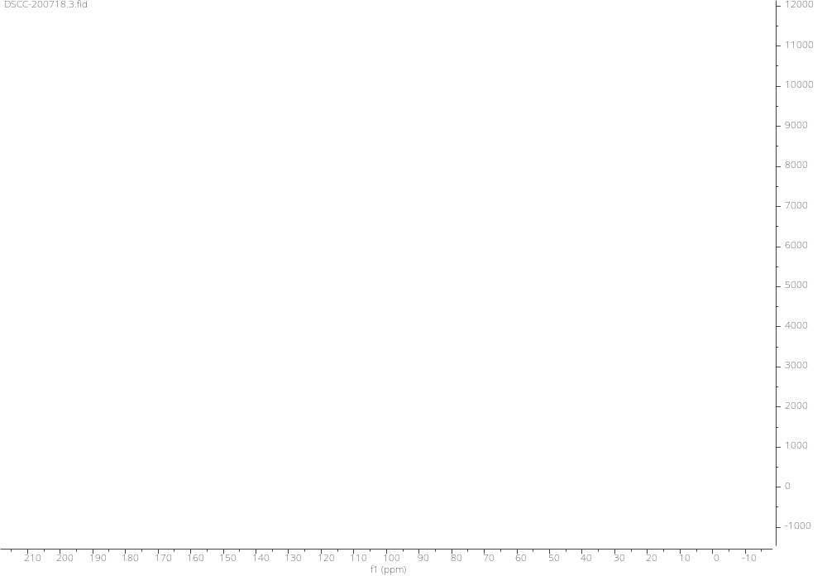
Fig. S1 A representative ¹³C NMR spectrum of Danshen’s ethanol precipitation supernatant
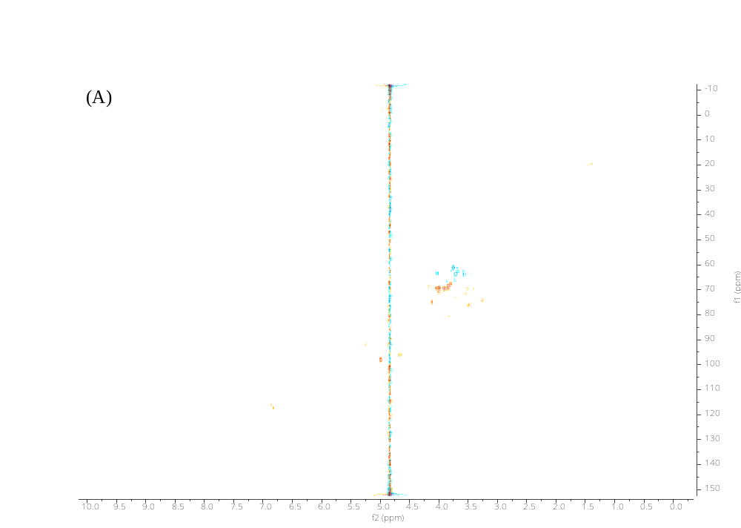
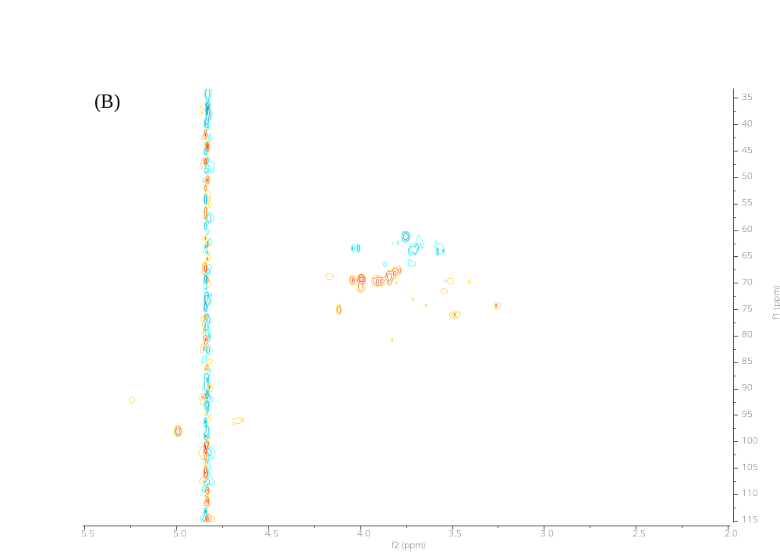
Fig. S2 A) Representative HSQC NMR spectra of Danshen’s ethanol precipitation supernatant; B) Enlarged field of δ 5.50-2.00

Table S2 Retention ratio of the chemical markers of experiments of Danshen’s ethanol precipitation process
Number | γ‐aminobutyrate |  | Pyroglutamate |  | Succinate |  | Acetate |  | Malonate
N1 | 0.7305 |  | 0.8337 |  | 0.6748 |  | 0.5903 |  | 0.8892
N2 | 0.8174 |  | 0.9767 |  | 0.9133 |  | 0.5094 |  | 0.9559
N3 | 0.8701 |  | 0.8484 |  | 0.8770 |  | 0.5132 |  | 0.8994
N4 | 0.3335 |  | 0.3551 |  | 0.4430 |  | 0.3840 |  | 0.6039
N5 | 0.5136 |  | 0.5316 |  | 0.5693 |  | 0.4271 |  | 0.7957
N6 | 0.6919 |  | 0.6425 |  | 0.7093 |  | 0.4314 |  | 0.8861
N7 | 0.2003 |  | 0.2308 |  | 0.3044 |  | 0.1048 |  | 0.4281
N8 | 0.2501 |  | 0.3008 |  | 0.3901 |  | 0.1370 |  | 0.5549
N9 | 0.4156 |  | 0.4505 |  | 0.5105 |  | 0.1902 |  | 0.7428
N10 | 0.7068 |  | 0.7772 |  | 0.7945 |  | 0.4553 |  | 0.7633
N11 | 0.9513 |  | 1.0177 |  | 0.9062 |  | 0.3421 |  | 0.9737
N12 | 0.8406 |  | 0.8644 |  | 0.8648 |  | 0.4028 |  | 0.8448
N13 | 0.3781 |  | 0.4739 |  | 0.4808 |  | 0.1624 |  | 0.7108
N14 | 0.4984 |  | 0.5119 |  | 0.5883 |  | 0.4421 |  | 0.7375
N15 | 0.7937 |  | 0.7960 |  | 0.7444 |  | 0.7737 |  | 0.9455
N16 | 0.2556 |  | 0.2242 |  | 0.3300 |  | 0.2681 |  | 0.5199
N17 | 0.3793 |  | 0.4266 |  | 0.5073 |  | 0.2649 |  | 0.5934
N18 | 0.4694 |  | 0.5440 |  | 0.5575 |  | 0.4849 |  | 0.8281
N19 | 0.8023 |  | 0.8758 |  | 0.8715 |  | 0.3481 |  | 0.8264
N20 | 0.9188 |  | 0.9962 |  | 0.9248 |  | 0.6515 |  | 0.9259
N21 | 0.8131 |  | 0.9209 |  | 0.9423 |  | 0.3025 |  | 0.8043
N22 | 0.4227 |  | 0.4116 |  | 0.4425 |  | 0.4422 |  | 0.6708
N23 | 0.3447 |  | 0.4393 |  | 0.4961 |  | 0.2505 |  | 0.7428
N24 | 0.7272 |  | 0.7419 |  | 0.7162 |  | 0.5410 |  | 0.8900
N25 | 0.4042 |  | 0.4052 |  | 0.4668 |  | 0.1913 |  | 0.6161
N26 | 0.4072 |  | 0.5043 |  | 0.4936 |  | 0.4109 |  | 0.7257
N27 | 0.5331 |  | 0.6169 |  | 0.6090 |  | 0.4255 |  | 0.9257
N28 | 0.6429 |  | 0.6073 |  | 0.5351 |  | 0.2707 |  | 0.7860
N29 | 0.6433 |  | 0.5690 |  | 0.6703 |  | 0.2576 |  | 0.7998
N30 | 0.5811 |  | 0.5716 |  | 0.7051 |  | 0.4754 |  | 0.7636
N31 | 0.2822 |  | 0.3262 |  | 0.3750 |  | 0.1369 |  | 0.5638
N32 | 0.7815 |  | 0.8662 |  | 0.7754 |  | 0.5248 |  | 0.9123
N33 | 0.9897 |  | 0.9640 |  | 0.9635 |  | 0.4510 |  | 0.9763
N34 | 0.3165 |  | 0.3060 |  | 0.4174 |  | 0.2032 |  | 0.6195
N35 | 0.6097 |  | 0.5897 |  | 0.6453 |  | 0.2435 |  | 0.7909
N36 | 0.7930 |  | 0.7616 |  | 0.7638 |  | 0.7404 |  | 0.9143
N37 | 0.8994 |  | 0.8802 |  | 0.9545 |  | 0.7652 |  | 0.8746
N38 | 0.2915 |  | 0.2950 |  | 0.4157 |  | 0.1379 |  | 0.6202
N39 | 0.5931 |  | 0.7170 |  | 0.6305 |  | 0.3015 |  | 0.8574
N40 | 0.6025 |  | 0.5214 |  | 0.6890 |  | 0.2634 |  | 0.7814
Number | Fructose |  | Sucrose |  | Raffinose |  | Stachyose |  | Mannotriose
N1 | 0.8059 |  | 0.8409 |  | 0.9002 |  | 0.6304 |  | 0.5956
N2 | 0.8130 |  | 0.8765 |  | 0.8536 |  | 0.8498 |  | 0.7698
N3 | 0.9057 |  | 0.8919 |  | 0.8694 |  | 0.9676 |  | 0.9281
N4 | 0.5227 |  | 0.5250 |  | 0.2967 |  | 0.2033 |  | 0.1755
N5 | 0.7457 |  | 0.6602 |  | 0.5919 |  | 0.3175 |  | 0.2505
N6 | 0.7651 |  | 0.8169 |  | 0.6039 |  | 0.5110 |  | 0.4710
N7 | 0.3023 |  | 0.2714 |  | 0.0820 |  | 0.0300 |  | 0.0399
N8 | 0.4327 |  | 0.3876 |  | 0.1639 |  | 0.0600 |  | 0.0792
N9 | 0.5872 |  | 0.5669 |  | 0.2685 |  | 0.1368 |  | 0.1398
N10 | 0.7435 |  | 0.7955 |  | 0.6669 |  | 0.6250 |  | 0.5596
N11 | 0.9776 |  | 1.0044 |  | 0.8316 |  | 0.9652 |  | 0.9122
N12 | 0.8195 |  | 0.9892 |  | 0.7796 |  | 0.9918 |  | 0.7089
N13 | 0.5731 |  | 0.5670 |  | 0.2748 |  | 0.1979 |  | 0.1738
N14 | 0.6863 |  | 0.6131 |  | 0.4685 |  | 0.3797 |  | 0.2854
N15 | 0.8420 |  | 0.8775 |  | 0.7786 |  | 0.6193 |  | 0.5150
N16 | 0.3986 |  | 0.3483 |  | 0.1541 |  | 0.0779 |  | 0.0787
N17 | 0.5779 |  | 0.5369 |  | 0.2403 |  | 0.1072 |  | 0.1127
N18 | 0.7873 |  | 0.6908 |  | 0.3016 |  | 0.1840 |  | 0.1815
N19 | 0.8817 |  | 0.8262 |  | 0.8335 |  | 0.7841 |  | 0.6729
N20 | 0.9292 |  | 1.0070 |  | 0.8750 |  | 0.9787 |  | 0.8129
N21 | 0.9349 |  | 0.9816 |  | 0.8585 |  | 1.0067 |  | 0.9148
N22 | 0.6130 |  | 0.5676 |  | 0.2871 |  | 0.2486 |  | 0.2262
N23 | 0.5864 |  | 0.5572 |  | 0.2179 |  | 0.0922 |  | 0.0968
N24 | 0.8454 |  | 0.9095 |  | 0.6903 |  | 0.6358 |  | 0.5329
N25 | 0.5730 |  | 0.5257 |  | 0.2357 |  | 0.1786 |  | 0.1357
N26 | 0.6120 |  | 0.5932 |  | 0.3090 |  | 0.1601 |  | 0.1437
N27 | 0.7761 |  | 0.7420 |  | 0.4004 |  | 0.2263 |  | 0.2061
N28 | 0.7314 |  | 0.7290 |  | 0.5079 |  | 0.4011 |  | 0.2949
N29 | 0.7300 |  | 0.7515 |  | 0.4974 |  | 0.4183 |  | 0.3527
N30 | 0.7201 |  | 0.7346 |  | 0.4865 |  | 0.3870 |  | 0.3405
N31 | 0.4474 |  | 0.4080 |  | 0.1766 |  | 0.1189 |  | 0.1011
N32 | 0.9494 |  | 0.9157 |  | 0.6680 |  | 0.6207 |  | 0.4972
N33 | 0.9650 |  | 0.9864 |  | 0.8980 |  | 0.9743 |  | 0.7935
N34 | 0.4752 |  | 0.4345 |  | 0.1907 |  | 0.0607 |  | 0.0639
N35 | 0.7120 |  | 0.7288 |  | 0.4851 |  | 0.4121 |  | 0.3917
N36 | 0.8632 |  | 0.8656 |  | 0.5968 |  | 0.6778 |  | 0.5307
N37 | 0.9439 |  | 0.9691 |  | 0.8524 |  | 0.9563 |  | 0.8012
N38 | 0.4076 |  | 0.3579 |  | 0.1147 |  | 0.0299 |  | 0.0505
N39 | 0.7548 |  | 0.7389 |  | 0.4960 |  | 0.4119 |  | 0.3021
N40 | 0.7130 |  | 0.7297 |  | 0.4618 |  | 0.3768 |  | 0.3539
Number | DSS | LA |  | PA |  | RA |  | SaB |  | SaA
N1 | 0.9433 | 0.7096 |  | 0.9484 |  | 0.8555 |  | 0.7726 |  | 0.7871
N2 | 1.0542 | 0.7365 |  | 0.7410 |  | 0.8493 |  | 0.8254 |  | 0.7601
N3 | 1.1201 | 0.8035 |  | 0.8297 |  | 0.8489 |  | 0.8483 |  | 0.7474
N4 | 0.6024 | 0.6368 |  | 0.7889 |  | 0.6870 |  | 0.5338 |  | 0.6560
N5 | 0.7799 | 0.5741 |  | 0.8514 |  | 0.8129 |  | 0.6562 |  | 0.7159
N6 | 0.9611 | 0.7442 |  | 0.8951 |  | 0.8546 |  | 0.7667 |  | 0.7273
N7 | 0.3205 | 0.2359 |  | 0.8293 |  | 0.5900 |  | 0.3011 |  | 0.5488
N8 | 0.4799 | 0.3243 |  | 0.7110 |  | 0.6676 |  | 0.4145 |  | 0.5989
N9 | 0.6627 | 0.6524 |  | 0.8252 |  | 0.7947 |  | 0.5667 |  | 0.6998
N10 | 0.9146 | 0.6531 |  | 0.7454 |  | 0.7556 |  | 0.7087 |  | 0.6654
N11 | 1.3413 | 0.9263 |  | 0.9351 |  | 1.0322 |  | 0.9680 |  | 0.8053
N12 | 1.1524 | 0.8231 |  | 0.8339 |  | 0.8573 |  | 0.8700 |  | 0.6639
N13 | 0.6637 | 0.5240 |  | 0.9267 |  | 0.7595 |  | 0.5604 |  | 0.6392
N14 | 0.8247 | 0.7252 |  | 0.9064 |  | 0.8246 |  | 0.6988 |  | 0.6693
N15 | 0.9735 | 0.7579 |  | 0.9624 |  | 0.8908 |  | 0.8275 |  | 0.6993
N16 | 0.4897 | 0.3556 |  | 0.9374 |  | 0.7165 |  | 0.4463 |  | 0.6236
N17 | 0.6219 | 0.4778 |  | 0.8763 |  | 0.8000 |  | 0.5352 |  | 0.6797
N18 | 0.7134 | 0.5111 |  | 0.9271 |  | 0.8219 |  | 0.6196 |  | 0.6021
N19 | 1.1142 | 0.7724 |  | 0.8717 |  | 0.8313 |  | 0.8116 |  | 0.7038
N20 | 1.1179 | 0.8046 |  | 0.8792 |  | 0.8407 |  | 0.8483 |  | 0.6693
N21 | 1.1509 | 0.8290 |  | 0.7685 |  | 0.8633 |  | 0.8643 |  | 0.5855
N22 | 0.6898 | 0.6238 |  | 0.8880 |  | 0.8135 |  | 0.5965 |  | 0.6083
N23 | 0.6231 | 0.4456 |  | 0.9773 |  | 0.8048 |  | 0.5455 |  | 0.6539
N24 | 1.0246 | 0.7605 |  | 0.8962 |  | 0.8844 |  | 0.8358 |  | 0.6201
N25 | 0.5745 | 0.4578 |  | 0.8848 |  | 0.7313 |  | 0.5381 |  | 0.5683
N26 | 0.6768 | 0.4833 |  | 0.8826 |  | 0.7750 |  | 0.5826 |  | 0.5925
N27 | 0.8457 | 0.6093 |  | 0.9652 |  | 0.9161 |  | 0.7181 |  | 0.6655
N28 | 0.8418 | 0.6364 |  | 0.9236 |  | 0.8421 |  | 0.7175 |  | 0.6298
N29 | 0.8659 | 0.6583 |  | 0.9463 |  | 0.8553 |  | 0.7254 |  | 0.5921
N30 | 0.8388 | 0.6247 |  | 0.9098 |  | 0.8260 |  | 0.7081 |  | 0.6226
N31 | 0.5227 | 0.3911 |  | 0.7703 |  | 0.7072 |  | 0.4676 |  | 0.5712
N32 | 1.0263 | 0.7632 |  | 0.9015 |  | 0.9767 |  | 0.8367 |  | 0.6323
N33 | 1.1520 | 0.8388 |  | 0.9389 |  | 0.8789 |  | 0.8687 |  | 0.6498
N34 | 0.5369 | 0.3629 |  | 0.9051 |  | 0.7365 |  | 0.4598 |  | 0.5993
N35 | 0.8453 | 0.6398 |  | 0.9118 |  | 0.8416 |  | 0.7140 |  | 0.6438
N36 | 1.0583 | 0.7855 |  | 0.9015 |  | 0.8826 |  | 0.8533 |  | 0.5764
N37 | 1.1474 | 0.8185 |  | 0.8692 |  | 0.8566 |  | 0.8479 |  | 0.6665
N38 | 0.4122 | 0.3016 |  | 0.8695 |  | 0.6800 |  | 0.3960 |  | 0.5218
N39 | 0.8521 | 0.6482 |  | 0.9359 |  | 0.8488 |  | 0.7244 |  | 0.6354
N40 | 0.8361 | 0.6257 |  | 0.9174 |  | 0.8392 |  | 0.7097 |  | 0.6112

