Supplementary material
1. Supplementary methods
1.1 Macrofossil analysis
Plant macrofossils were analysed at 4 cm intervals along each peat core to reconstruct vegetation dynamics since peat initiation. Subsamples of 4 cm³ were gently boiled in a 5% KOH solution before being washed through a 125 µm mesh sieve, following the protocol of Mauquoy et al. (2010). Macrofossils were analysed in a gridded Petri dish under a stereomicroscope (10-40 × magnification), using Lévesque et al. (1988) and Mauquoy and van Geel (2007) for plant identification. In addition to estimates of the relative abundances of the main peat components, the degree of plant material decomposition was also determined visually using an index ranging from 1 (poorly decomposed) to 5 (highly decomposed).

1.2 Testate amoeba analysis
In order to reconstruct past hydrological conditions, testate amoeba assemblages were analysed at 1 cm intervals along the cores. Testate amoeba shells were extracted from 1 cm³ peat subsamples following the standard protocol of Booth et al. (2010). Subsamples were gently boiled in distilled water and washed through 300 and 15 µm sieves. The material remaining in the 15 μm mesh was stained and mounted on glass slides before being analysed under an optical microscope (400× magnification). Testate amoebae were identified following the taxonomy of Mitchell (2002), Siemensma (2018), and Charman et al. (2000), with the modifications of Booth and Sullivan (2007).

The dataset of the transfer function used to reconstruct WTD variations (Lamarre et al. 2013) was improved by adding 40 surface samples collected along the study transect, and 40 others sampled in another forested peatland in the study area. Peat surface samples of approximately 10 cm³ were cut with a serrated knife, following the method described in Lamarre et al. (2013). Samples were collected in lawns and hummocks, as these are the only microforms found in our sites.

1.3 Isotopic analysis of tree rings
Black spruce ecophysiological response to rising ambient CO₂ concentration and climate variability was evaluated through δ¹³C and δ¹⁸O analyses. These analyses were performed on cross-sections from five trees per site. For each selected cross-section, two wood strips of 3 X 10 mm were cut and finely sanded on all sides. A five-year resolution covering a 100 year period (1919-2018) was considered. After having carefully cross-dated the wood strips, tree rings were cut with a razor blade under a binocular microscope. Rings of the same years were pooled together in equal amounts, resulting in 20 subsamples of five years per site, which were then grinded using a mixer mill (Retsch MM400) to ensure homogeneity (Borella et al. 1998). Alpha-cellulose was then extracted as suggested for black spruce samples (Bégin et al. 2015) following the protocol used by Naulier et al. (2014).

All isotopic analyses were carried out at the Light stable isotope geochemistry laboratory of the GEOTOP Research Center (Université du Québec à Montréal, Canada). Stable isotope ratios of carbon and oxygen were analyzed with an isotope ratio mass spectrometer (Isoprime 100 for δ¹³C and Isoprime VisIon for δ¹⁸O) coupled to an elemental analyser (Elementar Vario MicroCube for δ¹³C and Elementar Vario PyroCube for δ¹⁸O) in continuous flow mode. Results were normalized with three internal standards on NBS19-LSVEC and VSMOW-SLAP scales for δ¹³C and δ¹⁸O respectively. Results are reported in ‰ (± 0.1‰ for δ¹³C and ± 0.3‰ for δ¹⁸O) relative to VPDB for carbon isotopic ratios and to VSMOW for oxygen isotopic ratios. Because of the high combustion of ¹³C-depleted fossil fuels since the industrial period (~1850), atmospheric ¹³CO₂ concentration is significantly decreasing, which causes a declining trend in tree ring δ¹³C values. This Suess effect was therefore corrected as proposed by McCarroll and Loader (2004).

2. Supplementary figures
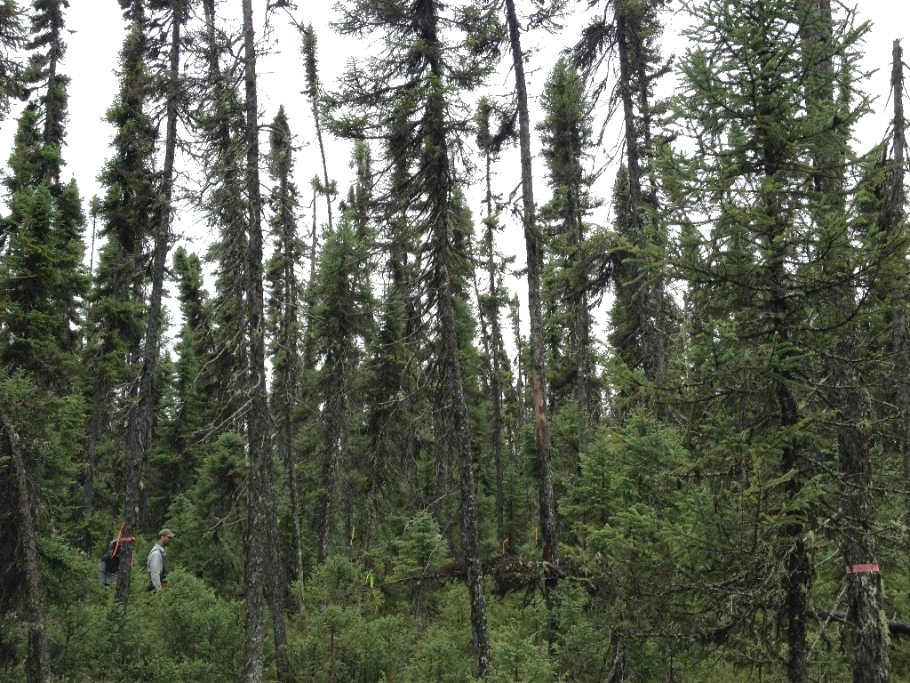
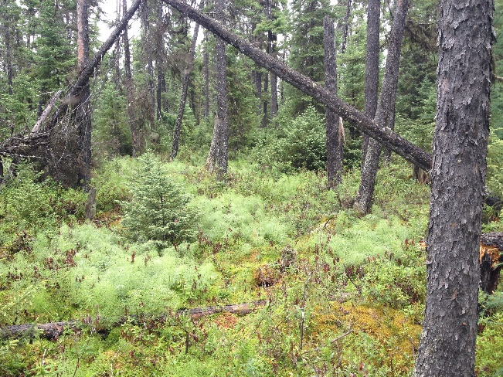
Figure S2.1. Photographs of the Casa forested peatland showing sites CAS100 (top) and CAS0 (bottom).

Figure S2.2. Plant macrofossil diagrams of three peat cores analysed. Data are presented in percentages (silhouettes) and in counts (bars, except for charcoals). The main peat components (%) are shown in the left column: Sphagnum (green), non-Sphagnum mosses (black), ligneous material (brown), Pteridophyte (orange), and Cyperaceae (white). The visual decay index, the dry density of peat, and the water table depth (WTD) reconstructions from testate amoeba assemblages (see figure S2.3) are also presented in the right columns.
Figure S2.3. Testate amoeba diagrams. Diagrams show the abundance (%) of the dominant taxa in the three peat cores analysed. The water table depth (WTD) values inferred from testate amoeba records are presented in the right column (high values indicate dry conditions). Blanks in WTD reconstructions are due to exceptionally low test concentrations in some horizons, where the minimum count (20 tests) was not reach. The main peat components (%) are shown in the left column: Sphagnum (green), non-Sphagnum mosses (black), ligneous material (brown), Pteridophyte (orange), and Cyperaceae (white).
Figure S2.4. Basal area increment distribution between the 25th and the 75th quantiles. Sites CAS0, CAS50, and CAS100 are shown in black, red, and blue respectively. The solid line represents the mean annual values of each site.
Figure S2.5. Raw tree-ring-width series and standardized ring-width series. Sites CAS0, CAS50, and CAS100 are shown in black, red, and blue respectively.
Figure S2.6. March to September climate trends in the study area for the period 1950-2013. (a) precipitation, (b) temperature, and (c) growing degree days (>0°C). Linear trends are shown by dotted lines. Data were extracted from McKenney et al. (2011).

Table S2.1. Radiocarbon (¹⁴C) dates.
Core | Depth (cm) | Laboratory number | Material dated | Radiocarbon age ± error  (¹⁴C yr BP) | Calibrated age range  (cal yr BP) | Median age  (cal yr BP)
CAS0 | 26-27 | UOC-9614 | Charcoal, charred needles | 158±29 | 0-285 | 175
 | 38-39 | UOC-8508 | Bulk peat | 1314±32 | 1182-1296 | 1255
CAS50 | 26-27 | UOC-9615 | Charcoal, charred needles | 171±29 | 0-290 | 179
 | 33-34 | UOC-8509 | Charcoal, charred needles | 1264±24 | 1175-1281 | 1224
 | 56-57 | UOC-9617 | Sphagnum stems | 6610±29 | 7440-7565 | 7502
 | 69-70 | UOC-9616 | Bulk peat | 6838±29 | 7610-7724 | 7667
CAS100 | 28-29 | UOC-8512 | Charcoal, charred needles | 154±24 | 35-284 | 178
 | 44-45 | UOC-8513 | Picea needles, Sphagnum stems | 4691±31 | 5320-5577 | 5397
 | 52-53 | UOC-8514 | Picea needles, Sphagnum stems | 5469±38 | 6190-6386 | 6274
 | 72-73 | UOC-8515 | Picea and Larix needles | 6466±34 | 7311-7436 | 7374
 | 95-96 | UOC-6053 | Bulk peat | 6635±41 | 7441-7578 | 7522

3. Supplementary references
Bégin C, Gingras M, Savard MM, Marion J, Nicault A, Bégin Y (2015) Assessing tree-ring carbon and oxygen stable isotopes for climate reconstruction in the Canadian northeastern boreal forest. Palaeogeogr Palaeoclimatol Palaeoecol 423:91-101.
Booth RK, Lamentowicz M, Charman DJ (2010) Preparation and analysis of testate amoebae in peatland palaeoenvironmental studies. Mires Peat 7:1-7.
Booth RK, Sullivan M (2007) Key to testate amoebae inhabiting Sphagnum-dominated peatlands with an emphasis on taxa preserved in Holocene sediments. Earth and Environmental Science Department, Lehigh University, Bethlehem.
Borella S, Leuenberger M, Saurer M, Siegwolf R (1998) Reducing uncertainties in δ¹³C analysis of tree rings: pooling, milling and cellulose extraction. J Geophys Res 103:19519-19526.
Charman DJ, Hendon D, Woodland WA (2000) The identification of Testate Amoebae (Protozoa: Rhizopoda) in peats, Technical Guide No. 9. Quaternary Research Association, London.
Lamarre A, Magnan G, Garneau M, Boucher É (2013) A testate amoeba-based transfer function for paleohydrological reconstruction from boreal and subarctic peatlands in northeastern Canada. Quat Int 306:88-96.
Lévesque PEM, Dinel H, Larouche A (1988) Guide illustré des macrofossiles végétaux des tourbières du Canada. Agriculture du Canada, Direction générale de la recherche. Publication no. 1817.
Mauquoy D, Hughes PDM, van Geel B (2010) A protocol for plant macrofossil analysis of peat deposits. Mires Peat 7:1-5.
Mauquoy D, van Geel B (2007) Plant macrofossil methods and studies: Mire and peat macros. In SA Elias (Ed.) Encyclopedia of Quaternary Science. Elsevier Science, Amsterdam.
McCarroll D, Loader NJ (2004) Stable isotopes in tree rings. Quat Sci Rev 23:771-801.
McKenney DW, Hutchinson MF, Papadopol P, Lawrence K, Pedlar J, Campbell K, … Owen T (2011) Customized spatial climate models for North America. Bull Am Meteorol Soc December 1612-1622.
Mitchell EAD (2002) The identification of Centropyxis, Cyclopyxis, Trigonopyxis and similar Phryganella species living in Sphagnum. Available online at http://istar.wikidot.com/id-keys.
Naulier N, Savard MM, Bégin C, Marion J, Arseneault D, Bégin Y (2014) Carbon and oxygen isotopes of lakeshore black spruce trees in northeastern Canada as proxies for climatic reconstruction. Chem Geol 374-375:7-43.
Siemensma F (2018) Microworld – World of amoeboid organisms. Available online at http://www.arcella.nl/.

