Survey Questionnaire on the Evaluation System for Optimizing the Location Selection of Township Health Centers Based on the Analytic Hierarchy Process
Dear Expert:
Greetings!
Our research group is currently conducting a study on the optimization of site selection for township health centers. To gain deeper insights into this field, we sincerely invite you to evaluate the weights of various influencing factors in the site selection system and provide your valuable suggestions for further optimizing this evaluation system. Your professional input will greatly contribute to the progress and quality of our research.
Before proceeding with the questionnaire, we kindly ask you to provide some basic personal information for statistical purposes. Please rest assured that all information collected in this questionnaire will be used solely for academic purposes, and your personal information will be kept strictly confidential and will not be disclosed.
We appreciate your cooperation and support in this study. Thank you for your time and contribution!

Name__________ Gender______ Age______ Position___________Title________________
1.Introduction to the Questionnaire Content
This survey aims to identify site selection criteria for township health centers, forming quantitative standards to serve as a reference for site selection and establishing a theoretical foundation for the location of these centers. The primary purpose of this study is to provide a more scientific basis for the location of newly built or renovated health centers, ensuring they meet the centers' developmental needs while also improving convenience for residents seeking medical care.
Please rate the following evaluation criteria based on their importance in the provided tables. Each criterion to be rated is listed on the left side of the value items, as shown in Fig. 1, where the grey-filled indicators highlight the criteria. Each indicator is scored out of 100 points, with higher scores indicating a greater impact on the site selection of township health centers. Scores of 90–100 points indicate "extremely important," 80–90 points "very important," 70–80 points "fairly important," 60–70 points "important," 50–60 points "slightly important," and below 50 points "not very important" or lower.
Fig. 1. Indicator Filling Guide
Standard Level Score Sub-standard Level Score | Standard Level Score Sub-standard Level Score | Standard Level Score Sub-standard Level Score
A1 | B1 | 100
A1 | B2 | 80
A1 | B3 | 92

- Research Framework Diagram
This study uses the Analytic Hierarchy Process (AHP) to summarize the factors influencing location selection. The research framework diagram is shown below.
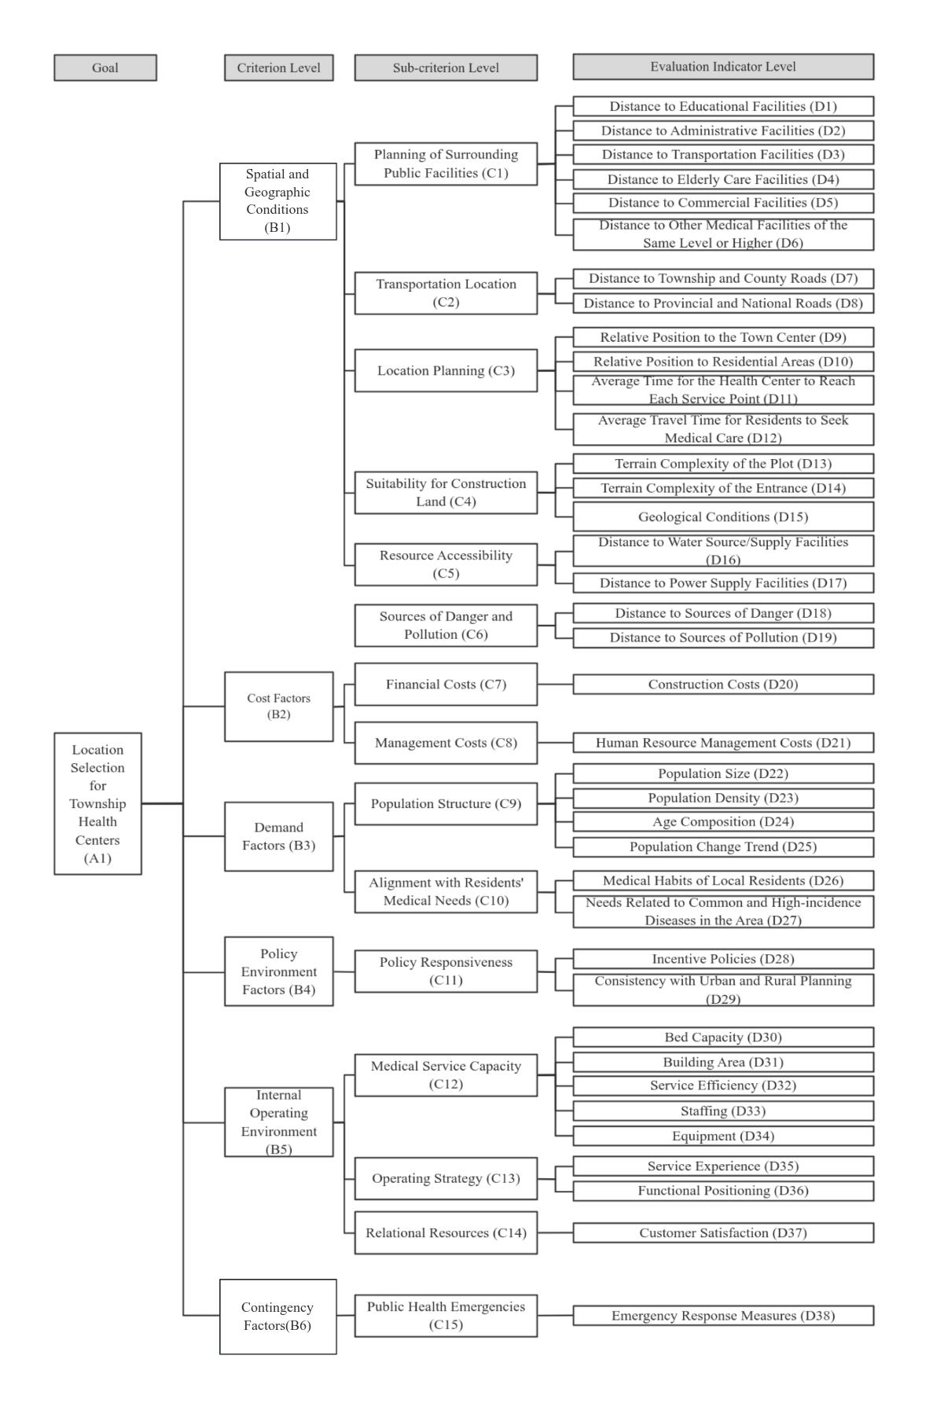

- Questionnaire Survey Section
①Factor Level
Fig. 2. Evaluation Table of Standards and Sub-standards for the Location Selection of Township Health Centers
Standard Level Score Sub-standard Level Score | Standard Level Score Sub-standard Level Score | Standard Level Score Sub-standard Level Score | Standard Level Score Sub-standard Level Score
Location and Geographic Conditions |  | Planning of Surrounding Public Facilities
Location and Geographic Conditions |  | Transportation Location
Location and Geographic Conditions |  | Location Planning
Location and Geographic Conditions |  | Suitability for Construction Land
Location and Geographic Conditions |  | Resource Accessibility
Location and Geographic Conditions |  | Sources of Danger and Pollution
Cost Factors |  | Financial Costs
Cost Factors |  | Management Costs
Demand Factors |  | Population Structure
Demand Factors |  | Alignment with Residents' Medical Needs
Policy Environment Factors |  | Policy Responsiveness
Internal Operating Environment |  | Medical Service Capacity
Internal Operating Environment |  | Operating Strategy
Internal Operating Environment |  | Relational Resources
Factors |  | Public Health Emergencies

②Indicator Level
Fig. 3. Scoring Table of Location Selection Indicators for Township Health Centers①
 | Sub-standard Level | Evaluation Indicator | Score
Spatial and Geographic Conditions | Planning of Surrounding Public Facilities | Distance to Educational Facilities
Spatial and Geographic Conditions | Planning of Surrounding Public Facilities | Distance to Administrative Facilities
Spatial and Geographic Conditions | Planning of Surrounding Public Facilities | Distance to Transportation Facilities
Spatial and Geographic Conditions | Planning of Surrounding Public Facilities | Distance to Elderly Care Facilities
Spatial and Geographic Conditions | Planning of Surrounding Public Facilities | Distance to Commercial Facilities
Spatial and Geographic Conditions | Planning of Surrounding Public Facilities | Distance to Other Medical Facilities of the Same Level or Higher
Spatial and Geographic Conditions | Transportation Location | Distance to Township Roads
Spatial and Geographic Conditions | Transportation Location | Distance to Provincial Roads
Spatial and Geographic Conditions | Suitability for Construction Land | Terrain Complexity of Plot*
Spatial and Geographic Conditions | Suitability for Construction Land | Terrain Complexity of Entrance
Spatial and Geographic Conditions | Suitability for Construction Land | Geological Conditions
Spatial and Geographic Conditions | Location Planning | Relative Position to Town Center
Spatial and Geographic Conditions | Location Planning | Relative Position to Residential Areas
Spatial and Geographic Conditions | Location Planning | Average Time for the Health Center to Reach Each Service Point
Spatial and Geographic Conditions | Location Planning | Average Travel Time for Residents to Seek Medical Care
Spatial and Geographic Conditions | Resource Accessibility | Distance to Water Source/Supply Facilities
Spatial and Geographic Conditions | Resource Accessibility | Distance to Power Supply Facilities
Spatial and Geographic Conditions | Sources of Danger and Pollution | Distance to Sources of Danger
Spatial and Geographic Conditions | Sources of Danger and Pollution | Distance to Sources of Pollution
（Terrain Complexity: Refers to the combination of three terrain factors—elevation, slope, and "surface fragmentation"—to determine the terrain complexity, which serves as a fundamental indicator for evaluating the suitability of construction land.）

Fig. 4. Scoring Table of Location Selection Indicators for Township Health Centers②
Standard Level | Sub-standard Level | Evaluation Indicator | Score
Cost Factors | Financial Costs | Construction Costs
Cost Factors | Management Costs | Human Resource Management Costs
Policy Environment Factors | Policy Responsiveness | Incentive Policies
Policy Environment Factors | Policy Responsiveness | Incentive Policies
Demand Factors | Population Structure | Population Size
Demand Factors | Population Structure | Population Density
Demand Factors | Population Structure | Age Composition
Demand Factors | Population Structure | Population Change Trend
Demand Factors | Alignment with Residents' Medical Needs | Medical Habits of Local Residents
Demand Factors | Alignment with Residents' Medical Needs | Needs Related to Common and High-incidence Diseases in the Area
Internal Operating Environment | Medical Service Capacity | Bed Capacity
Internal Operating Environment | Medical Service Capacity | Building Area
Internal Operating Environment | Medical Service Capacity | Service Efficiency
Internal Operating Environment | Medical Service Capacity | Staffing
Internal Operating Environment | Medical Service Capacity | Equipment
Internal Operating Environment | Operating Strategy | Service Experience
Internal Operating Environment | Operating Strategy | Functional Positioning
Internal Operating Environment | Relational Resources | Customer Satisfaction
Contingency Factors | Public Health Emergencies | Emergency Response Measures

③Other

Fig. 5. Additional Opinions and Suggestions
Do you think the factors considered in the location selection of township health centers are reasonable? Are there any other factors that should be considered? Please provide your valuable suggestions.

This survey is now concluded. Thank you sincerely for your cooperation, and we deeply appreciate your valuable professional suggestions!

