Assessment of multi-strain probiotic exhibiting in vitro cholesterol-lowering, antioxidative and lipolytic properties
Mehul Chauhan, Ishita Modasiya, Hina Maniya, Priya Mori, Vijay Kumar*
Postbiotics and Foodomics Lab, Department of Microbiology, School of Science,
RK University, Rajkot-360020, Gujarat, India
*Corresponding author Email: vijay.kumar@rku.ac.in
Supplementary Tables and Figures
Supplementary Table 1: All 23 isolates data with two standard culture

Sr.No | Culture code | Gram staining | Catalase test | pH tolerance | Bile tolerance | CSH (X) (%) | CSH (T) (%) | CAA (%) | ABTS (%) | DPPH (%) | FRAP (%) | cholesterolemic (%) | SBA | p-NPA (µM/15min)
S₁ | L. plantarum NCDC 347 | + | + | 1.5 | 2% | 64.00 | 42.00 | 98 | 89.37 | 43.32 | 65.40 | 51.00 | +++ | 206.72
S₂ | L. rhamnosus NDRI 184 | + | + | 1.5 | 2% | 70.00 | 46.00 | 98 | 88.92 | 43.45 | 78.18 | 61.75 | +++ | 195.39
1 | PIG5CI | + | + | 2 | 2% | 64.00 | 73.00 | 86 | 82.09 | 20.16 | 80.93 | 49.27 | + | 237.83
2 | PIG3IR | + | + | 1.5 | 2% | 64.20 | 73.60 | 86.9 | 82.51 | 32.95 | 83.66 | 43.17 | +++ | 151.44
3 | PIG6IR | + | + | 2 | 2% | 79.00 | 66.00 | 87 | 59.48 | 43.91 | 75.96 | 46.45 | +++ | 233.94
4 | PIB13MR | + | + | 1.5 | 2% | 71.16 | 46.46 | 87.33 | 79.78 | 32.77 | 79.67 | 52.09 | + | 247.33
5 | PIB14TR | + | + | 3 | 2% | 79.27 | 75.40 | 88.70 | 45.85 | 24.42 | 75.78 | 55.01 | +++ | 243.56
6 | PIB12FI | + | + | 1.5 | 2% | 61.50 | 57.93 | 82.43 | 73.56 | 28.07 | 78.80 | 62.93 | + | 186.94
7 | PIB12RB | + | + | 1.5 | 2% | 81.23 | 58.00 | 59.73 | 87.21 | 30.22 | 80.26 | 69.85 | - | 201.11
8 | PIM10FI | + | + | 2 | 2% | 91.56 | 84.66 | 87.41 | 94.35 | 33.71 | 72.20 | 65.66 | + | 199.72
9 | PIY1RC | + | + | 1.5 | 2% | 76.30 | 92.93 | 86.23 | 47.15 | 25.44 | 77.40 | 50.46 | +++ | 176.11
10 | PIC20SC | + | + | 1.5 | 2% | 80.86 | 95.10 | 98.58 | 75.61 | 30.64 | 80.00 | 58.11 | ++ | 183.83
11 | PIC20SY | + | + | 2 | 2% | 77.43 | 93.70 | 86.60 | 70.65 | 27.80 | 79.86 | 70.40 | ++ | 171.61
12 | PIC23R | + | + | 1.5 | 2% | 95.76 | 95.20 | 99.42 | 75.77 | 26.39 | 76.75 | 58.11 | ++ | 198.39
13 | PIC22IF | + | + | 2 | 2% | 84.90 | 89.96 | 98.90 | 65.78 | 27.58 | 81.62 | 46.36 | +++ | 174.44
14 | PIC22RI | + | + | 1.5 | 2% | 90.66 | 96.40 | 98.31 | 63.78 | 25.37 | 78.53 | 57.10 | +++ | 182.39
15 | PIM8CR | + | + | 1.5 | 2% | 84.56 | 78.00 | 83.60 | 83.12 | 20.47 | 83.19 | 57.74 | + | 191.78
16 | PIC5CR | + | + | 1.5 | 2% | 90.80 | 88.83 | 87.97 | 84.58 | 14.97 | 81.45 | 66.12 | ++ | 215.56
17 | PIM9FI | + | + | 1.5 | 2% | 89.76 | 89.00 | 88.70 | 83.94 | 27.26 | 78.86 | 60.66 | ++ | 189.39
18 | PIM9CR | + | + | 2 | 2% | 89.16 | 90.40 | 88.09 | 84.39 | 27.18 | 86.14 | 58.20 | ++ | 192.39
19 | PIB9SR | + | + | 2 | 2% | 78.36 | 90.26 | 86.44 | 67.92 | 22.46 | 24.75 | 69.85 | +++ | 155.56
20 | PIB10CR | + | + | 1.5 | 2% | 84.73 | 76.40 | 84.74 | 91.40 | 21.84 | 73.19 | 80.42 | +++ | 227.56
21 | PIB10MR | + | + | 2 | 2% | 88.60 | 88.23 | 88.02 | 78.07 | 25.80 | 76.44 | 58.11 | ++ | 215.67
22 | PIB9MR | + | + | 2 | 2% | 88.80 | 75.30 | 81.09 | 81.78 | 11.51 | 77.52 | 60.56 | ++ | 210.28
23 | PIB9CR | + | + | 2 | 2% | 91.10 | 88.03 | 81.32 | 87.11 | 14.39 | 64.92 | 67.30 | ++ | 272.61

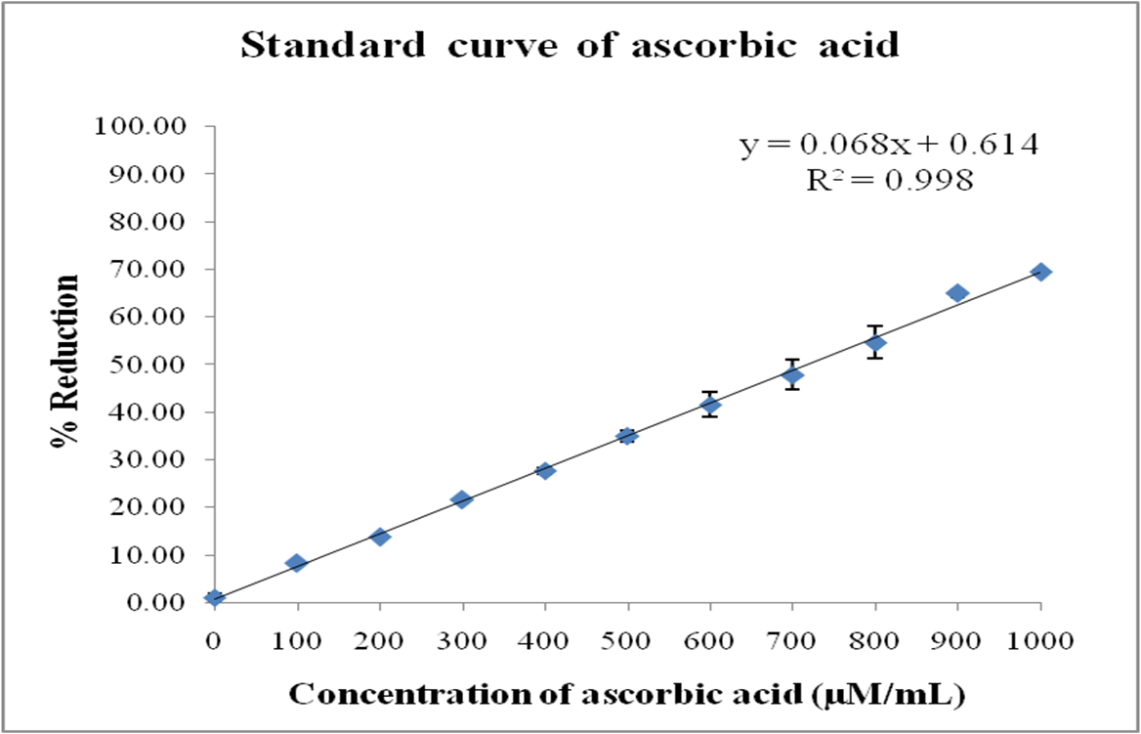

Supplementary Graph 1: Standard curve of DPPH by ascorbic acid

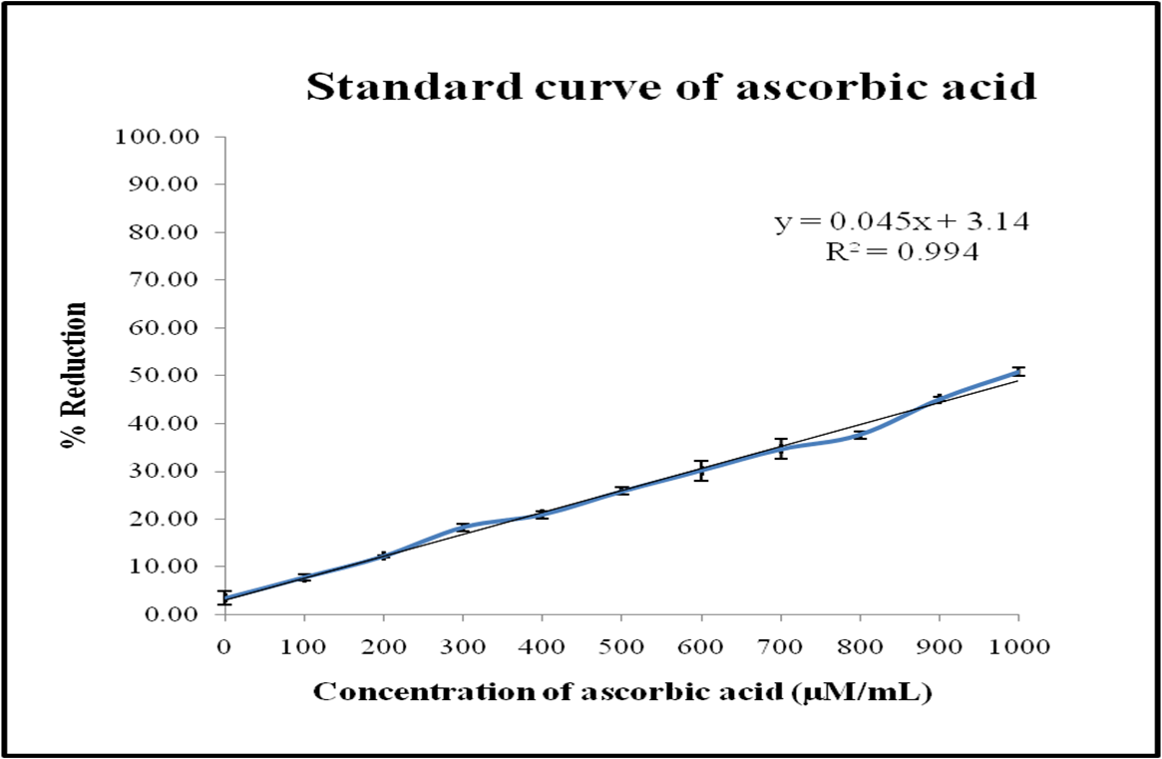
Supplementary Graph 2: Standard curve of ABTS by ascorbic acid

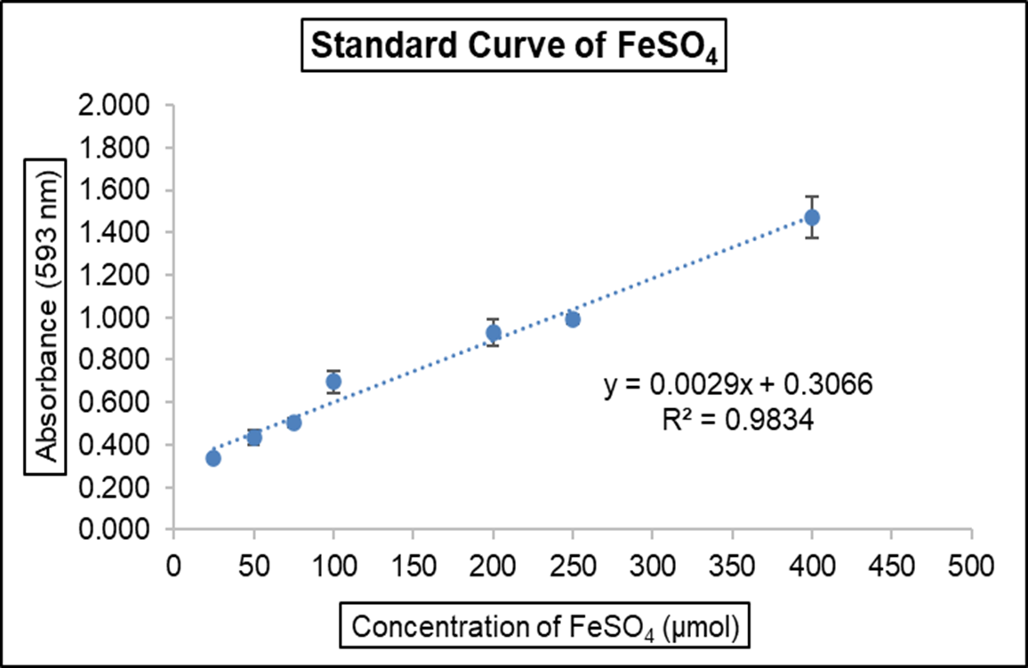

Supplementary Graph 3 : Standard curve of FRAP by FeSO₄
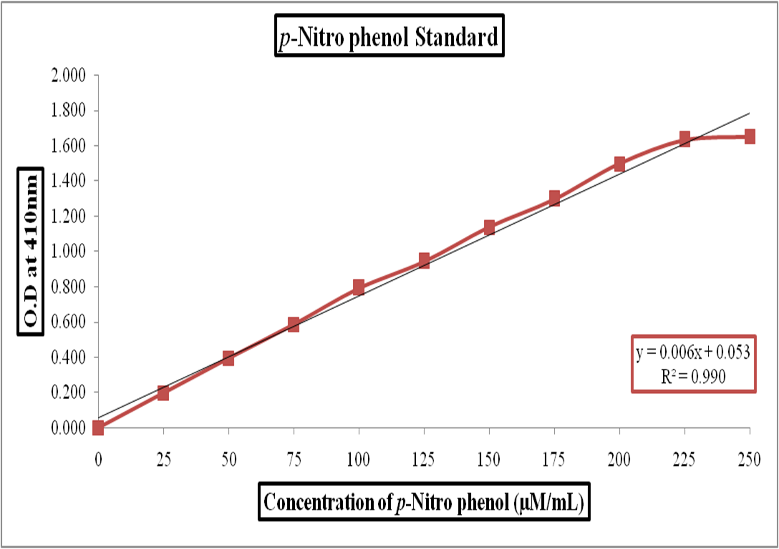

Supplementary Graph 4 : Standard curve of p-nitrophenol

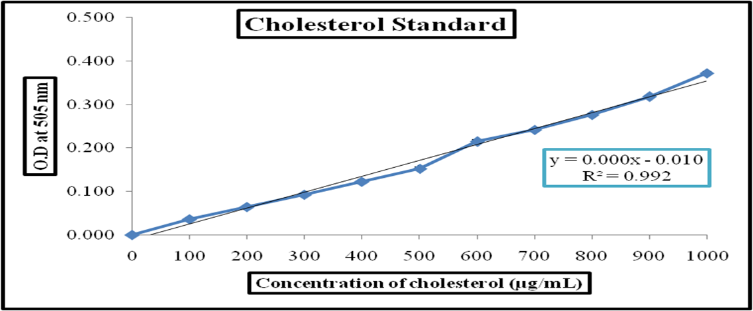

Supplementary Graph 5 : Standard curve of cholesterol

