Supplementary Materials for
Reversibly storing over 12 wt% H₂ by a trilayered lithium borohydride nanocomposite commencing from 70 ºC
Wenxuan Zhang^{1,6}, Xin Zhang^{1,6}, Chaoqun Li^{2,6}, Lingchao Zhang¹, Huifeng Liu¹, Zichen Lou¹, Zhenguo Huang³, Guanglin Xia², Mingxia Gao¹, Wenping Sun¹, Yongfeng Liu^{1,5✉} & Hongge Pan^{1,4✉}
¹State Key Laboratory of Silicon and Advanced Semiconductor Materials and School of Materials Science and Engineering, Zhejiang University, Hangzhou 310027, China. ²Department of Materials Science, Fudan University, Shanghai 200433, China. ³School of Civil & Environmental Engineering, University of Technology Sydney, 81 Broadway, Ultimo, NSW, 2007, Australia. ⁴Institute of Science and Technology for New Energy, Xi’an Technological University, Xi’an 710021, China. ⁵Zhejiang Key Laboratory of Advanced Solid State Energy Storage Technology and Applications, Taizhou Institute of Zhejiang University, Taizhou 318000, China. ⁶These authors contributed equally: Wenxuan Zhang, Xin Zhang, Chaoqun Li. ✉email: mselyf@zju.edu.cn; hgpan@zju.edu.cn.
Supplementary Table 1 | H adsorption energy (E_{ads}) at B sites in different coordination environments.
Site | Coordination number |  |  | E_{ads} (eV)
Site | Ni | C | B | E_{ads} (eV)
B1 | 0 | 0 | 5 | -1.80
B2 | 0 | 0 | 6 | 0.97
C1 | 0 | 0 | 5 | -1.34
C2 | 0 | 1 | 5 | -1.14
N1 | 3 | 0 | 4 | -1.08
N2 | 3 | 0 | 1 | -0.70
N3 | 3 | 0 | 2 | -0.65
N4 | 0 | 0 | 5 | -0.47
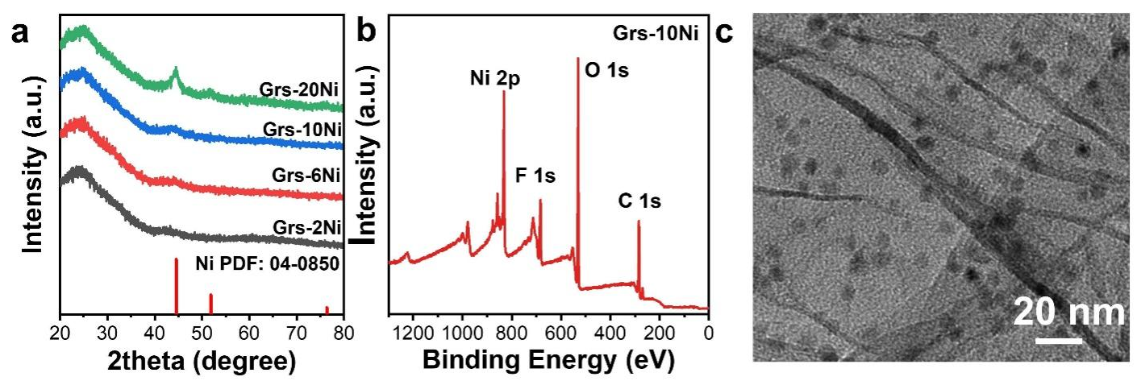
Supplementary Figure 1 | a) XRD patterns of Grs-xNi, b) XPS survey spectrum and c) HRTEM image of Grs-10Ni.

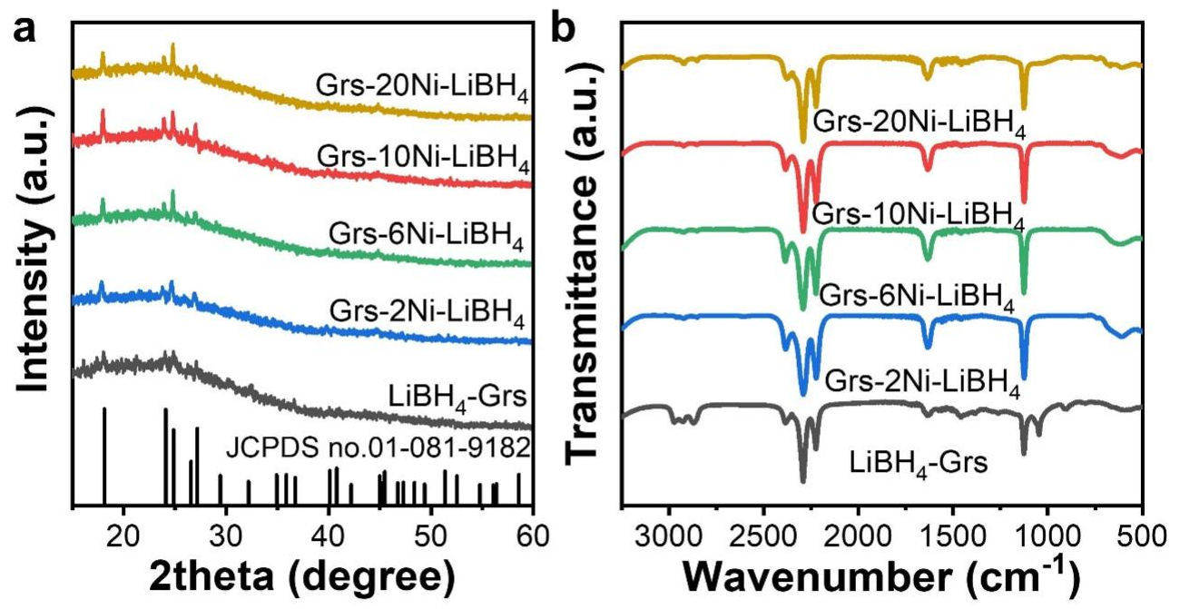
Supplementary Figure 2 | a) XRD patterns, b) FTIR spectra of Grs-xNi-LiBH₄ nanocomposite.

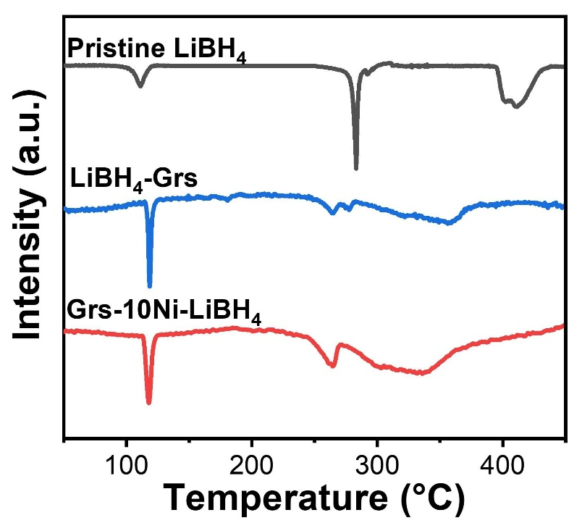
Supplementary Figure 3 | DSC curves of pristine LiBH₄ and Grs-xNi-LiBH₄ nanocomposites.
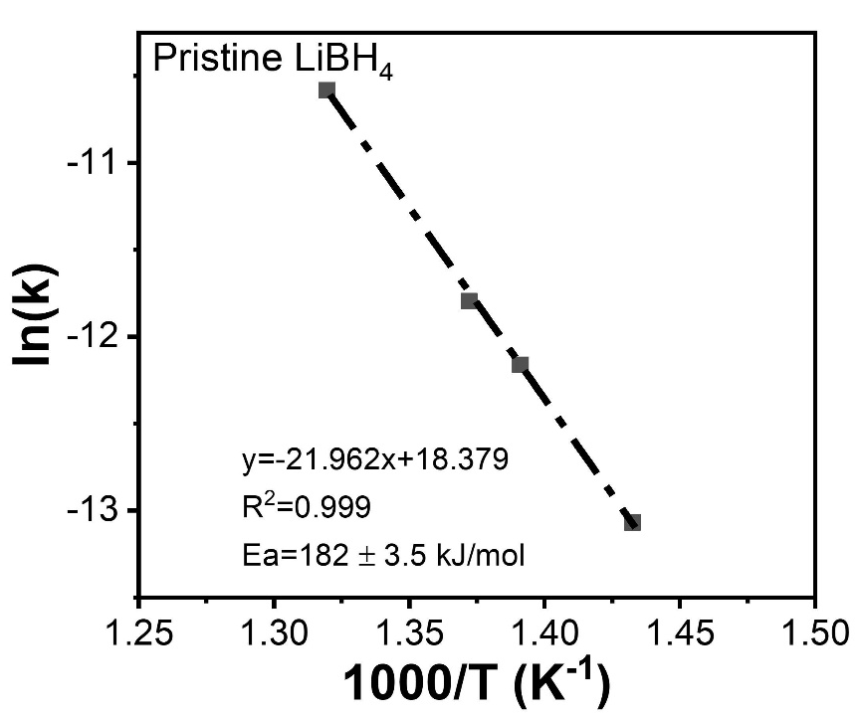
Supplementary Figure 4 | Kissinger’s plots of pristine LiBH₄ under different heating rates.
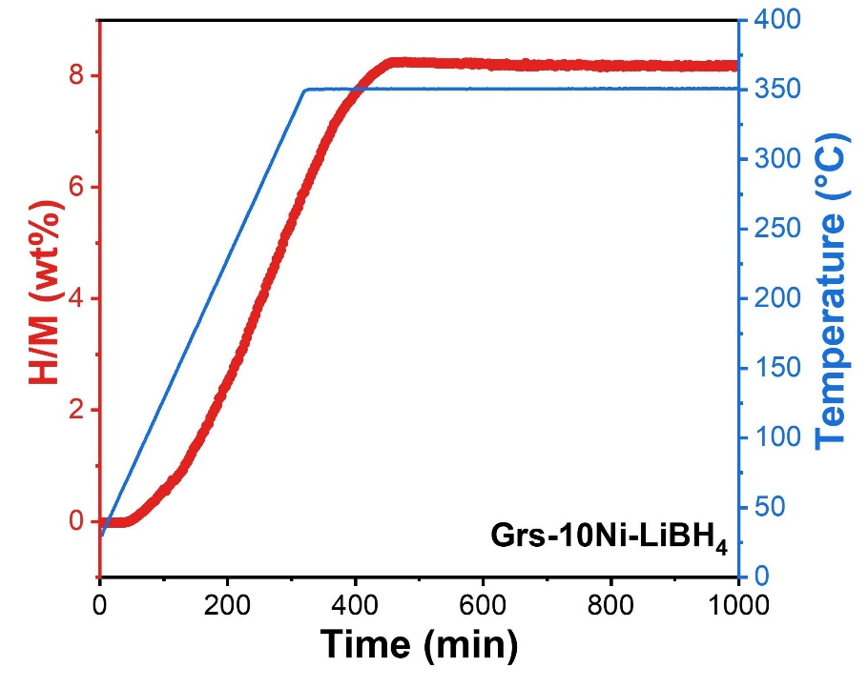
Supplementary Figure 5 | Non-isothermal hydrogenation curves of Grs-10Ni-LiBH₄ nanocomposite.
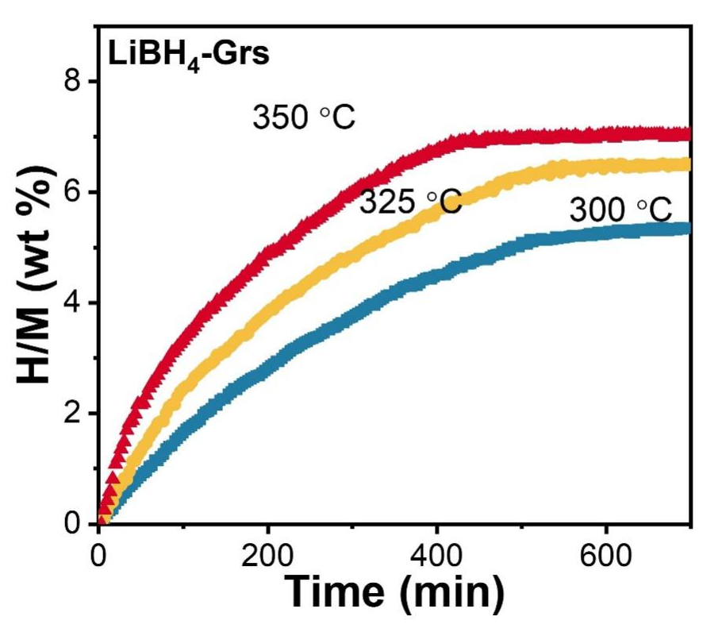
Supplementary Figure 6 | Isothermal hydrogenation curves of LiBH₄-Grs nanocomposites.
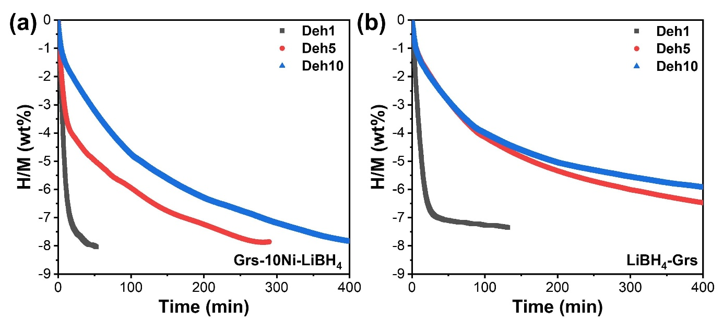
Supplementary Figure 7 | 1st, 5th and 10th isothermal dehydrogenation curves of a) Grs-10Ni-LiBH₄ and b) LiBH₄-Grs nanocomposites at 350 °C.
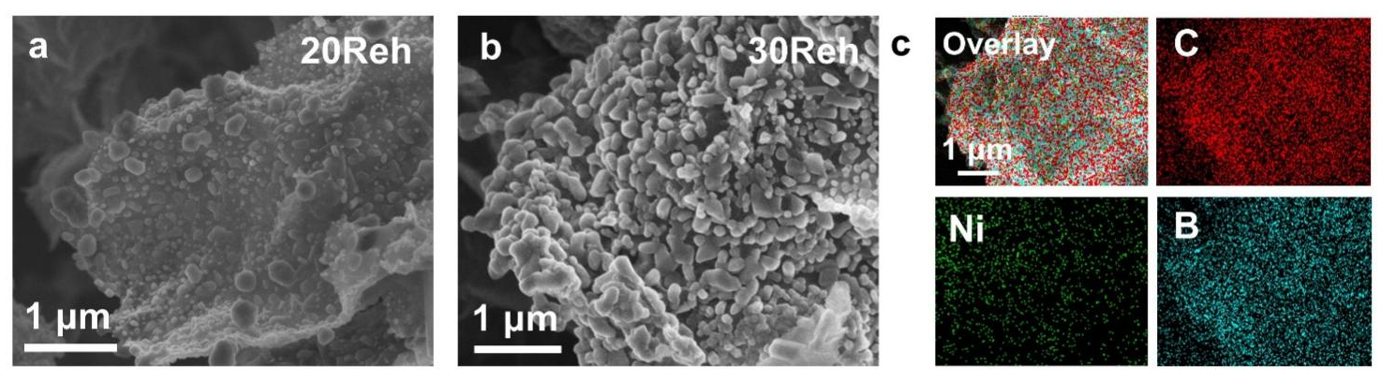
Supplementary Figure 8 | a) SEM image of Grs-10Ni-LiBH₄ after 20th rehydrogenation, b-c) SEM image and corresponding EDS mappings of Grs-10Ni-LiBH₄ after 30th rehydrogenation.
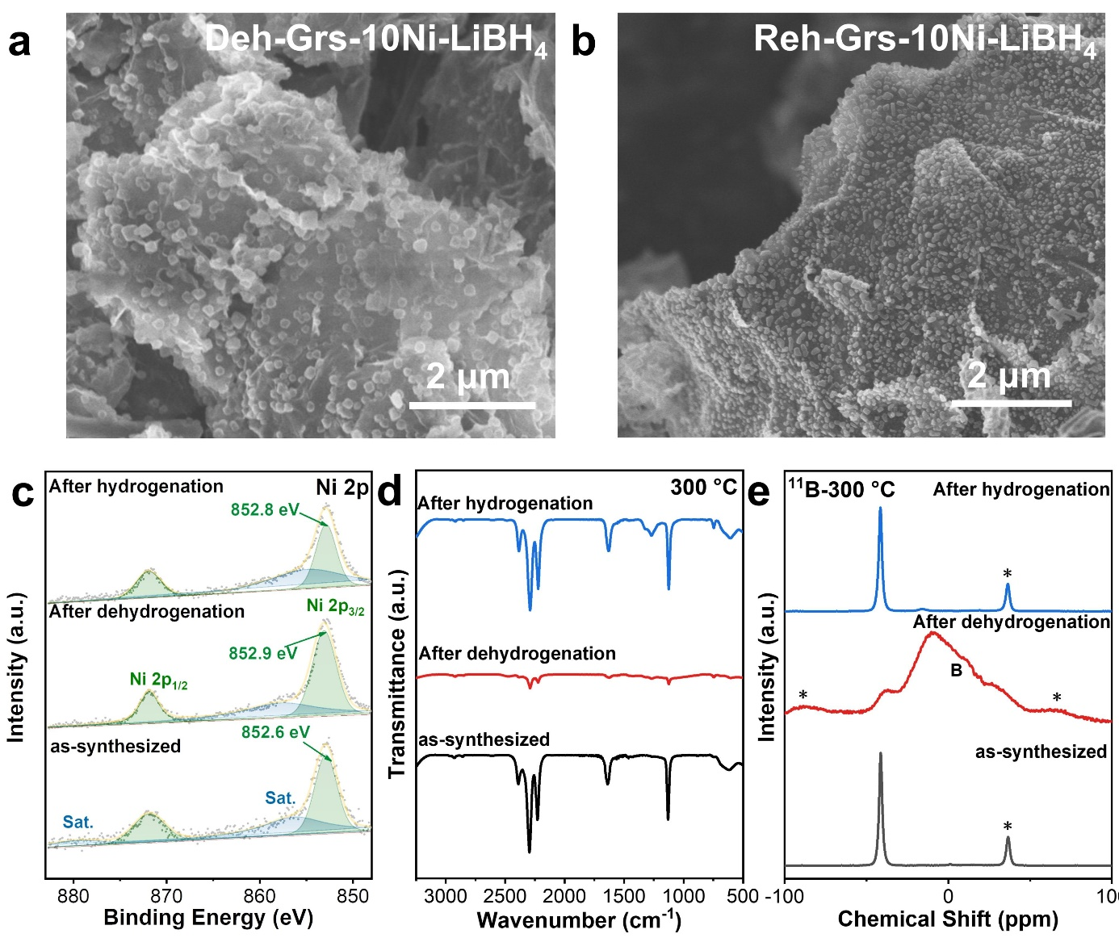
Supplementary Figure 9 | SEM images of Grs-10Ni-LiBH₄ nanocomposite after a) dehydrogenation and b) hydrogenation, c) high-resolution Ni 2p XPS spectra, d) FTIR spectra and e) solid state ¹¹B NMR spectra of LiBH₄-Grs-10Ni nanocomposite after dehydrogenation and hydrogenation at 300 ºC. The peaks marked with * in e) indicate the spinning sidebands.

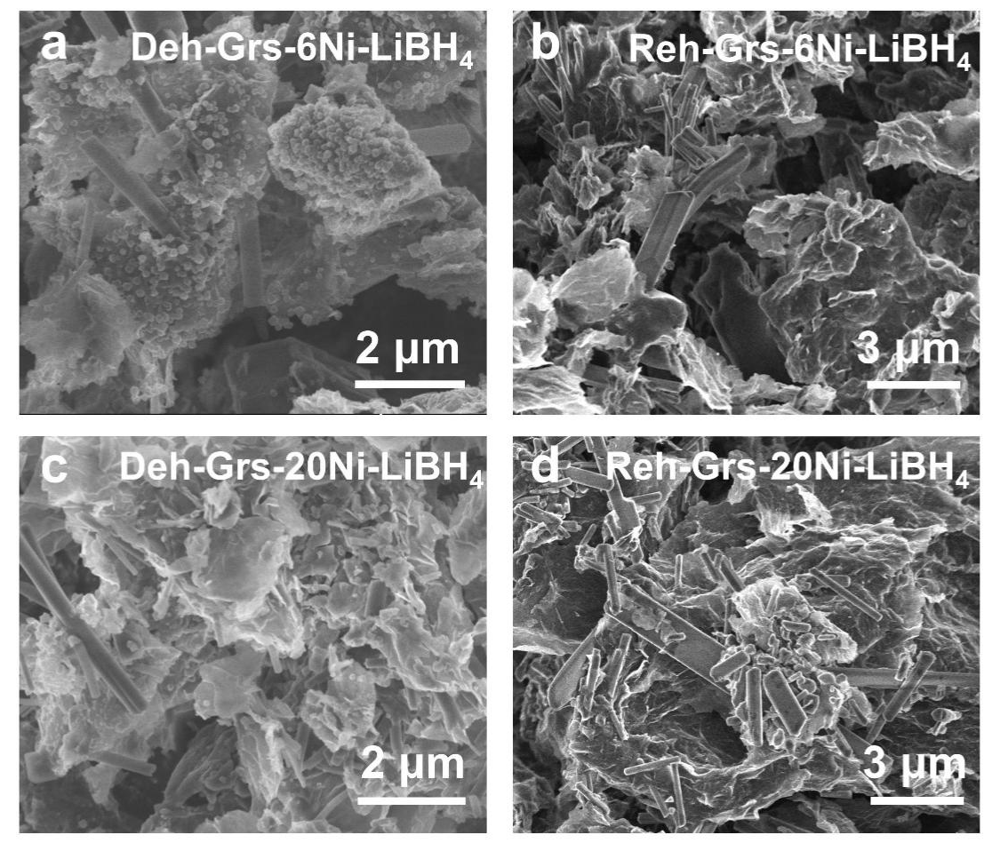
Supplementary Figure 10 | SEM images of Grs-6Ni-LiBH₄ after a) dehydrogenation and b) hydrogenation, SEM images of Grs-20Ni-LiBH₄ after c) dehydrogenation and d) hydrogenation.
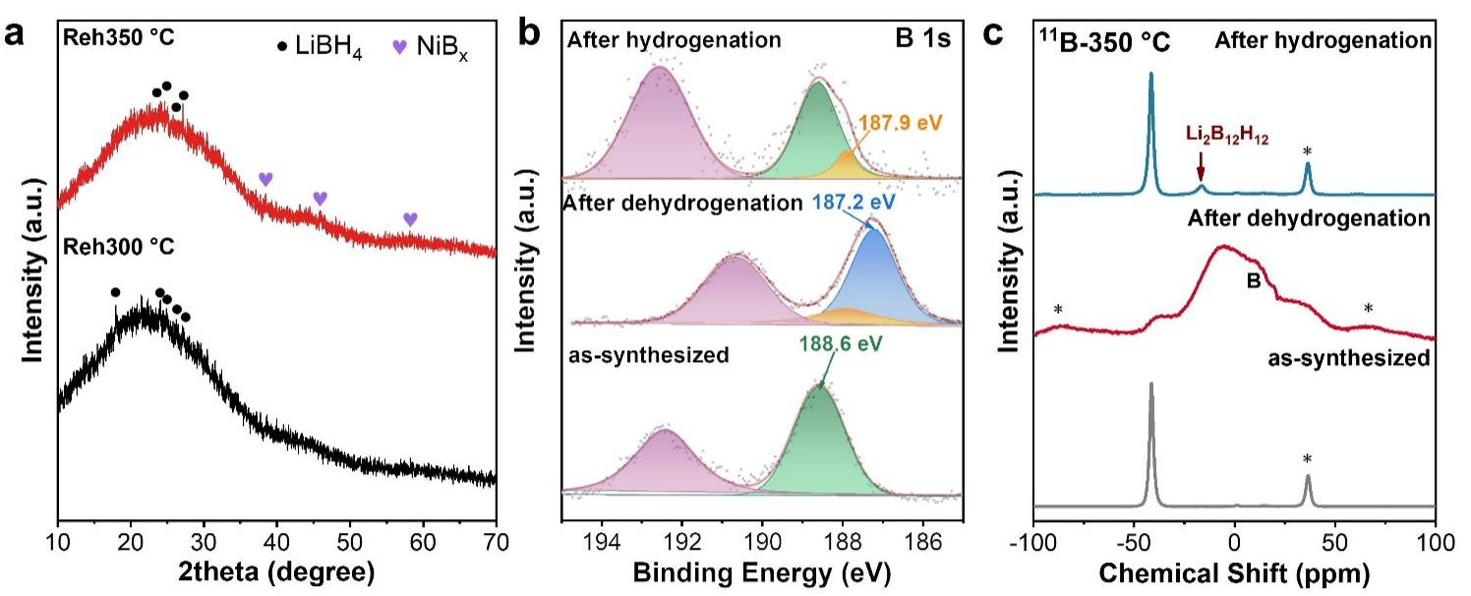
Supplementary Figure 11 | a) XRD patterns, b) high-resolution B 1s XPS spectra and c) solid state ¹¹B NMR spectra of LiBH₄-Grs-10Ni nanocomposite after dehydrogenation and hydrogenation at 350 ºC.. The peaks marked with * in c) indicate the spinning sidebands.
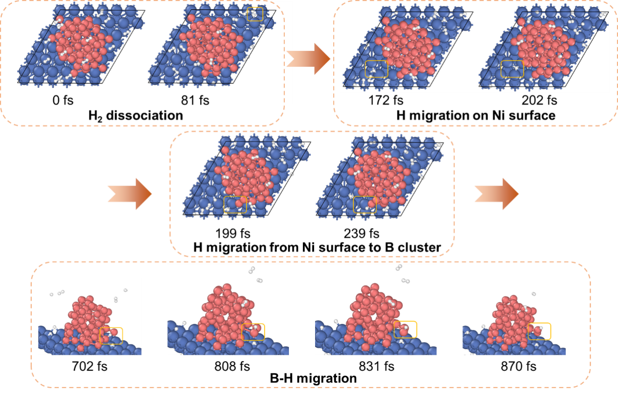
Supplementary Figure 12 | Ab initio molecular dynamics (AIMD) simulation of H₂ reaction around Ni-B. The dissociation, adsorption, and migration of hydrogen on the Ni-B surface at 500 K were simulated, revealing the breaking and recombination of B-B bonds during the migration of the B-H groups.

