Supplementary Information

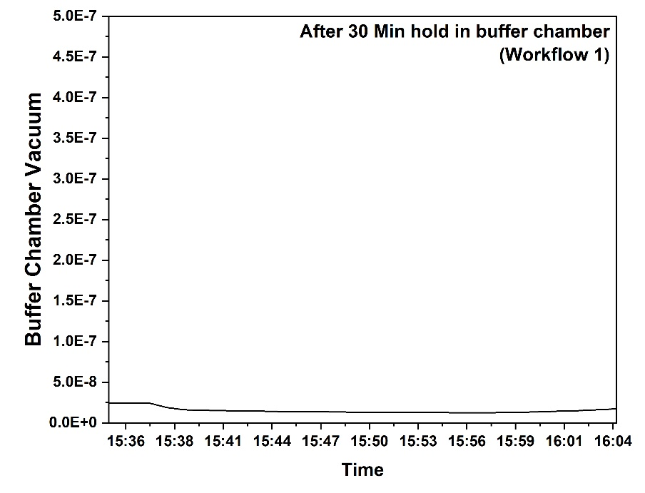
Supplementary Figure 1. Buffer chamber vacuum trends during the 30-minute hold in Workflow 1.

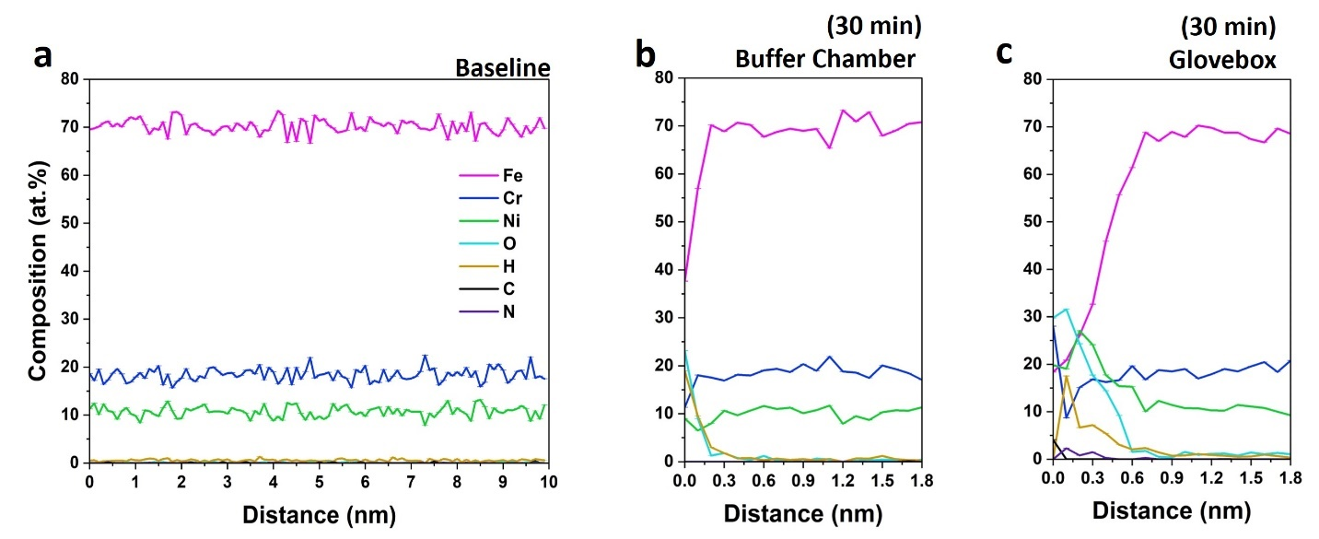
Supplementary Figure 2. 1D composition profiles of baseline, buffer chamber, and glovebox experimental condition for (a-c) Laser APT runs of workflow-1 (analyzing baseline for hydrogen and oxygen), respectively.

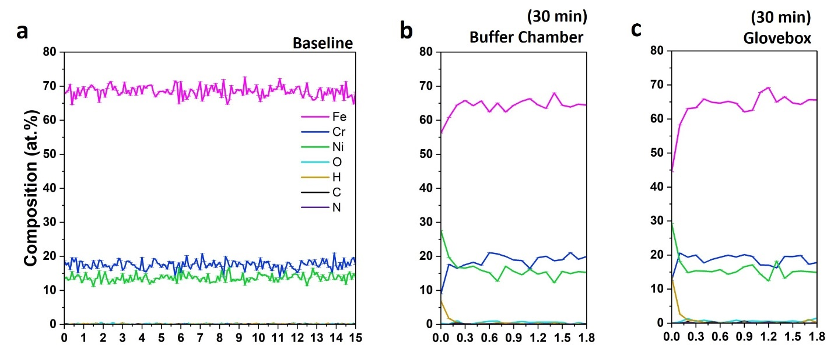
Supplementary Figure 3. 1D composition profiles of baseline, buffer chamber, and glovebox experimental condition for (a-c) Voltage APT runs of workflow-1 (analyzing baseline for hydrogen and oxygen), respectively.

Supplementary Figure 4. Recorded buffer chamber vacuum during the 30-minute and 90-minute hold in Workflow 2.

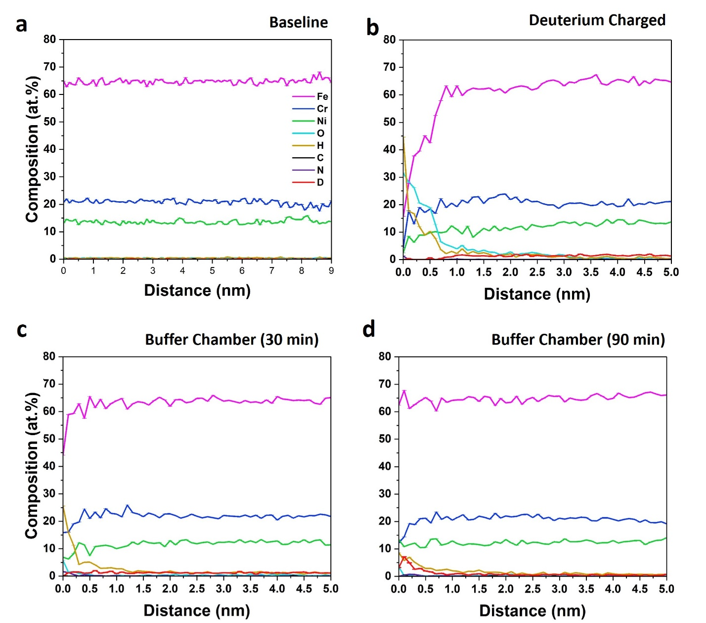
Supplementary Figure 5. 1D composition profiles of baseline, deuterium charged, buffer chamber 30- and 90-min experimental condition for (a-d) Voltage APT runs of workflow-2 (Deuterium electrochemical charging experiment).

