SUPPLEMENTARY MATERIAL
Geologic and Tectonic Setting of Analogue Sites

Broborg Hillfort Geologic Setting
Broborg is situated on the Fennoscandian (Baltic) shield and has been largely tectonically stable, with evidence from ancient volcanic processes.¹¹¹ Fine-grained plagioclase-porphyrite, quartz-andesite, and ultra-mafic gabbro are common in the area, as are the fine-grained schist and feldspar and quartzite-rich mica.¹¹² Quaternary post-glacial sand, mud, and clay deposits cover most of the bedrock.¹¹³

Timna Geologic Setting
Mount Timna, a structural dome¹¹⁴ and the surrounding hills rise out of Timna Valley in southern Israel's Avara desert. The bedrock in the Timna area primarily consists of Cambrian sandstones.¹¹⁴ Extensional forces linked to the Dead Sea Transform (DST) might have facilitated the intrusion of magmatic bodies, leading to localized heating and fluid circulation, which subsequently played a role in the formation of the copper ore deposits in the area.^{115,116}

Newberry Geologic Setting
Newberry is the largest volcano in the Cascade Volcanic Chain and began erupting roughly 600,000 years ago and, most recently, the Big Obsidian Flow (BOF) was formed in an eruption 1,350 years ago,.^{52,53,117,118} The early phases produced basaltic andesite to andesite lava flows, which now comprise the volcano's outer flanks.¹¹⁸ About 75,000 years ago, a significant eruption led to the summit's collapse and formed a caldera, which later filled with water, resulting in Paulina Lake and East Lake.¹¹⁸ The primary tectonic influence in the Pacific Northwest is the subduction of the Juan de Fuca Plate beneath the North American Plate. While the Cascade Mountain range is home to several stratovolcanoes resulting directly from this subduction, Newberry is slightly different. It is situated farther east and is often termed a 'rear-arc' volcano, lying behind the main Cascade volcanic arc.^{118,119} The BOF magma now feeds hot magmatic fluid to the caldera at a depth of 1 km, where it disperses into the volcano's hydrothermal system.¹²⁰ Another obsidian-rich flow occurred 3,500 years ago with a SiO₂ weight percent between 71.5 and 73.9.^{52,53,117,118} The early phases produced basaltic andesite to andesite lava flows, which now comprise the volcano's outer flanks.¹¹⁸

Dobkowice Geologic Setting
Dobkowice is located on the northern edge of the Carpathian Foredeep, a geological basin filled with sedimentary rocks deposited over millions of years. During the Miocene, sediment deposition that lithified into sandstone and mudstones was dominant and formed the region's bedrock. The Pliocene was marked by the retreat of shallow seas, leaving deposits of clays, sand, and gravel. Repeated glaciations of the Pleistocene scoured the area, leaving till, boulders, gravel, and sand atop the older formations.¹²¹

Ballidon Geologic Setting
Three hundred forty million years ago, during the Early Carboniferous Period, the Ballidon area was covered by warm, shallow seas rich in marine life, such as crustaceans and coral reefs. The remains of these organisms, rich in calcium carbonate, accumulated on the seabed, forming thick layers of carbonaceous limestone.¹²² The environment changed later in the Carboniferous period, and large estuaries dominated the area. These rivers deposited mud, which later compacted to form shale and rock layers. This transition marks the transition from a marine to a terrestrial environment. The area also experienced volcanic activity during this time, with submarine volcanoes spewing lava across the sea floor, leading to layers of basalt layers. During the Cenozoic periodic, the region experienced significant land movements that shaped its current topography. The dome-like shape of the Peak District, known as the Derbyshire Dome, results from a complex network of faults resulting in till blocks and half grabens.¹²³ The area was not heavily glaciated during the Last Glacial Maximum, but features such as glaciation and peat deposits on bogs indicate some glacial influence. The quarry is mined for its bedrock, the Bee Low Limestone Formation, a pale grey-brown fine-to-medium grain rock that is ~160 m thick in the area.¹²⁴

Elemental maps overlaid on SEM-BSE of Dobkowice sample

Figure S1. SEM-EDS maps overlaid on SEM-BSE images of fractured surfaces on the Dobkowice sample show a Si-rich layer (SL#1). The image in A) is taken in low magnification, and the image in B) is taken in higher magnification. Approximate boundary between SL#1 and the bulk glass is shown with a dashed line.

Elemental maps of Broborg BB1b samples
Below are elemental SEM-EDS maps of BB1b samples (overlayed in Figure 14) to allow for observation of the location of various elemental signatures.
Figure S2. SEM-EDS elemental maps of sample BB1b

SEM and elemental maps of Newberry samples
Below are elemental SEM-EDS maps of Newberry samples (overlayed in Figure 15) to allow for observation of the location of various elemental signatures.
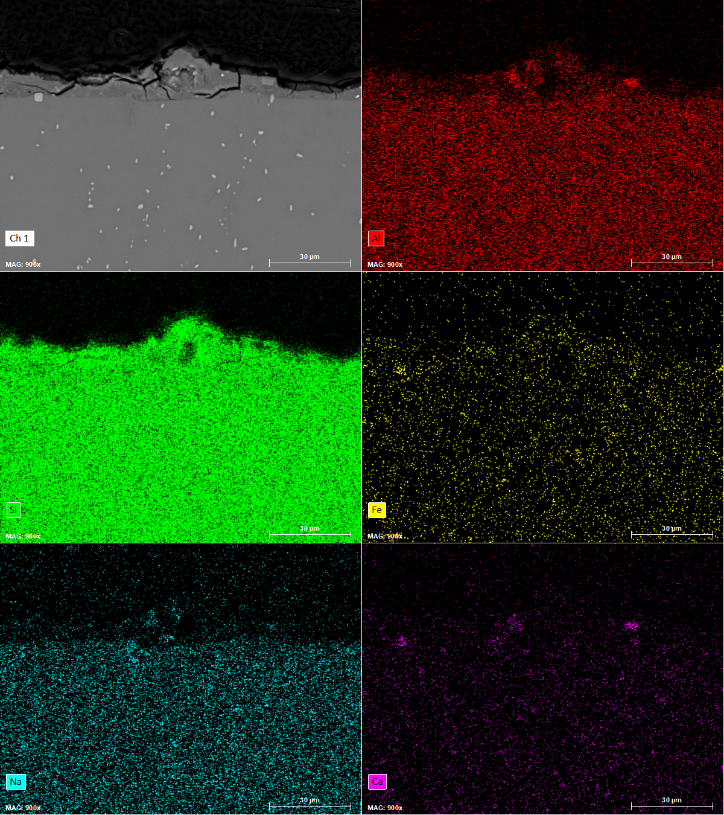
Figure S3. SEM-EDS elemental maps of sample MJS-1

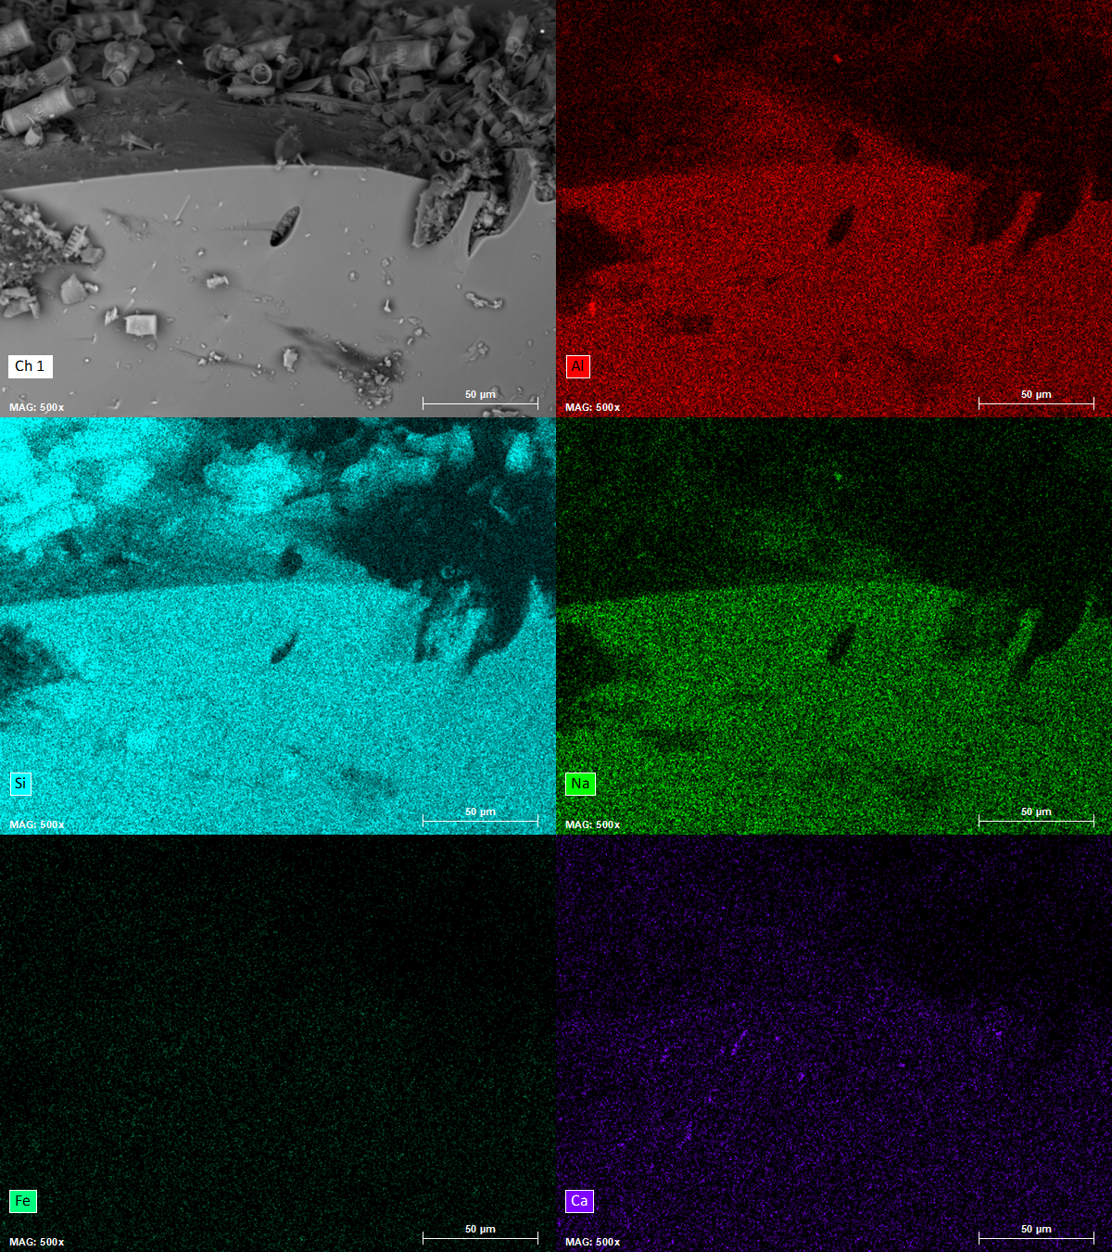
Figure S4. SEM-EDS elemental maps of sample BOF-6

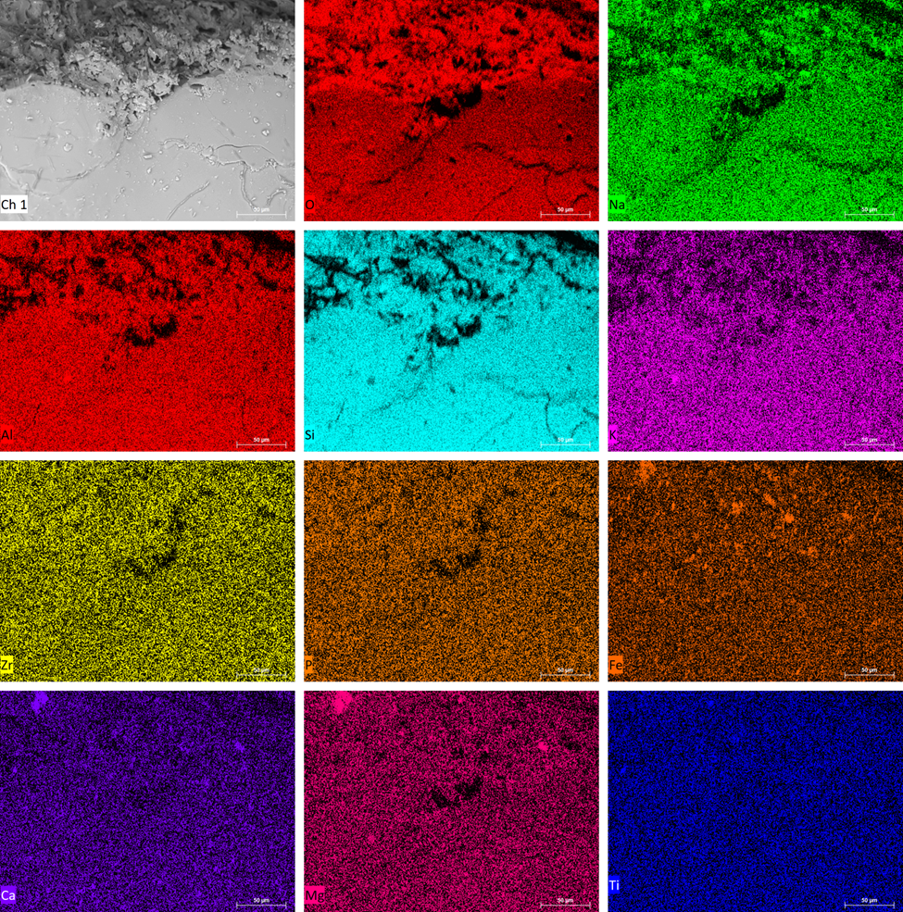
Figure S5. SEM-EDS elemental maps of sample BOF-9

