Supplementary Information 1
Country-level models, covariate inference
Model terms used in the spatiotemporal Bayesian models were found using a combination of OLS stepwise algorithms to determine an optimal set of covariates. Quality fitting metrics for OLS are not listed here but are in the Supplementary Information 2. Parameter and hyperparameter estimates, associated distribution statistics, and model fitting statistics for outflow and inflow models for Kenya are shown in Table S1 and Table S2, respectively.
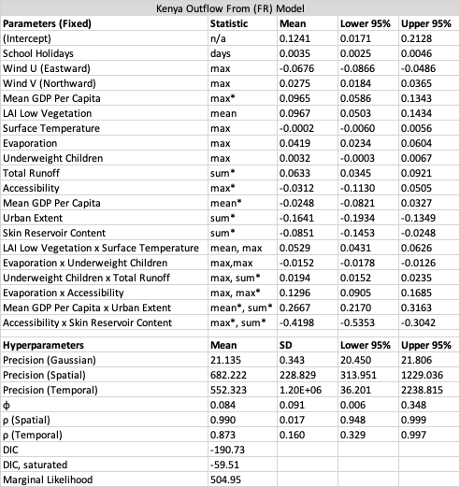
Table S1. Best fit parameter and hyperparameter estimates shown for the Kenya outflow (FR) model. Base-10 logarithmic transformations to covariates are denoted by an asterisk in the Statistic column. Statistics column denotes zonal statistics used to create covariate values for administrative units. Mean, standard deviation (SD), and upper and lower 95% credible interval values are shown. Hyperparameter estimates with upper and lower 95% CI bounds and performance metrics are given.

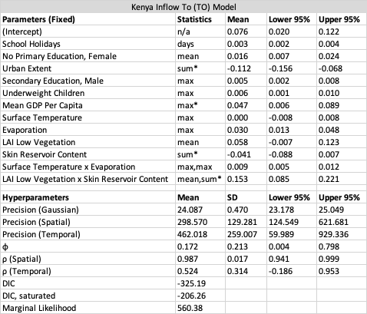
Table S2. Best fit parameter and hyperparameter estimates shown for the Kenya inflow (TO) model. Base-10 logarithmic transformations to covariates are denoted by an asterisk in the Statistic column. Statistics column denotes zonal statistics used to create covariate values for administrative units. Mean, standard deviation (SD), and upper and lower 95% credible interval values are also shown. Hyperparameter estimates with upper and lower 95% CI bounds and performance metrics are given.

All two-way interaction terms shown in Tables S1, S2 are significant to the model at a 5% level as indicated by zero exclusion in the 95% credible intervals. Observe there are no common two-way interaction terms shared between the two Kenya models. This tells us that mobility flow direction is an important aspect to consider in Kenya when analysing a relative change in mobility as their correlations with environmental and socioeconomic conditions differ considerably. Indeed, the only two common simple main effect terms (i.e. those not used in two-way interactions) were number of days for school holidays and maximum mean gross domestic product per capita. For each number of days per month taken as school holidays, there is a ~0.3% increase in the relative mobility change for any given month relative to the January mobility baseline for both inflow and outflow human movement in Kenya. For each percent increase in maximum mean gross domestic product per capita, there is 0.047% increase in relative mobility change for the inflow for Kenya, and a 0.097% increase in relative mobility change for the outflow for Kenya, which is double that of inflow.
(Note: For log-log regression models, $\log{Y}=a+b\log{X}+e$, we infer that for every 1% increase in $X$ there is a $b\%$ increase in $Y$, and for log-level regression models, $\log{Y}=a+bX+e$, for every unit increase in $X$ there is a $100×b\%$ increase in $Y$.)
Both main effect terms for any significant two-way interaction are always included in the model regardless of their individual significance. Interaction effects must be inferred as a set consisting of the two-way interaction term and its corresponding pair of main effects, where the slope estimate for one covariate varies with values of the other covariate in the interaction. Table S3 lists the common two-way interaction terms across 25 African countries. For the Kenya outflow (FR) model, the common interaction term consists of mean gross domestic product per capita (mean GDPC) and summed urban extent (sum URBN) as model coefficients with the two-way interaction set
$$-0.0248GDPC-0.1641URBN+0.2667mean_GDPC×sum_URBN.$$
Here, two-way interaction sets have the form ${\hat{β}}_{1}A+{\hat{β}}_{2}B+{\hat{β}}_{3}A×B$ for main effects $A$ and $B$ and a two-way interaction$A×B$ with parameter estimates ${\hat{β}}_{1}$, ${\hat{β}}_{2}$, and ${\hat{β}}_{3}$,. To find the slope for main effect $A$, use factored expression $\left({\hat{β}}_{1}+{\hat{β}}_{3}B\right)A$ with a slope ${\hat{β}}_{1}+{\hat{β}}_{3}B$ that varies over values of $B$. Similarly, for $B$, use factor $\left({\hat{β}}_{2}+{\hat{β}}_{3}A\right)B$ with slope ${\hat{β}}_{2}+{\hat{β}}_{3}A$ that varies over values of$A$. For the outflow Kenya model, the $GDPC×URBN$ interaction slopes for their main effect are calculated in Table S3 under KEN (FR), where the slope for mean GDPC is $-0.0248+0.2667sum_URBN$, the range of values for sum URBN is $\left[3.176, 6.650\right]$ with a slope range for mean GDPC as $\left[0.822, 1.749\right]$. Similarly, factoring the other way, the slope for sum URBN is $-0.1641+0.2667mean_GDPC$, the range of values for mean GDPC is $\left[3.386, 5.138\right]$ with a slope range for sum URBN as $\left[0.739, 1.206\right]$. For each percent increase in mean GDP per capita, there is a 0.882% to 1.749% increase in the relative change in mobility depending on the value of summed urban extent. For each percent increase in summed urban extent, there is a 0.739% to 1.206% increase in the relative change in mobility depending on the value of mean GDP per capita.
Other common interactions are grouped in the table as $PREC×ACCS$, $UWCH×URBN$, and $TEMP×SECM$. To clarify, these additional covariates are precipitation (PREC), accessibility (ACCS), underweight children (UWCH), surface temperature (TEMP), and secondary education for males (SECM). All main effect slopes for these interaction sets are calculated in Table S3 as well. Table S4 lists all main effects used across all 25 African countries in the country-level models along with a count of how many times each main effect term is significant across all models.

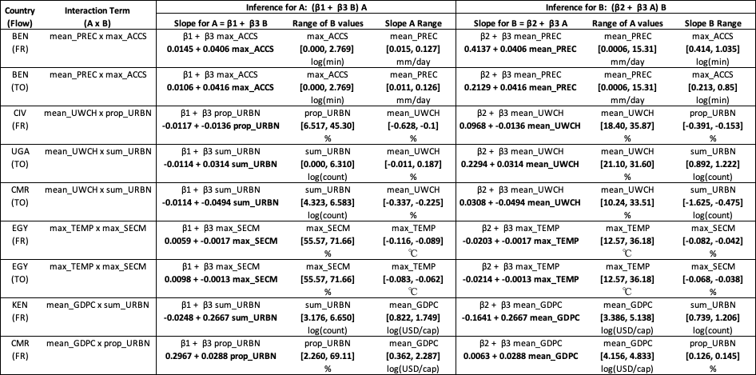
Table S3. Common significant interaction terms of outflow (FR) and inflow (TO) mobility models for 25 African countries. For main effect terms $A$ and $B$, two-way interaction term $A×B$, and model coefficients $β_{1}$, $β_{2}$, and $β_{3}$, two-way interactions terms always include their main effect terms, written as $β_{1}A+β_{2}B+β_{3}A×B$ in the model. Two-way interaction slopes terms for $A$ and $B$ are taken by factoring terms as $\left(β_{1}+β_{3}B\right)A$ and $\left(β_{2}+β_{3}A\right)B$, respectively, each with varying slopes given by $β_{1}+β_{3}B$ and $β_{2}+β_{3}A$, respectively. Slope values depend on a range of covariate values for $B$ and $A$, respectively. Finally, the range of slope values for $A$ and $B$ are given.

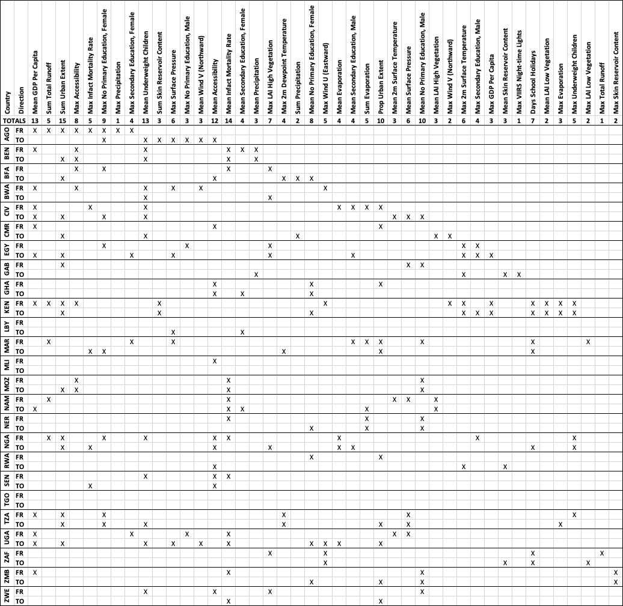
Table S4. Significant main effects terms across all 50 country-level models (25 FR and 25 TO). Terms are marked with an “X” and total counts are given for each term across all models. There were 43 main effect terms (shown) and 46 two-way interactions (not shown in table). Details of final model terms for OLS and the corresponding spatiotemporal Bayesian estimates and their performance statistics are found in Supplementary Information 2.

Spatial covariate data description
Several geospatial datasets, representing correlates and potential drivers of human mobility, were collected, assembled, and processed to produce monthly covariates best matching years of available GAMRD data. Eleven climatic datasets (Table S5) were retrieved from the Copernicus ERA-5 Land product (Muñoz Sabater, 2019), owing to its wide array of climatic gridded datasets quasi-globally available in a consistent format and at fine native spatial and temporal resolution (9km and 1 hour, respectively). Moreover, this product offers monthly averaged data from 1950 to present, allowing for seasonal and monthly variations to be properly computed, observed, and aligned with the obtained GAMRD data. An additional monthly covariates waw also prepared using the Suomi National Polar-orbiting Partnership (SNPP) Visible Infrared Imaging Radiometer Suite (VIIRS) night-time light data (Elvidge et al., 2017).

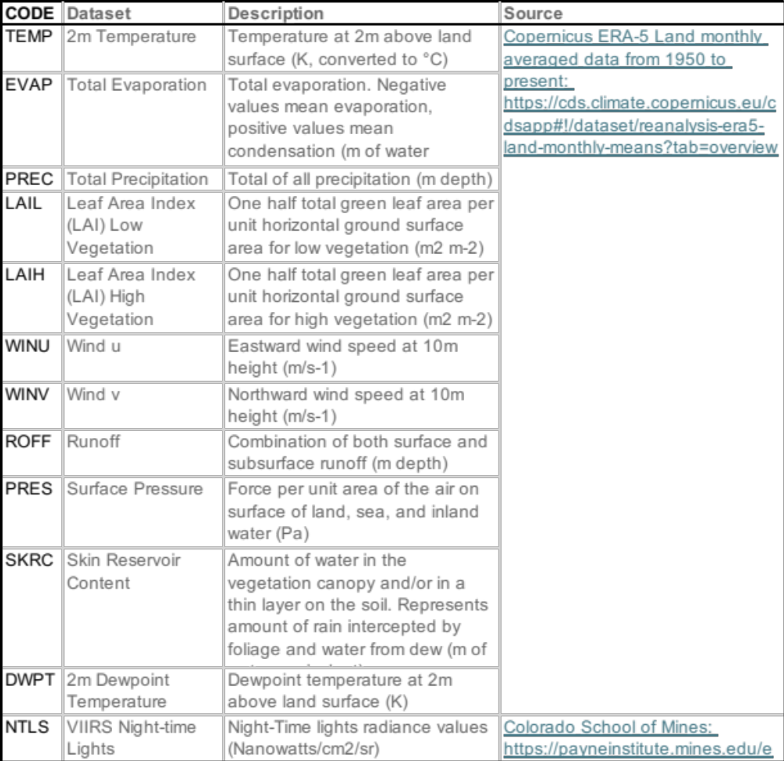
Table S5. Geospatial datasets collected, assembled, processed and converted into monthly covariates at the administrative level 1 for 2018 and 2019.
Additional covariates that could exhibit a relationship with human mobility were also produced using annual dataset (Table S6) which are less frequently updated. Therefore, the most recent year available was used, and an assumption was made that their values remain the same throughout each given year. Nevertheless, these covariates can be informative in terms of representing socio-economic characteristics influencing seasonal mobility. For example, it has been observed that more people are moving away from urban areas in favour of more rural/coastal locations during the crop season/summer months (Deville et al., 2014; Bharti et al., 2016). Some of these annual covariates were produced using datasets obtained by combining multiple inputs. In particular, the “Proportion Urban Population” dataset was created by combining WorldPop 1km gridded datasets for 2018 and 2019, depicting the spatial distribution of the population at the grid cell level, with the 2015 GHS Settlement Model grid (GHS-SMOD) after classifying each grid cell according to its Degree of Urbanization Level 1 (Florczyk et al., 2019). Similarly, the “Average GDP per capita” dataset was created dividing the 2015 GDP_PPP_30arcsec datasets, produced by Kummu et al. (2020) and representing the average gross domestic production of each grid cell, by the corresponding 2015 GHS-POP 1km gridded dataset to remove population weighting.
To suit seasonal mobility modelling needs, the gridded datasets outlined in Tables S5 and S6 were used to produce monthly and annual covariates, at the administrative unit level, using custom Python scripts (Py v3.6.6) calculating zonal statistics and outputting the results as tables (see GitHub site). Statistics such as monthly mean, median, minimum, maximum and sum of grid cell values were generated at the administrative unit Level 1 for 2018 and 2019 for all African countries, except Mauritius, Mayotte, and Seychelles. Monthly zonal statistics referring to the Night-time light data, focusing on the sum of the grid cell values located within each administrative unit to calculate its corresponding “Sum of Lights,” were also generated at administrative unit Level 2 for 2018 and 2019. In both cases, to ensure spatial harmonization between these covariates and the GAMRD data, GADM (v 3.6) shapefiles were used both for preparing the tabulated covariates and spatially aggregating the GAMRD data - allowing for each administrative unit to be uniquely identified across all covariate tables by its unique GADM GID_1 code.
A simplified version of the workflow used for processing all Copernicus ERA-5 Land climatic gridded datasets is given in Figure S1. In some instances, the gridded datasets were too coarse to provide values to a very small number of “tiny” administrative units not overlapping any grid cell center. In such situations, a point-filling method was implemented to assign to each tiny administrative unit the value of the grid cell underlying its center. In some cases, administrative units receive no values because of spatial gaps in some of the gridded datasets. In such a situation, it was decided not to introduce any imputed value, through techniques such as nibbling, to avoid artificially affecting the results of the subsequent correlation analysis. Coverage for Mauritius, Mayotte, and Seychelles was so limited that it was decided not to include them in the analysis.
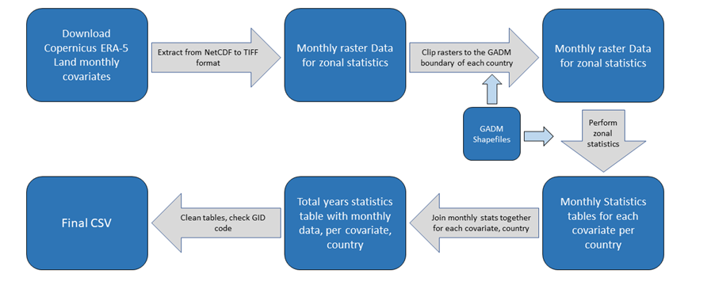
Figure S1. Simplified workflow diagram used for processing all Copernicus ERA-5 Land climatic gridded datasets and producing the corresponding monthly tabulated covariates as “.csv” files.


Table S6. Geospatial datasets collected, assembled, processed, and converted into annual covariates at the administrative unit Level 1 for 2018 and 2019.
Performance metrics for OLS models
Common performance metrics such as the coefficient of determination ($R^{2}$), adjusted coefficient of determination ($R_{adj}^{2}$), and various test statistics (i.e. t-value, p-value) are used to assess model performance, and estimated residuals and variance inflation factor (VIF) are used to check model fit and to validate assumptions. Other performance metrics not commonly used are defined here followed by a description of their usage. For data of size n and number of regressors p,
Variance decomposition proportions (VDP)
[complete this last, need to simplify expression]
Prediction sum of squares (PRESS)
PRESS is a leave-one-out statistic that is calculated by omitting each observation individually and then regressing the remaining $n-1$ observations, denoted by ${\hat{y}}_{i(i)}$. We calculate the $i^{th}$ PRESS residual as $y_{i}-{\hat{y}}_{i(i)}$. Then the PRESS statistics is given by the following sum of squares
$PRESS=\sum_{i=1}^{n}{{\left(y_{i}-{\hat{y}}_{i(i)}\right)}^{2}}$.
In general, the smaller the PRESS value, the better the predictability of the model.
Predictive R²
PRESS can also be used to assess model overfit through predicted $R^{2}$, which is defined as
$R_{pred}^{2}=1-\frac{PRESS}{SST}$,
where $SST$ is the total sum of squares. $R_{pred}^{2}$ values will always be less than $R^{2}$, but for a well fit model, $R_{pred}^{2}$ values usually exceed half the value of $R^{2}$. Negative values or very small values relative to $R^{2}$ indicates an overfit model. For OLS regression, $R_{pred}^{2}$ is used to validate the model.
VIF metrics combined with variance decomposition proportions (VDP) tables are used to assess model ill conditioning due to multicollinearity among model terms. VIF values over 10 are considered high and should be addressed, and while moderate VIF values between 5 and 10 are suspect, they are usually not too problematic for statistical inference⁴⁰. Although VIF indicates problems with model specification, the metric does not address which terms are involved in the multicollinearity. A VDP isolates which two (or more) terms are generating the collinearity, where a high condition index indicates the presence of high collinearity and corresponding high VDP values identifies the collinear terms⁴¹. Predicted R², which is based on a PRESS statistic^{42,43}, is used to evaluate model overfit as values for an overfit model are quite small relative to the R². Predicted R² values that are at least half the R² value indicates no overfit; and hence, models on the Bayesian side are already pre-validated through OLS model validation. Performance statistics are listed for all OLS regression models in the Supplementary Information 2, where the ratios for $R_{adj}^{2}$ to $R^{2}$ and $R_{pred}^{2}$ to $R^{2}$ facilitate model quality assessment.

