SUPPLEMENTARY INFORMATION

Efficacy, safety, and biomarker changes of B-cell activating factor- and A proliferation-inducing ligand-targeted therapies in IgA nephropathy: A systematic review and meta-analysis of randomized controlled trials

Rafael dos Santos Borges, Rodrigo Lara Santos, Luiza Haikal de Paula, Jefferson Manoel Borges Martins, Pedro Antônio Machado Gomes de Sousa, Giovanni Gosch Berton, Ana Cristina Simões e Silva

Complete search strategy: ("IgA Nephropathy" OR "Berger disease" OR "Berger s disease" OR Berger OR "synpharyngitic glomerulonephritis" OR "synpharyngitic hematuria") AND (BAFF OR "B-cell activation factor" OR "B-cell activating factors" OR Povetacicept OR ALPN-303 OR Telitacicept OR Atacicept OR Blisibimod OR APRIL OR "A proliferation inducing ligand" OR "TNFSF13" OR "tumor necrosis factor ligand superfamily member 13" OR "TNF superfamily member 13" OR Zigakibart OR "BION-1301" OR Sibeprenlimab OR VIS639 OR VIS649)
Table S1 GRADE quality of evidence
 |  |  |  |  |  |  | № of patients |  | Effect |  | Certainty
№ of studies | Study design (name of studies) | Risk of bias | Inconsistency | Indirectness | Imprecision | Other considerations | BAFF- or APRIL-targeted therapies | Placebo | Relative (95% CI) | Absolute  (95% CI) | Certainty
The mean percent change in 24-hour UPCR from baseline
3 | RCT (ENVISION, JANUS, ORIGIN) | not serious | not serious | not serious | not serious | publication bias strongly suspectedª | 181 | 68 | - | MD 38.80 lower  (59.17 lower to 18.44 lower) | ⨁⨁⨁◯  Moderate
The mean change in eGFR from baseline
3 | RCT (ENVISION, Jicheng Lv, ORIGIN) | not serious | not serious | not serious | not serious | publication bias strongly suspectedª | 213 | 84 | - | MD 7.05 higher  (3.83 higher to 10.27 higher) | ⨁⨁⨁◯  Moderate
The rate of any adverse effect
4 | RCT (ENVISION, JANUS, Jicheng Lv, ORIGIN) | not serious | serious^{b} | not serious | not serious | publication bias strongly suspectedª | 189/240 (78.8%) | 71/91 (78.0%) | RR 0.99  (0.86 to 1.13) | 8 more per 1000 (from 109 fewer to 101 more) | ⨁⨁⨁◯ Moderate
The rate of drug- or placebo-related adverse events
3 | RCT (ENVISION, JANUS, ORIGIN) | not serious | not serious | not serious | not serious | publication bias strongly suspectedª | 68/210 (32.4%) | 20/77 (26.0%) | RR 1.30  (0.87 to 1.93) | 78 more per 1000 (from 34 fewer to 242 more) | ⨁⨁⨁◯ Moderate
The rate of serious adverse effects
4 | RCT (ENVISION, JANUS, Jicheng Lv, ORIGIN) | not serious | not serious | not serious | not serious | publication bias strongly suspectedª | 13/240 (5.4%) | 7/91 (7.7%) | RR 0.74  (0.30 to 1.86) | 20 fewer per 1000 (from 54 fewer to 66 more) | ⨁⨁⨁◯ Moderate
The rate of upper respiratory tract infection
3 | RCT (ENVISION, Jicheng Lv, ORIGIN) | serious^{c} | serious^{d} | not serious | serious^{e} | publication bias strongly suspectedª | 26/229 (11.4%) | 6/86 (7.0%) | RR 2.02  (0.37 to 11.15 | 71 more per 1000 (from 44 fewer to 708 more) | ⨁◯◯◯ Very low
The rate of adverse events leading to discontinuation of the study
4 | RCT (ENVISION, JANUS, Jicheng Lv, ORIGIN) | not serious | not serious | not serious | serious^{f} | publication bias strongly suspectedª | 3/240 (1.3%) | 1/91 (1.1%) | RR 0.79  (0.14 to 4.39) | 2 fewer per 1000 (from 9 fewer to 37 more) | ⨁⨁◯◯  Low
The mean percent change in Gd-IgA1 from baseline
3 | RCT (ENVISION, JANUS, ORIGIN) | not serious | serious^{g} | not serious | not serious | publication bias strongly suspectedª | 179 | 67 | - | MD 46.48 lower  (63.46 lower to 29.49 lower) | ⨁⨁⨁◯  Moderate
The final level of serum IgG
3 | RCT (Jicheng Lv, JANUS, ORIGIN) | not serious | not serious | not serious | not serious | publication bias strongly suspectedª | 114 | 45 | - | MD 3.11 lower  (4.00 lower to 2.22 lower) | ⨁⨁⨁◯  Moderate
CI, Confidence interval; MD, Mean difference; RCT, Randomized controlled trial; RR, Risk ratio; UPCR urine protein-to-creatinine ratio; eGFR estimated glomerular filtration rate.
ªAlthough the treatment has been recently evaluated in clinical trials, the inclusion of only three to four studies raises concerns about potential unpublished negative results.
^{b}I²=25.9%
^{c}The presence of some concerns regarding the risk of bias assessment of the Jicheng Lv trial, which accounts for 74.24% of the weight for this outcome, is likely to reduce confidence in the estimate of effect.
^{d}I²=51.7%
^{e}The limited sample size may have resulted in unreliable statistical power to detect statistical significance, producing a wide CI that reduces confidence in the estimate of effect.
^{f}The limited sample size and wide CI may reduce confidence in the estimate of effect.
^{g}I²=61.2%

Fig. S1 Sensitivity analysis for the mean percent change in 24-hour UPCR from baseline. A SJHK method, B leave-one-out
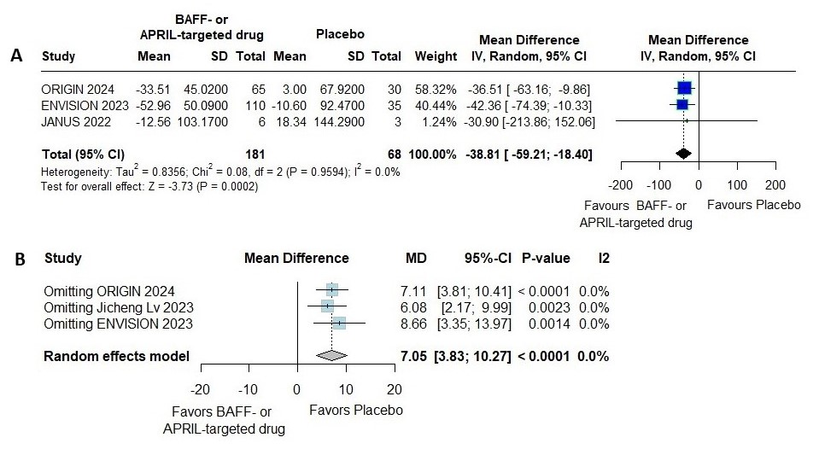
Fig. S2 Sensitivity analysis for the mean change in eGFR from baseline. A SJHK method, B leave-one-out
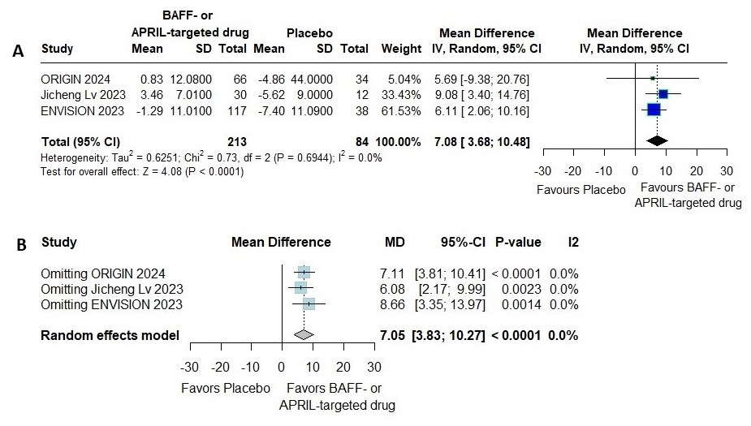
Fig. S3 Sensitivity analysis for the rate of any adverse effect. A SJHK method, B leave-one-out
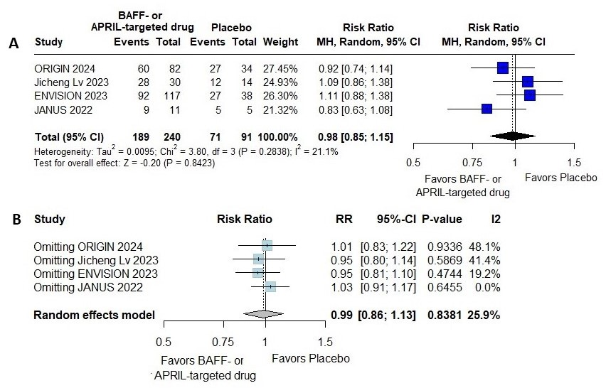
Fig. S4 Sensitivity analysis for the rate of upper respiratory tract infection. A SJHK method, B leave-one-out
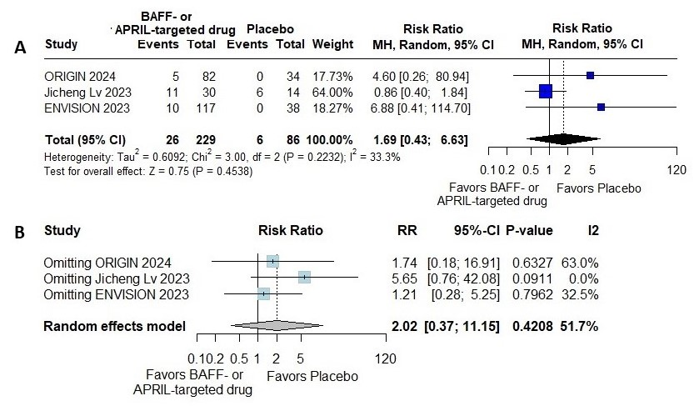
Fig. S5 The rate of drug- or placebo-related adverse events. A DL method, B SJHK method for sensitivity analysis, C leave-one-out sensitivity analysis
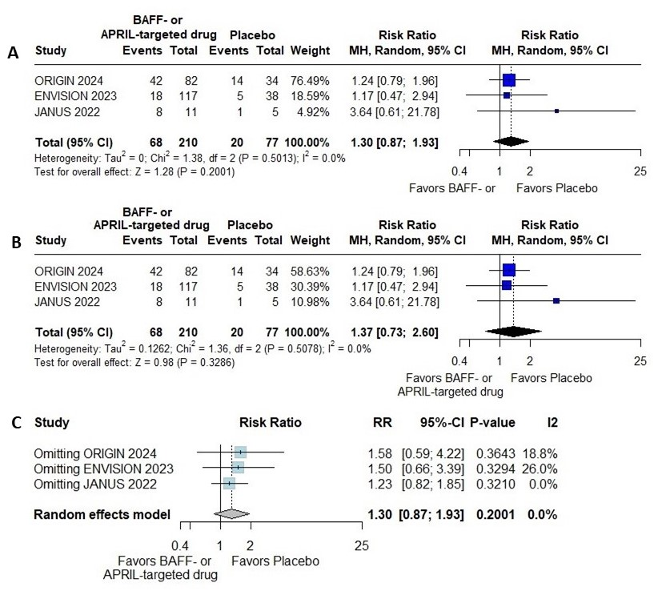
Fig. S6 The rate of serious adverse effects. A DL method, B SJHK method for sensitivity analysis, C leave-one-out sensitivity analysis
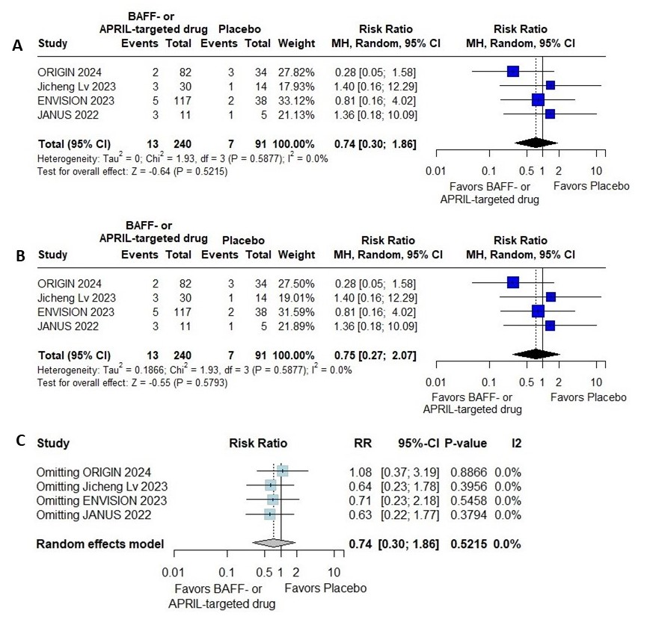
Fig. S7 The rate of adverse events leading to discontinuation of the study. A DL method, B SJHK method for sensitivity analysis, C leave-one-out sensitivity analysis
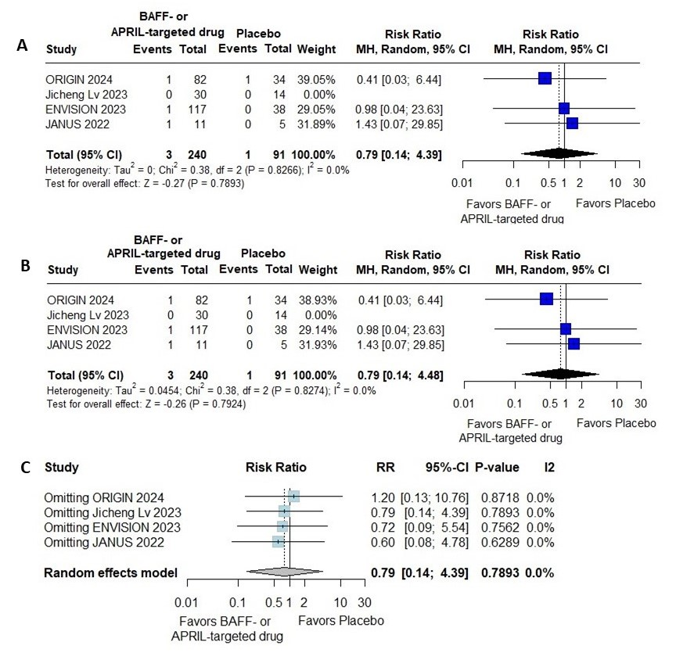
Fig. S8 Sensitivity analysis for the mean percent change in serum Gd-IgA1 from baseline. A SJHK method, B leave-one-out
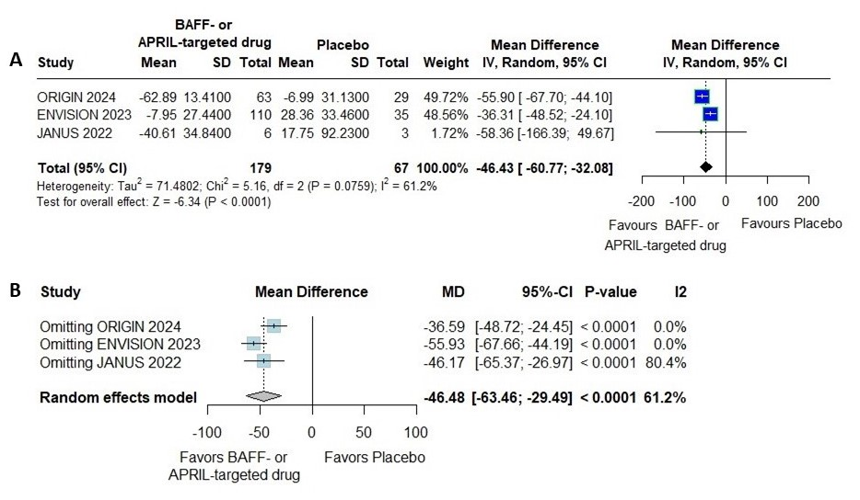
Fig. S9 The serum IgG level. A The mean percent change from baseline (DL method), B The mean percent change from baseline (SJHK method for sensitivity analysis), C The serum level at the end of the study (DL method), D The serum level at the end of the study (SJHK method for sensitivity analysis), E The serum level at the end of the study (leave-one-out sensitivity analysis)
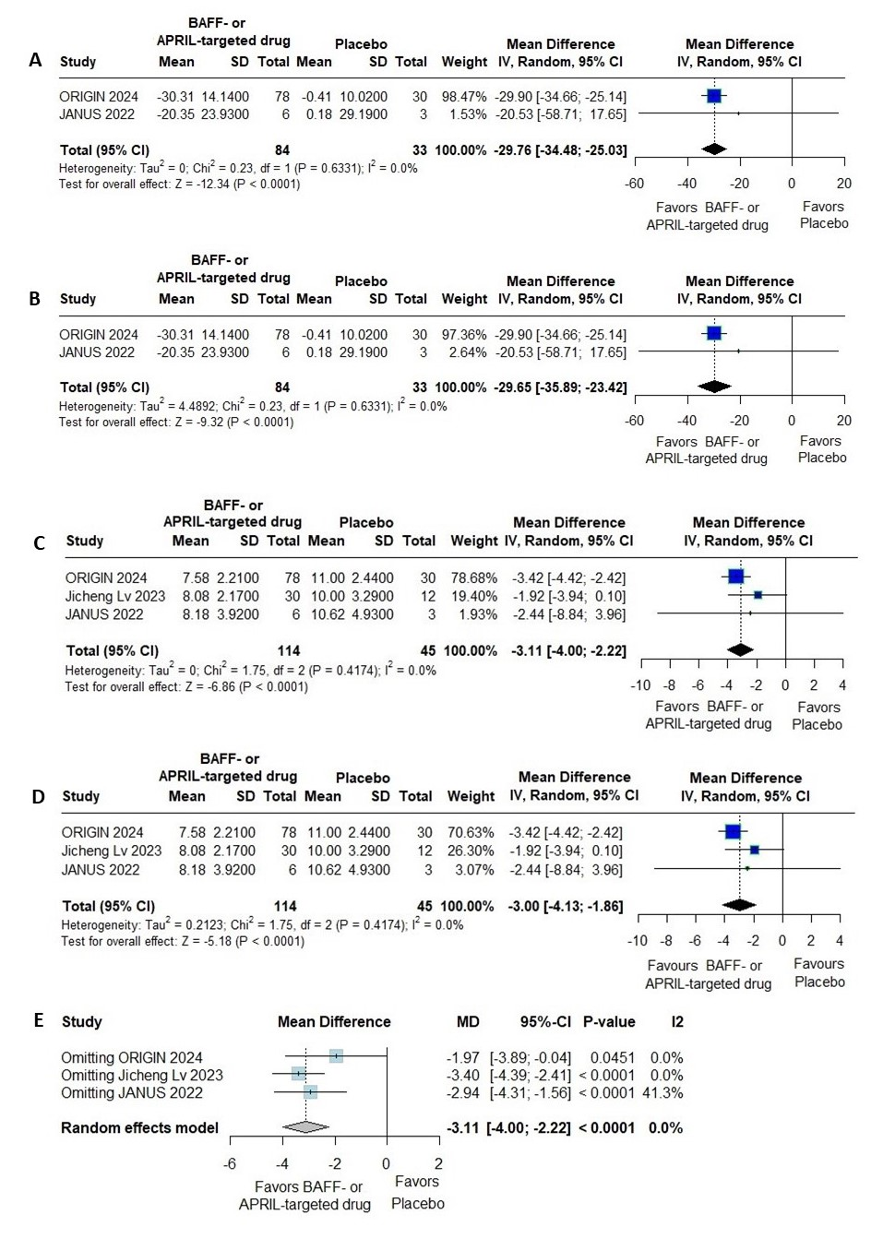
Fig. S10 The serum IgA level. A The mean percent change from baseline (DL method), B The mean percent change from baseline (SJHK method for sensitivity analysis), C The serum level at the end of the study (DL method), D The serum level at the end of the study (SJHK method for sensitivity analysis)
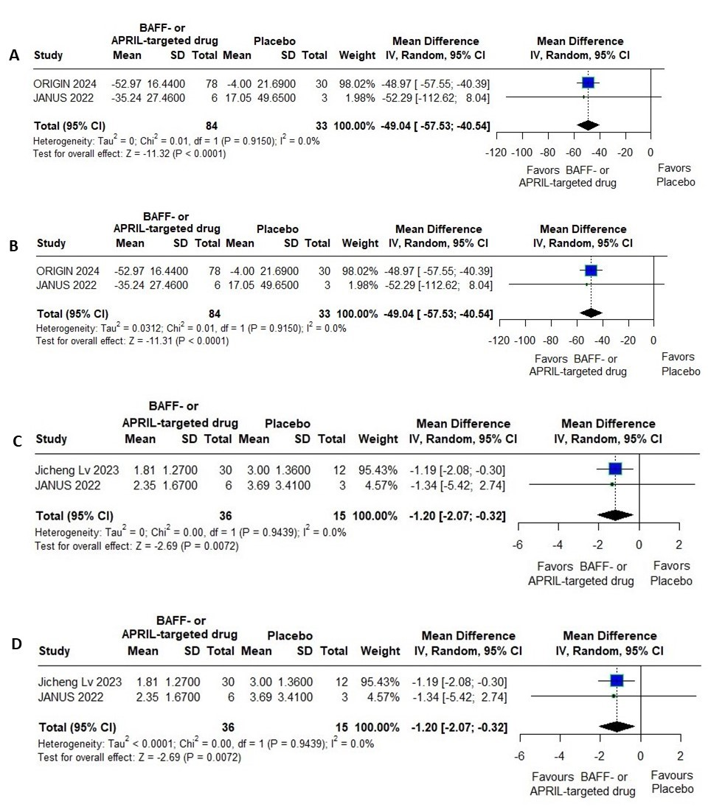
Fig. S11 The serum IgM level. A The mean percent change from baseline (DL method), B The mean percent change from baseline (SJHK method for sensitivity analysis), C The serum level at the end of the study (DL method), D The serum level at the end of the study (SJHK method for sensitivity analysis)
