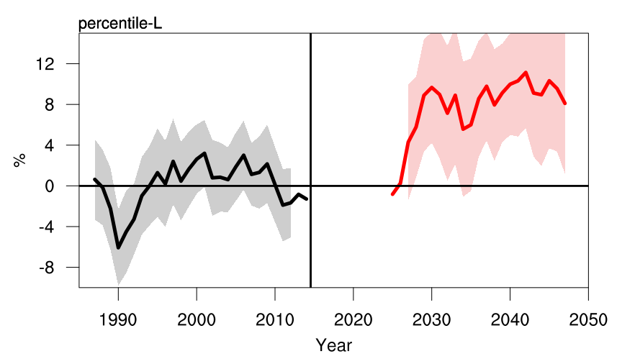
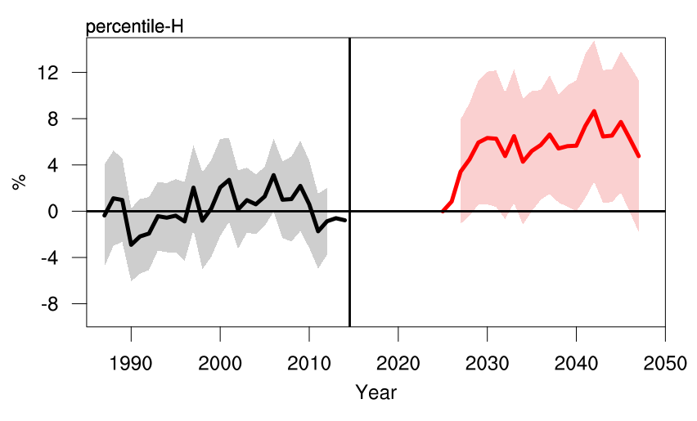
SUPPLIMENTARY
b
a

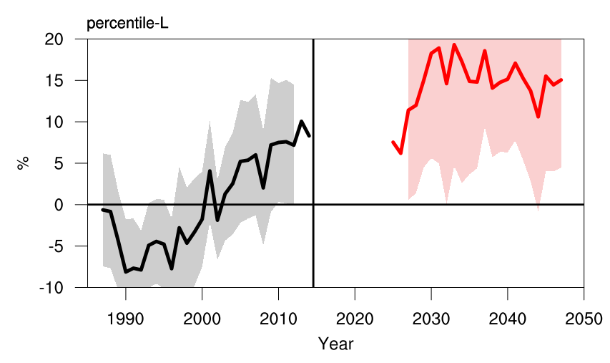
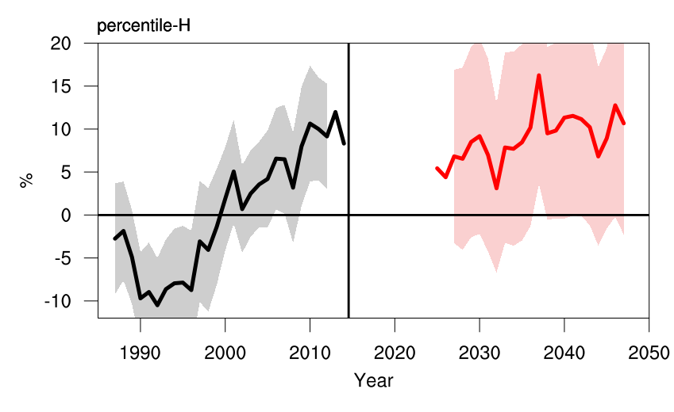
d
c

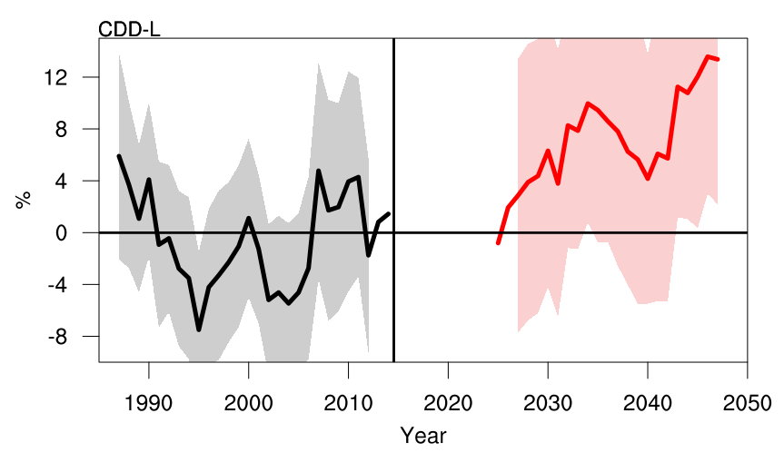
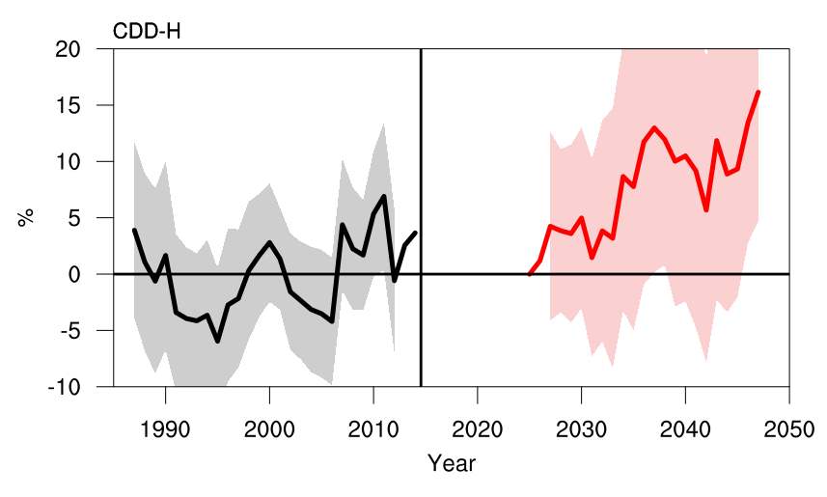
Figure S1. Temporal percentage change of R95p during 2025 – 2049 relative to the reference period 1985 – 2014 under SSP5-8.5 scenario average over West Africa. Solid lines represent the ENSEMBLE (high and low resolution simulation) and the shading depict 95% confidence in the CMIP6 HighResMIP ensemble members. The time series are smoothed with a 5-year running mean filter. Figure S1a, b depicts the percentage change over Guinea coast and Sahel between high and low resolution simulation.
b
a

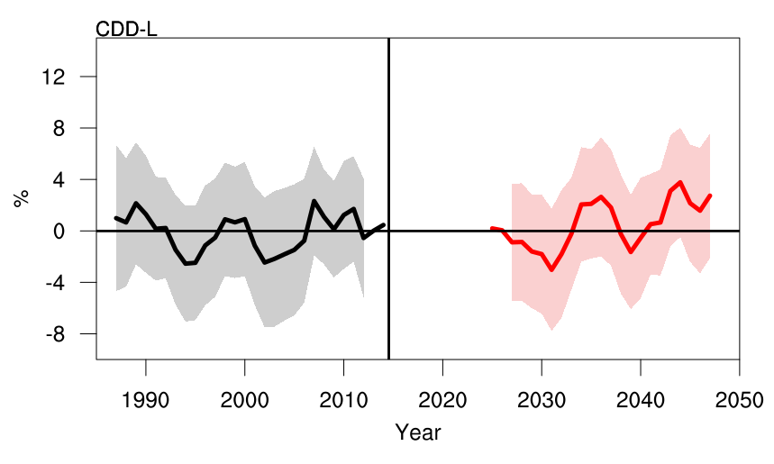
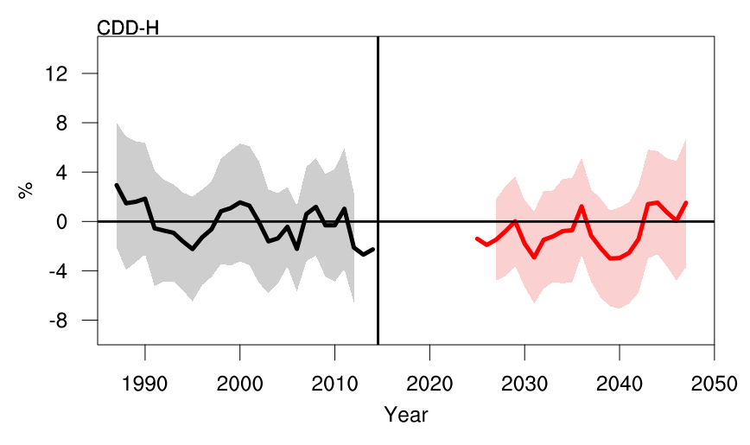
d
c

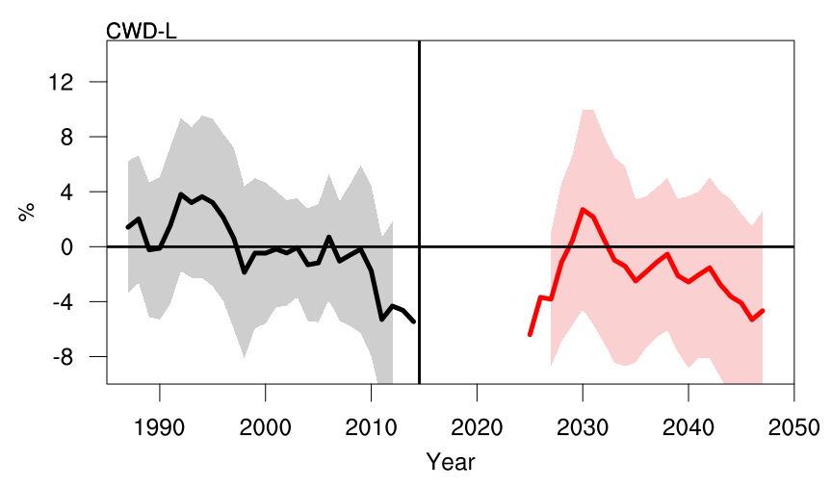
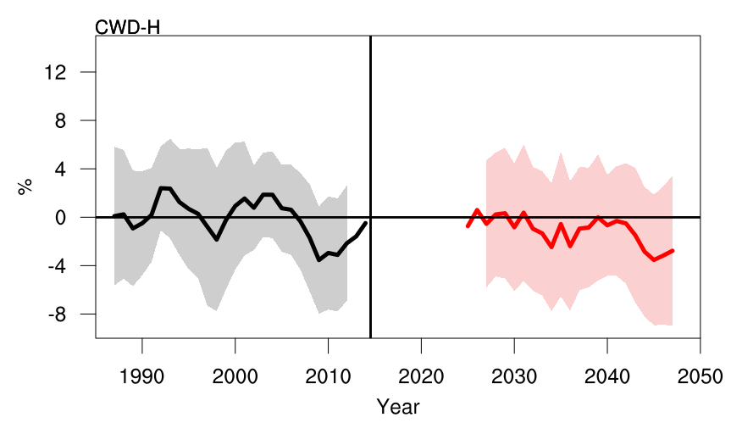
Figure S2. Same as figure S1 but for CDD
b
a

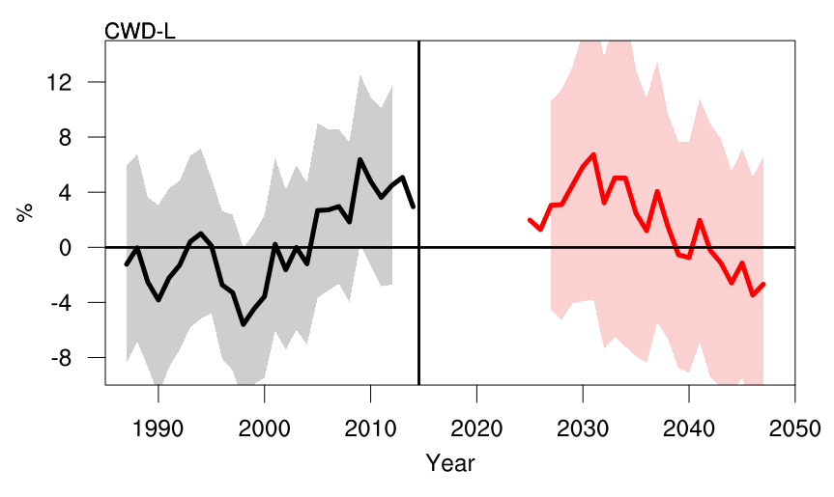
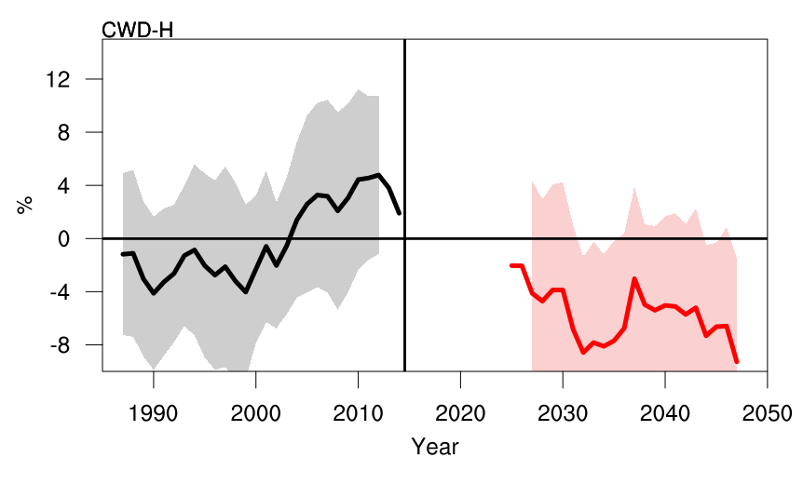
d
c

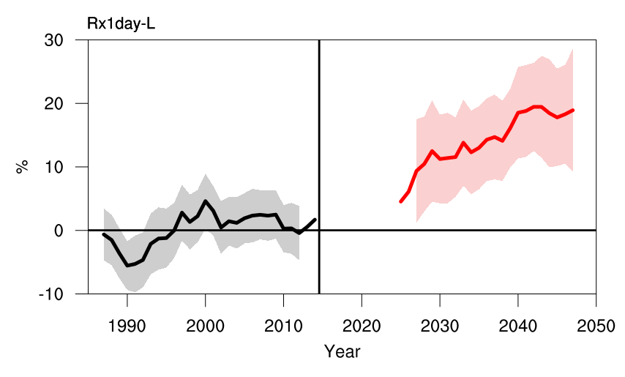
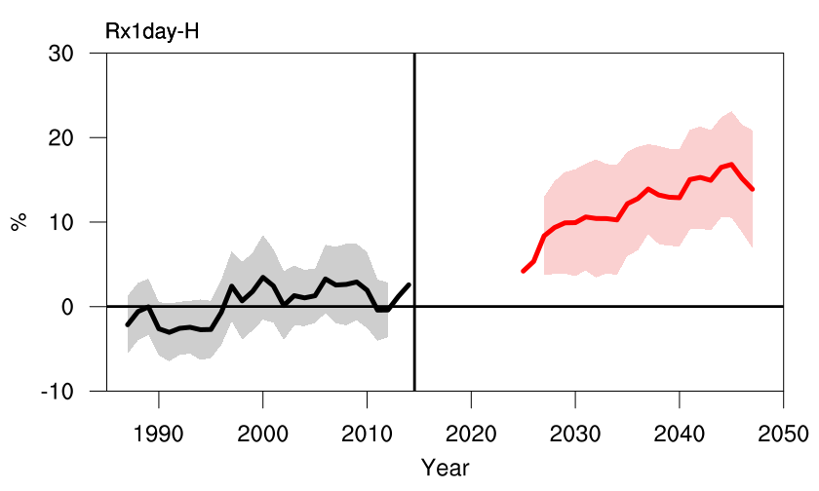
Figure S3. Same as figure S1 but for CWD
b
a

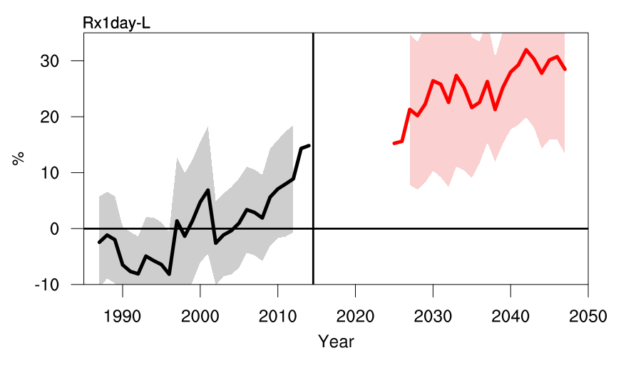
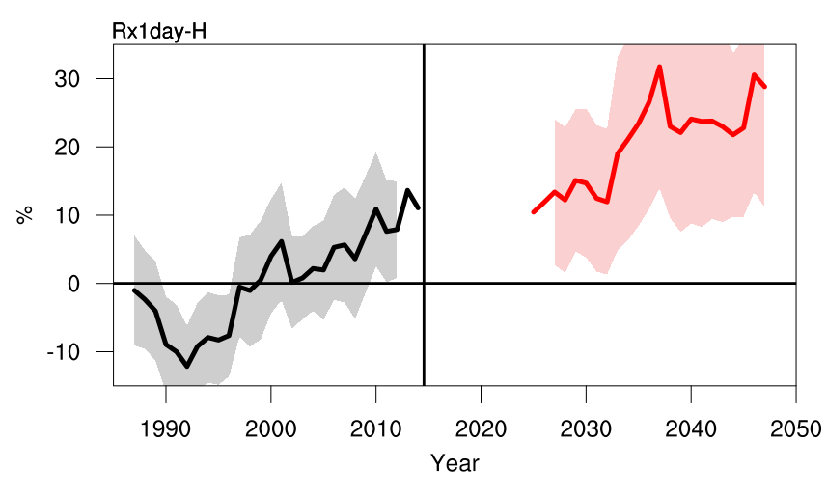
d
c

Figure S4. Same as figure S1 but for Rx1day

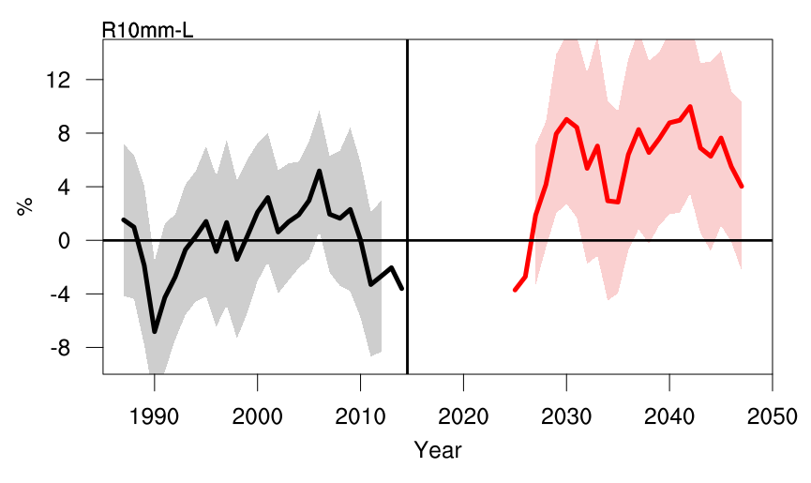
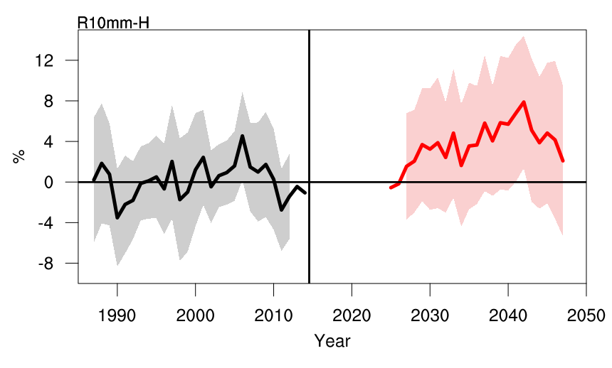
b
a

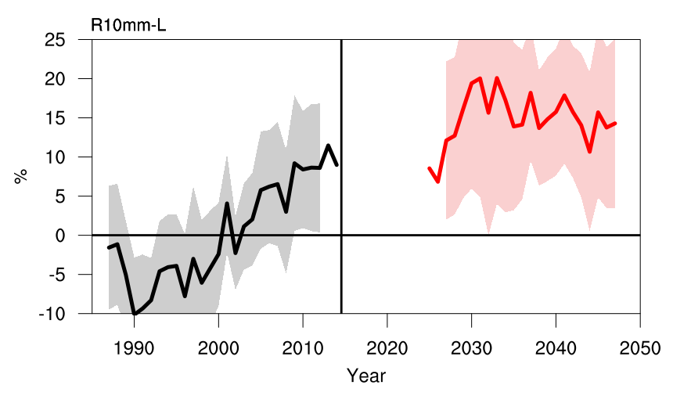
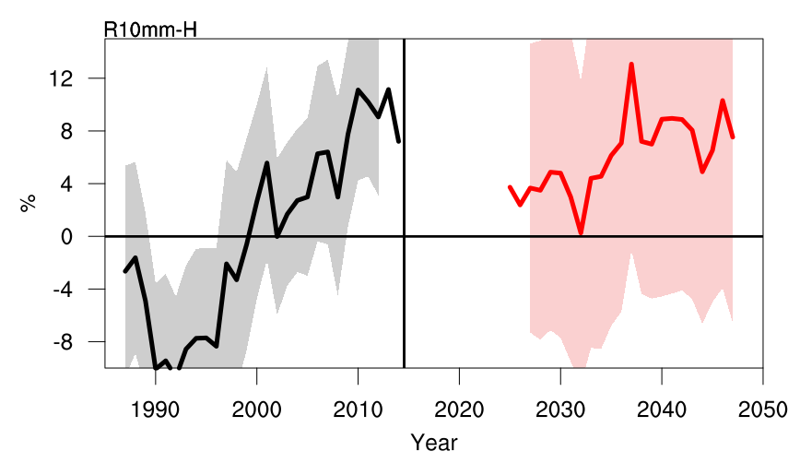
d
c

Figure S5. Same as figure S1 but for R10mm

