In silico bioprospecting of the Neotropical Plant Mandacaru (Cereus) for antimicrobial property
João Alfredo Teodoro¹, Marcus V. X. Senra¹, Fernando F. Franco², and Danilo T. Amaral^{1*}
¹Centro de Ciências Naturais e Humanas, Universidade Federal do ABC (UFABC), Santo André, São Paulo, Brasil.
²Departamento de Biologia. Centro de Ciências Humanas e Biológicas. Universidade Federal de São Carlos (UFSCar). Sorocaba, SP, 18052-780, Brazil.
*Corresponding author, Avenida dos Estados, 5001, bloco A, 504-3 room. ZIP CODE 09210-580, Santo André, Brasil. email: danilo.trabuco@ufabc.edu.br

SUPPLEMENTARY FIGURES.
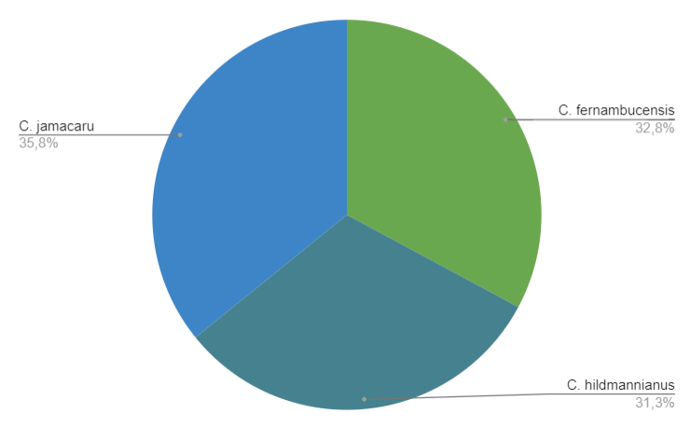
Figure S1: Percentage quantity of transcriptions by species of Cereus - Mandacaru (C. fernambucensis, C. hildmannianus and C. jamacaru).

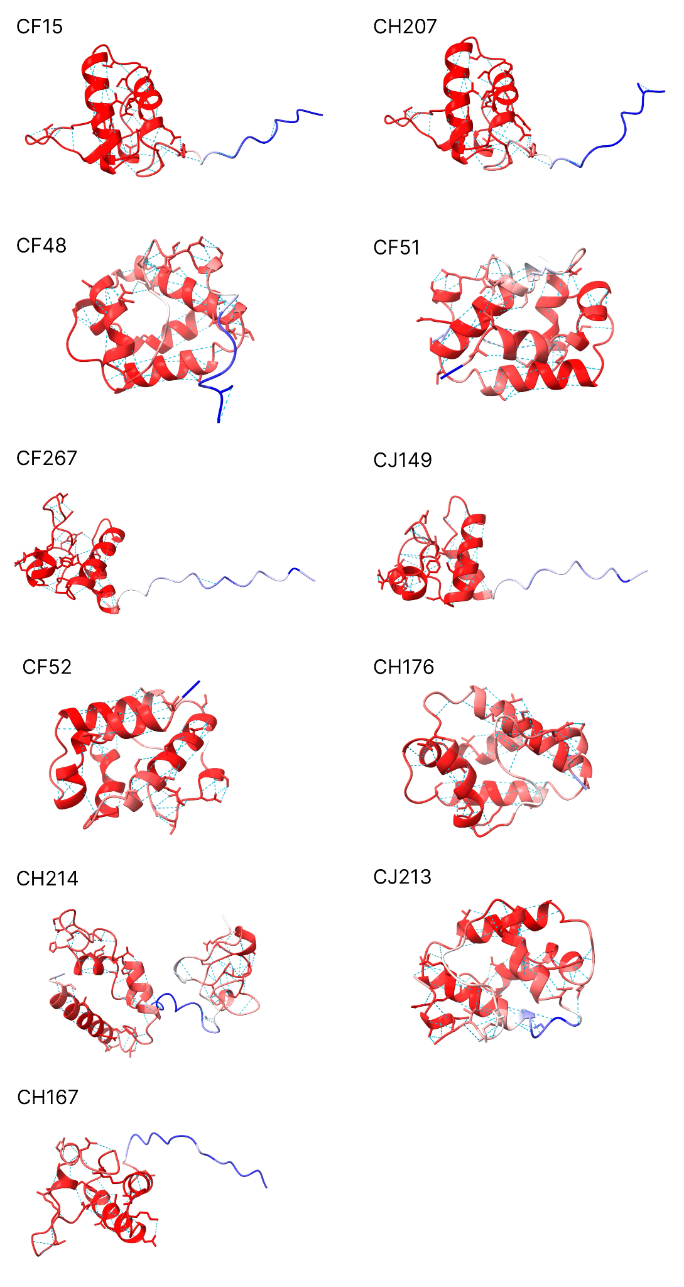
Figure S2: 3D modeling of peptide structures with their b-factor representation and the region of hydrogen bond interactions.
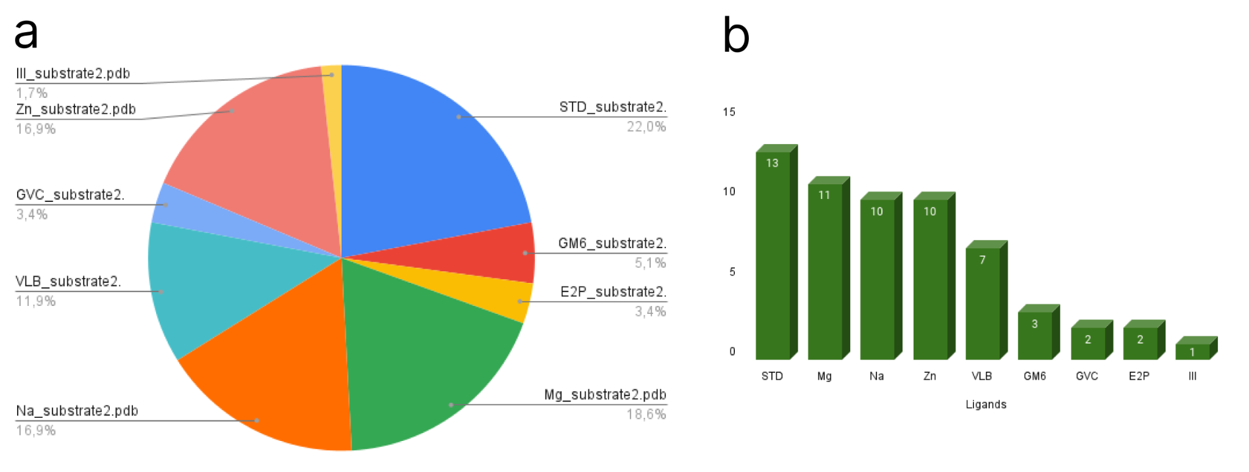

Figure S3: Number of peptide bindings per ligand used in the docking. a) The chart presents the percentage of peptides that have interaction with potential ligands for molecular docking. b) Bar representation of the number of ligands per peptide as a result of the cofactor system.

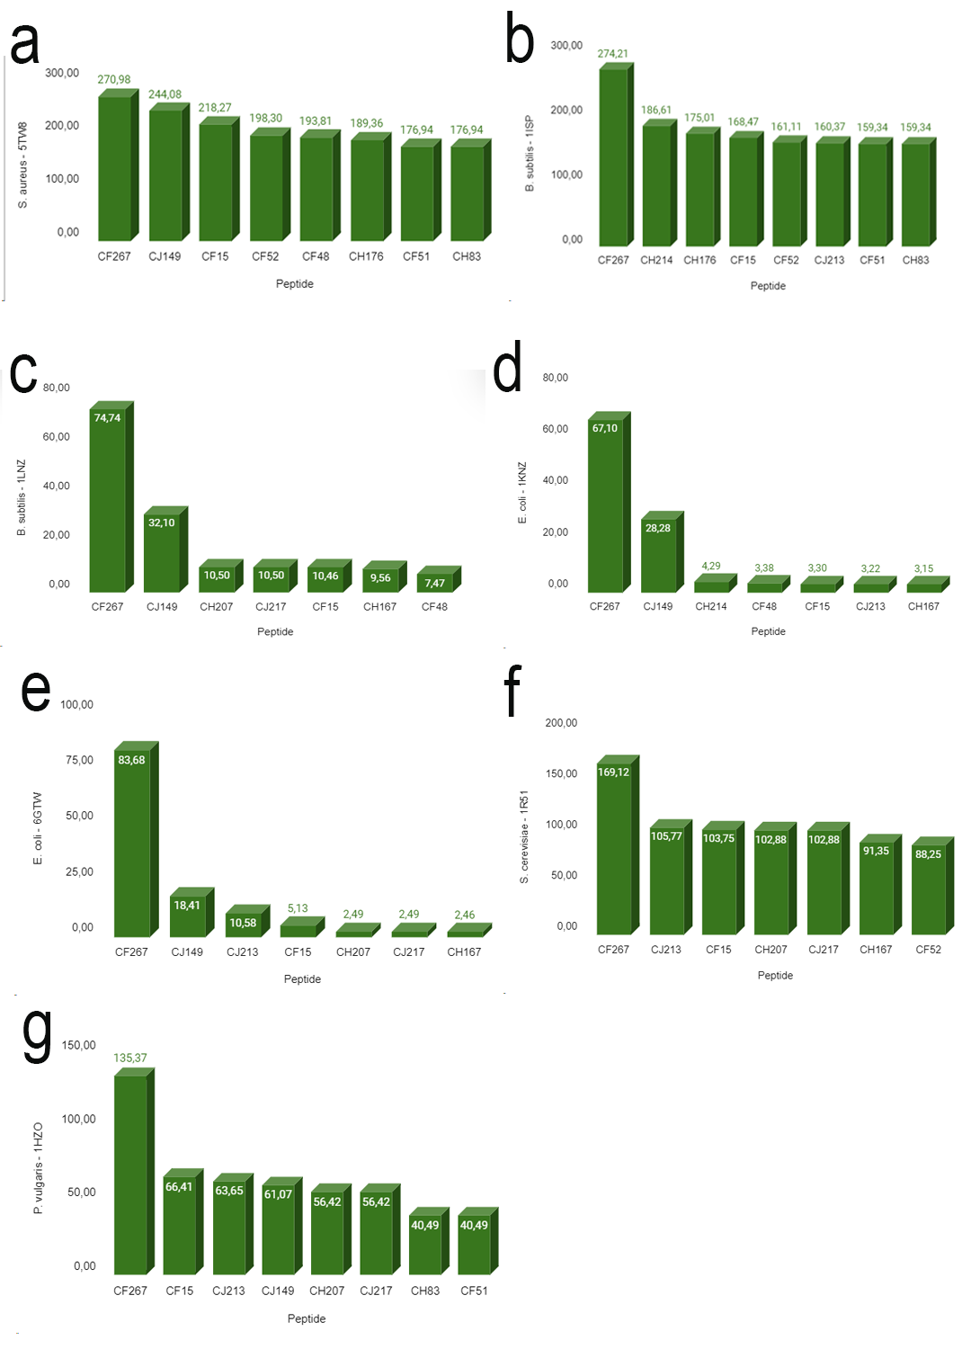
Figure S4: Filtering of the median binding scores between pathogens proteins versus peptides (a) S. aureus - 5TW8 x Peptides. (b) B. subitilis - 1ISP x Peptides. (c) B. subitilis - 1LNZ x Peptides. (d) E. coli - 1KNZ x Peptides. (e) E. coli - 6GTW x Peptides. (f) S. cerevisiae - 1R51 x Peptides. (g) P. vulgaris - 1HZO x Peptides.

A
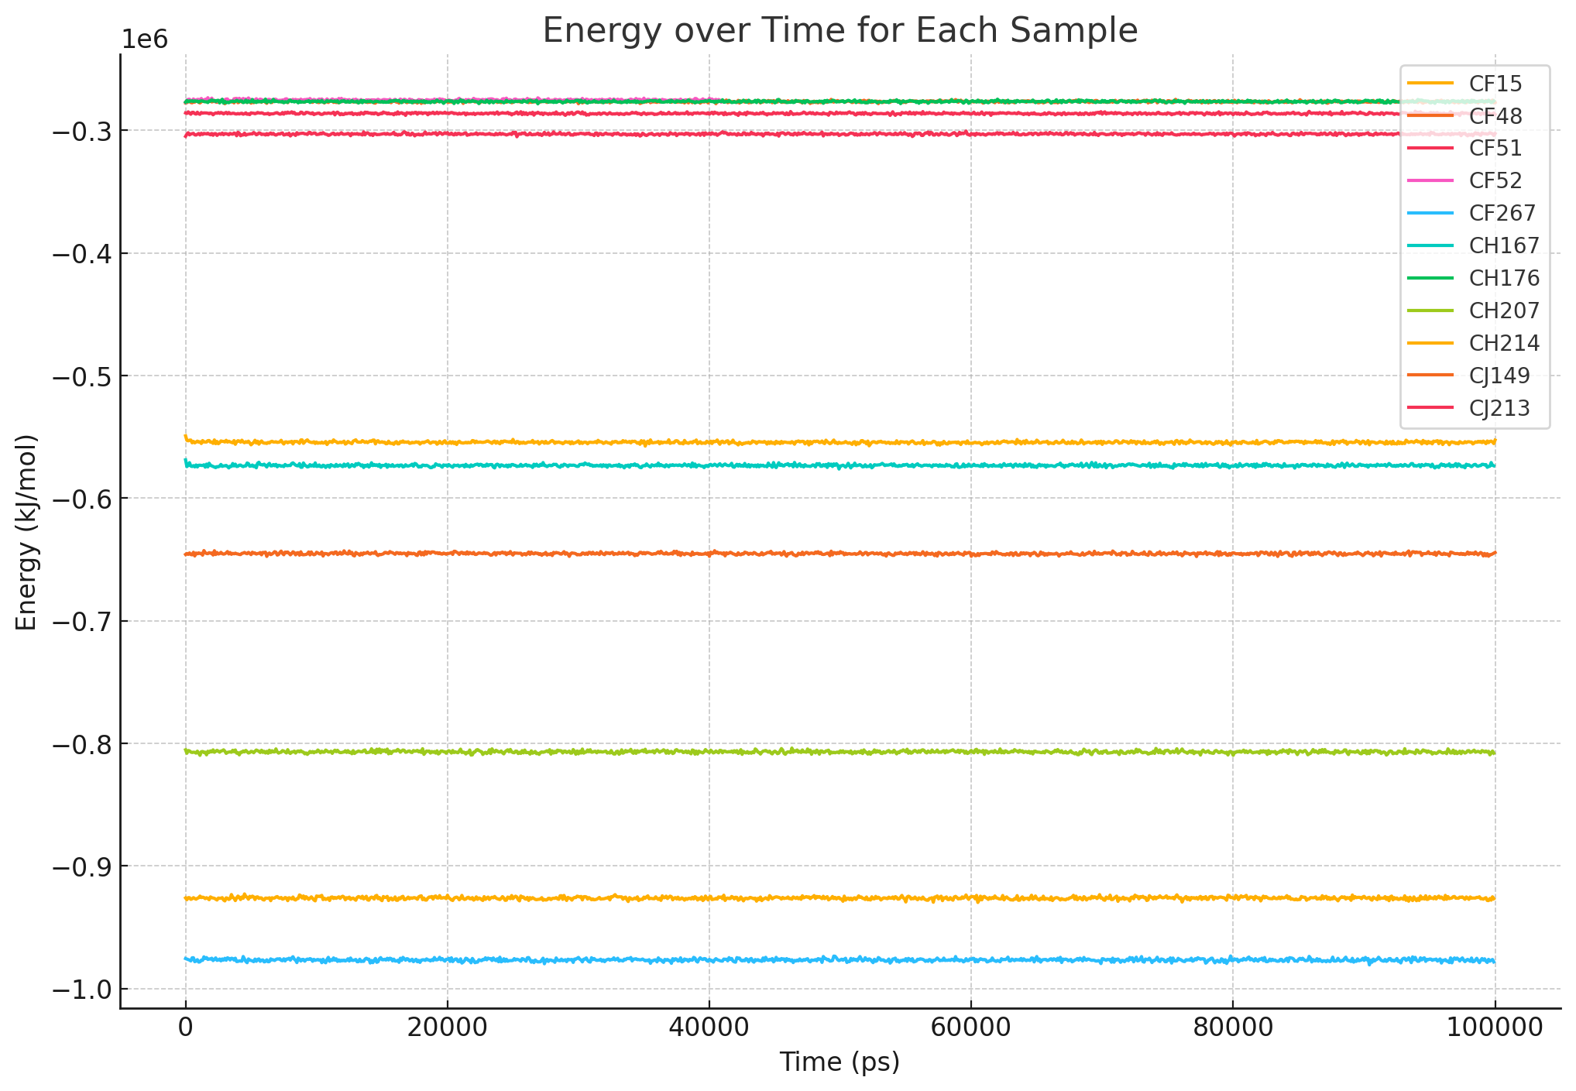
B
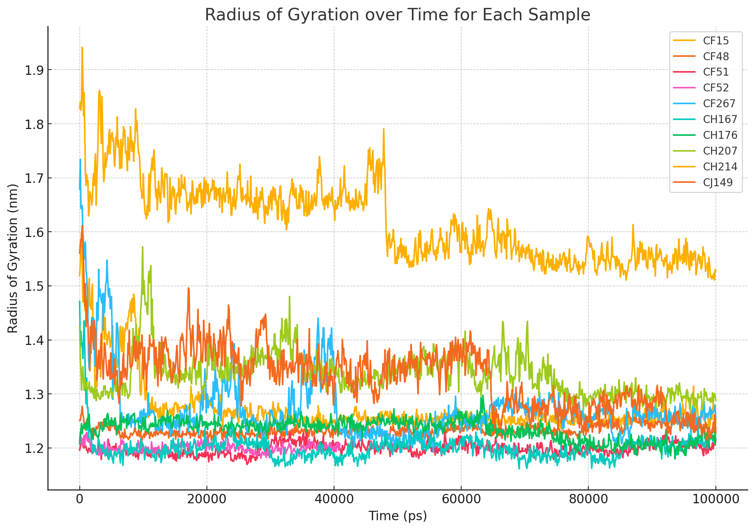
Figure S5: Plot represents (A) energy as a function of time and (B) radius of gyrations as a function of time for AMPs systems simulated in a molecular dynamics environment. The time scale is in picoseconds (ps).

SUPPLEMENTARY TABLES.
Table S1: Table of the possible substrates and ligand-binding sites on our target peptide, includes the PDB code, chemical formula, and names of the substrates.

PDB Code | Chemical Formula | Substrate
BLG | C16H30N3O14S2 | 4-O-(4-O-SULFONYL-N-ACETYLGLUCOSAMININYL)-5-METHYLHYDROXY-L-PROLINE-TAURINE
DAO | C12H24O2 | LAURIC ACID
E2P | C20H30O4 | PROSTAGLANDIN B2
GM6 | C20H28N4O4 | 3-(N-HYDROXYCARBOXAMIDO)-2-ISOBUTYLPROPANOYL-TRP-METHYLAMIDE
GVC | C10H7Cl2N3O2 | 1-(3,5-DICHLOROPHENYL)-5-METHYL-1H-1,2,4-TRIAZOLE-3-CARBOXYLIC ACID
HP6 | C7H16 | HEPTANE
III | C14H18N4 | ~{N},~{N}-dimethyl-2-pyrrolidin-1-yl-quinazolin-4-amine
LAP | C20H43NO7P | [2-((1-OXODODECANOXY-(2-HYDROXY-3-PROPANYL))-PHOSPHONATE-OXY)-ETHYL]-TRIMETHYLAMMONIUM
LNL | C18H30O2 | ALPHA-LINOLENIC ACID
LPC | C22H47NO7P | [1-MYRISTOYL-GLYCEROL-3-YL]PHOSPHONYLCHOLINE
MG | Mg | MAGNESIUM ION
NA | Na | SODIUM ION
NDG | C8H15NO6 | 2-ACETAMIDO-2-DEOXY-ALPHA-D-GLUCOPYRANOSE
PAF | C6H11O4 | PANTOATE
PAM | C16H30O2 | PALMITOLEIC ACID
PO4 | O4P | PHOSPHATE ION
QNA | C10H9BFO5 | (1~{a}~{R},7~{b}~{S})-5-FLUORANYL-2,2-BIS(OXIDANYL)-1~{a},7~{b}-DYHIIDRO-1~{H}-CYCLOPROPA[c][1,2]BENZOXABORININE-4-CARBIOXYLIC-ACID
STD | C32H44N2O9 | STREPTOLYDIGIN
STE | C18H36O2 | STEARIC ACID
TFA | C2HF3O2 | TRIFLUOROACETIC ACID
VLB | C46H58N4O9 | (2ALPHA,2'BETA,3BETA,4ALPHA,5BETA)-VINCALEUKOBLASTINE
ZN | ZN | Zinc ion

Table S2: Classification of the docking score for the interaction between peptides and ligands, using a median filter of -6.365 from the obtained raw data.

Peptide | Ligand | Score
T16 | STD | -10.080
T33 | STD | -8.143
T16 | GM6 | -7.969
T26 | STD | -7.778
T27 | STD | -7.772
T16 | E2P | -7.501
T23 | STD | -7.500
T29 | STD | -7.401
T1 | STD | -7.400
T28 | STD | -7.384
T2 | STD | -7.268
T41 | Mg | -7.205
T41 | Na | -7.205
T2 | VLB | -7.193
T4 | STD | -7.146
T65 | STD | -7.135
T22 | STD | -7.043
T23 | GVC | -6.996
T1 | Mg | -6.926
T1 | Na | -6.924
T1 | Zn | -6.924
T22 | GVC | -6.894
T26 | Mg | -6.876
T26 | Na | -6.876
T26 | Zn | -6.876
T23 | VLB | -6.865
T65 | VLB | -6.807
T33 | III | -6.780
T2 | Mg | -6.735
T4 | Mg | -6.735
T2 | Na | -6.735
T4 | Na | -6.735
T2 | Zn | -6.735
T4 | Zn | -6.735
T16 | Mg | -6.675
T16 | Na | -6.675
T16 | Zn | -6.675
T4 | VLB | -6.630
T33 | GM6 | -6.618
T26 | VLB | -6.597
T27 | VLB | -6.543
T27 | GM6 | -6.536
T33 | Mg | -6.535
T33 | Na | -6.535
T33 | Zn | -6.535
T27 | Zn | -6.516
T27 | Mg | -6.515
T27 | Na | -6.515
T29 | Zn | -6.477
T33 | VLB | -6.470
T29 | Na | -6.469
T29 | Mg | -6.468
T23 | Zn | -6.447
T22 | Mg | -6.445
T22 | Zn | -6.443
T23 | Na | -6.442
T23 | Mg | -6.436
T28 | E2P | -6.371
T41 | STD | -6.365

Table S3: Best docking scores analyzing only the interaction between the selected peptides and the proteins of Gram-negative bacterial species
Peptide | E. coli  1KNZ | E. coli  6GTW | P. vulgaris  1HZO
CF267 | 67,10 | 83,68 | 135,37
CJ149 | 28,28 | 18,41 | 61,07
CF15 | 3,30 | 5,13 | 66,41
CJ213 | 3,22 | 10,58 | 63,65S

Table S4: Mean RMSD and standard deviation for molecular dynamics simulations of each AMP.
AMP | Mean RMSD | Std Dev RMSD
CF48 | 607 | 70
CH176 | 818 | 56
CF267 | 887 | 155
CJ149 | 922 | 95
CF52 | 1.100 | 155
CF51 | 1.286 | 174
CH214 | 1.436 | 179
CH167 | 1.458 | 284
CJ213 | 2.057 | 320
CH207 | 2.458 | 342
CF15 | 3.015 | 472

