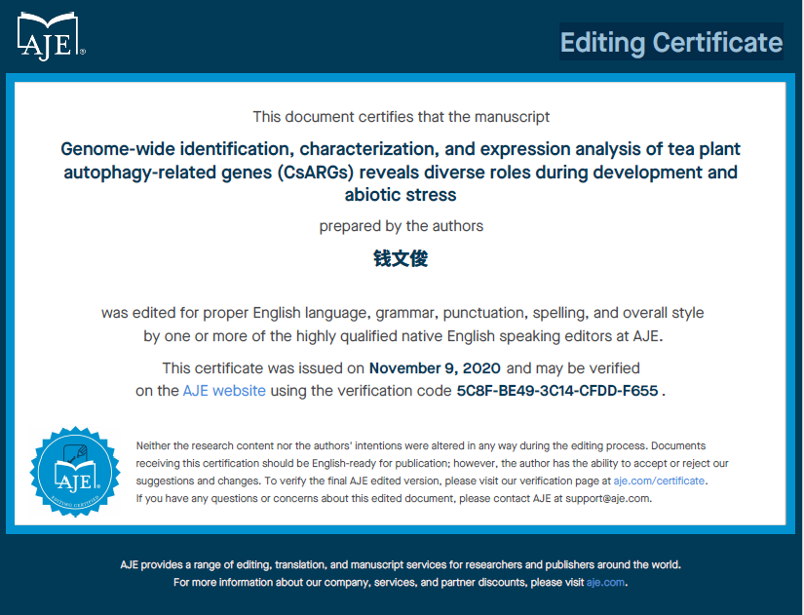
Fig. S3 Editing Certificate of the manuscript

