Supporting Information

Pine Pollen-Derived Porous Carbon by Chemical Activation for Supercapacitor Electrodes
Harun Kaya¹, Aydan Aksogan Korkmaz², Seher Guler³ and Funda Ersoy Atalay^{3,*}
¹Malatya Turgut Ozal University, The Faculty of Engineering and Natural Sciences, Malatya, Turkey
²Malatya Turgut Ozal Univ, Hekimhan MES Vocat Sch, Min Technol, Malatya, Turkiye
³Inonu University, The Faculty of Science and Arts, Department of Physics, Malatya, Turkey,
*Corresponding author:funda.atalay@inonu.edu.tr

Number of pages: 4; Number of figures:3

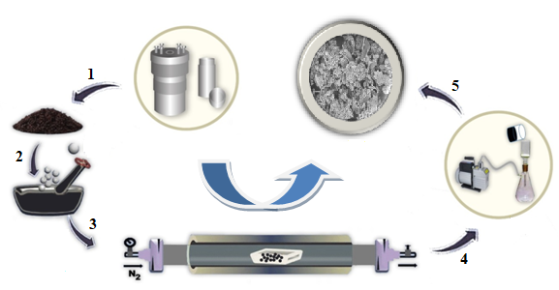

Figure S1. Steps of activated carbon synthesis process.

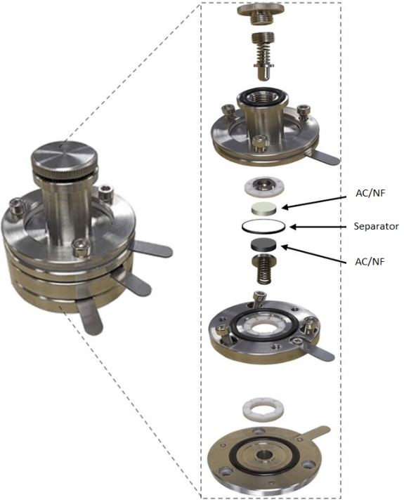

Figure S2. Swagelok cell components and the supercapacitor device were created using this cell.

a)
b)
c)

Figure S3. a) CV curves of symmetrical AC supercapacitor, b) Galvanostatic first ten CD curves of symmetrical KAC supercapacitor at 10 A/g, c) Long-term CD measurements of a symmetrical KAC supercapacitor at 10 A/g.

