Supplemental information
Short-term nutrient addition improves soil organic carbon accumulation in tropical forest
Tian-yan Suª, Ya-min Jiangª, Hua-ying Chenª, Ying Wangª, Qiu Yangª, Jia-ling Li^{b}, Jing-li Lu^{a*}, Hong-yu Ranª, Huai Yang^{c}, Wen-jie Liu^{a*}, Meng-yang Fang^{d}, Liang-hong Huang^{b}
ª Key Laboratory of Agro-Forestry Environmental Processes and Ecological Regulation of Hainan Province, School of Ecology, Hainan University, Haikou, China
^{b} Wuzhishan Division, Hainan Tropical Rainforest National Park Bureau, Wuzhishan, China
^{c} Rattan & Flower, Sanya Research Base, International Center for Bamboo and Rattan, Institute of Tropical Bamboo, Sanya, China
^{d} Sanya Tropical Ecosystem Carbon Source and Sink Field Scientific Observation and Research Station, Sanya, China
*Correspondence: lujingli@hainanu.edu.cn; liuwj@hainanu.edu.cn

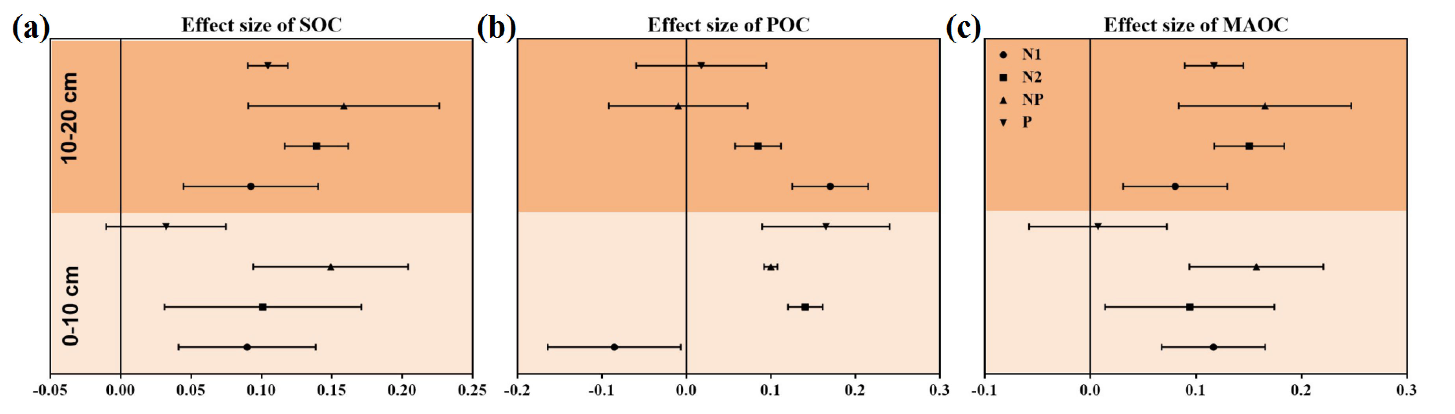
Figure S1 Effects of nutrient addition on the content of SOC, POC and MAOC. Error bars represent 95% confidence interval. SOC, POC, and MAOC represents soil organic carbon, particulate organic carbon, and mineral-associated organic carbon, respectively. N1: low N addition of 25 kg N ha⁻¹ year⁻¹; N2: high N addition of 50 kg N ha⁻¹ year⁻¹; P: P addition of 50 kg P ha⁻¹ year⁻¹; NP: N2 with P treatment.

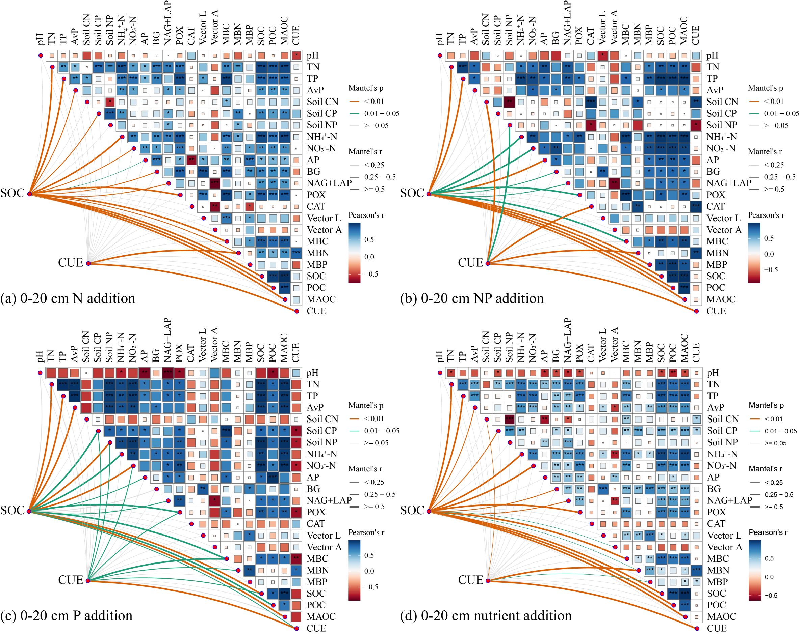
Figure S2 The Pearson's correlation mantel-test heatmap of the SOC and CUE with soil properties, Soil enzyme activity and microbial biomass. The colors indicate the pairwise comparisons of variables, the thicknesses of the lines indicate the strength of the correlation. The asterisks indicate the statistical significance (*p < 0.05; **p < 0.01; ***p < 0.001). (a) N addition represents (N1+N2) addition. (d) nutrient addition represents N1, N2, NP and P addition. AvP, soil available phosphorus; NH₄⁺-N, soil ammonium nitrogen; NO₃⁻-N, soil nitrate nitrogen; TN, soil total nitrogen; TP, soil total phosphorus; C:N, C:P, and N:P indicate the ratios of SOC to TN, SOC to TP, and TN to TP, respectively. BG, β-1, 4-glucosidase; NAG, β-1, 4-N-acetylglucosaminidase; LAP, leucine aminopeptidase; AP, Acid phosphatase; POX, Polyphenol oxidase; CAT, Catalase; Vector length, soil carbon limitation for microbes; Vector angle, soil N and or P limitation for microbes. SOC, POC, MAOC, and CUE represents soil organic carbon, soil particulate organic carbon, mineral-associated organic carbon, and carbon use efficiency, respectively. MBC, microbial biomass carbon; MBN, microbial biomass nitrogen; MBP, microbial biomass phosphorus.

